asgn01 Classes

Objectives

- Create a class
- Create class variables
- Create class methods
- Read class diagrams
- Use version control

Introduction

You will learn OOP (Object Oriented Programming).

For the first section of this class we will watch and code from the LinkedIn/Learning video In this assignment we will
- Install Prettier for PHP (different than Prettier for HTML/JS)
- Use Git and GitHub
- Write the code challenge from chapter 1 in the video
- Write code for a similar program called bird-class

The Assignment

VS Code
Read this article on setting up Prettier for PHP File Formats in VSCode. Install the plugin according to the instructions. Note, you will need to change the settings.json file so you can run Prettier for multiple programs.

Folder structure
Create the following folder structure in your web root (htdocs).

web250
asgn01
bike-challenge bird-challenge

Watch the PHP videos

Watch chapters 1 and 2 from the PHP: Object-oriented Programming video and code along. I recommend watching the videos first, then go back and code with the author while watching a second time.

Complete the Challenge: Properties and methods

Complete the Challenge at the end of Object Basics. It will serve as a template for the assignment. Mr. Skoglund provides a solution but give it your best shot without looking at the answer and without wasting too much time. Or, watch his answer, and try to code the challenge without referencing it. Challenge yourself.

UML - Unified Modelling Language

UML is a diagramming system comprised of many modeling techniques. We will use it for class diagrams just like the ones you saw in the OOD series. You can think of the class diagrams as a visual algorithm. These models are helpful in organizing your thoughts as your programs become more complex.
Here is a class diagram for the Challenge. Note that The class name is a singular noun, and the first letter is capitalized.
Use CamelCase if the class name is more than one word.

The properties (attributes) are located below the class name. Here you can include a default value.
The bottom section displays the methods (OOP speak), also called functions.

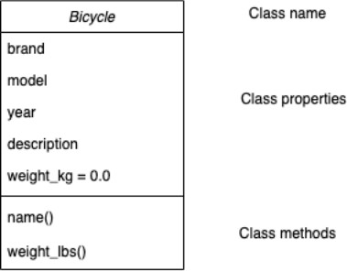

NOTE: The author's HTML code is dated. He is using HTML4 and also uses underscores in his file names.
- Change the HTMl them to fit the coding standards listed in Moodle.

- Change the file names so they use hyphens instead of underscores.

We will use the coding standards in listed in Moodle for the Bird Challenge later in this assignment.

Bird Challenge

  - Create a new folder named web250/bird-challenge .
  - Create a file named index.php Inside your bird-challenge folder.

Use the class diagram

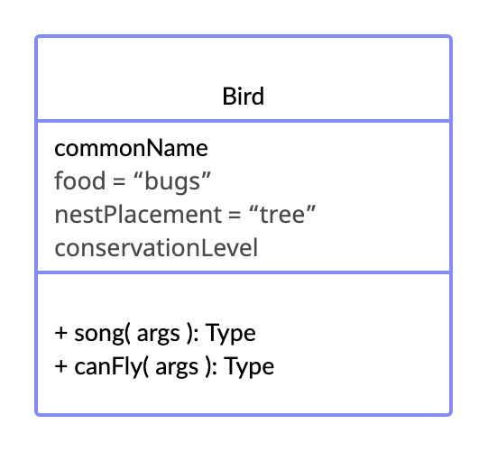 (ignore the + signs for now). I have provided default values.

Create an instance from the diagram
$bird2

Create two bird instances. Name the instances menthod information.
$bird1
and
. Here is the data and

$bird1

Note that the "code" below is from the class diagram. It is not using PHP syntax.
Properties
commonName = Eastern Towhee
foodfood = seeds, fruits, insects, spiders nestPlacementnestPlacement = Ground conservationLevelconservationLevel = Low

Methods
song = drink-your-tea!
canFly = This bird can fly

$bird2
Properties
commonName = Indigo Bunting
food = small seeds, berries, buds, and insects
nestPlacement = roadsides, and railroad rights-of-wafields and on the edges conservationLevel = Low

Methods
birdSongbirdSong
whatwhat!!
canFly = This bird can fly

Display the content for both bird instances.
==

Submit your code in Moodle

Zip up your web250 folder. Renamed the zipped folder to asgn01_yourLastName and submit it in Moodle.

