Cover Page

**Table of Contents**

1. **Getting Started**
   1. Logging In/Out
2. **Features: File Maintenance**
   1. Account Type
   2. Share Capital Setup
   3. Time Deposit Matrix
   4. Interest Rates
   5. Fiscal Year
   6. OR Management
   7. Company Profile
   8. Signatories
   9. Users
   10. User Rights
   11. System Lock
3. **Getting Started**
   1. **Logging In**
4. From your desktop view or anywhere you have saved the application, look for the application “CITCS - COOP Information System” and open it.



1. You will see a loading screen and wait for the loading screen to finish and you will be redirected to login your credentials.

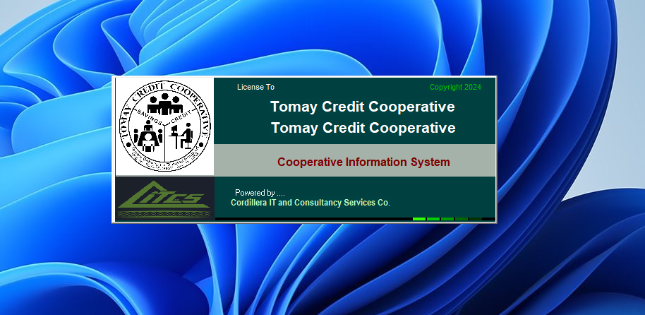

1. User Login

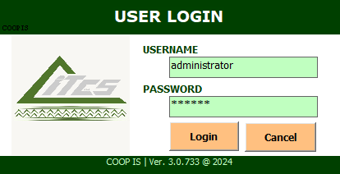

1. After logging in your credentials, you will be redirected to the landing page of the application shown below.

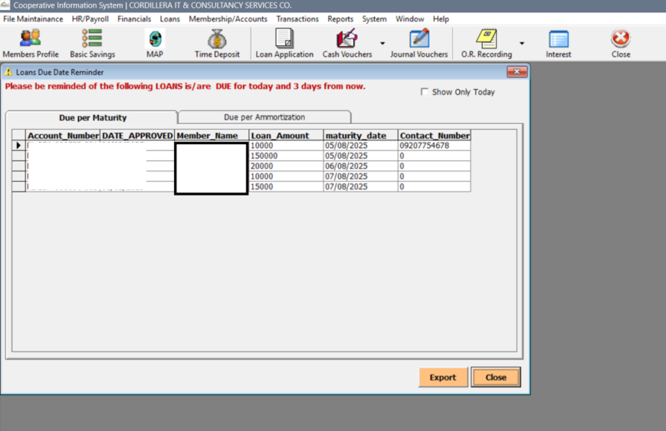

1. **Features: File Maintenance**
   1. **Account Type**
2. From your application window, you will see a button on the upper-left most part of the screen File Maintenance tab. Upon clicking, you will see a window like shown below.

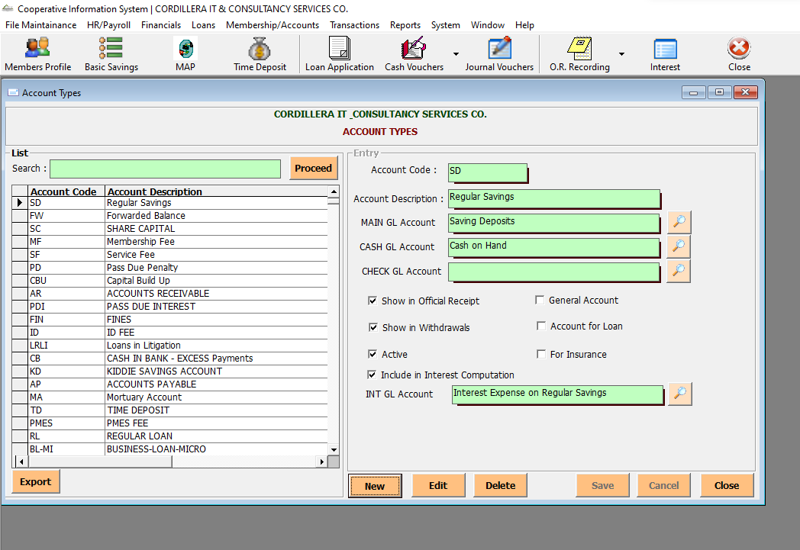

1. This feature allows you to setup account types of your organization and you can search or browse options if needed to suffice Account Descriptions and other related fields. (Wrong screenshot—to change upon opening in Wangal)

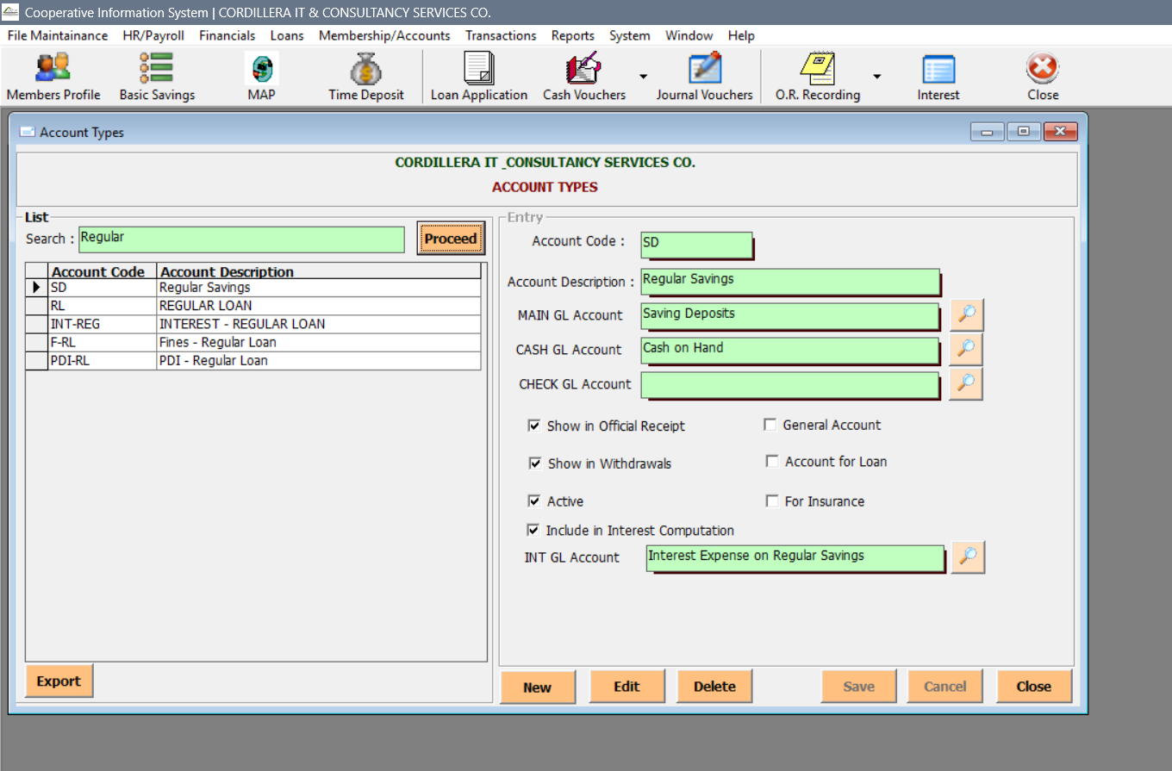

* 1. **Share Capital Setup**

1. You can also setup you Share Capital in the File Maintenance tab and clicking the File Maintenance Setup.

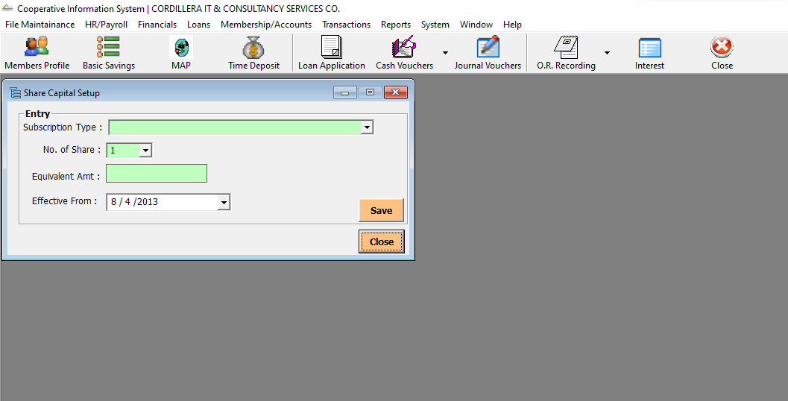

* 1. **Time Deposit Matrix**

1. Setting up for Time Deposit Matrix can also be found in the File Maintenance tab and clicking the Time Deposit Matrix

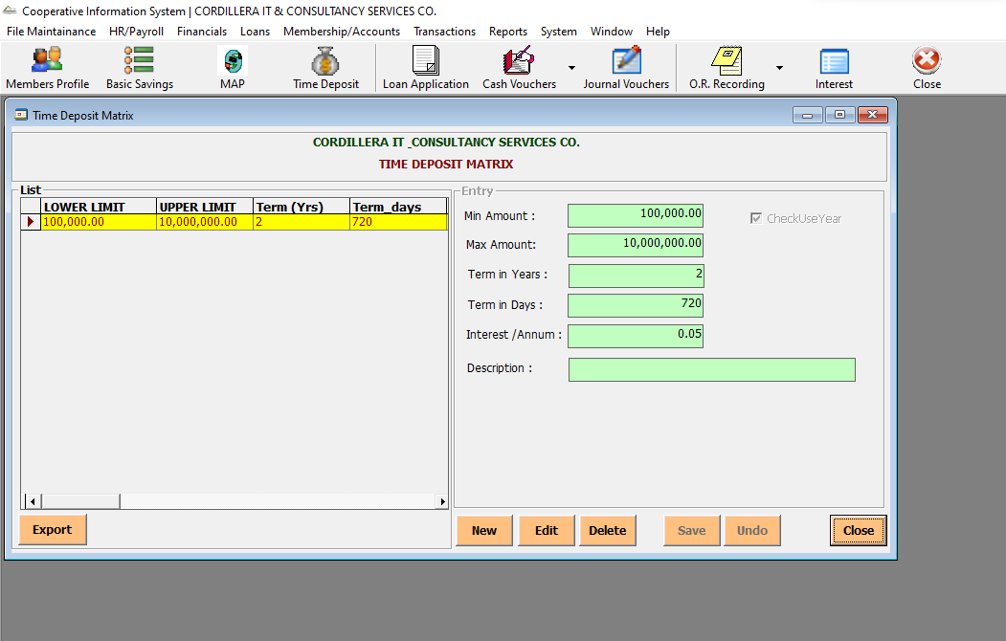

* 1. **Interest Rates**

1. You can set up and update Interest Rates in the File Maintenance Tab and clicking the Interest Rates

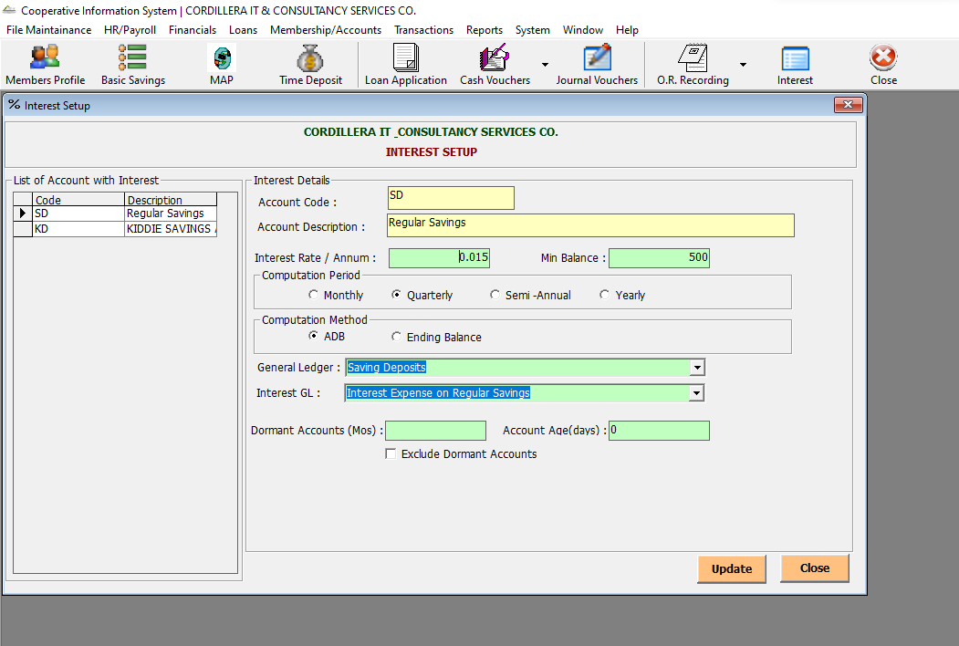

* 1. **Fiscal Year**

1. You can set up and update Fiscal Year in the File Maintenance Tab and clicking the Interest Rates

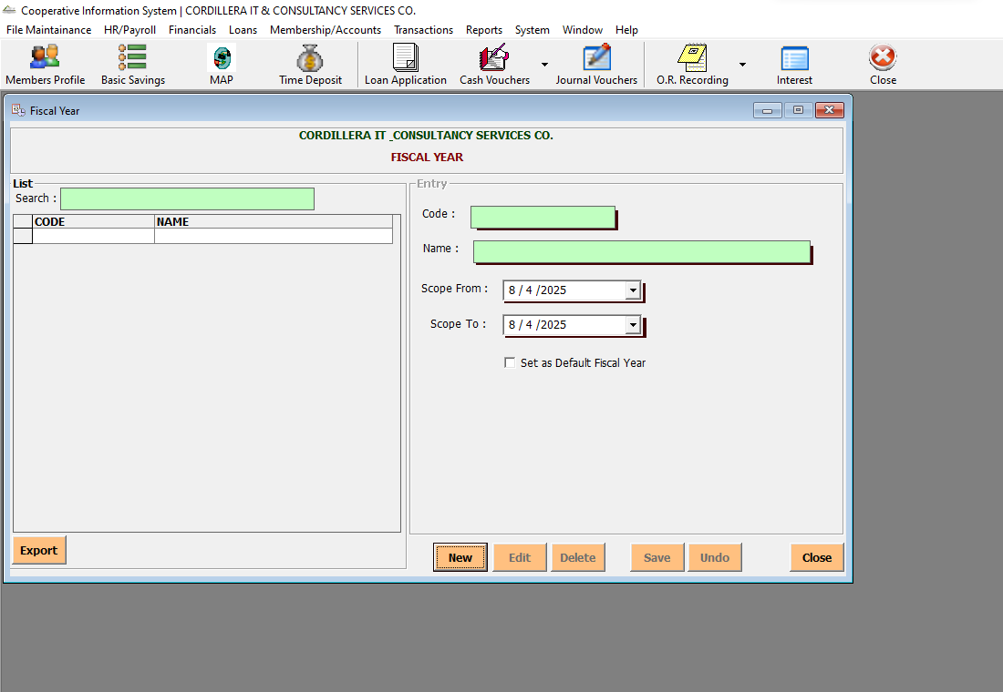

* 1. **OR Management**

1. Setting up for the OR Management can be found in the File Maintenance tab clicking the OR Management. You can also search in order to fill out related fields by clicking the search icon.

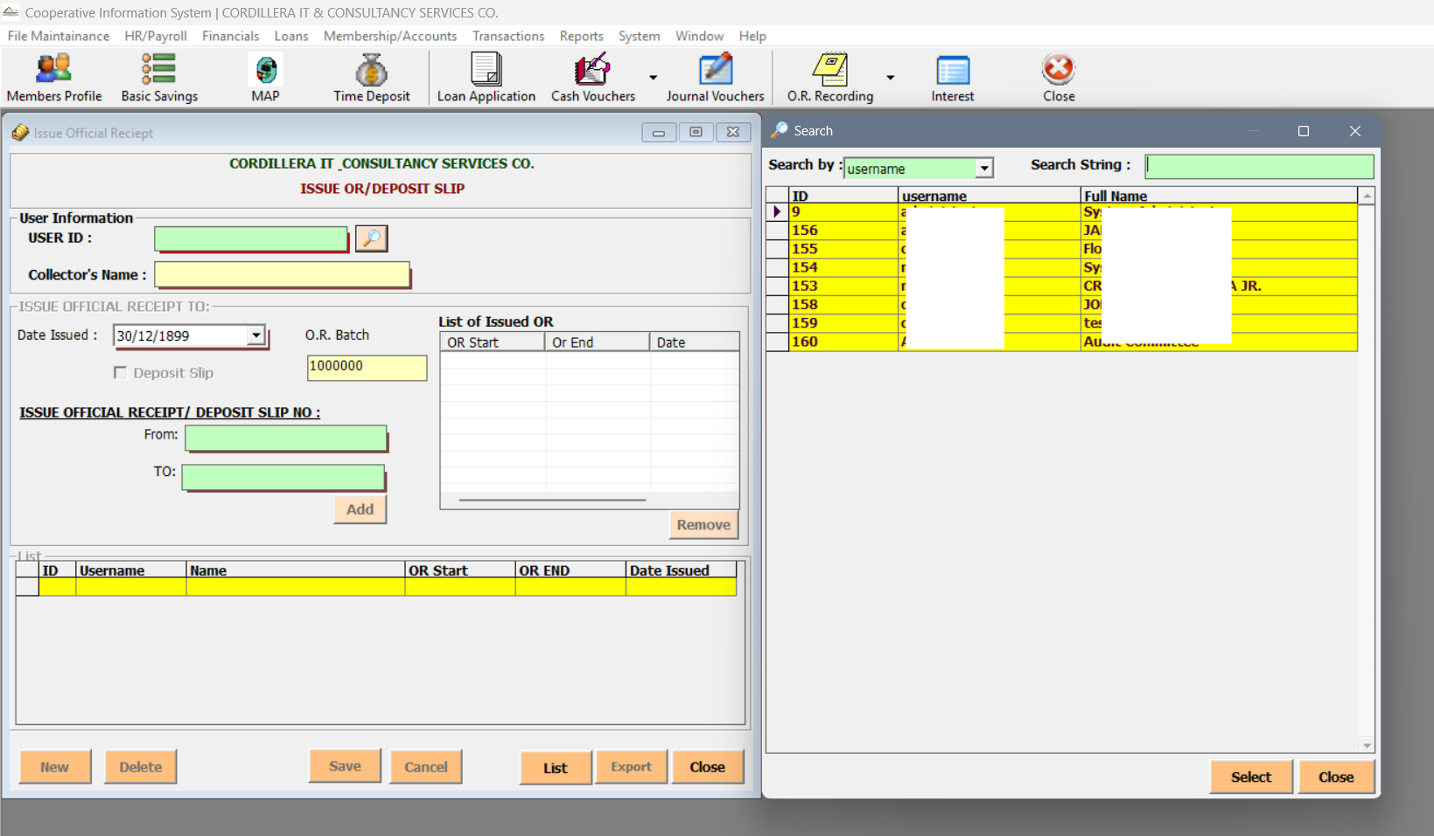

* 1. **Company Profile**

1. You can set up and update Fiscal Year in the File Maintenance Tab and clicking the Company Profile

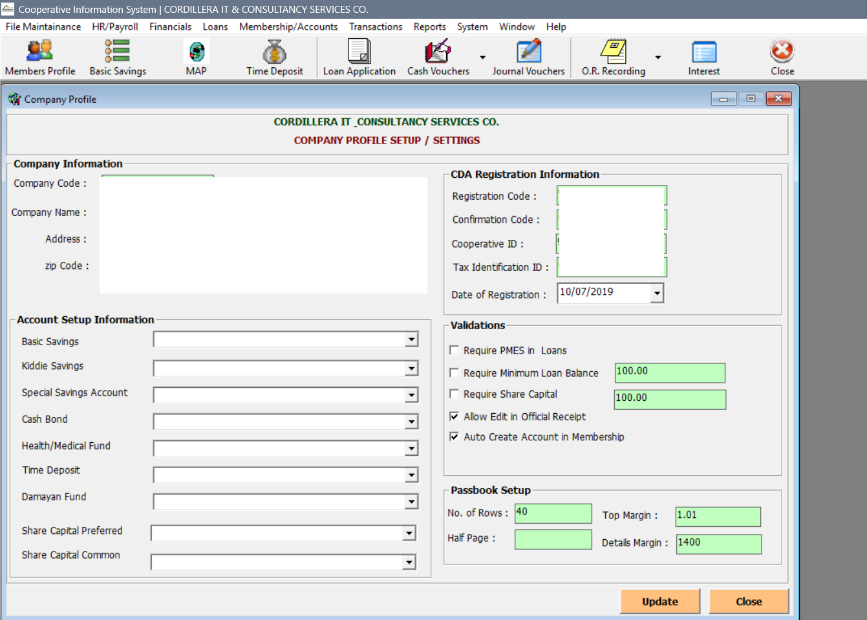

* 1. **Signatories**

1. In order to update and set up set of Signatories, you can do that by clicking the Signatories in the File Maintenance tab.

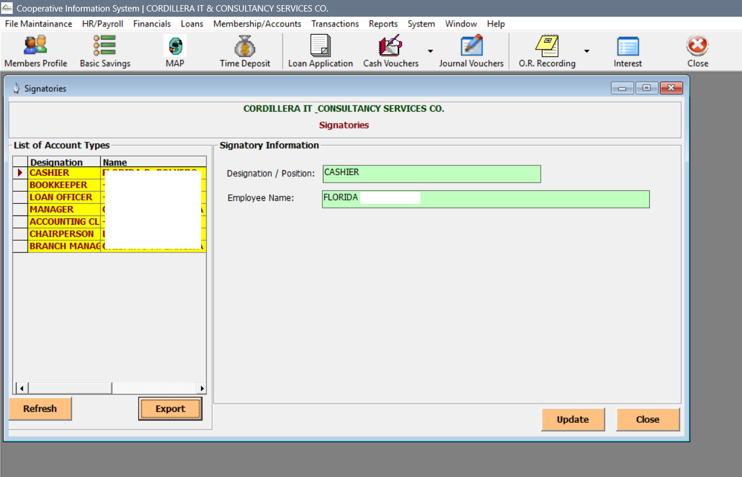

* 1. **Users**

1. You can view set of users for File Maintenance in the Users.

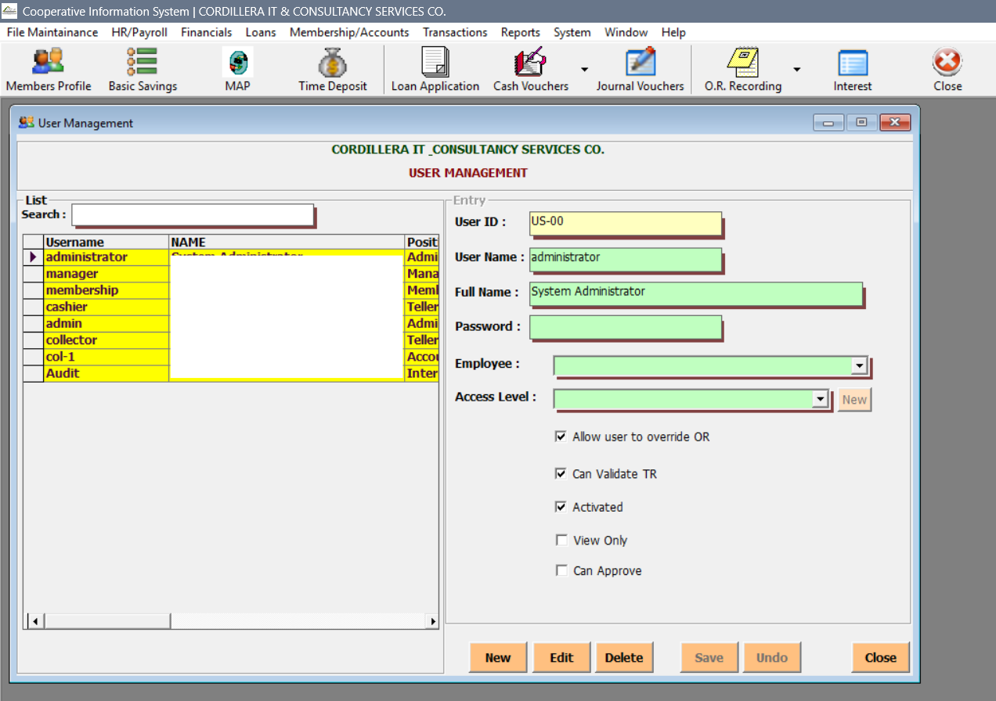

* 1. **User Rights**

1. You can also update User Rights under the File Maintenance Tab. A search icon is also available to help you filter needed inputs in the fields.

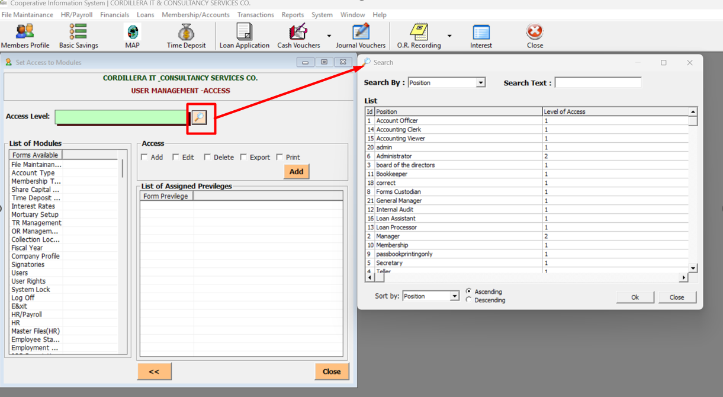

* 1. **System Lock**

1. You can lock your logged in user account to prevent unauthorize input of pertinent data in the system using your account under the File Maintenance tab.

