**Install Terraform on Ubuntu: 24.04 LTS**

Unzip the Terraform folder and check the version

Step -1 Initialize Terraform use the following command:

**terraform init**

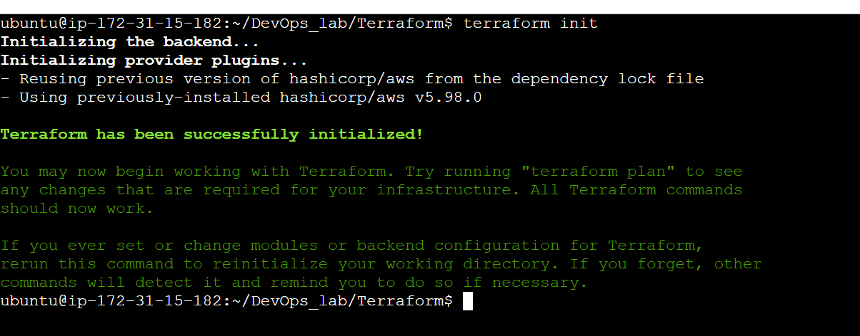

**Step 2: create the terraform.tf file**

**sudo nano example.tf**

provider "aws" {

profile = "default"

region = "ap-south-1"

}

resource "aws_instance" "example" {

ami = "ami-0e35ddab05955cf57"

instance_type = "t2.micro"

tags = {

Name = "myinstance"

}

}

**Step 3: validate the syntax of files**

**terraform validate**

**Step 4: check the resources created/deleted using terraform plan**

**terraform plan**

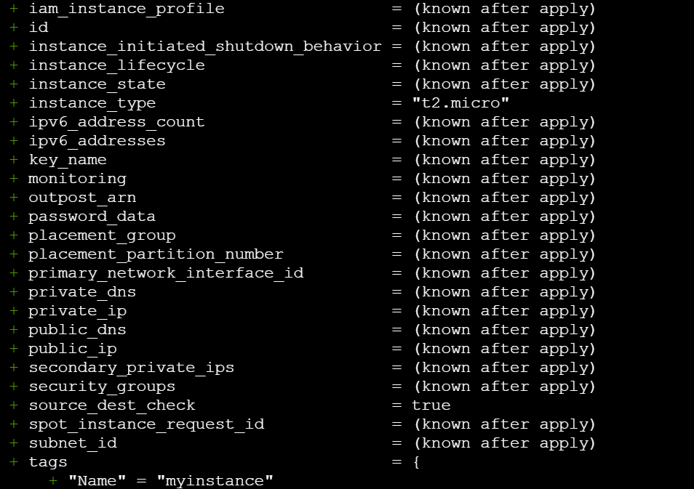

**terraform plan -out myplan**

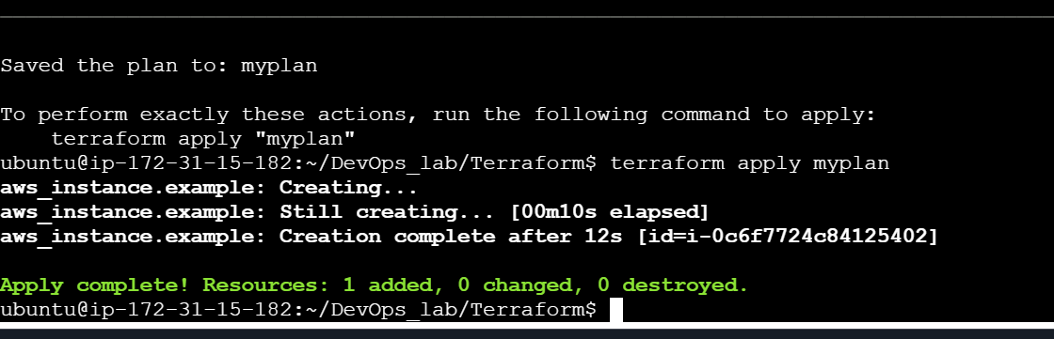

**Step 5: Apply the plan created**

**terraform apply myplan**

**Login to AWS console and check if new instance (myinstance) is created**

**Additional exercise**

Run a script inside the new EC2 instance created

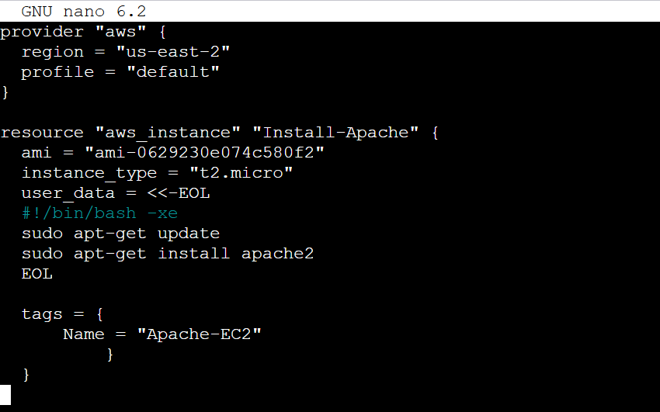

**terraform apply myplan2**

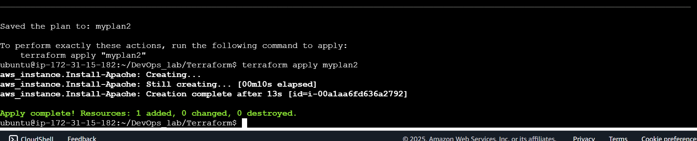

Destroy the resources – use **terraform destroy**



