**Lab 11: Design and deploy a simple web application architecture on AWS using AWS CloudFormation**

Navigate the AWS Management console to find AWS CloudFormation. Click on **Create stack**

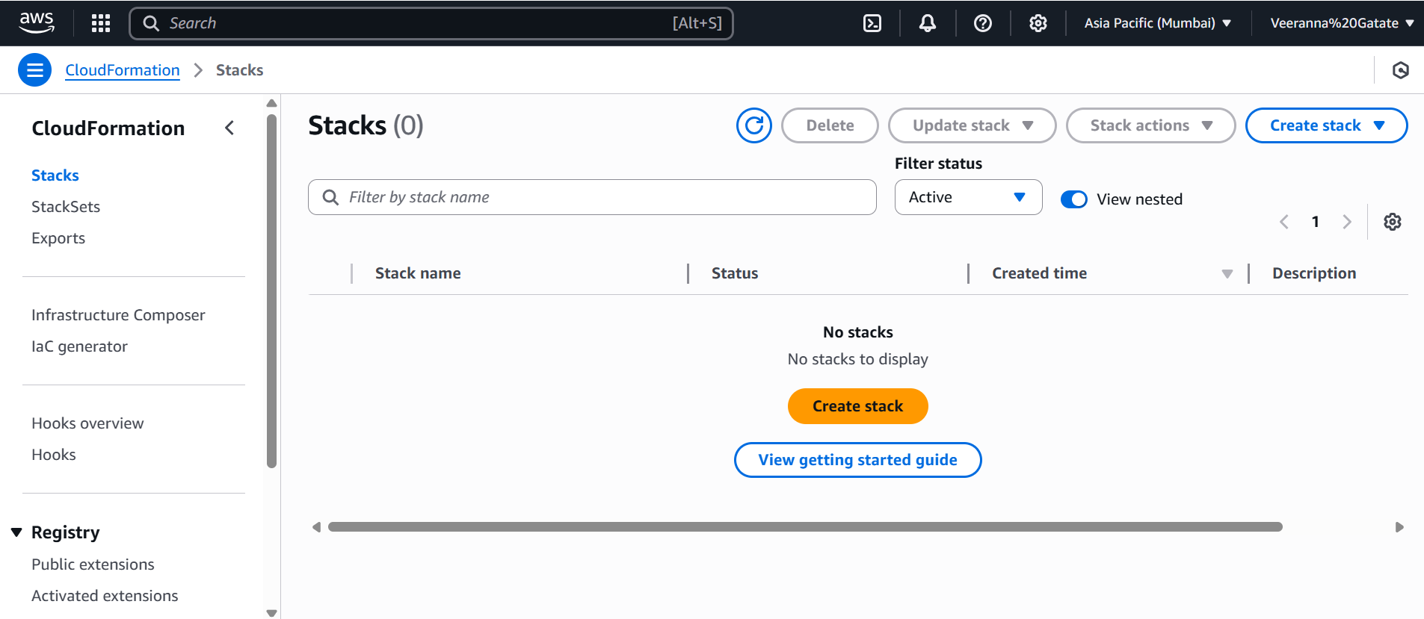

**Save the below YAML file in local folder and upload this file.**

**Ec2-s3-stack.yaml**

AWSTemplateFormatVersion: '2010-09-09'

Description: CloudFormation Stack to create an EC2 Instance and an S3 Bucket

Parameters:

  KeyName:

    Description: Name of an existing EC2 KeyPair to enable SSH access

    Type: AWS::EC2::KeyPair::KeyName

  InstanceType:

    Description: EC2 instance type

    Type: String

    Default: t2.micro

    AllowedValues:

      - t2.micro

      - t2.small

      - t3.micro

      - t3.small

    ConstraintDescription: must be a valid EC2 instance type.

Resources:

  MyS3Bucket:

    Type: AWS::S3::Bucket

    Properties:

      BucketName: !Sub 'cf-demo-bucket-${AWS::AccountId}-${AWS::Region}'

  MyEC2Instance:

    Type: AWS::EC2::Instance

    Properties:

      InstanceType: !Ref InstanceType

      KeyName: !Ref KeyName

      ImageId: ami-0e35ddab05955cf57  # Amazon Linux 2 AMI (change for your region)

      SecurityGroups:

        - !Ref InstanceSecurityGroup

  InstanceSecurityGroup:

    Type: AWS::EC2::SecurityGroup

    Properties:

      GroupDescription: Enable SSH access

      SecurityGroupIngress:

        - IpProtocol: tcp

          FromPort: 22

          ToPort: 22

          CidrIp: 0.0.0.0/0

Outputs:

  EC2InstanceId:

    Description: ID of the EC2 instance

    Value: !Ref MyEC2Instance

  S3BucketName:

    Description: Name of the created S3 bucket

    Value: !Ref MyS3Bucket

Click on **Next**

Click on **Next**

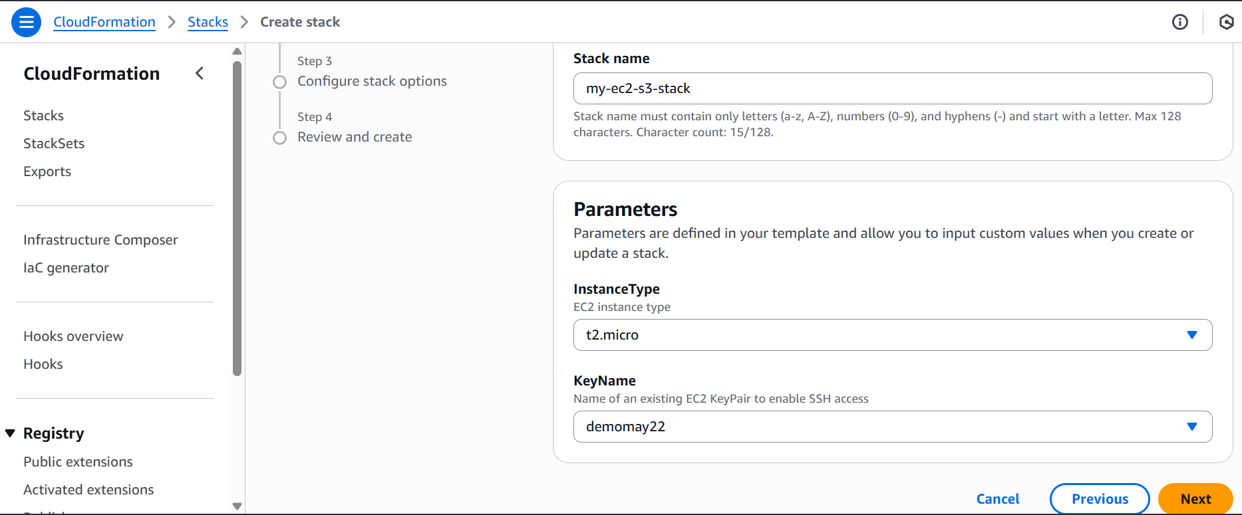

Click on **Submit**

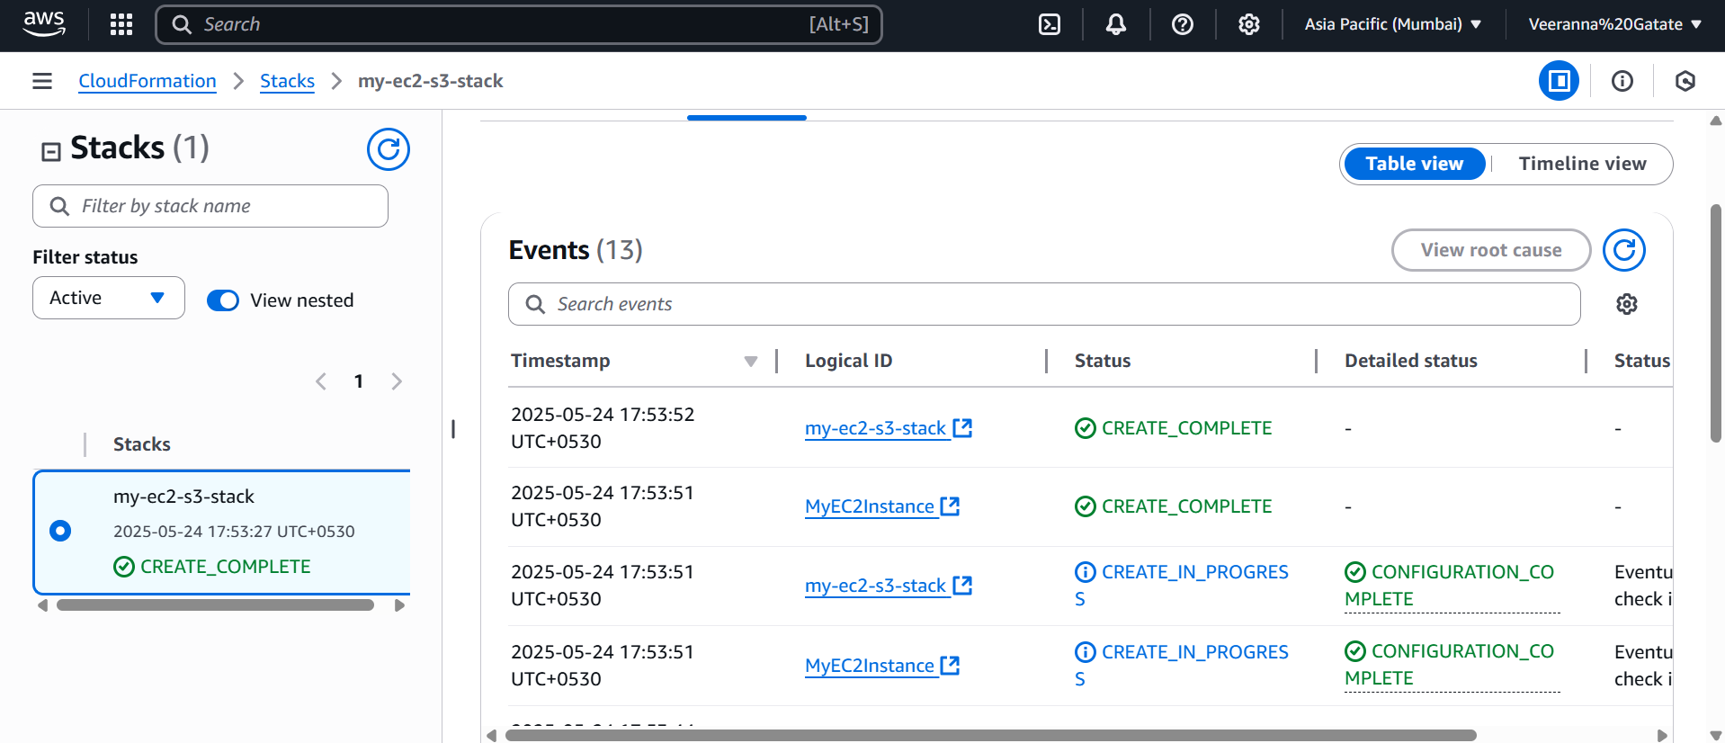

Delete the stack to delete all the resources

