**Lab 4:** Jenkins installation and setup, explore the environment.

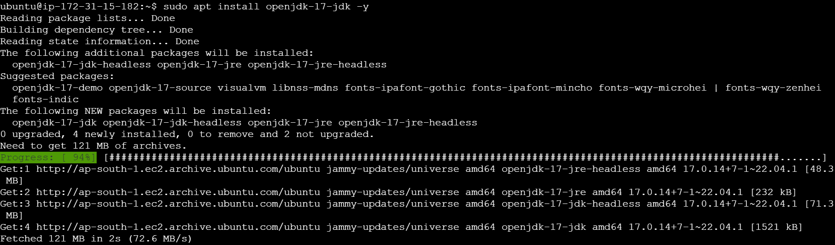

Add the Jenkins Debian package repository:

curl -fsSL https://pkg.jenkins.io/debian-stable/jenkins.io-2023.key | sudo tee \

/usr/share/keyrings/jenkins-keyring.asc > /dev/null

Add the repository:

echo deb [signed-by=/usr/share/keyrings/jenkins-keyring.asc] \

https://pkg.jenkins.io/debian-stable binary/ | sudo tee \

/etc/apt/sources.list.d/jenkins.list > /dev/null

**Install Jenkins:**

sudo apt update

sudo apt install jenkins -y

**Start and enable Jenkins:**

sudo systemctl start jenkins

sudo systemctl enable jenkins

sudo systemctl status Jenkins

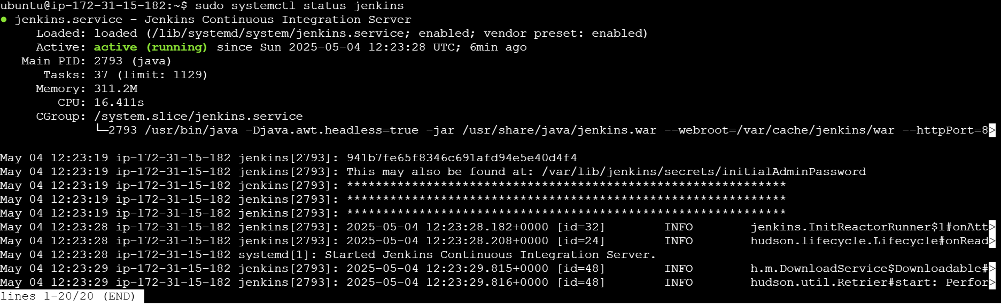

sudo ufw allow 8080

**Access the Jenkins UI**

Edit the Security group of EC2 instance to have access to Jenkins UI.

Add the SG rule on port 8080 and with anywhere IP address as shown here

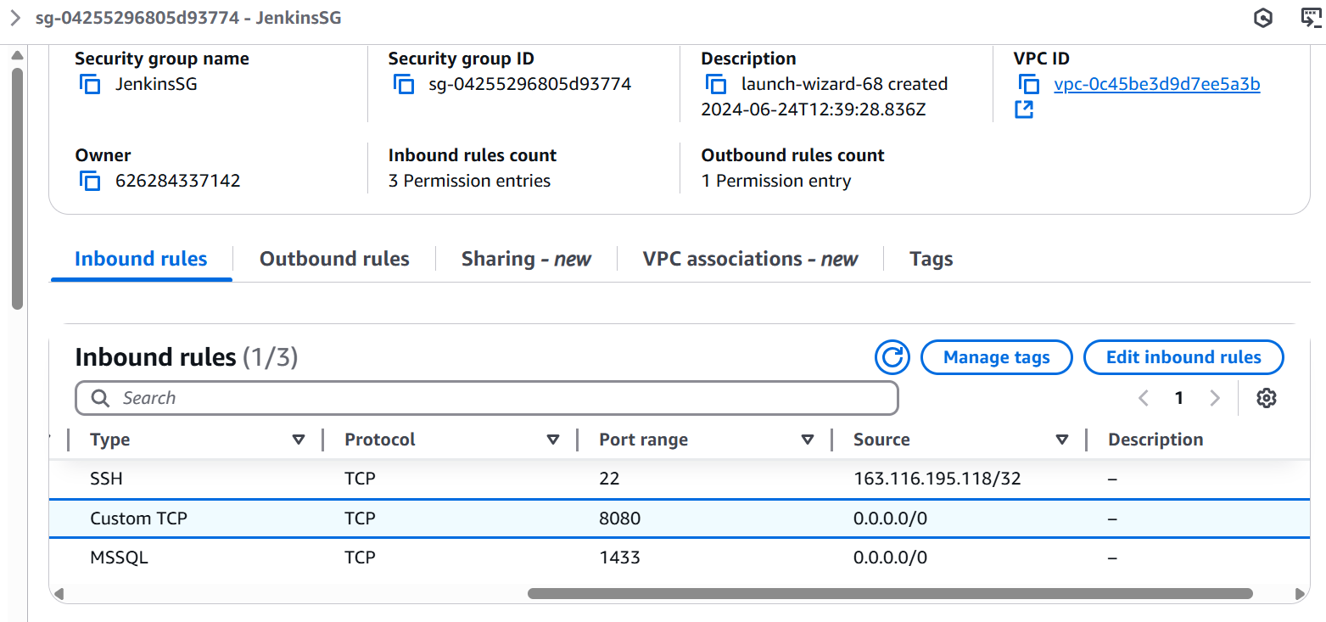

Copy paste the EC2 instance Public IP with port as 8080 and you can access the Jenkins UI

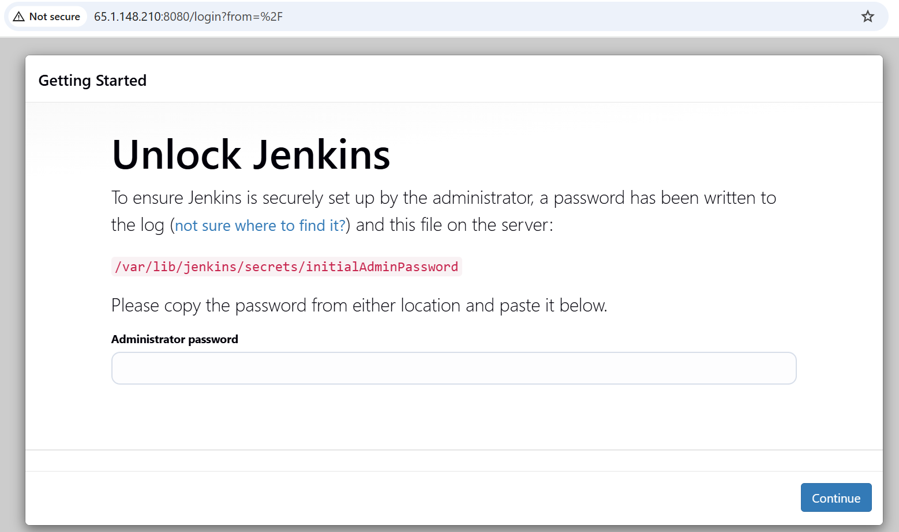

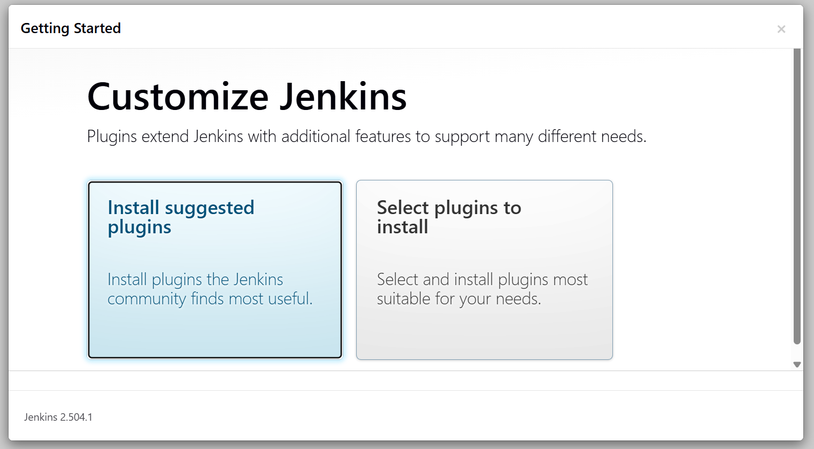

<http://65.1.148.210:8080/> -- access URL for Jenkins

