**Lab 6: Continuous Integration with Jenkins: Setting Up a CI Pipeline, Integrating Jenkins with Maven/Gradle, Running Automated Builds and Tests.**

Go to: **Manage Jenkins → Plugins → Available**  
Search and install the following plugins:

* **Git plugin**
* **Pipeline**
* **Maven Integration**
* **Gradle Plugin**

Install gradle on your host machine if it’s not found

**sudo apt update**

**sudo apt install gradle**

Check if Java, Maven and gradle are installed on your host machine, use following commands:

**mvn -version**

**java -version**

**gradle - version**

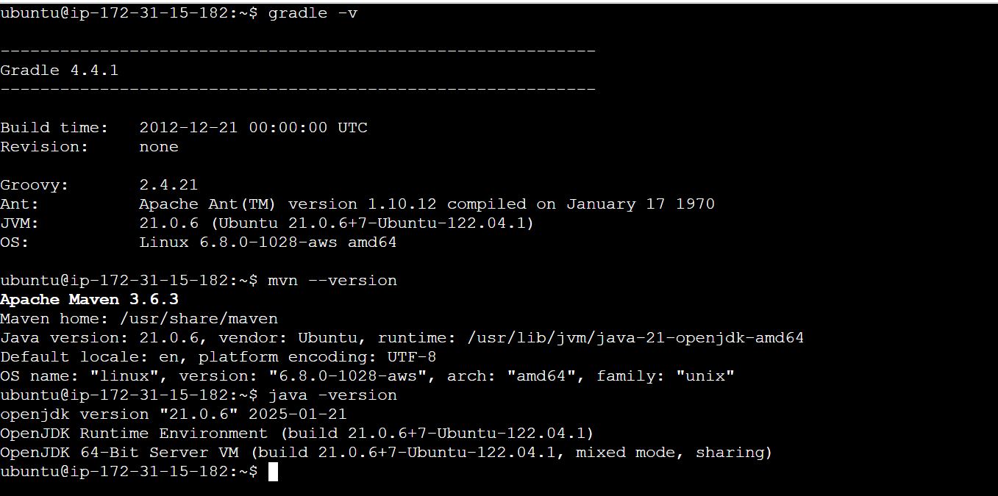

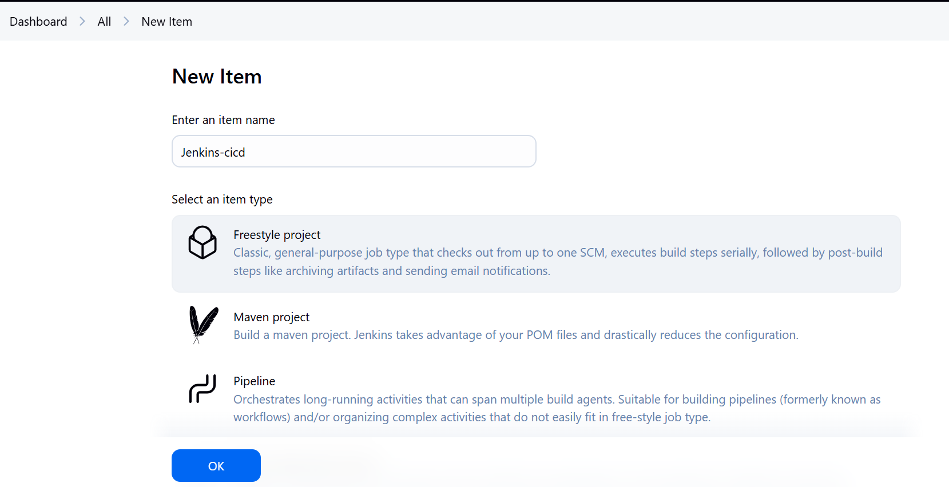

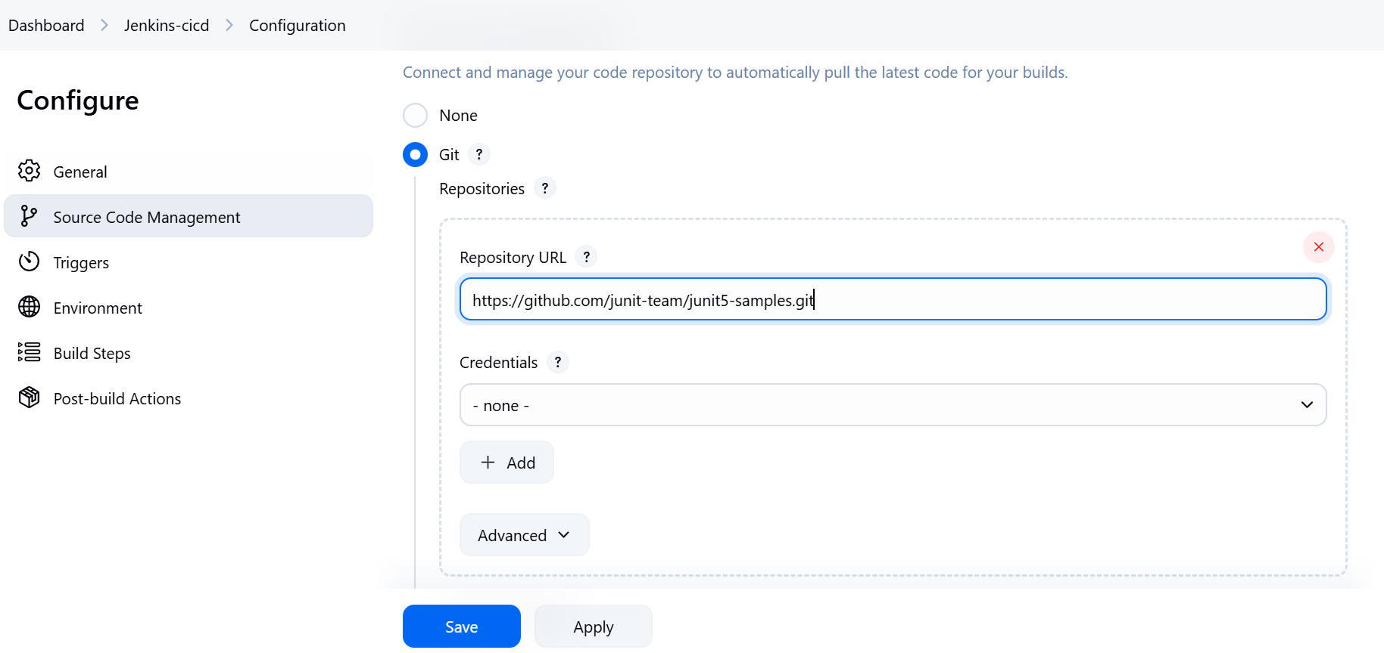

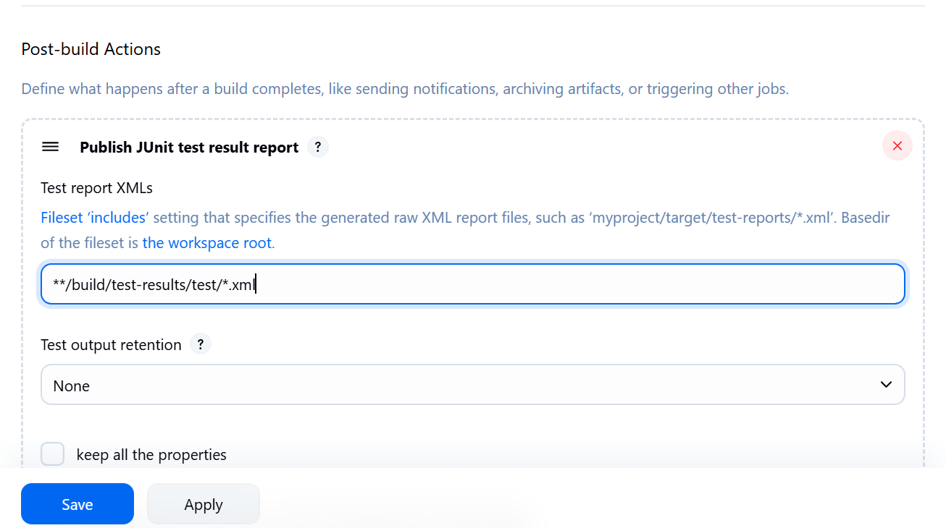

Click on **Build now**

You can see the Build Results in Jenkins Dashboard