Initialize the current working directory and check the git status by following command:

**git init**

**git status**

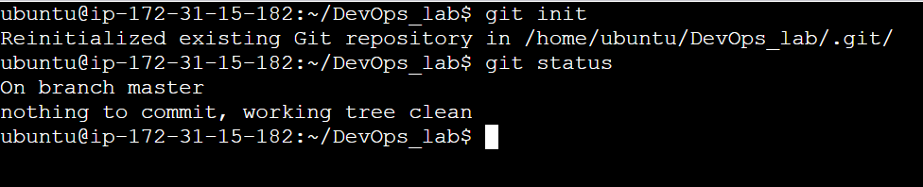

Create a new branch

**git checkout -b feature**

To list all the branches, type the command:

**git branch**

Create 2 files inside feature branch: 1.txt and 2.txt

Now check the git status, use following command:

**git status**

Add these files into staging area and commit the files

**git add .**  (. Adds all the files in your pwd)

**git commit -m “message”**

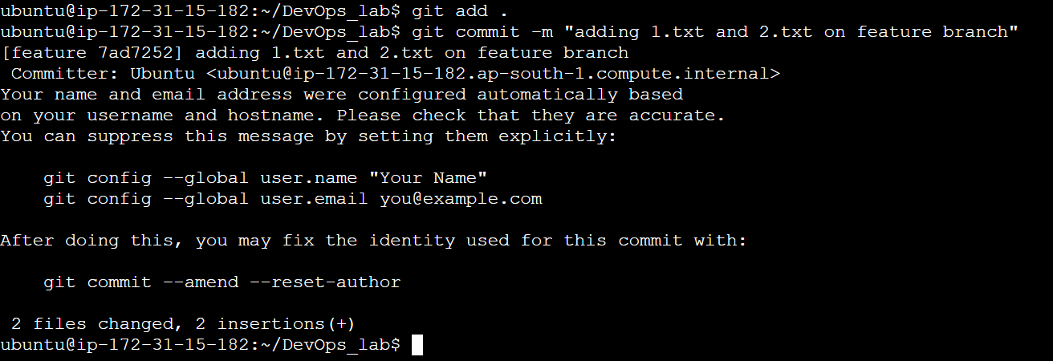

To push your code changes, use the following command:

**git push origin feature**

You may encounter some password issues so follow the following steps to have password less authentication on github.

To see all the ssh keys type the following command

ls -al ~/.ssh

Generate the ssh key type the following command:

ssh-keygen -t ed25519 -C “email@example.com"

Check if the ssh key has been generated: by the previous command

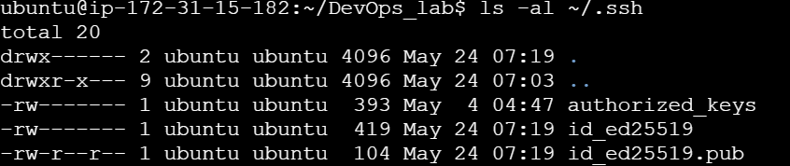

Add the ssh key to the ssh-agent

eval "$(ssh-agent -s)"



Add your ssh-private key to the agent:



Now add the ssh key in your git hub account:

Go to New SSH key under SSH and GPG keys. Click on New SSH Key and paste the entire ssh-key which begins with **ssh-ed25519**



Now change the git remote url to use SSH. Use the following command:

**git remote set-url origin** [**git@github.com:vcgatate/myGitDemo.git**](mailto:git@github.com:vcgatate/myGitDemo.git)

Test the SSH connection by following command:

**ssh -T git@github.com**

Now push the changes into feature branch:



