Lab:7 Develop a simple containerized application using Docker.

Simple web application
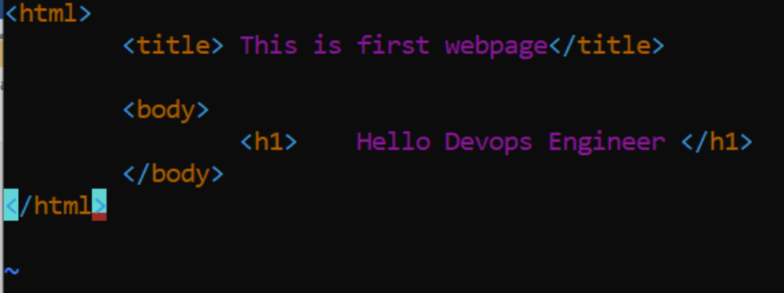

Dockerfile
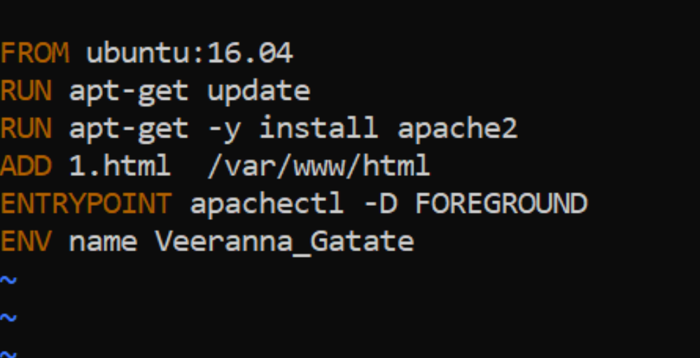

Build the Dockerfile
- ubuntu@ip-172-31-39-74:~/dockerfile$ cd
- ubuntu@ip-172-31-39-74:~$ cd dockerfile/
- ubuntu@ip-172-31-39-74:~/dockerfile$ ls
- 1.html Dockerfile
- ubuntu@ip-172-31-39-74:~/dockerfile$
- ubuntu@ip-172-31-39-74:~/dockerfile$ sudo docker build . -t new_dockerfile

- Sending build context to Docker daemon 3.072kB
- Step 1/6 : FROM ubuntu:16.04
- ---&gt; b6f507652425
- Step 2/6 : RUN apt-get update
- ---&gt; Using cache
- ---&gt; bf05c22a886d
- Step 3/6 : RUN apt-get -y install apache2
- ---&gt; Using cache
- ---&gt; a4753e6014a5
- Step 4/6 : ADD 1.html /var/www/html
- ---&gt; a5a7ce8b8982
- Step 5/6 : ENTRYPOINT apachectl -D FOREGROUND
- ---&gt; Running in 89a3425f548c
- Removing intermediate container 89a3425f548c
- ---&gt; 28a589c4fe23
- Step 6/6 : ENV name Veeranna_Gatate
- ---&gt; Running in 5964f2cac053
- Removing intermediate container 5964f2cac053
- ---&gt; 1dcd5a2224e3
- Successfully built 1dcd5a2224e3
- Successfully tagged new_dockerfile:latest
- ubuntu@ip-172-31-39-74:~/dockerfile$

