[GLOBAL RECIPROCAL COLLEGES]
[BSIT]
PROFESSIONAL ELECTIVE: DATA SCIENCE
CASE STUDY
AI Impact on Jobs 2030: Workforce Analysis and Job Growth Forecasting Using Data Science and Machine Learning
Dataset: AI Impact on Jobs 2030 (Kaggle)
Tools: Python, Google Colab, Pandas, Matplotlib, Seaborn, Scikit-learn
Standard: ISO/IEC 25059:2023 (Quality Model for AI Systems)
Submitted by:
[ Libatod, Charlie mer M.]
Course Code and Section:
[BSIT-304]
Submitted to:
[ROMARK CACHO]
Date Submitted:
[10-19-2026]

Contents
- Abstract
- 1. Introduction
- 2. Dataset Description
- 3. Data Cleaning
- 4. Exploratory Data Analysis
- 5. Data Visualization
- 6. Supervised Learning (Regression)
- 7. Forecasting
- 8. Unsupervised Learning
- 9. ISO/IEC 25059:2023 Quality Evaluation
- 10. Results and Discussion
- 11. Limitations
- 12. Conclusion
- 13. References

Abstract
This case study analyzes how artificial intelligence (AI) may affect 3,000 employees across 20 job titles, 10 industries and 10 countries, using basic data science and machine learning in Python. The topic matters because workers, schools and companies need to know which jobs face higher automation risk and which industries are expected to grow. The study uses the AI Impact on Jobs 2030 dataset from Kaggle, which contains each employee's job details, AI replacement risk, salary, skills and projected job growth up to 2030. Data cleaning was done with Pandas by checking data types, missing values, duplicate records and outliers; none were found, so all 3,000 records were kept. Categorical columns were converted into numbers so that the models could use them. Eleven visualizations, including bar charts, a pie chart, a histogram, a scatter plot, a box plot and a correlation heatmap, were created with Matplotlib and Seaborn. For supervised learning, Linear Regression and Random Forest models were trained to predict Job Growth 2030. Both reached an R² close to zero (−0.021 and −0.035) with an average error of about 14.6 percentage points, because the columns in this dataset are almost unrelated to each other (every correlation is 0.054 or less). The Linear Regression model was then used to forecast job growth for each industry from 2026 to 2030. Government and Finance are forecast to grow the most (about +19%) and Manufacturing and Healthcare the least (about +16%). For unsupervised learning, K-Means clustering split the employees into three groups: a high-automation group, a low job-growth group (about +4%) and a high job-growth group (about +32%). All models were evaluated against ISO/IEC 25059:2023, the international quality model for AI systems. The study describes patterns in the data. It does not prove what causes them.
Keywords: artificial intelligence, job growth, forecasting, Linear Regression, Random Forest, K-Means clustering, ISO/IEC 25059:2023, Python, Pandas

1. Introduction
AI tools are changing how people work. Some tasks are being automated, while new roles such as AI Engineer and Prompt Engineer are appearing. Workers and schools want to know which jobs are most at risk and which industries will keep hiring. Raw employee records do not answer these questions on their own. When the data is cleaned, organized and visualized, it can show patterns: which jobs have the highest replacement risk, how salaries are spread, and how job growth differs between industries. This is what data science does. It turns raw numbers into information that people can understand and use.
This case study applies basic data science to the AI Impact on Jobs 2030 dataset from Kaggle. The dataset has records of 3,000 employees, including job title, industry, country, education, AI replacement risk, salary, required skills and projected job growth for 2030. Using Python in Google Colab, the study cleans the data, explores it with Pandas, visualizes it with Matplotlib and Seaborn, and applies three machine learning tasks:
- Supervised learning (regression): Linear Regression and Random Forest predict Job Growth 2030.
- Forecasting: the regression model projects job growth for each industry from 2026 to 2030.
- Unsupervised learning: K-Means clustering groups employees with similar profiles.
Every model is checked against ISO/IEC 25059:2023, a standard that describes what makes an AI system good quality: correct, transparent, robust and built on quality data.
The purpose of this study is not to prove why some jobs grow and others shrink. Its purpose is to practice the complete data science process, from raw data to forecast, and to explain every result in simple and honest language, including results that are weaker than expected.

2. Dataset Description
The study uses the AI Impact on Jobs 2030 dataset from Kaggle. The file used is AI_Impact_on_Jobs_2030-selected-columns.csv. The values are spread very evenly across categories, and the numeric columns are almost unrelated to each other. This suggests that the records were generated for learning and practice rather than collected from real employees. This is discussed further in the Limitations section.
Table 1. Description of the dataset columns
Column | Description | Data Type | Values found in the dataset
Employee_ID | Unique employee code | Text | AIJ-100000 to AIJ-102999 (3,000 unique)
Job_Title | Employee's job | Categorical | 20 jobs, 124 to 164 employees each (e.g. Software Developer 164, AI Engineer 124)
Industry | Industry sector | Categorical | 10 industries, 273 (Healthcare) to 335 (Energy) employees each
Country | Country of work | Categorical | 10 countries, 267 (Singapore) to 347 (UAE) employees each
Education_Level | Highest education | Categorical | High School (727), Bachelor (782), Master (712), PhD (779)
Years_Experience | Years of work experience | Numerical | 0 to 25 (average 12.38)
AI_Replacement_Risk | Chance the job is replaced by AI | Numerical | 0.05 to 0.95 (average 0.50)
Future_Demand_Score | Expected future demand for the job | Numerical | 0.20 to 0.99 (average 0.60)
Remote_Work_Possibility | Remote work option | Categorical | No (986), Hybrid (1,011), Yes (1,003)
Average_Salary_USD | Yearly salary in US dollars | Numerical | $30,221 to $219,998 (average $126,642)
Required_Skills | Skills the job needs | Text (list) | e.g. "Python, Communication, Deep Learning"
Automation_Level | How automated the job is | Categorical | Low (1,037), Medium (1,011), High (952)
Job_Growth_2030 | Projected job growth by 2030 (%) | Numerical | −10% to +45% (average +17.24%)
Work_Hours_Per_Week | Weekly working hours | Numerical | 30 to 60 (average 44.77)
Company_Size | Size of the company | Categorical | Startup (985), Medium (1,025), Enterprise (990)
AI_Tool_Usage | How much the employee uses AI tools | Categorical | Low (1,033), Moderate (953), High (1,014)
Performance_Score | Work performance rating | Numerical | 2.00 to 5.00 (average 3.51)
Upskilling_Needed | Whether new skills are needed | Categorical | No (1,511), Yes (1,489)
Job_Satisfaction | Job satisfaction rating | Numerical | 1.00 to 5.00 (average 3.03)
Hiring_Trend_2026 | Hiring trend in 2026 | Categorical | Declining (980), Stable (1,010), Growing (1,010)

Table 2. Summary of the dataset
Item | Description
Number of rows | 3,000 (each row is one employee)
Number of columns | 20
Categorical and text variables (12) | Employee_ID, Job_Title, Industry, Country, Education_Level, Remote_Work_Possibility, Required_Skills, Automation_Level, Company_Size, AI_Tool_Usage, Upskilling_Needed, Hiring_Trend_2026
Numerical variables (8) | Years_Experience, AI_Replacement_Risk, Future_Demand_Score, Average_Salary_USD, Job_Growth_2030, Work_Hours_Per_Week, Performance_Score, Job_Satisfaction
Target variable for supervised learning | Job_Growth_2030, the projected % job growth by 2030
Missing values / duplicate rows | 0 / 0

In Python, the 12 text columns are stored as text (shown as object in Google Colab), 4 columns are whole numbers (int64) and 4 columns are decimals (float64). The first five rows of the dataset are shown below, with some columns left out to fit the page.
Table 3. First five rows of the dataset (selected columns)
Job_Title | Industry | Country | Education | AI Risk | Salary (USD) | Automation | Job Growth 2030 (%)
Data Engineer | Healthcare | Japan | PhD | 0.25 | 207,392 | Low | 3
Healthcare Analyst | Retail | UK | Bachelor | 0.73 | 140,785 | Low | −5
HR Specialist | Education | Canada | High School | 0.80 | 124,800 | Medium | −5
Cybersecurity Analyst | Government | UK | Bachelor | 0.29 | 199,878 | Medium | 7
Healthcare Analyst | Education | UAE | PhD | 0.11 | 178,682 | Low | 6

3. Data Cleaning
Data cleaning was done in Google Colab using Python and Pandas. The goal was to make sure the data is complete, has the correct data types, has no repeated records, and is in a form the models can use. The complete code is in Sections 1 to 3 of the Google Colab notebook.
Table 4. Data cleaning steps and results
Step | What the code does (in simple words) | Result
1. Import libraries | Loads Pandas, NumPy, Matplotlib, Seaborn and Scikit-learn. | Libraries ready
2. Upload and load the CSV file | files.upload() uploads the file; pd.read_csv() reads it into a table called df. | Data loaded
3. Check rows and columns | df.shape counts the rows and columns. | 3,000 rows, 20 columns
4. Check data types | df.dtypes shows the type of each column. | 12 text, 4 integer, 4 decimal columns
5. Check missing values | df.isna().sum() counts empty cells; empty cells would be filled with the median (numbers) or the most common value (text). | 0 missing values; nothing filled
6. Check and remove duplicates | df.duplicated().sum() counts repeated rows; df.drop_duplicates() removes them. | 0 duplicate rows; nothing removed
7. Trim spaces | str.strip() removes extra spaces in text columns, so "Low " and "Low" are not treated as different values. | Text values consistent
8. Drop the ID column | df.drop() removes Employee_ID, because an ID number cannot predict anything. | 19 columns left
9. Check outliers | The IQR rule flags values far below the first quarter or far above the third quarter of each numeric column. | 0 outliers in every numeric column
10. Encode ordered categories | map() turns ordered text into numbers: Education (0–3), Automation (0–2), AI Tool Usage (0–2), Remote Work (0–2), Company Size (0–2), Upskilling (0–1). | 6 new number columns
11. One-hot encode Industry | pd.get_dummies() makes one 0/1 column per industry, because industries have no natural order. | 10 new columns
12. Create Risk Band | pd.cut() groups AI risk into Low (0–0.30), Medium (0.30–0.70) and High (above 0.70). | 1 new column
13. Check the cleaned dataset | Counts rows and missing values once more. | 3,000 rows, 36 columns, 0 missing

What this means. The dataset was already clean. There were no empty cells, no repeated employees and no outliers, so no rows were removed and all 3,000 records were used in every later step. Running these checks is still important, because missing or repeated records can quietly change averages and machine learning results.
Why encoding is needed. Machine learning models only understand numbers. Columns with a natural order, such as Low, Medium and High, were given the numbers 0, 1 and 2. Industry has no natural order, so giving it numbers 0 to 9 would wrongly suggest that one industry is "bigger" than another. Instead, each industry got its own 0/1 column. This is called one-hot encoding.

4. Exploratory Data Analysis
Exploratory data analysis (EDA) means asking simple questions of the data. Pandas functions such as mean(), min(), max(), describe() and groupby() were used. The groupby() function splits the employees into groups and calculates a statistic for each group.

Average, Lowest and Highest Values
Table 5. Summary of the main numeric columns
Column | Average | Lowest | Middle (median) | Highest
AI Replacement Risk | 0.50 | 0.05 | 0.50 | 0.95
Future Demand Score | 0.60 | 0.20 | 0.60 | 0.99
Average Salary (USD) | 126,642 | 30,221 | 127,661 | 219,998
Job Growth 2030 (%) | +17.24 | −10 | +17 | +45
Years of Experience | 12.38 | 0 | 12 | 25

The average AI replacement risk is exactly in the middle of the scale (0.50). The average projected job growth is positive (+17.24%), so most jobs are expected to grow by 2030, although some are expected to shrink by up to 10%. Salaries range widely, from about $30,000 to $220,000. In every column the average and the median are almost the same, which means the values are spread evenly on both sides.

AI Replacement Risk by Risk Band
Table 6. Employees by AI risk band
Risk Band | AI Risk range | Employees | Share
Low | 0 to 0.30 | 848 | 28.3%
Medium | 0.30 to 0.70 | 1,297 | 43.2%
High | above 0.70 | 855 | 28.5%

About 2 in 7 employees (28.5%) are in the high-risk band. About half of all employees (49.6%) need upskilling.

Average Values by Industry
Table 7. Average AI risk, salary and job growth by industry
Industry | Employees | AI Risk | Salary (USD) | Job Growth 2030 (%)
Finance | 310 | 0.53 | 132,017 | 18.57
Government | 323 | 0.53 | 120,626 | 18.28
Technology | 291 | 0.52 | 127,689 | 18.01
Education | 300 | 0.50 | 124,410 | 17.88
Media | 287 | 0.49 | 129,685 | 17.64
Energy | 335 | 0.50 | 127,261 | 17.09
Retail | 285 | 0.50 | 121,075 | 16.52
Manufacturing | 303 | 0.50 | 128,614 | 16.39
Healthcare | 273 | 0.48 | 125,682 | 15.88
Transportation | 293 | 0.49 | 129,411 | 15.87

Finance has the highest average job growth (18.57%) and the highest average salary ($132,017). Transportation and Healthcare have the lowest job growth (about 15.9%). The gap between the highest and lowest industry is only about 2.7 percentage points, so industries differ only a little.

Average Values by Education Level
Table 8. Average salary and job growth by education level
Education Level | Employees | AI Risk | Salary (USD) | Job Growth 2030 (%)
High School | 727 | 0.51 | 128,510 | 17.42
Bachelor | 782 | 0.50 | 128,002 | 18.36
Master | 712 | 0.51 | 124,825 | 15.83
PhD | 779 | 0.50 | 125,193 | 17.23

Salaries do not rise with education in this dataset. High School employees have the highest average salary ($128,510) and Master's degree holders the lowest ($124,825). This is different from what we would expect in real life, and it is another sign that the data was generated for practice.

AI Replacement Risk by Job Title
The job titles with the highest average AI replacement risk are DevOps Engineer (0.569), Cloud Architect (0.564) and IoT Specialist (0.527). The lowest are UX Designer (0.460), Data Scientist (0.470) and Machine Learning Engineer (0.472). The most common required skills are Cloud Computing (785 employees), Leadership (778), Communication (776) and Cybersecurity (776).

5. Data Visualization
Graphs were created in Google Colab using Matplotlib and Seaborn. Each graph is followed by a short explanation of what it shows. The code for every graph is in Section 4 of the Google Colab notebook.

Average AI Replacement Risk by Job Title
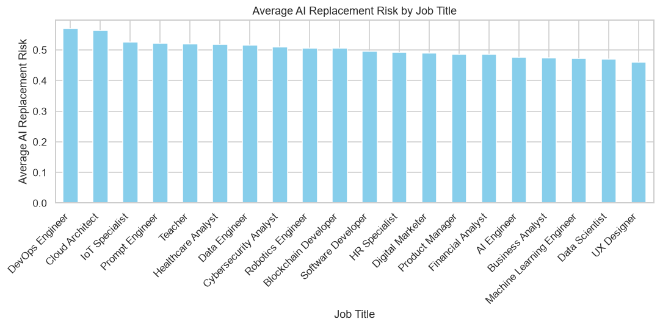
Figure 1. Bar chart of average AI replacement risk by job title
This bar chart ranks the 20 job titles by average AI replacement risk. DevOps Engineer (0.569) and Cloud Architect (0.564) are at the top, and UX Designer (0.460) is at the bottom. The bars are close in height. Every job has an average risk between 0.46 and 0.57, so no job is clearly safe or clearly doomed.

Employees by Risk Band
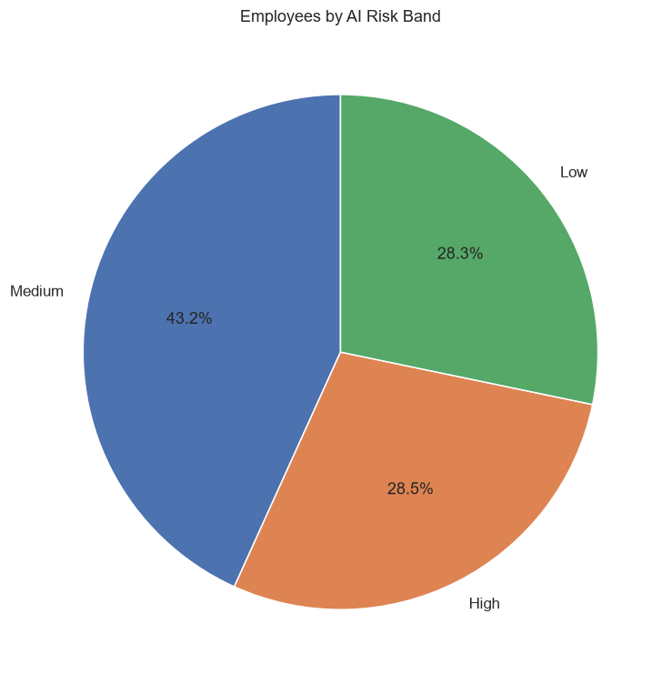
Figure 2. Pie chart of employees by AI risk band
The pie chart shows that 43.2% of employees are in the Medium risk band, while the Low (28.3%) and High (28.5%) bands are almost equal in size.

Distribution of Salary
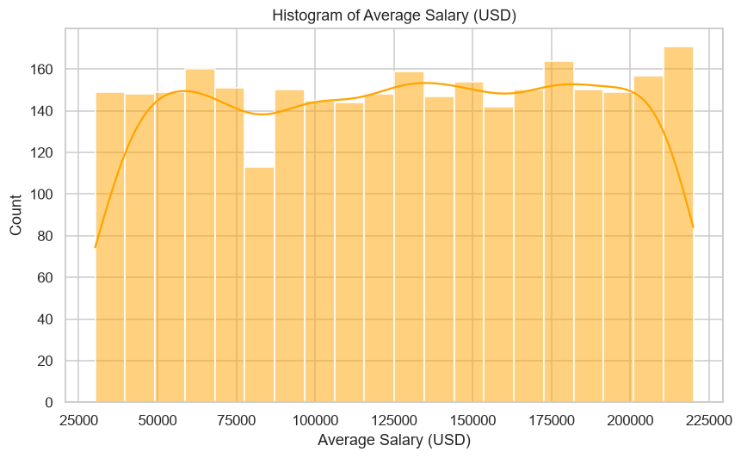
Figure 3. Histogram of average salary
The salary histogram is almost flat. Employees are spread fairly evenly from about $30,000 to $220,000, with no clear peak. Real salary data usually has a peak in the middle and fewer very high earners, so this flat shape suggests generated data.

AI Replacement Risk vs Future Demand
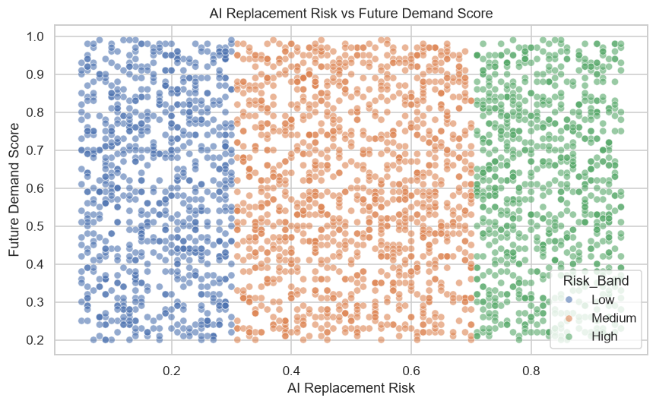
Figure 4. Scatter plot of AI replacement risk vs future demand score
Each dot is one employee, colored by risk band. The dots fill the whole chart with no upward or downward trend. The correlation is 0.008, which means AI risk and future demand are not related. A high-risk job can still have high future demand.

Salary by Education Level
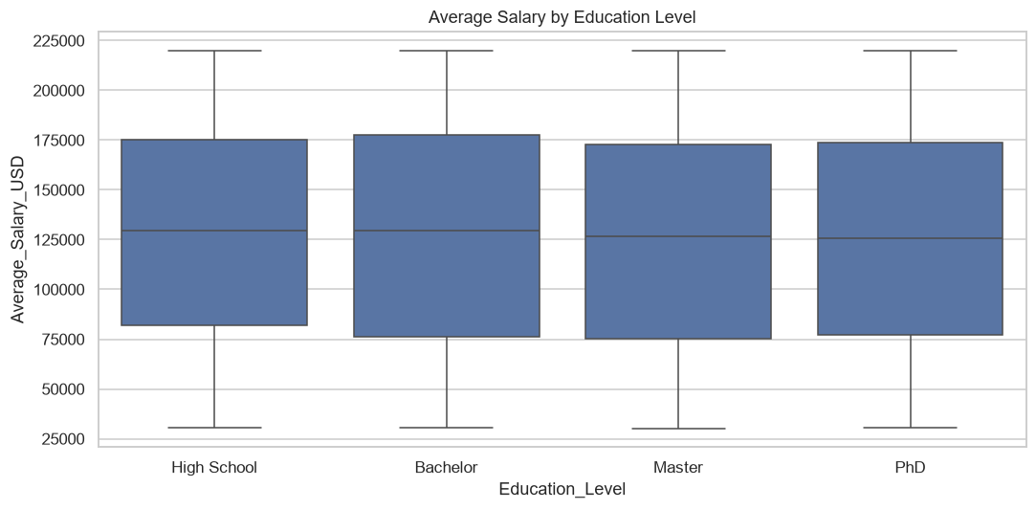
Figure 5. Box plot of salary by education level
In a box plot, the box covers the middle half of the employees and the line inside the box is the median. The four boxes are almost the same, so salary is spread the same way at every education level. Education alone does not decide salary in this dataset.

Correlation Heatmap
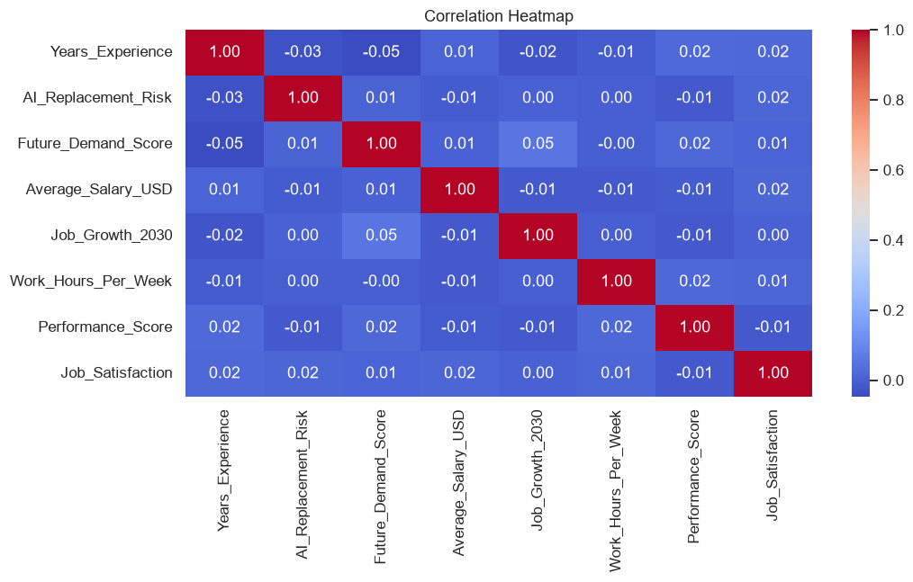
Figure 6. Correlation heatmap of the numeric columns
The heatmap shows the correlation between every pair of numeric columns. A value near 1 or −1 means a strong relationship, and a value near 0 means no relationship. Every pair is between −0.047 and 0.054, which is almost zero. The strongest pair is Future Demand Score and Job Growth 2030 (0.054). This is the most important chart in the study, because it explains why the regression models in the next section cannot predict job growth well.

6. Supervised Learning (Regression)

What Is Supervised Learning?
Supervised learning is a type of machine learning where the computer learns from examples that already have the correct answer. The correct answer is called the target. Like a student who studies solved exercises before a quiz, the model studies many examples with answers and then tries to give the right answer for new examples. When the answer is a number (such as a growth percentage), the task is called regression.

Features, Target and Data Split
- Features (X): the information given to the model: AI replacement risk, future demand score, automation level, AI tool usage, years of experience, education level, salary, and the 10 industry columns (17 features in total).
- Target (y): the answer the model tries to predict: Job_Growth_2030.
- Training and testing data: the data was split 80% and 20%, using 2,400 employees to train the models and 600 employees to test them. The test employees are kept hidden during training, so they show how the model works on employees it has never seen.

The Two Models
- Linear Regression draws the best straight-line relationship between the features and the target. Each feature gets a coefficient that says how much the prediction goes up or down when that feature increases by 1. It is simple and easy to explain.
- Random Forest Regressor builds 200 decision trees, each asking yes-or-no questions about the features, and averages their answers. It can find curved and complex patterns that a straight line would miss.

How the Models Are Scored
- R² (R-squared): how much of the variation in job growth the model explains. 1.0 is perfect, 0 means no better than always guessing the average, and a negative value means slightly worse than guessing the average.
- MAE (Mean Absolute Error): the average size of the error, in percentage points.
- RMSE (Root Mean Squared Error): like MAE, but big errors count more.

Results
Table 9. Supervised learning results on the 600 test employees
Model | R² | MAE (% points) | RMSE (% points)
Linear Regression | −0.021 | 14.64 | 16.77
Random Forest | −0.035 | 14.71 | 16.89

Both models have an R² slightly below zero and an average error of about 14.6 percentage points. For comparison, simply guessing the training average (+17.2%) for every employee gives an average error of 14.52 points. This means neither model predicts job growth better than guessing the average.
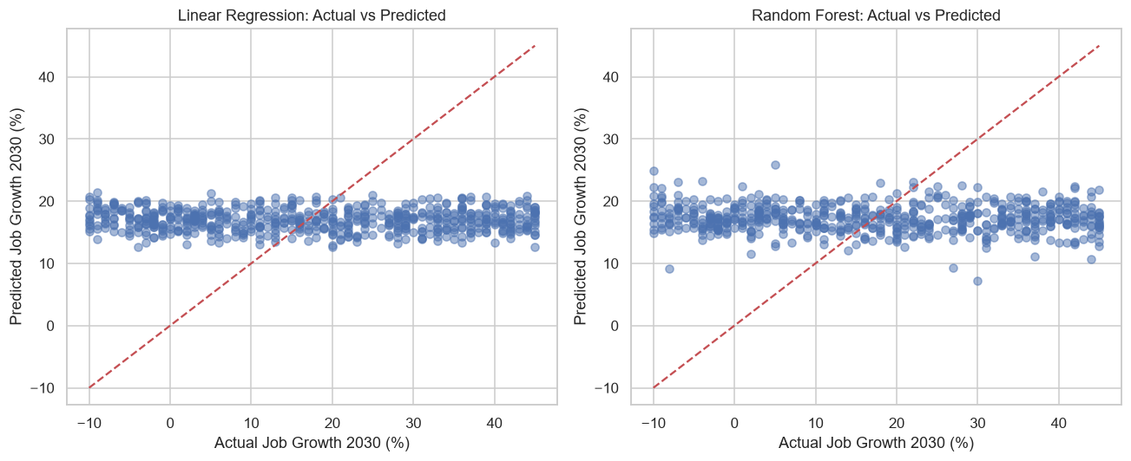
Figure 7. Actual vs predicted job growth for both models
If the predictions were perfect, every dot would sit on the red dashed line. Instead, the predictions form a flat band around 17%, while the actual values range from −10% to +45%. The models have learned to predict close to the average for everyone.

What the Models Learned
Table 10. Largest Linear Regression coefficients
Feature | Coefficient | Meaning
Future Demand Score | +4.50 | Going from a demand score of 0 to 1 adds about 4.5 points of growth
Government (industry) | +1.79 | Government jobs are predicted about 1.8 points higher
Finance (industry) | +1.78 | Finance jobs are predicted about 1.8 points higher
AI Replacement Risk | −0.80 | Going from a risk of 0 to 1 lowers growth by about 0.8 points
Manufacturing (industry) | −1.36 | Manufacturing jobs are predicted about 1.4 points lower
Healthcare (industry) | −1.41 | Healthcare jobs are predicted about 1.4 points lower

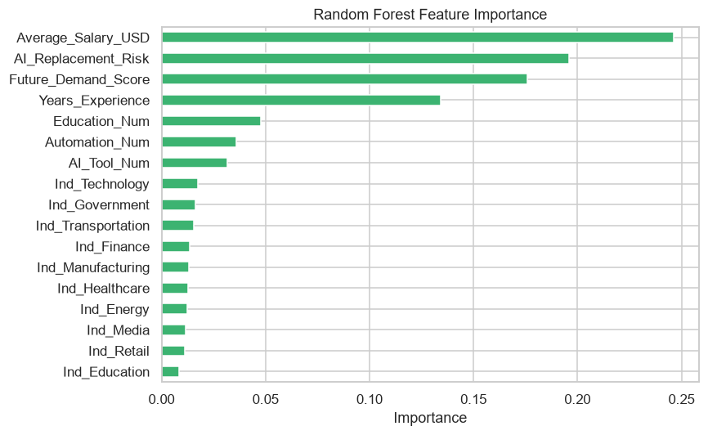
Figure 8. Random Forest feature importance
The directions make sense: higher future demand goes with higher growth, and higher AI risk goes with lower growth. However, the effects are very small compared with the 14.6-point error. The Random Forest relied most on Average Salary (0.246), AI Replacement Risk (0.196) and Future Demand Score (0.176). Because the Random Forest did not beat the average, these importance values mostly show which columns it used to split the data, not real predictive power.

Important note
The low R² is not a coding mistake. The heatmap in Figure 6 showed that every column is almost unrelated to Job Growth 2030 (correlation 0.054 or less). A model cannot learn a pattern that is not in the data. Reporting this honestly is part of good practice and is required by the transparency principle of ISO/IEC 25059:2023. With a real dataset where the columns are related, the same code would be expected to give a higher R².

7. Forecasting

What Is Forecasting?
Forecasting means using what we know to estimate what will happen in the future. In this study, the trained Linear Regression model was used to forecast how jobs in each industry will grow from 2026 to 2030. Linear Regression was chosen over Random Forest because both scored about the same, and Linear Regression is easier to explain.

How the Forecast Was Made
- The model predicted the total job growth up to 2030 for every employee. These predictions were averaged for each industry.
- The total growth was turned into a yearly growth rate using the formula: yearly rate = (1 + total growth)^(1/4) − 1, because there are 4 years from 2026 to 2030.
- Starting from an index of 100 jobs in 2026, the yearly rate was applied each year up to 2030.
Table 11. Forecasted job index by industry (2026 = 100)
Industry | Predicted growth to 2030 | 2026 | 2027 | 2028 | 2029 | 2030
Government | +18.98% | 100.0 | 104.4 | 109.1 | 113.9 | 119.0
Finance | +18.83% | 100.0 | 104.4 | 109.0 | 113.8 | 118.8
Education | +17.79% | 100.0 | 104.2 | 108.5 | 113.1 | 117.8
Technology | +17.58% | 100.0 | 104.1 | 108.4 | 112.9 | 117.6
Media | +17.26% | 100.0 | 104.1 | 108.3 | 112.7 | 117.3
Energy | +16.90% | 100.0 | 104.0 | 108.1 | 112.4 | 116.9
Transportation | +16.14% | 100.0 | 103.8 | 107.8 | 111.9 | 116.1
Retail | +15.78% | 100.0 | 103.7 | 107.6 | 111.6 | 115.8
Healthcare | +15.69% | 100.0 | 103.7 | 107.6 | 111.6 | 115.7
Manufacturing | +15.66% | 100.0 | 103.7 | 107.5 | 111.5 | 115.7

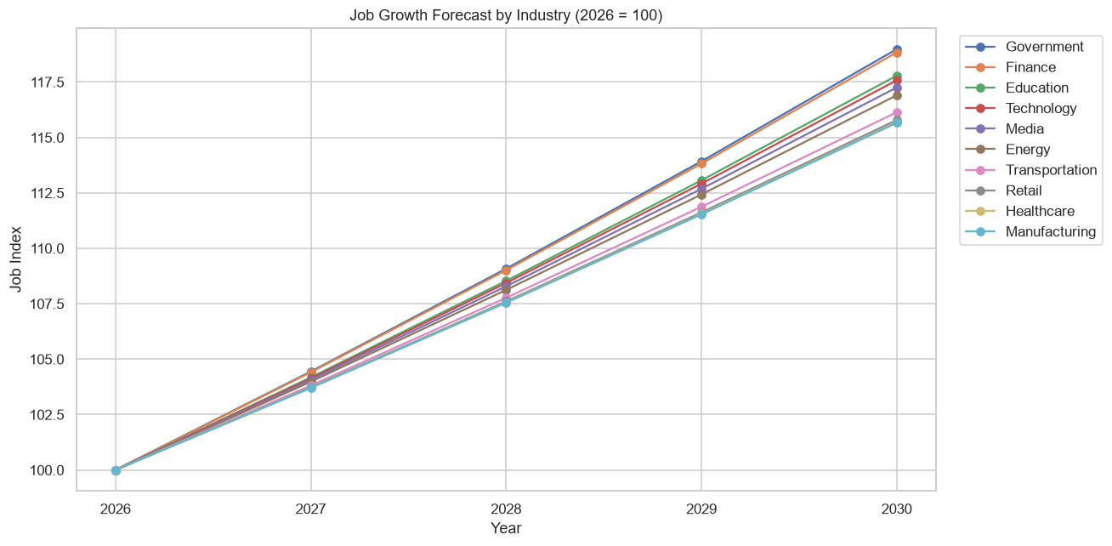
Figure 9. Job growth forecast by industry, 2026 to 2030
Every industry is forecast to grow. Government (119.0) and Finance (118.8) grow the most, and Healthcare and Manufacturing (115.7) grow the least. In other words, for every 100 Government jobs in 2026, the model expects about 119 by 2030. The lines are close together because the industries differ only a little in the data.

Forecast for a New Employee
The model can also forecast job growth for a person who is not in the dataset. For example, a Retail employee with high AI risk (0.80), low future demand (0.40), high automation, low AI tool usage, 5 years of experience, a Bachelor's degree and a $60,000 salary:
Model | Forecasted job growth by 2030
Linear Regression | +15.69%
Random Forest | +19.27%

The two models give different answers for the same person. This matches the low R²: with weak patterns in the data, each model's forecast for one person is uncertain. The values in the notebook can be changed to try other profiles.

Important note
This forecast is a classroom demonstration of how a regression model can be used to project the future. The dataset has no real dates, only a single projected growth value per employee, so this is not a true time-series forecast. The yearly values assume steady growth each year, which real job markets rarely follow.

8. Unsupervised Learning

What Is Unsupervised Learning?
Unsupervised learning is machine learning without a target. The computer is not told what the correct groups are. Instead, it looks at the data and finds structure by itself, like sorting a pile of photos into piles of similar-looking pictures without being told the categories.

K-Means Clustering
K-Means is a simple clustering algorithm. We choose the number of groups (K). The algorithm places K centers in the data, assigns every employee to the nearest center, and moves the centers until the groups settle. Employees in the same cluster have similar values. Seven columns were used: AI replacement risk, future demand score, salary, years of experience, job growth 2030, automation level and AI tool usage.
The columns were standardized first using StandardScaler. K-Means is based on distances, and salary (in the hundred-thousands) would otherwise outweigh AI risk (between 0 and 1).

Choosing the Number of Clusters
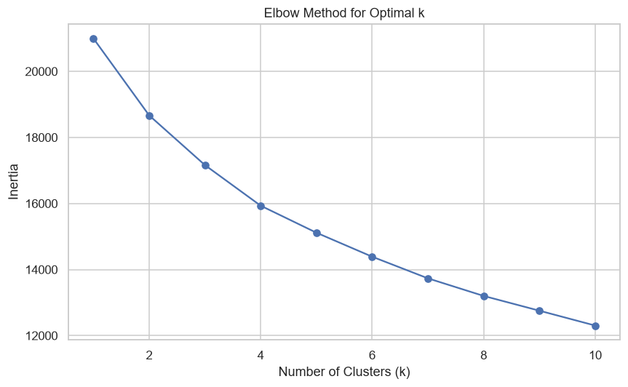
Figure 10. Elbow method for choosing the number of clusters
The elbow method plots the inertia (how spread out the points are inside their clusters) for K = 1 to 10. Inertia always goes down as K grows, and we look for the point where it stops dropping quickly. In this dataset, the curve goes down smoothly without a sharp bend, so there is no clear best K. K = 3 was chosen to keep the groups easy to interpret.

Cluster Results
Table 12. Number of employees and average values in each cluster
Cluster | Employees | AI Risk | Demand | Salary (USD) | Experience | Job Growth 2030 (%) | Automation (0–2) | AI Tool Use (0–2)
Cluster 0 | 950 (31.7%) | 0.50 | 0.60 | 126,300 | 12.59 | 17.18 | 2.00 | 1.03
Cluster 1 | 1,098 (36.6%) | 0.50 | 0.57 | 129,968 | 13.01 | 4.28 | 0.47 | 1.04
Cluster 2 | 952 (31.7%) | 0.50 | 0.64 | 123,146 | 11.45 | 32.25 | 0.52 | 0.90

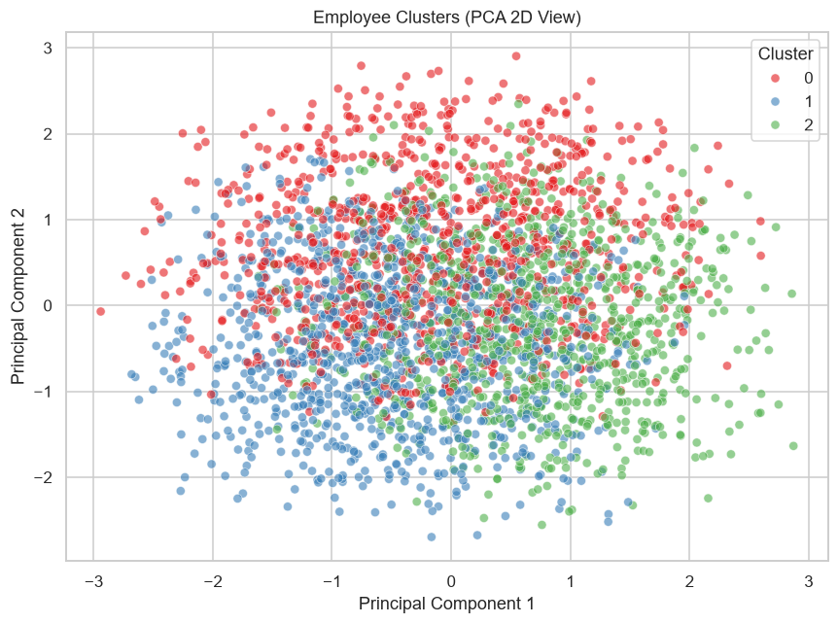
Figure 11. Employee clusters shown in 2D using PCA

Interpreting the Clusters
The clusters were described by looking at their actual average values, not by assuming what each number means:
- Cluster 0 (950 employees) is the high-automation group. Every employee in it has a High automation level (average 2.00). Its job growth (+17.18%) is close to the overall average.
- Cluster 1 (1,098 employees) is the low job-growth group. Its average job growth is only +4.28%, and its automation level is low to medium. It is the largest group.
- Cluster 2 (952 employees) is the high job-growth group. Its average job growth is +32.25%, and it has the highest future demand score (0.64).
All three clusters have the same average AI risk (0.50), so K-Means did not separate employees by AI risk. It mainly split them by automation level and job growth.
Figure 11 uses PCA (Principal Component Analysis) to squeeze the 7 columns into 2, so the clusters can be drawn on a flat chart. The colors overlap heavily, because the 2 components keep only about 31% of the information (15.7% and 15.0%). The silhouette score, which measures how well separated the clusters are (1 is perfect, 0 is overlapping), was 0.102 for 3 clusters. It was between 0.10 and 0.11 for 2 to 5 clusters, so the groups are weakly separated whatever the K.

Notes about the clusters
The cluster numbers (0, 1, 2) are only labels. When the code is run again, possibly with different library versions, the numbers may be assigned in a different order. Always read the cluster averages before naming a group.

9. ISO/IEC 25059:2023 Quality Evaluation
ISO/IEC 25059:2023 is an international standard that describes the quality of AI systems. It extends the general software quality model (ISO/IEC 25010) with characteristics that matter for AI, such as functional correctness, transparency and robustness. Table 13 shows how each part of this study addresses it.
Table 13. Mapping the study to ISO/IEC 25059:2023
Quality characteristic | What it means | How this study addresses it | Result
Functional correctness | The AI gives correct results | Both models were tested on 600 unseen employees using R², MAE and RMSE | R² ≈ 0; MAE about 14.6 points. Accuracy is low, and this is reported openly
Data quality | The data used is complete and consistent | Missing values, duplicates and outliers were checked; categories were encoded | 0 missing, 0 duplicates, 0 outliers
Transparency and interpretability | People can understand why the AI gives its result | Linear Regression coefficients and Random Forest feature importance show which features drive the predictions | Demand +4.50, AI risk −0.80; industry effects shown
Functional adaptability | The AI works on new inputs | The model forecasts each industry to 2030 and a new employee profile | Forecasts produced for 10 industries and 1 new profile
Robustness | Results are stable and not dependent on one method | Two different algorithms were compared on the same data split | Both models agree that the data has no strong pattern

The evaluation shows that the system meets the data quality, transparency, adaptability and robustness characteristics. It does not meet functional correctness, because the data has no strong pattern to learn. ISO/IEC 25059 values reporting this limitation honestly rather than hiding it.

10. Results and Discussion
This section summarizes the results of each part of the study. For each part, it explains what was observed, what it means, and why it is important. The discussion describes patterns only and makes no claims about what causes job growth or AI risk.
Data Cleaning
Question | Answer
What was observed? | The dataset has 3,000 rows and 20 columns, with no missing values, no duplicate rows and no outliers. No rows were removed. Six columns were encoded as numbers and Industry was one-hot encoded.
What does it mean? | The data was complete and ready to use, so every analysis included all 3,000 employees.
Why is it important? | Missing or repeated records can distort averages and model results. Checking first makes the later results more trustworthy.

Exploratory Data Analysis
Question | Answer
What was observed? | Average AI risk is 0.50 and average job growth is +17.24%. 28.5% of employees are high-risk and 49.6% need upskilling. Finance has the highest average growth (18.57%) and Transportation the lowest (15.87%). Salaries do not rise with education.
What does it mean? | Most jobs are expected to grow, but differences between industries, education levels and jobs are small.
Why is it important? | Group comparisons show where to look more closely, without claiming a cause.

Data Visualization
Question | Answer
What was observed? | Salaries are spread evenly. AI risk and future demand are unrelated (correlation 0.008). Every correlation between numeric columns is 0.054 or less.
What does it mean? | The columns in this dataset barely affect each other.
Why is it important? | Graphs reveal the shape of the data before modeling. The heatmap warned us early that the models would struggle.

Supervised Learning
Question | Answer
What was observed? | Linear Regression (R² −0.021, MAE 14.64) and Random Forest (R² −0.035, MAE 14.71) did not beat simply guessing the average (MAE 14.52). Higher demand and lower AI risk go with higher predicted growth.
What does it mean? | The features contain almost no information about Job Growth 2030 in this dataset.
Why is it important? | It demonstrates the complete supervised learning workflow (select features, split the data, train, predict and evaluate) and shows why evaluating on unseen data matters.

Forecasting
Question | Answer
What was observed? | Every industry is forecast to grow by 2030, from +15.7% (Manufacturing, Healthcare) to +19.0% (Government).
What does it mean? | According to the model, AI is expected to change jobs rather than remove them overall, with only small differences between industries.
Why is it important? | It shows how a trained model can be used to look ahead and support planning, such as which industries to prepare students for.

Unsupervised Learning
Question | Answer
What was observed? | K-Means found three groups: a high-automation group (950), a low job-growth group (1,098, about +4%) and a high job-growth group (952, about +32%). The silhouette score was 0.102.
What does it mean? | Employees can be grouped by automation level and job growth, but the groups overlap and the borders between them are not sharp.
Why is it important? | It shows how unlabeled data can be explored to find groups of similar employees, for example to decide who may need reskilling support.

11. Limitations
- The data appears to be generated. Categories have almost equal counts, salaries are spread evenly, salary does not rise with education, and the numeric columns are almost unrelated. The results describe this dataset, not the real job market.
- The models are weak. Because the columns are unrelated, both regression models scored an R² near zero. Their forecasts should not be used for real decisions.
- The forecast is not a true time series. The dataset has no real dates, only one projected growth value per employee. The yearly values assume steady growth.
- The clusters overlap. The silhouette score was about 0.10, and K = 3 was chosen for simple interpretation, not because the data clearly has three groups.
- No causes are proven. All findings are associations between columns. They do not show that one thing causes another.

12. Conclusion
This case study completed the full data science process on the AI Impact on Jobs 2030 dataset using Python in Google Colab. The data was checked and found complete, with no missing values, duplicates or outliers, and was encoded for machine learning. The visualizations showed that AI risk is similar across jobs (0.46 to 0.57 on average), that most jobs are expected to grow by 2030 (+17.24% on average), and that the numeric columns are almost unrelated to each other.
Linear Regression and Random Forest were trained to predict Job Growth 2030. Both scored an R² near zero, which matches the weak correlations in the data. The Linear Regression model forecast growth in every industry from 2026 to 2030, led by Government and Finance (about +19%). K-Means clustering grouped employees into a high-automation group, a low job-growth group and a high job-growth group.
Evaluated against ISO/IEC 25059:2023, the study meets the data quality, transparency, adaptability and robustness characteristics, and openly reports that functional correctness is limited by the dataset. The main lesson is that a good model needs data with real patterns. The same notebook can be reused on a real-world dataset, where stronger relationships between columns would be expected to give more useful predictions.

13. References
- AI Impact on Jobs 2030 dataset. Kaggle. https://www.kaggle.com
- ISO/IEC 25059:2023. Software engineering — Systems and software Quality Requirements and Evaluation (SQuaRE) — Quality model for AI systems. International Organization for Standardization.
- Pandas documentation. https://pandas.pydata.org
- Matplotlib documentation. https://matplotlib.org
- Seaborn documentation. https://seaborn.pydata.org
- Scikit-learn documentation. https://scikit-learn.org
- Google Colaboratory. https://colab.research.google.com

