Charlie Ritter

ISTM233P -LAB1

4/4/2025

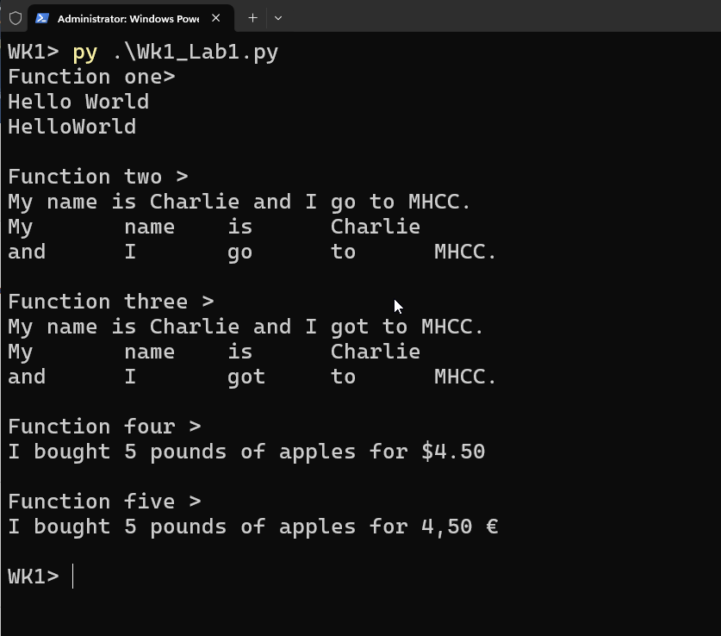

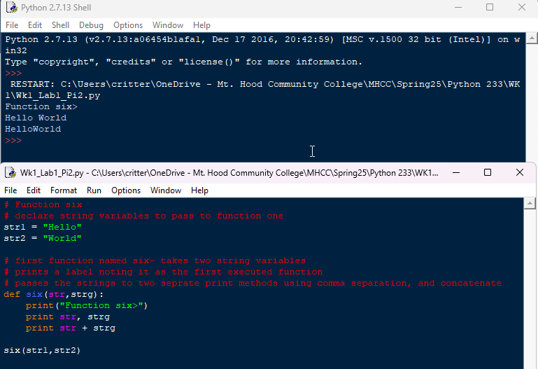

import locale

locale.setlocale(locale.LC_ALL, '')

# Function one

# declare string variables to pass to function one

str1 = "Hello"

str2 = "World"

# first function named one- takes two string variables

# prints a label noting it as the first executed function

# passes the strings to two seprate print methods using comma separation, and concatenate

def one(str,strg):

    print("Function one>")

    print(str, strg)

    print(str + strg)

one(str1,str2)

# Function Two

# declare string variables to pass to function two

name = "Charlie"

school = "MHCC"

# execute two print statements

# one with format method and the other demonstrating

# the use of tabs and next-line with escape characters

def two(str1, str2):

    print("\nFunction two >")

    print("My name is {} and I go to {}.".format(str1, str2))

    print("My\t name\t is\t {} \nand\t I\t go\t to\t {}.".format(str1, str2))

two(name,school)

# Function three

# Replicate the output of function two using f-string technique

# pass the same string variables.

def three(str1, str2):

    print("\nFunction three >")

    print(f"My name is {str1} and I got to {str2}.")

    print(f"My\t name\t is\t {str1} \nand\t I\t got\t to\t {str2}.")

three(name, school)

# Function four

# decalre string, integer, and float variable

fruit = "apples"

qty = 5

price = 4.5

# Funtion four - pass the three variables to

# print "I bought 5 pounds of apples for $4.50" no local

def four(str1, int1, float1):

    print("\nFunction four >")

    print("I bought {} pounds of {} for ${:.2f}".format(str1, int1, float1))

four(qty,fruit, price)

# Function five - Replicate the output of function four using locale to format currency

def five(str1, int1, float1):

    fmt_price = locale.currency(float1)

    locale.setlocale(locale.LC_ALL, 'fr_FR')

    fmt_price = locale.currency(float1)

    print("\nFunction five >")

    print("I bought {} pounds of {} for {}\n".format(str1, int1, fmt_price))

five(qty, fruit, price)

# Function six

# declare string variables to pass to function one

str1 = "Hello"

str2 = "World"

# first function named six- takes two string variables

# prints a label noting it as the first executed function

# passes the strings to two seprate print methods using comma separation, and concatenate

def six(str,strg):

    print("Function six>")

    print str, strg

    print str + strg

six(str1,str2)