# Program:      WK2 Lab - Order Entry Form

# Programmer:   Charlie Ritter

# Date:         4/8/2025

# Purpose:      Design a functional GUI program using Tkinter. An Order Form with selections and itemized totals.

Program running

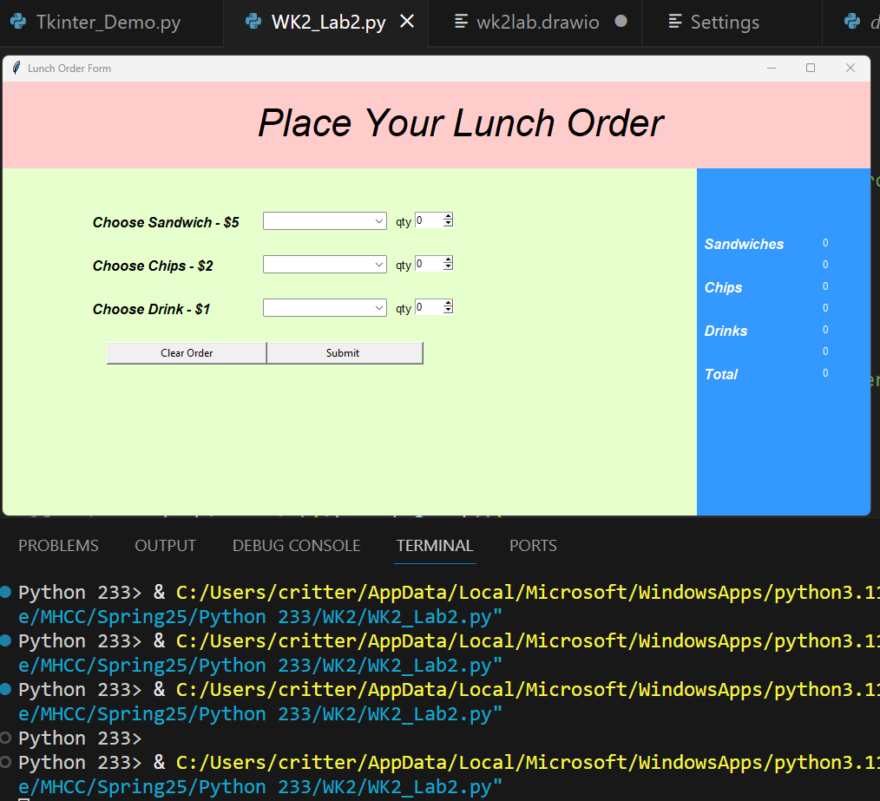

Submit sends data to static labels in separate frame

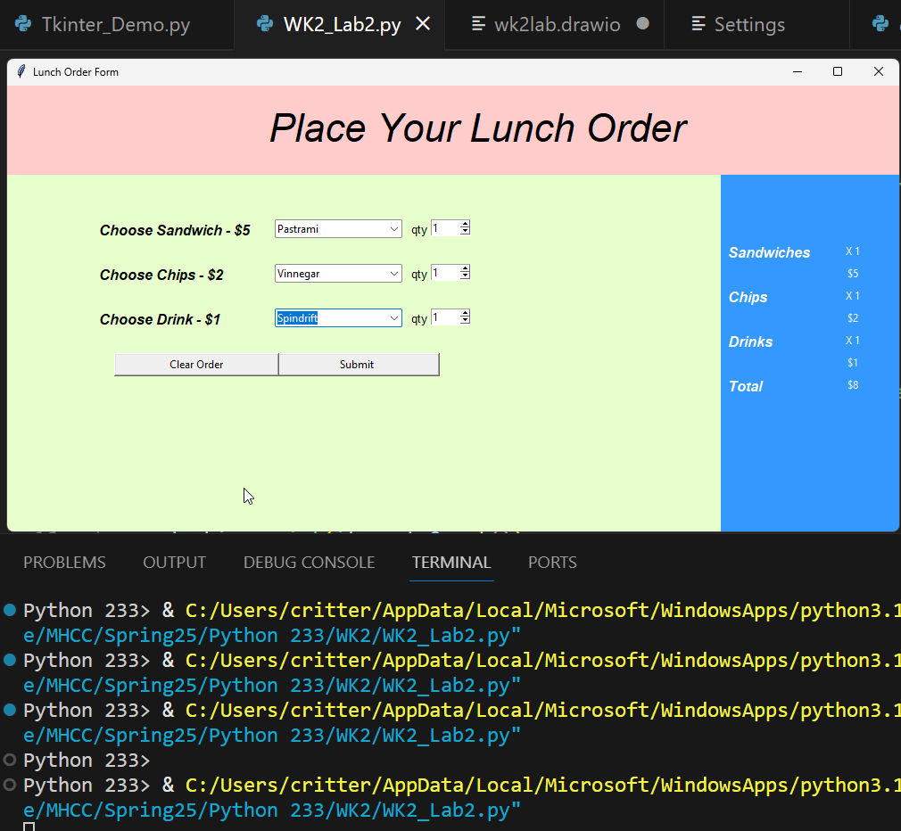

Clear Order button clears only data in the first frame

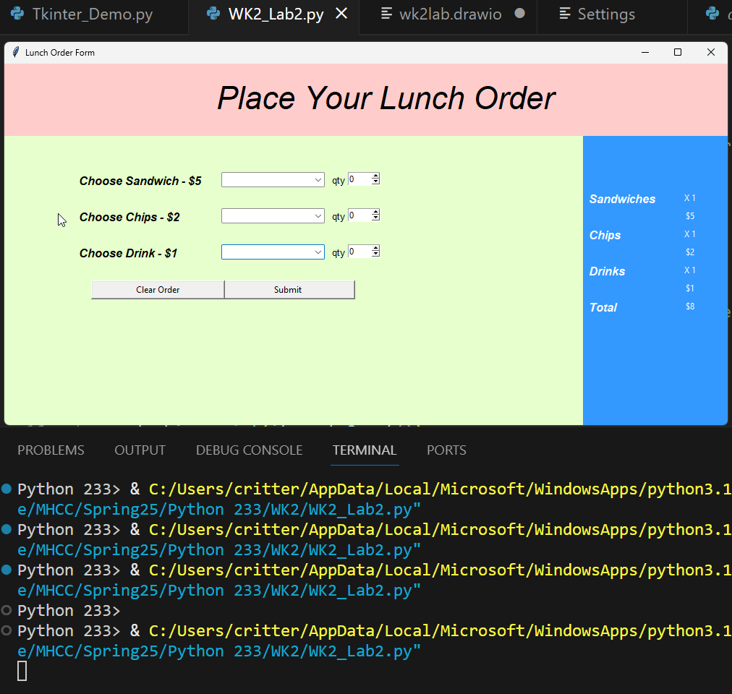

from tkinter import ttk # Imported for combobox

import tkinter as tk

#---------Functions----------#

# Function will take the qty amount and display in items sum_frame labels

def quantity():

    sel_sand = int(item_qty.get())

    sandwich["text"] = f"X {sel_sand}"

    sel_chips = int(item_qty2.get())

    chips["text"] = f"X {sel_chips}"

    sel_drink = int(item_qty3.get())

    drinks["text"] = f"X {sel_drink}"

# sum all of the selected items and display total.

def total():

    # sandwich total

    sel_sand = int(item_qty.get())

    sand_tot = sel_sand * 5

    sand_price["text"] = f"${sand_tot}"

    # chips total

    sel_chips = int(item_qty2.get())

    chips_tot = sel_chips * 2

    chips_price["text"] = f"${chips_tot}"

    # drinks total

    sel_drinks = int(item_qty3.get())

    drinks_tot = sel_drinks * 1

    drinks_price["text"] = f"${drinks_tot}"

    sum_total = sand_tot + chips_tot + drinks_tot

    order_total["text"] = f"${sum_total}"

# Clear qty spinboxes in the sel_frame when

# called with the "Clear Order" button command.

def clear_qty():

    Clear_var = tk.IntVar(sel_frame)

    Clear_var.set(0)

    item_qty.config(textvariable=Clear_var)

    Clear_var2 = tk.IntVar(sel_frame)

    Clear_var2.set(0)

    item_qty2.config(textvariable=Clear_var2)

    Clear_var3 = tk.IntVar(sel_frame)

    Clear_var3.set(0)

    item_qty3.config(textvariable=Clear_var3)

# Clear item Comboboxes in the sel_frame when

# called with the "Clear Order" button command.

def clear_sel():

    choose_sand.set("")

    choose_drink.set("")

    choose_chips.set("")

window = tk.Tk()

window.title("Lunch Order Form")

#-------Frame set ups---------#

bg_one = "#E6FFCC"

d_grey = "#3399FF"

# page title

header_frame = tk.Frame(master=window, width=1000, height= 100, bg='#FFCCCC')

header_frame.pack(fill='both', expand=True)

# order fill here

sel_frame = tk.Frame(master=window, width=800, height=400, bg=bg_one)

sel_frame.pack(fill='both', side=tk.LEFT, expand=True)

# itemized totals

sum_frame = tk.Frame(master=window, width=200, bg=d_grey)

sum_frame.pack(fill='both', side=tk.RIGHT, expand=True)

# -----header frame----- #

label = tk.Label(master=header_frame,

                 text=('Place Your Lunch Order'),

                 bg='#FFCCCC',

                 font=('Time', '33', 'italic'))

label.place(x=290, y=20)

# ----Fill out the order form in sel_frame---- #

# Enter Item Labels

label = tk.Label(master=sel_frame,

                 text="Choose Sandwich - $5",

                 bg=bg_one,

                 font=('Helvetica', '12', 'bold', 'italic'))

label.place(x=100, y=50)

label = tk.Label(master=sel_frame,

                 text="Choose Chips - $2",

                 bg=bg_one,

                 font=('Helvetica', '12', 'bold', 'italic'))

label.place(x=100, y=100)

label = tk.Label(master=sel_frame,

                 text="Choose Drink - $1",

                 bg=bg_one,

                 font=('Helvetica', '12', 'bold', 'italic'))

label.place(x=100, y=150)

# Enter Sandwich Combobox

choose_sand = ttk.Combobox(master=sel_frame,

                           values=("Ham", "Turkey", "Pastrami", "Sietan"))

choose_sand.place(x=300, y=50)

# Enter Chips Combobox

choose_chips = ttk.Combobox(master=sel_frame,

                           values=("Vinnegar", "Salt & Pepper", "Tortilla"))

choose_chips.place(x=300, y=100)

# Enter Drink Combobox

choose_drink = ttk.Combobox(master=sel_frame,

                           values=("La Croix", "Spindrift", "Coca-Cola", "Water"))

choose_drink.place(x=300, y=150)

# Item qty Entry spinbox

item_qty = tk.Spinbox(master=sel_frame, from_= 0, to=5, width=5)

item_qty.place(x=475, y=50)

label = tk.Label(master=sel_frame, text="qty", font=('Time','10'), bg=bg_one)

label.place(x=450, y=50)

# Item qty Entry spinbox

item_qty2 = tk.Spinbox(master=sel_frame, from_= 0, to=5, width=5)

item_qty2.place(x=475, y=100)

label = tk.Label(master=sel_frame, text="qty", font=('Time','10'), bg=bg_one)

label.place(x=450, y=100)

# Item qty Entry spinbox

item_qty3 = tk.Spinbox(master=sel_frame, from_= 0, to=5, width=5)

item_qty3.place(x=475, y=150)

label = tk.Label(master=sel_frame, text="qty", font=('Time','10'), bg=bg_one)

label.place(x=450, y=150)

# Submit button. Will call both quantity and total functions displaying calculated

# Data in sum_frame

button1 = tk.Button(master=sel_frame,

                    text= "Submit",

                    width= 25,

                    command= lambda:[quantity(), total()]

                    )

button1.place(x=300, y=200)

# Clear Order button. will call both functions to clear the comboboxes and

# the spinboxes

button2 = tk.Button(master=sel_frame,

                    text= "Clear Order",

                    width= 25,

                    command= lambda:[clear_qty(), clear_sel()]

                    )

button2.place(x=120, y=200)

# -----Itemized Totals in sum_frame---- #

# Sandwiches number and total

label = tk.Label(master=sum_frame,

                 text="Sandwiches",

                 font=('Helvetica', '12', 'bold', 'italic'),

                 bg=d_grey,

                 foreground='white')

label.place(x=5, y=75)

sandwich = tk.Label(master=sum_frame,

                    text="0",

                    width=10,

                    bg=d_grey,

                    foreground='white')

sandwich.place(x=110, y=75)

sand_price = tk.Label(master=sum_frame,

                      text="0",

                      width=10,

                      bg=d_grey,

                      foreground='white')

sand_price.place(x=110, y=100)

# Chips number and total

label = tk.Label(master=sum_frame,

                 text="Chips",

                 font=('Helvetica', '12', 'bold', 'italic'),

                 bg=d_grey,

                 foreground='white')

label.place(x=5, y=125)

chips = tk.Label(master=sum_frame,

                    text="0",

                    width=10,

                    bg=d_grey,

                    foreground='white')

chips.place(x=110, y=125)

chips_price = tk.Label(master=sum_frame,

                      text="0",

                      width=10,

                      bg=d_grey,

                      foreground='white')

chips_price.place(x=110, y=150)

# Drinks number and total

label = tk.Label(master=sum_frame,

                 text="Drinks",

                 font=('Helvetica', '12', 'bold', 'italic'),

                 bg=d_grey,

                 foreground='white')

label.place(x=5, y=175)

drinks = tk.Label(master=sum_frame,

                    text="0",

                    width=10,

                    bg=d_grey,

                    foreground='white')

drinks.place(x=110, y=175)

drinks_price = tk.Label(master=sum_frame,

                      text="0",

                      width=10,

                      bg=d_grey,

                      foreground='white')

drinks_price.place(x=110, y=200)

# Total

label = tk.Label(master=sum_frame,

                 text="Total",

                 font=('Helvetica', '12', 'bold', 'italic'),

                 bg=d_grey,

                 foreground='white')

label.place(x=5, y=225)

order_total = tk.Label(master=sum_frame,

                    text="0",

                    width=10,

                    bg=d_grey,

                    foreground='white')

order_total.place(x=110, y=225)

window.mainloop()