**Worksheet 1**

**Student Name**: Vivek Singh Rawat     **UID**:20MCA1232

**Branch:**MCA                       **Section/Group**-2/A

**Semester:**1 **Date of** **Performance:**08/09/20

**Subject Name:** Advance internet programming lab                **Subject Code:** 20CAP-617

**Q. : Write a program to initialize an integer array with values and check if a given number is present in the array or not.**

**Aim:** Introduction to arrays.

**Task to be done:** Implementation of arrays.

**Algorithm/flowchart-**

**Search**

Step 1: Set i to 1

Step 2: if i > n then go to step 7

Step 3: if Arr[i] = x then go to step 6

Step 4: Set i to i + 1

Step 5: Go to Step 2

Step 6: Print Element x Found at index i and go to step 8

Step 7: Print element not found

Step 8: Exit

**Data Set:**

Array id:[1,2,3]

Array name=[”vivek”,”Shivani”,”Rahul”]

Array score=[99,90,80]

Search id:2

**Code for experiment/Practical:**

public class Practical1 {

public static void main(String[] args) {

Scanner scan=new Scanner(System.in);

boolean flag=false;

System.out.println("enter the number of students");

int size=scan.nextInt(),i; //taking number of students

int id[]=new int[size]; //initializing array id of int type

String name[]=new String[size]; //initializing array name of String type

double score[]=new double[size]; //initializing array score of double type

System.out.println("enter the id of the student");

for(i=0;i<size;i++)

{

System.out.print("Student "+(i+1)+":");

id[i]=scan.nextInt(); //inserting id to array

}

System.out.println("enter the name of the student");

for(i=0;i<size;i++)

{

System.out.print("Student "+(i+1)+":");

name[i]=scan.next(); //inserting name to array

}

System.out.println("enter the score of the student");

for(i=0;i<size;i++)

{

System.out.print("Student "+(i+1)+":");

score[i]=scan.nextDouble(); //inserting id to array

}

System.out.println("enter the id to search");

int search=scan.nextInt(); //search value

for(i=0;i<size;i++)

{

if(search==id[i]) //if id found

{

System.out.println("====================");

System.out.println("index:"+i);

System.out.println("student id:"+search);

System.out.println("student name:"+name[i]);

System.out.println("student score:"+score[i]);

flag=true;

}

}

if(!flag) //if id not found

{

System.out.println("-1");

System.out.println("student not found");

}

}

}

**Result/Output/WritingSummary:**

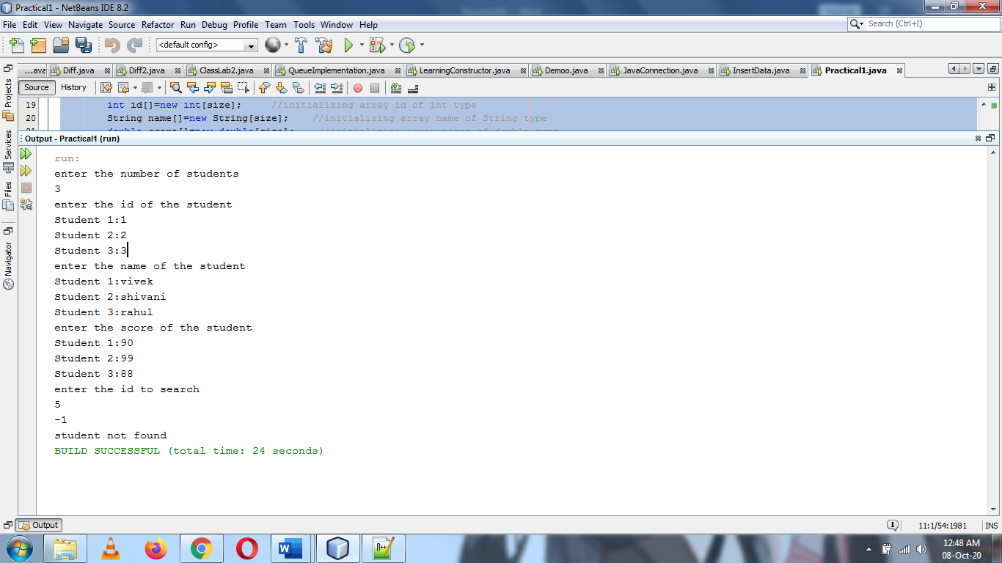

**Learning Outcomes:**

* + 1. Arrays of different data type.
    2. Searching in array.