Applications of Array In Java.

**Student Name:** Advanced Internet Programming

**Subject Code:** CAP716/20CAP726

# UID: 20MCA1232 Section/Group :2A

**Semester: 1st Date of Performance:10/10/20**

**Experiment No. 2**

1. **Aim/Overview of the practical:**

Write a program to print the sum of the elements of an array following the given below condition.

# Task to be done:

### If the array has 6 and 7 in succeeding orders, ignore the numbers between 6 and 7 and consider the other numbers for calculation of sum.

***Eg1)*** *Array Elements - 10,3,6,1,2,7,9*

***O/P:*** *22*

### [i.e 10+3+9]

***Eg2)*** *Array Elements - 7,1,2,3,6*

***O/P:****19*

### **Eg3**) Array Elements - 1,6,4,7,9

***O/P:****10*

# Algorithm/Flowchart :

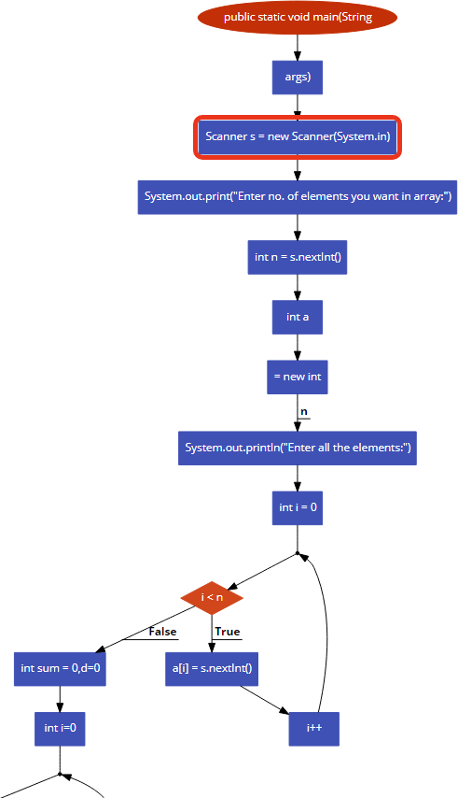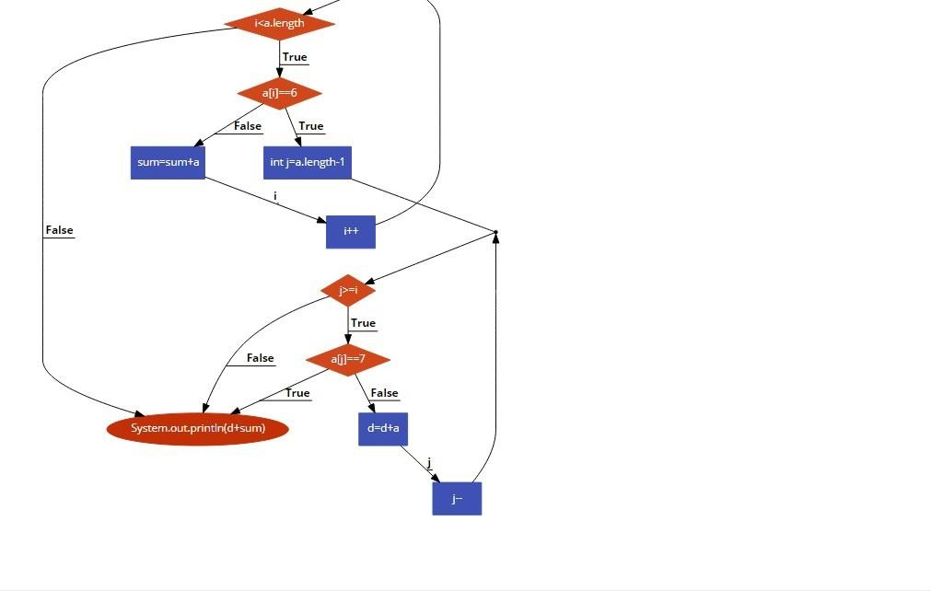

1. **Dataset:**

### **Eg1)** Array Elements - 10,3,6,1,2,7,9 **Eg2)** Array Elements - 7,1,2,3,6 **Eg3**) Array Elements - 1,6,4,7,9

1. **Code for experiment/practical:**

Class MyClass{

public static void main(String[] args) { Scanner s = new Scanner(System.in);

System.out.print("Enter no. of elements in array:"); int n = s.nextInt();

int a[] = new int[n]; System.out.println("Enter the elements:"); for(int i = 0; i < n; i++)

{

a[i] = s.nextInt();

}

int sum = 0,gap=0;

for(int i=0;i<a.length;i++){ if(a[i]==6){

for(int j=a.length-1;j>=i;j--){ if(a[j]==7)

break; gap+= [j];

}

break;

}

sum=sum+a[i];

}

System.out.println(gap+sum);

}

}

# Result/Output/Writing Summary:

Example 1

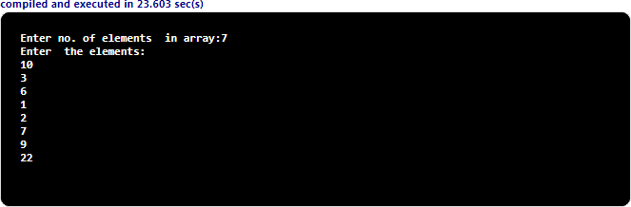

Example 2

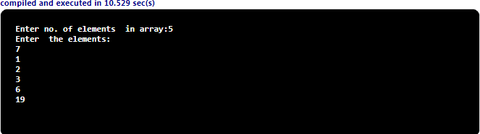

Example 3

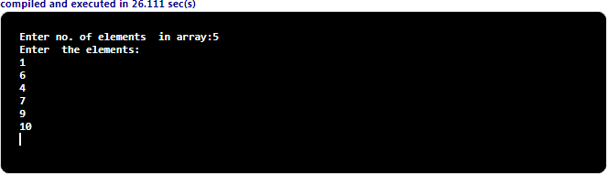

 

## Learning outcomes (What I have learnt): 1.array initialization

**2.looping statements 3.arithmetic operation on array**

**4.importation of various libraries 5.diffrent functions in java**