Worksheet-3

**Subject Name:** Advanced Internet Programming

**Subject Code:** CAP716/20CAP726

# UID: 20MCA1232 Section/Group:2-A

**Semester: 1 Date of Performance: 28.09.20**

## **Aim/Overview of the practical:** Create a Collection “ContactList” using HashMap to store name and phone number of contacts added. The program should use appropriate generics (String, Integer).

**Task to be done:**

1. *Check if a particular key exists or not.*
2. *Check if a particular value exists or not.*
3. *Use Iterator to loop through the map.*

**Algorithm/Flowchart:**

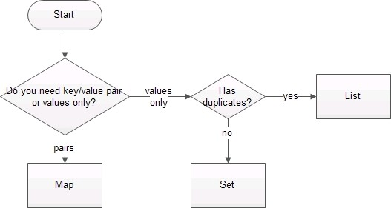

**Dataset:**

|  |  |
| --- | --- |
| **Name** | **Contact** |
| Ram | 987654321 |
| Shyam | 123456789 |
| Lakshman | 564738291 |

**Code for experiment:**

public class HashMapping {

HashMap<String,Long>contactList=new HashMap<String,Long>(); public static void main(String[] args) {

Scanner scan=new Scanner(System.in); HashMapping hm=new HashMapping(); char ch='n';

int op=0;

while(ch=='n')

{

\n5.Exit");

System.out.println("");

System.out.println("1.Add Contact \n2.Search Key \n3.Search Value \n4.List

op=scan.nextInt(); switch(op)

{

case 1:

System.out.print("Enter name:"); String name=scan.next(); System.out.print("Enter phone:"); long phone=scan.nextLong(); hm.addContact(name, phone); System.out.println("contact added!");

break; case 2:

System.out.print("Enter key to be searched:"); String key=scan.next();

if(hm.searchKey(key)) System.out.println("key is present");

else

break; case 3:

break; case 4:

System.out.println("key is not present");

System.out.print("Enter value to be searched:"); long value=scan.nextLong();

if(hm.searchValue(value)) System.out.println("value is present");

else

System.out.println("value is not present");

System.out.println("Contact List"); hm.list();

break;

case 5: ch='y'; break;

default:

System.out.println("choose from above options");

}

}

}

//adding contact

public void addContact(String name,Long phone)

{

contactList.put(name, phone);

}

//searching key

public boolean searchKey(String key)

{

boolean flag=false; if(contactList.get(key)!=null)

flag=true;

return flag;

}

//searching value

public boolean searchValue(Long value)

{

boolean flag=false;

List<Long> values = new ArrayList<>(contactList.values()); for(int i=0;i<values.size();i++)

{

if(Objects.equals(values.get(i), value))

{

flag=true; break;

}

}

return flag;

}

//all key-value pairs public void list()

{

for(Map.Entry m:contactList.entrySet()){ System.out.println(m.getKey()+" "+m.getValue());

}

}

}

**Result:**

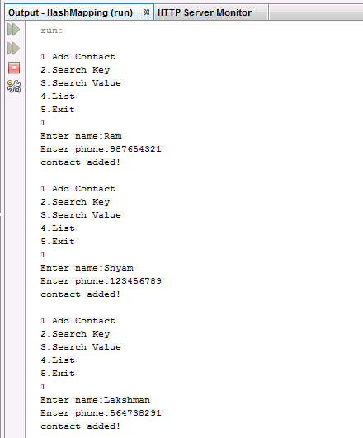

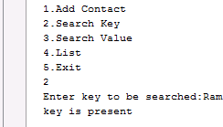

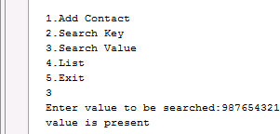

**Learning outcomes:**

## Creating HashMaps.

* 1. Inserting data into HashMaps.
  2. Accessing key/values.