Experiment-4

**Subject Name:** Advanced Internet Programming

**Subject Code:** CAP716/20CAP726

# UID: 20MCA1232 Section/Group:2-A

**Semester: 1 Date of Performance: 05.10.20**

**Aim/Overview of the practical:** Implementation of CRUD operations on JDBC Applications with Oracle- MySQL-PostgreSQL.

## Task to be done:

CRUD operations

* Insertion into the database
* Updation from the database
* Searching from the database
* Deletion of records(Row) from the database

**Algorithm/Flowchart:**

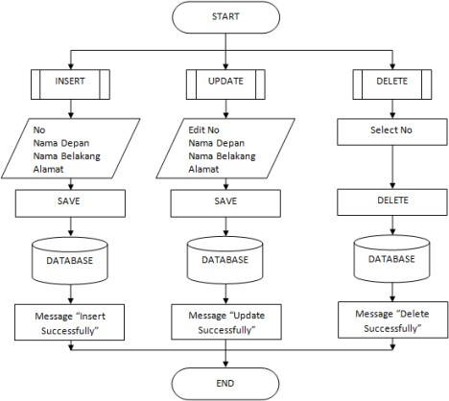

**Dataset:**

**Insertion:**

|  |  |
| --- | --- |
| Name | Age |
| James | 23 |
| Julie | 24 |

**Update:**

SET James Age=34

**Search:**

List all the records where Age>20

**Delete:**

Delete the record of Julie.

**Code for experiment:**

public class MyJdbc {

static Connection connect=null;

public static Connection connection(String database,String user,String password)

{

String url="jdbc:mariadb://localhost:3306/"+database;

try {

//register the driver

DriverManager.registerDriver(new org.mariadb.jdbc.Driver());

//connecting to database connect=DriverManager.getConnection(url,user,password);

} catch (SQLException ex) { Logger.getLogger(MyJdbc.class.getName()).log(Level.SEVERE, null, ex);

}

return connect;

}

public int insertData(Statement stmt,String table,String data) throws SQLException

{

int flag=0;

String []st=data.split(" ");

String sql="INSERT INTO "+table+" VALUES ("+st[0]+","+st[1]+")";

flag=stmt.executeUpdate(sql); return flag;

}

public int updateData(Statement stmt,String table, String column, String newData,int id) throws SQLException

{

int flag=0;

String sql="UPDATE "+table+" SET "+column+"="+newData+" WHERE id="+id; flag=stmt.executeUpdate(sql);

return flag;

}

public int deleteRow(Statement stmt,String table,int id) throws SQLException

{

int flag=0;

String sql="DELETE FROM "+table+" WHERE id="+id; flag=stmt.executeUpdate(sql);

return flag;

}

public void showData(Statement stmt,String table) throws SQLException

{

String sql="SELECT * FROM "+table; ResultSet rs=stmt.executeQuery(sql); while(rs.next())

System.out.println(rs.getInt(0)+" "+rs.getString(1)+" "+rs.getString(2));

}

}

//main

public class Jdbc {

/**

* @param args the command line arguments

*/

public static void main(String[] args) throws SQLException { Scanner scan=new Scanner(System.in);

// TODO code application logic here

String url ="jdbc:mariadb://localhost:3306/test"; //update connection string

String user = "root";//add your db user id here String password = "";//add your db password here

Connection conn = DriverManager.getConnection(url, user, password); System.out.println("Successfully connected");

//insert employee record into database Statement stmt = conn.createStatement();

int rows = stmt.executeUpdate("insert into employee (age,name) values(23,'James'),(24,'Julie')");

System.out.println("Rows inserted = "+ rows);

scan.next();

//update employee record

rows= stmt.executeUpdate("Update employee set age=31 where name='James'"); System.out.println("Rows updated = "+ rows);

scan.next();

//read employee records

ResultSet rs = stmt.executeQuery("Select * from employee where age>20"); while(rs.next()){

System.out.println("Emp Id : " + rs.getInt("id") + ", Name : " + rs.getString("name") + ", Age : " + rs.getInt("age"));

}

scan.next();

//delete employee record

rows = stmt.executeUpdate("delete from employee where name = 'Julie'"); System.out.println("Rows deleted = "+ rows);

}

}

## Result:

**Insert**

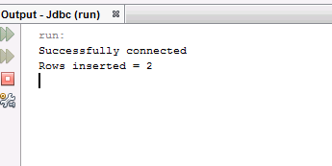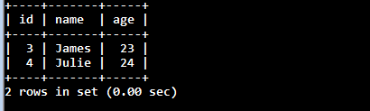

**Update**

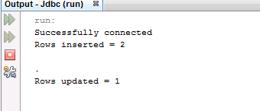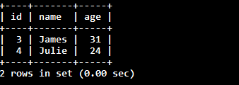

**Search:**

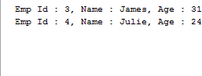

**Delete:**

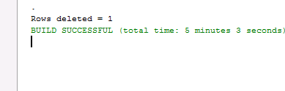

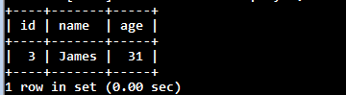

**Learning outcomes:**

1. **Creating jdbc connection.**
2. **CRUD operation in jdbc.**