**Java Servlet and JSP.**

**Subject Name:** Advanced Internet Programming

**Subject Code:** CAP716/20CAP726

**UID: 20MCA1232 Section/Group:2A**

**Semester: 1 Date of Performance: 16/11/2020**

**Experiment No. 2.2:**

Create Servlet based application to store and retrieve data from database.

Add only four columns of table:

uid, name, class, age

Note: Retrieve all data into table structure(<table>) along with serial number.

Sr.No. UID Name Class Age

1. **Algorithm/Flowchart :**

start

After data insertion

Index.html

Data insertion

InsertData.java

database

Data Fetching

Data display in Table format

Display Student Data

1. **Dataset:** UID:20MCA1232 | Name:Vivek | class:2B | Age:20
2. **Code for experiment/practical:**

**Index.html**

<!DOCTYPE html>

<!--

To change this license header, choose License Headers in Project Properties.

To change this template file, choose Tools | Templates

and open the template in the editor.

-->

<html>

<head>

<title>Insert Form</title>

<meta charset="UTF-8">

<meta name="viewport" content="width=device-width, initial-scale=1.0">

</head>

<body>

<h3 align="center">Insert</h3>

<form action="InsertData" method="post" id="insert"></form>

<table width="650" height="70" border="0" align="center">

<tr>

<td>

<label for="uid" form="insert">uid</label>

<input type="text" name="uid" placeholder="enter uid" form="insert">

<label for="name" form="insert">name</label>

<input type="text" name="name" placeholder="enter name" form="insert">

<label for="class" form="insert">class</label>

<input type="text" name="class" placeholder="enter class" form="insert">

<center>

<label for="age" form="insert">age</label>

<input type="number" name="age" placeholder="enter age" form="insert">

<br>

<button type="submit" name="submit" value="insert" form="insert" >submit</button>

</center>

</td>

</tr>

<tr>

<td>

<label for="textDislay" form="insert">view data</label> <button type="submit" name="submit" form="insert" value="display" >display Data</button>

</td>

</tr>

</table>

<br>

</body>

</html>

**InsertData.java(Servlet)**

/*

* To change this license header, choose License Headers in Project Properties.

* To change this template file, choose Tools | Templates

* and open the template in the editor.

*/

import java.io.IOException;

import java.io.PrintWriter;

import java.sql.Connection;

import java.sql.DriverManager;

import java.sql.PreparedStatement;

import java.sql.ResultSet;

import java.sql.Statement;

import javax.servlet.RequestDispatcher;

import javax.servlet.ServletException;

import javax.servlet.http.HttpServlet;

import javax.servlet.http.HttpServletRequest;

import javax.servlet.http.HttpServletResponse;

/**

*

* @author Charlie

*/

public class InsertData extends HttpServlet {

PrintWriter out=null;

Connection conn=null;

RequestDispatcher rd=null;

@Override

protected void doPost(HttpServletRequest request, HttpServletResponse response)

throws ServletException, IOException {

try{

out=response.getWriter();

Class.forName("com.mysql.jdbc.Driver");

conn=DriverManager.getConnection("jdbc:mysql://localhost:3306/servlet","root","");

String type=request.getParameter("submit");

if(type.equals("insert"))

{

String uid=request.getParameter("uid");

String name=request.getParameter("name");

String classData=request.getParameter("class");

String age=request.getParameter("age");

String query="insert into multiData(uid,name,class,age) values(?,?,?,?)";

PreparedStatement preparedStmt = conn.prepareStatement(query);

preparedStmt.setString(1,uid);

preparedStmt.setString(2,name);

preparedStmt.setString(3,classData);

preparedStmt.setInt(4,Integer.parseInt(age));

int i=0;

try{

i=preparedStmt.executeUpdate();

}

catch(Exception e)

{

System.out.println(e.toString());

}

System.out.println("result"+i);

if(i==0)

{

out.println("<script>alert('data insertion failed')</script>");

request.getRequestDispatcher("./index.html").include(request, response);

}

else

{

out.println("<script>alert('data insertion successful')</script>");

request.getRequestDispatcher("./index.html").include(request, response);

}

}

else if(type.equals("display"))

{

String query="select * from multidata";

Statement stmt=conn.createStatement();

ResultSet rst=stmt.executeQuery(query);

response.setContentType("text/html;charset=UTF-8");

out.println("<!DOCTYPE html>");

out.println("<html>");

out.println("<head>");

out.println("<title>Servlet Welcome</title>");

out.println("</head>");

out.println("<body>");

out.println("<h4 align='center'>Display Data</h4>");

out.println("<center>");

out.println("<table border='1'>");

out.println("<tr><th>serial no</th><th>uid</th><th>name</th><th>class</th><th>age</th></tr>");

int i=0;

while(rst.next())

{

i++;

out.println("<tr>");

out.println("<td>"+i+"</td>");

out.println("<td>"+rst.getString(1)+"</td>");

out.println("<td>"+rst.getString(2)+"</td>");

out.println("<td>"+rst.getString(3)+"</td>");

out.println("<td>"+rst.getInt(4)+"</td>");

out.println("</tr>");

}

out.println("</center>");

out.println("<br><button type=\"submit\"><a href=\"./index.html\" style=\"text-decoration: none; color: black;\" >insertData</a></button>");

System.out.println("count"+i);

out.println("</body>");

out.println("</html>");

}

}

catch(Exception e)

{

System.out.println(e.getMessage());

}

}

}

1. **Result/Output/Writing Summary:**

**Index.html**

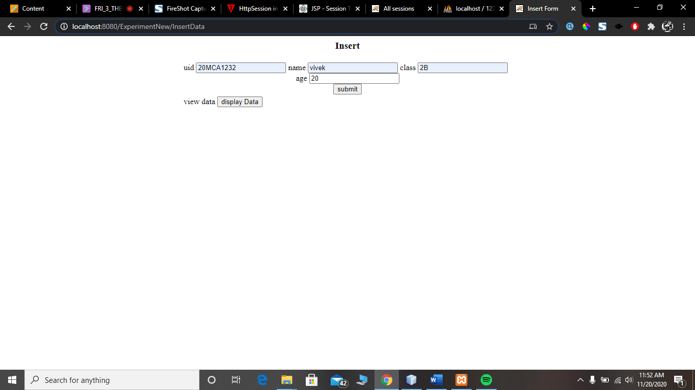

**Successful insertion of Data Message**

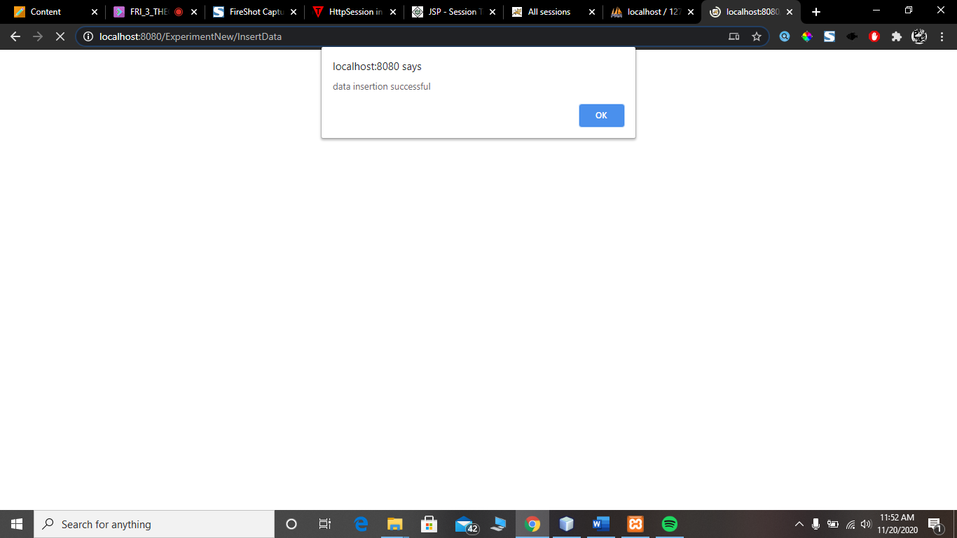

**InsertData.java**

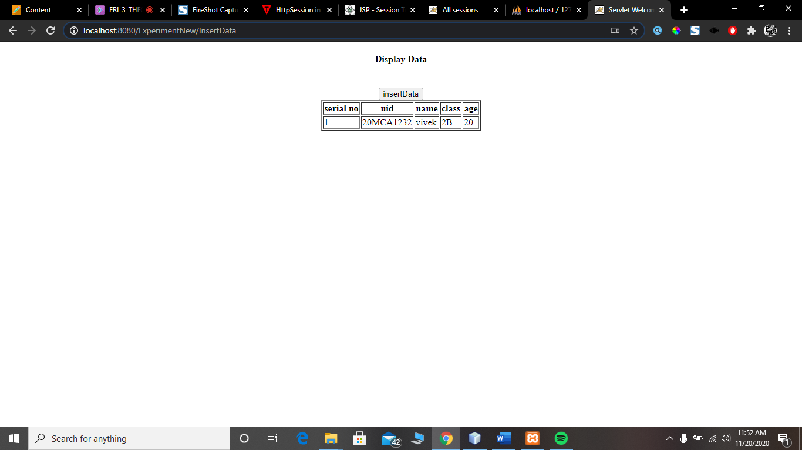

**Database:**

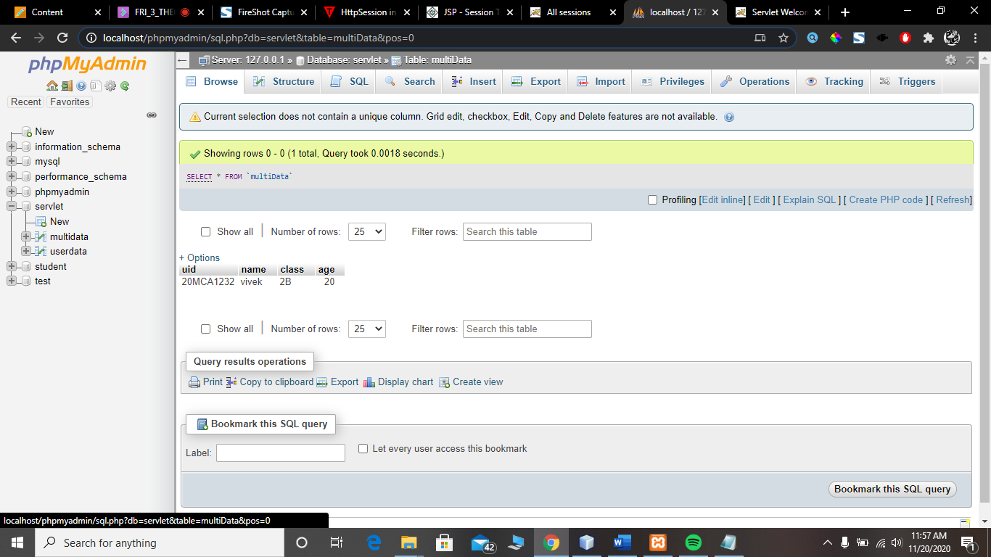

**Learning outcomes (What I have learnt):**

**1.Java servlets**

**2.MySqL**

**3.JDBC**

**Evaluation Grid:**

|  |  |  |  |
| --- | --- | --- | --- |
| Sr. No. | Parameters | Marks Obtained | Maximum Marks |
| 1. | Demonstration and Performance (Pre Lab Quiz) |  | 5 |
| 2. | Worksheet |  | 10 |
| 3. | Post Lab Quiz |  | 5 |