**Java Servlet and JSP.**

**Subject Name:** Advanced Internet Programming

**Subject Code:** CAP716/20CAP726

**UID: 20MCA1232 Section/Group:2A**

**Semester: 1 Date of Performance: 20/11/2020**

**Task to be done:**

**Experiment No. 2.4:**

Create a Servlet that uses session tracking to show per-client access counts.

Also, show other generic-info about the session such as time when this session was created and maximum time interval (minutes), that the servlet container will keep the session.

1. **Algorithm/Flowchart :**

start

Check Session Button

Index.jsp

Check Session Exist

false

null

Session creation request

true

SessionHandling.java

(Servlet)

Session created

Session Info

Invalidate

1. **Dataset:** Username:ABC | password:123
2. **Code for experiment/practical:**

**Index.jsp**

<%--

Document : index

Created on : Nov 20, 2020, 10:07:42 AM

Author : vivek

--%>

<%@page contentType="text/html" pageEncoding="UTF-8"%>

<!DOCTYPE html>

<html>

<head>

<meta http-equiv="Content-Type" content="text/html; charset=UTF-8">

<title>Home</title>

</head>

<body>

<form action="SessionHandling" method="post">

<label for="username">username</label>

<input type="text" name="username" required>

<label for="password">password</label>

<input type="password" name="password" required>

<br>

<input type="submit" name="submit" value="submit">

<input type="submit" name="submit" value="check">

</form>

</body>

</html>

**SessionHandling.java(Servlet)**

/*

* To change this license header, choose License Headers in Project Properties.

* To change this template file, choose Tools | Templates

* and open the template in the editor.

*/

package com.vivek;

import java.io.IOException;

import java.io.PrintWriter;

import javax.servlet.ServletException;

import javax.servlet.http.HttpServlet;

import javax.servlet.http.HttpServletRequest;

import javax.servlet.http.HttpServletResponse;

import javax.servlet.http.HttpSession;

/**

*

* @author vivek

*/

public class SessionHandling extends HttpServlet {

HttpSession session=null;

PrintWriter out;

protected void service(HttpServletRequest request,HttpServletResponse response) throws IOException, ServletException

{

out=response.getWriter();

String type=request.getParameter("submit");

session=request.getSession();

if(type.equals("submit"))

{

String username=request.getParameter("username");

session.setAttribute("username",username);

int count=0;

if(null!=session.getAttribute(username))

{

count=Integer.parseInt(session.getAttribute(username).toString());

}

session.setAttribute(username,count++);

request.getRequestDispatcher("display.jsp").include(request, response);

}

if(type.equals("check"))

{

request.getRequestDispatcher("display.jsp").include(request, response);

}

if(type.equals("close"))

{

session.invalidate();

response.sendRedirect("index.jsp");

}

}

}

**Display.jsp**

<%@page import="java.util.Date"%>

<%@page contentType="text/html" pageEncoding="UTF-8"%>

<!DOCTYPE html>

<html>

<head>

<meta http-equiv="Content-Type" content="text/html; charset=UTF-8">

<title>All sessions</title>

</head>

<% HttpSession s=request.getSession(false);

boolean flag=true;

if(null == session.getAttribute("username"))

{

flag=false;

}

System.out.println("flag:"+flag); %>

<script>

</script>

<body>

<%

if(flag)

{

String username=s.getAttribute("username").toString();

int count=Integer.parseInt(s.getAttribute(username).toString());

count++;

s.setAttribute(username,count);

long creationTime=s.getCreationTime();

int timeInterval=s.getMaxInactiveInterval();

String sessionId=s.getId().toString();

%>

<p> session id: <%= sessionId %></p>

<p> username:<%=username%></p>

<p> count:<%=count%></p>

<p>creation time:<%=new Date(creationTime)%></p>

<p> time interval:<%= timeInterval/60 %>minutes </p>

<form action="SessionHandling" method="post">

<input type="submit" name="submit" value="close" >

<button><a href="index.jsp" >index.jsp</a></button>

</form>

<% } else { %>

<h3> no Session Created</h3>

<a href="index.jsp" >index.jsp</a>

<% } %>

</body>

</html>

1. **Result/Output/Writing Summary:**

**Index.jsp**

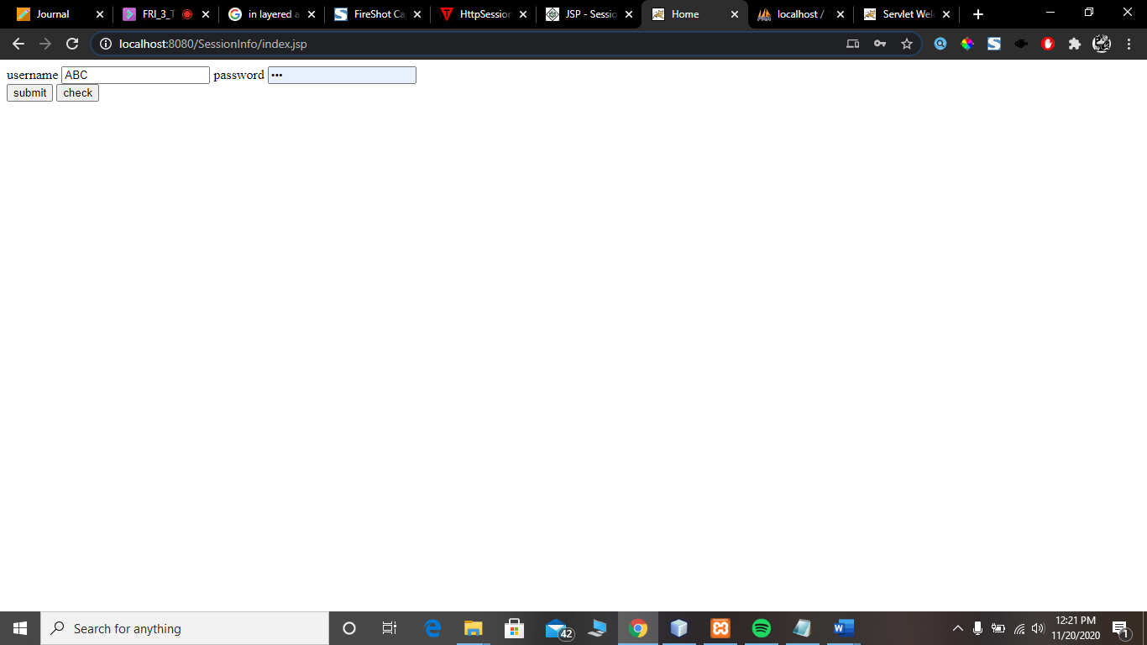

**Display.jsp(first run):count is 1**

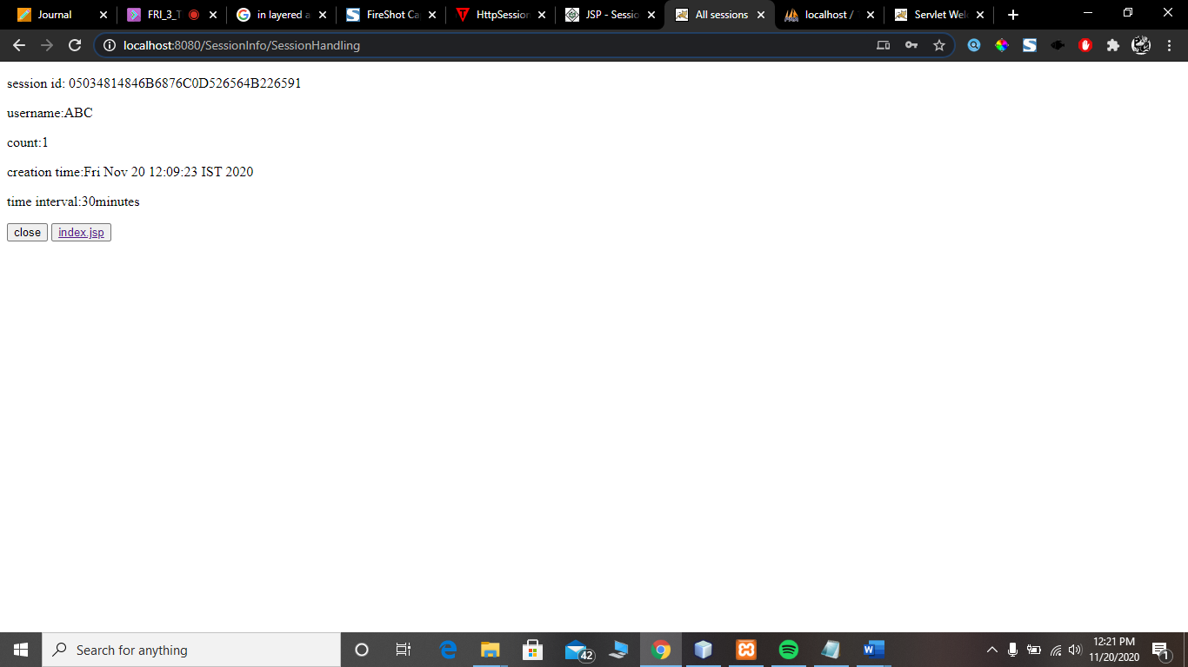

**Display.jsp(Second run):count is 2**

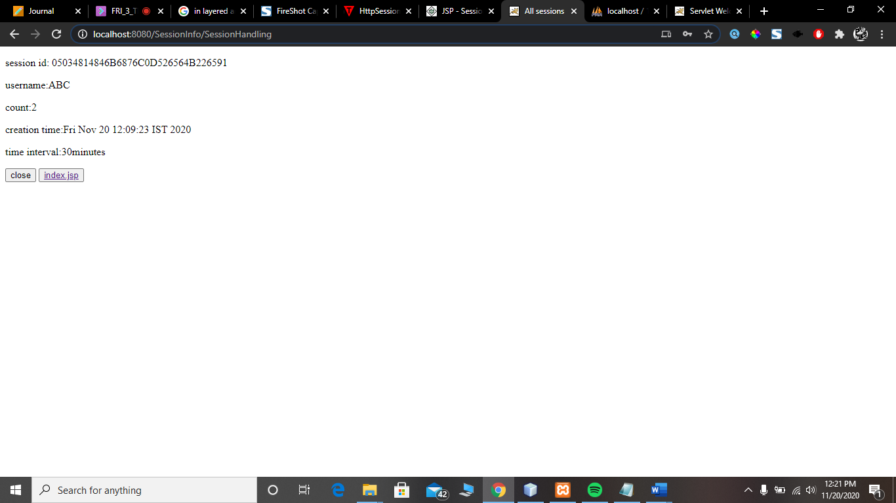

**Learning outcomes (What I have learnt):**

**1.** JSP

**2.** Java servlet

**3.** Session handling

**Evaluation Grid:**

|  |  |  |  |
| --- | --- | --- | --- |
| Sr. No. | Parameters | Marks Obtained | Maximum Marks |
| 1. | Demonstration and Performance (Pre Lab Quiz) |  | 5 |
| 2. | Worksheet |  | 10 |
| 3. | Post Lab Quiz |  | 5 |