電子學(二) Integrated-Circuit Amplifiers

自主學習 作業2

1. Use the Bode plot to draw the magnitude response and the phase response of each of the following transfer functions.

$T\left(s\right)= \frac{10(s+1000)}{(s+100)}$

$T\left(s\right)= \frac{20s}{(2s+100)}$

$T\left(s\right)= \frac{{10}^{5}}{(s+{10}^{3})(s+{2×10}^{4})}$

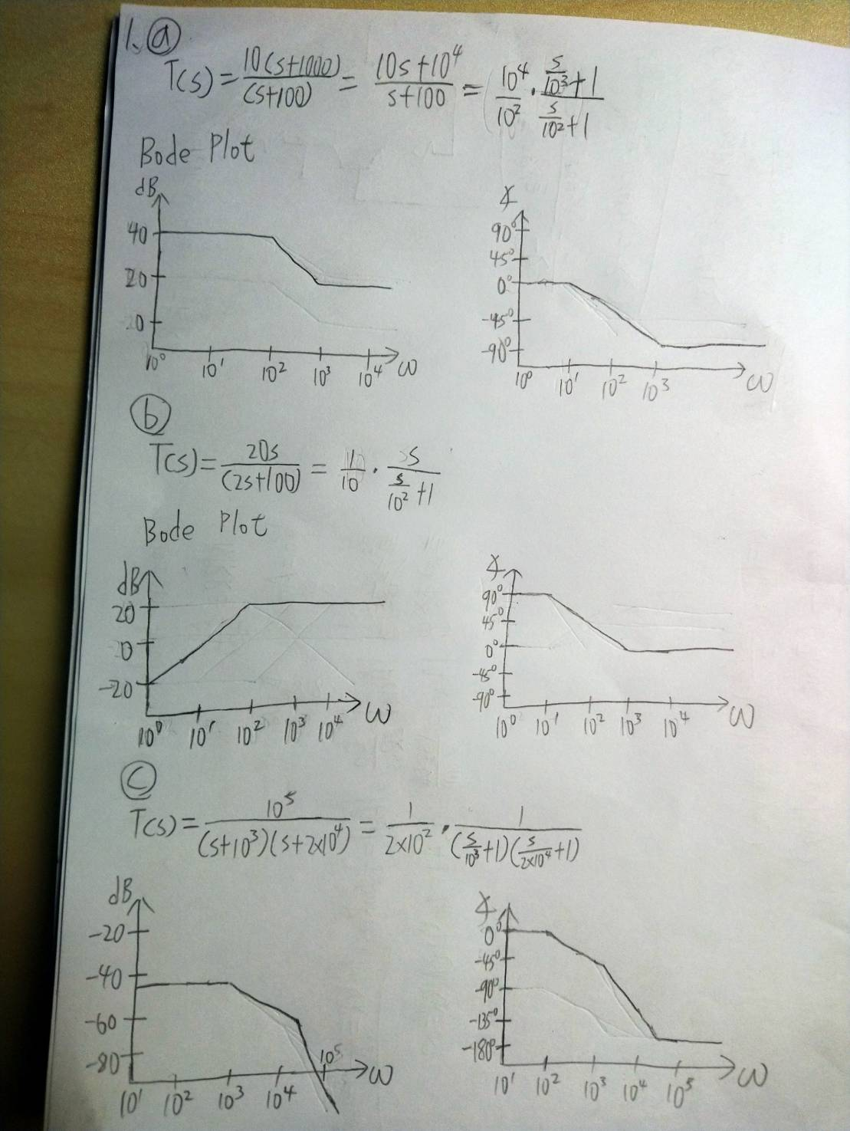

1. Consider a voltage amplifier having a frequency response of the low-pass STC(single-time-constant) type with a dc gain of 40 dB and a 3-dB frequency of 2000 Hz. Find the gain in dB at f = 20 Hz, 2 kHz, 20 kHz, and 2 MHz. Also, express the transfer function for the amplifier.

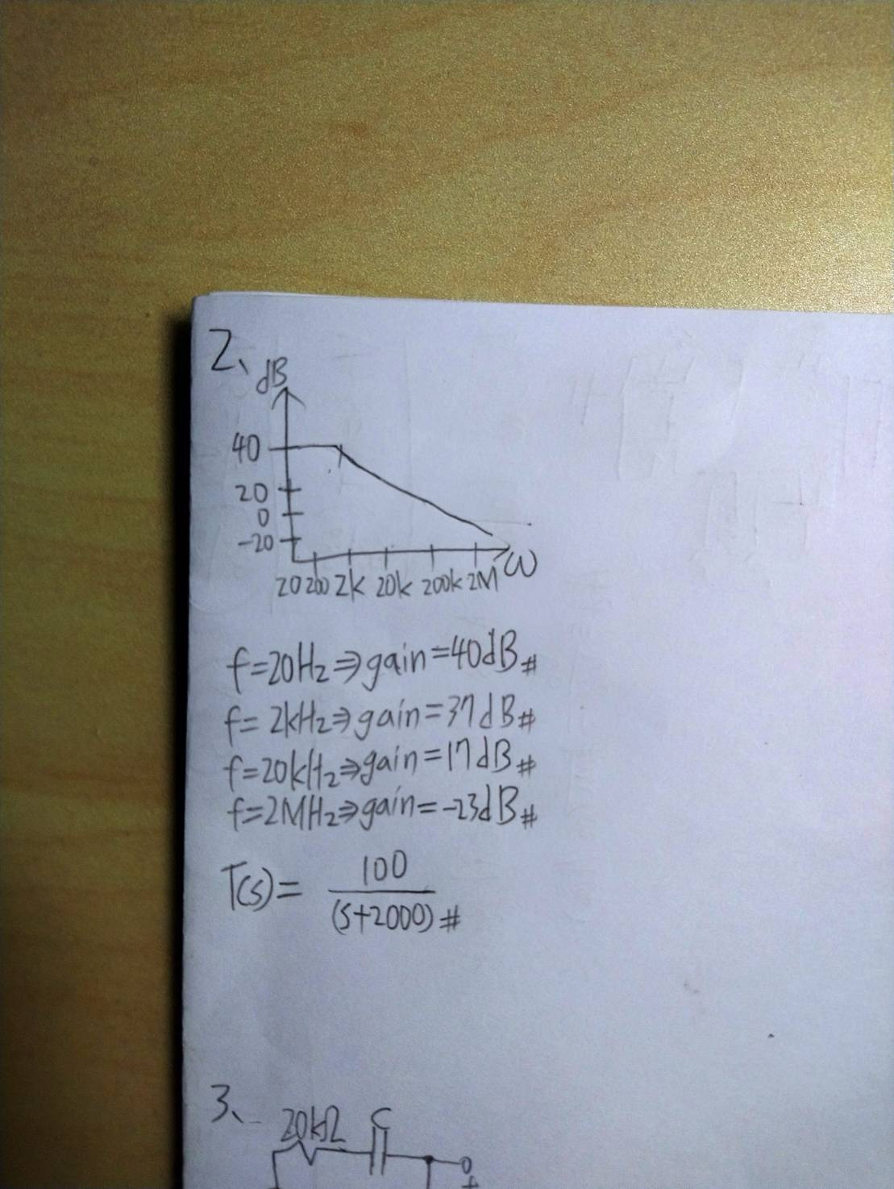

1. Consider the circuit in Fig. 1. Let *Rs* = 20 kΩ and *Ri* = 80 kΩ. Convince yourself that V2/Vs is a high-pass STC function. What is the smallest value for C that will ensure that the 3-dB frequency is not higher than 100 Hz?

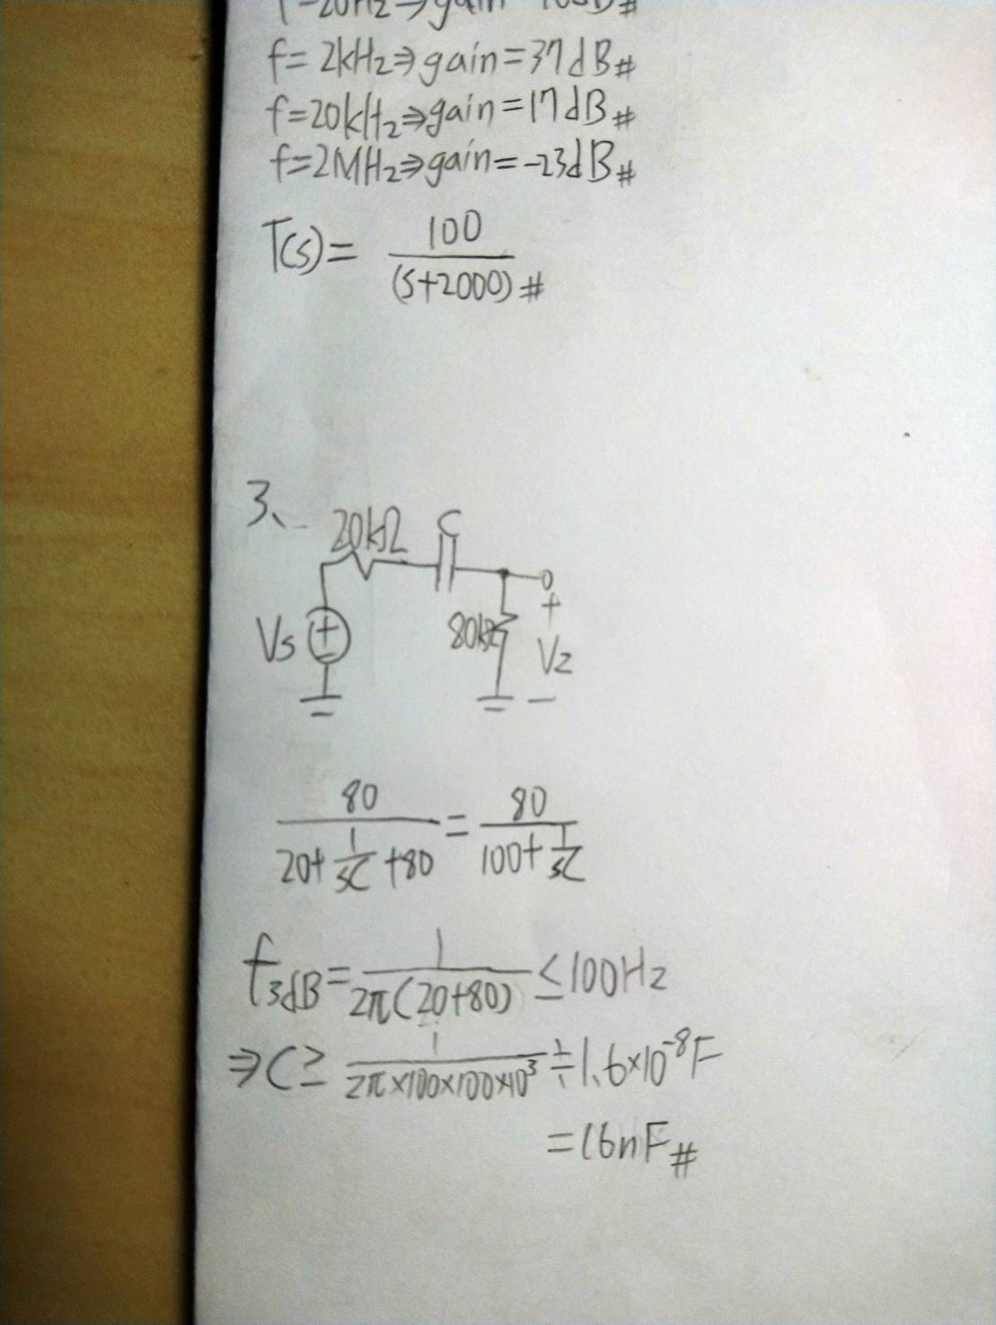

Fig. 1