Program assignment report

309833023 智慧綠能 簡廷羽

Introduction:

This project asked us to implement a floor planning algorithm to perform with macro chips. There are several ways to achieve the goal, include heuristic and non-heuristic ones. Simulate Annealing method may have better performance dealing with this mission, but it’s a little bit hard to implement. So I wrote a simple one to handle the problem.

About code:

I use several list to save the input data and their coordinate respectively.

And there are two main sections about the algorithm.

First section put blocks from left to right.

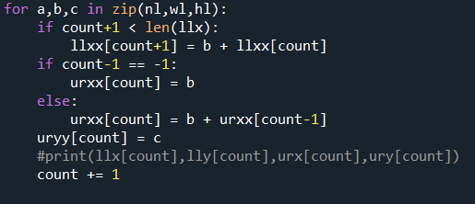

Second section consider target block, choosing whether put the next block on its right side or on top by comparing their cost.

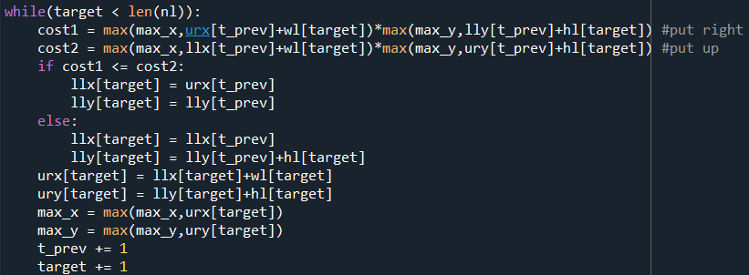

After that, I compare the area that above section calculated. The less one become the result. 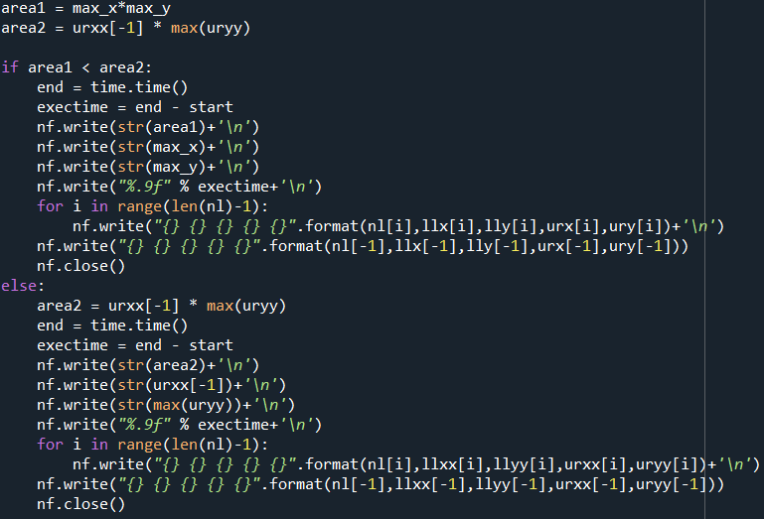

Result and Review:

Below graphs show that in some condition left-to-right method performs well, others condition right-or-top is better than former. I thought the former algorithm performs well because of less data and coordinate values difference are not quite large, max y-axis is still small result in this outcome.

right-or-top left-to-right

