Task P1: Personal Website
By charlie mason

Report:
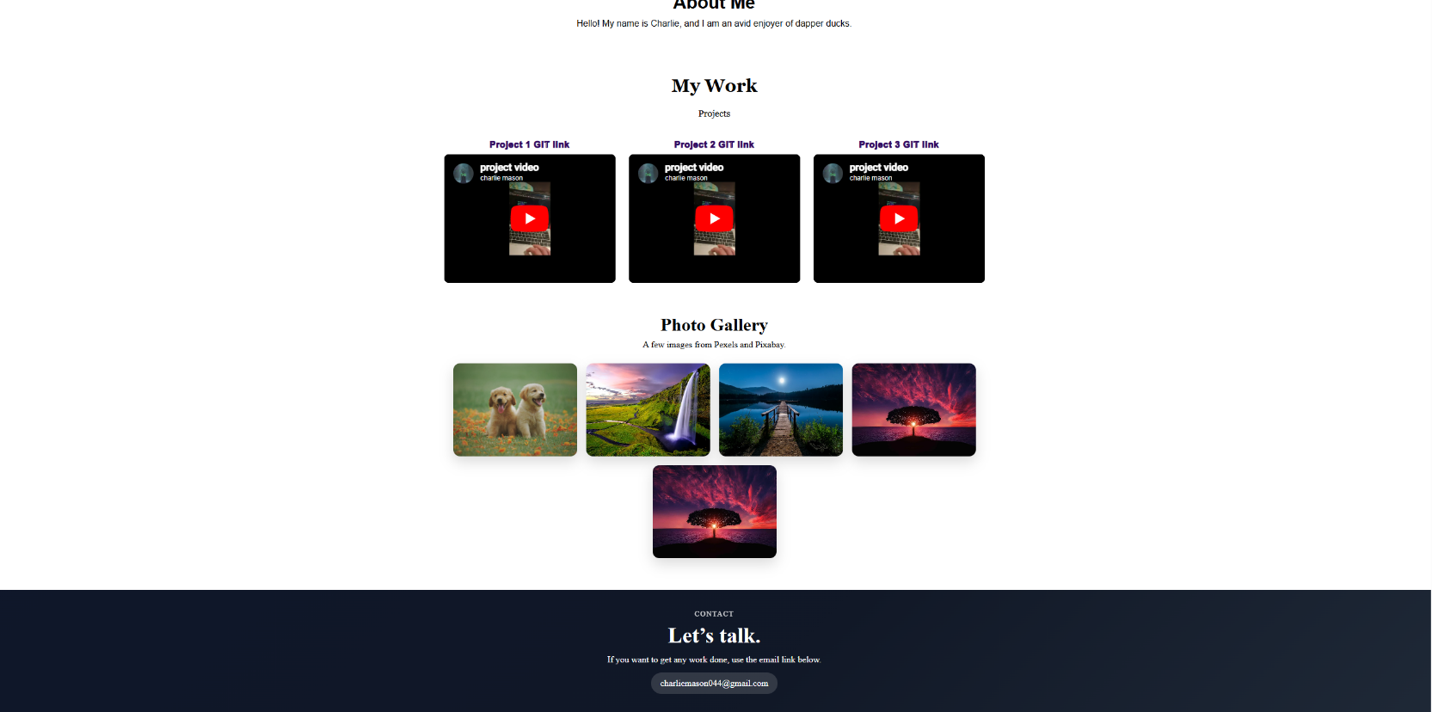
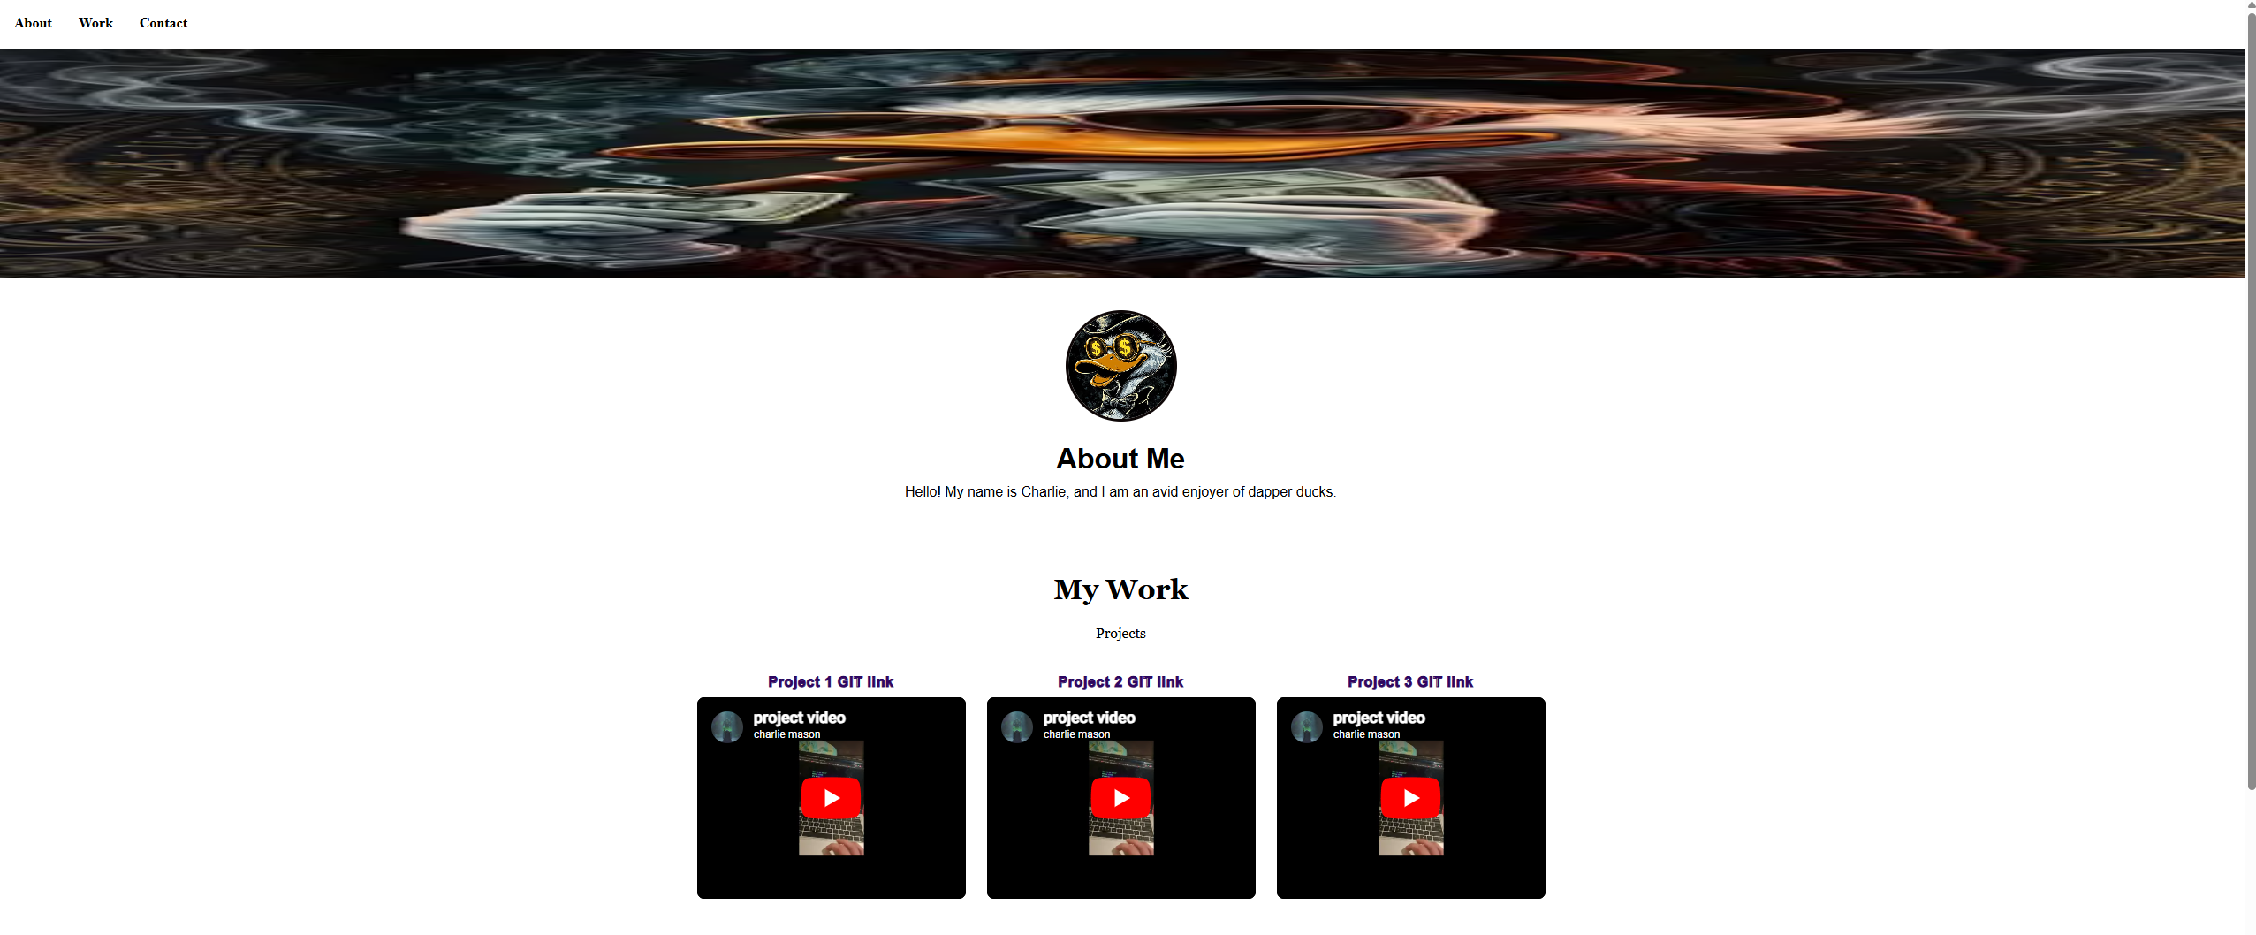
This is the personal website I made

This page contains
- navigation bar
- banner photo
  - the banner will resize itself to fit the page and can use any photo because of the max height restrictions it contains
  - the banner will display my name when it is hovered over


- about me
  - there is a short description of myself and a profile picture
- my work
  - this contains a group of projects that are currently all the same
    - these project have a link to my git repo and a YouTube preview player of the project in action
  - there is also a photo gallery containing some pictures from pexels and pixabay
    - these photo enlarge when you hover over them 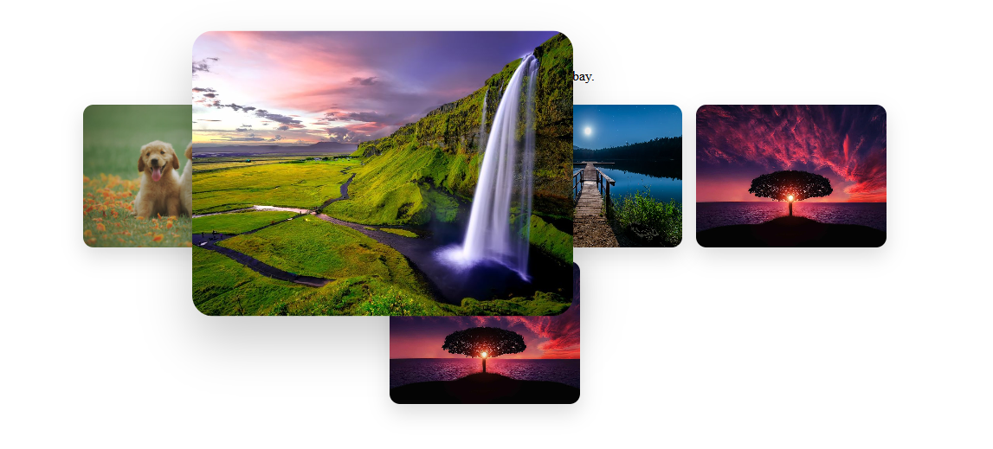
- contact
  - contain a bottom banner and my email should anyone want to contact me for some work
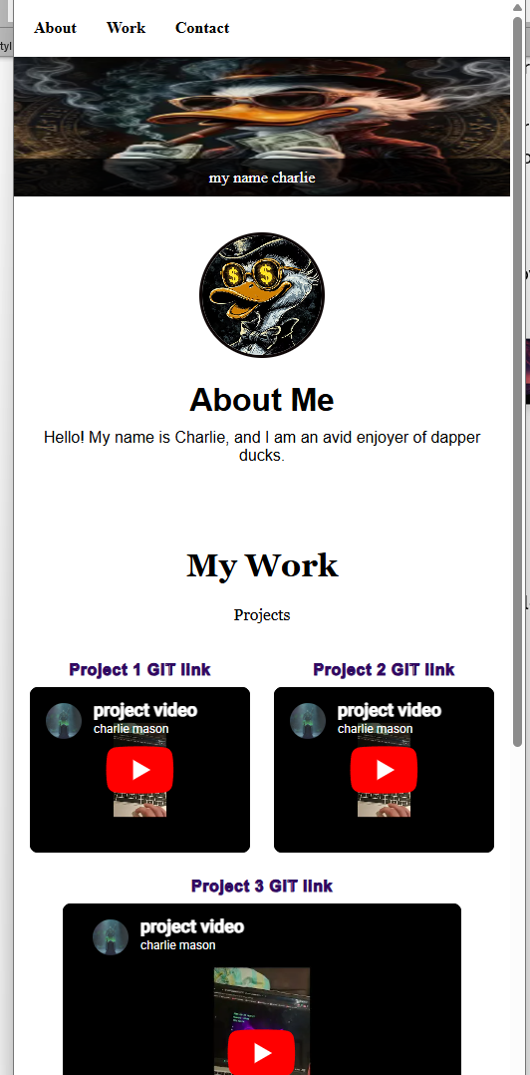
resizeing:
The pages images and text will all resize appropriately to the window shape

