Task P2: Welcome Email
By Charlie Mason (223391013)

Report:
This is the git and email backend with an ExpressJS backend set up I made for my personal website
This is what the sign up looks like in the header:
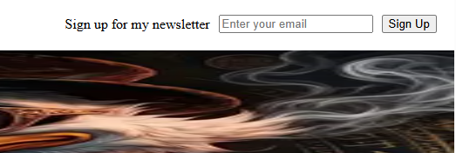
This is what a successful sign up looks like in the console:
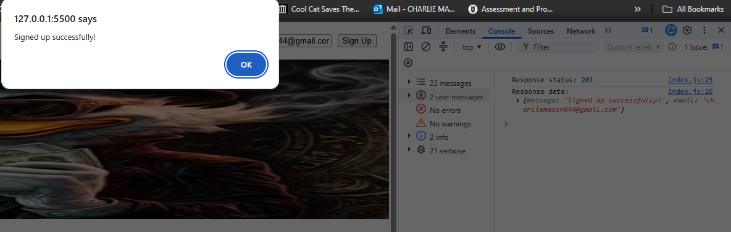
This is what a failed sign up looks like in the console (this error is caused by not having the Express server running:
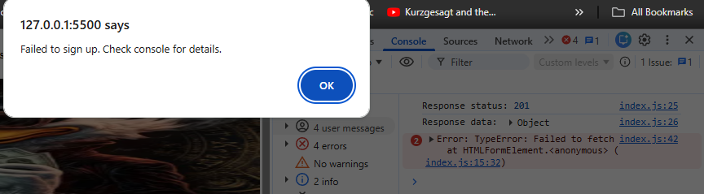

This is what an invalid email looks like:
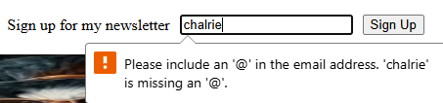

The email flex’s when the window shape is changed:
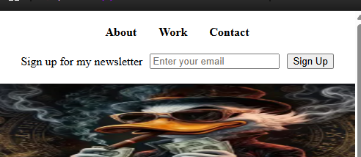
This is the email received from the node server:
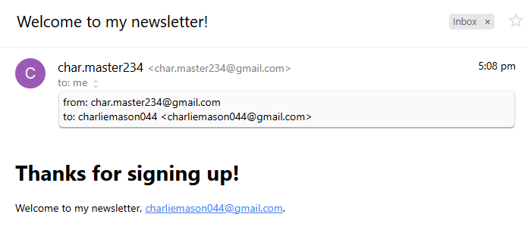
GitLab Link: https://gitlab.deakin.edu.au/s223391013/SIT_313_frontend/-/tree/main/p2?ref_type=heads
Video Link: https://deakin.au.panopto.com/Panopto/Pages/Viewer.aspx?id=5ce3951d-4b22-4c24-8287-b491002f1566

