Task C2: Deploy DEV@Deakin App

Website link: https://elegant-pie-ed987a.netlify.app/

Project configuration:
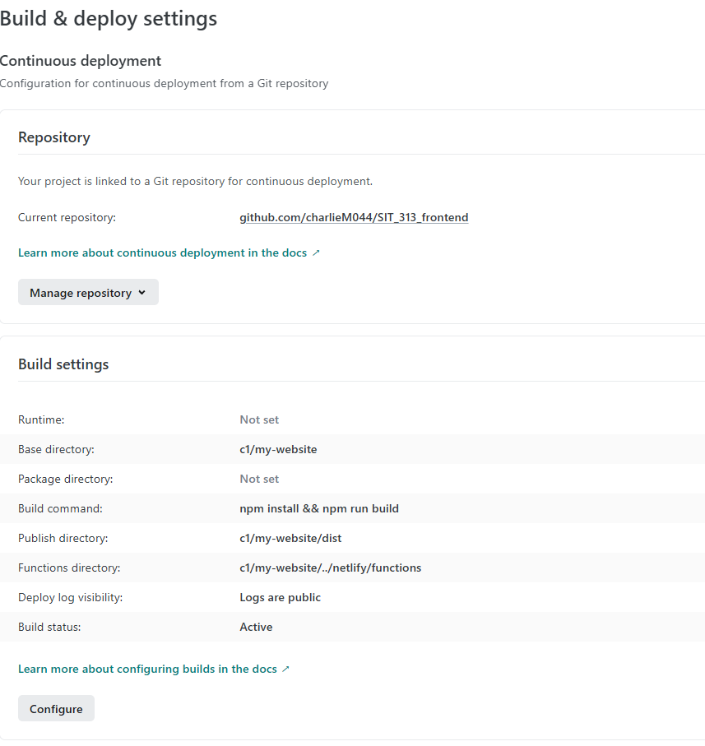
Nelify is connected to my GITHUB repo and grabs latest commit files in the c1/my-website directory

Successfully deployed:
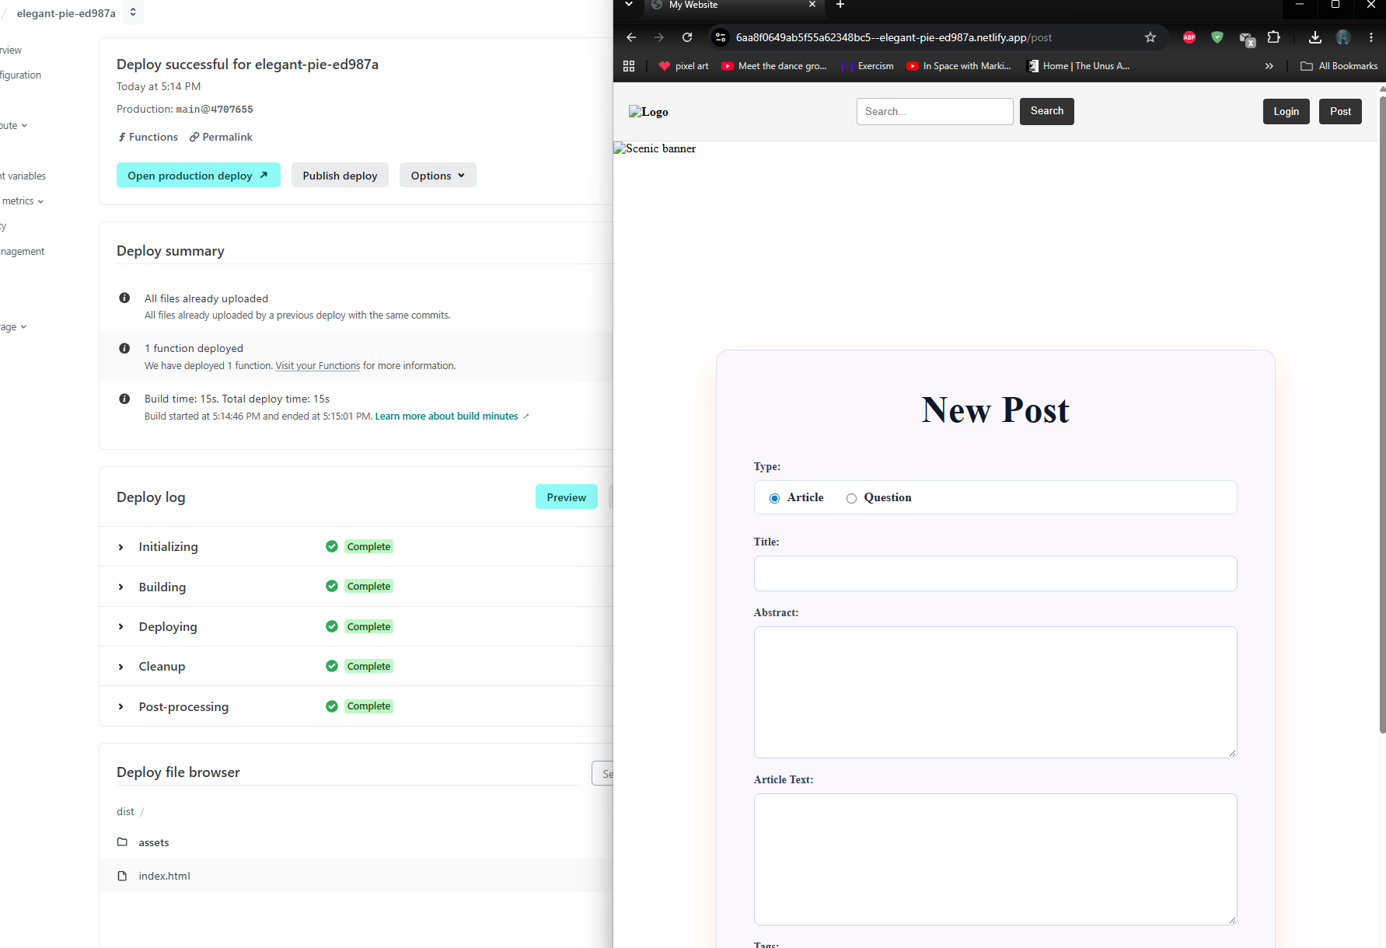
the site successfully deployed and can
.toml file:
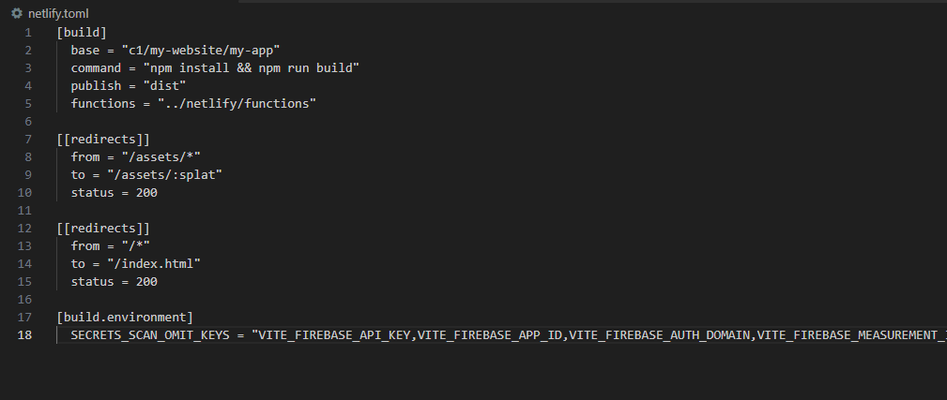
the toml file contains the instructions for Netlify so it can locate and load the correct files

Firebase:
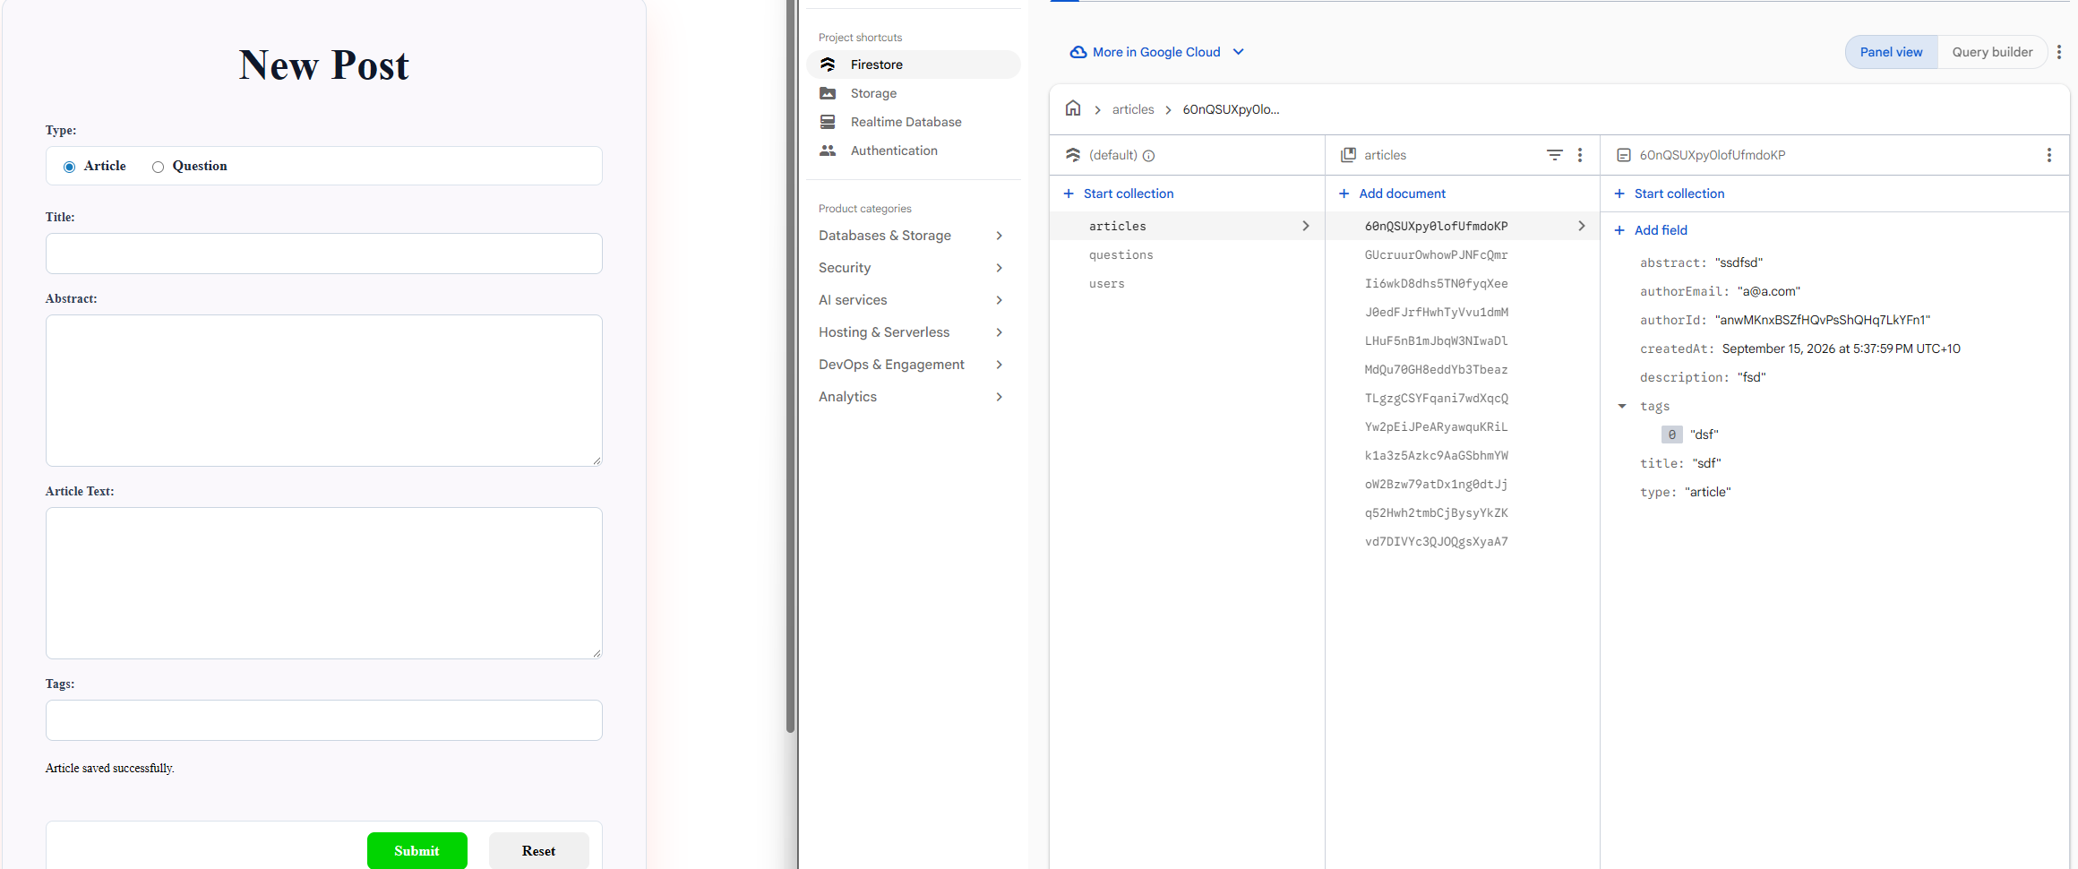
With the firebase .evn secrets added the project deployment the webpage has full access and functionality.

