Task P2: Welcome Email
By Charlie Mason (223391013)

Report:
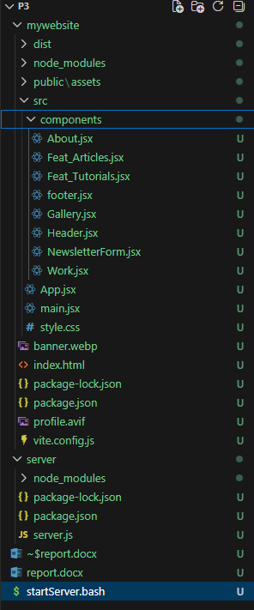
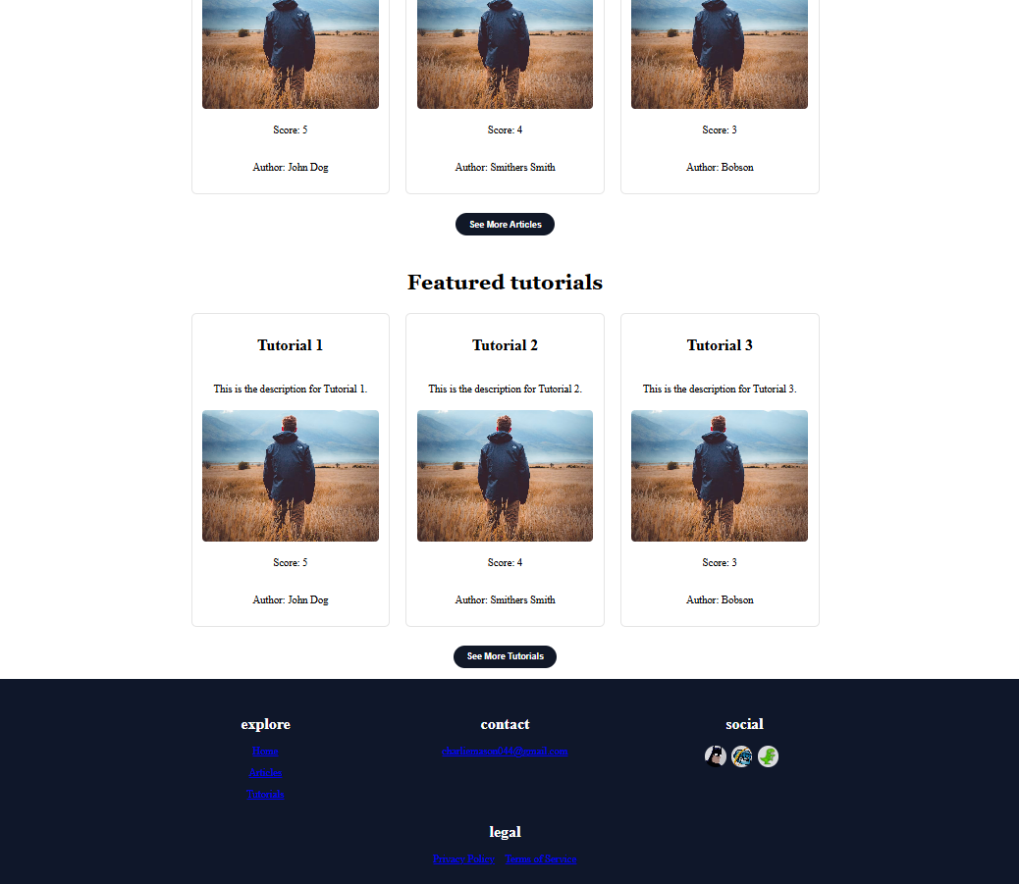
This is the react migration from single JS with new footer and added sections:

This is the new footer with contact, social icons, legal, and a nav list:
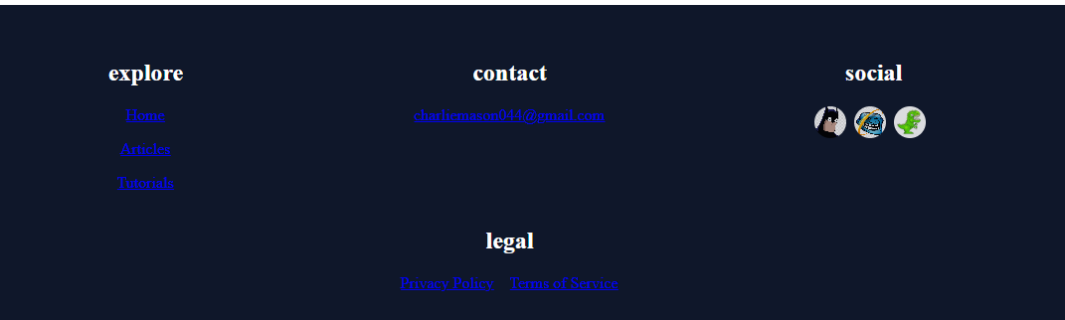

This is the expanding section:
This
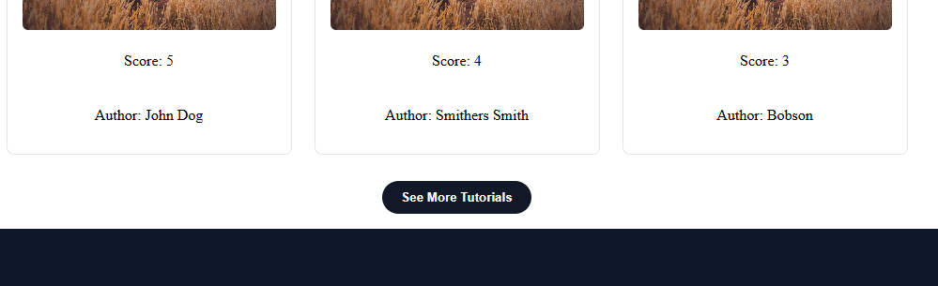
To This
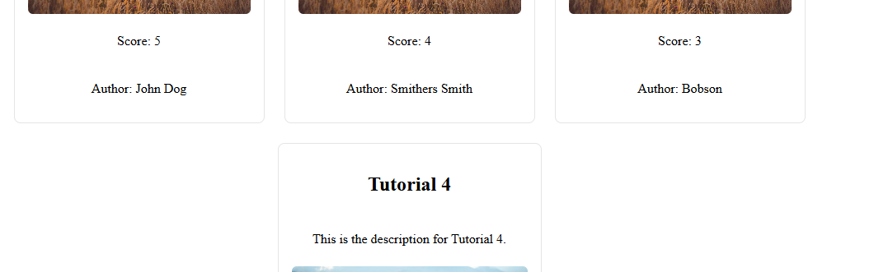
The page still forms to new Windows form:

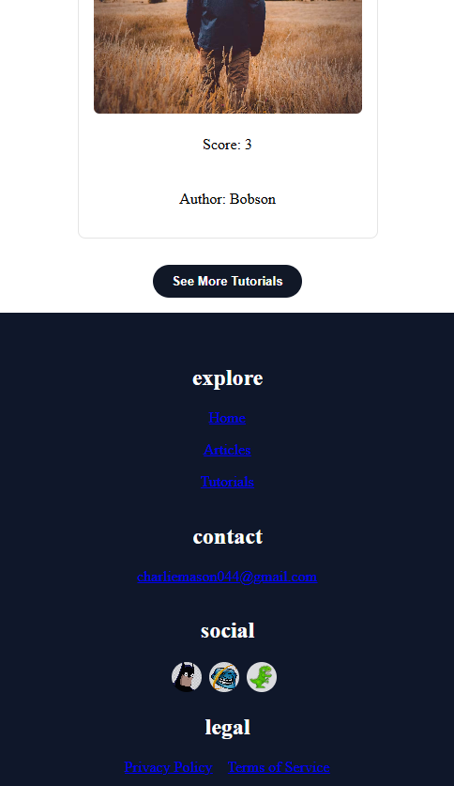

GitLab Link: https://gitlab.deakin.edu.au/s223391013/SIT_313_frontend/-/tree/main/p3?ref_type=heads
Video Link:

