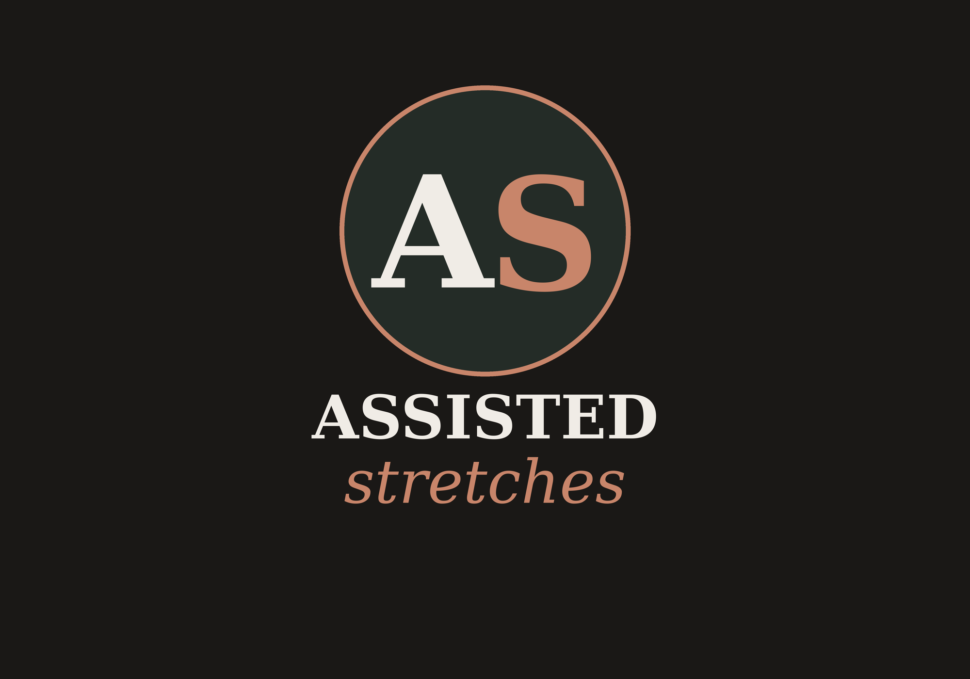
PRODUCT PAGE PACK
Assisted Stretches
Sessions, Packs & Gift Cards
Built on the 6-Layer PDP Framework
Hook · Trust · Desire · Education · Validation · Maximization

How to use this pack
This pack is the master copy reference for the Assisted Stretches website. It is structured around the 6-layer PDP framework and applies that framework to each of seven products: a single 60-minute session, a 5-pack, a 10-pack, and four gift card denominations (1, 3, 5, and 10 sessions).
The bulk of the pack is built around the flagship product — the single session — because it carries the full 6-layer treatment and most of its copy is reusable on the pack and gift-card pages. A short, focused PDP brief follows for each pack and each gift card variant, calling out only what changes from the flagship.

BRAND VOICE
Calm, confident, and unfussy. We talk about the body honestly — what stretches do, what they don’t, and how it feels. No mystic jargon. No hype. Read every line out loud; if it sounds like a wellness brochure, rewrite it.

Product range at a glance
Product | Format | Best for
Single 60-min session | One-time | First-timers, casual users
5-session pack | 5 × 60 min, valid 6 months | Building a habit, athletes in season
10-session pack | 10 × 60 min, valid 12 months | Regulars and committed clients
Gift card — 1/5/10 session | Digital or printed | Premium gifts, partner gifts

PART ONE
Flagship PDP — Single 60-Minute Session
The full six-layer treatment. Everything that follows builds on this foundation.

LAYER  1 | The Hook — Hero Section  Customer asks: “Is this what I’m looking for?”  Goal: Capture attention and communicate core value in 3 seconds.  Primary impact: Add-to-Cart Rate

The 3-second test
In the hero section the visitor must instantly answer four questions: What is this? What will it do for me? Can I trust it? What does it cost? If any answer takes more than three seconds, the hero has failed.

Hero copy
EYEBROW | ONE-ON-ONE · 60 MINUTES · BRISBANE STUDIO

H1 HEADLINE | Stretch deeper than you can on your own.

SUBHEAD | A guided 60-minute assisted stretch session that goes where solo stretching cannot — hamstrings, hips, shoulders, lower back. You lie down. We do the work.

PRICE BLOCK | $125 single session · 5-pack from $115/session · 10-pack from $100/session

PRIMARY CTA | Book a session — $125

SECONDARY CTA | See how it works

Hero image direction
- Lead image: practitioner’s hands gently guiding a client’s leg into a hamstring stretch on a low padded table. Studio lighting, neutral palette, no faces required.
- Avoid: stock yoga images, cliched stretching poses, gym equipment, or anything that looks like a massage.
- Mobile-first: ensure the headline and CTA are visible above the fold on a 375px viewport without scrolling.

Buy box checklist
- Sticky CTA on scroll (mobile and desktop)
- Format selector: Single / 5-pack / 10-pack — with 5-pack pre-highlighted as recommended
- Visible scarcity cue when relevant (e.g. “3 spots left this week”) — only when true
- Express checkout (Apple Pay / Google Pay) above the fold

LAYER  2 | Trust Signals  Customer asks: “Can I trust this brand and this practitioner?”  Goal: Build immediate credibility before visitors scroll past the fold.  Primary impact: Conversion Rate

Trust bar (placed directly under the hero)
A single horizontal row, four to five signals. Each item should be true — if you don’t have it yet, leave it out rather than fudge it.
SIGNAL 1 | Qualified practitioners

SIGNAL 2 | Over 2,400 sessions delivered

SIGNAL 3 | 4.9 / 5 across 180+ Google reviews

Editorial trust block (mid-page)
A short paragraph beside a photo of the lead practitioner. Use a real name, real qualifications, real face.

Guarantee
THE FIRST-SESSION PROMISE
Try one session. If you don’t feel a real, honest difference in how your body moves, we’ll refund it. No paperwork, no awkward conversation — just send an email within 48 hours and it’s done.

LAYER  3 | Desire Creation — Benefits  Customer asks: “What will this actually do for me?”  Goal: Show specific, measurable transformation. Lead with outcomes, not features.  Primary impact: Add-to-Cart Rate

Section headline
H2 | Designed for people who sit too much, train too hard, or sleep too little.

SUBHEAD | Whether you’re chasing a PB, recovering from desk life, or just want to bend down without grunting — here’s what 60 minutes on the table can do.

Benefit cards (3 across desktop, stacked mobile)
BENEFIT 1 — RANGE
Headline: Reach further by the end of the session. Body: Most clients report measurable improvement in hip, hamstring or shoulder range within a single session. We test before, test after, and you feel the difference walking out.

BENEFIT 2 — RECOVERY
Headline: Train harder, recover faster. Body: Assisted stretching after heavy training days helps clear lactic build-up and reduces next-day stiffness. Pair it with your weekly long run, lift, or ride.

BENEFIT 3 — RELEASE
Headline: Switch your nervous system off for a full hour. Body: Held stretches with the right pressure trigger the parasympathetic response — the same one that takes over when you finally fall asleep. Most clients leave calmer than they came in.

Quantified proof strip
Place this directly under the benefit cards. Numbers should come from your own client data once available; placeholders shown.
- +22% average increase in hamstring range after a single session (sit-and-reach test).
- 94% of clients book a second session within two weeks.
- 4.9 / 5 average rating across 180+ Google reviews.

LAYER  4 | Education — How It Works  Customer asks: “How does this actually work? Will I be comfortable?”  Goal: Remove confusion and objections through clarity. Reduce cart abandonment.  Primary impact: Conversion Rate

What happens in a 60-minute session
STEP 1 · ARRIVE (5 min) | You arrive in comfortable clothes — think gym gear, not activewear you can’t move in. We chat for a few minutes about how your body is feeling and what you want from the session.

STEP 2 · ASSESS (5 min) | A quick range-of-movement check on the major joints. This gives us a starting point and lets you actually feel the change at the end.

STEP 3 · STRETCH (45 min) | You lie on a padded table. We move your limbs through a full sequence of held and dynamic stretches — hamstrings, hips, lower back, shoulders, neck. Pressure is always within your comfort.

STEP 4 · RETEST (3 min) | The same checks as step two. You’ll feel the difference. Most clients are surprised at how much further their body will go.

STEP 5 · GO (2 min) | You leave with two or three take-home stretches matched to whatever was tightest — 30 seconds a day, no equipment.

How assisted stretching is different
 | Solo stretching | Massage | Assisted stretching
Reaches deep range | Limited | Indirect | Yes
Active joint movement | Yes | No | Yes
Recovery focus | Mild | High | High
Time per session | Variable | 60–90 min | 60 min
Take-home program | Self-directed | Rare | Included

FAQ — the questions everyone asks
Will it hurt?
No. Pressure is always within your comfort. We work to a “good stretch” feeling — if it ever tips into pain, we back off.
Do I need to be flexible?
No. The less flexible you are, the more dramatic the gain. Tightness is the reason to come, not the reason to wait.
What do I wear?
Gym shorts and a t-shirt, or anything you can move freely in. No need to undress.
How often should I come?
Most clients see best results once a week or fortnight. Athletes in heavy training blocks come twice a week.
Is it covered by health funds?
Many extras policies cover remedial elements of the session through HICAPS on-site. Ask your fund or contact us before booking.

LAYER  5 | Validation — Reviews & Social Proof  Customer asks: “What do other people actually say?”  Goal: Provide peer confirmation and address remaining objections through real voices.  Primary impact: Conversion Rate

Section headline
H2 | Don’t take our word for it.

SUBHEAD | 180+ verified Google reviews. Here’s what people say after their first session.

Featured reviews (3 cards)
REVIEW 1 · 5 STARS
“I’ve had massage every fortnight for ten years and never felt the kind of release I got in 60 minutes here. Walked out two inches taller.” — Sarah K., desk worker, runner

REVIEW 2 · 5 STARS
“My hips have been a wreck since I started lifting heavy. Three sessions in and my squat depth is back. Genuinely surprised.” — Marcus T., powerlifter

REVIEW 3 · 5 STARS
“Went in skeptical, came out a convert. The take-home stretches alone are worth the price.” — Anna L., physiotherapist

Social proof bar (full-width strip)
- Star rating: 4.9 / 5 (180+ Google reviews) — link to public listing
- Press / partner logos when available (gyms, run clubs, physio referrers)
- User-generated photos from Instagram — only with consent, only studio space, never identifiable client faces without explicit permission

Objection handlers
Place these as accordion items below the reviews. Each one closes a specific objection.
- “60 minutes is a lot of time — do I need that long?” It’s the right length to do the work properly. Shorter sessions skip body areas; longer ones lose your nervous system. 60 minutes is the sweet spot.
- “I can stretch myself for free.” Solo stretching plateaus quickly. Assisted work reaches angles and depths your own body protects against.
- “I’m too inflexible.” That’s exactly the starting line. The session adapts to where your body is today.

LAYER  6 | Maximization — Cross-sells & Bundles  Customer asks: “Should I buy this, or something else from you?”  Goal: Increase average order value and customer lifetime value at the moment of intent.  Primary impact: Average Order Value

Pricing ladder (place above the secondary CTA)
 | Single session | 5-pack | 10-pack
Price | $125 | $575 | $1,000
Per session | $125 | $115 | $100
You save | — | $50 (8%) | $250 (20%)
Validity | Use anytime | 6 months | 12 months
Includes | 1 × 60-min session | 5 × 60-min sessions | 10 × 60-min sessions + free guest pass
Best for | Trying it out | Building a habit | Athletes & regulars

Bundle suggestion (cart upsell)
AT THE BUY BOX
Add a 10-pack and pay $25 less per session. Most regular clients land on the 10-pack within 6 weeks anyway — lock the rate now and we’ll keep your credits valid for 12 months.

Cross-sell modules (below the buy box, pre-checkout)
- Gift cards — 1, 3, 5 or 10 sessions. “Best gift our clients have ever received” angle.
- Take-home recovery kit — mini foam roller and massage ball pair. Branded packaging.
- Partner offer — first month at a recommended local gym, recovery cafe, or sleep brand.

Post-purchase upsell (thank-you page)
After a single-session purchase, the thank-you page should offer the 5-pack credit upgrade for a one-click difference, e.g. “Upgrade to a 5-pack and we’ll credit your $125 toward it — only on this page, only today.”

PART TWO
Session Packs — 5-pack & 10-pack
Reuse Layers 2–5 from the flagship. Override Layers 1 and 6 with the copy below.

5-Session Pack — PDP brief
The 5-pack is the most-recommended option for new regulars. The PDP for this product reuses the flagship’s Trust, Desire, Education, and Validation layers. Override the Hook and Maximization layers with the copy below.

Layer 1 — Hook overrides
EYEBROW | FIVE SESSIONS · 6-MONTH VALIDITY · SAVE $50

H1 HEADLINE | Five sessions. The habit takes hold.

SUBHEAD | Five 60-minute assisted stretch sessions, used at your pace over six months. The format most regulars start with — long enough to feel real change, short enough to commit to today.

PRICE BLOCK | $575 total · $115 per session · Save $50 vs single sessions

PRIMARY CTA | Buy 5-pack — $575

SECONDARY CTA | Compare with 10-pack

Layer 6 — Maximization overrides

Pack-specific value framing (place under the buy box)
WHY MOST CLIENTS PICK THIS PACK
A single session shows you what’s possible. Five sessions makes the change stick. Most regulars start here, then graduate to the 10-pack once they realise they’re coming weekly anyway.

Upsell prompt (cart and thank-you page)
Show the 10-pack as a one-click upgrade with the 5-pack value already credited. Frame: “Five more sessions, $15 less per session, and twice the validity window.”

Cross-sell
- Gift card — 1 or 3 sessions: “Know someone who needs to feel what you’re feeling? Gift them a session.”
- Take-home recovery kit at 20% off when bundled.

10-Session Pack — PDP brief
The 10-pack is the loyalty product. It’s for clients who already know assisted stretching works and want the best per-session price. The PDP reuses Trust, Desire, Education, and Validation from the flagship. Override the Hook and Maximization layers with the copy below.

Layer 1 — Hook overrides
EYEBROW | TEN SESSIONS · 12-MONTH VALIDITY · SAVE $250

H1 HEADLINE | Ten sessions. The best per-session price we offer.

SUBHEAD | Ten 60-minute assisted stretch sessions, used at your pace over twelve months. For people who already know how this feels and want it as part of life.

PRICE BLOCK | $1,000 total · $100 per session · Save $250 vs single sessions

PRIMARY CTA | Buy 10-pack — $1,000

SECONDARY CTA | Compare with 5-pack

Layer 6 — Maximization overrides

Pack-specific value framing
THE LOYALTY PACK
Ten sessions at $100 each. Twelve months to use them.

Included perks (callout list)
- Credits valid for 12 months from purchase

Cross-sell
- Gift card — 5 or 10 sessions: “Give what changed your year.”
- Take-home recovery kit at 30% off when bundled.

PART THREE
Gift Cards — 1, 3, 5 & 10 Sessions
A shared parent PDP for the gift card range, with copy variants per denomination.

Gift Cards — parent PDP
All four gift cards live on a single parent product page with a denomination selector. The gifting context shifts the messaging: the buyer is not the recipient, so the page must speak to two audiences — the giver and the person they’re giving to.

Layer 1 — Hook (gift context)
EYEBROW | GIFT CARDS · DIGITAL OR PRINTED · 12-MONTH VALIDITY

H1 HEADLINE | Give the feeling of a body that finally lets go.

SUBHEAD | A gift card for one, three, five or ten 60-minute assisted stretch sessions. Delivered the moment you buy it, redeemable for twelve months, and — according to our clients — the best gift they’ve received in a long time.

PRICE BLOCK | From $125 · Up to $1,000 · Includes a personal message

PRIMARY CTA | Choose a gift card

SECONDARY CTA | See what people say

Hero image direction (gift context)
- Lead image: a printed gift card resting on textured stone or wood, with a hand-tied ribbon. Brand colours, no faces, no studio interior — this is about the object and the gesture.
- Optional secondary image: digital card preview on a phone screen for the digital delivery option.
- Avoid: glossy stock gift photography, ribbons in foreign brand colours, cliched “spa” imagery.

Layer 6 — Denomination selector
 | 1 session | 3 sessions | 5 sessions | 10 sessions
Price | $125 | $345 | $575 | $1,000
Saving vs single | — | $30 (8%) | $50 (8%) | $250 (20%)
Best gift for | A taste, an introduction | Birthdays, thank-yous | Milestones | Premium gifts, partners
Validity | 12 months | 12 months | 12 months | 12 months

Per-denomination headlines (used in the selector card)
1 SESSION · $125 | “One hour where the world stops.” — a single 60-minute session. The right gift when you’re not sure if they’ll like it. They will.

3 SESSIONS · $345 | “Enough to feel the change.” — three 60-minute sessions. The sweet spot for birthdays and meaningful thank-yous.

5 SESSIONS · $575 | “A real reset.” — five 60-minute sessions. For someone who needs more than a one-off — a parent, a partner, a hard-working friend.

10 SESSIONS · $1,000 | “A year of looking after themselves.” — ten 60-minute sessions. The premium gift, and our best per-session value.

Gift Cards — additional sections

Layer 2 — Trust (gift context)
Reuse the flagship trust signals, but lead with these gift-specific reassurances:
- Card delivered instantly to your inbox — or to theirs on a date you choose.
- Includes a personal message you write at checkout.
- Twelve months to redeem, with reminder emails before expiry.
- Refundable within 14 days if unused.

Layer 3 — Desire (gift context)

Section headline
H2 | Most gifts get used once. This one changes how someone moves.

Three gift-context benefit cards
FOR THE PERSON WHO HAS EVERYTHING
The chronic over-shoppers, the hard-to-buy-for partner, the parent who waves off birthdays. They don’t need another candle. They need an hour where someone takes care of them.

FOR THE PERSON WHO WON’T LOOK AFTER THEMSELVES
Athletes who skip recovery. Desk workers who never stop. Parents running on empty. A gift card removes the excuses — it’s booked, it’s paid for, all they have to do is turn up.

FOR THE PERSON YOU ACTUALLY LOVE
A 10-pack is a year of being looked after. A 5-pack is a real reset. Even a single session lands harder than a bunch of flowers — because they remember it for a week.

Layer 4 — How it works (giver flow)
The flagship’s “What happens in a session” copy still applies once they’re booked. But for the giver, walk through the gifting flow:
STEP 1 · CHOOSE | Pick a denomination, a delivery format (digital or printed), and a date.

STEP 2 · PERSONALISE | Add a message. Up to 280 characters — enough to be meaningful, short enough to actually write.

STEP 3 · DELIVER | Digital cards arrive instantly or on the date you choose. Printed cards ship within 2 business days.

STEP 4 · REDEEM | They book online with the code on the card. Twelve months from purchase to use it. We send them a reminder before it expires.

Layer 5 — Validation (gift context)

Gift-specific reviews (3 cards)
GIVER REVIEW 1
“My partner kept saying his back was killing him. I bought the 5-pack on a whim. He’s been three times and is a different person. Easily the best gift I’ve given him.” — Jo M., partner gift

GIVER REVIEW 2
“Mum is the world’s worst gift recipient — nothing is ever right. The 3-session card was the first thing in years she actually got excited about.” — Pete H., daughter’s gift

GIVER REVIEW 3
“Gave the 10-pack to my training partner for his 40th. He told me later it was the gift that made him take recovery seriously. He’s lifting better than ever.” — Lou S., birthday gift

Layer 6 — Cross-sell (gift context)
At checkout for a gift card, offer:
- Wrapping upgrade — brand-stamped envelope and ribbon, $9.
- Take-home recovery kit add-on — the mini foam roller and ball pair as a physical companion to the card.
- A second card at 10% off — “grab one for someone else while you’re here”.

Site structure summary
A one-page reference for the developer or designer. Each row maps to a live URL and the layers it inherits or overrides.
Page | URL | Layers (inherit / override) | Primary metric
Single session | /session | Full 1–6 (flagship) | Add-to-Cart
5-pack | /5-pack | Inherit 2–5. Override 1, 6. | AOV
10-pack | /10-pack | Inherit 2–5. Override 1, 6. | AOV + LTV
Gift cards (parent) | /gift-cards | Custom 1–6 (gift context) | AOV + new customers
Sticky CTA | all pages | Always visible | All

Final checks before launch
- Every claim on every page is true and traceable to a source.
- Hero loads in under 2 seconds on a 4G connection.
- CTA is visible on every viewport without scrolling sideways.
- Reviews link to the public Google listing — not screenshots.
- Mobile sticky CTA does not cover key content.
- Pricing matches what is charged at checkout, including any platform fees.
- Gift cards include validity, refund policy, and reminder cadence in the legal footer of the email.

