**Link to Frontend:** [**http://udagram-api-dev22222.us-east-1.elasticbeanstalk.com/**](http://udagram-api-dev22222.us-east-1.elasticbeanstalk.com/)

**Frontend App**

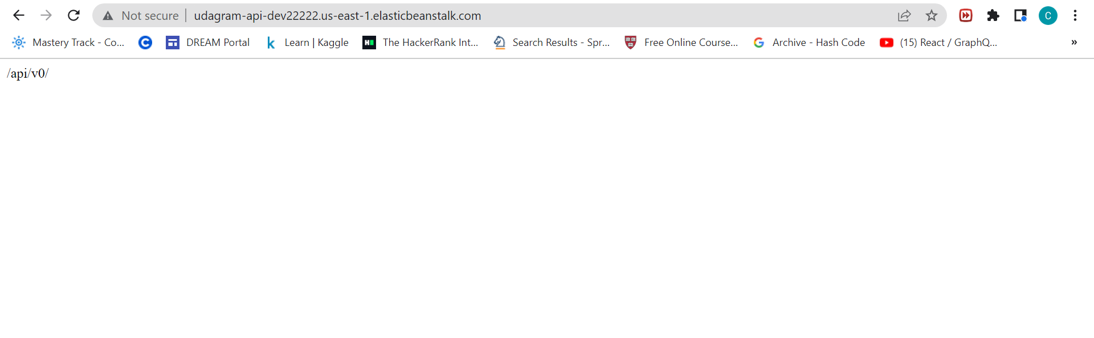

**Screenshots**

RDS Database

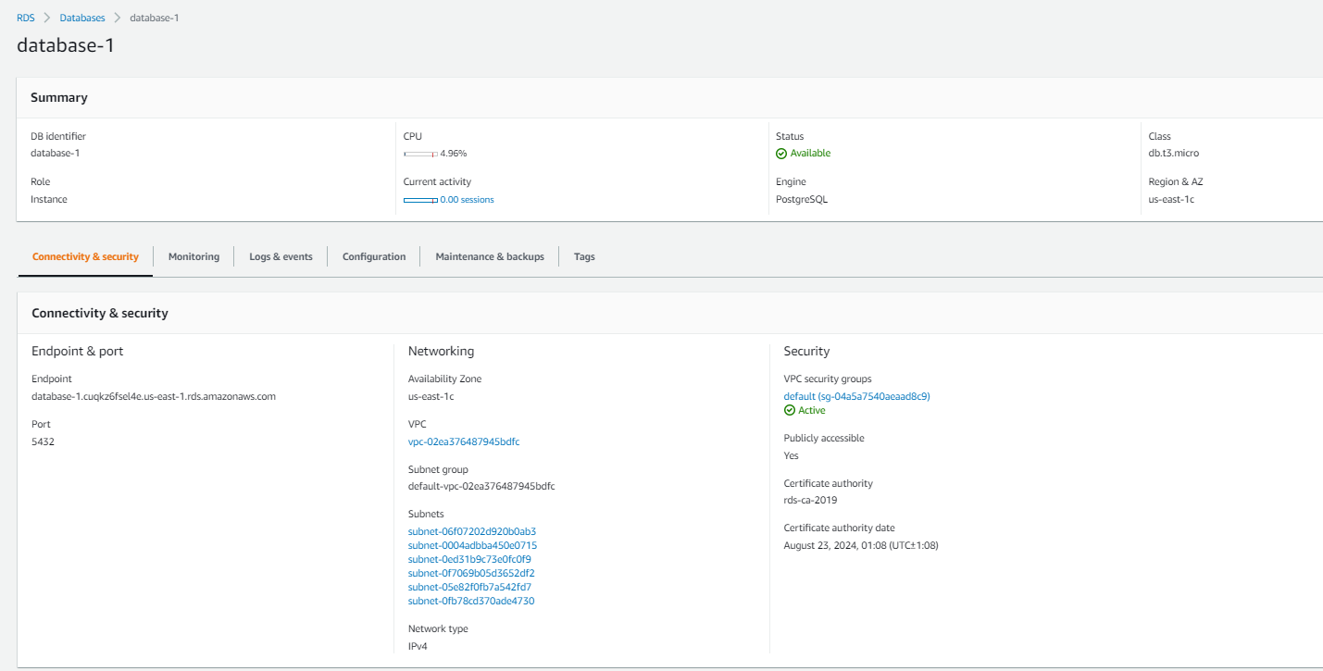

AWS S3 Bucket

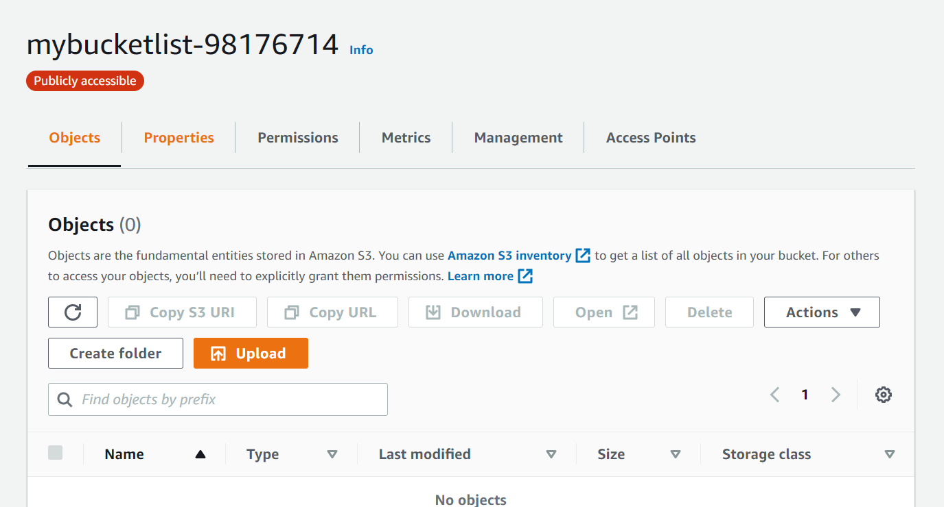

AWS S3 for Frontend Web Hosting

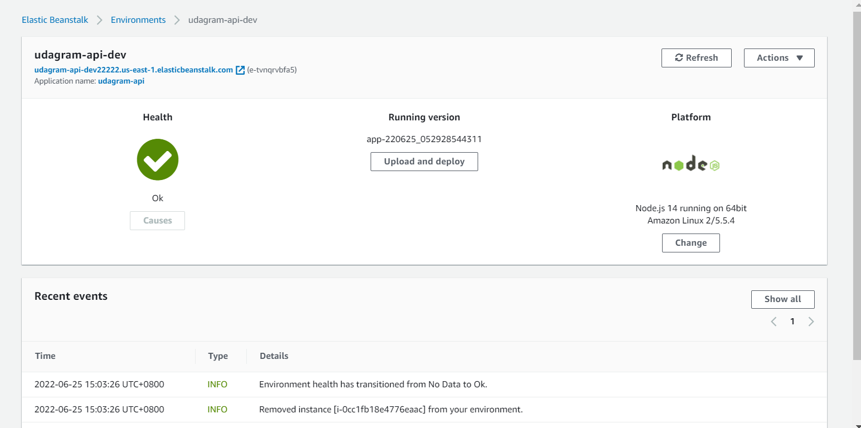

Success Pipeline

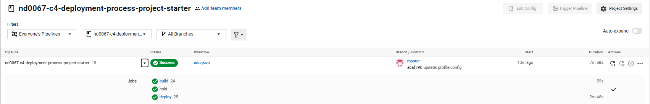

Successful build phase details

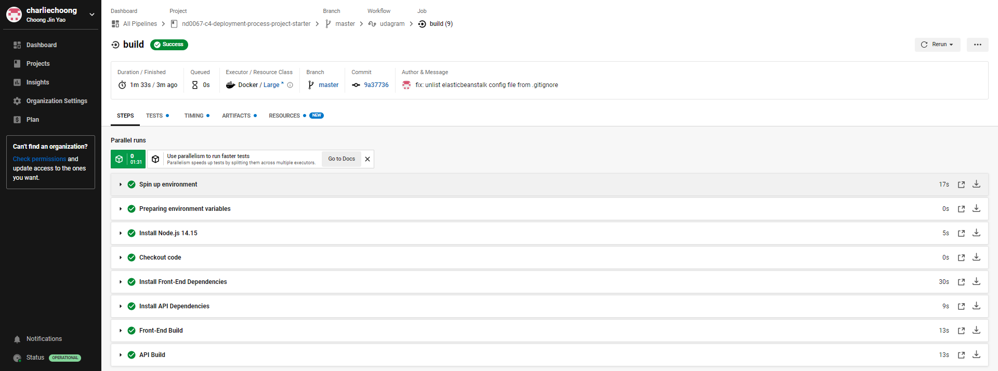

Successful deploy phase details

