Online Billing System Proposal
Prepared for South Cotabato Integrated Port Services
Prepared by [Seller legal name and contact details]
Date 24 September 2026
Proposal summary. We propose to deliver the SCIPSI Online Billing System for customer billing, controlled invoice and receipt issuance, collections, and management reporting. The project includes a one-time software use license, implementation, a reviewed legacy-history import, testing, and handover. Work under this proposal starts after approval, with beta testing targeted for November 2026 and BIR compliance readiness work targeted for December 2026.

System architecture
The proposed application uses a Vue 3 and TypeScript browser interface, a Laravel API, and a PostgreSQL database. The API owns calculations, permissions, numbering, and posting; the browser does not issue financial documents on its own. Background workers generate protected PDF artifacts and notifications after transactions commit. Reverb provides scoped live updates with API refresh as the recovery path.

Functional scope
- Identity and administration. Customer, Teller, PPA, and Administrator roles; organization and location access; user administration, allowlisted settings, and activity audit.
- Customer and teller billing. Registration and account linking, private supporting files, configurable billing requirements, teller queue, walk-in billing, and verified bill claims.
- Invoice calculation and issuance. Versioned tariff and fuel rules, server-calculated decimal totals, draft review, controlled numbering, separate service invoice layouts selected by cargo code, immutable posted invoice data, and digital PDFs.
- Collection and credit. Bill selection, manual payment proof and teller review, receipt allocation and PDF output, PPA payment-status view, and policy-governed VIP credit and repayment workflows.
- Operations and reporting. Statements, invoice and receipt transmittals, billing and collections registers, authorized exports, and centrally controlled document layouts.
- Communication. In-app notifications and scoped live updates; connect and test SkySMS for agreed transactional events using the client's provider account and designated test contacts. Production sending follows provider and privacy checks.

Technical controls and deliverables
- Financial integrity. Use PostgreSQL transactions, controlled series, retry protection, decimal amounts, immutable issued records, and linked corrections or reversals. SMS delivery never changes financial state.
- BIR review package. Use client-approved taxpayer and buyer data to produce protected invoice fields, extractable invoice data, sample PDFs, audit history, and reconcilable sales and collection exports.
- Data and access. Keep uploads and PDFs private, enforce server-side role and location policies, and stage legacy SQL Server history with source IDs, stored amounts, and exception reports.
- Deployment and recovery. Document worker and scheduler configuration, backup and restore procedures, and operating steps for the client's internal IT team.

Billing and collection flow
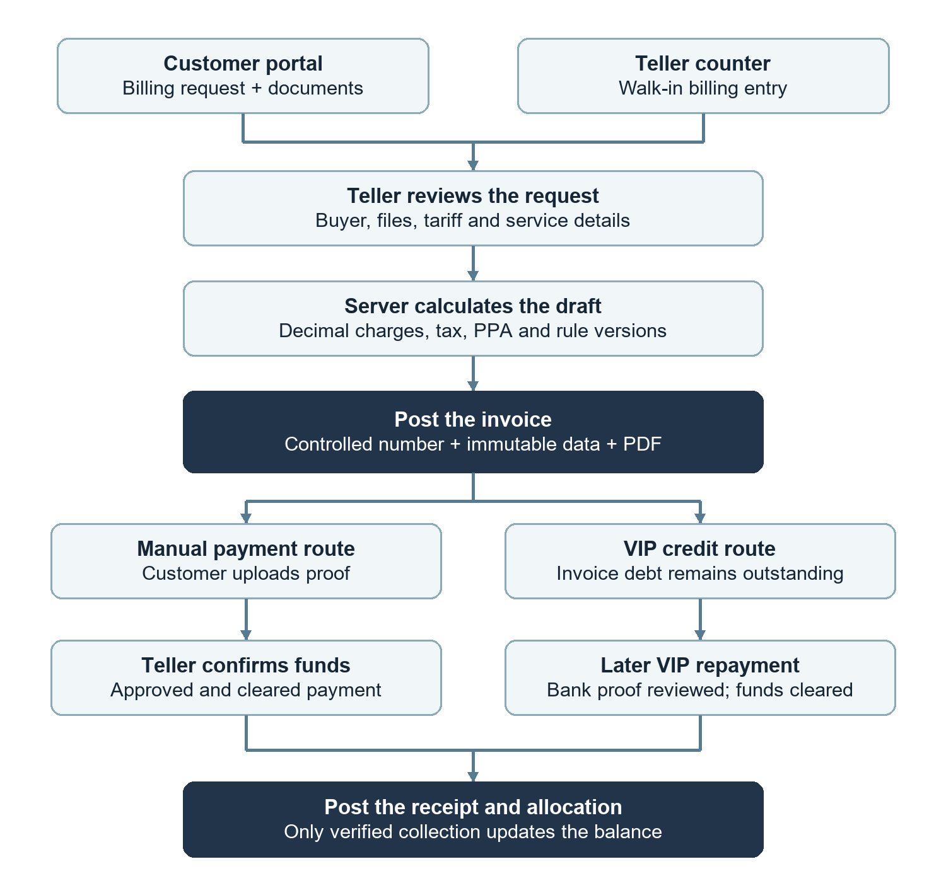
Uploaded payment proof alone does not settle an invoice. Cleared funds must be confirmed before receipt posting. A VIP credit assignment leaves the invoice debt outstanding until repayment is verified. PPA status reads posted receipt or policy-qualified VIP credit facts without changing payment records. Reports and SMS read committed records; SMS cannot post or settle an invoice.

Project timetable
After approval Start work under the approved scope once kickoff inputs are available.
November 2026 Target beta testing, issue logging, and in-scope fixes with nominated users.
December 2026 Target completion of agreed BIR readiness deliverables and accountant review, followed by handover.
The dates depend on timely fiscal inputs, samples, infrastructure access, and client decisions. Engineering readiness and beta testing do not establish external BIR approval.

Commercial proposal
The working total project fee is PHP 200,000 for the one-time software use license and agreed implementation. It reflects the urgent November beta and December BIR readiness targets, including invoice, control, and review outputs. The amount and tax treatment remain subject to final agreement. Client-paid server, domain, and SMS API expenses are outside this project fee.
Phase and payment trigger | Share | Amount (PHP)
1 Approval and kickoff - signed scope and development start | 20% | ₱40,000
2 Beta-ready build - agreed billing and administration flows demonstrated | 30% | ₱60,000
3 November beta - testing completed and in-scope bugs corrected | 30% | ₱60,000
4 December readiness and handover - agreed evidence and handover accepted | 20% | ₱40,000
Total working project fee | 100% | ₱200,000
Each installment is invoiced when its phase trigger is accepted in writing. The final installment depends on the agreed readiness and handover deliverables, not on external BIR registration or approval. The parties will confirm the license term, permitted users and locations, and whether applicable taxes are included before signing.

Acceptance and handover
Acceptance evidence will include isolated PostgreSQL calculation and posting tests, role-based browser walkthroughs, representative invoice and receipt PDFs, reviewed history-import reconciliation, a restore exercise, and SMS provider test results. The client's accounting reviewers must approve fiscal fields and treatment before live issuance. The programmer will fix bugs in agreed features found during testing and handover. November beta and December readiness are not external BIR approval.

Client inputs and operating expenses
South Cotabato Integrated Port Services will provide approved issuer and buyer details, tariff and payment rules, sample documents, access to the agreed historical data, nominated reviewers, and timely decisions on exceptions. The implementation schedule depends on these inputs and pilot feedback.
The client will pay for the server or hosting service, domain registration and renewal, and SMS API subscription and usage. After handover, the company's internal IT team will administer and maintain the server. These third-party costs are outside the one-time software license and implementation fees.

Feature changes and separate scope
A request for a new feature or an enhancement to the agreed functionality, even if raised before turnover, will be treated as a separate project with its own scope, fee, and schedule. Physical printer integration, payment gateway services, and external electronic reporting also require separate agreement. BIR registration or approval is an external process; this proposal does not represent the system as BIR-approved.

Recommended next step
Confirm the proposed modules and implementation boundaries, then complete the statement of work with the PHP 200,000 working amount, tax treatment, phase payment triggers, acceptance cases, and target dates.

