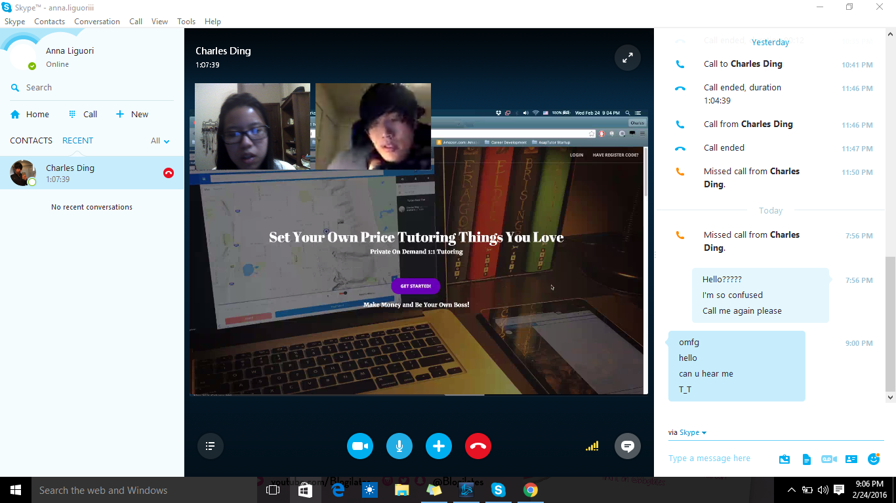

Tutor Your Peers on Campus – Set Your Own Schedule!

You have taken those classes and you aced them. You’ve figured out the way to get it done and to succeed in the class. We bet that your fellow peers wish they can learn from you! AsapTutor provides a platform just for this. You will be able to tutor other students who needs some help in doing homework and studying for exams for the class you just aced. You set your own schedule, and then any students will be able to book you for tutoring in minutes! Gain some money while helping out other students!

## How AsapTutor Works

If you want to make some money right on your campus, AsapTutor can help you. Just follow this simple, four-step process after creating an account with us and students will be coming your way!

### **1) Set up your availability schedule**

Have that 1-2 hours gap between classes? Or you’re planning to study on campus on Saturday for a project? Whenever you think you’ll have a few hours to spare to tutor, you can put that in the calendar. You can update your calendar anytime you want, too.

### **2) Meet Up with Students**

After a student book you for tutoring, you can arrange on a place to meet. You can also prepare a little bit in advance by asking the student about what they need help on via our chatting feature. Update your student with your location so they’ll be ready when you arrive.

### **3) Receive Payment Online**

After the session is finished, your student will pay you from the website using credit card or PayPal. Make sure you set up your payment account so the money can go straight to your bank.

### **4) Repeat!**

Now relax (or study!) while you wait for your next tutoring session. Help others be awesome like you!

### **Flexible Scheduling**

Our platform allows you to set your own schedule and change it anytime.

### **Chat With Your Student**

You can chat and send documents to each other before your session, all through our platform, so you can better prepare for the session!

### **Send Notifications**

Alert your student via our platform when you’re on your way accept a tutoring appointment, or cancel due to an emergency.

### **Made by Students like You**

We’ve been in your shoes and we know about all the struggles students face. We also know that there are some of us who successfully went through the hard times and now can help other succeed. We want to help you help others face their struggles. We've designed this platform to be as hassle-free as possible for you to do just that.