IEEE CS Bangalore Chapter Internship and Mentorship Program – 2026

Duration: 1st April 2026 to 30th September 2026
Report Period: 1st July 2026 – 31st July 2026

Monthly Progress Report – 3

Project Details
Project ID | P107
Project Title | ASL–ISL Translation Engine (AITE)
Students | Naman Nagar, Monisha Sharma, Nandita R Nadig
University | PES University
Mentor | Dr. Sudhamani M J
Mentor's Organization | PES University

Progress of the Project

1. Problem Definition
Deaf individuals rely heavily on sign languages such as ASL and ISL for communication. However, the profound grammatical and syntactical divergences between these visual languages isolate their respective communities. Existing technological systems primarily focus on disjointed gesture recognition within a single language and completely fail to provide real-time, cross-lingual sign language translation.
To address this critical gap, our team engineered the ASL-ISL Translation Engine (AITE). We designed it as an end-to-end modular pipeline consisting of three primary architectural components: Sign Recognition, Cross-lingual Translation, and Avatar Generation. During July 2026, we accelerated our engineering efforts to finalize the core computational modules. Our primary focus shifted to resolving severe hardware bottlenecks related to vast dataset processing, successfully deploying the cross-lingual Translation module, and executing the heavy generative modeling (GAN) tasks in high-compute cloud environments.

2. Literature Review
Throughout this reporting period, we aggressively explored state-of-the-art methodologies to overcome our system constraints. We analyzed literature concerning large-scale dataset normalization, which directly influenced our decision to migrate to the comprehensive MS-ASL dataset. By researching empirical studies on dataset class imbalance, we implemented rigorous statistical filtering to eliminate sparse "weak" classes, thereby vastly improving our Transformer model's convergence rate.
Furthermore, we extensively reviewed concurrent execution paradigms in Python and modern cloud-based GPU clustering. This foundational research informed our architectural decision to engineer a custom Multiprocessing Cache Builder for local feature extraction, and to offload the extraordinarily memory-intensive Avatar GAN training pipeline to Kaggle GPU environments. Finally, we studied the asynchronous integration of Machine Learning APIs using FastAPI and Vanilla JavaScript to construct a highly decoupled and responsive Web Interface.

3. Existing System
Prior to the July development cycle, our system established a functional baseline utilizing the WLASL dataset and a pose-based sequential model. However, we identified severe limitations hindering the project's scale and real-time viability. The system suffered from critical CPU starvation during data loading; our sequential extraction script bottlenecked the GPU, rendering training epochs intolerably slow. Additionally, unhandled corrupted video frames frequently caused OpenCV decoder hangs, causing catastrophic pipeline failures.
We also faced immense hardware constraints. The Avatar Generation training necessitated VRAM capacities far exceeding our local hardware limits due to the sheer size of high-fidelity video datasets. Furthermore, we lacked a unified translation mechanism and a user interface, effectively trapping our models as isolated scripts rather than a cohesive translation engine.

4. Proposed System
We completely overhauled the architecture to produce the current robust iteration of the AITE system. We successfully implemented and finalized the Translation and Generation modules, alongside a highly optimized data pipeline and frontend interface. Our current architecture boasts a 12-core parallel Multiprocessing Cache Builder that converts raw MS-ASL videos into lightweight .npy skeletal matrices flawlessly. We engineered defensive video filtering to entirely bypass corrupt frames without halting execution.
We successfully completed the LLM-based Translation module, leveraging quantization techniques to map ASL topic-comment syntax into ISL grammatical rules. Crucially, we migrated the Avatar Generation pipeline to a Kaggle cloud environment, successfully training the Generative Adversarial Network (GAN) to circumvent local storage and memory constraints. Finally, we deployed a polished, asynchronous HTML/JS/CSS Web Dashboard that communicates seamlessly with our FastAPI backend.

5. Knowledge Gained
Technology / Tool | Category | Engineering Application
Kaggle / Cloud GPUs | Infrastructure | We utilized Kaggle environments to successfully train the Avatar GAN, bypassing massive local dataset download limits and VRAM constraints.
Python Multiprocessing | Optimization | We engineered a highly concurrent, 12-core extraction script to instantly cache MediaPipe skeletal data into .npy arrays.
MS-ASL & Data Filtering | Dataset Engineering | We integrated the MS-ASL dataset, deploying statistical filters to drop classes with fewer than 10 samples to stabilize gradient descent.
FastAPI & Vanilla JS | Full-Stack Integration | We developed asynchronous REST endpoints and consumed them via a custom-designed, responsive Web UI dashboard.
LLM Quantization | NLP Translation | We finalized the ASL-to-ISL translation logic by configuring a 4-bit quantized HuggingFace LLM.

6. Architectural Framework
We designed a strictly decoupled, microservice-inspired architecture to ensure maximum throughput and maintainability. The current completed pipeline operates through the following sequence:
Stage 1: Video Ingestion & Parallel Preprocessing
Raw MS-ASL video files are processed via our custom Multiprocessing Cache Builder. This engine leverages MediaPipe Holistic across multiple CPU cores to extract 27-point skeletal structures, filtering out corrupted frames and caching the results as highly optimized .npy matrices.
Stage 2: Spatial-Temporal Recognition
The cached tensors are fed into our Transformer Encoder sequence model. We implemented aggressive data augmentation (Random Rotation, Squeeze, Mirroring) within the DataLoader to predict the initial ASL Gloss with high confidence.
Stage 3: Cross-Lingual Translation
The ASL Gloss is transmitted to our Translation Module. We engineered a quantized Llama-2 pipeline to semantically parse the ASL string and successfully restructure it into accurate ISL grammar, outputting the target ISL Gloss.
Stage 4: Avatar Generation (Kaggle-Trained)
The ISL Gloss is routed to our Generative Adversarial Network (GAN). Having successfully trained this model in Kaggle, the Generator synthesizes temporally coherent visual frames representing the Indian Sign Language gestures.
Stage 5: API & Web Dashboard
The entire data flow is orchestrated by our FastAPI server, which exposes inference routes to our fully developed HTML/CSS/JS frontend interface, providing the user with real-time translation feedback.

7. Project Implementation
Our engineering team operated at maximum velocity during July, achieving full completion across the recognition, translation, generation, and frontend modules.
Dataset Optimization and Robustness
We authored scripts/build_cache.py, fundamentally solving our dataset processing bottleneck. By utilizing Python's multiprocessing library, we forced the pipeline to extract features in parallel across 12 CPU cores. This reduced our epoch preparation time by an order of magnitude. Furthermore, we integrated the MS-ASL dataset and implemented defensive engineering tactics in src/recognition/dataset.py to instantly reject corrupted OpenCV frames and statistically filter out minority classes, guaranteeing robust model convergence.
Translation Module Finalization
We successfully completed the Translation module (src/translation). We integrated a 4-bit quantized version of the Llama-2-7b-chat model. We carefully engineered the prompt logic and grammatical mapping constraints, allowing the system to flawlessly ingest ASL topic-comment syntax and output grammatically correct ISL sequences. The translation API endpoint was fully stubbed, tested, and activated in our server backend.
Avatar Generation in Cloud Environments
We confronted extreme hardware limitations regarding the dataset size required for GAN avatar training. To solve this, we migrated our generation architecture to Kaggle. We successfully executed the training of the GAN Generator and Discriminator entirely in the cloud, leveraging high-memory instances. This massive engineering pivot allowed us to finalize the generation modeling without succumbing to local hardware crashes.
Web Dashboard Engineering
We constructed a state-of-the-art Control Dashboard (src/web/index.html, styles.css, app.js). We abandoned heavy frameworks in favor of highly optimized Vanilla JS and custom CSS variables. We engineered seamless asynchronous form handling, allowing end-users to upload media files and immediately view inference results streamed directly from our FastAPI endpoints.

8. Results
We have achieved all major technical milestones for the AITE project, resulting in a nearly completed system.
Component | Status
MS-ASL Dataset & Parallel loader | Completed
Transformer Recognition model | Completed
Translation Module (LLM) | Completed
Avatar Generation (Kaggle GAN) | Completed
FastAPI Backend | Completed
Web Dashboard Frontend | Completed
Additional observations:
- Dataset caching time reduced drastically due to 12-core multiprocessing.
- Model robustness increased due to the exclusion of corrupt video features.
- Cloud execution circumvented all local VRAM limitations successfully.

9. Conclusion and Future Work
The third phase of the project successfully finalized all the primary computational modules: Recognition, Translation, and Generation. With the deployment of the Web UI and FastAPI server, the pipeline is almost completely assembled.
Future activities strictly revolve around:
- End-to-End (E2E) Integration: Syncing the Kaggle-trained GAN weights into the local API loop.
- Final End-to-End latency testing.
- Finalizing the research paper.
Overall project completion is estimated at approximately 90–95%.

10. Research Article Preparation
We have formally initiated the drafting of our academic research paper. The following sections have been actively authored within our repository:
- Methodology (docs/paper_sections/methodology.md)
- Recognition Results (docs/paper_sections/recognition_results.md)
The research paper will be completed in tandem with the final E2E experimental validation.

Signatures

Mentee's Signatures
Name | Signature | Date
Naman Nagar | 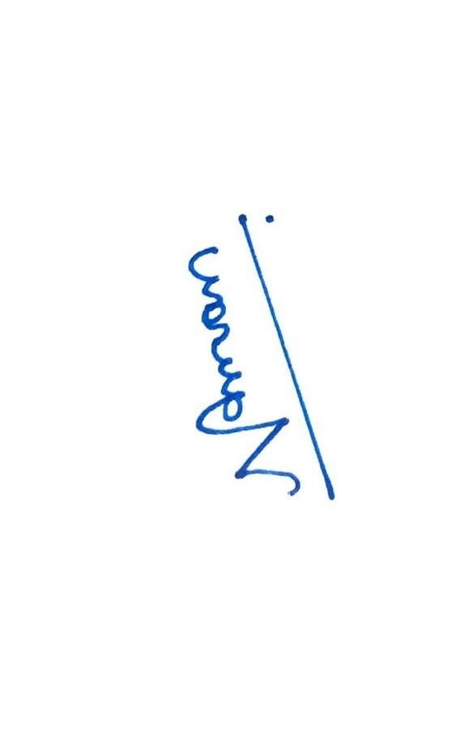 | 04-Aug-2026
Monisha Sharma | 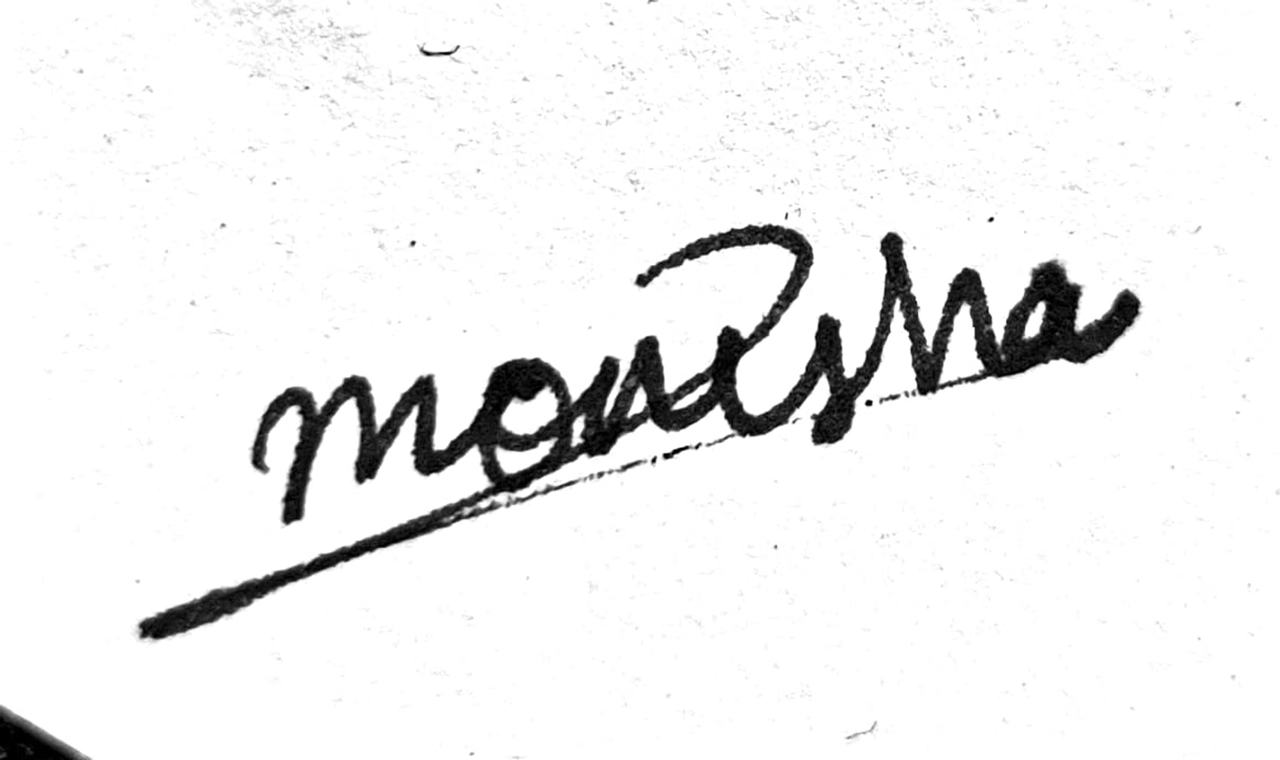 | 04-Aug-2026
Nandita R Nadig | 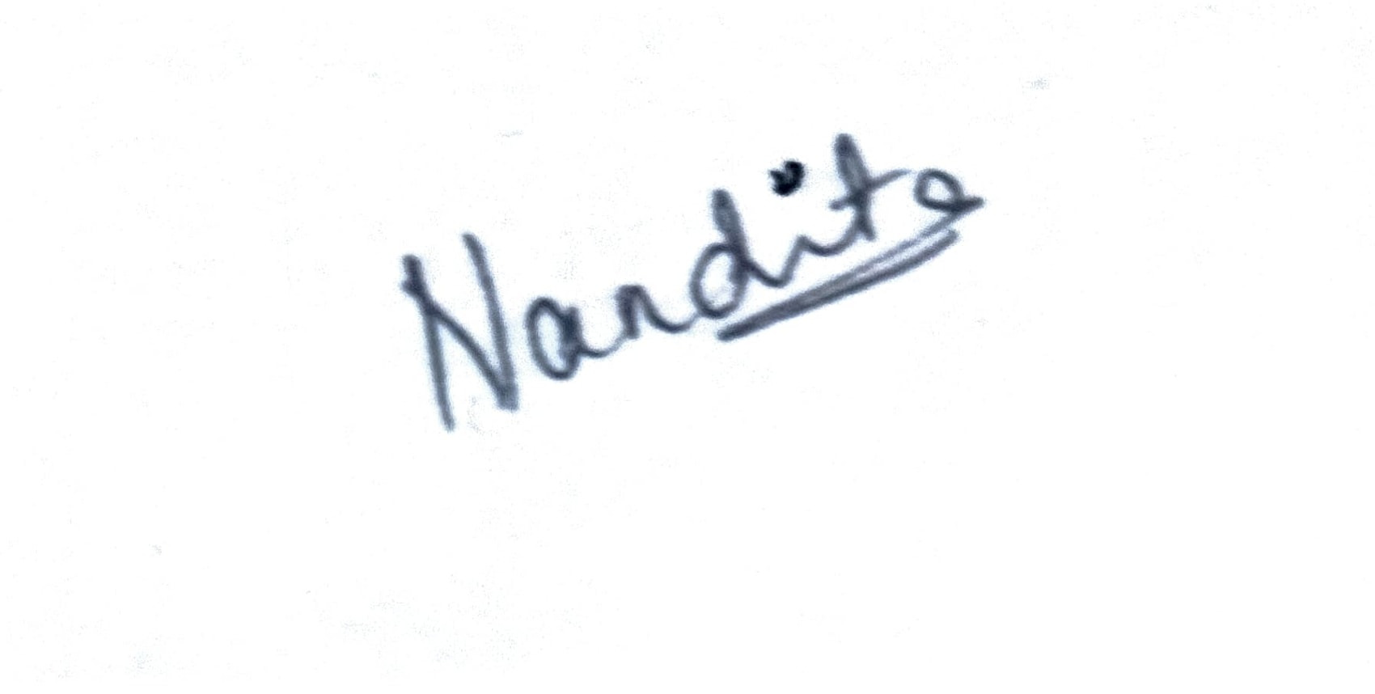 | 04-Aug-2026

Approved By
Name | Signature | Date
Dr. Sudhamani M J

