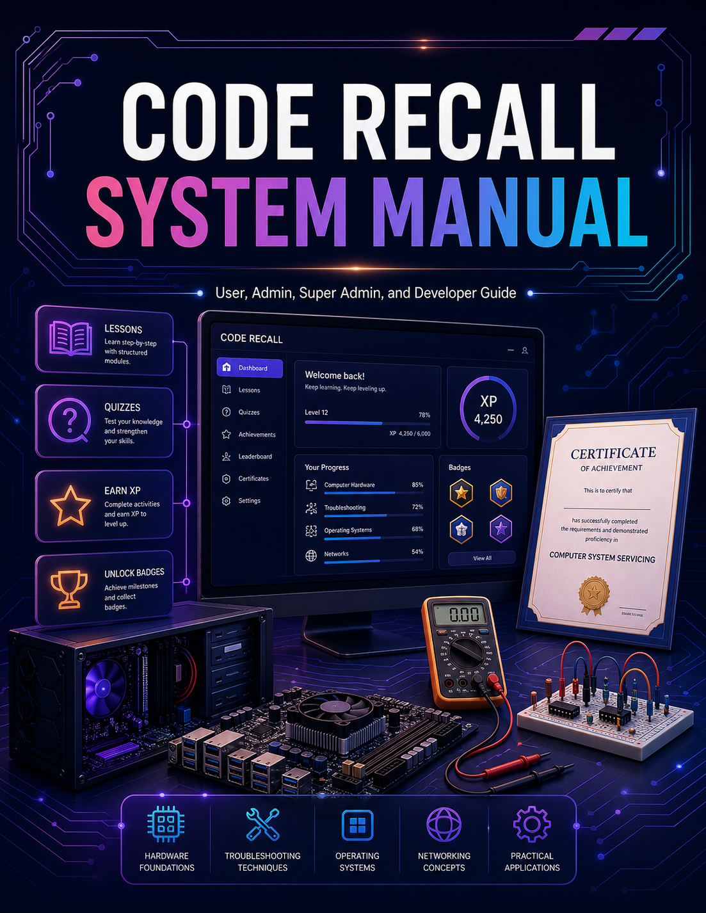

OPENING STATEMENT
The researchers present this manual as a complete guide for the use, management, and future development of the Code Recall system. This document was prepared to help users, administrators, super administrators, and developers understand the purpose, functions, structure, and proper operation of the system.

Code Recall was developed as a gamified learning platform designed to support learners in studying Computer System Servicing-related topics through interactive lessons, assessments, progress tracking, achievements, and review tools. The system aims to provide a more engaging and organized learning experience by combining educational content with game-based elements such as XP, badges, certificates, and leaderboards.

This manual serves as both an operational guide and a technical reference. It explains how learners can access the system, use the Play as Guest feature, complete subject activities, answer assessments, review progress, and unlock certificates. It also explains how administrators and super administrators can monitor learner activity, manage system-related responsibilities, and support the proper use of the platform. For future developers, this manual provides an overview of the system structure, including the HTML, CSS, JavaScript, data files, assets, Firebase configuration, and contribution guidelines.

The researchers prepared this manual to ensure that the system can be used properly, maintained effectively, and improved continuously. It is intended to support system implementation, user training, administrator orientation, developer handover, and future enhancement of the Code Recall platform.

Through this manual, the researchers hope that users will be guided clearly in using the system, administrators will be assisted in managing learner progress, and future developers will be able to understand and continue improving the project.

MESSAGE FROM THE RESEARCHERS
The researchers would like to present this manual as a guide for understanding and using the Code Recall system. This manual was created to support learners, administrators, super administrators, and future developers who will use, manage, maintain, or improve the system.

Code Recall was developed with the goal of making learning more engaging, organized, and interactive. The system focuses on Computer System Servicing-related topics and uses gamified features such as XP, achievements, certificates, progress tracking, and leaderboards to encourage learners to participate actively in the learning process.

This manual explains the different parts of the system, including the learner dashboard, Play as Guest feature, subject learning path, pre-tests, modules, quizzes, post-tests, review tools, certificates, admin tools, super admin tools, and developer structure. It also provides guidance on how the system files are organized and how future developers may contribute to its improvement.

The researchers believe that a system is more useful when its users understand how to operate it properly and when future maintainers understand how it was built. For this reason, this manual was prepared not only as a user guide, but also as a reference for system management and future development.

It is the hope of the researchers that this manual will help users navigate the Code Recall system with confidence, assist administrators in monitoring learner progress effectively, and guide future developers in maintaining and enhancing the platform for continued use.

