DHCP- Lecture ( February 5, 2013)

Discovery

Source IP 0.0.0.0 (Tells the DHCP server that this guy has no IP address

DHCP packet is broadcasted (Destination is 255.255.255)

DHCP frame is broadcast FF:FF:FF

ARP frame is broadcast

But packet is unicast

Offer

Everyone drops broadcast call except for DHCP server

DHCP offers address with X amount of time

Source IP is DHCP IP

Destination IP address is till 255.255.255.255

Destination MAC Broadcast frame as well sometimes even when we could make it uni-cast because we know the MAC address of the receiver.

Offered IP address is in message

Request

Source IP is 0.0.0.0 (We are still requesting address so source is still 0.0.0.0

Destination IP is known so we can uni-cast it or we can broadcast

AC-Phase

Destination IP is broadcast because IP is not assigned

MAC address is usually uni-casted because we know

Source IP is known

When there is only one DHCP then frame is uni-casted but packet is always broadcasted

Ethan Chan

2:00pm-3:30pm

EE450

**LAB 2: Wireshark**

**Part I**

To release and renew a host IP address for a Mac computer one must first access click the Apple located at the top left hand corner of the desktop and select “System Preferences…"

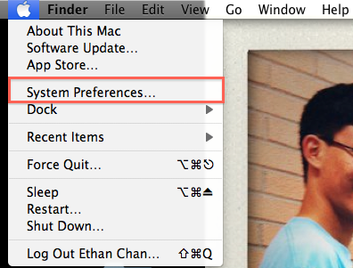

In the System Preferences Window select the “Network” icon

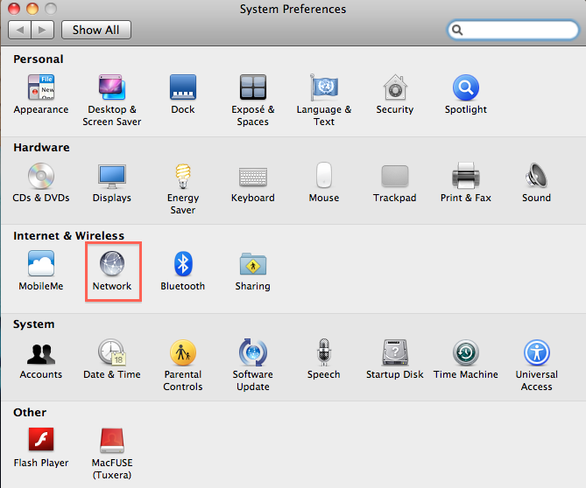

The equivalent to “ipconfig /release” in Windows on the Mac is going to

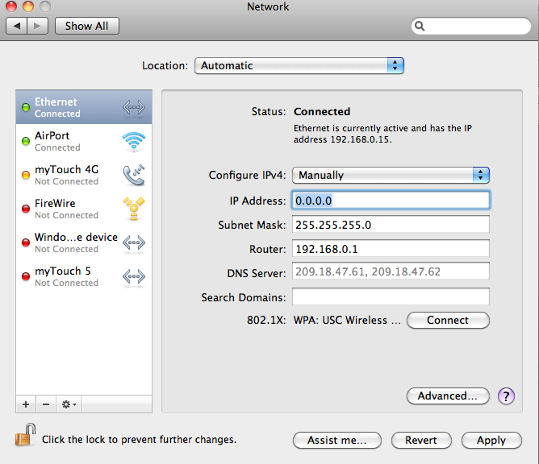

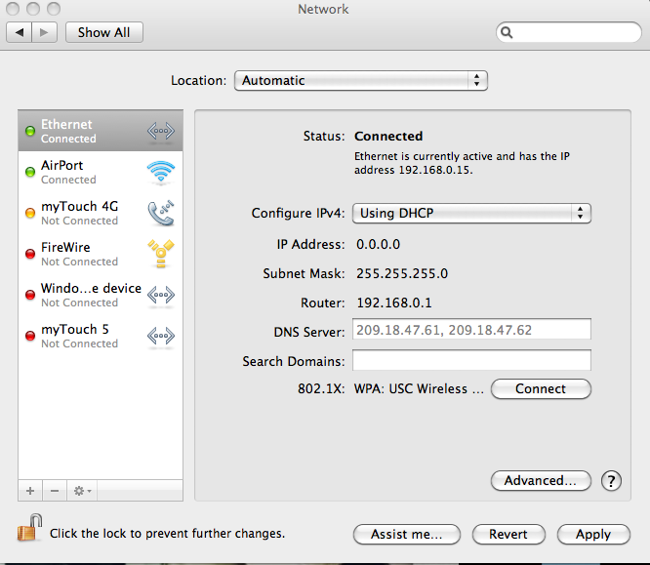

1.

2.

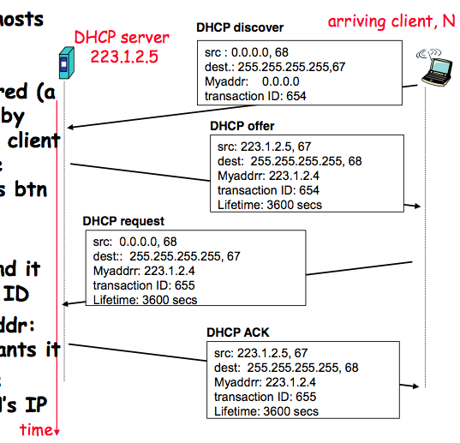

3.

4.

**Part II**