Lab 3: Ethernet

EE450

Ethan Chan

**Part 1**

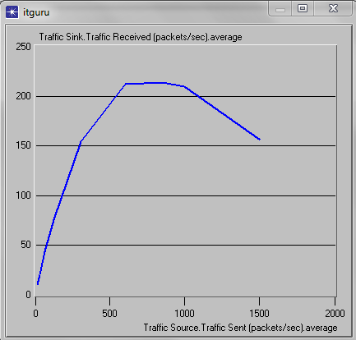

1) Initially as the number of packets/sec sent increases the number of packets/sec received increases rapidly but this slope slowly decreases and eventually levels out at around 600packets/sec sent and begins decreasing at around 1100packets/sec sent. The number of packets/sec received, otherwise known as the throughput, drops when the number of packets sent, otherwise known as the load, is very high because of heavy traffic. As each node sends more and more packets/second there is a higher probability of collision and when a collision occurs in the shared link, the packets are dropped, not received, and need to be resent, which results in a decrease in throughput.

2)

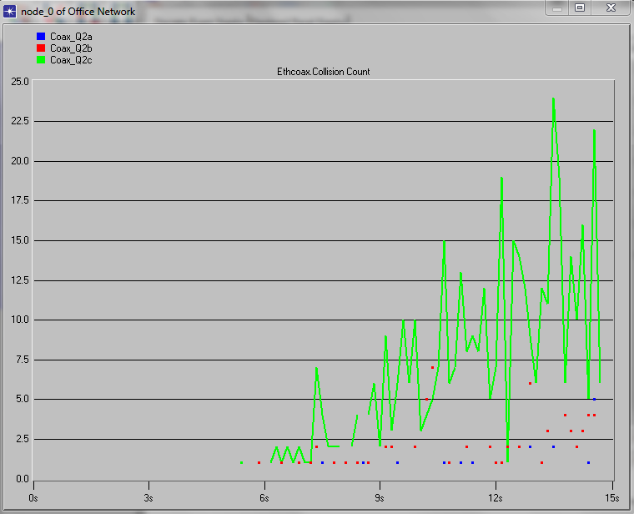

Node 0 collision count

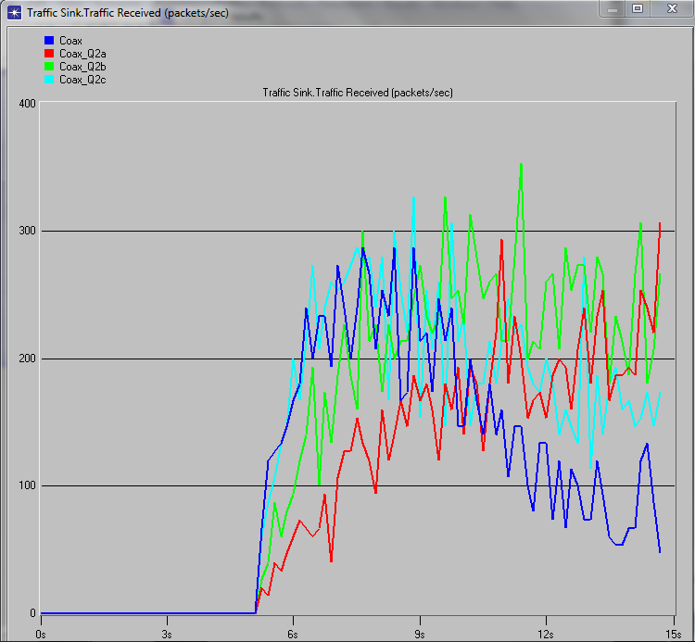

Packets/sec received

We can see from these two graphs that as the interarrival time decreased, the number of collisions for node zero increased and that the throughput generally decreased as well from the number of packets received/second vs time. This makes sense because as we increase the frequency of which packets are sent that would mean less wait time between each packet sent and would make the system more susceptible to sending messages during collisions that have occurred but have not yet been detected yet due to the “vulnerable time” or propagation delay. Waiting longer would be able to detect more collisions because the collision signal would have enough time to propagate back to the node that wants to send a message before the message is sent. This in turn would decrease the overall number of collision and increase the throughput. By decreasing the interarrival time we would achieve the opposite effect.

3)

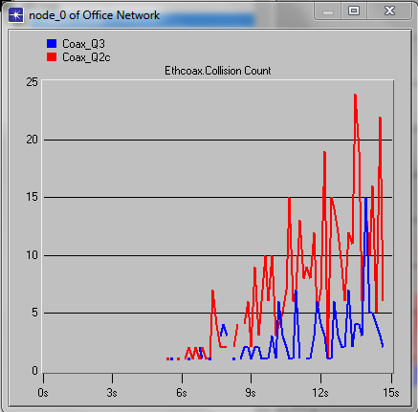

We can clearly see that as time progresses the number of collisions increase for both scenarios Coax_Q3 and Coax_Q2c. However, we can also see that scenario Coax_Q3 has much less collisions than Coax_Q2c and this makes sense because it has half the number of nodes sharing the same bus. Since there are less nodes sharing the same access point, that would mean that fewer messages are sent over the shared link which would substantially decrease the overall number of collisions.

4)

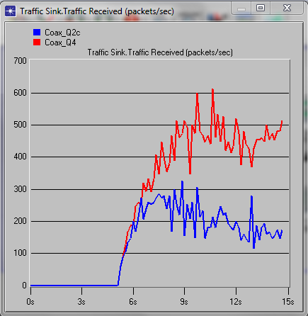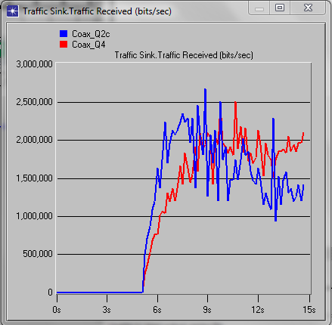

We can see that the number of packets received/sec for situation Coax_Q4 is much higher than the packets received/sec for situation Coax_Q2c and this makes sense since situation Coax_Q4 is sending less packets/sec and putting a lower load on the shared network which helps in driving down the number of collisions and increasing the overall throughput. This is also is the general case for the throughput for bits/second, however, the effect does not look as apparent because the y-axis is scaled in the thousands but if we were to zoom in to the hundreds as in the y-axis for the number of packets/second delivered successfully we would see the same effect as the first graph.

**Part 2**

1)

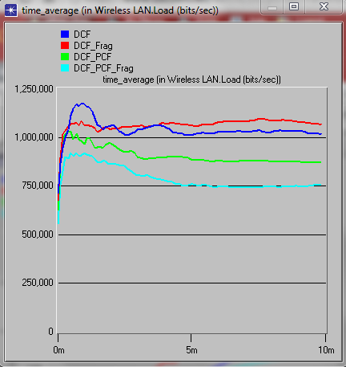

Load is defined as the number of bits/second each node transmits. PCF enabled means that the system has a method of determining which node is “allowed” to used the shared network next and which nodes are not “allowed” to use the network. This restricts the load on the system because only certain nodes are allowed to load information onto the system at a given time while others are restricted. This restriction drives down the overall load the nodes put on the system.

2)

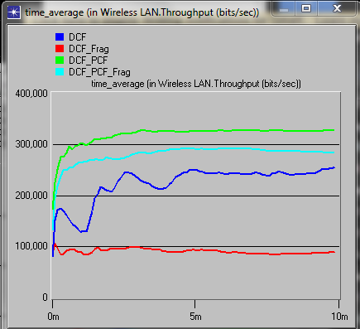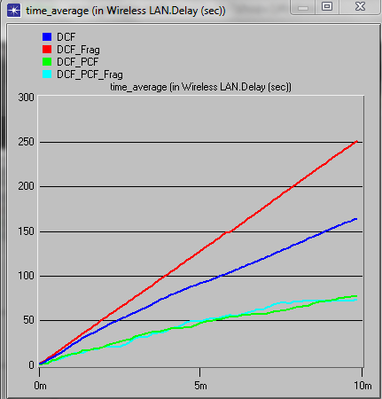

For the first graph that looks at the throughput of the system, we can see that PCF increases the throughput of a system dramatically. This makes sense because its ordered method of transmitting data from one node to the next provides efficiency of transmission, decreases the chances of collisions, and increases the number of bits transmitted successfully. In addition, systems with PCF have less total delay since there are fewer collisions so there are less bits to retransmit through the system which would increase the throughput and decrease the total delay. Fragmentation also decreases delay in a system and also increases the throughput in a system but not with the same intensity as PCF does.

3)

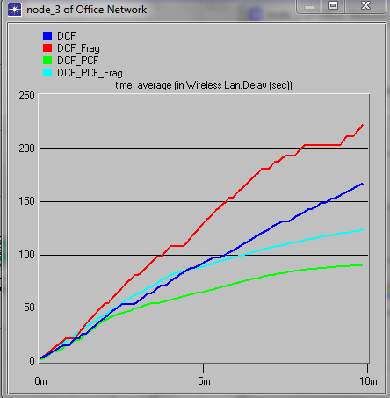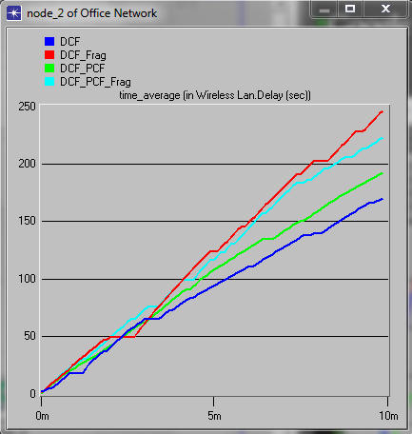

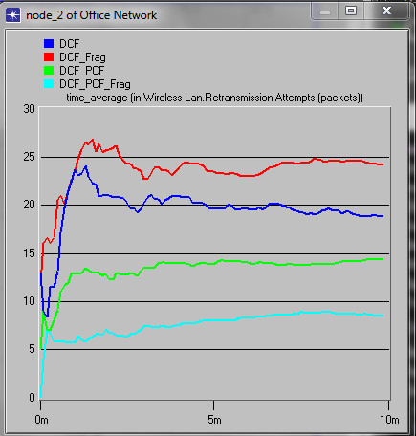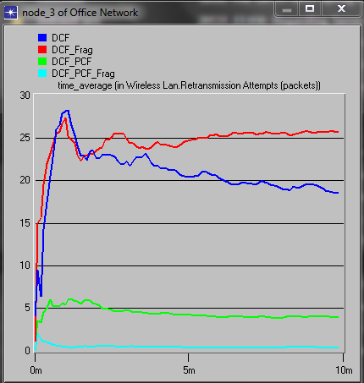

Node 3 has PCF and Node 2 does not have PCF. We can clearly see that the delay of node 3 that has PCF is clearly lower that when node 3 did not have PCF and the average retransmission attempts for the times node 3 had PCF is clearly lower than the times when it didn’t. Node 2 on the other hand, never had PCF in its node but was in sometimes in a system where other nodes, like node 3, had PCF. Although the effects are not as strong as the effects of actually having PCF in the node itself, when node 2 was in a system with other nodes with PCF, its delay did decrease and its retransmission attempts were definitely lower than the retransmission attempts during the time when it wasn’t in a system without PCF.

4)

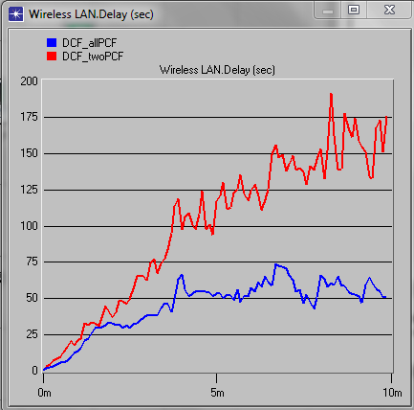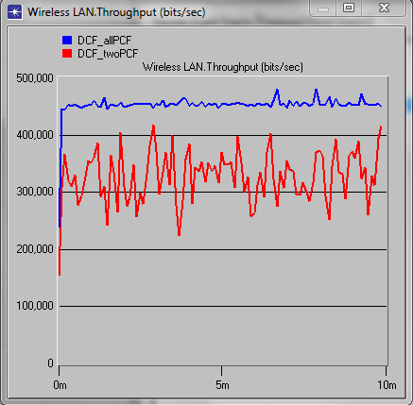

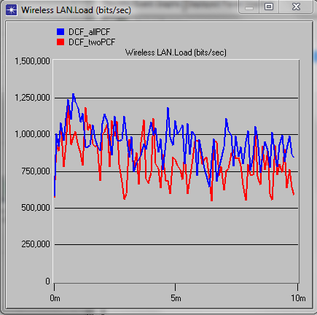

We can see from these two graphs that by having more nodes with PCF enabled, the average delay decreases and the throughput increases. However, having more nodes with PCF enabled doesn’t necessarily mean that the load on the system decreases. It appears that the DCF_twoPCF situation has put less load on the system than the DCF_allPCF situation. This could be due to the PCF algorithm asking the system too many questions to determine what node will go next and therefore overloading the system.

5)

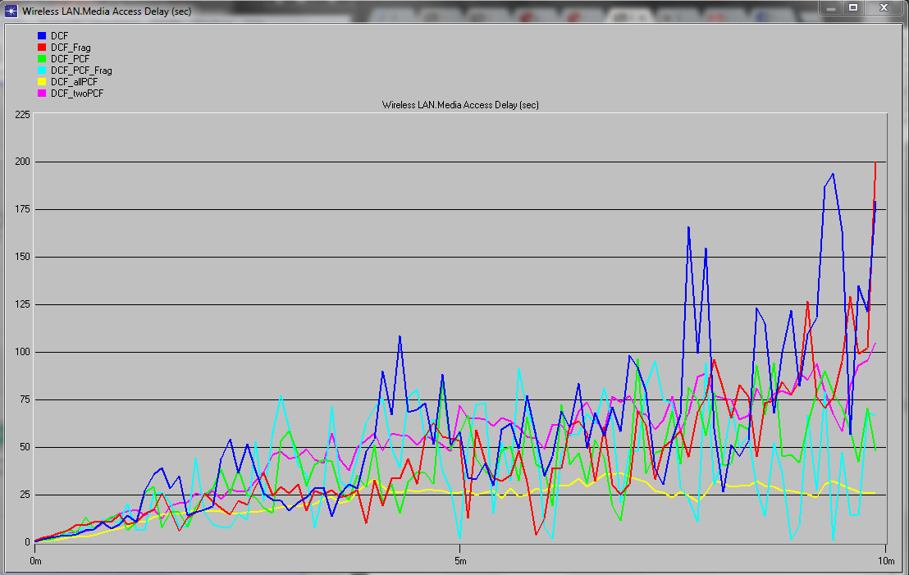

From looking at this graph we can that the DCF_allPCF situation has the lowest Media Access Delay, closely followed by the DCF_PCF_Flag situation, followed by the DCF_PCF situation, followed by the DCF_Flag situation, followed by the DCF_twoPCF situation, while the DCF situation has the highest Media Access Delay. It appears that both PCF and fragmentation have positive effects on lowering the Media Access Delay of a system while PCF seems to have a more powerful effect given our fragmentation method for this lab. Also there is direct relationship between the decrease in Media Access Delay and the number of PCF nodes in a system. As the number of PCF nodes in a system increases, the Media Access Delay decreases.