Charlie Gorman

8-21-25

Homework 1

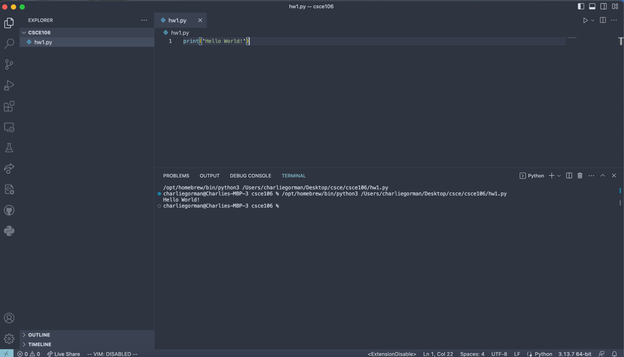

Installed 3.13 using brew on MacOS.