## **Lesson Plan: Guess My Passcode Game / Intro to AI**

*Authors:* [*Young Data Scientists League (YDSL)*](https://www.youngdatascientists.org/)

**Time: 1-2 class periods**

**Lesson Objective:** Prime students for learning the basics of “artificial intelligence” and “machine learning” with a 50 minute, hands-on activity that guides students through a story-based collaborative math game.

**Priming Question:** Have you heard of the term “artificial intelligence”, or “AI”? What are some real-world examples that come to mind of an “AI” tool that you’ve interacted with before? How do you think it works?

**Standards:** Tested for Grades 6+. No coding experience required. Common Core Math Standards covered include:

* Gr 4. “Use the four operations with whole numbers to solve problems” ([4.OA.A.2](https://www.thecorestandards.org/Math/Content/4/OA/A/2/), [4.OA.A.3](https://www.thecorestandards.org/Math/Content/4/OA/A/3/))
* Gr 5. “Write and interpret numerical expressions” ([5.OA.A.1](https://www.thecorestandards.org/Math/Content/5/OA/A/1/), [5.OA.A.2](https://www.thecorestandards.org/Math/Content/5/OA/A/2/))
* Gr 6. “Develop understanding of statistical variability” ([6.SP.A.1](https://www.thecorestandards.org/Math/Content/6/SP/A/1/))

**Prep BEFORE the Lesson (15-30 minutes):**

* Make sure you can access Google Colab (free version) through your school’s Google Drive.
* Open the interactive game in Google Colab using this public [Google Drive link](https://drive.google.com/file/d/1QfUBruKMoEIU74oUYXub8VB-Zym_ynYT/view?usp=drive_link).
* Test the game:
  + [First Run Only] Check the runtime type, by clicking this drop-down menu in the upper RH corner.

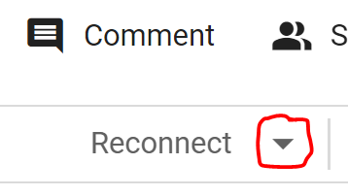

* + Ensure that the runtime is using Python 3 // CPU, which should be selected by default:

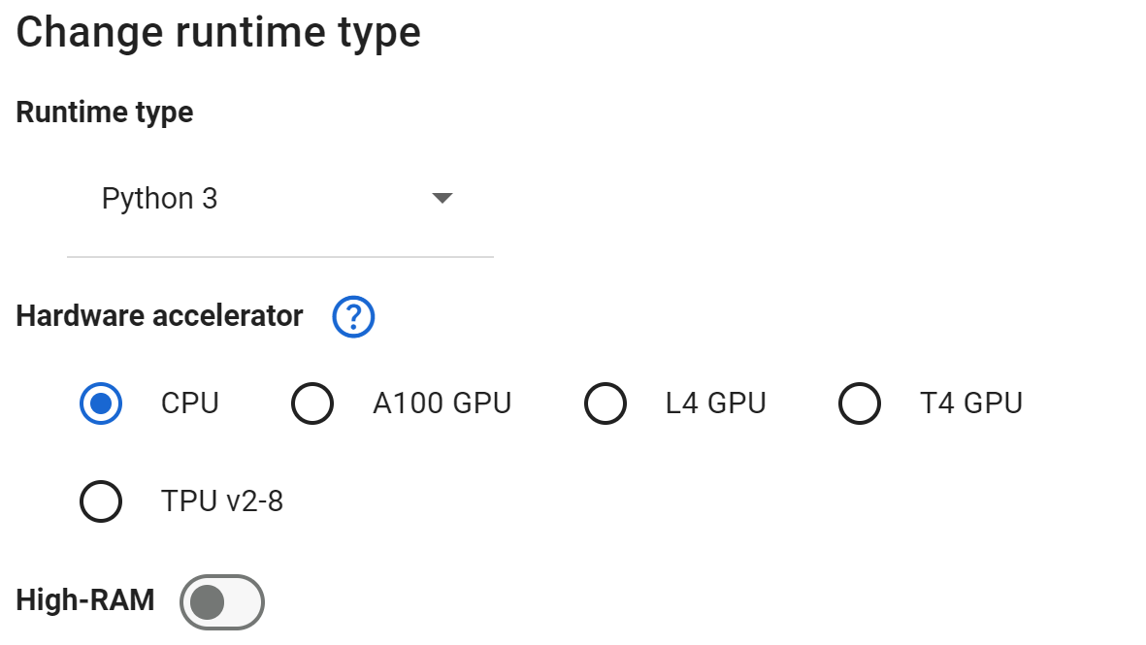

* + Walk through the game demo beforehand, and ensure that the game loads. You should see a selection screen like this after running the “Play Game” cell:

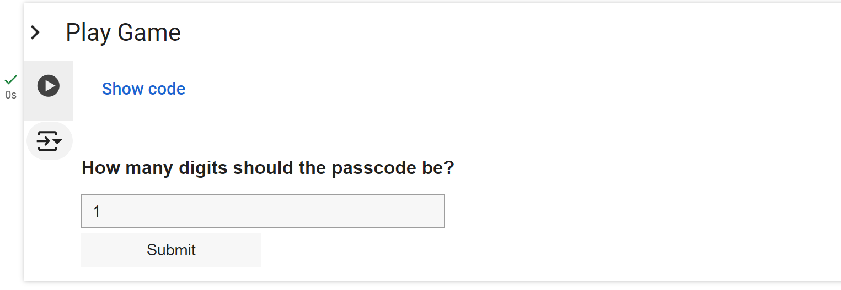

* + Familiarize yourself with the game by trying it out beforehand. Be prepared to screen-share with your class using a projector, smartboard, Zoom, etc.

**Suggested Pacing-at-a-Glance:**

**Lesson Activities (Part 1, 2, and 3):** (50 Minutes)

| **“Part 1: Ground AI”** (5 minutes)  Open-ended discussion on student relevant examples of AI, e.g. social media (see “Priming Question”). | **“Part 2: Play”**: (35 minutes)  Guide students through the “Guess My Passcode” story notebook, gathering guess suggestions from different students across the whole class. Emphasize trial and error. | **“Part 3: Debrief”**: (10 minutes)  Leave time for discussion questions related to the game. Interpret connections to AI - emphasizing that the “AI” algorithm uses basic arithmetic to “learn” from feedback. |
| --- | --- | --- |

**Teaching Guide**

“Guess My Passcode” is a story-based game tested for grades 6 and above that aims to demystify what is commonly referred to as “artificial intelligence”. Learning sciences research on the [role of language in scientific knowledge acquisition](https://hep.gse.harvard.edu/9781682533741/science-in-the-city/) shows that highly technical terms like those that are frequently used in Intro to AI courses (e.g. “machine learning”, “AI”, or “backpropagation”) may widen learning gaps by presenting additional cultural barriers for diverse students. However, “AI” is far from inscrutable, and contrary to common knowledge it is possible to gain a deep understanding of how AI algorithms “learn” from data using mathematics commonly taught prior to middle school. Indeed, perhaps the most central algorithm in modern AI - backpropagation - is often implemented using only the four arithmetic operations. In “Guess My Passcode”, students are challenged to learn the intuition behind backpropagation through a mathematical guessing game that can be played collaboratively or individually. The game uses a low-floor, high-ceiling approach to challenge learners ranging from middle school to the undergraduate level. No prior programming experience is required, although supplementary activities are included for computer science classrooms. Participants finish with a concrete understanding of how computer algorithms learn from feedback using elementary mathematics.

**Suggestion #1: Reframe “Failure” and Encourage Iteration**

The game requires guessing a passcode that at first glance may seem difficult. In our experience, students respond to this challenge in different ways (and older students in fact will place more pressure on themselves to arrive at the correct guess more rapidly). Instead of emphasizing speed, we find that the most inclusive and productive way to teach this lesson is to create a safe space for incorrect guesses and to encourage learning from “failure”.

**Suggestion #2: Use Scaffolding**

The game can be played at a variety of difficulty levels that vary based on the length of the passcode. We always recommend starting with a passcode length of one, as specified in the game notebook itself. Although this may be trivial for some students, we find that engaging students in the process of explaining their thinking at this stage will not only be more inclusive, but will also prime them for gaining a deeper understanding of how AI works in the second half of the game.

**Suggestion #3: Encourage Collaboration**

The game is meant to be collaborative and can be played as an entire class. To do this, take turns seeking guesses from multiple student volunteers.

**Suggestion #4: Focus on Play**

The story is meant to be whimsical and lighthearted. As a fair warning, there is a teacher in the plot who eventually gets their ringtone changed. If you feel comfortable doing this, or providing some sort of reward to your students to “tease” you, it will create a more relaxed atmosphere especially for the younger learners.

**Suggestion #5: Leave Time for Discussion**

While the game can be a fun puzzle for some students in its own right, the end goal with this lesson is not to stay in “symbol-land” but rather to connect the game to real-world applications. If you have prior knowledge in statistics, you may recognize the underlying data-generating mechanism as a **linear regression**, although using this terminology is not necessary, especially at the middle school levels. As the end of the game notebook explains, each of the key game concepts relates to fundamental AI concepts:

| **“Guess My Passcode” Concept** | **AI Concept / Big Picture Idea** |
| --- | --- |
| Multipliers | **Training Data** - examples of collected data that is fed to an AI model so that it can identify patterns and accomplish tasks. For example, a social media feed may learn what posts to recommend users based on ***what posts each user interacts with*** |
| Passcode | **Weights** - an arrangement of individual algebraic variables (or “parameters”) in a model that store patterns learned from seeing examples of data. For example, a social media recommender may have some weights that encode ***patterns across what similar groups of users like***. |
| Total | **Prediction** - the output of an AI model when given new data, based on how the new data interacts with the weights. For example, a social media recommender may choose to ***recommend you new content based on individual preference***. |
| Target Number | **Label** - feedback associated with each piece of training data. For example, a social media recommender may use labels such as ***whether you like or dislike a post*** to learn what to recommend to you in the future. |

**Suggestion #6: Focus on Implications**

Leave time for students to reflect on how the lesson has shaped their understanding of AI. For example, consider what may happen when the multipliers (i.e. training data) don’t reflect the real patterns they want to learn (i.e. the real passcode). This may provide a foundation for how ***algorithmic bias*** may occur in mathematical models that are not neutral.

### **Additional Resources and Links:**

* See attached slides ([link to Google Drive](https://docs.google.com/presentation/d/1qUfr1WOInsSwWNaJeFv5zkRZhseP_6pJ1wdZA7gexWY/edit?usp=sharing)) for an example of how one might teach this lesson
* For teachers who are able to devote a second day to this activity, you may also reinforce their connections between the game AI through watching this video: <https://www.youtube.com/watch?v=PmlRbfSavbI>