Two columns in Word Documents

# Intro

There are a collection of packages called [{officeverse}](https://ardata-fr.github.io/officeverse/) for creating and manipulating MS Word and MS Powerpoint documents. To create two column layouts we need to use two of these packages:

* {officedown}: This package provides additional RMarkdown output formats for creating .docx and .pptx files. We change the YAML header to contain output: officedown::rdocx_document.
* {officer}: This package allows us to programmatically generate (and modify existing) .docx and .pptx files. We use this package to add column breaks with the run_columnbreak() function.

There are two steps to creating multiple columns:

1. Use a pair of HTML comments as follows:

<!–BLOCK_MULTICOL_START—>

<!—BLOCK_MULTICOL_START—>

1. Call run_columnbreak() as an inline expression at the beginning of the content for the second column.

## What’s an inline expression?

An inline R expression allows us to run R code within a Markdown content instead of in a code chunk. It looks like this:

There are `r 2+2` lights

## Page break

I’ve manually inserted a page break here with run_pagebreak()

run_pagebreak()

# Example two column layout

The two column content begins underneath the HTML comment. Remember that the HTML comment won’t display inside the output document.

This is the beginning of the first column

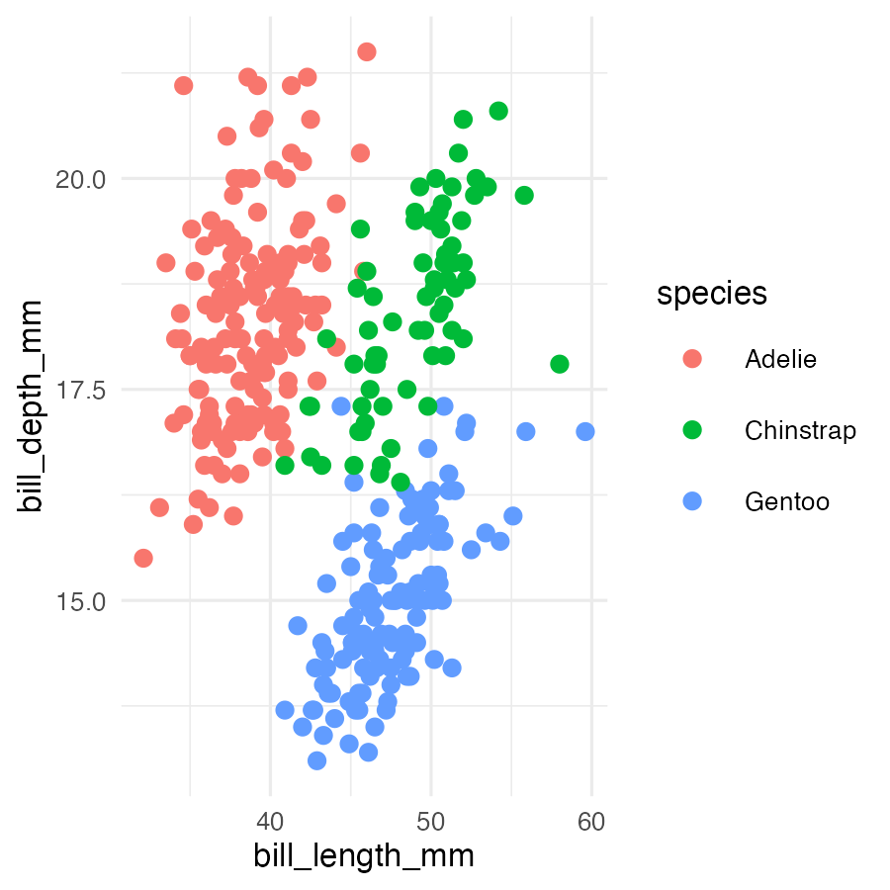

Figure : Penguin scatter plot

This sentence begins the second column.

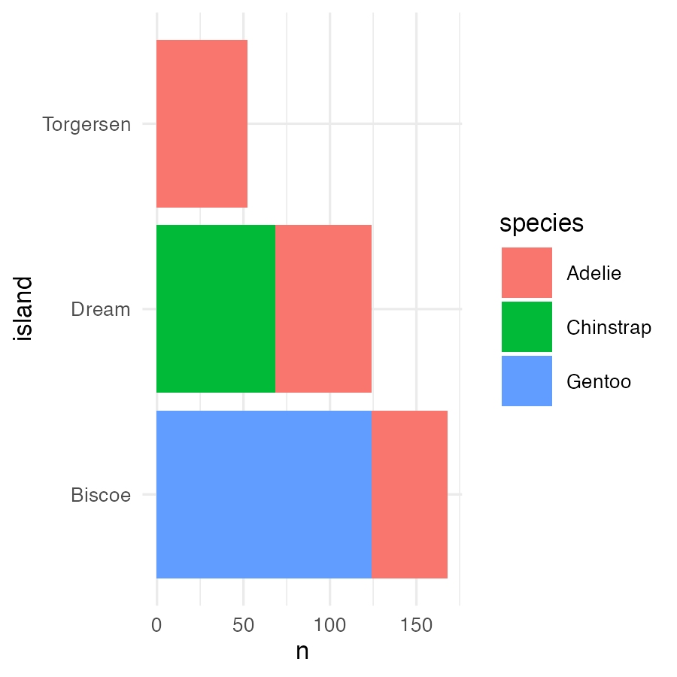

Figure : Penguin scatter plot

The multi column will end after this sentence.

**This text** is just below the HTML comment so Word continues in single column mode. There’s another manual page break here.

run_pagebreak()

# Customising column appearance

By modifying the closing HTML comment it’s possible to customise the appearance of the columns:

This is the beginning of the first column



Figure : Penguin scatter plot

This sentence begins the second column.



Figure : Penguin scatter plot

The multi column will end after this sentence.