**ENSF-381**: **Full Stack Web Development Laboratory**

**Lab03**

**Section: B02**

**Group information:**

Charlie Lang (30118227)

Justin Vuong (30205375)

**GitHub Link:**

**https://github.com/charlielang02/ENSF381Lab3**

**Exercise 1 Output:**

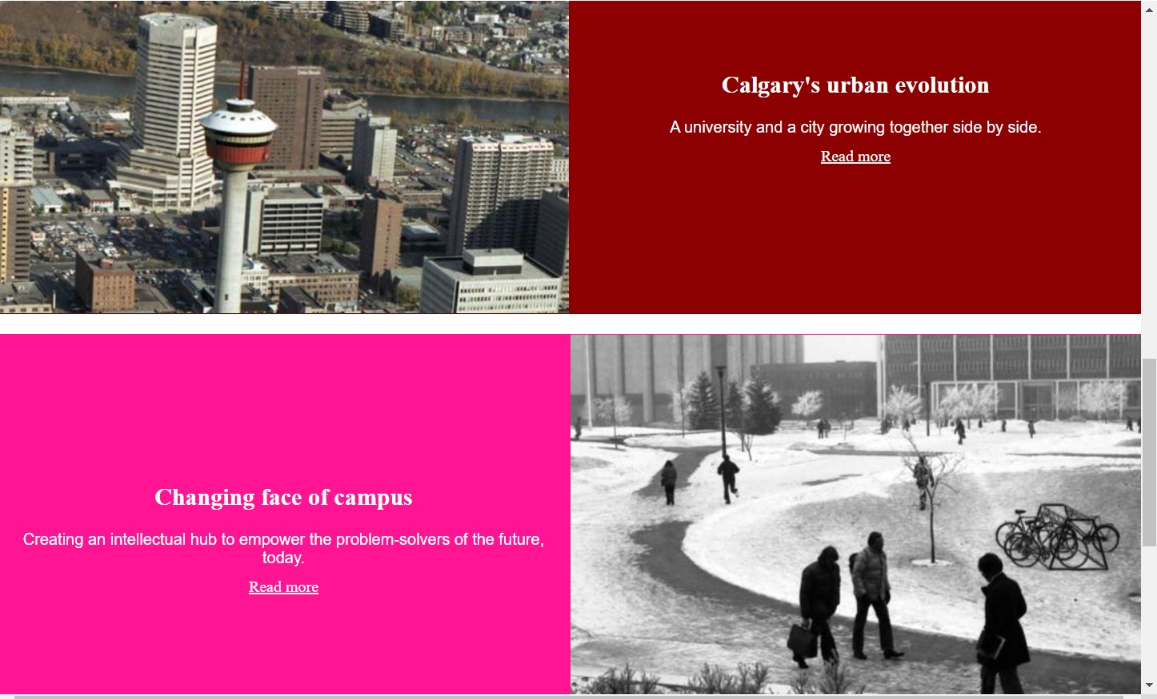

**Exercise 2 Output:**

**Exercise 3 Output:**

