Supah-Silicon
What we did, from scratch
Sundai @ MIT hackathon, Track 2 (design the coolest chiplet layout) · Sunday, October 18, 2026

1. Summary
Test 1, designed a four-GPU, four HBM AI accelerator package laid out to run a cooler. The challenge constrains the chips, power, wiring, and cooler. We control where the chips are sat in the 52 x 42 mm silicon interposer.
Our best layout scores 0.9873 against the organizers' reference of 1.000 (lower is better): the hottest GPU drops from 104.59 °C to 103.58 °C and the hottest memory from 97.68 °C to 95.17 °C. The organizers' own simulator reproduced that score exactly.
Layout | Score | Hottest GPU | Hottest HBM
Organizers' reference | 1.000 | 104.59 °C | 97.68 °C
Supah-Silicon (best, p2) | 0.9873 | 103.58 °C | 95.17 °C

2. Steps

Step 1: Understand the challenge
Instructions that Claude followed (Opus 5.5)
- Read the Sundai kickoff deck and the photo of the "3 Cases" slide. There were two tracks: Track 1 (design a 2035 AI data center) and Track 2 (lay out four GPUs and four HBM memory stacks so they run cool, modeled on AMD's MI300A).
- Chose Track 2, the chip track. Its rules: chips at least 1 mm apart, 8 required links (600 GB/s main links up to 5 mm, 300 GB/s side links up to 6 mm), a shared wire budget of 13,500 GB/s·mm, and a cooler whose good-contact area is a fixed 44 × 34 mm box.

Step 2: Research
- Built a reading list for chip layout and heat: HotSpot (the simulator the challenge uses), TAP-2.5D (Boston University, thermally aware chiplet placement), AMD's MI300 paper, cross-layer chiplet placement, RLPlanner, the critique of reinforcement-learning placement, Chiplet Actuary (cost model) and imec's HBM-on-GPU study.
- Added Track 1 papers on memory bandwidth for AI serving (Splitwise, DistServe, vLLM, "AI and Memory Wall").
- Read the paper you shared, "See it to Place it" (VeoPlace): an AI looks at pictures of earlier layouts and proposes where each block should go. It beat a learned placer on 9 of 10 benchmarks (up to about 32–35%) and an analytical placer on all 8 (0.7–4.3%). It only optimized wire length, so applying it to heat would be new.
- Researched Lam Research's work on 3D chips: cryogenic etch (Cryo 3.0, Aug 2024), molybdenum wiring (ALTUS Halo, Feb 2025, over 50% lower resistance than tungsten), the Akara etch tool for gate-all-around and 3D transistors, HBM through-silicon-via tools (Syndion, SABRE 3D), and Lam/imec papers on 3D DRAM and backside power.

Step 3: Set up the simulator
- AutoLab's site was blocked by this workspace's network, so we installed the hills tool and used the organizers' public GitHub copy of the same challenge ("beat-the-hotspot") as a local, version-locked scorer.
- Measured the cost of one official test: about 94 seconds per layout on 2 processor cores.

Step 4: First tests and faster checks
- First guess (v0): move every chip into the well-cooled area. Score 1.003, slightly worse. The chips ended up closer together and heated each other more.
- Built a fast estimate (same HotSpot, coarser grid). At 16 × 16 it took about 2 seconds but read the GPU up to 4.4 °C too cool, which is too inaccurate to rank layouts.
- Found an exact shortcut: run only the two workloads that decide the GPU score, at the official 64 × 64 grid. About 39 seconds, and it matched the official GPU number to 0.01 °C.

Step 5: Search for a cooler layout
- First search (p1): simulated annealing on the fast estimate. Official score 0.9987.
- Bold idea (r1): turn every GPU's hot corner toward the middle. GPU 108.01 °C, much worse. The middle collects heat from all four GPUs.
- Second search (p2): simulated annealing with the exact GPU check. Official score 0.9873. The GPUs moved toward the outer corners, with the memory stacks repositioned to keep links legal.

Step 6: Explore a 3D version (Supah-Silicon 2.0)
- Built a 3D model with the same HotSpot, workloads and cooler, stacking each memory stack on its GPU. Swept 16 designs over which die is on top, how well heat passes through the memory, the bond type, and the filler material.
- Memory on top of the GPU ran the GPU at 126–197 °C. GPU on top of memory ran 110.5–119 °C, with the best case at 110.5 °C GPU and 110.5 °C memory, against about 104 °C for the flat chip on the same grid. The challenge doesn't score 3D, so this is roadmap material.

Step 7: Check the organizers' second tool
- Compared the organizers' GUI repo (Chiplet Thermal Studio) with the scorer file by file. The physics files are byte-for-byte identical, so results carry over.
- Found two useful points: the scorer accepts hand-drawn wire routes (a lever we haven't used yet), and the organizers advise re-checking close results on finer grids before final rankings.

Step 8: Name, GitHub and documents
- Created a private repo (now ravic4/supah-silicon), accepted Charlie's invite to the team repo (charliemags/supah-silicon), and published everything there under simulation/.
- Wrote seven plain-English guides: how the heat simulation works, running a test, making it faster, searching, the 3D experiment, the organizers' tools, and how to run and see a test.

Step 9: Make the tests visible and tell the story
- Ran the organizers' own runner on the reference, the first guess and Supah-Silicon. It reproduced every score exactly and drew the official temperature maps and wire-heat pictures.
- Found the trade-off: Supah-Silicon uses 13,435 of the 13,500 GB/s·mm wire budget, and its wires make 7.41 W versus 4.82 W for the reference in the memory-heavy workload.
- Wrote the story (simulation/STORY.md) and published it as a web page with the pictures and a chart of every test.
- Wrote and tested a one-command script, simulation/run.sh. It printed the same scores: reference 1.0000, Supah-Silicon 0.9873.

3. Results

Every official test (64 × 64 grid)
Layout | Score | Hottest GPU | Hottest HBM | Outcome
Organizers' reference | 1.000 | 104.59 °C | 97.68 °C | Baseline
v0: all inside the cool zone | 1.003 | 104.66 °C | 97.90 °C | Worse
p1: first search | 0.9987 | 104.49 °C | 96.12 °C | Better
p2: Supah-Silicon | 0.9873 | 103.58 °C | 95.17 °C | Best
r1: hot spots facing inward* | — | 108.01 °C | — | Much worse
* r1 was checked only on the two GPU-deciding workloads, so it has no full score.

Speed vs. accuracy of the heat check
Method | Time per layout | GPU accuracy
Coarse grid, 16 × 16 | about 2 s | up to 4.4 °C too cool
Coarse grid, 32 × 32 | about 9 s | 0.6–1.2 °C too cool
Official grid, 2 GPU workloads | about 39 s | exact (0.01 °C)
Official grid, all 5 workloads | about 94 s | exact (official)

3D what-if (coarse grid, assumed materials)
Design | Hottest GPU | Hottest HBM
Flat Supah-Silicon (same grid) | ~103.6 °C | ~95.6 °C
Memory on top of GPU, best | 126.3 °C | 110.8 °C
Memory on top of GPU, worst | 197.3 °C | 152.3 °C
GPU on top of memory, best | 110.5 °C | 110.5 °C

4. What we learned
- Spacing matters more than the cooling strip. Squeezing chips into the well-cooled area made things worse.
- A fast test that's wrong is worse than a slow test that's right. The coarse grid's error was bigger than the gains we were chasing.
- Point hot spots at open space, not at each other. Aiming all GPU hot corners at the middle added about 3.5 °C.
- The GPUs decide the score. Each hot GPU mostly heats itself, so gains come in tenths of a degree. The memory has slack.
- Spreading out costs wire. Our best layout is near the wire budget limit, so more gains need a smarter layout, not just more spreading.
- In 3D, which die sits on top decides almost everything, and memory heat becomes the main problem.

5. Where everything is
What | Where
Team repo (public) | github.com/charliemags/supah-silicon, folder simulation/
The story | simulation/STORY.md, and the published story page (private until shared): claude.ai/artifact/PNnSss8pdWxjPwxefFdrVo
Plain-English guides (7) | simulation/docs/
Run a test with one command | bash simulation/run.sh (Linux or a GitHub Codespace)
Official pictures | simulation/img/temperature_maps.png and wire_heat_memory_stream.png
Every scored layout and report | simulation/layouts/
Search, heat-map and 3D code | simulation/tools/
Private backup | github.com/ravic4/supah-silicon

6. Honest assessment and next steps

What's strong
- Every number is real, came from the organizers' own simulator, and reproduced across three independent runs.
- The work is documented and repeatable by anyone on the team with one command.
- The story includes the failures and why they failed, which makes it credible.

What's still weak
- The gain is modest: about 1.3% on the score (1.0 °C GPU, 2.5 °C memory). We can't see other teams' scores.
- Not yet checked on the 128 × 128 finalist grid, where close results can shift.
- The AI-guided search from "See it to Place it" is planned, not run. All results so far come from plain simulated annealing. The pitch must not claim AI guidance unless we run it.
- Only about 200 layouts searched so far; the faster reduced-order model is designed but not built.

Recommended next steps before the 8pm demos
- Re-check the best layout on the 128 × 128 finalist grid (about 15 minutes).
- Run a longer search that respects the wire budget, and try hand-routing wires away from G0's hot corner (2–3 hours).
- Either run the AI-guided search as a fair test against plain search, or remove it from the pitch.
- Share the story page with the team from its Share menu.

7. Sources
- Organizers' simulator and scorer: github.com/Czaja107/chiplet-thermal-simulator
- Organizers' GUI: github.com/Czaja107/chiplet-thermal-gui
- HotSpot: Skadron et al., ISCA 2003; Huang et al., IEEE Transactions on Computers 2008
- TAP-2.5D: Ma, Delshadtehrani, Demirkiran, Abellán, Joshi, DATE 2021
- "See it to Place it: Evolving Macro Placements with Vision-Language Models" (VeoPlace), ICML submission under review
- imec HBM-on-GPU thermal study, IEDM 2025 (reported by IEEE Spectrum)
- Lam Research: Cryo 3.0 (Aug 2024), ALTUS Halo (Feb 2025), Akara (2025); Hong et al., IEEE J. Electron Devices Society 2026 (3D DRAM)

Part 2: Full workings
Everything behind the summary: the chip's fixed inputs, every design we tried with its exact coordinates and pictures, every official result by workload and by chip, the calculations, the search settings, the 3D experiment, the finalist check, the Monte Carlo contest and the code.
A note on CPUs: this challenge's chip has no CPU. It has 4 GPU dies and 4 HBM memory stacks. AMD's MI300A, which the challenge is modeled on, does include CPU dies, but they are not part of this layout problem.

A. The chip: fixed inputs

A1. Dies
Positions are the lower-left corner of each die, in millimetres from the interposer's lower-left corner. Hot-spot position is the fraction of the die's width and height, measured from its lower-left corner.
Die | Type | Size (mm) | Hot spot (fraction of die)
G0 | GPU | 11.5 × 10.5 | compute at (0.25, 0.28)
G1 | GPU | 11.5 × 10.5 | compute at (0.73, 0.25)
G2 | GPU | 11.5 × 10.5 | compute at (0.7, 0.75)
G3 | GPU | 11.5 × 10.5 | compute at (0.27, 0.73)
H0 | HBM memory | 10.5 × 10.2 | memory banks at (0.35, 0.34)
H1 | HBM memory | 10.5 × 10.2 | memory banks at (0.65, 0.31)
H2 | HBM memory | 10.5 × 10.2 | memory banks at (0.63, 0.72)
H3 | HBM memory | 10.5 × 10.2 | memory banks at (0.34, 0.68)

A2. Power per workload (watts, before link heat)
Workload | G0 | G1 | G2 | G3 | H0 | H1 | H2 | H3
tensor_training | 88 | 94 | 86 | 90 | 10 | 11 | 10 | 10
skewed_compute | 104 | 56 | 92 | 48 | 12 | 10 | 11 | 9
attention_decode | 53 | 57 | 50 | 55 | 24 | 26 | 25 | 23
memory_stream | 44 | 46 | 42 | 48 | 51 | 49 | 50 | 53
mixed_serving | 72 | 79 | 54 | 63 | 18 | 15 | 24 | 19

A3. Links
Link | Connects | Bandwidth | Max length | Edge needed per end
P0 | G0 to H0 | 600 GB/s | 5 mm | 4 mm
P1 | G1 to H1 | 600 GB/s | 5 mm | 4 mm
P2 | G2 to H2 | 600 GB/s | 5 mm | 4 mm
P3 | G3 to H3 | 600 GB/s | 5 mm | 4 mm
S0 | G0 to H3 | 300 GB/s | 6 mm | 2 mm
S1 | G1 to H0 | 300 GB/s | 6 mm | 2 mm
S2 | G2 to H1 | 300 GB/s | 6 mm | 2 mm
S3 | G3 to H2 | 300 GB/s | 6 mm | 2 mm
Ports must sit in the middle 60% of a die side, at least 0.4 mm apart. Wires run on a 0.5 mm grid, keep 0.2 mm from dies, and share one budget: the sum of bandwidth × length over all 8 links must stay at or under 13,500 GB/s·mm.

A4. Package and cooling
Item | Value
Interposer | 52 × 42 mm silicon, 500 µm thick
Die layer | 150 µm silicon; gaps filled with material of resistivity 2 m·K/W (silicon: 0.0076923)
Thermal paste (TIM) | 20 µm; 0.25 m·K/W inside the 44 × 34 mm good-contact box at (4, 4); 2 outside it (8× worse)
Spreader / heat sink | 55 mm / 60 mm copper; cooling resistance 0.08 °C per watt
Room temperature | 25 °C
Link energy | 0.2 pJ/bit at the ports (split between both ends) + 0.08 pJ/bit per mm of wire

B. Every design we tried

B1. Coordinates (lower-left corner of each die, mm)
Die | Reference | v0 first guess | p1 first search | p2 Supah-Silicon | r1 hot spots inward
G0 | 7.56, 3.26 | 7.56, 4.30 | 6.00, 2.46 | 4.87, 3.29 | 31.24, 27.05
G1 | 33.27, 2.86 | 33.27, 4.30 | 33.25, 2.48 | 32.57, 3.09 | 4.89, 29.01
G2 | 33.07, 27.37 | 33.07, 27.40 | 31.24, 27.05 | 31.12, 27.75 | 6.00, 2.46
G3 | 7.99, 27.61 | 7.99, 27.40 | 4.89, 29.01 | 5.36, 27.79 | 33.25, 2.48
H0 | 20.93, 3.58 | 20.93, 4.30 | 18.86, 1.66 | 18.62, 1.77 | 19.65, 30.01
H1 | 34.12, 15.89 | 34.12, 16.00 | 32.41, 14.63 | 31.23, 15.06 | 5.78, 15.18
H2 | 20.77, 27.31 | 20.77, 27.60 | 19.65, 30.01 | 18.62, 29.76 | 18.86, 1.66
H3 | 8.75, 15.16 | 8.75, 16.00 | 5.78, 15.18 | 5.36, 14.97 | 32.41, 14.63
Each cell is x,y in mm.

B2. Wire use per design
Design (routed mm) | P0 | P1 | P2 | P3 | S0 | S1 | S2 | S3 | Budget used
Reference | 2.2 | 2.9 | 2.6 | 2.5 | 2.2 | 2.5 | 2.0 | 2.0 | 8,729
v0 first guess | 2.7 | 2.5 | 1.9 | 2.0 | 3.5 | 2.7 | 1.9 | 1.4 | 8,364
p1 first search | 2.4 | 3.0 | 4.3 | 4.5 | 2.9 | 4.9 | 3.6 | 4.4 | 13,230
p2 Supah-Silicon | 4.6 | 3.8 | 3.9 | 3.4 | 1.5 | 5.2 | 3.3 | 3.6 | 13,436
r1 hot spots inward | 4.3 | 4.5 | 2.4 | 3.0 | 3.6 | 4.4 | 2.9 | 4.9 | 13,230
Main links (P) may be up to 5 mm, side links (S) up to 6 mm, and the budget limit is 13,500 GB/s·mm.

B3. Floorplans
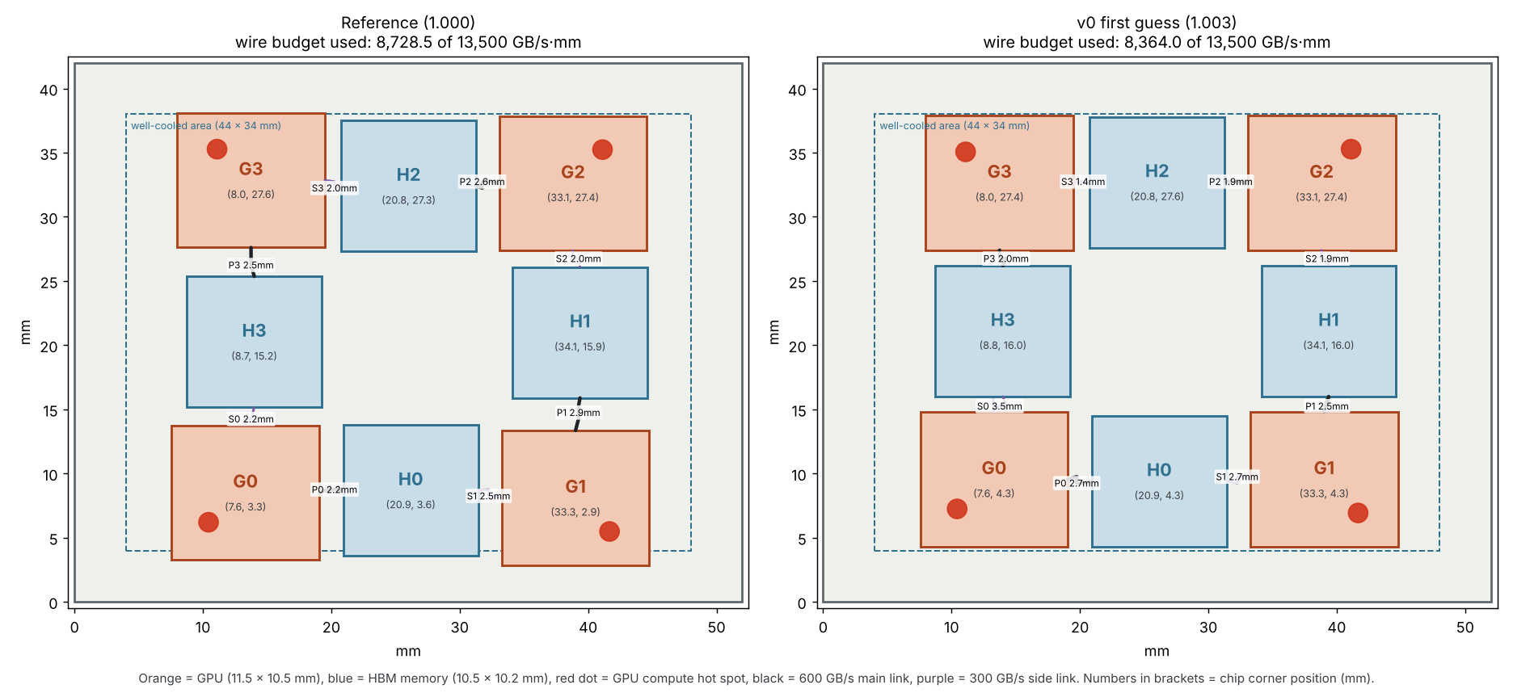
Reference vs. v0 (first guess). Orange = GPU, blue = HBM, red dot = compute hot spot, lines = routed wires.
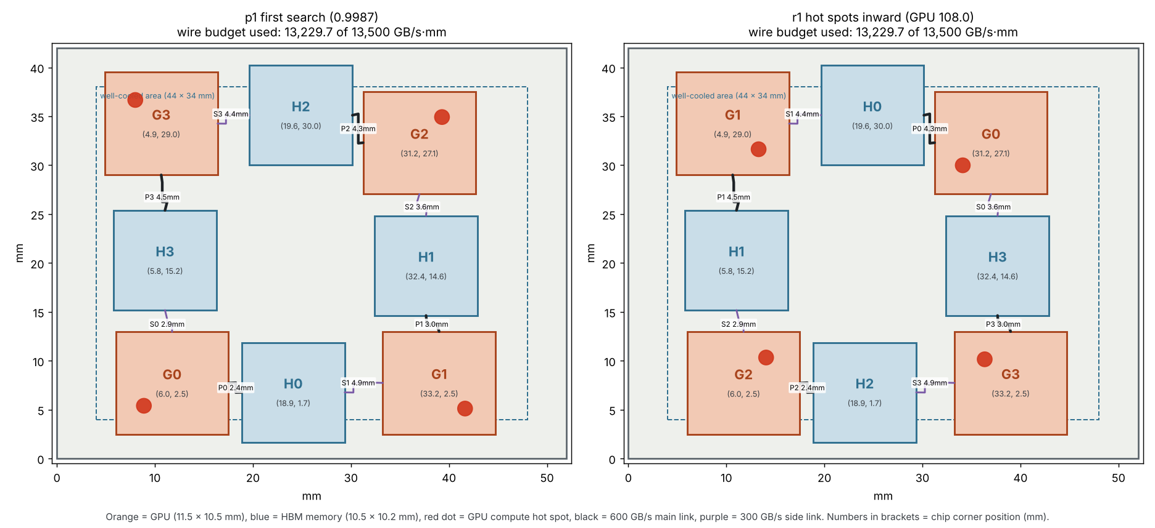
p1 (first search) vs. r1 (hot spots turned inward).
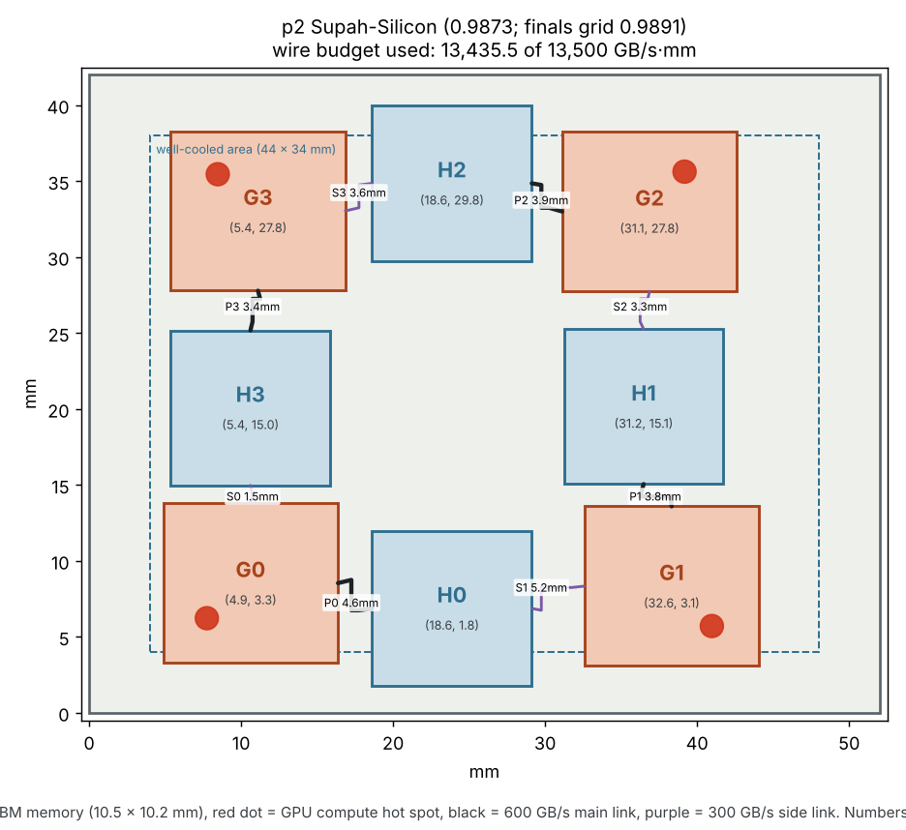
p2: Supah-Silicon, the best design.

B4. Heat maps
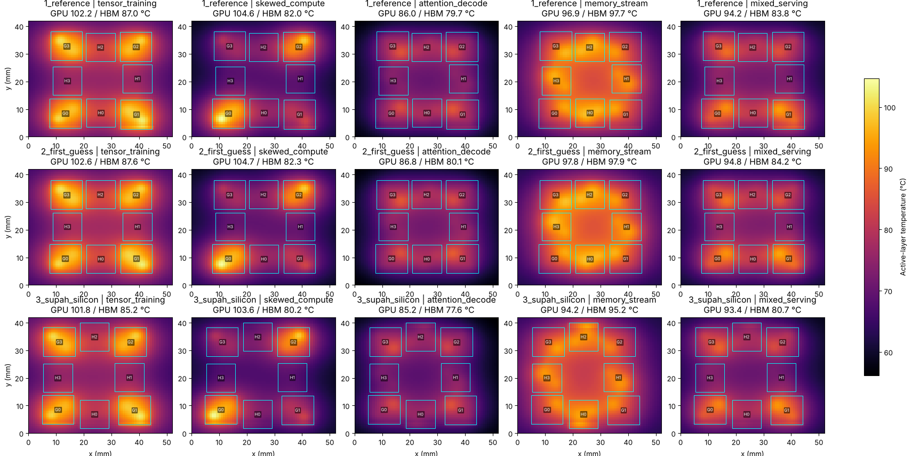
Official output (64 × 64 grid): rows are reference, first guess and Supah-Silicon; columns are the five workloads.
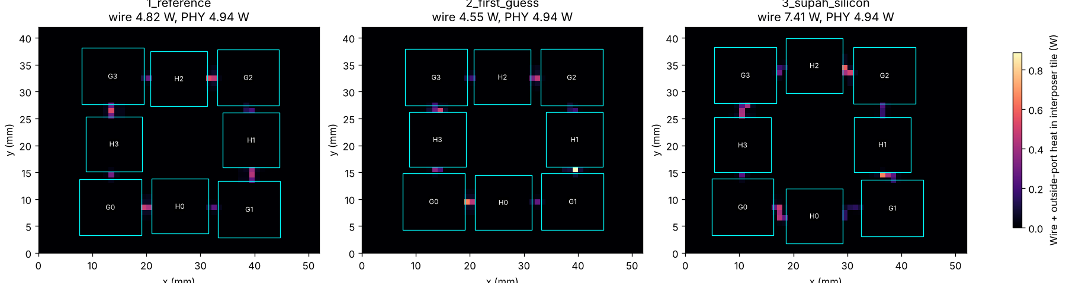
Heat from wires and link ports, memory-heavy workload: Supah-Silicon makes 7.41 W vs. 4.82 W for the reference.

C. Official results in detail

C1. Hottest GPU and HBM per workload (64 × 64 grid, °C)
Workload | Ref GPU | Ref HBM | v0 GPU | v0 HBM | p1 GPU | p1 HBM | p2 GPU | p2 HBM
tensor_training | 102.21 | 87.05 | 102.58 | 87.63 | 104.14 | 85.67 | 101.82 | 85.22
skewed_compute | 104.59 | 81.97 | 104.66 | 82.31 | 104.49 | 82.71 | 103.58 | 80.23
attention_decode | 86.01 | 79.73 | 86.81 | 80.07 | 84.76 | 77.81 | 85.16 | 77.64
memory_stream | 96.89 | 97.68 | 97.83 | 97.90 | 93.19 | 96.12 | 94.23 | 95.17
mixed_serving | 94.23 | 83.77 | 94.85 | 84.23 | 93.08 | 82.23 | 93.42 | 80.66
The score uses the single hottest GPU and hottest HBM across all five workloads. For every design the GPU peak is set by G0 in skewed_compute, and the HBM peak by memory_stream.

C2. Every chip's peak in Supah-Silicon (64 × 64 grid, °C)
Workload | G0 | G1 | G2 | G3 | H0 | H1 | H2 | H3
tensor_training | 99.42 | 101.82 | 99.30 | 100.22 | 83.87 | 81.53 | 85.22 | 80.15
skewed_compute | 103.58 | 82.31 | 98.83 | 79.08 | 80.23 | 71.18 | 78.90 | 75.42
attention_decode | 83.54 | 85.16 | 82.53 | 84.30 | 76.74 | 76.68 | 77.64 | 73.27
memory_stream | 93.28 | 93.12 | 91.13 | 94.23 | 95.03 | 93.23 | 95.17 | 93.61
mixed_serving | 91.36 | 93.42 | 84.25 | 87.76 | 80.66 | 77.81 | 80.15 | 76.93

C3. Every chip's peak in the reference (64 × 64 grid, °C)
Workload | G0 | G1 | G2 | G3 | H0 | H1 | H2 | H3
tensor_training | 100.05 | 102.21 | 99.23 | 100.79 | 87.05 | 81.41 | 86.57 | 81.05
skewed_compute | 104.59 | 82.94 | 98.67 | 79.21 | 81.97 | 75.03 | 78.95 | 76.25
attention_decode | 84.48 | 86.01 | 83.62 | 85.59 | 79.36 | 74.86 | 79.73 | 74.62
memory_stream | 94.98 | 94.97 | 93.57 | 96.89 | 97.68 | 93.03 | 96.73 | 95.97
mixed_serving | 92.40 | 94.23 | 85.19 | 88.92 | 83.77 | 75.94 | 82.07 | 77.99

C4. Finalist check: Supah-Silicon on the 128 × 128 grid
Workload | Hottest GPU | Hottest HBM | Hottest die
tensor_training | 101.98 °C | 85.56 °C | G1 (101.98 °C)
skewed_compute | 103.87 °C | 80.75 °C | G0 (103.87 °C)
attention_decode | 85.27 °C | 77.75 °C | G1 (85.27 °C)
memory_stream | 94.37 °C | 95.09 °C | H0 (95.09 °C)
mixed_serving | 93.53 °C | 81.04 °C | G1 (93.53 °C)
Score at 128 × 128: 0.9891 (reference at this grid: GPU 104.74 °C, HBM 97.70 °C). One 128-grid run took 22.5 minutes on 2 processor cores.

D. The calculations, worked through

D1. The score
score = the larger of (hottest GPU − 25) ÷ (reference hottest GPU − 25) and (hottest HBM − 25) ÷ (reference hottest HBM − 25).
- Supah-Silicon GPU: (103.58 − 25) ÷ (104.59 − 25) = 78.58 ÷ 79.59 = 0.98731
- Supah-Silicon HBM: (95.17 − 25) ÷ (97.68 − 25) = 70.17 ÷ 72.68 = 0.96546
- Score = max(0.98731, 0.96546) = 0.98731. The GPU sets the score; the memory has about 2% to spare.
- Each 0.1 °C on the hottest GPU is worth 0.1 ÷ 79.59 ≈ 0.0013 of score.

D2. Link heat, one example
A 600 GB/s link at full use moves 600 × 8 × 10⁹ = 4.8 × 10¹² bits per second.
- Port heat: 4.8 × 10¹² × 0.20 pJ = 0.96 W, split 0.48 W per end (half inside the die, half on the interposer).
- Wire heat over 4 mm: 4.8 × 10¹² × 0.08 pJ × 4 = 1.536 W, spread along the wire.
- In the memory-heavy workload, Supah-Silicon's wires make 7.41 W vs. 4.82 W for the reference; ports make 4.94 W in both.

D3. Wire budget and why re-routing is blocked
Budget used = Σ (bandwidth × routed length). Supah-Silicon uses 13,435.5 of 13,500 GB/s·mm, leaving 64.5. The smallest detour on the 0.5 mm grid adds 1 mm, which costs 600 GB/s·mm on a main link or 300 on a side link, so no wire can be re-routed without first shortening another.

D4. Speed and accuracy of each heat check
Check | Grid | Time per layout | Hottest-GPU error
Coarse estimate, all 5 workloads | 16 × 16 | ~2 s | up to 4.4 °C too cool
Coarse estimate, all 5 workloads | 32 × 32 | ~9 s | 0.6–1.2 °C too cool
Exact GPU check (2 workloads) | 64 × 64 | ~39 s | 0.00–0.01 °C
Official score (5 workloads) | 64 × 64 | ~94 s | official
Finalist score (5 workloads) | 128 × 128 | ~22.5 min | finals

E. How the searches ran
Search | Heat check | Settings | Result
First search (p1) | 16 × 16 estimate | 150 tests; steps 1.5 → 0.15 mm; start = reference | 0.9987 official
Second search (p2) | Exact GPU check | 45 tests; steps 0.8 → 0.15 mm; start = p1 | 0.9873 official
Simulated annealing: each step moves one or two dies by a random amount, shifts all dies together, or swaps two dies of the same kind. Illegal layouts are discarded instantly. Cooler layouts are kept; slightly hotter ones are sometimes kept early on, to escape dead ends. Every test is logged in simulation/runs/search/ in the team repo.

F. Supah-Silicon 2.0: the full 3D sweep
Packaged 3D (separate dies bonded on top of each other), not monolithic 3D (transistor layers built on one wafer). Each HBM stack sits on its own GPU. Same HotSpot, workloads and cooler; coarse 32 × 32 grid; assumed materials (memory stack 720 µm, bond layer 10 µm).
Order | Memory conductivity | Bond conductivity | Filler | GPU °C | HBM °C
Memory on top | 10 W/m·K | 1.5 W/m·K | mold | 197.25 | 152.30
Memory on top | 10 W/m·K | 1.5 W/m·K | silicon | 155.20 | 125.64
Memory on top | 10 W/m·K | 100 W/m·K | mold | 191.65 | 152.78
Memory on top | 10 W/m·K | 100 W/m·K | silicon | 152.37 | 125.30
Memory on top | 30 W/m·K | 1.5 W/m·K | mold | 149.92 | 129.59
Memory on top | 30 W/m·K | 1.5 W/m·K | silicon | 131.17 | 109.14
Memory on top | 30 W/m·K | 100 W/m·K | mold | 142.52 | 129.64
Memory on top | 30 W/m·K | 100 W/m·K | silicon | 126.27 | 110.78
GPU on top | 10 W/m·K | 1.5 W/m·K | mold | 119.06 | 132.62
GPU on top | 10 W/m·K | 1.5 W/m·K | silicon | 113.58 | 130.89
GPU on top | 10 W/m·K | 100 W/m·K | mold | 118.64 | 128.86
GPU on top | 10 W/m·K | 100 W/m·K | silicon | 113.03 | 127.43
GPU on top | 30 W/m·K | 1.5 W/m·K | mold | 116.05 | 115.75
GPU on top | 30 W/m·K | 1.5 W/m·K | silicon | 111.33 | 114.00
GPU on top | 30 W/m·K | 100 W/m·K | mold | 115.20 | 112.06
GPU on top | 30 W/m·K | 100 W/m·K | silicon | 110.50 | 110.48

G. Monte Carlo contest (in progress)
Goal: find which search method lowers the hottest GPU most for the same effort. Every method gets 25 exact GPU checks, starts from the organizers' reference, and runs with 3 different random seeds.
- Pure Monte Carlo: each try moves every die randomly by up to ±1.5 mm from the reference; illegal tries are discarded (about 1.5% of tries are legal); the best is kept.
- Simulated annealing: the method behind our current best.
- AI-guided (VeoPlace-style): a fresh AI agent with no knowledge of our results looks at the reference pictures and proposes a box for each die; the search starts inside the boxes with a gentle pull toward them. After 12 tests the agent sees its own scores and proposes again for the last 13.
Round 1 finding: all three independent AI agents proposed the same idea, turning the layout so every GPU hot spot faces the middle. That is the idea our own test r1 already measured as much worse (108.01 °C). Round 2 will show whether the agents correct themselves after seeing their scores. Results will be added to this document when the runs finish.
Robustness Monte Carlo (queued): each chip's power varied by ±5% and each position by a small random amount, with Supah-Silicon and the reference tested under the same random draws, to check that the design stays cooler under manufacturing variation.

H. The code
File (team repo, simulation/) | What it does
run.sh | One command: downloads the organizers' simulator, checks the rules, simulates, prints the score table, saves pictures
tools/fast.py | Runs the organizers' HotSpot on any grid and any set of workloads; instant rule check
tools/climb.py | Search: simulated annealing or pure Monte Carlo, optional AI boxes, logs every test
tools/render.py | Heat-map picture of a layout
tools/floorplan.py | Floorplan drawing with dies, hot spots and routed wires
tools/stack3d.py | 3D stack model for Supah-Silicon 2.0
layouts/ | Every scored design with its official report
runs/ | Raw logs of every search and the official run

