Freight Rate Prediction: Approach and Validation

1. Split and validation approach
- validation.csv is a later period (Nov-Dec 2025) than train-test.csv (Jan-Oct 2025), so random K-fold would leak time. I used an expanding-window split: for each test month M in Jun-Oct, train on every month before M and score on M. This mimics the real task of predicting the next period from the past.
- Metrics: MAE, RMSE, MAPE and median APE. Spotter's metric is unknown, so I report several and picked the model that wins on all of them. Scores are reported on clean labels and on raw labels.

2. Data-quality issues and fixes
- About 1.4% of posted_rate values (677 rows) are corrupted: rate per mile is about 12x too high or about 3x too low, while distance is consistent with the coordinates. They are detected with a deliberately low-capacity model (distance + equipment) whose log-residual exceeds 0.5, and removed from training only.
- Negative weights (292 train, 145 validation) are sign errors; their magnitudes match the positive distribution, so I take abs(). Missing weight (300 / 165) uses the equipment median plus an indicator.
- Missing market_index (374 / 249) is left as NaN with an indicator.

3. Model and results
Rate is driven by distance (corr 0.91) with a decreasing rate per mile, so I model log(posted_rate) with LightGBM using distance, equipment, weight, origin, destination, coordinates, circuity and day of week. Baselines: median rate per mile by equipment and distance bucket, and a Ridge model.
Scope | Model | MAE | RMSE | MAPE % | MedAPE %
clean | baseline_rpm | 99.69 | 134.55 | 4.44 | 3.90
clean | lgb_full | 71.36 | 96.99 | 3.07 | 2.83
clean | lgb_no_market | 68.49 | 93.05 | 2.83 | 2.58
clean | ridge | 82.47 | 110.34 | 3.57 | 3.22
raw | baseline_rpm | 154.84 | 654.89 | 6.71 | 3.97
raw | lgb_full | 126.70 | 648.43 | 5.31 | 2.87
raw | lgb_no_market | 123.94 | 647.65 | 5.11 | 2.60
raw | ridge | 137.81 | 651.21 | 5.84 | 3.27

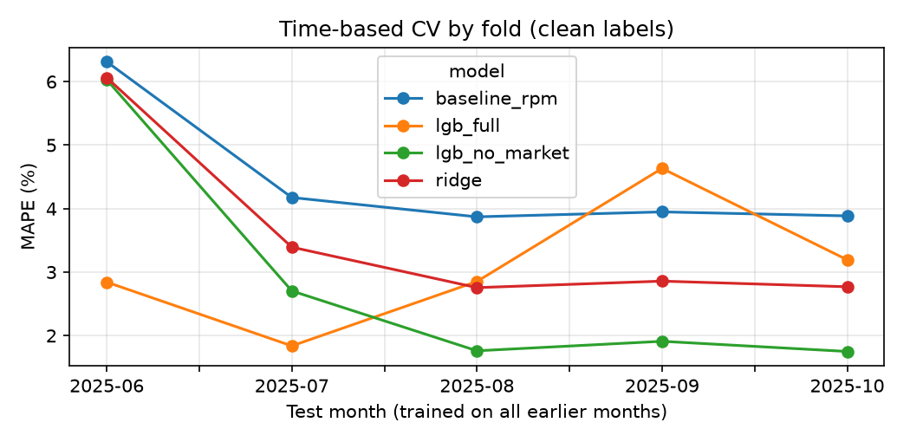
Market features (market_index, quote_signal) did not improve time-based CV (lgb_full vs lgb_no_market), so the final model excludes them. This also lets one model serve both the 12,000 validation loads and the December chart, where those features do not exist. The raw-label RMSE is dominated by the corrupted labels, which no model can predict.

4. December prediction
The fixed lane (Lexington to Fort Wayne, 360 mi, Dry Van, 32,000 lb) is scored with the same model, so only the date changes. The curve is a weekly cycle (about $814 to $832, mean $826, about $2.29/mi), consistent with the lane's own Jan-Oct history (mean $2.26/mi). There is no trend because the training data shows no reliable month-level effect once distance and equipment are accounted for.
