Database Application Programming
Project Status and Design Report

Topic: | Milestone
Date: | 2/16/2020
Revision: | 1.1
Team: | - Charles Davis
Team Status:
  Task | Team  Member | Hours  Worked | Hours Remaining
  User Info Database Creation | Charles | 1 | 0
  User Registration | || | 1 | 0
  User Login | || | 2 | 0
  Start Page | || | 1 | 0
  Admin Page | || | 1 | 0
  Admin User List Display | || | 1 | 0
  User Info Display Page | || | 1 | 0
  Create Blog Post Page | || | 3 | 0
  Prohibited Words finder | || | 2 | 0
GIT URL: | n/a
Hosting URL: | Localhost
Peer Review: | Y | We acknowledge that our team has reviewed this Report and we agree to the approach we are all taking.
Supporting Design Documentation
Install Instructions:
- Install MAMP on to your computer
- Import user table
  - Open MAMP
  - Start the MAMP servers
  - Open the web start page from the MAMP application
  - Under the tools dropdown menu in the MAMP web start page, select the phpMyAdmin link
  - On the left panel of phpMyAdmin click on New
  - Name the data base “milestonedb”
  - Select the import tab and upload the SQL file from the project folder
  - Press the go button at the bottom of the page
  - The user and post tables are now set up
- Server set up
  - Place the project folder inside of “C:\MAMP\htdocs”

General Technical Approach:
In the current status of the project, the approach of the design is learning the different components of web programming and then applying them to a product that will eventually allow a user to have a blog.

Key Technical Design Decisions:
Because of this project is a first time learning experience, the project does not have a final design because the minimal understanding web programming. Once a point of sufficient understanding is achieved, a final technical design will be made.
Current Design: functional : beautification comes after all of the functionality is completed.

ER Diagram:
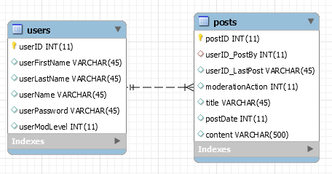
Sitemap Diagram:
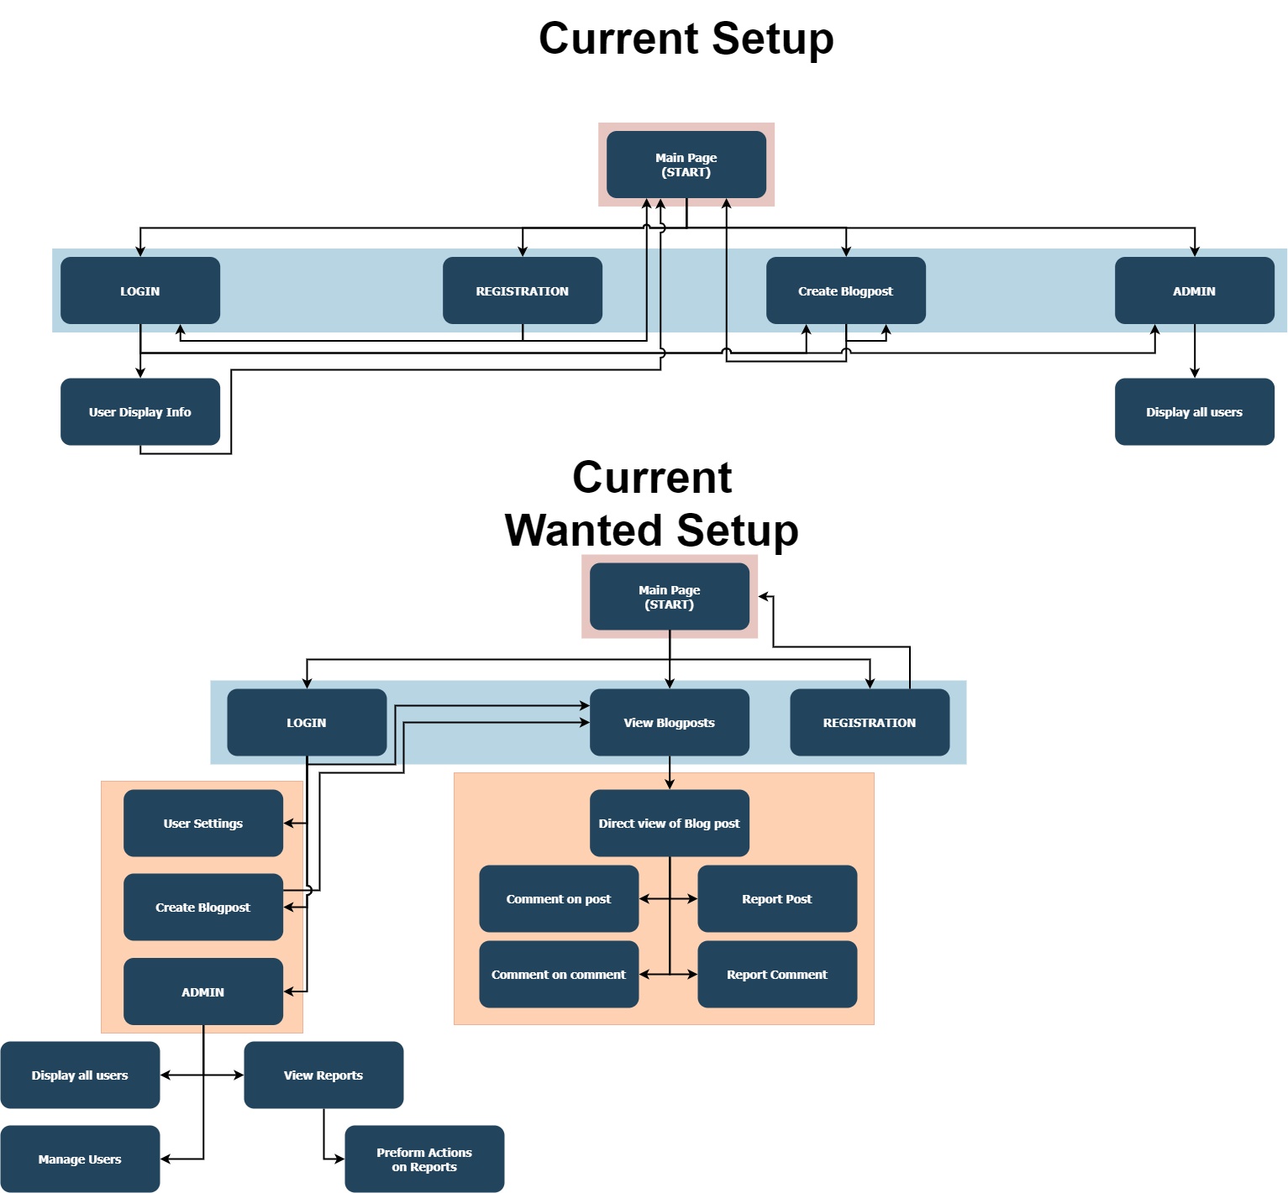

DDL Scripts:
n/a
This should contain a link to Bitbucket where the DDL script can be downloaded.

User Interface Diagrams:
Img not made. UI currently a basic HTML websight that contains: User Registration, User Login, Create Blog Post, User Info Display, Admin Page.

Other Documentation:
None has been made.
General drawings / SBs will be made after the functionality of the site is done.
You should insert any additional drawings, storyboards, white board pictures, project schedules, tasks lists, etc. that support your approach, design, and project. If you have no supporting documentation, please explain the rationale for leaving this section as N/A.

