# Financial Policy Summary

**The Financial Policy Committee (FPC) aims to ensure the UK financial system is prepared for, and resilient to, the wide range of risks it could face — so that the system can serve UK households and businesses in bad times as well as good.**

##### The UK financial system is supporting the economy during the pandemic

UK households and businesses have needed support from the financial system to weather the economic disruption associated with Covid-19 (Covid). The financial system has so far provided that support, reflecting the resilience that has been built up since the global financial crisis, and the extraordinary policy responses of the UK authorities.

Businesses have raised substantial external financing since the start of the Covid pandemic from banks and financial markets, to help finance their cash-flow deficits. Households’ debt-servicing burdens have fallen during that period, supported by payment deferrals from lenders. The extension of the Coronavirus Job Retention Scheme has supported household incomes.

Although there have been encouraging developments on vaccines, the FPC, consistent with its remit, is focused on the range of downside risks that remain. These include risks that could arise from the evolution of the pandemic and consequent measures to protect public health, as well as from the transition to new trading arrangements between the European Union and the United Kingdom.

##### The outlook for financial stability

###### Banking system resilience

The FPC judges that the UK banking system remains resilient to a wide range of possible economic outcomes. It has the capacity to continue to support businesses and households even if economic outcomes are considerably worse than currently expected. This reflects the build-up of substantial buffers of capital since the global financial crisis.

Over the course of 2020, major UK banks’ and building societies’ (‘banks’) aggregate Common Equity Tier 1 capital ratio has increased to 15.8% at end-September, which is over three times higher than at the start of the global financial crisis. Over this period, they have provisioned for £20 billion of credit losses, although the effect on the capital ratio is reduced by the transitional relief of IFRS 9.

Some headwinds to banks’ capital ratios are therefore anticipated over coming quarters as unemployment rises, business insolvencies rise from current low levels, and risk weights on banks’ exposures increase. Nevertheless, the major UK banks can absorb credit losses in the order of £200 billion, much more than would be implied if the economy followed a path consistent with the MPC’s central forecast.

The FPC judges that the UK and global macroeconomic scenarios required to generate losses on this scale would need to be very severe with, for example, UK unemployment rising to more than 15%.

The FPC expects banks to use all elements of capital buffers as necessary, to continue to support the economy. Alongside the Prudential Regulation Authority (PRA), it is taking action to support the use of capital buffers.

The FPC is updating its guidance on the path for the UK countercyclical capital buffer (CCyB) rate. It now expects this rate to remain at 0% until at least 2021 Q4. Due to the usual 12-month implementation lag, any subsequent increase is not expected to take effect until 2022 Q4 at the earliest. The eventual pace of return to a standard 2% UK CCyB rate will depend on banks’ ability to rebuild capital while continuing to support households and businesses.

The FPC welcomes the PRA’s intention to return towards the standard framework for bank distributions. This reflects some reduction in the uncertainty related to Covid, and the ability of banks to withstand significant losses. The FPC recognises the importance of a stable and predictable capital framework which provides certainty to banks and facilitates the use of capital buffers where necessary.

**Cutting support to the economy to avoid the use of capital buffers would be costly for the wider economy and consequently for banks themselves.**

###### Stability in the provision of financial services at the end of the transition period with the EU

**Financial sector preparations for the end of the transition period with the EU are now in their final stages. Most risks to UK financial stability that could arise from disruption to the provision of cross-border financial services at the end of the transition period have been mitigated.** The mitigation of these risks reflects extensive preparations made by authorities and the private sector over a number of years.

However, financial stability is not the same as market stability or the avoidance of any disruption to users of financial services. Some market volatility and disruption to financial services, particularly to EU-based clients, could arise.

Market volatility could be reinforced in the event that some derivative users are not fully ready to trade with EU counterparties or on EU or EU-recognised trading venues. Financial institutions should continue taking measures to minimise disruption.

**Irrespective of the particular form of the UK’s future relationship with the EU, and consistent with its statutory responsibilities, the FPC remains committed to the implementation of robust prudential standards in the UK. This will require maintaining a level of resilience that is at least as great as that currently planned, which itself exceeds that required by international baseline standards, as well as maintaining UK authorities’ ability to manage UK financial stability risks.**

###### Developments in the UK mortgage market

Mortgage credit conditions remain tighter than at the start of the year, particularly for high loan to value mortgages. This reflects reduced risk appetite from lenders due to the economic outlook, as well as operational constraints in meeting the current high demand for mortgages.

The FPC’s mortgage market Recommendations limit the proportion of new mortgages with high loan to income ratios, guarding against an increase in the number of highly indebted households.

The measures are structural and intended to remain in place through cycles in the mortgage market. The FPC’s last review of its Recommendations in 2019 found no evidence that they were having a material impact on mortgage availability overall since they were introduced in 2014. That has remained the case since.

The FPC periodically reviews its measures, including their calibration. It judges that changes over time in the risks faced by households mean the measures warrant a further review. That is under way and the FPC will report its conclusions in 2021.

##### Ensuring the financial system is ready to serve the future economy

###### The supply of productive finance for companies

In order to help limit the degree of economic scarring caused by Covid, work to increase the supply of longer-term, equity-like financing is increasingly important. The Bank, with HM Treasury and the Financial Conduct Authority, has launched an industry working group to facilitate investment in productive finance.

###### Systemic stablecoins

Stablecoins are digital tokens that claim to maintain a stable value at all times, primarily in relation to existing national currencies. They could provide benefits to users but will be adopted widely and become successful as a means of payment only if they meet appropriate standards and confidence in their value is assured.

The FPC, along with many authorities internationally, is considering the potential effects on financial stability if stablecoins were to be adopted widely. A discussion paper on these issues will be published in due course by the Bank. That paper will also address issues that may arise in connection to the concept of a Central Bank Digital Currency — an electronic form of central bank money that could be used by households and businesses to make payments.

The FPC is also considering how the regulatory system should adapt to assure confidence in the value of stablecoins at all times, while supporting innovation, in an efficient way. Their users must be as sure of their ability to redeem their money in cash, at face value, at all times, as they are with private money ― commercial bank deposits ― that is in widespread circulation in the UK today.

# Overview of risks to UK financial stability

UK households and businesses have needed support from the financial system to weather the economic disruption associated with the Covid-19 (Covid) pandemic. The UK financial system has so far provided that support, reflecting the resilience that has been built up since the global financial crisis, and the extraordinary policy responses of the UK authorities.

The Financial Policy Committee (FPC) judges that the UK banking system remains resilient to a wide range of possible economic outcomes. It has the capacity to continue to support households and businesses, even if economic outcomes are considerably worse than currently expected. Cutting support to the economy to avoid the use of capital buffers would be costly for the wider economy and consequently for the major UK banks and building societies themselves.

In order to help limit the degree of economic scarring caused by Covid, work to increase the supply of longer-term, equity-like financing is increasingly important. The Bank, with HM Treasury and the Financial Conduct Authority (FCA), has launched an industry working group to facilitate investment in productive finance.

Vulnerabilities in the global system of market-based finance were exposed in March. Should the outlook worsen, and markets to adjust abruptly, these vulnerabilities could be exposed again. The FPC continues to advance its work, domestically and internationally, to address the underlying issues.

#### : The economic backdrop

The impact of the Covid pandemic and the measures introduced to reduce its spread continue to pose risks to financial stability, globally and in the UK.

In recent months, an increase in new Covid cases resulted in governments in many countries reintroducing restrictions on activity to help control the resurgence of the virus. As set out in the [November 2020 *Monetary*](https://www.bankofengland.co.uk/monetary-policy-report/2020/november-2020)[*Policy Report*](https://www.bankofengland.co.uk/monetary-policy-report/2020/november-2020)(*MPR*), this is expected to weigh on both UK and global GDP.

In November, there was encouraging news on three potential Covid vaccines. But the economic outlook remains exceptionally uncertain. It depends on the evolution of the pandemic and the measures taken to protect public health, as well as the response of households, businesses and financial markets to these developments. There is uncertainty around the nature of and transition to new trading arrangements between the European Union (EU) and United Kingdom.

#### : Near-term risks to UK financial stability

##### Companies

Businesses have raised substantial external financing since the start of the Covid-19 pandemic from banks and financial markets, and many may have been able to finance their cash-flow deficits.

Bank staff estimate that UK companies could face a cash-flow deficit in the 2020–21 financial year of up to around £180 billion under the forecast set out in the November *MPR*, and after taking into account Government action to support businesses announced since then (**Chart 1.1**).1 This estimate is materially higher than a typical cash-flow deficit for businesses, of around £100 billion.2

**Chart 1.1:** Many businesses might have been able to finance their cash-flow deficits

UK corporates’ cumulative net finance raised alongside estimated cash-flow deficits(a)(b)(c)

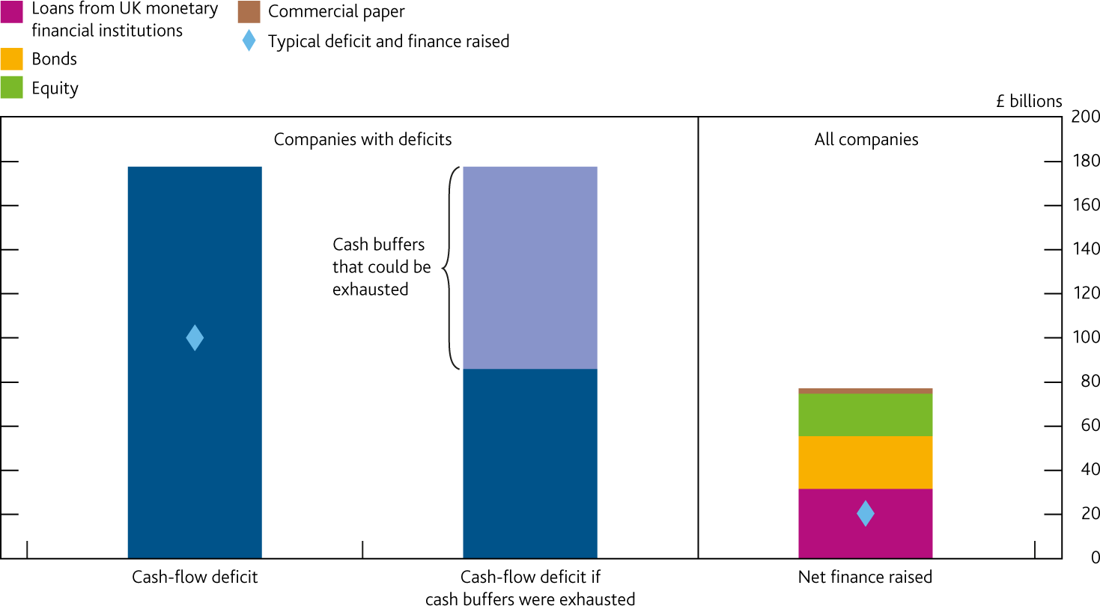

Sources: Bank of England, Fame (Bureau van Dijk), ONS, S&P Global Market Intelligence LLC’s Capital IQ service and Bank calculations.

1. The cash-flow deficit bar considers only firms with deficits. The deficit after exhausting cash buffers assumes firms use up all their available cash. Net finance raised considers UK private non-financial corporates (and excludes some forms of finance, eg private equity) between March and October 2020 (not seasonally adjusted). Some finance raised will not finance deficits, nor be raised by firms with deficits.
2. The ‘typical’ cash-flow deficit refers to the aggregate negative cash flows estimated from companies’ latest pre-Covid balance sheet data, measured before dividend distributions and share buybacks. ‘Typical’ finance raised is the average cumulative net finance raised between March and October for 2016–19 (not seasonally adjusted).
3. The cash-flow deficit figures shown are the maximum of the estimated ranges (£148 billion–£176 billion and, for the typical deficit, £90 billion–£100 billion). Cash buffers that could be exhausted is the mid-point of the estimated range (£87 billion–£97 billion).

If UK companies with available cash balances before this year used these to finance their cash-flow deficits, this would reduce the estimated deficit to around £90 billion. But the extent to which they would choose to do so is uncertain; many may prefer to preserve existing cash balances.

Since March, UK businesses have raised over £77 billion of net additional financing from banks and through access to financial markets. Supervisory intelligence suggests the vast majority of net bank lending over that period has been via government-backed loan schemes. Net bank lending to UK small and medium-sized enterprises (SMEs) in the year to October was more than 40 times higher than the 2016–19 average. By contrast, larger UK corporates have repaid bank loans in recent months but have at the same time issued equity and bonds. UK businesses’ cumulative net equity issuance in the year to October was over £18 billion — compared to negative cumulative net issuance on average for the same period between 2016 and 2019.

This net increase in finance, coupled with existing cash buffers, may have enabled many businesses to finance their cash-flow deficits in the period up to October. However, some businesses may need additional finance to bridge the renewed disruption to activity since then.

1. The estimate is a little lower than presented in the [August 2020 *Financial Stability Report*](https://www.bankofengland.co.uk/report/2020/monetary-policy-report-financial-stability-report-august-2020)(*FSR*) as, in aggregate, the effect of Government measures on cash-flow deficits is estimated to slightly more than offset the effect of the new restrictions.
2. The typical cash-flow deficit refers to aggregate negative cash flows before dividend distributions and share buybacks, according to latest available data.

Some businesses may look to access further external finance to help meet cash-flow deficits in the period ahead…

The Government has confirmed that access to its three lending schemes — the Bounce Back Loan Scheme (BBLS), the Coronavirus Business Interruption Loan Scheme and the Coronavirus Large Business Interruption Loan Scheme — will be extended, to receive applications through to the end of January 2021. This will provide support to qualifying businesses that may require further financing during this phase of restrictions.

Some companies may have already reached the maximum borrowing limit under the schemes. Supervisory intelligence also indicates many BBLS borrowers would have fallen outside lender risk appetites without the guarantee. In November, however, the Government announced that BBLS borrowers could ‘top up’ their existing loan under the scheme if they had originally borrowed less than the maximum amount available to them: staff estimate that this could accommodate an additional £5 billion of lending in aggregate.3

Reflecting the uncertain economic environment, the terms on loans not backed by government-backed schemes are tightening. Supervisory intelligence indicates that lenders have reduced loan limits or tightened their underwriting standards for certain sectors.

In addition, a large number of businesses — many of which are SMEs — have made claims for losses related to the pandemic under business interruption insurance policies. The variation in the types of cover provided and wordings used mean it can be difficult to determine whether customers have cover and can make a valid claim. [The FCA brought a test case to the High Court to help resolve this uncertainty as quickly as possible,](https://www.fca.org.uk/firms/business-interruption-insurance#latest-updates) and appeals at the Supreme Court were heard in November. The scope of the test case covered policy wordings held by approximately 370,000 policyholders.

…and unemployment and insolvencies are likely to increase in 2021.

Some companies, particularly those in sectors of the economy exposed to more structural change that has been accelerated by Covid, may face challenges to their longer-term viability. Analysts’ expectations of earnings in three years’ time provide one perspective on those sectors perceived as most affected (**Chart 1.2**). These companies may be unable, or unwilling, to access additional external finance.

**Chart 1.2:** Weakness in earnings is expected to persist into the medium term in certain sectors

Analysts’ expectations for listed company earnings in three years’ time, as a proportion of pre-Covid earnings(a)

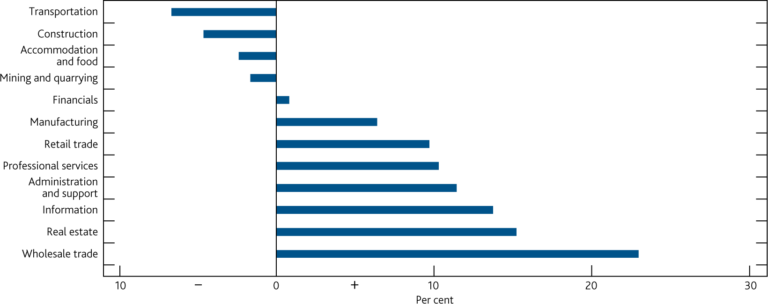

Sources: Eikon by Refinitiv and Bank calculations.

(a) Includes listed companies headquartered in the UK for which at least one analyst has estimated their earnings before interest, taxes, depreciation and amortization (EBITDA) in three financial years’ time. Chart shows sector averages, weighted by companies’ pre-Covid EBITDA. Pre-Covid earnings defined as the EBITDA most recently reported for an annual period concluding prior to 28 February 2020. Analysts’ expectations calculated as the average of analysts’ EBITDA forecasts for each company as of 2 December 2020.

Smaller companies tend to: be more concentrated in those sectors most affected by the public health measures; have seen a greater increase in indebtedness relative to larger firms to date; and also may find their capacity for further borrowing limited because they have already borrowed heavily using the government schemes.

1. The BBLS loan limit is the lower of £50,000 or 25% of turnover.

Unemployment is expected to increase in 2021 (see [November 2020 *MPR*](https://www.bankofengland.co.uk/monetary-policy-report/2020/november-2020)), and insolvencies are likely to increase from their current low levels. Insolvencies have remained subdued to date (**Chart 1.3**). They are a lagging indicator of corporate distress, and changes to the law on winding up petitions (introduced in April) have also reduced the number of insolvencies.4

**Chart 1.3:** Insolvencies have remained subdued to date but are expected to pick up into 2021

Total new corporate insolvencies(a)

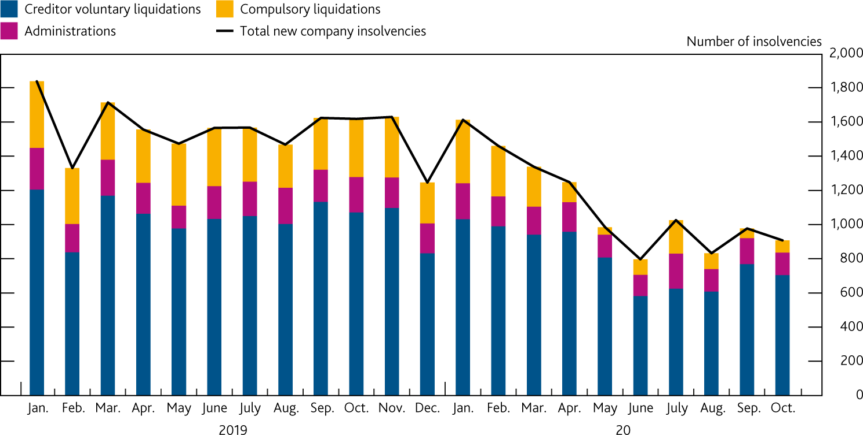

Sources: The Insolvency Service and Bank calculations.

1. Data on members’ voluntary liquidations are not included in this chart.

##### Households

The share of households with high debt-servicing burdens fell at the beginning of 2020 H2.

Results from the NMG survey suggested that the share of UK households with high debt-servicing burdens on their mortgages — ie debt-servicing ratios (DSRs) of at least 40% — was 1.3% at the beginning of 2020 H2.5 This is consistent with the Covid special survey from Understanding Society, which estimates the share at 1.4% in July (**Chart 1.4**). The share has fallen since May, driven by a faster than expected recovery in households’ earnings, but remains elevated compared with its pre-Covid level of 0.9%.

**Chart 1.4:** The share of households with high mortgage DSRs has fallen since May

Percentage of households with mortgage DSRs at or above 40%(a)(b)(c)

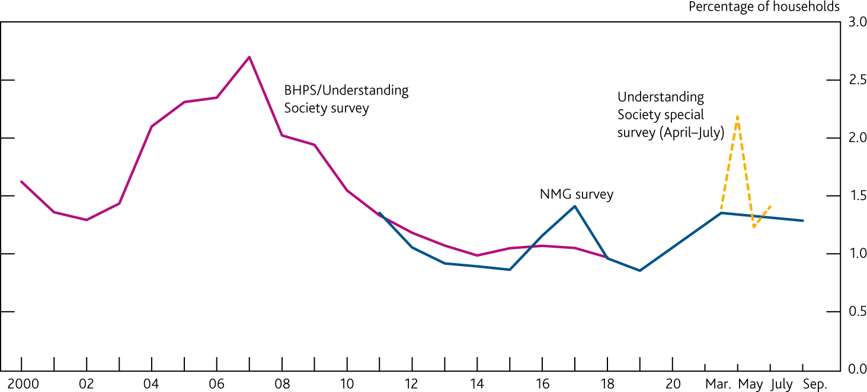

Sources: British Household Panel Survey/Understanding Society (BHPS/US), NMG Consulting survey and Bank calculations.

1. Percentage of households with mortgage DSR at or above 40% calculated using BHPS (1991–2009), US (2009–19), and the online waves of NMG Consulting survey (2011–20). NMG data are from H2 surveys only, aside from in 2020. Mortgage DSR calculated as total mortgage payments as a percentage of pre-tax income.
2. A new household income question was introduced in the NMG survey in 2015. Adjustments have been made to data from previous waves to produce a consistent time series.
3. US special survey estimates calculated by adjusting latest mortgage DSRs reported in the main survey for the change in household earnings since January/February reported in Waves 1–4 of the US Covid survey.
4. These changes were implemented by and under the [Corporate Governance and Insolvency Act (2020).](https://www.legislation.gov.uk/ukpga/2020/12/contents/enacted)
5. These estimates do not take into account the effect of payment deferrals, under which households do not have to make repayments on debt for the duration of the deferral, temporarily reducing their DSR.

*The extension of the Coronavirus Job Retention Scheme (CJRS) will limit job losses in the near term…* The reintroduction of restrictions on activity in October and November is expected to adversely affect households’ earnings. But the extension of the CJRS to March 2021 will provide immediate support to household incomes and can be expected to dampen the unemployment rate in the near term. The share of private-sector employees on furlough, which reached around 40% in the April/May period, fell to around 8% ahead of the recent restrictions. It reached 15% in the first half of November as employees were once again placed on furlough in response to the restrictions.

*…and the extension of payment deferral measures will support households in servicing their debt.* Payment deferral schemes (‘payment holidays’), announced by the FCA and offered by lenders, have also provided a form of forbearance to support borrowers who may be experiencing financial difficulties, by allowing a temporary freeze on mortgage and other loan repayments. They have helped to keep debt-servicing burdens low for UK households. UK Finance data for October suggested a total of 4.4 million payment deferrals had been agreed since the start of the pandemic, with around 320,000 deferrals still in place.

The FCA has extended its payment deferral guidance, with borrowers able to apply for an initial or further payment deferral until March 2021, and to extend existing deferrals until July 2021. This is subject to limitations: for example, the total duration of payment deferrals on a credit product may not exceed

six months. This can provide respite for borrowers facing challenging financial circumstances.

Payment deferrals are expected to mostly unwind by the end of 2021 H1, and in any case are limited to

six months. With unemployment likely to rise, some households might experience challenges making their debt repayments at the end of deferral periods. It will be important for lenders to work flexibly with borrowers as they resume repayments.

##### Banks

Major UK banks’ and building societies’ (banks’) capital positions remain strong.

Over the course of 2020, banks’ aggregate Common Equity Tier 1 (CET1) ratio had increased to 15.8%. However, some headwinds to banks’ capital positions are anticipated during 2021. This is principally from risk-weighted asset inflation, and the reduction in International Financial Reporting Standard 9 transitional relief on the existing stock of provisions as unemployment and insolvencies increase and some assets move

into default. Analyst consensus expectations are that major UK banks will incur further credit impairments over the course of 2021.

Nevertheless, the major UK banks can absorb credit losses in the order of £200 billion, much more than would be implied if the economy followed a path consistent with the MPC’s central forecast. The FPC judges that the UK and global macroeconomic scenarios required to generate losses on this scale would need to be very severe with, for example, UK unemployment rising to more than 15%. The FPC judges that the UK banking system has the capacity to continue to support businesses and households, even if economic outcomes are considerably worse than currently expected.

##### Markets

There remain a number of risks to market functioning — including corrections to prices of risky assets…

Global risky asset prices have been responsive to recent news — picking up in November after the US election and positive results on late-stage tests of three potential vaccines. However, corporate bond spreads appear compressed, despite the uncertain economic conditions, and credit fundamentals (**Chart 1.5**).

**Chart 1.5:** Relative to historical levels, corporate bonds spreads are compressed, despite uncertainty

Option-adjusted corporate bond spreads, relative to historical averages(a)(b)

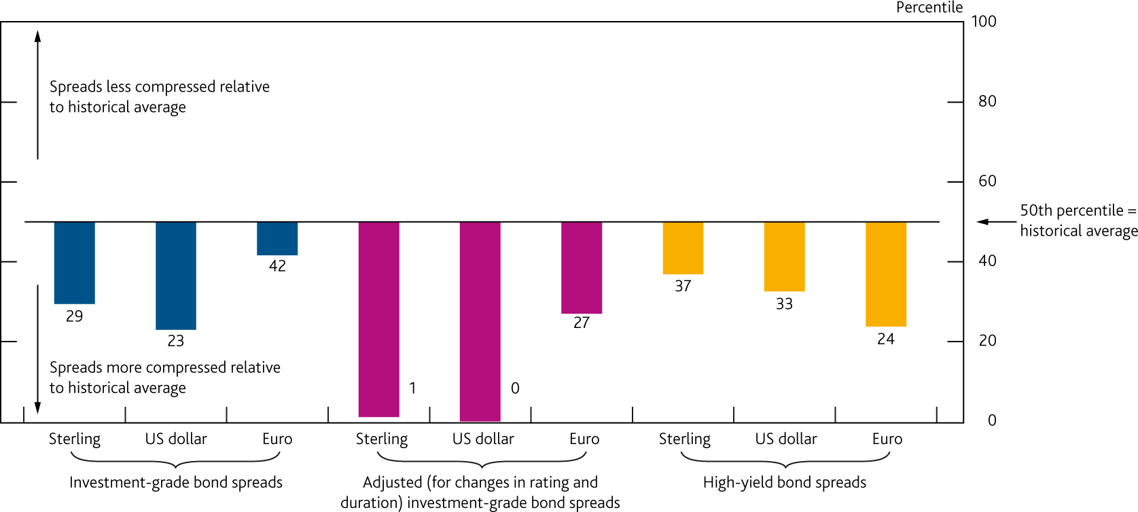

Sources: ICE/BoAML and Bank calculations

1. Bars show the percentile of the latest observation, relative to historical values. Data is from January 1998, with the exception of adjusted EUR corporate bond spreads starting in March 1998.
2. The adjusted credit spread is based on available data. It accounts for changes in credit quality and duration of the index since 1998, but not for changes to rating agencies’ methodologies over time.

…and the risk of fallen angels, where the immediate risk has fallen but remains elevated one to two years out.

Following a sharp increase in downgrades during March and April the volume of ‘fallen angels’ — bonds that have lost their investment grade status — has stabilised. The face value of ‘BBB-’ rated bonds across major currencies with a 50% chance of being downgraded in the next 90 days has more than halved since March. But the expected performance of bonds at a slightly longer — one to two year – horizon has worsened, with the share of sterling ‘BBB-’ rated bonds on ‘negative outlook’ having increased almost fivefold since March.

An increase in fallen angels could potentially lead to sales of such bonds accelerating and a disproportionate tightening in credit conditions. These risks could crystallise earlier if the outlook deteriorates. The capacity of the sterling high-yield market to absorb such sales could still be tested, were downgrade rates to increase.

While financial markets have continued to function effectively since the August FSR…

Financial markets have continued to function effectively since the ‘dash for cash’ episode in March. This episode saw certain markets — including those essential to the smooth functioning of the UK financial system

— become severely disrupted, making central bank intervention necessary to restore order.

Bid-offer spreads on long-term gilts — which provide a benchmark for many other borrowing rates relevant to the Government, businesses and households, and are therefore a key component of the functioning of the financial system — have returned to their pre-Covid levels (**Chart 1.6**). Corporate bond bid-offer spreads are only slightly elevated compared to pre-Covid levels. And the sterling repo market, an important source of liquidity for financial institutions, also has been stable with spreads remaining around their historical averages.

**Chart 1.6:** Bid-offer spreads on gilts and corporate bonds remain stable

Bid-offer spreads for gilts, US treasuries and corporate bonds

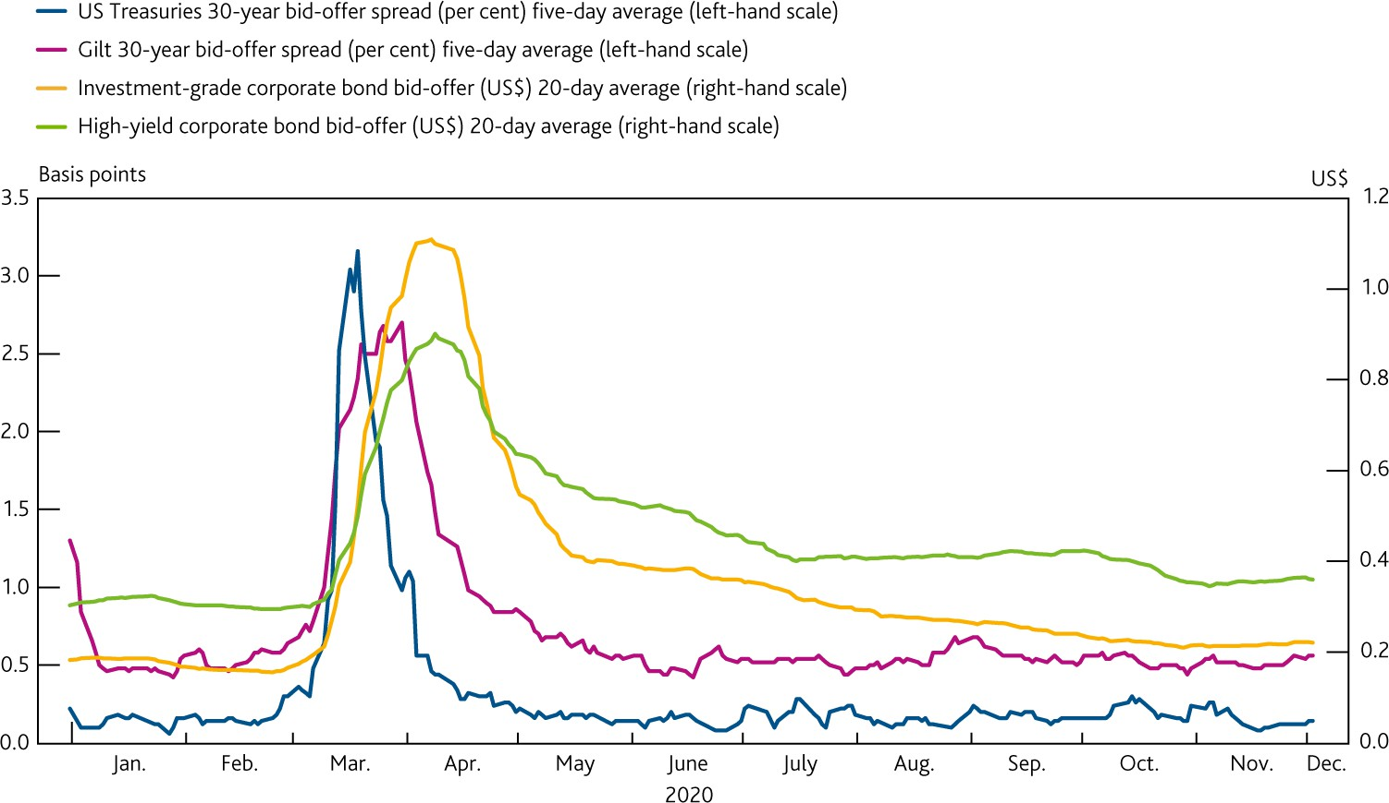

Sources: Eikon by Refinitiv, MarketAxess and Bank calculations.

…it remains crucial to analyse and, where necessary remediate, vulnerabilities exposed in the ‘dash for cash’ episode.

As set out in the August *FSR*, a number of areas need to be explored to address the vulnerabilities exposed in market-based finance during the March ‘dash for cash’ episode. Such work is necessarily a global endeavour, reflecting the international nature of these markets and their interconnectedness.

In November, [the Financial Stability Board (FSB) published its holistic review of the March market turmoil.](https://www.fsb.org/2020/11/holistic-review-of-the-march-market-turmoil/) The report concludes that this episode underscored the need to strengthen resilience in the sector, and sets out a comprehensive workplan for addressing the vulnerabilities that were exposed.

The FPC welcomes the FSB’s report, and the Bank and FCA will continue to work closely with counterparts in the FSB on the next stages of this work to enhance the resilience of the non-bank financial system. The FPC will publish a full update on its market-based finance agenda in 2021 H1. This follows publication of the FPC’s preliminary findings in the August *FSR*, and will also represent the FPC’s response to HM Treasury’s recommendation to publish a more detailed assessment of the oversight and mitigation of systemic risks from the non-bank financial sector by end-2020. Completing this review in 2021 H1 enables the FPC to incorporate the findings of the FSB’s holistic review into its assessment, and help the Bank to feed its findings into the international consideration of efforts to address any problems identified.

##### Operational risks

While most risks to UK financial stability at the end of the transition period with the EU have been mitigated, some market volatility and disruption to financial services could arise.

As set out in Section 3, most risks to UK financial stability that could arise from disruption to the provision of cross-border financial services at the end of the transition period have been mitigated. However, financial stability is not the same as market stability or the avoidance of any disruption to users of financial services. Some market volatility and disruption to financial services, particularly to EU-based clients, could arise.

The FPC welcomes announcements from ICE Benchmark Administration (IBA) and the FCA to support an orderly wind down of Libor benchmarks.

It remains essential to end reliance on Libor benchmarks. In November, [the administrator of Libor, IBA,](https://ir.theice.com/press/news-details/2020/ICE-Benchmark-Administration-to-Consult-On-Its-Intention-to-Cease-the-Publication-of-GBP-EUR-CHF-and-JPY-LIBOR/default.aspx) [announced that it will consult on its intention for the euro, sterling, Swiss franc, Japanese yen and some](https://ir.theice.com/press/news-details/2020/ICE-Benchmark-Administration-to-Consult-On-Its-Intention-to-Cease-the-Publication-of-GBP-EUR-CHF-and-JPY-LIBOR/default.aspx) [US$ Libor panels to cease at end-2021, and for the remainder of US$ panels to cease at end-June 2023;](https://ir.theice.com/press/news-details/2020/ICE-Benchmark-Administration-to-Consult-On-Its-Intention-to-Cease-the-Publication-of-GBP-EUR-CHF-and-JPY-LIBOR/default.aspx) this

consultation was [published in December.](https://www.theice.com/publicdocs/ICE_LIBOR_Consultation_on_Potential_Cessation.pdf) In parallel, [US regulators issued supervisory guidance on limiting new](https://www.federalreserve.gov/newsevents/pressreleases/files/bcreg20201130a1.pdf) [use of US$ Libor after end-2021.](https://www.federalreserve.gov/newsevents/pressreleases/files/bcreg20201130a1.pdf) The [FCA also set out, and published consultations on, its potential approach to](https://www.fca.org.uk/news/statements/fca-consults-on-new-benchmark-powers)

[the use of proposed new powers under the Financial Services Bill to ensure an orderly wind down of Libor,](https://www.fca.org.uk/news/statements/fca-consults-on-new-benchmark-powers) and [noted it will co-ordinate with US and other authorities around limiting new use of US$ Libor.](https://www.fca.org.uk/news/statements/fca-response-iba-proposed-consultation-intention-cease-us-dollar-libor)

Work is under way across global markets to reduce the risk of disorderly outcomes for contracts that continue to rely on Libor. In October, [ISDA published a protocol for legacy Libor-linked derivatives contracts.](https://www.isda.org/2020/10/23/isda-launches-ibor-fallbacks-supplement-and-protocol/) This provides a readily available avenue to adopt fallbacks into most non-centrally cleared derivative contracts and replace Libor with risk-free rate alternatives, once the fallbacks have been triggered. So far over 1,500 entities worldwide have signed up, including the Bank in respect of its own market activity*.*

#### : Ensuring the financial system is ready to serve the future economy

The FPC’s workplan on productive finance is intended to support the sustainability of corporate sector financing.

At the aggregate level, the UK corporate debt to earnings ratio increased from 320% at the end of 2019 to 344% at the end of 2020 H1. Removing impediments to businesses’ access to longer-term, equity-like and potentially more illiquid financing, can support economic growth and financial stability. It could also help to support the Government’s aim to transition to an economy with net zero greenhouse gas emissions.

Addressing possible distortions to the supply and intermediation of longer-term productive finance, as set out in the [August *FSR*,](https://www.bankofengland.co.uk/report/2020/monetary-policy-report-financial-stability-report-august-2020) is one of many factors that can help pave the way for a higher level of investment.

There have been important developments in this work since August. This includes a [new industry working](https://www.bankofengland.co.uk/news/2020/november/hmt-boe-and-fca-convene-working-group-to-facilitate-investment-in-productive-finance) [group, to be convened by the FCA, the Bank and HM Treasury to facilitate investment in productive finance.](https://www.bankofengland.co.uk/news/2020/november/hmt-boe-and-fca-convene-working-group-to-facilitate-investment-in-productive-finance) The FCA plans to consult early in 2021 on setting up a framework for a long-term asset fund.

The Climate Biennial Exploratory Scenario will resume in 2021.

Every two years, the Bank runs a biennial exploratory scenario (BES), an exercise that uses an exploratory scenario to test the UK financial system against a potential future risk. In May 2020, as part of the Bank’s response to Covid, the FPC and Prudential Regulation Authority agreed to postpone the launch of the BES on climate change risk, due to take place in 2021. On 9 November, [the Governor announced that the work would](https://www.bankofengland.co.uk/speech/2020/andrew-bailey-speech-corporation-of-london-green-horizon-summit) [resume, with a launch date of June 2021.](https://www.bankofengland.co.uk/speech/2020/andrew-bailey-speech-corporation-of-london-green-horizon-summit) The exercise will explore the largest UK banks’ and insurers’ resilience to three different climate scenarios, testing different combinations of physical and transition risks over a

30-year period.

*The FPC is taking forward its consideration of risks from payment systems that are or could attain systemic importance in the United Kingdom, including new forms of payments involving stablecoins.* The FPC has set out clear expectations for the regulation of such payment systems and will be developing these further to ensure that regulation of innovative payment systems aligns with the risks they could pose (see Section 5). The FPC supports HM Treasury’s Payments Landscape Review and its planned consultation on the UK regulatory approach to cryptoassets and stablecoins, as well as the Bank of England’s upcoming discussion paper on digital assets.

# In focus The resilience of the UK banking sector

The FPC judges that the UK banking system remains resilient to a wide range of possible economic outcomes. It has the capacity to continue to support households and businesses even if economic outcomes are considerably worse than currently expected. This reflects the build-up of substantial buffers of capital since the global financial crisis.

Over the course of 2020, the aggregate Common Equity Tier 1 (CET1) capital ratio of the major UK banks and building societies (banks) has increased to 15.8% — around 9 percentage points above minimum requirements. Some headwinds to banks’ capital ratios are anticipated during 2021. Nevertheless, banks remain well capitalised and able to support the economy.

The FPC expects banks to use all elements of capital buffers as necessary, to continue to support the economy. Alongside the Prudential Regulation Authority (PRA), it is taking action to support the use of capital buffers. Cutting support to the economy to avoid the use of capital buffers would be costly for the wider economy and consequently for the banks themselves.

#### : The resilience of the UK banking sector

Banks’ capital positions remain strong, even as they have provisioned for credit losses.

The CET1 capital ratios of the major UK banks have continued to rise over the course of 2020 (**Chart 2.1**).

**Chart 2.1:** The aggregate CET1 ratio is more than three times higher than it was before the financial crisis

Aggregate CET1 capital ratio of major UK banks(a)(b)

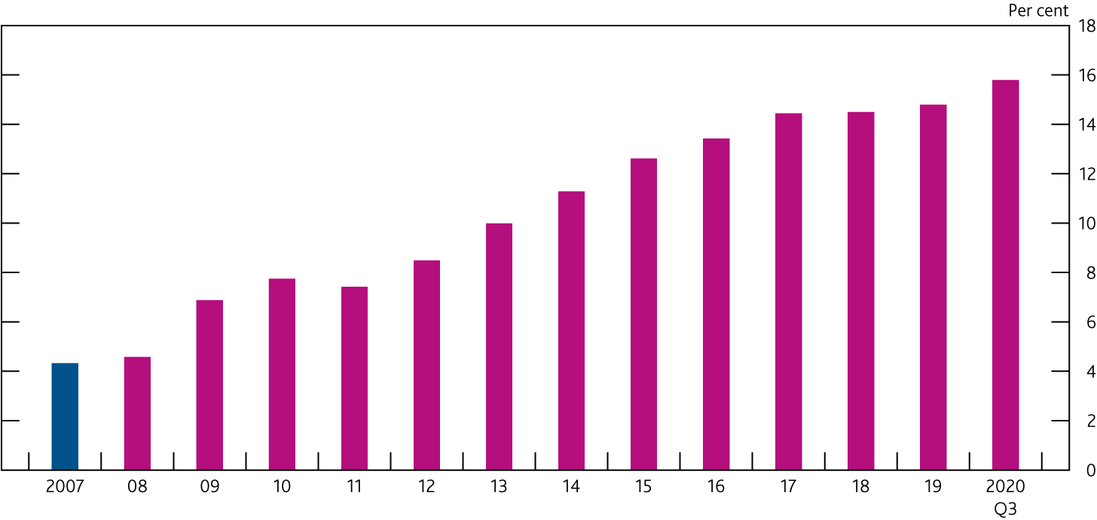

Sources: PRA regulatory returns, published accounts, Bank analysis and calculations.

1. The CET1 capital ratio is defined as CET1 capital expressed as a percentage of risk-weighted assets. Major UK banks are Barclays, HSBC, Lloyds Banking Group, Nationwide, NatWest Group, Santander UK and Standard Chartered. From 2011, data are CET1 capital ratios as reported by banks. Prior to 2011, data are Bank estimates of banks' CET1 capital ratios.
2. Capital figures are year-end, except 2020 Q3.

The aggregate CET1 capital ratio increased from 14.8% at end-2019 to 15.8% at end-September — over three times its pre-global financial crisis level. Banks have provisioned for around £20 billion of credit losses so far this year, although the effect on their capital ratios is reduced by the impact of International Financial Reporting Standard 9 (IFRS 9) transitional relief, which limits the extent to which credit loss provisions taken against assets that have not actually defaulted affect capital. The cancellation of outstanding 2019 dividends in line with the PRA’s guidance, has also bolstered banks’ capital ratios.

#### : The outlook for bank resilience

Some headwinds to banks’ capital ratios are anticipated in 2021.

Looking ahead, there are a number of factors that are likely to weigh on banks’ capital positions. For example, the credit losses banks have taken so far will be followed over time by an increase in risk-weighted assets as the underlying deterioration in credit quality begins to be reflected in risk weights. And as unemployment and insolvencies rise, and more impaired loans default, the benefit banks get from IFRS 9 transitional relief will fall away. Analyst consensus expectations are that banks will incur further impairments over the course of 2021.

Banks’ market valuations reflect the uncertainty about the economic outlook.

The average UK bank price to book ratio, which measures the market value of shareholders’ equity relative to the accounting value of that equity, has been persistently below one for a number of years now. It fell even more at the beginning of the year as the pandemic hit and profit expectations decreased materially (**Chart 2.2**). The recent weakness of bank valuations also reflects a material increase in the returns demanded by investors

— the cost of equity. The biggest influence on the cost of equity has been uncertainty about the economic outlook. Consistent with this, UK banks’ share prices increased sharply in mid-November, following the news regarding potential vaccines.

Developments over the course of the 2020 support the view that UK banks’ low price to book ratios are consistent with market concerns over expected future profitability rather than concerns about the solvency of banks. For example, while credit default swap spreads, which capture investors’ views on default risk, rose sharply at the onset of the Covid-19 (Covid) outbreak, they have now returned to pre-Covid levels. That is consistent with the high aggregate CET1 capital ratio for the major UK banks.

Although there are material downside risks, banks are resilient to a wide range of possible economic outcomes…

There are a range of downside risks to the economic outlook (see Section 1). However, even with some

near-term headwinds to capital, the August 2020 ‘reverse stress test’ suggested that banks would need to incur around £120 billion of credit losses (that is, a further £100 billion of losses beyond those already provisioned for) in order to deplete aggregate end-2019 capital by 5.2 percentage points — the extent of the capital drawdown in the 2019 stress test in which banks demonstrated they could continue to lend.

The FPC judges that the macroeconomic scenarios required to generate such losses would need to be very severe, with UK unemployment peaking at around 15%. This judgement is based on the ‘reverse stress test’ conducted by the FPC in August 2020, which used analysis of banks’ balance sheets and stress-testing data to assess how severe an economic shock would need to be to generate a particular level of credit losses.

In reality, the banking system is able to withstand scenarios even more severe than this. Banks have buffers of capital larger than those set for regulatory purposes; so, based on the end-2019 start point of the ‘reverse stress test’, £120 billion of losses would, in aggregate, deplete only around 60% of the buffers of capital which sit above banks’ minimum requirements. In aggregate, banks would be left with the ability to absorb a further

£80 billion of losses arising from further shocks before breaching regulatory minima. In total therefore, the ‘reverse stress test’ demonstrated how the major UK banks can absorb credit losses in the order of £200 billion, much more than would be implied if the economy follows a path consistent with the Monetary Policy Committee’s (MPC) central forecast.

*…and the most recent outlook is much less severe than the scenarios to which banks are resilient.* The MPC’s most recent central forecast for the UK and global economies in the November *MPR* remains materially less severe than the scenarios generated by the ‘reverse stress test’.6 While the outlook had

weakened since August 2020 on the back of the second wave of Covid, three-year cumulative GDP losses in the November *MPR* central projection were forecast to total around £470 billion (21% of annual 2019 GDP) — lower than the £610 billion included in the ‘reverse stress-test’ scenarios (**Chart 2.3**). Reflecting the extension of government support measures, the path for UK unemployment was also much less severe, averaging a little under 6% over three years.

|  |  |  |
| --- | --- | --- |
| **Chart 2.2:** The average price to book ratio of the major UK banks has been consistently under one, and fell further when the pandemic hit  Major UK banks’ price to book ratio(a)(b)  The blue line shows how the average share price of UK banks relates to its book value – that is the value of shareholder equity per share.  Sources: Bloomberg Finance L.P., Eikon from Refinitiv and Bank calculations.   1. UK banks are Barclays, HSBC, Lloyds Banking Group and NatWest Group. HSBC’s price to book ratio is adjusted for currency movements. 2. The underlying data have been sourced from Eikon from Refinitiv up to 2013, and from Bloomberg from 2014 onwards. |  | **Chart 2.3:** The central forecast in the November *MPR* is well within the ‘reverse stress-test’ scenario that would deplete banks’ capital buffers materially Comparison of key metrics in the November *MPR* and the August 2020 ‘reverse stress test’ over a three-year period(a)  Black dots show how the most recent central economic outlook compared with the double dip scenario in the ‘reverse stress test’.  Sources: Bank analysis and calculations.   1. The distance between the end points shows the proportionate change between shocks in the November *MPR* figures relative to the ‘reverse stress test’. For example,   three-year cumulative world GDP losses are roughly half those in reverse stress test so  the November *MPR* end point is roughly half way down the first black line. |

#### : Buffer usability

Cutting support to the economy to avoid the use of capital buffers would be costly for the wider economy and consequently for the banks themselves.

Capital buffers allow banks to continue to support the economy in downturns while also weathering losses. In doing that, the UK banking system can be a source of strength for the economy, helping to absorb rather than amplify the economic shock caused by Covid. It is in banks’ collective interest to continue to support viable, productive businesses, rather than seek to defend capital ratios and avoid using buffers by cutting their lending. If viable businesses are unable to meet their financing needs this could trigger larger corporate losses for banks, deepen the economic stress and have an even greater negative effect on banks’ capital ratios.

To ensure buffers can be used to support the economy, the FPC is updating its guidance on the path for the UK countercyclical capital buffer (CCyB) rate. It expects this rate to remain at 0% until at least 2021 Q4. Due to the usual 12-month implementation lag, any subsequent increase is not expected to take effect until 2022 Q4 at the earliest. The eventual pace of return to a standard 2% UK CCyB rate will depend on banks’ ability to rebuild buffers while continuing to support the UK economy, households and businesses. This guidance should give firms clarity that they can use capital buffers as necessary.

The FPC also welcomes the Prudential Regulation Committee’s (PRC) decision to freeze systemic risk buffer (SRB) rates for a further year. The FPC is mindful that banks’ ‘total assets’, the metric used to calibrate SRB

1. The ‘reverse stress test’ generated two scenarios, a ‘slow recovery’ and ‘double-dip’ scenario. Both were calibrated to result in the same level of capital drawdown. All references to the ‘reverse stress rest’ in this section refer to the double-dip scenario.

rates, have grown significantly during 2020 in part due to the MPC’s expansion of central bank reserves through quantitative easing. Without this action, some banks may have faced incentives to constrain lending to the real economy, in order to avoid sharp increases in capital requirements. The PRC decision supports buffer usability. The FPC intends to revisit this issue in due course, as part of a broader review of lessons learnt from the crisis about how the capital framework has supported lending to the economy under stress.

The FPC further welcomes the PRA’s intention to transition back towards the standard framework for bank distributions (see Box 1). Recommencing some distributions is consistent with the judgement that banks are resilient to, and can continue to lend in, a wide range of economic scenarios.

The FPC continues to support the Bank on its work with international colleagues in the Basel Committee to monitor the situation and assess the extent to which temporary changes to the capital framework may be necessary to promote the use of capital buffers for their intended purpose.

#### : Next steps

The FPC and PRC will conduct a stress test of the major UK banks and building societies in 2021.7 The Bank’s approach to stress testing aims to use periods in which the economy is growing to build up banks’ buffers of capital, ready to be drawn on to support the economy in a stress. This is achieved by stress testing banks against a broad, severe and hypothetical stress scenario that gets tougher as debt — and other vulnerabilities that can amplify a recession — builds up.

Once the economy enters a stress, as it has now, the focus changes, with stress tests used to assess if the buffers of capital that banks have built up are large enough to deal with how the stress could unfold. In the first instance, that involves testing banks against the likely effects of the stress. The FPC undertook this exercise in May 2020 through its desktop stress test, see the [May 2020 interim *Financial Stability Report*.](https://www.bankofengland.co.uk/report/2020/monetary-policy-report-financial-stability-report-may-2020) This found that banks had the capital buffers to withstand even greater losses than those resulting from the MPC’s plausible illustrative scenario.

The next step, given the uncertain economic outlook in an unfolding stress, is to assess that banks’ buffers of capital are sufficient to deal with the stress, even if it turns out to be more severe than central expectations. The August 2020 ‘reverse stress test’ therefore considered how severe a macroeconomic stress banks could withstand while continuing to lend. Policymakers can then use this analysis to assess how likely it is that banks’ resilience could be compromised, and to identify the point at which further policy actions might be necessary if the economic outlook deteriorated significantly.

The ‘reverse stress-test’ exercise showed that the macroeconomic paths required to deplete banks’ regulatory capital buffers would need to be very severe (**Chart 2.3**). The FPC judges the scenarios included in the ‘reverse stress test’ to reflect reasonable worst cases for the current economic outlook. Banks therefore have capital buffers that allow them to lend in and remain resilient to a wide range of possible scenarios for the UK and global economies over the coming year.

The aim of the 2021 stress test will be to update and refine the FPC’s assessment. It will test banks’ end-2020 balance sheets to a scenario similar to that generated in the ‘reverse stress test’. It will therefore be a

cross-check on the FPC’s judgement of how resilient banks are to a reasonable worst-case stress in the current environment and will support the PRA’s objective of promoting the safety and soundness of PRA-regulated firms. There will be no mechanical link from the results to regulatory response. But the outcome of the test will be used to update the FPC’s judgements about the most appropriate ways in which the banking system can continue to support the economy through the stress. It will therefore be used as an input into the PRA’s transition back to its standard approach to capital-setting and shareholder distributions through 2021.

1. This will involve the usual ‘annual cyclical scenario’ banks: Barclays, HSBC, Lloyds Banking Group, Nationwide, NatWest Group, Santander UK and Standard Chartered, and, for the first time, Virgin Money UK.

### Box 1

**Large UK banks’ 2020 shareholder distributions**

The Prudential Regulation Authority (PRA) made the exceptional request in March that banks suspend distributions, reflecting the uncertainty around the Covid-19 (Covid) shock

At the end of March 2020, the PRA welcomed the decisions of the boards of the large UK banks8 to suspend dividends and buybacks on ordinary shares until the end of 2020. At the PRA’s request they also cancelled payments of any outstanding 2019 dividends, even though these banks held capital well above regulatory levels, and above the levels at which prudential regulations would require restrictions on distribution.

This exceptional request reflected the unprecedented levels of economic uncertainty facing the global economy at that time due to the onset of the Covid pandemic. The unprecedented public health measures in prospect at the time would clearly lead to a very marked and widespread drop in economic activity but the extent and scale of these was not possible to forecast at that time. There was uncertainty, also, about the scale of monetary and fiscal responses that would be implemented to support the economy. It was unclear how these factors would impact upon macroeconomic outcomes, demand for bank lending, losses, and ultimately bank capital. Reflecting this overall uncertainty, share prices of many UK banks had nearly halved since the start of the year and wider risky asset prices had fallen sharply. Financial market volatility had surged and there had been severe market dysfunction, including in advanced-economy government bond markets.

The initial global spread of Covid occurred at a moment late in banks’ dividend calendars when dividend distributions they had announced were about to be paid out. Given this timing, the then existing market conditions, the very large and uncertain size of the forthcoming downturn, and the unique role that banks play in supporting the wider economy, the PRA’s request was a necessary precautionary step in order to reduce the possibility of an unsafe depletion of banks’ capital in the face of a risk of unknown dimensions.

The capital retained through this precautionary action contributed around 50 basis points to the aggregate Common Equity Tier 1 (CET1) ratio of the large UK banks. However, given the PRA’s actions did not reflect a permanent change in banks’ capital requirements, the capital retained would be available either to support lending, absorb future losses or be distributed to shareholders.

The PRA judges that banks have capacity to make prudent payouts with their 2020 results and intends to transition back towards the standard framework for bank distributions

Notwithstanding the impact of the Covid pandemic on the global economy, banks remain well capitalised and are expected to be able to continue to support the real economy through this period of disruption. The Prudential Regulation Committee (PRC) and Financial Policy Committee (FPC) have now carried out two stress tests of banks’ capital positions and have judged that banks are resilient to a wide range of economic outcomes (see Section 2), including economic scenarios that are materially more severe than current central expectations. Based on these assessments, although some headwinds to banks’ capital positions are expected during 2021, banks remain well capitalised and able to support the economy.

Set against that, economic uncertainty as a result of the Covid pandemic remains high, economic disruption continues and widespread government economic support is still in place. In addition, considerable uncertainty remains about the new relationship with the EU to which the UK will need to adapt in the coming months.

Weighing those considerations, and consistent with the PRA’s view that distributions are an important and necessary part of the functioning of the banking system, the PRA judges that an extension of the exceptional and precautionary action taken in March is not necessary and that there is scope for banks to recommence some distributions should their boards choose to do so, within an appropriately prudent framework.

With the removal of the PRA’s request not to make shareholder distributions, it is for banks’ boards to determine the appropriate level of distributions. Any distributions should be prudent, reflecting the still

1. Barclays, HSBC, Lloyds Banking Group, NatWest, Santander UK and Standard Chartered.

elevated levels of economic uncertainty and the need for banks to continue to support households and businesses through the continuing economic disruption, even in the event that this disruption is more prolonged and severe than currently anticipated. As a stepping stone back towards its standard approach to capital setting and shareholder distributions, the PRA therefore asks boards, when making their decisions for 2020 distributions, to operate within a framework of temporary guardrails (see [PRA statement on capital](https://www.bankofengland.co.uk/prudential-regulation/publication/2020/pra-statement-on-capital-distribution-by-large-uk-banks) [distributions by large UK banks](https://www.bankofengland.co.uk/prudential-regulation/publication/2020/pra-statement-on-capital-distribution-by-large-uk-banks)).

The PRA intends to transition back to its standard approach to capital setting and shareholder distributions through 2021. Under this framework, banks’ boards are responsible for making distribution decisions subject only to the standard constraints of the regulatory framework, including the regular annual stress test. In the meantime, for 2021 dividends the PRA is content for appropriately prudent dividends to be accrued but not paid out and aims to provide a further update ahead of the 2021 half-year results of large UK banks.

The FPC welcomes the PRA’s intention to transition back towards the standard framework for bank distributions

The FPC supported the exceptional actions taken in March, which were appropriate given the unprecedented levels of economic uncertainty at the time. The FPC now welcomes — from the perspective of its own objectives to support the supply of credit to the economy during this stress — the PRA’s intention to transition back towards the standard framework for bank distributions.

The FPC judges that banks are resilient to, and can continue to lend in, a wide range of economic scenarios (see Section 2). Recommencing some distributions is consistent with this judgement. The PRA’s framework of temporary guardrails will help to protect the resilience of the banking system in a wide range of possible outcomes.

The FPC recognises the importance of a stable and predictable capital framework which provides certainty to banks and facilitates the use of capital buffers where necessary. The high returns currently demanded by bank investors (banks’ high cost of equity) primarily reflect the uncertain economic outlook. The transition back towards the standard framework for bank distributions through 2021 should, by reducing any additional uncertainty about the outlook for dividends, help to reduce their cost of equity.

# In focus The provision of financial services after the end of the transition period

Financial sector preparations for the end of the transition period with the EU are now in their final stages. Most risks to UK financial stability that could arise from disruption to the provision of cross-border financial services at the end of the transition period have been mitigated. The mitigation of these risks reflects extensive preparations made by authorities and the private sector over a number of years.

However, financial stability is not the same as market stability or the avoidance of any disruption to users of financial services. Some market volatility and disruption to financial services, particularly to EU-based clients, could arise. Irrespective of the particular form of the UK’s future relationship with the EU, and consistent with its statutory responsibilities, the FPC will remain committed to the implementation of robust prudential standards in the UK.

*The UK’s transition period with the EU will end on 31 December 2020.*

The UK left the EU with a Withdrawal Agreement on 31 January 2020, entering an 11-month transition period that will end on 31 December 2020. Negotiations on a free trade agreement (FTA) covering the broad arrangements for trading goods and services between the UK and EU are continuing. The ability to provide cross-border financial services between the UK and the EU will largely be determined by regulatory decisions made autonomously by the UK and EU, distinct from the broader FTA negotiations.

To facilitate continued access by UK households and businesses to financial services provided by EU financial institutions after the end of the transition period, the UK has temporary permissions and recognition regimes in place, alongside temporary powers allowing UK regulators to delay or phase-in changes to UK regulatory requirements. In addition, following its equivalence assessments of the EU, the Government has made a number of equivalence determinations in relation to the EU, with the intention of supporting well-regulated open markets.

Those equivalence decisions will, beyond the end of the temporary regimes and powers, allow favourable regulatory treatment for UK banks’ and insurers’ cross-border activity with the EU, and facilitate UK users’ continued access to EU central counterparties (CCPs) and central securities depositories (CSDs). The Government may make further equivalence determinations in the future.

The EU’s equivalence assessment of the UK is ongoing. The European Commission has stated that it will not assess the UK for equivalence in nine areas in the short or medium term, including MiFIR Article 47, which covers the direct provision of investment banking services across borders.9 It has provided time-limited equivalence for the UK legal and supervisory framework for UK CCPs and CSDs.

Irrespective of the particular form of the UK’s future relationship with the EU, and consistent with its statutory responsibilities, the FPC will remain committed to the implementation of robust prudential standards in the UK. This will require maintaining a level of resilience that is at least as great as that currently planned, which itself

1. Markets in Financial Instruments Regulation.

exceeds that required by international baseline standards, as well as maintaining UK authorities’ ability to manage UK financial stability risks.

*Most risks to UK financial stability that could arise from disruption to the provision of cross-border financial services at the end of the transition period have been mitigated*.

Financial sector preparations for the end of the transition period are now in their final stages. Consistent with its financial stability objective, since 2016 the FPC has identified and monitored risks of disruption that could arise if no further arrangements were put in place for the provision of cross-border financial services when the UK’s trading arrangements with the EU change. The FPC reviewed its checklist of actions that would mitigate risks of disruption at the end of the transition period to important financial services used by households and businesses (**Table 3.A**). The FPC also reviewed other risks to the provision of cross-border financial services that could cause some, albeit less material, disruption if they are not mitigated (**Table 3.B**).

As set out above, temporary permission and recognition regimes and other preparations have been made by UK authorities to facilitate UK households’ and businesses’ access to existing and new services from EU financial institutions for a period after the end of the year. UK authorities have also acted to allow UK firms to continue trading all shares on EU trading venues after the end of the transition period.

UK financial institutions have continued to prepare for the continued provision of services to EU users.10 All material subsidiaries of UK firms have been authorised in the EU and are fully operational and over two thirds of clients of major UK-based banks have now completed the necessary documentation to enter into derivatives trades with EU entities. Many clients are also actively trading from the new EU entities. UK firms also continue to novate existing trades where necessary to ensure clients can manage risks related to ‘lifecycle’ events. 11 The EU has announced its intention to provide relief from margin and clearing requirements for certain existing trades that are novated from UK to EU counterparties before January 2022. If implemented, this would create further time for those trades to be novated without triggering additional requirements.

Reflecting the extensive preparations by UK authorities and the financial sector, the FPC continues to judge that most risks to UK financial stability that could arise from disruption to the provision of cross-border financial services at the end of the transition period have been mitigated.

*Financial stability is not the same as market stability or the avoidance of any disruption to users of financial services.*

Financial markets can be expected to react to the outcome of the negotiations on arrangements for trading goods and services between the UK and EU.

As reflected in the residual risks identified by the FPC in **Table 3.A** and **Table 3.B**, some disruption to financial services could arise. This could particularly affect EU-based clients and customers.

Some participants may not be fully ready to trade with EU counterparties or on EU or EU-recognised venues when EU participants’ ability to trade with UK entities or on UK venues becomes restricted. This could reinforce market volatility.

For example, on the basis of the approach that has been announced by the EU and in the absence of further authority action, EU firms in scope of the EU Derivatives Trading Obligation (DTO) would no longer be able to trade some classes of derivatives, such as certain interest rate swaps and credit default swaps, on UK trading venues, and UK firms in scope of the UK DTO would no longer be able to trade these derivatives on EU trading venues.

Based on transaction reporting data as of October 2020, it is estimated that around US$200 billion of interest rate swap trading that takes place daily in the UK is currently captured by the DTO. Absent a further change in policy, the portion of this covered by the EU DTO after the end of the transition period would be required to be

1. In most cases, the impact on EU users of changes to the provision of services will apply to the wider European Economic Area (EEA).
2. These lifecycle events include for example amendments to the contract, compressions, rolling of contracts or exercise of some options.

traded on EU trading venues, or trading venues elsewhere recognised by the EU. To put this into context, the 2019 BIS triennial survey of derivative activity, which would include activity taking place on and off trading venues, suggested around US$1.2 trillion of interest rate swaps were traded in the UK daily.12

UK-based branches of EU firms would be subject to the UK DTO as well as the EU regime. As a result, these branches would only be able to trade those derivatives captured by the obligation on trading venues in other jurisdictions deemed equivalent by both the UK and the EU.

Firms are preparing to comply with the relevant obligations after the end of the transition period, including by executing some trades currently taking place on UK trading venues in the EU or other jurisdictions if necessary. This would result in fragmentation, and could give rise to disruption if some counterparties are not ready to trade immediately after the end of the transition period.

Other examples of disruption would affect households and businesses. Some UK banks have notified EU-based customers that they will not continue to provide certain retail banking services in some jurisdictions.

Processing payments, including Single Euro Payments Area (SEPA) payments, between the UK and EU will require additional information to be included after the end of the transition period, such as payers’ addresses. While banks will generally hold payers’ information for credit transfers originating from their customers, they are less likely to hold it for direct debits, where payments are initiated by creditors. Banks have been putting the necessary information in place. Larger UK firms are generally well advanced in providing the information, but there is less clarity about the progress of EU firms. To the extent that gaps remain at the end of the transition period, they are likely to result in some disruption to both EU and UK customers and businesses seeking to make and receive such payments.

Financial institutions should continue taking measures to minimise disruption, including by engaging with clients and customers.

1. The BIS triennial survey includes data from April 2019. Quoted figure from that survey is daily trading in interest rate swaps other than overnight indexed swaps.

**Table 3.A** Checklist of actions to avoid disruption to end-users of financial services at the end of the transition period This checklist reflects the risk of disruption to end-users including households and companies if no further arrangements are put in place for cross-border trade in financial services at the end of the transition period on 31 December 2020. The risk assessment takes account of progress made in mitigating any risks. It assesses risks of disruption to end-users of financial services in the UK and, because the impact could spill back, also to end-users in the EU.

Risks of disruption are categorised as low (green), medium (amber) or high (red). Arrows reflect developments since the FPC’s previously published checklist alongside the October 2020 [Financial Policy Summary.](https://www.bankofengland.co.uk/financial-policy-summary-and-record/2020/october-2020) Blue text is news since then.

The checklist is not a comprehensive assessment of risks to economic activity arising from the end of the transition period. It covers only the risks to activity that could stem from disruption to provision of cross-border financial services.

|  |  |  |  |  |
| --- | --- | --- | --- | --- |
|  | **Risk to UK**  UK Flag |  | **Risk to EU**  EU Flag |  |
| **Ensure a UK legal and regulatory framework is in place** | Low risk to UK |  |  | The passage of the EU (Withdrawal) Act 2018 and secondary legislation has ensured that an effective framework for the regulation of financial services will be in place, and that EU financial services companies can continue to serve UK customers.  Following the completion of secondary legislation, remaining EU Exit instruments will be finalised by the regulators to ensure new EU legislation and provisions coming into force before the end of 2020 can operate effectively in the UK following the end of the transition period.  The State Aid (Revocations and Amendments) statutory instrument has been made. This ensures the Bank of England can continue to provide certain types of emergency lending, should it be needed in future. |
| **Insurance contracts** | Low risk to UK |  | Low risk to EU | The UK Government has legislated to ensure that the 16 million insurance policies that UK households and businesses have with EU insurance companies can continue to be serviced after the end of the transition period.  UK insurance companies have restructured their business in order to service the vast majority of their £60 billion of EU liabilities. The European Insurance and Occupational Pensions Authority (EIOPA) has published recommendations to national authorities supporting recognition or facilitation of UK insurance companies’ continued servicing of existing EU contracts at the end of the transition period. |
| **Asset management** | Low risk to UK |  | Low risk to EU | Co-operation agreements between the Financial Conduct Authority (FCA), the European Securities and Markets Authority (ESMA) and EU National Competent Authorities will apply from the end of the transition period. This enables EU asset managers to delegate the management of their assets to the UK.  The UK Government has legislated for EU asset management firms to continue operating and marketing in the UK. And to operate in the EU, the largest UK asset managers have completed their establishment of EU authorised management companies |
| **Banking services** | Low risk to UK |  | Medium risk to EU | The UK Government has legislated to ensure that UK households and businesses can continue to be serviced by EU-based banks after the end of the transition period. EU authorities have not taken similar action. As a result, major UK-based banks have been transferring their EU clients to subsidiaries in the EU so that they can continue providing services to them. All material subsidiaries are authorised, fully operational and trading.  Firms are in the final stages of transferring clients to their EU entities. Over two thirds of clients of major UK-based banks have now completed the necessary documentation to enter into derivatives trades with EU entities.  Many clients are also actively trading from the new EU entities. However, some operational risks remain, including if many of the remaining clients seek to switch trading to the EU entities in a short period of time. This could amplify market volatility.  The EU has stated that in the short to medium term it will not assess the equivalence of the UK’s regulatory and supervisory regime to its own for the purposes of MiFIR Article 47, which covers investment services. This would have allowed for material cross-border access for investment services, further reducing the residual risk of disruption. |

|  |  |  |  |  |
| --- | --- | --- | --- | --- |
| **Over-the- counter (OTC)**  **derivative contract continuity** | Medium risk to UK |  | Medium risk to EU | Certain ‘lifecycle’ events may not be able to be performed on UK/EEA uncleared derivative contracts after the end of the transition period and on cleared derivatives contracts between UK clearing members and EEA clients. In the absence of mitigating actions this could compromise the ability of derivatives users to manage risks.  There are £16 trillion of uncleared derivative contracts between the EU and UK, of which £13 trillion is currently due to mature after 31 December 2020.  The UK Government has legislated to ensure that EU banks can continue to perform lifecycle events on contracts they have with UK businesses. The European Commission has not reciprocated for UK-based banks’ contracts with EU businesses. Some EU member states have permanent or temporary national regimes which could enable lifecycle events on certain contracts to be performed. UK firms are prioritising the novation of at-risk contracts.  The European Supervisory Agencies have proposed amendments to EU legislation that, if adopted, would enable certain trades novated from UK to EU entities before 2022 to continue to benefit from relief from clearing and margin requirements, creating further time for those trades to be novated without triggering additional requirements.  The EU has stated that in the short to medium term it will not assess the equivalence of the UK’s regulatory and supervisory regime to its own for the purposes of MiFIR Article 47, which covers investment services. This would have mitigated risks of disruption to lifecycle events on the majority of contracts. |
| **Central clearing of OTC**  **derivative contracts** | Low risk to UK |  | Low risk to EU | The UK Government has legislated to ensure that UK businesses can continue to use clearing services provided by EU-based clearing houses after the end of the transition period.  There are currently £60 trillion of derivative contracts between UK CCPs and EU clearing members, £54 trillion of which is due to expire after December.  The EU has adopted a decision to provide equivalence to the future UK legal and supervisory framework for central counterparties (CCPs) until end-June 2022, and UK CCPs have been recognised by ESMA. This will allow UK CCPs to continue servicing EU clearing members after the end of the transition period. The Bank and ESMA have put in place a new co-operation agreement to support this activity. |
| **Personal data** | Medium risk to UK |  | Medium risk to EU | The UK Government has legislated to allow the free flow of personal data from the UK to the EU after the transition period.  The European Commission is undertaking an assessment of the adequacy of the UK’s data protection standards. If the EU does not deem the UK’s data regime adequate, both UK and EU households and businesses may be affected due to the two-way data transfers required to access certain financial services.  Companies can add standard contractual clauses (SCCs) and binding corporate rules (BCRs) into contracts in order to comply with the EU’s cross-border personal data transfer rules in the absence of adequacy. UK firms are generally well advanced in implementing these mechanisms.  Following recommendations from the European Data Protection Board and a statement from the Information Commissioner’s Office, firms are undertaking an assessment of whether SCCs and BCRs need to be updated to comply with EU requirements, and whether further appropriate measures need to be taken where personal data transfers from the EEA into the UK are necessary to ensure the continuity of services. |

**Table 3.B** Other risks of disruption to financial services

These risks could cause disruption to economic activity at the end of the transition period if they are not mitigated and there are no further financial services arrangements in place at the end of the transition period. The FPC judges their disruptive effect to be somewhat less than that of those issues in its checklist.

|  |  |
| --- | --- |
| **Access to euro payment systems** | The Single Euro Payments Area (SEPA) schemes are currently used by UK payment service providers (PSPs, including banks) to make lower-value euro payments such as bank transfers between businesses, mortgage and salary payments on behalf of their customers.  The European Payments Council has confirmed that the UK will retain SEPA access after the end of the transition period subject to its continued compliance with the established participation criteria.  Once the UK becomes a third country, processing payments, including SEPA payments, between the UK and EU will require additional information to be included for the payment instructions to meet regulatory requirements, such as payers’ addresses. While banks will generally hold payers’ information for credit transfers originating from their customers, they are less likely to hold it for direct debits, where payments are initiated by creditors.  Banks have been putting the necessary information in place where possible. Larger UK firms are generally well advanced in providing the information, but there is less clarity about the progress of EU firms. To the extent that gaps remain at the end of the transition period, they are likely to result in some disruption to both EU and UK customers and businesses seeking to make and receive such payments until the necessary information is in place.  UK firms will also need to maintain access to TARGET2 to use it to make high-value euro payments. UK banks intend to access TARGET2 through their EU branches or subsidiaries or correspondent relationships with other banks. |
| **Ability of EEA firms to trade on UK trading venues** | EU-listed or traded securities are traded heavily at UK trading venues which offer deep liquidity pools for a range of securities traded by UK and EU firms. The EU’s Trading Obligations require EU investment firms to trade EU-listed or traded shares and some classes of OTC derivatives on EU trading venues or trading venues in jurisdictions deemed equivalent by the EU. The UK will also have analogous trading obligations when the transition period ends.  ESMA has excluded from the EU Share Trading Obligation EU shares which are traded on UK trading venues in sterling. The FCA has acted to allow UK firms to continue trading all shares on EU trading venues and systemic internalisers providing they have a UK recognised status after the transition period. This largely mitigates the risk of disruption, though a portion of trades currently taking place on UK venues will be required to take place on EU venues in future which could result in market fragmentation.  In the absence of further authority action in relation to derivatives trading, EU firms in scope of the EU Derivative Trading Obligation (DTO) would no longer be able to trade some classes of derivatives, such as certain interest rate swaps and credit default swaps, on UK trading venues, and UK firms in scope of the UK DTO would no longer be able to trade these derivatives on EU trading venues.  Based on transaction reporting data as of October 2020, it is estimated that around US$200 billion of interest rate swap trading that takes place daily in the UK is currently captured by the DTO. Absent a further change in policy, the portion of this covered by the EU DTO after the end of the transition period would be required to be traded on EU trading venues, or trading venues elsewhere recognised by the EU. To put this into context, the 2019 BIS triennial survey of derivative activity, which would include activity taking place on and off trading venues, suggested around US$1.2 trillion of interest rate swaps were traded in the UK daily.13  UK-based branches of EU firms would be subject to the UK DTO as well as the EU regime. As a result, these branches would only be able to trade those derivatives captured by the obligation on trading venues in other jurisdictions deemed equivalent by both the UK and the EU.  ESMA has stated that it does not consider that a change of its approach to the EU DTO is warranted. The FCA has not adjusted its approach either. They continue to monitor market developments.  Firms are preparing to comply with the relevant obligations after the end of the transition  period, including by executing some trades currently taking place on UK trading venues in the EU or other jurisdictions if necessary. This would result in fragmentation and could |

|  |  |
| --- | --- |
|  | give rise to disruption if some counterparties are not ready to trade immediately after the end of the transition period.  The EU and UK could deem each other’s regulatory frameworks as equivalent for the purposes of relevant regulations, thereby comprehensively mitigating risks of fragmentation and disruption. |
| **Servicing banking and insurance customers** | Major UK banks’ and insurers’ actions to prepare their EU subsidiaries will enable their provision of new services to many EU customers after the end of the transition period.  The ability of UK banks and insurers to continue providing some services to customers — particularly retail customers — resident in the EU will be determined by national regimes. The scope and availability of national regimes is decided by individual EU member states. Depending on the national regime in place, the ability of UK banks and insurers to provide certain services to EU-based customers may be impaired.  Some UK banks have been notifying EU-based customers that they will not continue to provide certain retail banking services in some jurisdictions. As referred to above, EIOPA has published recommendations to national authorities supporting recognition or facilitation of UK insurance companies’ continued servicing of EU contracts at the end of the transition period. |
| **Financial market infrastructure** | After the end of the transition period, UK financial market infrastructures (FMIs) will no longer be protected under EU law against payments or transfers being revoked, or collateral being clawed back, in the event that an EEA member enters insolvency.  EEA countries accounting for most of the EEA members of UK FMIs have implemented national legislation intended to provide settlement finality protection in the event of insolvency of local firms using UK-based financial market infrastructure. Some member states and UK FMIs are expected to complete the final steps required to maintain settlement finality protections by the end of the transition period.  The UK Government has legislated transitional provisions to allow central securities depositories (CSDs) established outside the UK to continue to provide CSD services in the UK after the transition period. The EU has adopted a decision to provide equivalence to the UK legal and supervisory framework for CSDs, until end-June 2021. Depending on whether ESMA also recognises the UK CSD, the UK CSD could continue to provide CSD services to issuers in respect of securities issued under EU law after the end of the transition period. |
| **Prudential requirements** | The UK Government has legislated to allow regulators to delay the impact on UK-based firms of prudential requirements on EU exposures that would apply after the transition period. UK regulators intend to delay the application of some requirements for  15 months, to end-March 2022.  EU regulations will subject EU banks’ and insurance companies’ UK exposures to stricter capital and liquidity requirements. Some restrictions might also be imposed for EU Money Market Funds and institutional investors on holdings of UK-managed or located exposures.  If the EU were to deem the UK’s regulatory and supervisory regimes as equivalent, this would avoid the application of some of these requirements. |
| **Credit Rating Agencies (CRAs)** | EU rules will prevent some banks and insurance companies in the EU from calculating prudential requirements using ratings issued by UK CRAs after the end of the transition period unless the ratings are endorsed by an EU CRA.  In advance of the UK’s withdrawal from the EU, the FCA and ESMA reached a co-operation agreement and undertook assessments to facilitate endorsements. These will apply from the end of the transition period. The largest UK CRAs have EU entities. The decision to endorse ratings ultimately lies with the CRA. |

1. The BIS triennial survey includes data from April 2019. Quoted figure from that survey is daily trading in interest rate swaps other than overnight indexed swaps.

# In focus The UK mortgage market

Mortgage credit conditions remain tighter than at the start of the year, particularly for high loan to value (LTV) mortgages. This reflects reduced risk appetite from lenders due to the riskier economic outlook, as well as operational challenges for lenders in meeting the very strong demand for mortgages.

A rapid build-up of mortgage debt has historically been an important source of risk to financial and economic stability. To insure against such risks, the FPC’s mortgage market Recommendations limit the proportion of new mortgages with high loan to income ratios, guarding against an increase in the number of highly indebted households. These Recommendations are structural measures, intended to remain in place through cycles in the mortgage market. The FPC’s last review of its Recommendations in 2019 found no evidence that they were having a material impact on mortgage availability overall since they were introduced in 2014. That has remained the case since.

The FPC periodically reviews its mortgage market measures, including their calibration. It judges that changes over time in the risks faced by households warrant a further review. That is underway and the FPC will report its conclusions in 2021.

#### : Background on the FPC’s mortgage market Recommendations

The mortgage market can be a key source of risk to UK financial stability.

Buying a house is the largest investment that many people will make in their lives, and one which is typically financed through borrowing. In the UK, mortgages are households’ largest financial liability and lenders’ largest loan exposure in aggregate.

The rapid build-up of mortgage debt has historically been an important source of risk to financial and economic stability. The FPC has identified two channels through which high household indebtedness may be a source of risk to UK financial stability:

* + - **Borrower resilience**: highly indebted households are more likely to cut back sharply on spending to make their mortgage payments during a stress. This may amplify a downturn, increasing the risk of losses to lenders on all forms of lending.
    - **Lender resilience**: highly indebted households are more likely to face difficulties in making repayments on mortgage debt and other consumer debt in a downturn. This can lead to losses for lenders and test their resilience.

Build-ups of mortgage debt can also be self-reinforcing. Since housing is the main source of collateral in the real economy, higher house prices tend to lead to higher levels of mortgage lending, feeding back into higher valuations. And in an upturn, when risks are perceived to be low, lenders’ underwriting standards can loosen excessively and at times shift from responsible to reckless, as they seek to maintain or build market share.

The FPC’s mortgage market Recommendations limit the proportion of new mortgages with high loan to income ratios, guarding against an increase in the number of highly indebted households.

To insure against such risks, the FPC introduced two Recommendations in 2014. These limit the proportion of new mortgages with high loan to income (LTI) ratios and promote minimum standards for how lenders test affordability for borrowers in the owner-occupier mortgage market.14

**The ‘affordability test’ Recommendation** builds on FCA rules and specifies that lenders should assess whether borrowers could still afford their mortgage if, at any point over the first five years of the loan, mortgage rates were to be 3 percentage points higher than the contractual reversion rate.15 The affordability test builds a ‘safety margin’ between a household’s mortgage payments and income that seeks to ensure the household sector is better able to withstand adverse shocks to income, employment and mortgage interest rates. It effectively sets an implicit LTI cap for each borrower that depends on the term of the mortgage, the borrower’s spending commitments and the reversion rate on the mortgage. For example, a borrower seeking a 25-year mortgage with a reversion rate of 4% (and hence a ‘stress rate’ in the test of 7%) would be able to borrow 4.7 times their income if they could afford to spend 40% of income on mortgage payments.

**The ‘loan to income flow limit’ Recommendation** limits the number of mortgages extended at LTI ratios of 4.5 or higher to 15% of a lender’s new mortgage lending. The LTI flow limit can therefore serve as a simple backstop to the affordability test, while ensuring that access to high LTI mortgages remains for those borrowers who can afford it, even if they were to experience an adverse shock (see [December 2019 *Report*](https://www.bankofengland.co.uk/financial-stability-report/2019/december-2019)).

#### : Developments in the mortgage market and the role of the Recommendations

Mortgage credit conditions have tightened, particularly at high loan to value ratios…

The number of advertised mortgage products has continued to fall in recent months and is materially lower than earlier in the year. While some lenders have reintroduced products since the early stages of the pandemic, others have withdrawn further, especially at higher LTV ratios.

Having been at unusually low levels by historical standards before March, spreads over the risk-free rate on new mortgages have increased in recent months. This widening has been most pronounced at higher LTVs. In October, the spread of quoted rates for new mortgages over the risk-free rate on 2-year 90% LTV mortgages was 3.6 percentage points, 1.9 percentage points higher than in March. Despite the recent rise, spreads remain lower than in the years after the global financial crisis (**Chart 4.1**).

…reflecting concerns over the outlook for the UK economy…

Tighter credit conditions may reflect lender concerns over the economic outlook, which may lead to losses, especially on high LTV lending. As noted in the [November 2020 *Monetary Policy Report*](https://www.bankofengland.co.uk/monetary-policy-report/2020/november-2020)(*MPR*), the outlook for the economy remains unusually uncertain. At the point of that *Report*, the unemployment rate was projected to peak at around 7¾% in 2021 Q2, meaning more households could face difficulties in servicing their debts. When the economic outlook worsens or becomes more uncertain, lenders tend to charge higher interest rates to compensate for additional risk. In particular, in the event of a fall in house prices, high LTV mortgages are more likely to fall into ‘negative equity’, meaning that the value of the housing collateral does not cover the mortgage loan.

…as well as operational constraints interacting with the very strong demand for mortgages.

Activity in the housing market has picked up sharply since restrictions were first eased earlier in the year. The temporary increase in the threshold at which homebuyers start paying stamp duty in England and Northern Ireland has also provided some support to activity. The number of mortgage approvals for house purchase increased to around 97,500 in October — their highest level since September 2007. Cumulative mortgage approvals in the ten months to October were at a similar level to that over the same period in 2019.

1. The FPC’s housing policies apply to owner-occupier mortgage contracts. In 2016, the PRA issued a [Supervisory Statement](https://www.bankofengland.co.uk/prudential-regulation/publication/2016/underwriting-standards-for-buy-to-let-mortgage-contracts-ss) to outline its expectations for underwriting standards in the buy-to-let market. It set the baseline minimum stressed interest rate to be used in the affordability test at the higher of 5.5% or a 2 percentage point increase in buy-to-let mortgage interest rates.
2. The reversion rate is the (typically floating) interest rate to which a mortgage reverts after an initial contractual period that is often based on a fixed interest rate.

Intelligence from the Bank’s Agents suggests that the high volume of applications has led to operational difficulties for lenders, lengthening processing times. Supervisory intelligence suggests that lenders also continue to face Covid-related operational constraints — for example, from staff shortages and complex income assessments. As a result, lenders may have increased spreads and reduced product availability to manage the flow of business.

|  |  |  |
| --- | --- | --- |
| **Chart 4.1:** Mortgage spreads have increased, particularly at high LTVs  Spreads on selected fixed-rate owner-occupier mortgages(a)  Line chart showing that the spreads on quoted rates for new mortgages over the risk-free rate have increased in 2020, and that the increase has been most pronounced for 90% LTV two-year fixed rate mortgage products  Sources: Bank of England, Bloomberg Finance L.P. and Bank calculations.   1. Spreads over swap rates of equivalent maturity. Data are not seasonally adjusted. The Bank’s quoted rates series are weighted monthly average rates advertised by all UK banks and building societies with products meeting the specific criteria. In February 2019 the method used to calculate these data was changed. More information is available on the [Bank’s website.](https://www.bankofengland.co.uk/statistics/articles/2019/introduction-of-new-quoted-rates-data) |  | **Chart 4.2:** There has been an uptick in the share of new lending at high LTI ratios  Share of new mortgage lending at selected LTI ratios(a)(b)(c)  Bar chart of the share of new lending at high loan to incomes. Lending between LTIs of 4 and 4.5 has increased in recent years; lending above 4.5 has been stable.  Sources: Bank of England, FCA Product Sales Data and Bank calculations.   1. The Product Sales Data includes regulated mortgage contracts only. LTI ratio calculated as loan value divided by the total reported gross income for all named borrowers. Chart excludes lifetime mortgages, second charge mortgages, advances for business purposes and remortgages with no change in amount borrowed. 2. Includes loans to first-time buyers, and council/registered social tenants exercising their right to buy. 3. Data include regulated mortgage contracts only, and therefore exclude other   regulated home finance products such as home purchase plans and home reversions, and unregulated products such as buy-to-let mortgages. |

There is no evidence that the FPC’s Recommendations have contributed to the recent tightening in credit conditions.

To date, the tightening in mortgage availability is much more pronounced at high LTVs than at high LTIs. This suggests that lenders’ internal risk limits and operational constraints have driven the recent reduction in mortgage availability, rather than the FPC’s policies.

The FPC’s limit on high LTI mortgage lending has not been reached in aggregate. The share of new lending at LTI multiples at or above 4.5 — the level at which the FPC’s flow limit applies — increased to 10.4% in 2020 Q3, similar to the level seen at 2017 Q3 (**Chart 4.2**). And while a small number of lenders have withdrawn high LTI products to manage the risk of breaching the LTI flow limit, in aggregate there continues to be headroom for additional lending before reaching the LTI limit.

The recent increase in the proportion of mortgages extended at high LTI multiples reflects both demand and supply-side factors. For example, data on completions and market intelligence both suggest that the issuance of loans to first-time buyers — who typically borrow at higher LTI multiples — has been strong since the housing market reopened compared to other activity. Separately, over the first half of 2020 the average reversion rate decreased from 4.2% to 3.6%, as the Monetary Policy Committee’s cut to Bank Rate was passed through to lenders’ reversion rates.16 A lower reversion rate means that borrowers who might have otherwise been constrained by the affordability test, are able to access mortgages at higher LTIs.

1. The reversion rate series used in this calculation is a weighted average of quoted rates across lenders using constant market shares.

More generally, since their implementation, there is no evidence that the FPC’s measures have had a material impact on mortgage availability in aggregate.

The FPC’s mortgage market Recommendations work by limiting the amount that prospective mortgagors can borrow relative to their incomes. These measures operate alongside other constraints — dictated by lenders’ own internal risk appetites — that together influence how much a prospective mortgagor is able to borrow.

Assessing the precise impact of the FPC’s mortgage market measures at any time is difficult because what individual borrowers would have done in the absence of the measures is not directly observable. However, Bank staff have reviewed household level data to make a preliminary assessment of the extent to which the FPC's mortgage measures — and, specifically, the affordability test Recommendation — might be constraining renters who want to purchase a home.

Given the distribution of incomes and savings, around 75% of renters are likely to be constrained in the amount they could borrow by a lack of sufficient savings to meet deposit requirements, and not by the FPC's policies.

Put differently, they would pass the affordability test for any home on which they could afford a 5% minimum deposit, based on their current liquid asset holdings.

The remaining 25% of renters are in principle constrained in the amount they could borrow by their income. About 44% of this group — representing 11% of total renters — could afford the median first-time buyer property if the FPC’s measures were not in place and they were instead subject only to minimum affordability testing standards.17 And 36% of the group — 9% of total renters — are still able to pass the FPC’s affordability test in purchasing the median first-time buyer home in their region. This suggests that the FPC’s Recommendations might currently be constraining only around 2% of renters — as measured by the difference between the 11% and 9% figures mentioned above — from purchasing the median first-time buyer property.

|  |  |  |
| --- | --- | --- |
| **Chart 4.3:** House price to income ratios for first- time buyers are relatively higher in London Interquartile range of house price to income ratios for first- time buyer mortgages completed in 2019, by UK region(a)(b)  This chart summarises the distribution of house price to income ratios for first-time buyer mortgages within each UK region. It shows that house price to income ratios for first-time buyers are relatively higher in London.  Sources: FCA Product Sales Data, ONS and Bank calculations.   1. The Product Sales Data includes regulated mortgage contracts only, and therefore excludes other regulated home finance products such as home purchase plans and home reversions, and unregulated products such as buy-to-let mortgages. 2. UK regions defined using ONS postcode directory. House price to income ratios are calculated for each first-time buyer mortgage in the FCA Product Sales Data that was completed in 2019. This chart summarises the distribution of house price to income   ratios within each UK region. |  | **Chart 4.4:** Mortgage approvals have recovered strongly  Owner-occupier mortgage approvals and share of approvals to first-time buyers(a)  Chart shows the level of owner-occupier mortgage approvals and the split of first-time buyers. Mortgage approvals have increased sharply in 2020 Q3, and have generally increased to levels above those seen in 2014. The share of first-time buyers has also increased since 2014.  Sources: Bank of England, UK Finance and Bank calculations.   1. Seasonally adjusted approvals for sterling loans secured on dwellings, net of cancellations. The split of approvals by borrower type is based on UK Finance mortgage completions data. |

1. In the absence of the FPC’s policies, the FCA’s [Mortgages and Home Finance: Conduct of Business Sourcebook (MCOB)](https://www.handbook.fca.org.uk/handbook/MCOB) rules would apply. To estimate the additional impact of the FPC's policies, Bank staff have compared the properties that prospective first-time buyers could afford under these minimum affordability testing standards relative to the FPC's affordability test, using data from the latest wave of the Wealth and Assets Survey and the FCA Product Sales Data. Under minimum affordability testing, a property is considered affordable if mortgage repayments do not exceed 40% of income, given a 'stress rate' of 5% (i.e., a 100 basis points buffer over a 4% reversion rate) and a typical first-time buyer term of 30 years. Under the FPC's affordability test, a stress rate of 7% (i.e., a 300 basis points buffer over a 4% reversion rate) is used to assess affordability.

Those affected are likely to be concentrated in regions where homes are more expensive relative to incomes, such as in London (**Chart 4.3**). But it is important to note that the measures do not necessarily prevent these households from entering the housing market. In practice, these renters may choose to save for a larger deposit and reduce the loan they take out, or adjust the size of the property they purchase.

Evidence from lending data is consistent with the conclusion that FPC policy is unlikely to be constraining the majority of prospective mortgagors. Overall, mortgage approvals have increased to levels slightly above those seen before the FPC’s Recommendations were introduced. And the share of first-time buyers — who are typically more reliant on high LTI borrowing — has increased (**Chart 4.4**). Therefore, it does not appear that the Recommendations have had a material impact on mortgage market activity since their introduction.

At the same time, there is evidence that some borrowers are taking out a somewhat smaller loan as a result of the Recommendations. This is consistent with the intention of the measures to limit the number of highly indebted households. For example, there has been increased ‘bunching’ of mortgage lending flows at LTI ratios just below 4.5, suggesting that some borrowers might be constrained to smaller loans than they would have otherwise obtained (**Chart 4.2**). The size of this impact on mortgage lending is small in aggregate.18

#### : Next steps

*The insurance provided by the FPC’s Recommendations provides significant macroeconomic benefits...* The FPC considered the benefits and costs of these Recommendations when it introduced them in 2014 and again when it reviewed them in 2017 and 2019. It judged that by guarding against a build-up in household debt the benefits of the measures in terms of financial and economic stability substantially outweighed any macroeconomic costs. It further judged that, without policy action, the risk of excessive household indebtedness would be material.

The FPC reviews the calibration and implementation of its Recommendations regularly. For example, in 2017 the FPC withdrew and replaced the affordability test Recommendation in order to promote consistency of implementation across lenders, with the aim of insuring against a future loosening in underwriting standards (see [June 2017 *Report*](https://www.bankofengland.co.uk/financial-stability-report/2017/june-2017)).

In concluding its 2019 review, the FPC also noted that in the absence of these tools alternative policies to reduce the risks posed by excessive household debt — such as setting a higher Bank Rate than might otherwise be warranted, or raising the UK countercyclical capital buffer (CCyB) for banks — might be necessary, and that these would be much more costly to the wider economy and present a greater risk to the Committee’s secondary objective to support the Government’s economic policy of strong, sustainable and balanced growth.

…and the FPC views them as structural measures.

The FPC views its mortgage market Recommendations as structural measures, intended to remain in place through cycles in the housing market (see [December 2019 *Report*)](https://www.bankofengland.co.uk/financial-stability-report/2019/december-2019). A key aim of the Recommendations is to reduce risks to the economy associated with higher household debt, thereby supporting sustainable growth through financial and economic cycles. Nonetheless, the Committee monitors developments in the housing market and banks’ underwriting standards closely. As noted above, the FPC’s last review of its Recommendations in 2019 found no evidence that they were having a material impact on mortgage availability overall since they were introduced in 2014. That has remained the case since.

The FPC is reviewing the calibration of its mortgage market Recommendations.

The mortgage market Recommendations are intended to remain in place through cycles in the housing market, but the FPC is committed to revisiting the calibration of the measures in response to structural changes in the economic environment.

1. For example, staff analysis suggests that, if the share of borrowers with an LTI between 4 and 4.5 had not increased from the level before the FPC Recommendations were made, and the additional borrowers in that category were to obtain an LTI of 5 instead, the value of new mortgage lending since the measures were put in place would be only 1% higher than it is today.

With this in mind, the FPC is reviewing the calibration of its mortgage market Recommendations, and will report its conclusions in 2021. The review is considering:

* + **Structural changes in the interest rate risk related to household finances.** Increases in interest rates can lead to higher mortgage rates and, accordingly, higher mortgage payments, which then increase households’ debt-servicing burdens. There has been a substantial fall in longer-term bond yields since 2014. Moreover, the ‘equilibrium interest rate’ — the interest rate at which monetary policy is neither expansionary nor contractionary — has fallen to very low levels over recent decades, as a result of longer-term structural factors. Alongside that, since the global financial crisis, central banks in the UK and other countries have had to lower policy rates below the equilibrium rate to provide stimulus in response to headwinds to growth and inflation (see Box 1 of the [August 2020 *MPR*](https://www.bankofengland.co.uk/report/2020/monetary-policy-report-financial-stability-report-august-2020)). Consistent with these factors, the option-implied distribution of future interest rates suggests a lower probability of a 300 basis points rise than in 2014 (**Chart 4.5**). This suggests that households’ capacity to service debt is more likely to be supported by a prolonged period of lower interest rates than it was in 2014.
  + **Changes in reversion rate spreads over quoted rates and Bank Rate.** The affordability test is specified as a ‘buffer’ over reversion rates. The spread of reversion rates over quoted mortgage rates nearly doubled from around 130 basis points in December 2013 to around 250 basis points in December 2019 (**Chart 4.6**), as banks lowered their quoted mortgage rates, but not average reversion rates. The current wide spread between reversion rates and Bank Rate may, in part, be a response to pressure on lenders’ net interest margins caused by the very low level of Bank Rate since the global financial crisis. Lenders could restore the previous spread by passing on less of any future increase in Bank Rate to reversion rates. This would reduce the risk that reversion rates rise in the future.
  + **Risks to household incomes and unemployment.** Risks to household incomes and unemployment may have changed over time. While the calibration of the affordability test is expressed as a rate rise, it also seeks to ensure that households in aggregate are better able to withstand fluctuations in income and employment through an economic cycle.

The FPC will also assess the role and appropriate calibration of the LTI flow limit. The Committee has previously noted that it will consider the measures together when keeping the Recommendations under review.

|  |  |  |
| --- | --- | --- |
| **Chart 4.5:** There has been a fall in expectations for interest rate rises  Estimated option-implied probabilities of given rises in overnight interest rates in five years’ time(a)  Line chart with three lines showing the option-implied probability of 300, 200 and 100 basis points rises in overnight interest rates in the next five years. The probability of a 300 basis points rise in overnight interest rates in the next five years is less than 5 per cent.  Sources: Barclays, Bloomberg Finance L.P. and Bank calculations.   1. The series are calculated using risk-neutral probability distributions implied by options on sterling interest rate swaps. For further information on how option-implied distributions are derived, see [Recent developments in extracting information from options markets.](https://www.bankofengland.co.uk/quarterly-bulletin/2000/q1/recent-developments-in-extracting-information-from-options-markets) |  | **Chart 4.6:** There has been an increase in the spread between reversion rates and quoted rates  Mortgage rates, deposit rates and Bank Rate(a)(b)  Line chart with lines for reversion rate, deposit rate, a weighted average of quoted mortgage rates, and Bank Rate. The spread between reversion rates and the weighted average of quoted rates has increased since 2014. The spread between reversion rates and Bank Rate also remains elevated  Sources: Bank of England, FCA Product Sales Data and Bank calculations.   1. The deposit rate series refers to time deposits. The reversion rate series is a weighted average of quoted rates across lenders using constant market shares. Initial rates and deposit rates are average quoted rates across lenders. 2. The weighted average of quoted rates series is a weighted average of quoted mortgage rates, using 90% LTV two-year fixed rate mortgages and 75% LTV tracker, two and five-year fixed-rate mortgages. The tracker product has been held constant since March 2020, when it was temporarily discontinued due to too few lenders advertising the product. FCA   Product Sales Data includes regulated mortgage contracts only. |

# In focus Systemic stablecoins and financial stability

Stablecoins are digital tokens that claim to maintain a stable value at all times, primarily in relation to existing national currencies. They could provide benefits to users. But they will be adopted widely and become successful as a safe and trusted means of payment only if they meet appropriate standards and confidence in their value is assured at all times. In particular, their users must be as sure of their ability to redeem their money in cash, at face value, at all times, as they are with private money ― commercial bank deposits ― that is in widespread circulation in the UK today.

The FPC, along with many authorities internationally, is considering how the regulatory system should adapt to ensure this, while supporting innovation, in an efficient way. It is also considering the potential effects on financial stability more broadly if stablecoins were to be adopted widely. A discussion paper on these issues will be published in due course by the Bank. That paper will also address issues that may arise in connection to the introduction of a Central Bank Digital Currency (CBDC)

— an electronic form of central bank money that could be used by households and businesses to make payments.

Stablecoins are an innovation in payments that could be widely adopted.

Stablecoins are a type of ‘crypto’ (or ‘digital’) token that claim to maintain a stable value at all times, primarily in relation to existing national currencies. Their stability of value is what distinguishes them from other forms of crypto-assets which have proved too volatile for widespread use in payments. Their developers claim a number of benefits, such as increasing the speed and lowering the cost of domestic and international payments, and greater convenience through integration of stablecoin ‘wallets’ with other technology, such as social media platforms or online shopping services. If attractive to users, stablecoins could become widely used by households and businesses in the UK as a means of payment.

But they will only be adopted widely and become successful as a safe and trusted means of payment, if they meet appropriate standards…

The FPC set out two expectations for widely used (‘systemic’) stablecoins in December 2019. The first expectation addressed the financial stability risks associated with the payment functionality of stablecoins: ‘Payment chains that use stablecoins should be regulated to standards equivalent to those applied to traditional payment chains. Firms in stablecoin-based systemic payment chains that are critical to their functioning should be regulated accordingly.’ To ensure this, the Bank — as the regulator of systemic payment systems with the objective of maintaining financial stability — would need to have the necessary powers over systemic payment firms that use stablecoins, including stablecoin issuers and wallets.

This expectation is part of the FPC’s broader principles for payments, which set out that: regulation should capture systemic payments chains end-to-end; payments firms should be regulated based on the risks they pose and not their legal form; and regulators should have enough information to monitor changes in payments.

Given the need for reforms to the regulatory framework as payment technologies evolve, the FPC supports HM Treasury’s (HMT’s) Payments Landscape Review and its planned consultation on the UK regulatory

approach to cryptoassets and stablecoins. The FPC has a statutory duty to monitor and identify risks to the UK financial system. Consistent with its statutory responsibilities it will, where necessary, make Recommendations to HMT regarding gaps in the regulatory perimeter which might represent risks to financial stability. Doing so will deliver the FPC’s primary objective to protect UK financial stability, while providing certainty for both regulators and innovators, and ensure that innovation can take place in the UK with confidence.

…and confidence in their value is assured at all times.

Two types of money circulate and are used for transactions in the UK today: money issued by the public sector (cash and reserves held at the central bank); and money issued by private institutions (primarily the deposits of commercial banks). In recent decades, privately issued money has become more dominant as a means of payment. Around 95% of the funds people hold that can be used to make payments are now held as bank deposits rather than cash, compared to around two thirds in the 1980s (**Chart 5.1**).

**Chart 5.1:** In recent decades, commercial bank deposits have become more dominant as a means of payment

Cash as a share of money that can be used to make payments(a)

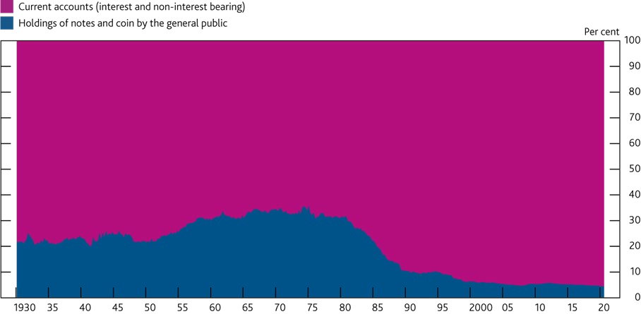

Sources: Bank of England, Thomas, R and Dimsdale, N (2017), ‘A millennium of macroeconomic data for the UK’, [Bank of England dataset.](https://www.bankofengland.co.uk/-/media/boe/files/statistics/research-datasets/a-millennium-of-macroeconomic-data-for-the-uk.xlsx)

(a) Prior to 1989 Q2 the data only cover the current accounts of banks. There are multiple breaks in the series reflecting the inclusion of building society sight deposits into the data.

The public needs to have complete trust in the reliability and stability of the money it uses every day. Ensuring this confidence is a vital role of central banks. The Bank of England protects the value of public money (cash and central bank reserves) in the United Kingdom. And in turn, rules and protections for commercial banks ensure that the private money they issue in the form of deposits can be used interchangeably with cash. These rules give households and businesses confidence that bank deposits can be redeemed in cash, at face value, at all times. To ensure this, banks are subject to extensive prudential regulation, have access to central bank liquidity facilities, and deposits are insured up to £85,000.

Stablecoins could be an additional type of ‘private’ money. If they are to be adopted widely then, as with bank deposits, confidence must be assured in the public’s ability to redeem their money in cash, at face value, at all times. The FPC’s second expectation addressed this: ‘Where stablecoins are used in systemic payment chains as money-like instruments, they should meet standards equivalent to those expected of commercial bank money in relation to stability of value, robustness of legal claim and the ability to redeem at par in fiat.’ Implementation of this expectation would maintain a payments landscape where users can substitute between different forms of money, without consequence for their level of protection. To ensure this remains the case in future, other forms of private money, such as e-money, would also need to meet the FPC’s expectation, were their issuers to become systemic.

The FPC is considering how the regulatory system can adapt to ensure this, while supporting innovation, in an efficient way.

The Bank is exploring design choices for a systemic stablecoin regime which could deliver the protections needed to meet the FPC’s expectations. A discussion paper covering this will be published in due course. The FPC is considering the extent to which equivalent standards to those that apply to commercial bank money

should be met using the same mechanisms of prudential regulation, retail depositor protection, and access to central bank facilities. Systemic stablecoins that back the money they issue with assets like those held by banks (such as loans) would require a regime and protections similar to banks. However, for systemic stablecoins backed by a much narrower range of less risky assets, and in a legally ring-fenced manner, it may be possible to design an appropriate regime that would deliver the standards of protection currently required of commercial bank money without application of the full regime applied to commercial banks. For example, one possibility could be a regime in which systemic stablecoins are backed with high-quality, highly liquid assets, such as government bonds, held in a legal structure only for the benefit of coinholders.

Another possibility would be to back systemic stablecoins with central bank money in one form or another. Such an approach exists in the UK for private issuers of physical cash in Scotland and Northern Ireland. If a stablecoin were backed only by central bank money, it would be economically similar to a CBDC. This is an electronic form of central bank money that could be used by households and businesses to make payments. The discussion paper will therefore also explore questions about the role of the private and public sector in the provision of money, building on the Bank’s [March 2020 CBDC Discussion Paper.](https://www.bankofengland.co.uk/paper/2020/central-bank-digital-currency-opportunities-challenges-and-design-discussion-paper)

Growth of stablecoins could have implications for wider financial stability…

If they meet the necessary requirements and standards, systemic stablecoins could emerge as a substitute for commercial bank deposits as a means of payment. This could mean that deposits flow out of the banking system into stablecoin ‘wallets’. In recent decades, the increased prominence of electronic payments and declining use of cash in how people pay means that the money banks create increasingly stays within the banking system (**Chart 5.1**). But the growth of systemic stablecoins could mean a reversal of this trend, with more bank deposits ending up outside of the banking system. The extent of this potential reversal would depend on the size of the stablecoin balances people may wish to hold. That in turn would depend, in part, on how the benefits for users of holding stablecoins compare to the benefits of bank deposits. Where stablecoins are backed by a much narrower range of assets than loans typically held by banks, the financial system may need to adapt to maintain the supply of credit to the economy.

…including reinforcing existing risks of large flows of money, for example during stress.

In addition to the potential risks associated with a gradual and predictable growth in the use of stablecoins, there may also be a risk that users could transfer large volumes of money between the banking system and systemic stablecoins in a volatile manner. An extreme example of this would be bank runs in a stress. Similar challenges exist at present, as banks already manage flows from one bank to another as part of their

day-to-day risk management, and have had to adjust as technology has enabled payments and transfers to be made at higher speed. The Bank of England already has tools to mitigate the financial and monetary stability impacts of volatile flows of money from one bank to another, or into cash, in times of stress.

The FPC will consider whether there are particular aspects of systemic stablecoins that could make flows from a bank to a stablecoin more likely or more difficult to manage than flows between banks. It may be necessary to develop the existing mitigants. These could, for example, include: features of the stablecoin itself, such as remuneration or the quantity available; adjustments to the amount of liquid assets held by banks to self-insure against outflows of deposits; or development of the lending facilities at central banks that help banks to access liquidity in a stress. Further work is needed to explore the potential of this risk, its impact and severity and the relative effectiveness and viability of the available mitigants. The upcoming discussion paper will cover these points, with the aim of ensuring that the growth of stablecoin can be supported while maintaining or enhancing financial stability.

### Annex: Macroprudential policy decisions

This annex lists any FPC Recommendations from previous periods that have been implemented or withdrawn since the previous *Report*, as well as Recommendations and Directions that are currently outstanding.19 It also includes those FPC policy decisions that have been implemented by rule changes and are therefore still in force.

Each Recommendation or Direction has been given an identifier to ensure consistent referencing over time. For example, the identifier 17/Q2/1 refers to the first Recommendation made at the 2017 Q2 Committee meeting.

##### Recommendations implemented or withdrawn since the previous *Report*

There are no Recommendations that have been implemented or withdrawn since the [August 2020 *Report*.](https://www.bankofengland.co.uk/report/2020/monetary-policy-report-financial-stability-report-august-2020)

##### Recommendations and Directions currently outstanding

There are currently no outstanding Recommendations or Directions awaiting implementation.

##### Other FPC policy decisions

Set out below are previous FPC decisions, which remain in force, on the setting of its policy tools. The calibration of these tools is kept under review.

**Countercyclical capital buffer (CCyB)**

The FPC agreed at its meeting on 8 December to maintain the UK CCyB rate at 0%, unchanged from August. It expects to maintain a UK CCyB rate of 0% until at least December 2021. Due to the usual 12-month implementation period, any subsequent increase will not be expected to take effect until 2022 Q4 at the earliest.

[The UK has also previously reciprocated a number of foreign CCyB decisions.](https://www.bankofengland.co.uk/financial-stability) Under PRA rules, foreign CCyB rates applying from 2016 onwards will be automatically reciprocated up to and including 2.5%.

**Recommendation on loan to income ratios**

In June 2014, the FPC made the following Recommendation (14/Q2/2):

The Prudential Regulation Authority (PRA) and the Financial Conduct Authority (FCA) should ensure that mortgage lenders do not extend more than 15% of their total number of new residential mortgages at loan to income ratios at or greater than 4.5. This Recommendation applies to all lenders which extend residential mortgage lending in excess of £100 million per annum. The Recommendation should be implemented as soon as practicable.

The PRA and the FCA have published approaches to implementing this Recommendation: [the PRA issued a](https://www.bankofengland.co.uk/prudential-regulation/publication/2014/implementing-the-fpcs-recommendation-on-loan-to-income-ratios-in-mortgage-lending) [Policy Statement](https://www.bankofengland.co.uk/prudential-regulation/publication/2014/implementing-the-fpcs-recommendation-on-loan-to-income-ratios-in-mortgage-lending) in October 2014, including rules, and the FCA issued general guidance in October 2014 which it clarified in February 2017.

1. The previous *Report* here refers to the *Financial Stability Report* which was published in August 2020.

**FPC Recommendation on mortgage affordability tests**

In June 2017, the FPC made the following Recommendation (17/Q2/1), revising its June 2014 Recommendation:

When assessing affordability, mortgage lenders should apply an interest rate stress test that assesses whether borrowers could still afford their mortgages if, at any point over the first five years of the loan, their mortgage rate were to be 3 percentage points higher than the reversion rate specified in the mortgage contract at the time of origination (or, if the mortgage contract does not specify a reversion rate, 3 percentage points higher than the product rate at origination). This Recommendation is intended to be read together with the FCA requirements around considering the effect of future interest rate rises as set out in MCOB 11.6.18(2). This Recommendation applies to all lenders which extend residential mortgage lending in excess of £100 million per annum.

Lenders were required to have regard to the FPC’s June 2017 revision to its June 2014 affordability Recommendation immediately, by virtue of the existing FCA MCOB rule. At its September 2017 meeting the FPC confirmed that the affordability Recommendation did not apply to any remortgaging where there is no increase in the amount of borrowing, whether done by the same or different lender.

##### Other FPC activities since the August 2020 *Report*

The FPC judged that the FCA’s recent proposals to extend the redemption notice periods for open-ended property funds were better aligned with principles the FPC had previously set out to address liquidity mismatch in open-ended funds. The FPC considered that, from the perspective of financial stability, and given the illiquidity of property assets in stressed conditions, there would be benefits from extending notice periods to at least as far as the range proposed in the consultation. The FPC also considered that further work was now needed by authorities, funds, platforms and investment managers acting in concert to ensure that pools of capital were able to be deployed into fund structures with longer notice periods. The FPC recognised the importance of addressing liquidity mismatches in open-ended funds internationally, given the global nature of asset management, and within that, the UK’s role.

Under the UK legislation implementing the systemic risk buffer (SRB), the FPC is required to review the framework used to guide the setting of the SRB every two years. The FPC decided no changes to the framework were necessary at this time, not least as buffer rates were currently maintained at the level set in December 2019 and would not be reassessed until December 2021. Any decision on buffer rates taken in December 2021 would take effect from January 2023 in line with the PRA’s policy. The FPC would keep this judgement under review in light of any further information that became available during the Covid-19 shock.

The FPC also noted that the introduction of the Capital Requirements Directive V (CRD V), as transposed in the UK by HM Treasury, would require the legal basis for the SRB to change from December 2020. As such, the FPC would replace the SRB framework with the other systemically important institutions (O-SIIs) buffer framework. Other than changing the name of the buffer, the framework would remain substantively unchanged, and the economic substance of the buffer would not be impacted. The FPC noted the PRA’s plans to launch a consultation on its proposals to apply the O-SII buffer to firms instead of the SRB from December 2020, in line with the FPC approach.