**Financial Policy Summary**

### The Financial Policy Committee (FPC) aims to ensure the UK financial system is prepared for, and resilient to, the wide range of risks it could face – so that the system can serve UK households and businesses in bad times as well as good.

**The outlook for financial stability**

### Support for the economy during the pandemic

### The UK financial system has provided support to households and businesses to weather the economic disruption from the Covid pandemic, reflecting the resilience that has been built up since the global financial crisis, and the exceptional policy responses of the UK authorities.

In recent months, the rapid rollout of the UK’s vaccination programme has led to an improvement in the UK economic outlook. But risks to the recovery remain. Households and businesses are likely to need continuing support from the financial system as the economy recovers and the Government’s support measures unwind over the coming months.

### The UK banking system has the capacity to continue to provide that support. The FPC continues to judge that the banking sector remains resilient to outcomes for the economy that are much more severe than the Monetary Policy Committee’s central forecast. This judgement is supported by the interim results of the 2021 solvency stress test.

**The FPC expects banks to use all elements of their capital buffers as necessary to support the economy through the recovery.** It is in banks’ collective interest to continue to support viable, productive businesses, rather than seek to defend capital ratios by cutting lending, which could have an adverse effect on the economy and, consequently, on banks’ capital ratios. To support this, the FPC expects to maintain the UK countercyclical capital buffer rate at 0% until at least December 2021. Due to the usual 12-month implementation lag, any subsequent increase would therefore not be expected to take effect until the end of 2022 at the earliest.

The FPC supports the Prudential Regulation Committee’s (PRC’s) decision that extraordinary guardrails on shareholder distributions are no longer necessary, consistent with the return to the Prudential Regulation Authority’s (PRA’s) standard approach to capital-setting and shareholder distributions through 2021. The FPC judges that the interim results of the 2021 solvency stress test, together with the central outlook, are consistent with the PRC’s decision.

### Debt vulnerabilities

As the economy recovers, the FPC will continue to remain vigilant to debt vulnerabilities in the financial system that could amplify risks to financial stability.

The FPC judges that UK corporate debt vulnerabilities have increased modestly. The increase in indebtedness has not been large in aggregate, but has been more substantial in some sectors and among small and medium-sized enterprises (SMEs). UK businesses’ aggregate interest payments as a proportion of earnings did not increase over 2020, and are around historic lows. And a large part of the additional debt taken on by companies has been issued at relatively low interest rates via government-sponsored loan schemes. Support from the financial system and the Government has helped to keep business insolvencies relatively low. However, companies with weaker balance

sheets, particularly in sectors most affected by restrictions on economic activity and SMEs, may be more vulnerable to increases in financing costs.

The share of households with high debt-servicing burdens has increased slightly during the course of the pandemic, but remains significantly below its pre-global financial crisis level. House price growth and housing market activity during 2021 H1 were at their highest levels in over a decade, reflecting a mix of temporary policy support and structural factors. However, so far, there has only been a small increase in mortgage borrowing relative to income in aggregate, and debt-servicing ratios remain low. The FPC’s mortgage market measures are in place and aim to limit any rapid build-up in aggregate indebtedness and in the share of highly indebted households. The FPC is continuing its review of the calibration of its mortgage market measures.

### Increased risk-taking in global financial markets

**Risky asset prices have continued to increase, and in some markets asset valuations appear elevated relative to historical norms.** This partly reflects the improved economic outlook, but may also reflect a ‘search for yield’ in a low interest rate environment, and higher risk-taking.

The proportion of corporate bonds issued that are high-yield is currently at its highest level in the past decade, and there is evidence of loosening underwriting standards, especially in leveraged loan markets. This could increase potential losses in a future stress, and highly leveraged firms have also been shown to amplify downturns in the real economy.

Asset valuations could correct sharply if, for example, market participants re-evaluate the prospects for growth or inflation, and therefore interest rates. Any such correction could be amplified by vulnerabilities in market-based finance, and risks tightening financial conditions for households and businesses.

**Building the resilience of the financial system**

### Market-based finance

It is important that market-based finance is resilient to, and does not amplify, shocks. The FPC has previously identified a number of vulnerabilities in the sector. In March 2020, these vulnerabilities amplified the initial market reaction to the pandemic to create a severe liquidity shock (the ‘dash for cash’). This disrupted market functioning and threatened to harm the wider economy. Significant policy action from central banks was needed to restore market functioning.

### The FPC strongly supports the work, co-ordinated internationally by the Financial Stability Board (FSB), to assess and, where necessary, remediate the underlying vulnerabilities associated with the March 2020 ‘dash for cash’. Such work is necessarily a global endeavour, reflecting the international nature of these markets and their interconnectedness.

To reduce the likelihood and impact of disruptions to market-based finance in the future, the FPC has identified the following areas of focus: reducing the demand from the non-bank financial system for liquidity in stress, ensuring the resilience of the supply of liquidity in stress, and potential additional central bank liquidity backstops for market functioning. In particular:

* To address vulnerabilities in the global money market fund sector, a robust and coherent package of international reforms needs to be developed. The FPC welcomes the publication of a consultation paper by the FSB which sets out policy proposals to enhance the resilience of money market funds.
* The FPC supports the international work, co-ordinated by the FSB, to understand the role of leveraged investors in government bond markets.
* The FPC supports international work to assess whether there was more procyclicality in margin calls than was warranted, whether market participants were prepared for margin calls in a stress, and any consequent need for policy in light of this, without compromising the benefits of the post-global financial crisis margining reforms.
* The FPC judges that there would be value in exploring ways to enhance the capacity of markets to intermediate in a stress, without compromising on the resilience of dealers.
* In order for central banks to deal effectively with financial instability caused by market dysfunction, the FPC supports examining whether new tools are needed specifically for this purpose. Any tools would need to be both effective and minimise any incentives for excessive risk-taking in the future through appropriate pricing and accompanying regulatory requirements.

The FPC supports the development of international standards through the FSB work and, consistent with its statutory responsibilities, remains committed to the implementation of robust standards in the UK. The FPC will continue to undertake its own assessment of the resilience of market-based finance on a regular basis, and in light of the FSB’s work, will consider whether there may be a need for additional policy responses in the UK.

### The joint Bank-Financial Conduct Authority review of open-ended investment funds

As the FPC has noted previously, the mismatch between redemption terms and the liquidity of some funds’ assets means there is an incentive for investors to redeem ahead of others, particularly in a stress. This first-mover advantage has the potential to become a systemic risk by creating run dynamics. It could result in forced asset sales by funds, further amplifying asset price moves and, by testing markets’ ability to absorb sales, contributing to dysfunction in markets of the sort observed in March 2020. This could impair the issuance of new securities and thereby disrupt the supply of credit to the real economy.

As part of its domestic work to identify and reduce vulnerabilities in market-based finance, the Bank and Financial Conduct Authority (FCA) have concluded their joint review into risks in open-ended funds. In doing so, the Bank and FCA have developed a possible framework for:

* how an effective liquidity classification framework for open-ended funds could be designed – consistent and realistic classification of the liquidity of funds’ assets is an essential step to ensuring funds can address mismatches between asset liquidity and redemption terms; and
* the calculation and use of swing pricing such that pricing adjustments more accurately represent, where possible, the cost of exiting a fund over the specified redemption period.

The FPC fully endorses this framework and views it as an important contribution to the international work currently in train. The FPC judges that this framework for liquidity classification and swing pricing could reduce the risks arising from the liquidity mismatch in certain funds.

The FPC emphasises the importance of addressing these issues internationally, given the global nature of asset management and of key markets.

The FPC recognises that further work is needed to consider how these principles could be applied, and a number of operational challenges will need to be addressed before any final policy is designed and implemented.

Funds that hold highly illiquid, infrequently traded assets, such as commercial real estate, may not be able to implement swing pricing effectively in practice. In these cases, longer redemption notice periods can address the first-mover advantage and financial stability risks that may otherwise arise. More generally, the development of funds with longer notice periods could help to increase the supply of productive finance to the economy. The FPC welcomes the FCA’s consultation on a

Long-Term Asset Fund structure.

### The transition to robust alternative benchmarks to Libor

Most new use of Libor is due to stop by the end of 2021. The FPC emphasises that market participants should use the most robust alternative benchmarks available in transitioning away from use of Libor to minimise future risks to financial stability.

It is the FPC’s view that recently created credit sensitive rates – such as those being used in some US dollar markets – are not robust or suitable for widespread use as a benchmark, and the FPC considers these rates to have the potential to reintroduce many of the financial stability risks associated with Libor. The FPC welcomes recent remarks made by members at the US Financial Stability Oversight Council, warning that widespread use of these credit sensitive benchmarks may replicate many of Libor’s shortcomings, and calling for the use of robust risk-free rates. These credit sensitive rates would not appear to be in compliance with the IOSCO Principles for Financial Benchmarks if their use became widespread.

### Cloud service providers

The FPC has previously highlighted that the market for cloud services is highly concentrated among a few cloud service providers (CSPs), which could pose risks to financial stability. Since the start of 2020, financial institutions have accelerated their plans to scale up their reliance on CSPs. Although

the PRA and FCA have recently strengthened the regulation of firms’ operational resilience and third party risk management, the increasing reliance on a small number of CSPs and other critical third parties could increase financial stability risks without greater direct regulatory oversight of the resilience of the services they provide.

### The FPC is of the view that additional policy measures to mitigate financial stability risks in this area are needed, and welcomes the engagement between the Bank, FCA and HM Treasury on how to tackle these risks. The FPC recognises that absent a cross-sectoral regulatory framework, and cross-border co-operation where appropriate, there are limits to the extent to which financial regulators alone can mitigate these risks effectively.

### Review of the UK leverage ratio framework

The FPC considers leverage requirements, including the scope of the regime, to be an essential part of the framework of capital requirements for the UK banking system. It has conducted a

comprehensive review of the UK leverage ratio framework in light of revised international standards and its ongoing commitment to review its policy approach and agreed a number of proposed changes on which it is consulting. The FPC welcomes the approach set out by the PRA to implementing those changes, which are now also being consulted on.

# 1: Overview of risks to the UK financial system

The outlook for economic growth has improved since the [December 2020 Report](https://www.bankofengland.co.uk/financial-stability-report/2020/december-2020), but risks to the recovery remain. The UK financial system has provided support to households and businesses to weather the economic disruption from the pandemic.

Households and businesses are likely to need continuing support from the financial system as the economy recovers and the Government’s exceptional support measures unwind over the coming months.

The Financial Policy Committee (FPC) judges that UK corporate debt vulnerabilities have increased modestly. The increase in indebtedness has not been large in aggregate, but has been more

substantial in some sectors and among small and medium sized enterprises (SMEs). UK businesses’ aggregate interest payments as a proportion of earnings are around historic lows and did not increase over 2020. And a large part of the additional debt taken on by companies has been issued at relatively low interest rates via government-guaranteed loan schemes. Support from the financial system and the Government has helped to keep business insolvencies relatively low. However, companies with weaker balance sheets, particularly in sectors most affected by restrictions on economic activity and SMEs, may be more vulnerable to increases in financing costs.

The share of households with high debt-servicing burdens has increased slightly during the course of the pandemic, but remains significantly below its pre-global financial crisis level. House price growth and housing market activity during 2021 H1 were at their highest levels in over a decade, reflecting a mix of temporary policy support and structural factors. However, there has only been a small increase in mortgage borrowing relative to income in aggregate, and debt-servicing ratios remain low.

UK banks’ capital and liquidity positions remain strong, and they are able to continue to support UK businesses and households. This judgement is supported by the interim results of the 2021 Solvency Stress Test.

Risky asset prices have continued to increase, and in some markets appear elevated relative to historical levels. This partly reflects the improved economic outlook but may also reflect a ‘search for yield’ in a low interest rate environment, and higher risk-taking. There is also evidence of loosening underwriting standards, for example in leveraged lending markets. Asset valuations could correct sharply if, for example, market participants re-evaluate the prospects for growth or inflation, and therefore the path of interest rates. Any such correction could be amplified by vulnerabilities in market-based finance, and risks tightening financial conditions for households and businesses. The Bank is working with international counterparties to assess and respond to these vulnerabilities.

## : Economic backdrop

### The outlook for UK and global economic growth has improved relative to the December 2020 Report, but risks to the recovery remain, particularly in the short term.

In recent months, the rapid rollout of the UK’s vaccination programme has led to an improvement in the UK economic outlook, as set out in the Monetary Policy Committee’s (MPC’s) central forecast in the May 2021 [Monetary Policy Report](https://www.bankofengland.co.uk/monetary-policy-report/2021/may-2021) and as further discussed by the MPC in its [June 2021 meeting.](https://www.bankofengland.co.uk/monetary-policy-summary-and-minutes/2021/june-2021)

The outlook for the global economy has also improved over this period, reflecting vaccine rollouts and an easing of Covid-related restrictions in many countries, and substantial fiscal stimulus in a number of countries including the US.

Despite the improved outlook, there remain downside risks to growth that could negatively impact financial stability, particularly in the short term. For example, economic activity could be curtailed following a further pickup in Covid case numbers, or a possible drop in vaccine effectiveness arising from mutations of the virus.

## : UK and global debt vulnerabilities and businesses’ financing needs

### UK businesses

### Support from the financial system and Government has helped to keep business insolvencies relatively low since April 2020…

Since March 2020 the UK banking system has supported UK businesses including through new lending and refinancing, and most recently through the Recovery Loan Scheme, which acts as a successor to previous government-guaranteed loan schemes. But take-up of this scheme has been lower than predecessors, likely reflecting a combination of factors including its more stringent eligibility criteria and the reduced demand for credit more broadly. Since March 2020, UK businesses have raised around £76 billion of net additional financing from UK banks and global financial markets, materially higher than the average raised in recent years.

This finance, alongside wider government support (such as the Coronavirus Job Retention Scheme (CJRS) and targeted measures such as the temporary ban on winding up petitions), has helped businesses to weather the pandemic. As a result, insolvencies have been relatively muted, averaging around 3,000 per quarter since April 2020, compared to around 4,200 per quarter between 2015 and 2019.

### …and it has also helped to improve businesses’ cash positions in aggregate.

The combination of financing and government support has also led to an improvement in UK businesses’ aggregate liquidity positions. Overall, businesses’ cash balances have increased by around £132 billion (around 25%) since end-2019. Just over half of this increase has come from external financing. The proportion of SMEs that are in overdraft has fallen from 9% to 6%, and 48%

of SMEs held at least one month’s worth of turnover as cash reserves in February 2021, compared to 39% in the previous year.

### In aggregate, corporate debt levels have increased modestly, although the increase in indebtedness has been more substantial in some sectors and across SMEs more broadly.

The improvement in cash positions during 2020 is likely to explain partially businesses’ muted demand for credit in 2021, relative to 2020. Large companies have been repaying some of their outstanding loans, while SMEs’ borrowing has reduced to around £0.5 billion per month in 2021, compared to £3.6 billion per month in 2020. Overall, net financing raised turned negative in March and April 2021 (Chart 1.1).

Overall, business indebtedness increased by around 5% from around £1.3 trillion at end-2019 to

£1.4 trillion at end-2020. This relatively muted increase reflects a modest rise in the indebtedness of large firms of around 2%, while SME indebtedness rose more substantially, by around 25%. This increase – rather than reduced earnings – was the main driving factor behind the aggregate debt to

earnings ratio for UK businesses increasing from 320% at end-2019 to 350% at end-2020. This ratio remains below its 2009 peak of almost 380%.

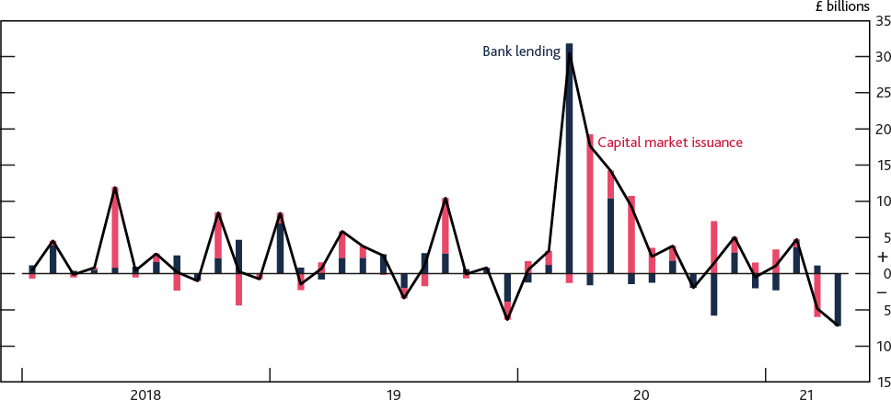**Chart 1.1: In aggregate, companies have started to repay more finance than they raise Net finance raised by UK private non-financial corporations (PNFCs) per month** **(a)**

Sources: Bank of England and Bank calculations.

(a) Data are non-seasonally adjusted.

But a large part of the additional debt taken on by companies has been issued at relatively low interest rates via government-guaranteed loan schemes. Given this, UK PNFCs’ aggregate interest payments as a proportion of earnings did not increase over 2020, and are around historic lows. The FPC judges that UK corporate debt vulnerabilities in aggregate have so far increased modestly over the pandemic.

### But as the economy recovers and government support unwinds as planned, some businesses may face additional pressure on their cash flow and insolvencies could increase…

As the economy recovers and government support unwinds, businesses may face additional pressure on their cash flow. For example, businesses may face substantial repayments as VAT and rent deferrals begin to lapse, costs could increase as broader government support such as the CJRS unwinds, and businesses that have borrowed under government support schemes will need to start making repayments on them. Additionally, the end of the temporary ban on winding up petitions in September 2021 is likely to lead to an increase in insolvencies over the next twelve months.

### …particularly in sectors that are most affected by restrictions on economic activity, and among SMEs.

It is likely that some businesses have become more vulnerable to insolvency compared to before the pandemic. For example, those that were already facing challenges to their businesses models, or had weak balance sheets at the onset of the pandemic (as set out in the [December 2019 Report](https://www.bankofengland.co.uk/financial-stability-report/2019/december-2019)), may have seen their positions worsen.

This pressure could be particularly acute in sectors that are more affected by economic activity being curtailed further should Covid cases rise, such as accommodation and food, and there are some signs of stress emerging. For example, Bank staff analysis suggests that as of January 2021, 11.8% of SMEs in these sectors are already in arrears on their outstanding loans or have formally defaulted (Chart 1.2). 5.5% of the broader SME population were in a similar situation in 2021 Q1, compared to

3.6% in 2020 Q1. This suggests that if earnings fall, for example if the economic outlook worsens, or should financing costs and debt-servicing burdens rise, SMEs could face further pressure.

**Chart 1.2: SMEs in some sectors are more likely to be facing additional cash flow needs**

**Proportion of SMEs in distress (either arrears or default on pre-existing loans) split by sector** **(a)****(b)**

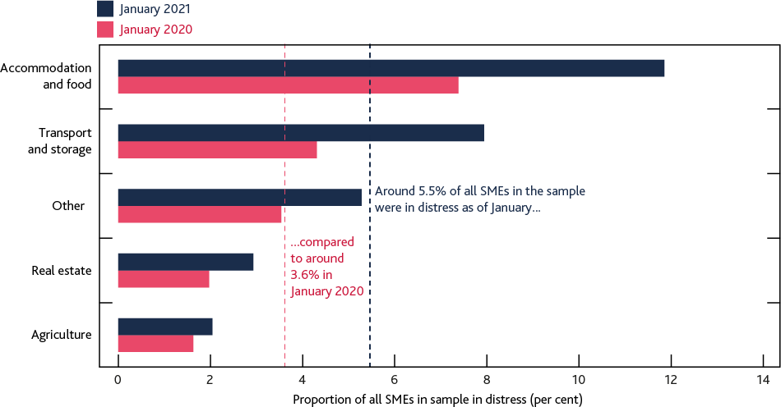

Sources: Regulatory reporting and Bank calculations.

(a) The data sample refers to around 500,000 SMEs which had outstanding debt as of March 2020.

(b) ‘Other’ includes a range of sectors such as arts and entertainment, construction and manufacturing. It also includes SMEs that it has not been possible to assign a sector classification to.

### UK households

### The share of households with high debt-servicing burdens has increased slightly during the course of the pandemic but remains significantly below its pre-global financial crisis level.

Overall, the share of UK households with high debt-servicing burdens on their mortgages – ie debt-servicing ratios (DSRs) of 40% or higher – has increased slightly since March 2020.

According to the latest NMG survey it was around 1.4% in March 2021, higher than its pre-Covid level, but significantly below its 2007 level of 2.7% (Chart 1.3).

**Chart 1.3: The proportion of households with high DSRs remains broadly in line with its level at the time of the December Report**

**Proportion of households with mortgage DSRs at or above 40%**

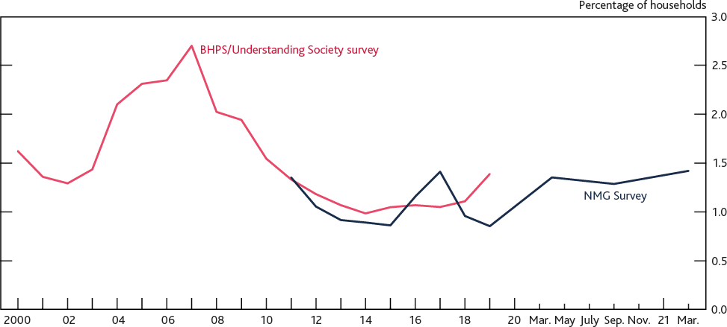

Sources: British Household Panel Survey (BHPS)/Understanding Society (US), NMG Consulting Survey and Bank calculations.

There is some evidence that households’ finances are likely to remain resilient as some support measures unwind. For example, a significant number of households had previously made use of the ability under the Financial Conduct Authority’s (FCA’s) Payment Deferral Guidance to take a payment deferral on mortgages and consumer credit without this being reflected on their credit file. As of May 2021, over 80% of households that had taken out mortgage payment deferrals had returned to full repayments after their deferrals ended.

**But households may face additional pressure if downside risks to the economic outlook crystallise.** The full effect of the pandemic on households’ finances will become clearer as the economy recovers and broader government support for household income unwinds fully, particularly the CJRS, which the Government has announced will run until 2021 Q3. Under the MPC’s May forecast, the projected increase in unemployment associated with the closure of the CJRS is relatively low as the support ends when activity is projected to be much closer to its pre-pandemic level. But if the economic outlook deteriorated without further support, the increase in unemployment and reduction in household income could be more severe than in the MPC’s forecast.

Should this risk crystallise, a combination of factors suggests that losses are more likely to arise from consumer credit than mortgage debt. Historically, there has been a strong correlation between unemployment and consumer credit loss rates. Relative to mortgages, unsecured debt is also more concentrated at the lower end of the income distribution. And lower income households have fared less well through the pandemic as they faced more persistent shocks to income and were less likely to accumulate savings ([Franklin et al (2021](https://www.bankofengland.co.uk/quarterly-bulletin/2021/2021-q2/household-debt-and-covid))).

### House price growth and housing market activity during 2021 H1 were at their highest levels in over a decade, reflecting a mix of temporary policy support and structural factors.

After a period of muted price growth and very limited activity during the early stages of the pandemic, the UK House Price Index (UK HPI) is around 9% higher than it was a year ago, despite a decrease in April. The year-on-year increase reflects prices rising by almost 8% from October 2020 to March 2021, the fastest six-month growth rate in over a decade. Nearly 450,000 residential property

transactions took place in 2021 Q1, or one and a half times the average quarterly level over the past decade, and the highest since before the global financial crisis.

Recent high levels of activity are likely to reflect in part a temporary boost provided by the stamp duty holiday, as shown by the peak in housing transactions completing in March 2021 ahead of its original deadline (Chart 1.4). They may also partially reflect structural factors such as households prioritising additional space to accommodate flexible working arrangements and increased savings accumulated during the pandemic, as well as the continued low interest rate environment. There are similar trends in some other advanced economies. Other, timelier indicators of house prices than the UK HPI remain strong, suggesting that some of that strength in demand may persist beyond the end of the stamp duty holiday in September.

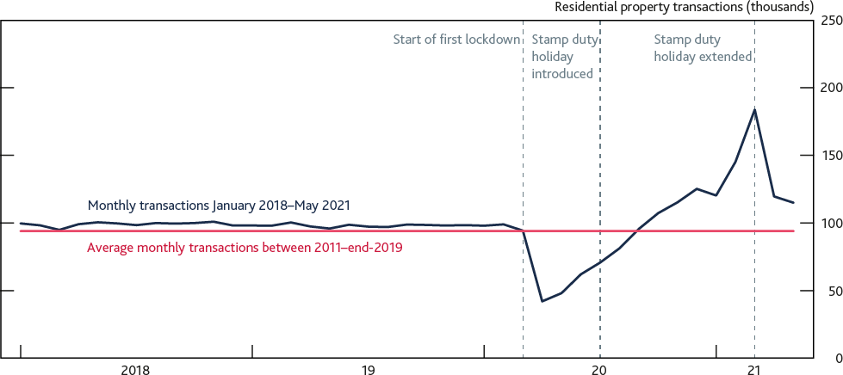**Chart 1.4: Recent housing activity was boosted by the stamp duty holiday Monthly residential property transactions from January 2018 to May 2021** **(a)**

Sources: Her Majesty’s Revenue and Customs (HMRC) and Bank calculations.

(a) Transactions are reported based on when they were completed and only include those with a value of above £40,000.

The recent housing market activity has also been accompanied by increased mortgage availability. More lenders have re-entered the market for mortgages with loan to value (LTV) ratios at 90% or above in recent months, and the number of mortgage products available at these higher LTV ratios has more than tripled since the start of the year. However, the share of new mortgages issued at high LTV ratios remains low relative to the pre-pandemic period. In 2021 Q1, just under 6% of new lending to owner-occupiers was at 90% LTV or above, compared to 20% in 2019. As a result, the proportion of high LTV loans in the stock of outstanding mortgages remains lower than its pre-global financial crisis level. The share of new mortgages at loan to income (LTI) ratios of 4.5 or higher increased to 10.4% in 2021 Q1, a marginal increase from 9.5% in 2020 Q1 and below the FPC’s 15% limit in aggregate (Chart 1.5).

**Chart 1.5: The stock of high LTV mortgages remains low compared to its pre-global financial crisis level**

**Proportion of outstanding and new mortgages issued at LTV at or above 90%** **(a)****(b)**

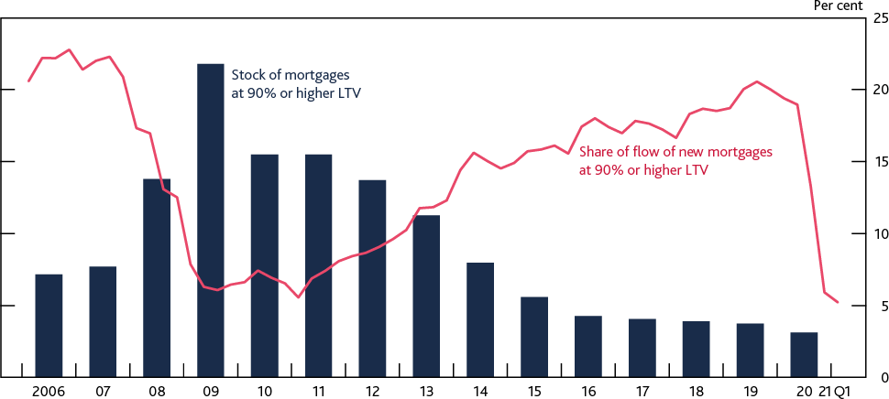

Sources: British Household Panel Survey, FCA Product Sales Data, Prudential Regulation Authority (PRA) regulatory returns and Bank calculations.

(a) The blue bars show LTV ratios at the given point in time (ie updated for house price changes and repayments since the loan was originated).

(b) The pink line is based on Product Sales Data and excludes lifetime mortgages, second charge mortgages, advances for business purposes, remortgages with no change in amount borrowed, home purchase plans, home reversions, and unregulated products such as buy-to-let mortgages.

### The FPC is continuing with its review of its mortgage market Recommendations.

As set out in previous Reports, the FPC has previously made two Recommendations which aim to limit any rapid build-up in aggregate indebtedness and in the number of highly indebted households*.* These are:

* The **affordability test** which builds on FCA rules and specifies that lenders should assess whether prospective borrowers could still afford their mortgage if their repayment rate rose to be 3 percentage points higher than the reversion rate specified in their contract.
* The **LTI flow limit** which limits the number of mortgages that lenders can extend at LTI ratios of 4.5 or higher at 15% of their new mortgage lending.

The FPC views these measures as structural, intended to remain in place through cycles in the housing market (see [December 2019 Report](https://www.bankofengland.co.uk/financial-stability-report/2019/december-2019)). However, the Committee regularly reviews the calibration and implementation of its Recommendations, and as set out in the [December 2020](https://www.bankofengland.co.uk/financial-stability-report/2020/december-2020) [Report,](https://www.bankofengland.co.uk/financial-stability-report/2020/december-2020) it will report the conclusions of its latest review in 2021 H2.

### Global debt vulnerabilities

### Globally, business indebtedness has increased over the course of the pandemic…

As the global financial crisis demonstrated, vulnerabilities in the global financial system can spill over to the UK through a range of channels. For example, a credit boom abroad could directly increase risks to the UK financial system via UK banks’ foreign exposures. And UK businesses raise a substantial portion of their funding through overseas sources, so a tightening in credit conditions abroad could materially affect businesses’ ability to fund their operations.

Prior to the pandemic, the FPC had highlighted the risks to the UK arising from high levels of business indebtedness in some major advanced economies. Since then, global business indebtedness as a proportion of GDP has risen to 110%, an increase of around 15 percentage points between 2019 Q4 and 2020 Q4, compared to an average increase of around 1.5 percentage points per year between 2009 Q4 and 2019 Q4.

A proportion of this lending has been carried out under government guarantee schemes and represents the global financial system working to support businesses through the pandemic. But the Federal Reserve has highlighted the risks of heightened US corporate leverage in its [May 2021](https://www.federalreserve.gov/publications/files/financial-stability-report-20210506.pdf) [Financial Stability Report,](https://www.federalreserve.gov/publications/files/financial-stability-report-20210506.pdf) and the European Central Bank has noted the risks associated with a tail of over-indebted businesses in Europe in its [May 2021 Financial Stability Review](https://www.ecb.europa.eu/pub/financial-stability/fsr/html/ecb.fsr202105~757f727fe4.en.html#%3A~%3Atext%3DThe%20May%202021%20FSR%20assesses%2Cthe%20non%2Dbank%20financial%20sector). Furthermore, the government guarantees backing this debt issuance have increased sovereign exposures to businesses within their jurisdictions.

### …and house prices in global markets have grown sharply over the past year.

Between end-2019 and end-2020, house prices in global economies (such as Canada, the US and a range of euro-area countries) have increased by between 5% and 11%. This increase was driven

in part by a similar range of structural factors to those underpinning the recent increases in the UK housing market. Authorities in some of these jurisdictions have begun to tighten macroprudential policy tools targeting the housing market.1

Although global house prices have increased rapidly, vulnerabilities in global housing markets have not grown as quickly. For example, mortgage credit growth typically remains below levels seen ahead of the global financial crisis, as do DSRs.

## : Banking sector resilience

### Banks are sufficiently capitalised to continue supporting the economy as needed.

UK banks and building societies (‘banks’) ended 2020 with an aggregate Common Equity Tier 1 (CET1) capital ratio of over 16% – more than three times higher than before the global financial crisis – and it remained flat in 2021 Q1. They have also continued to hold ample liquidity.

The banking system, with support from government-guaranteed lending schemes, provided credit to UK businesses helping to cushion the impact of the pandemic on their cash flows. Since the initial government loan schemes closed, banks have largely continued to lend to businesses. But there is a risk that businesses operating in vulnerable sectors would be outside banks’ risk appetite.

UK households and businesses are likely to need continuing support from the financial system as the economy recovers and the Government’s exceptional support measures unwind over the coming months. It remains the FPC’s judgement that it is in banks’ collective interest to continue to support productive businesses and that capital buffers are there to be used if needed. The FPC also judges that banks have sufficient capital resources to support lending, and this judgement is supported by the interim results of the solvency stress test (Section 2).

1 For example authorities in Canada [have tightened the ‘minimum qualifying rate’](https://www.osfi-bsif.gc.ca/Eng/osfi-bsif/med/Pages/b20nr-0521.aspx) for uninsured mortgages.

### Globally, banks’ returns have been boosted by their investment banking operations, where there is some evidence of increased risk-taking and loosening underwriting standards.

Globally, banks’ profitability has improved over the course of 2021 Q1 largely reflecting strong investment banking revenues, and the partial release of provisions held for expected credit losses in 2020 that did not materialise. Investment banking and trading revenues in 2021 Q1 were over 30% higher than in 2020 Q1, and were at their highest level since 2010. This was driven by higher client trading volumes (partially due to higher volatility), and high fee income.

But income from these business streams could fall if, for example, volatility diminishes and client activity declines. Some supervisory intelligence suggests global banks are seeking to maintain higher risk exposures in some parts of their trading and securitisation businesses. For example, the post global financial crisis trends of increased leverage lending issuance and loosening in underwriting standards in these markets (as set out in the [December 2019 Report](https://www.bankofengland.co.uk/financial-stability-report/2019/december-2019)) have continued. Borrowers are more indebted and a record 72% of new lending in these markets have no maintenance covenants, compared to around 65% in 2020 Q1 and around 14% in 2007. The FPC will monitor developments in this area closely.

## : Financial markets

### Financial markets have continued to support the economic recovery.

Capital markets have continued to function effectively since the [December 2020 Report](https://www.bankofengland.co.uk/financial-stability-report/2020/december-2020), and market conditions have largely recovered from the dysfunction seen during the March 2020 ‘dash for cash’ episode. Bid-offer spreads in both corporate and government debt markets have broadly returned to their pre-Covid levels, and UK corporate bond issuance in most major currencies remains in line with average levels in recent years.

### Risky asset prices have continued to increase, which partly reflects an improvement in the economic outlook…

Asset prices have continued to increase since the [December 2020 Report](https://www.bankofengland.co.uk/financial-stability-report/2020/december-2020). Major equity indices have risen by around 15% on average, and corporate bond spreads have also tightened over the same period. For example, spreads on indices of sterling, euro and US dollar high-yield bonds in particular decreased by just under 100 basis points on average, bringing spreads close to their lowest levels since 2007.

This partly reflects the improved economic outlook, as well as an expectation that fiscal and monetary policy will remain accommodative to reduce the likelihood of downside risks to the outlook for growth materialising.

### …but it also reflects heightened risk appetite, which has supported increased asset valuations and reduced compensation for risk in some markets.

Alongside the recent increase in risk-taking in investment banking activities, the FPC judges there is evidence of an increase in risk-taking in global financial markets. Some metrics which compare asset valuations against economic fundamentals, such as the cyclically adjusted price to earnings ratio, are above average and appear close to record highs in some markets such as US equities, but appear less elevated in UK equity markets (Chart 1.6).

Other metrics can be used to gauge the compensation for risk embedded in asset prices (the ‘risk premium’) by taking into account the current low level of long-term interest rates.2 For example some isolate expected returns in excess of those on government bonds. In some cases, valuations appear elevated even when measured using such metrics. Additionally, estimates of the equity risk premium and the spread on high-yield corporate bonds appear low in the US, and US

investment-grade bond spreads appear notably compressed particularly when adjusted for changes in credit quality and duration over time (Chart 1.6). Elevated asset valuations and compressed bond spreads could be evidence of investors’ ‘search for yield’ behaviour, which could reflect the low interest rate environment and higher risk-taking.

**Chart 1.6: Some equity valuations are elevated and some corporate bond spreads are low, relative to historical norms**

**Current level of selected asset valuation metrics as a percentile of historical values** **(a)**

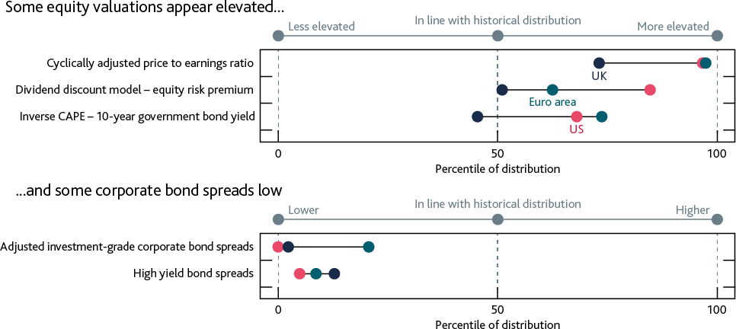

Sources: Bloomberg Finance LP, Datastream from Refinitive, ICE BofAML and Bank calculations.

(a) Adjusted for changes in credit quality and duration over time.

There is also evidence of investors’ appetite for risk in the non-price terms in some financial markets. Public offerings by US non-operating Special Purpose Acquisition Companies – whose ability to generate a return in future is highly uncertain and opaque to investors – hit record highs in 2021 Q1, although the pace of issuance has reduced significantly since. For example, alongside the loosening in underwriting standards in the leveraged lending market, new collateralised loan obligation (CLO) issuance is strong at over 135% to 150% of the levels seen over the past five years, while refinancing and resetting activity is at record high levels as CLO managers try to benefit from the current compression in market spreads.3 More generally a fund manager survey indicated that the balance of fund managers taking ‘higher than normal’ levels of risk is close to its highest level over the past 20 years.4

2 A low rate environment increases the price of assets relative to the yield investors expect to receive on them. It may also incentivise them to seek higher returns by taking on higher risk.

3 CLO refinancing refers to re-pricing some or all tranches of a CLO to effectively lower its liability cost, helping to improve returns for CLO equity investors. CLO resets involve a CLO manager calling existing tranches and issuing new ones (typically with longer maturities than those just called) at current market yields and sometimes with new terms.

4 June 2021 Bank of America Global Fund Manager Survey.

**The increase in risk-taking has also manifested in the price volatility of certain cryptoassets.** Alongside these indicators, rapid appreciation of cryptoasset valuations and recent high levels of price volatility in these instruments could highlight potential pockets of exuberance. Prices of major cryptoassets such as Bitcoin and Ethereum experienced sharp appreciation over the 12 months to April 2021. In particular, the price of Bitcoin rose six-fold over that period. But it then sold off sharply in May – such that its price fell by around 50% and has remained at this lower level – and remains particularly volatile with price changes skewed to the downside in June 2021. Spillovers to broader financial markets from this episode were limited.

Market intelligence suggests cryptoassets are largely held by retail investors, with institutional investors having limited exposure at present. However, there are some signs of growing interest in cryptoassets and related services from institutional investors, banks, and key payment system operators. These developments could increase the interlinkages between cryptoassets and other systemic financial markets and institutions.

### The increase in risk-taking behaviour creates a vulnerability to a sharp correction in asset valuations…

Elevated asset valuations and compressed risk premia imply a vulnerability to a sharp correction in asset prices. Sharp decreases in asset prices can amplify economic shocks by impairing businesses’ ability to raise finance, primarily through increasing the cost of bond and equity issuance.

Additionally a sharp correction can directly affect the financial system, for example from banks taking losses on assets held in trading portfolios or by reducing the value of collateral securing existing loans, and by creating sharp increases in the demand for liquidity.

There are several possible triggers for such a correction. Market participants could reassess their outlook for growth should, for example, economic data disappoint. Participants could also adjust their assessment of prospects for inflation and therefore the future path of interest rates. Market intelligence suggests this possibility is high among investor concerns. Should such an adjustment take place, the resulting tightening in financial conditions could also exacerbate debt vulnerabilities from UK households and businesses.

**…and structural vulnerabilities in market-based finance could amplify such a correction.** Such a correction could be amplified by existing vulnerabilities in the system of market-based finance which were exposed during the March 2020 dash for cash episode, and risks tightening

financial conditions for households and businesses. The vulnerabilities identified include leveraged positions in hedge funds and liquidity mismatches in open-ended funds and some money market funds (Section 3).

There is evidence that some of these vulnerabilities may have increased. For example assets under management (AUM) in US and emerging market corporate bond funds are around 120% of their January 2020 levels, albeit AUM at UK focused funds has remained broadly flat, while their holdings of liquid assets have decreased to around their pre-Covid level. And there are mixed signals from the available data on leverage in the non-bank financial system. For example, in the US, hedge fund leverage appears somewhat elevated when measured by gross exposures obtained through borrowing and derivatives. One measure of the amount of securities purchased on margin, mainly by hedge funds, increased over the course of 2020 to reach an all-time high, although this remains moderate when measured relative to the size of the equity market.

The Bank is working with international counterparties to tackle these vulnerabilities. Further details are set out in Section 3 and in the Bank’s report [‘Assessing the resilience of market-based finance](https://www.bankofengland.co.uk/report/2021/assessing-the-resilience-of-market-based-finance)’.

### The FPC reiterates that it remains essential to end reliance on Libor before end-2021 and it emphasises that market participants should use the most robust alternative benchmarks available to minimise future risks to financial stability.

Globally, businesses are undertaking the crucial transition away from the use of Libor in around

$300 trillion of contracts across five major currencies, such that the majority of Libor usage in these markets will be discontinued by the end of 2021. In June 2021, the Financial Stability Board reiterated that the transition from Libor will only reduce vulnerabilities if it addresses the core weakness of Libor: the lack of deep and liquid underlying markets. In sterling markets, most use of Libor in new contracts has now ceased and has largely been replaced with the Sterling Overnight Index Average, which is derived from around £54 billion of daily transactions compared to few transactions underpinning sterling Libor. In US dollar markets however, some market participants are using alternatives to the preferred risk-free rates, known as credit sensitive rates. It is the FPC’s view that recently created credit sensitive rates are not robust or suitable for widespread use as a benchmark (Box A).

## : Ensuring the financial system is ready to serve the future economy

Alongside risks prevalent in the current economic conjuncture, the FPC considers future risks and challenges that are on the horizon for the UK financial system.

### The Bank has launched the Climate Biennial Exploratory Scenario.

There are two types of exercise within the Bank’s concurrent stress-testing framework for banks and buildings societies: annual solvency stress tests; and biennial exploratory scenarios (BES). Running biennial exploratory scenarios allows policymakers to probe the resilience of the UK financial system to a wide range of risks that may not be neatly linked to the financial cycle, and is a tool to enhance participants’ strategic thinking on how to manage those risks.

The 2021 BES uses three scenarios to explore the resilience of the largest UK banks and insurers to the physical and transition risks associated with climate change. In June 2021, the Bank launched the exercise by publishing the [Key Elements of the 2021 BES](https://www.bankofengland.co.uk/stress-testing/2021/key-elements-2021-biennial-exploratory-scenario-financial-risks-climate-change) and guidance for participants. The Bank expects to publish results in May 2022. The exercise will not be used by the Bank to set capital

requirements, but may inform the FPC’s approach to system-wide issues related to climate change.

**The FPC welcomes the publication of the Bank’s discussion paper on new forms of digital money.** On 7 June 2021, the Bank published a [discussion paper](https://www.bankofengland.co.uk/news/2021/june/new-forms-of-digital-money-discussion-paper-and-summary-of-responses-to-the-discussion-paper-on-cbdc) focused on new forms of digital money to promote debate on issues around retail-orientated stablecoins with a potential to become systemically important, as well as some issues around central bank digital currencies. The FPC has previously highlighted the considerable pace of innovation in payment systems, that it views the ability to make payments safely and smoothly as critical to financial stability, and has set out expectations for operators of systemically important stablecoins, as set out in the [December 2019](https://www.bankofengland.co.uk/financial-stability-report/2019/december-2019) [Report](https://www.bankofengland.co.uk/financial-stability-report/2019/december-2019). The Committee has also previously highlighted the need for the regulatory system to adapt so the public can have similar confidence in new forms of digital money as in existing forms, allowing them to be widely used and trusted. The Committee welcomes the publication of this discussion paper.

**Box A: Securing transition to robust reference rates**

### Most new use of Libor is due to stop by the end of 2021. The FPC emphasises that market participants should use the most robust alternative benchmarks available in transitioning away from the use of Libor to minimise future risks to financial stability.

The majority of Libor settings will be discontinued at the end of this year, with some settings continuing for a limited period to support an orderly wind-down of legacy contracts only. Use of any continuing settings in new contracts by supervised entities will not be permitted, except for limited circumstances in US dollar markets. To the extent that any sterling and yen settings continue after 2021, as proposed by the [FCA on 24 June](https://www.fca.org.uk/publications/consultation-papers/cp21-19-proposed-decision-article-23d-bmr-6-sterling-yen-libor-settings), their use is intended only for legacy contracts that cannot feasibly transition away from Libor and will be subject to the FCA’s decisions on permitted use under the Benchmarks Regulation.

As set out in the [FPC’s May 2020 Interim Report,](https://www.bankofengland.co.uk/report/2020/monetary-policy-report-financial-stability-report-may-2020) the wholesale term funding markets – on which Libor is based – are prone to becoming volatile and unreliable in stressed periods. In June, the [Financial Stability Board (FSB)](https://www.fsb.org/2021/06/interest-rate-benchmark-reform-overnight-risk-free-rates-and-term-rates-2/) reiterated that the transition away from Libor will only reduce systemic vulnerabilities if it addresses the core weakness of Libor: the lack of deep and liquid underlying markets. Recognising this, industry working groups have selected risk-free reference rates (RFRs) in each currency as the preferred alternatives to Libor, which are calculated from high volumes of confirmed transactions in overnight markets.

In sterling markets, most use of Libor in new contracts has now ceased and been largely replaced by the Sterling Overnight Index Average (SONIA), a risk-free rate produced by the Bank. Alongside this, there is also a recognised role for RFR-derived term rates to support transition in certain areas. Since these are less robust than the RFRs themselves, the [FSB has been clear](https://www.fsb.org/2021/06/interest-rate-benchmark-reform-overnight-risk-free-rates-and-term-rates-2/) that their use should be more limited to remain compatible with financial stability. In the UK, a relatively narrow range of specific use cases have been identified by industry working groups.

In US dollar markets however, some market participants are considering using alternatives to the preferred RFR, Secured Overnight Financing Rate (SOFR). These alternatives, often referred to as ‘credit sensitive rates’ – which include the Bloomberg Short-Term Bank Yield Index (BSBY) – are

typically based on similar markets to Libor, relying heavily on transactions in commercial paper (CP) and certificates of deposit (CD) and are susceptible to many of Libor’s vulnerabilities. Namely, they:

* Measure a small fraction of banks’ actual funding costs, as issuance of CPs and CDs represent only a small proportion of banks’ funding.
* Typically have very low average transaction volumes (Chart A), and almost none in periods of market stress. As seen during the ‘dash for cash’ in March 2020, transactions in underlying CP and CD markets fell away, and the liquidity premium for cash placed upward pressure on rates. In comparison, the volume of transactions underpinning SONIA and SOFR rose over the same period.
* Are highly sensitive to liquidity conditions, introducing large risk premia during stressed periods (Chart A), which do not reflect wider funding conditions and could disproportionately affect borrowers.
* Rely on models, quoted rates and other techniques, such as expanding the window of ‘daily volumes’, to compensate for low underlying volumes.

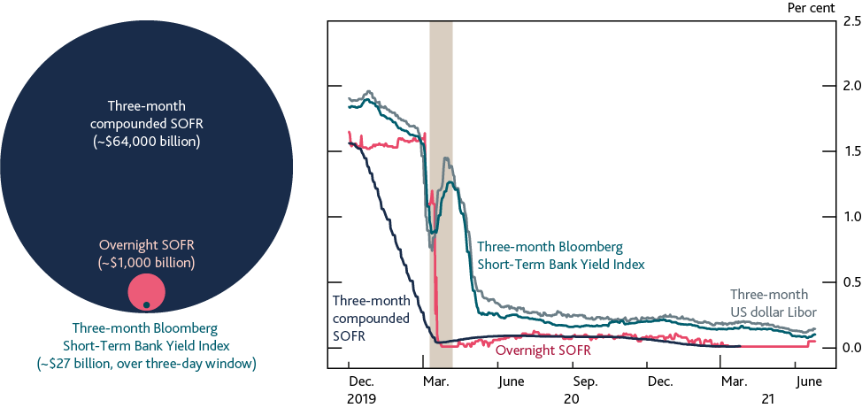

* Are vulnerable to potential structural market shifts, such as from potential future money market fund reforms (see Section 3).

In addition, contractual documentation referring to these rates has not consistently incorporated robust fallbacks to RFRs, particularly among derivatives. While fallbacks are not a substitute for directly using the most robust rates, market participants should consider the possibility of issues arising in the availability of these rates, to avoid costly changes in the future.

**Chart A: Volumes in CP and CD markets are very low and rates are volatile in stressed periods**

**Average daily transaction volumes in underlying markets (left-hand panel), and short-term US dollar interest rates (right-hand panel)** **(a)****(b)**

Sources: Bloomberg Finance L.P, Federal Reserve Bank of New York and Bank calculations.

1. Each circular area shows the estimated daily average volumes underpinning the respective rate and market product. BSBY volumes reflect executable quotes and transactions.
2. Compounded SOFR is shifted backward by three months, for comparability with the relevant interest periods for forward-looking US dollar Libor and BSBY.

The FSB’s report clearly states that ‘to ensure financial stability, benchmarks which are used extensively must be especially robust’, and is also reflected in the [International Organization of](https://www.iosco.org/library/pubdocs/pdf/IOSCOPD415.pdf) [Securities Commissions (IOSCO) Principles for Financial Benchmarks](https://www.iosco.org/library/pubdocs/pdf/IOSCOPD415.pdf), specifically Principle 6 which calls for administrators to take into account the ‘relative size of the underlying market in relation to the volume of trading’. Recently created credit sensitive rates – such as those being used in some US dollar markets – would not appear to be in compliance with the IOSCO Principles if their use became widespread.

### It is the FPC’s view that such credit sensitive rates are not robust or suitable for widespread use as a benchmark, and the FPC considers these rates to have the potential to reintroduce many of the financial stability risks associated with Libor.

The FPC welcomes similar remarks made by members of the [US Financial Stability Oversight Council](https://treas.yorkcast.com/webcast/Play/f5be3d221c084e9ea64adba4bd6c15aa1d), warning markets that widespread use of these credit sensitive benchmarks may replicate many of Libor’s shortcomings, and calling for the use of robust RFRs, as underlying volumes are unmatched by any other alternatives.

# 2: In focus – Resilience of the UK banking sector

The UK banking sector has been resilient to the challenges posed by Covid. Despite an historic fall in UK output in 2020, banks’ capital and liquidity positions remain strong.

Downside risks remain and some headwinds to banks’ capital can be expected. But the FPC continues to judge that the banking sector remains resilient to outcomes for the economy that are much more severe than the MPC’s central forecast. This judgement is supported by the interim results of the 2021 solvency stress test.

The FPC expects banks to use all elements of their capital buffers as necessary to support the economy through the recovery. Households and businesses are likely to need continuing support over the coming months as the economy recovers and the Government’s support measures unwind. The FPC continues to judge that it is in the collective interest of banks to support viable, productive businesses, rather than to seek to defend capital ratios and avoid using buffers by cutting lending.

The FPC also supports the PRC’s decision that extraordinary guardrails on shareholder distributions are no longer necessary, consistent with the return to the PRA’s standard approach to capital-setting and shareholder distributions through 2021. The FPC judges that the interim results of the

2021 solvency stress test, together with the central outlook, are consistent with this decision.

## : Interim results of the 2021 solvency stress test

### UK banks began the 2021 solvency stress test (SST) with strong capital and liquidity positions.

The major UK banks ended 2020 with an aggregate Common Equity Tier 1 (CET1) ratio of over 16% – more than three times higher than before the global financial crisis – and it remained flat in the first quarter of 2021 (Chart 2.1). Leverage ratios are also robust and the banking system has continued to have ample liquidity.

**Chart 2.1: The aggregate CET1 ratio remains more than three times higher than it was before the global financial crisis**

**Aggregate CET1 capital ratio of major UK banks since the global financial crisis** **(a)**

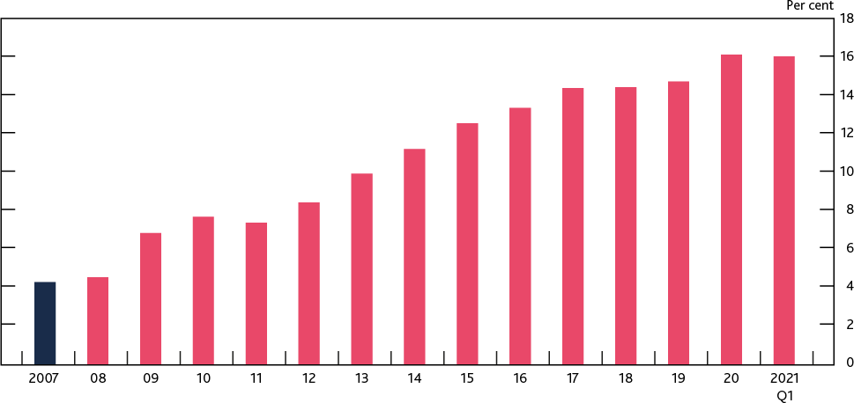

Sources: PRA regulatory returns, published accounts and Bank analysis and calculations.

(a) The CET1 capital ratio is defined as CET1 capital as a percentage of risk-weighted assets. Major UK banks are Barclays, HSBC, Lloyds Banking Group, Nationwide, NatWest Group, Santander UK, Standard Chartered and, from end-2020, Virgin Money UK. Prior to 2011, the chart shows Bank estimates of banks' CET1 ratios. Capital figures are year-end, except 2021 Q1.

### The 2021 SST assesses the resilience of the UK banking system to a very severe macroeconomic stress.

The [scenario](https://www.bankofengland.co.uk/stress-testing/2021/key-elements-of-the-2021-stress-test) used for the 2021 SST has been designed to assess banks’ end-2020 balance sheets against a severe path for the economy in 2021–25 on top of the baseline economic shock associated with the Covid pandemic.5 It is broadly consistent with the ‘double-dip’ scenario generated in the FPC’s [‘reverse stress test’](https://www.bankofengland.co.uk/report/2020/monetary-policy-report-financial-stability-report-august-2020) (RST) of August 2020 and represents an intensification of the macroeconomic shocks seen in 2020. When combined with the economic shocks already seen in 2020, it implies a cumulative three-year loss (relative to the pre-Covid baseline forecast) of 37% of 2019 UK GDP. In the stress scenario, UK residential property prices fall by 33% between end-2020 and the trough of the stress, and UK unemployment rises by 5.6 percentage points to peak at a little under 12% (Chart 2.2). The stress scenario is also considerably more severe than the MPC’s central projection from the [May 2021 Monetary Policy R](https://www.bankofengland.co.uk/monetary-policy-report/2021/may-2021)eport in which cumulative UK GDP losses, relative to the pre-Covid baseline forecast, totalled 18% of 2019 GDP and unemployment rose to 5.4%.

5 Banks participating in the 2021 SST are Barclays, HSBC, Lloyds Banking Group, Nationwide, NatWest Group, Santander UK, Standard Chartered and Virgin Money UK.

**Chart 2.2: In the 2021 SST three-year cumulative UK GDP losses total around £800 billion and unemployment peaks at a little under 12%**

**UK real GDP, three-year cumulative loss, relative to a pre-Covid baseline forecast, and UK unemployment in the 2021 SST** **(a)**

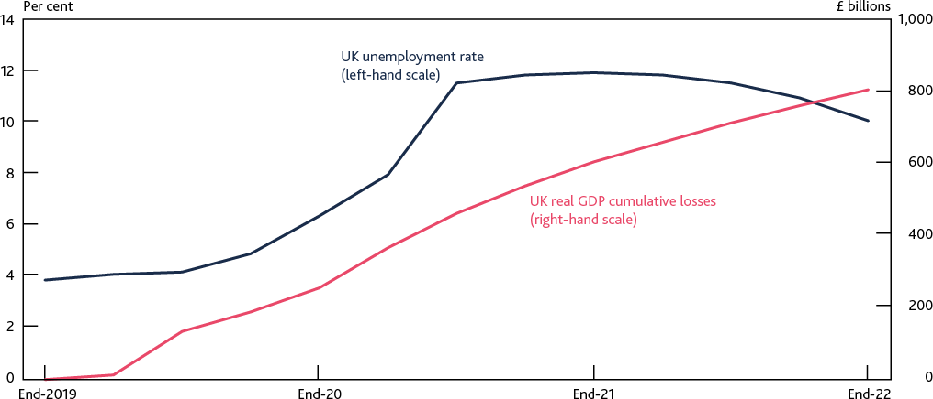

Sources: Office for National Statistics and Bank calculations.

(a) Three-year cumulative GDP losses are relative to a pre-Covid baseline projection consistent with the January 2020 Monetary Policy Report.

In January 2021 the FPC and PRC also announced that the timetable for the 2021 SST would be staggered, with interim aggregate results, based on early credit projections from participating banks, published in Summer 2021. These accelerated aggregate results would allow the exercise to act as a timely cross-check on the FPC’s judgement of how severe the existing stress would need to be in order to jeopardise banks’ resilience and challenge their ability to lend. The outcome would also be used as an input into the PRA’s assessment of how best to return to its standard approach to

capital-setting and shareholder distributions.

### The FPC continues to judge that the banking sector remains resilient to outcomes for the economy that are much more severe than the MPC’s central forecast. This judgement is supported by the interim results of the 2021 SST.

The interim results of the 2021 SST show the aggregate CET1 ratio falling from 16.2% at end-2020 to a low point of 10.4% in 2022, above the aggregate ‘reference rate’ of 7.7%.6 This also applies when considered on a leverage ratio basis. The CET1 low point is higher than those observed in the

2020 RST and the [2019 annual cyclical scenario](https://www.bankofengland.co.uk/stress-testing/2019/bank-of-england-stress-testing-results) despite a larger drawdown in capital.

Based on the interim results of the test, the FPC continues to judge that UK banks, in aggregate, are resilient to an economic shock much more severe than the MPC’s current economic forecast and have sufficient capital to continue to support UK households and businesses even if economic outcomes are considerably worse than currently expected. Indeed, the total impact of the stress would use up less than 60% of banks’ aggregate capital buffers.

6 This aggregate ‘reference rate’, which comprises banks’ minimum requirements and systemic buffers, has been adjusted to account for the impact of IFRS 9. Final reference rates will be published as part of the updated and final results due to be published in 2021 Q4. For further details of the approach to ‘reference rates’ see [Key Elements of the 2021 stress test.](https://www.bankofengland.co.uk/stress-testing/2021/key-elements-of-the-2021-stress-test)

### The interim results show banks incurring credit impairments of more than £70 billion over 2021 and 2022.

As in previous stress tests, the material fall in the aggregate capital ratio is driven primarily by credit impairments, which total more than £70 billion between end-2020 and the low point of the stress in 2022. When the impairments banks actually incurred in 2020 are included, this rises to over

£90 billion of impairments between the outbreak of Covid and the 2022 capital low point.

Around 60% of these impairments are incurred on banks’ exposures to UK borrowers and there is a broadly even split between impairments on retail and wholesale loans (Chart 2.3). In the UK, the severity of the initial unemployment shock increases defaults on retail lending, with consumer credit exposures particularly affected. However, the strong rebound in residential property prices helps to limit losses on mortgages. Losses totalling £37 billion are incurred on banks’ non-UK exposures, with the global low interest rate environment helping to limit corporate impairments by reducing companies’ debt-servicing costs.

The scenario also results in a rise in credit risk weights. The rise in total risk-weighted assets (RWAs) contributes 3 percentage points to the aggregate CET1 drawdown from the end-2020 start point.

Credit risk migration on UK mortgages and non-UK corporate loans are key drivers of the increase.

**Chart 2.3: Approximately 60% of impairments are incurred on UK exposures and there is a broadly even split between retail and corporate losses**

**Interim three-year (2020–22) impairment charges and rates in the 2021 SST** **(a)**

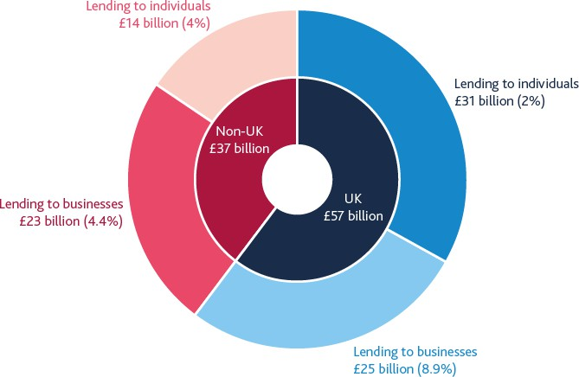

Sources: Participating banks’ Stress Testing Data Framework (STDF) submissions, and Bank analysis and calculations.

1. Cumulative impairment charge rates are calculated as the three-year total impairment charge divided by the average gross on-balance sheet exposure.

### Some of the credit impact is assumed to be offset by other elements of the SST.

Bank staff have also conducted desktop analysis of other risk areas in the 2021 SST (Table 2.A). This work does not yet take account of participating banks’ own data submissions, which will be considered later in the year. The desktop analysis includes assumptions around banks’ net interest income and trading income as well as their other income and expenses in the scenario. Stressed projections for misconduct costs have also been incorporated into the interim results.

**Table 2.A: Impairments are the most material driver of the overall capital drawdown Key drivers of the fall in the aggregate CET1 capital ratio in the 2021 SST** **(a)****(b)****(c)**

|  |  |
| --- | --- |
| **2021 solvency stress test (per cent)** | |
| **Start CET1 capital ratio (end-2020)** | **16.2** |
| Impairments (including IFRS 9 relief) | -4.6 |
| of which UK impairments | -2.7 |
| of which mortgage impairments | -0.4 |
| of which consumer credit impairments | -1.1 |
| of which corporate impairments | -1.2 |
| of which non-UK impairments | -1.7 |
| Growth in risk-weighted assets | -3.0 |
| Trading operations | 1.3 |
| Other | 0.5 |
| **Low-point CET1 capital ratio** | **10.4** |

Sources: Participating banks’ STDF submissions, and Bank analysis and calculations.

1. The CET1 capital ratio is defined as CET1 capital expressed as a percentage of RWAs, where both terms are defined in line with the CRR and the UK implementation of CRD V via the PRA Rulebook. The CET1 capital ratio at the end point is shown before the conversion of additional Tier 1 instruments.
2. Trading operations comprise: investment banking revenues, market risk losses, counterparty credit risk losses, losses arising from changes in banks’ fair value adjustments, prudential valuation adjustments and losses on fair value positions not held for trading.
3. ‘Other’ comprises other profit and loss and other capital movements. Other profit and loss includes misconduct, net interest income, expenses, fees and commission, other wholesale impairments, share of profit/loss in investments in associates, and other income. Other capital movements include pension assets devaluation, prudential filters, accumulated other comprehensive income, Internal Ratings-Based shortfall of credit risk adjustment to expected losses, and actuarial gain/loss from defined benefit pension schemes.

### Credit impairments in the interim results of the 2021 SST are significant, but are lower than those implied in the 2020 RST.

Credit impairments to the two-year capital low point of the SST interim results are lower than the

£120 billion implied by the 2020 RST, despite the fact that the FPC and PRC judge both scenarios to be of broadly equal severity.

A key factor in explaining this difference is the more granular approach taken by the Bank in assessing the impact of the scenario in this exercise, in conjunction with the detailed credit submissions from participating banks. This has led the Bank to attach greater weight to the strength of the economic recovery than it did in the 2020 RST, which is important because under IFRS 9, losses are recognised before they are incurred. The more the economic recovery reduces

impairments later in the scenario, the fewer losses there are to be brought forward. As an example, the relatively rapid recovery in UK residential property prices in both scenarios is now judged to reduce mortgage impairments by an even greater extent than the 2020 RST results implied.

Bank staff have also judged the low interest rate environment to be even more of a mitigant than in the 2020 RST.

However, the impact of other risk areas on capital more than offsets the reduction in impairments, relative to the August 2020 RST, leading to a larger overall capital drawdown. For example, the

SST scenario incorporates shocks to financial market variables that were not included in the

2020 RST, which reduces some of the gain banks are able to make through their trading operations in the test. Meanwhile, the other income banks make in the test is lower than in the RST, predominantly due to the lower starting level of income at end-2020.

## : Outlook for the UK banking sector

### The improved economic outlook looks set to limit credit losses this year, but risks remain, as the economy recovers and the Government’s support measures unwind.

Banks’ profitability increased in 2021 Q1 (see Section 1). But while statutory return on equity rose to over 9% from around 1% in December 2020, higher profits did not lead to an increase in capital.

They were broadly offset by a number of factors, including banks making deductions from capital to allow for future dividends and share buy-backs, and a reduction in IFRS 9 transitional relief.

In 2020, UK banks provisioned for around £22 billion of aggregate credit losses over the course of the year. In 2021 Q1 they reported a small provision release of around £0.7 billion. That reflected the improved macroeconomic outlook, a perceived improvement in the credit performance of borrowers (the proportion of loans that banks defined as performing but at heightened risk of default has fallen since the peak of last year (Chart 2.4)), and a reduction in the stock of unsecured lending balances. Banks also expect impairments in 2021 to be lower than in 2020 and analysts’ expectations for 2020–21 impairments have fallen from at least £45 billion last year to less than

£30 billion (in part helped by the extension of government support schemes earlier this year as well as positive vaccine news). These developments have supported an improvement in market participants’ view of the sector. The market capitalisation of major UK banks is now around 80% higher than the lows of September 2020, with the average major UK bank price-to-book ratio, which measures the market value of shareholders’ equity relative to the accounting value of that equity, at over 0.6.

**Chart 2.4: The proportion of major UK banks’ loans classed as at heightened risk of default has fallen from the peak seen in mid-2020**

**Proportion of loans classed as stage 2 (heightened risk of default) and stage 3 (credit impaired) under IFRS 9** **(a)**

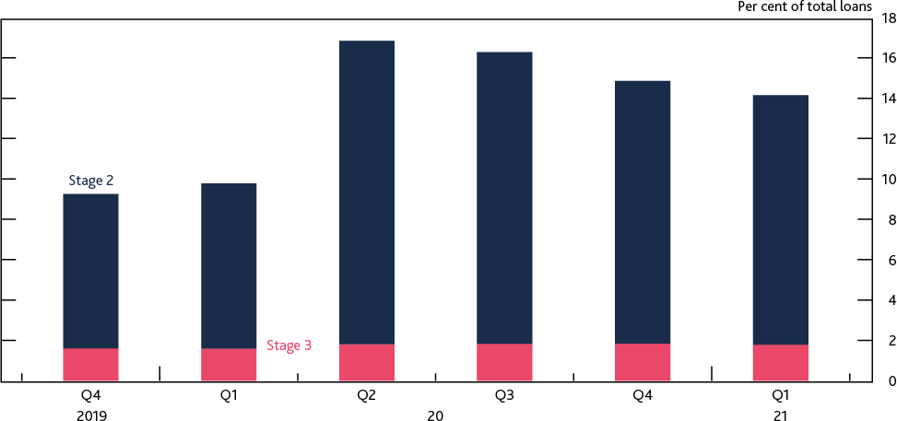

Sources: PRA regulatory returns and Bank calculations.

(a) Major UK banks are Barclays, HSBC, Lloyds Banking Group, NatWest Group, Nationwide, Santander UK and Standard Chartered.

But the potential for future credit deterioration remains, especially if unemployment and business insolvencies were to rise by more than expected. A key challenge will come when government support schemes unwind later this year as the economy recovers. Risk weights on banks’ exposures could increase, mechanically pushing down on risk-weighted capital ratios.

### The FPC supports the PRC’s decision that extraordinary guardrails on shareholder distributions are no longer necessary and judges that the interim results of the 2021 SST, together with the central outlook, are consistent with this decision.

In December 2020 the PRA [judged](https://www.bankofengland.co.uk/prudential-regulation/publication/2020/pra-statement-on-capital-distribution-by-large-uk-banks) that banks had the capacity to make prudent payouts in relation to their full-year 2020 results. Since then, the PRA has reviewed its approach to shareholder distributions in light of developments in, and uncertainty around, the economic outlook, banks’ capital positions and trajectories and the evolution of the Covid pandemic. It has also considered the interim results of the 2021 SST.

As discussed above, banks remain well capitalised and able to withstand headwinds to capital. The PRA has therefore concluded that the extraordinary guardrails within which bank boards were asked to determine the appropriate level of distributions in relation to full-year 2020 results are no longer necessary and have been removed. The FPC supports this decision and judges it to be consistent with the interim results of the 2021 SST as well as the central outlook.

## : Capital buffers and buffer usability

### The FPC expects banks to use all elements of their capital buffers as necessary to support the economy through the recovery.

Following the outbreak of the pandemic in 2020, lending by UK banks has helped many businesses finance their cash-flow deficits, most recently through the Recovery Loan Scheme, which acts as a successor to previous government-guaranteed loan schemes. Indeed, UK businesses have raised

around £76 billion of net additional financing from banks and through access to global financial markets since March 2020. The vast majority of bank lending has been via government-backed schemes (Section 1).

The ability and willingness of banks to continue to lend as the economic outlook improves and government support schemes end will be necessary for a robust recovery. The FPC judges banks to have sufficient resources to support lending. As covered in Section 1, banks are re-entering the high loan to value mortgage market, though on the corporate side have a more selective appetite for lending to sectors most affected by the pandemic. Supervisory intelligence suggests banks are offering the Pay As You Grow7 options of the Bounce Back Loan Scheme (BBLS), and are working constructively with distressed business borrowers to support repayment of loans. However, many of the loans issued under BBLS are relatively high risk and it will be important to monitor default levels as repayments data begins to come in. It remains the FPC’s judgement that it is in banks’ collective interest to continue to support viable, productive businesses rather than to seek to defend capital ratios and avoid using buffers by cutting lending.

Capital buffers are there to be used if needed. Banks’ capital ratios have remained above their regulatory buffers since the outbreak of Covid and banks have continued to lend. But the Bank, along with other central banks, is keen to learn from recent events to better understand factors that may hinder buffer usability.

### The FPC reiterates its policy to set the UK countercyclical capital buffer (CCyB) rate in the region of 2% when risks are judged to be standard.

The FPC’s strategy for setting the UK CCyB rate aims to ensure that the buffer is large enough to create capacity for banks to lend through downturns. Taking into account the state of the economy and the financial system, the FPC expects to maintain the UK CCyB rate at 0% at least until December 2021. To inform its decision around when to increase the UK CCyB rate, the FPC will monitor a range of factors, including the evolution of the economic recovery, prevailing financial conditions, and the outlook for banks’ capital. The pace of return to a standard UK CCyB rate in the region of 2% will depend on banks’ ability to rebuild capital while continuing to support UK households and businesses.

## : Next steps on the 2021 solvency stress test

Updated and final results of the 2021 SST, including bank specific outcomes, will be published in 2021 Q4. Bank staff continue to analyse submissions from banks participating in the 2021 SST, including for non-credit risk areas. It is likely that the final aggregate results in 2021 Q4 will differ to a certain extent from those published in this section. This is because the stressed projections from participating banks that cover other risk areas are likely to expose bank-specific dynamics not captured by the aggregate desktop analysis. The final results of the 2021 SST will be used as an input into the PRA’s transition back to its standard approach to capital-setting.

7 Pay As You Grow enables businesses who have started repaying their Bounce Back Loans to: request an extension of their loan term; reduce their monthly repayment for six months by paying interest only; and/or take a repayment holiday for up to six months.

# 3: In focus – The resilience of market-based finance

Since the global financial crisis, market-based finance has become increasingly important to the

UK economy, including by providing finance to support investment, helping businesses finance cash flows and providing other critical services.

The Financial Policy Committee (FPC) has the responsibility to identify, monitor and take action to mitigate risks to protect and enhance the resilience of the whole of the UK financial system, both now and in the future. This includes risks from the non-bank financial sector, which the FPC has been assessing regularly since 2014. The FPC’s assessments are underpinned by a framework that considers both the potential vulnerabilities in the non-bank financial system and also transmission channels through which disruptions in the non-bank financial system can affect financial stability.

As part of this work, the FPC identified a number of vulnerabilities in the sector. In March 2020, these and other vulnerabilities amplified the initial market reaction to the pandemic to create a severe liquidity shock (the ‘dash for cash’). This disrupted market functioning and threatened to harm the wider economy. Significant interventions from central banks were required to restore market functioning.

It is important that market-based finance is resilient to, and does not amplify, shocks. The FPC strongly supports the work, co-ordinated internationally by the Financial Stability Board, to assess and, where necessary, remediate the underlying vulnerabilities associated with the March 2020 ‘dash for cash’. Such work is necessarily a global endeavour, reflecting the international nature of these markets and their interconnectedness.

As part of this work, it will also be important to enhance data on the non-bank financial sector, internationally and domestically, so that regulators are better able to assess the resilience of the sector and risks to it.

To reduce the likelihood and impact of disruptions to market-based finance in the future, the FPC has identified three areas of focus: reducing the demand from the non-bank financial system for liquidity in stress; ensuring the resilience of the supply of liquidity in stress; and potential additional central bank liquidity backstops for market functioning.

As part of the domestic work to identify and reduce vulnerabilities in market-based finance, the Bank and Financial Conduct Authority (FCA) have concluded their joint review into risks in

open-ended funds. In doing so, the Bank and FCA have developed a possible framework for how an effective liquidity classification for open-ended funds could be designed, as well as for the calculation and use of swing pricing, which taken together could reduce the liquidity mismatch in certain funds. The FPC fully endorses this possible framework and views it as an important contribution to the international work currently in train.

## : The FPC’s assessment of risks in market-based finance

### The FPC has been monitoring vulnerabilities in market-based finance for a number of years.

Market-based finance has grown substantially in recent years. Since the global financial crisis,

non-bank financial institutions have grown to account for around half of UK financial sector assets. This has diversified the supply of finance for UK businesses — all of the net increase in UK corporate debt since 2008 has come from market-based finance. The sector also serves the real economy in other important ways such as intermediating between savers and investors, and transferring risk.

The greater role that market-based finance plays makes it vital that the sector is resilient enough to support UK households and businesses in bad times, as well as good.

As part of its mandate to monitor risks to financial stability originating in market-based finance, the FPC has conducted annual reviews of its resilience since 2014. These assessments are based on a framework that considers both the vulnerabilities within the sector, and the channels by which those vulnerabilities could translate into economic harm to the real economy. In light of these assessments, the FPC has also undertaken a number of in-depth assessments into specific issues.

In 2020, HM Treasury asked the FPC for a [detailed assessment of the oversight and mitigation of](https://www.bankofengland.co.uk/letter/2020/remit-for-the-fpc-2020) [systemic risks from the sector](https://www.bankofengland.co.uk/letter/2020/remit-for-the-fpc-2020). Preliminary analysis was presented in the [August 2020 Financial](https://www.bankofengland.co.uk/report/2020/monetary-policy-report-financial-stability-report-august-2020) [Stability Report,](https://www.bankofengland.co.uk/report/2020/monetary-policy-report-financial-stability-report-august-2020) focusing on the lessons learned from the March 2020 market stress. This section, combined with the detailed analysis provided in the Bank’s report [‘Assessing the resilience of](https://www.bankofengland.co.uk/report/2021/assessing-the-resilience-of-market-based-finance) [market-based finance’](https://www.bankofengland.co.uk/report/2021/assessing-the-resilience-of-market-based-finance), completes the FPC’s response to this request from HM Treasury. The Bank’s report provides further detail on how the FPC makes its assessment, its current areas of focus with respect to vulnerabilities in market-based finance, and the workplan (both domestically and internationally) to reduce the risk of those vulnerabilities crystallising in future.

### Given its importance to the UK economy, and the evidence of vulnerabilities, the resilience of market-based finance needs to be enhanced.

In March 2020, existing vulnerabilities interacted with financial markets’ reaction to the expected economic effect of the Covid pandemic and public health measures to contain its spread. These existing vulnerabilities included: the liquidity mismatch in money market funds (MMFs) and other open-ended funds; unwinding of trades by leveraged investors; liquidity management responses by non-bank derivatives users; and constraints on dealer intermediation. Many parts of the UK financial system, including the banking system and financial market infrastructure, proved resilient in the face of this shock. But, in financial markets, vulnerabilities amplified the effects of adjustments to risky asset prices and the need for a large redistribution of liquidity around the system, which caused market dysfunction.

Dysfunction even affected the core advanced-economy government bond markets. And the impairments to markets risked amplifying the impact of the shock on the real economy via tighter financial conditions. [Czech et al (2021)](https://www.bankofengland.co.uk/financial-stability-paper/2021/the-role-of-non-bank-financial-intermediaries-in-the-dash-for-cash-in-sterling-markets) provides a full account of these events in sterling markets.

As risks to the real economy rose, central banks globally took actions to maintain monetary and financial stability. In the UK, the [Monetary Policy Committee decided](https://www.bankofengland.co.uk/monetary-policy-summary-and-minutes/2020/monetary-policy-summary-for-the-special-monetary-policy-committee-meeting-on-19-march-2020) to purchase £200 billion of bonds in March 2020 to mitigate gilt market dysfunction and prevent a material tightening in financial conditions that would have depressed demand and output even further. Without actions such as these, it is likely that the liquidity stress would have been even more severe. Although these interventions were necessary and effective, such action could carry risks – for example, they could

create moral hazard, whereby market participants are encouraged to take excessive risks (see Box 7 of the [August 2020 Report](https://www.bankofengland.co.uk/report/2020/monetary-policy-report-financial-stability-report-august-2020)).

The need for emergency central bank intervention to address dysfunction in these markets suggests it is necessary to enhance the resilience of these markets under stress. While this shock was exceptionally severe, it is part of an increasing body of evidence that in recent years market-based finance has become more prone to liquidity shocks (see, for example, the [December 2019 Report](https://www.bankofengland.co.uk/financial-stability-report/2019/december-2019) on volatility in US repo markets). It is important that these vulnerabilities are addressed to reduce the risk of such events occurring again.

### The FPC supports work at the Financial Stability Board (FSB) to enhance the resilience of market-based finance and support financial stability.

The FSB is co-ordinating international effort to analyse and, where necessary, address the vulnerabilities observed in March 2020. The FSB published an update on this workplan in its interim report [‘Lessons learnt from the Covid-19 pandemic from a financial stability perspective](https://www.fsb.org/2021/07/lessons-learnt-from-the-covid-19-pandemic-from-a-financial-stability-perspective-interim-report)’. The Bank, the FCA and HM Treasury are engaged in this work programme, and the G20 will be updated on progress in October. Taking these issues forward in concert with other global regulators is essential, given the international and interconnected nature of markets and mobility of capital

(see [Kashyap (2020)](https://www.bankofengland.co.uk/speech/2020/anil-kashyap-speech-london-business-school)).

This work should address vulnerabilities across different parts of the non-bank system and consider its resilience as a whole. The ‘dash for cash’ demonstrated that actions that were probably rational and desirable from the point of view of individual institutions in one sector could affect the entire chain that facilitates the provision of finance and so pose systemic risks. To address these vulnerabilities comprehensively, it will be important to enhance the sector’s resilience as a whole (Section 3.2) and in doing so, improve regulators’ ability to monitor the sector (Section 3.3).

The FPC supports the development of international standards through the FSB work and, consistent with its statutory responsibilities, remains committed to the implementation of robust standards in the UK. The FPC will continue to undertake its own assessment of the resilience of market-based finance on a regular basis, and in light of the FSB’s work, will consider whether there may be a need for additional policy responses in the UK.

### The FPC judges that it will also be important to ensure that reforms to enhance the resilience of market-based finance increase the resilience of the system overall, and do not come at the cost of resilience elsewhere in the system.

Since 2009, significant reforms have been implemented to enhance the ability of the financial system to withstand and dampen stress, rather than amplify it. For example, reforms to the banking sector have resulted in higher capital and liquidity standards; and the promotion of greater central clearing of over-the-counter (OTC) derivatives, supported by robust margining requirements, has supported the resilience of the system to counterparty credit risk under stress.

As set out in Section 3 of [‘Assessing the resilience of market-based finance](https://www.bankofengland.co.uk/report/2021/assessing-the-resilience-of-market-based-finance)’, it will be important to learn the lessons of the ‘dash for cash’ for all parts of the financial sector. However, it will also be important to ensure that the resilience of other parts of the financial system is not reduced in order to enhance the resilience of market-based finance.

## : The FPC’s areas of focus

### The FPC has identified three areas of focus to reduce the likelihood and impact of disruptions to liquidity: reducing the demand from the non-bank financial system for liquidity in stress; ensuring the resilience of the supply of liquidity in stress; and potential additional central bank liquidity backstops for market functioning.

The FPC is concerned about liquidity risks that can disrupt the smooth provision of market-based finance. Market participants depend on the crucial assumption that core markets, eg government bond markets, will remain liquid. As highlighted in September 2019 in the US repo market, and March 2020 in a number of markets including advanced-economy government bond markets, liquidity can break down under stress.

Such ‘jumps to illiquidity’ could pose risks to financial stability. They could lead to disruption of core markets, and so can adversely impact the sector’s ability to serve the real economy (for example, if the resultant tightening in financial conditions restricts the provision of finance). And such risks may be heightened when market participants are leveraged (see Section 3.2.1). Consistent with its remit, the FPC supports the adoption of reforms to non-bank financial intermediation that will ensure it is resilient to stress and so able to dampen, rather than amplify, future shocks.

To reduce vulnerabilities in the market-based finance sector, policy is likely to be needed in a number of areas. The work in train both domestically and internationally should focus on three areas:

* **Reducing the demand from the non-bank financial system for liquidity in stress:** Following a negative economic shock, or under stressed conditions, investor appetite usually shifts from risky assets to safer, more liquid, assets. This can lead to an aggregate increase in demand for liquidity. It is important that features of the financial system do not unduly exacerbate this demand for liquidity.
* **Ensuring the resilience of the supply of liquidity in stress:** The non-bank financial system is always likely to need some additional liquidity in stress. It is important to ensure this need can be met in ways that avoid forced asset sales or disruption to market functioning.
* **Potential additional central bank liquidity backstops for market functioning:** It is first and foremost for market participants to manage the liquidity risks they face. However, it is not realistic or efficient to expect them to self-insure against every conceivable shock or stress. It is therefore also important to examine whether central banks have the appropriate facilities to provide liquidity to the whole of the financial system in stress in order to support market functioning without creating moral hazard – or whether any further tools are needed.

Various possible policy approaches to addressing these themes are under discussion at international fora. The table below sets out the main examples of policy work on the agenda to address vulnerabilities in market-based finance, and these issues are explored in greater detail in the remainder of this section.

**Table 3.A: Possible areas for consideration in the market-based finance sector**

|  |  |  |  |
| --- | --- | --- | --- |
| **FPC’s areas of focus** | **High-level objective** | **Description** |  |
| **Manage the demand for liquidity in stress** | Examine and address the liquidity mismatch in funds | * There is a need to examine and address the mismatch between the liquidity of assets held in open-ended funds – including money market funds (MMFs) – and the redemption terms they offer * Many investors regard their MMF holdings as ‘cash-like’, but they are subject to risks because MMFs may not always be able to make good on this expectation * Some open-ended funds offer daily redemptions but invest in illiquid assets – this means there is an incentive for investors to redeem ahead of others,   particularly in a stress | Improve the robustness and coverage of data on market-based finance, domestically and globally |
| Assess the role of leveraged non-bank investors in the functioning of core markets under stress | * The use of leverage can offer market efficiency benefits but also makes the investor less resilient and can amplify stress in core markets * Data reported to supervisors of non-banks do not   include all information important to assessing risks from leverage |
| Assess liquidity demands from margin calls in stress | * Margin requirements are designed to increase in stress to increase protection in the system, but this should not be more procyclical than warranted and market participants need to be prepared to meet those demands * International work is examining the framework and dynamics of margin calls in centrally cleared and uncleared derivatives markets and the liquidity management and preparedness of market   participants to meet margin calls |
| **Ensure the supply of liquidity is resilient** | Enhance the capacity of markets to intermediate in a stress without compromising on the  resilience of dealers | * The use of banks’ capital and liquidity buffers in times of stress can support market capacity * Some structural features of markets may also act to reduce market capacity in stress |
| **Consider potential central bank actions to backstop market**  **functioning** | Identify potential new central bank liquidity tools that can address dysfunction in core  markets | * Central bank liquidity support can support market functioning in extreme circumstances * Such tools should minimise moral hazard, and avoid posing excessive risk to central bank balance   sheets |

### : Limiting the demand for liquidity rising unduly in a stress period

The March 2020 market disruption highlighted how a ‘flight to safety’ in financial markets can lead to an aggregate increase in demand for liquidity and become an abrupt and extreme ‘dash for cash’. Vulnerabilities within the financial system can exacerbate this demand for liquidity, including:

* + - * the mismatch between the liquidity of assets held in open-ended funds – including MMFs – and the redemption terms offered by those funds;
      * the forced unwinding of leveraged positions by non-bank financial institutions; and
      * the management of liquidity demands following increases in derivative margin calls.

### Examining and addressing the liquidity mismatch in funds

### There is a need to examine and address the mismatch between the liquidity of assets held in open-ended funds – including MMFs – and the redemption terms they offer.

In [December 2019,](https://www.bankofengland.co.uk/financial-stability-report/2019/december-2019) the FPC set out three key principles for fund design that, in its view, would deliver greater consistency between funds’ redemption terms and their underlying assets:

* + - * **Liquidity classification**: The liquidity of funds’ assets should be assessed either as the price discount needed for a quick sale of a representative sample of those assets or the time period needed for a sale to avoid a material price discount.
      * **Pricing adjustments**: Redeeming investors should receive a price for their units in the fund that reflects the discount needed to sell the required portion of a fund’s assets in the specified redemption notice period.
      * **Notice periods**: Redemption notice periods should reflect the time needed to sell the required portion of a fund’s assets without discounts beyond those captured in the price received by redeeming investors.

For open-ended funds, the FPC has judged that the mismatch between the redemption terms and the liquidity of some funds’ assets means there is an incentive for investors to redeem ahead of others, particularly in a stress. This first-mover advantage has the potential to become a systemic risk by creating run dynamics. The Bank and FCA have been conducting a joint review into

vulnerabilities associated with the liquidity mismatch in open-ended funds, which included a survey of UK-authorised open-ended funds and their liquidity management practices. The FPC welcomes the conclusions of that review (see Box B).

MMFs are a particular form of open-ended fund. Investors tend to use MMFs as part of their cash management strategies because MMFs offer ‘same-day’ liquidity – meaning investors can generally expect to redeem their full principal at any time. Although many investors regard their

MMF holdings as cash-like assets and generally redeemable on demand, they are subject to the risk of losses because MMFs may not be able to make good on this expectation in all circumstances.

### The ‘dash for cash’ episode highlighted structural vulnerabilities in MMFs.

In March 2020, prime MMFs – those that invest largely in non-government assets – faced significant outflows and found their ability to generate additional liquidity constrained, exposing the risk of a run on these funds (see [‘Assessing the resilience of market-based finance’](https://www.bankofengland.co.uk/report/2021/assessing-the-resilience-of-market-based-finance)). Such a problem in one fund risks contagion to other funds, and thus could lead to a highly destabilising run on MMFs.

Suspensions of redemptions by MMFs could have had potentially severe implications for UK financial stability and the economy, due to their interlinkages with other financial institutions as well as with

corporates and local authorities. These consequences were avoided by central bank interventions that alleviated demand for liquidity across the financial system.

### To address vulnerabilities in the global money market fund sector, a robust and coherent package of international reforms needs to be developed.

One of the most important vulnerabilities to address is the liquidity mismatch inherent in MMFs that hold assets which are not liquid in stress. Potential ways to address this range from – at one extreme – increasing the range of stress scenarios under which MMF assets remain cash-like (such as limiting funds’ asset holdings to government instruments only), to – at the other extreme – recognising that certain MMF assets are not cash-like in stress (by, for example, requiring notice periods for redemption). Within this range, it is possible that a set of measures could be used to reduce risks to a sufficiently low level and make MMFs resilient for the purpose for which they are used. In addition, any reform package should remove the adverse incentives introduced by liquidity thresholds related to the use of suspensions, gates and redemption fees (see [Bailey (2021)](https://www.bankofengland.co.uk/speech/2021/may/andrew-bailey-international-swaps-and-derivatives-association)).

Recognising the global nature of financial markets, any work to assess and ensure the resilience of MMFs should continue to be co-ordinated internationally. The FSB has published [a consultation](https://www.fsb.org/2021/06/policy-proposals-to-enhance-money-market-fund-resilience-consultation-report/) [paper](https://www.fsb.org/2021/06/policy-proposals-to-enhance-money-market-fund-resilience-consultation-report/) which sets out policy proposals to enhance MMF resilience. The FPC welcomes this consultation paper.

### Assessing the role of leveraged non-bank investors

### The FPC supports the international work, co-ordinated by the FSB, to understand the role of leveraged investors in government bond markets.

Hedge funds can provide valuable liquidity and aid market efficiency during normal market conditions. But, in a stress, they may be forced to deleverage and unwind their trades. They may reduce their provision of liquidity, or even demand liquidity, as they exit positions. This can have a negative effect on market liquidity.

This was observed in US Treasury markets in March 2020. Prior to the Covid outbreak, relative-value hedge funds were heavily engaged in US Treasury markets and arbitraging price discrepancies between US Treasuries and US Treasury futures. As these positions became loss-making in the stress, some of them unwound their positions, exacerbating the stress in that market (see, eg, [Kruttli et al (2021)](https://papers.ssrn.com/sol3/papers.cfm?abstract_id=3817978) and the [Office of Financial Research’s Annual Report (2020)](https://www.financialresearch.gov/annual-reports/2020-annual-report/)).

By contrast, there was no evidence of widespread deleveraging by hedge funds in the gilt market in March 2020: [Czech et al (2021)](https://www.bankofengland.co.uk/financial-stability-paper/2021/the-role-of-non-bank-financial-intermediaries-in-the-dash-for-cash-in-sterling-markets) find that they appeared to buy gilts instead. Nevertheless, given both the important role of hedge funds in gilt repo markets and the ability for stress in US Treasury markets to spill over to gilt markets, it is important to address these issues and their possible amplification roles in stress.

The recent failure of Archegos, a highly levered family office, also exposed the issues around leverage. While the failure was not a systemic issue, it translated into material losses for certain banks and demonstrated the effects of leverage in the non-bank sector on other counterparties and markets more broadly. It also demonstrated the need for greater visibility of non-banks’ exposures, particularly with respect to derivatives, given the limited information available about Archegos’ exposures. The default presents important lessons for prime brokerage.

The FPC supports the FSB’s work to assess the role of leveraged investors in core government bond markets, and to assess whether excessive leverage could be a cause for concern in future episodes of market dysfunction.

### Managing liquidity demands from margin calls in a stress

### The collection of margin reduces and mitigates risks that the failure of one firm could have a severe impact on the rest of the financial system. In March 2020, as a result of very large asset price moves, margin calls increased significantly, as expected during periods of increased risk. Aside from a very small number of exceptions, this increase in margin calls was met and ensured that counterparty credit risks were contained.

During the global financial crisis of 2007/08, uncertainty about how losses at one institution might flow through to others, in part via derivatives exposures, led to counterparties withdrawing funding from each other and cutting unsecured exposures, which amplified stress. In response, G20 leaders agreed a number of improvements to OTC derivatives markets to improve transparency, prevent market abuse and reduce systemic risk. Since then, the vast majority of derivatives trades have moved to being bilaterally margined or centrally cleared (see [Segal-Knowles (2021)](https://www.bankofengland.co.uk/speech/2021/january/christina-segal-knowles-omfif-covid-19-dash-for-cash-and-international-ccp-regulation)).

These post-crisis reforms promoted the greater central clearing of OTC derivatives, supported by robust margining requirements. As the prices of derivatives contracts change, market participants exchange gains and losses daily, preventing the build-up of exposures between firms. This is known as variation margin. Market participants must also post collateral to cover potential future adverse changes in the market value of the contract following a default; this ‘pre-paid self-insurance’ – known as initial margin – increases as volatility rises, since the potential for losses is higher when markets are volatile. Initial margin, on cleared and uncleared derivatives, protects market participants from counterparty credit risk. By design, margin requirements are procyclical in that they rise in stressed market conditions to match the increase in expected losses and risks. However, increases in margin that are unpredictable, unexpectedly large, or more procyclical than warranted can cause severe liquidity strains on market participants and the financial system as a whole.

### The March 2020 ‘dash for cash’ provides lessons on how non-bank derivatives users managed liquidity risks from margin calls.

In the ‘dash for cash’, as would be expected in any high-volatility period, firms faced large variation margin flows and initial margin self-insurance charges rose significantly. Although more rapid reallocation of liquidity around the system and margin requirements that rise with volatility are a key and well-understood feature of post-crisis derivatives reforms, some users of derivatives were better prepared than others for the liquidity pressures in 2020. In order to raise cash to meet margin calls, replenish their liquid asset holdings, or in anticipation of further calls, some non-bank financial institutions redeemed MMF shares, borrowed in the gilt repo market, and sold gilts and corporate bonds (see [Czech et al (2021)](https://www.bankofengland.co.uk/financial-stability-paper/2021/the-role-of-non-bank-financial-intermediaries-in-the-dash-for-cash-in-sterling-markets)). These actions contributed to selling pressures in those markets and the large withdrawals from MMFs in mid-March. Managing the liquidity demands from margin calls is therefore a key component of risk management for derivatives users (see [Hall (2021)](https://www.bankofengland.co.uk/speech/2021/may/jon-hall-building-financial-market-resilience)). All derivative users need to have structures and processes in place to predict and manage potential liquidity outflows due to margined trades.

It is also important to consider whether there are design elements of margin models that led to increases in margin calls that were in some cases more procyclical than warranted in March 2020, placing unnecessary liquidity pressures on market participants. Transparency regarding central

counterparty (CCP) initial margin models is also important in ensuring market participants are able to prepare prudently for margin calls. There is considerable variation in the level of transparency regarding margin models and potential margin calls provided by CCPs internationally.

### The FPC supports international work to assess whether there was more procyclicality in margin calls than was warranted, whether market participants were prepared for margin calls in a stress, and any consequent need for policy in light of this, without compromising the benefits of the post-global financial crisis margining reforms.

The FSB’s work programme on non-bank financial institutions includes work to examine the framework and dynamics of margin calls in centrally cleared and uncleared derivatives markets and market participants’ liquidity management and preparedness to meet margin calls. The Bank has been closely involved in this work.

Consistent with the FSB’s initial findings in the interim report on [‘Lessons learnt from the Covid-19](https://www.fsb.org/2021/07/lessons-learnt-from-the-covid-19-pandemic-from-a-financial-stability-perspective-interim-report) [pandemic from a financial stability perspective’](https://www.fsb.org/2021/07/lessons-learnt-from-the-covid-19-pandemic-from-a-financial-stability-perspective-interim-report), the FPC supports further work on an international level that aims to:

* understand the drivers of differences in procyclicality across CCPs, asset classes, and products, and for setting out clear criteria for analysing the levels and effects of procyclicality;
* examine the degree to which prudent pre-crisis margin levels driven by CCPs’ anti-procyclicality measures or other tools or actions taken by CCPs helped to dampen the response of initial margin to extreme volatility;
* assess the extent to which non-bank clients were adequately prepared for the size of margin calls and to what extent their actions to raise liquidity impacted the rest of the financial system; and
* analyse the extent to which the information made available by CCPs to market participants is or can be used in liquidity planning.

### : Increasing the resilience of the supply of liquidity in stress

### Higher capital and liquidity requirements introduced in the aftermath of the global financial crisis ensured that banks and dealers remained resilient during the Covid stress.

Dealers entered the March 2020 market stress with high levels of capital and liquidity. They were initially able to absorb, rather than amplify the shock, by providing liquidity to market participants via repo lending and building up an inventory of securities. They quickly reached their limits, however, due to the magnitude and one-sided nature of the flows.

### While dealers initially provided liquidity in core markets, they became constrained, in part due to regulatory factors and their own risk appetite.

Dealers’ capacity to intermediate in gilt and gilt repo markets may, in some cases, have been related to how much room they had above their regulatory thresholds. For example, UK dealer subsidiaries that entered the stress with higher buffers over the leverage ratios expected by their supervisors appeared to use those buffers more to support client activity, including to expand repo intermediation.

Market and supervisory intelligence suggests that some dealers had significant buffers above leverage requirements at group level. However, the approach taken to balance sheet management – such as the application of leverage requirements to business lines – meant that extra capacity was not always readily available to the subsidiary or desk responsible for market intermediation. This

may be partly driven by their own risk management, for example, to conserve capacity to support other business lines (such as lending via committed credit facilities).

**Structural features of markets were also important drivers of market capacity during the stress.** A number of factors related to market structure affected the supply of liquidity. Market segments where clearing was possible appeared more resilient. Cleared transactions with the same counterparty (ie a CCP) may benefit from netting arrangements, and so result in lower capital charges. Dealers charged lower rates on less capital-intensive term gilt repo transactions (ie those that made use of netting, which are often cleared) relative to more capital-intensive transactions during the March 2020 market stress.

In other markets, high-frequency market participants are an important source of liquidity in normal conditions. But some (ie principal trading firms) reduced their activity in the US Treasury market during the stressed period and so may have exacerbated the deterioration in liquidity (see [‘Assessing](https://www.bankofengland.co.uk/report/2021/assessing-the-resilience-of-market-based-finance) [the resilience of market-based finance](https://www.bankofengland.co.uk/report/2021/assessing-the-resilience-of-market-based-finance)’). And, as noted in [Hall (2021)](https://www.bankofengland.co.uk/speech/2021/may/jon-hall-building-financial-market-resilience), while primary dealers are required to provide continuous liquidity under all conditions, market makers are generally exempt from providing liquidity in ‘exceptional circumstances’ of severe volatility.

### The FPC judges that there would be value in exploring ways to enhance the capacity of markets to intermediate in a stress, without compromising on the resilience of dealers.

There is therefore merit in exploring ways to enhance market capacity, without compromising on the resilience of dealers. As noted earlier, it is essential that measures to improve the resilience of the market-based finance sector improve the resilience of the financial system as a whole.

As set out in [‘Assessing the resilience of market-based finance’](https://www.bankofengland.co.uk/report/2021/assessing-the-resilience-of-market-based-finance), market capacity could be enhanced by, for example, the greater use of regulatory capital and liquidity buffers by banks in times of stress, as well as potential changes to market structure. For example, there would be value in considering, as part of future work, whether greater central clearing of government bond and repo transactions would be beneficial, taking into account the effect such proposals may have on liquidity overall.

As well as contributing to the FSB’s work examining dealer behaviour, the Bank is also contributing to the Basel Committee on Banking Supervision’s (BCBS) evaluation of the effectiveness of Basel III reforms, including work on the lessons learned from Covid. The BCBS recently published an interim evaluation report, [‘Early lessons from the Covid-19 pandemic on the Basel reforms](https://www.bis.org/bcbs/publ/d521.htm)’.

### : The role of central banks in supporting market functioning

### In order for central banks to effectively deal with financial instability caused by market dysfunction, the FPC supports examining whether new tools are needed specifically for this purpose.

As demonstrated in March 2020, access to liquidity via the market for even the safest core sovereign debt may be reduced or disrupted during times of stress. Central bank interventions were necessary to restore market functioning (see [August 2020 Financial Stability Report](https://www.bankofengland.co.uk/report/2020/monetary-policy-report-financial-stability-report-august-2020)). Central banks acted quickly, at unprecedented scale and in a co-ordinated manner to respond to the economic shock and stabilise markets.

In March 2020, traditional central bank tools to backstop liquidity via the banking sector proved insufficient to calm conditions in the broader financial system. Asset purchases implemented under quantitative easing were able to do so, however, and so supported both monetary and financial

stability. But there could be scenarios in which monetary policy tools, such as quantitative easing, would not be appropriate to support market functioning given the monetary policy stance. More generally, large scale central bank intervention in response to market dysfunction risks embedding inappropriate expectations of how central banks might behave in the future, encouraging excessive risk-taking and giving rise to moral-hazard concerns.

The FPC supports examining whether new tools are needed to provide liquidity to the wider financial system in stress, to support market functioning. Any tools would need to be act as a backstop, and be effective at resolving market dysfunction. Central banks need to be able to manage the risks to their balance sheets. And negative side effects, including incentives for excessive risk-taking in the future, should be minimised through appropriate pricing and accompanying regulatory requirements (see [‘Assessing the resilience of market-based finance’](https://www.bankofengland.co.uk/report/2021/assessing-the-resilience-of-market-based-finance) for more detail).

## : Improving the oversight of market-based finance

### In order to improve understanding of the risks to, and resilience of, market-based finance, regulators require more robust data, with better coverage.

In order for the domestic and international work to address vulnerabilities in market-based finance to progress effectively, regulators need access to more robust data on the sector, with better coverage. Data on the sector is much more fragmented than in the banking sector. This is due to the approach of regulating activities in the non-bank financial institution sector (as opposed to regulating entities in the banking sector), the global nature of these markets and the often

cross-border activities of non-bank financial institutions limiting the line of sight any single regulator can acquire from their own, domestic data. International effort and co-operation will be essential to remediating any data gaps.

The FPC has sought to overcome these issues, by drawing on analysis and insights from a broad range of datasets and indicators (see Box C of [‘Assessing the resilience of market-based finance](https://www.bankofengland.co.uk/report/2021/assessing-the-resilience-of-market-based-finance)’). That report also details the work done by the Bank so far, alongside other UK regulators, both domestically and internationally to remediate a number of these gaps.

### The FPC will continue to scan for potential vulnerabilities originating outside of the core UK banking sector, and to monitor the growth of risks in those sectors.

The FPC will continue to use the data and analysis available to scan the horizon for new and growing risks as the financial system continues to evolve. This includes monitoring developments in parts of the financial system that are already systemically important, as well as those which may not yet be systemically important but have the potential to become so, including as the result of innovations and the use of new technologies. As noted, international work to remediate data gaps will continue to be important – for example, the FPC views that an important step forward will be to resume work on aggregating and sharing trade repository data with other international regulators. As part of its work, the FPC will assess the suitability of the regulatory perimeter, in line with its remit.

**Box B: Concluding the joint Bank and FCA review into open-ended funds**

### The FPC welcomes the conclusion of the joint Bank and FCA review into open-ended funds,

### which considered how the FPC’s principles for fund design could be developed further, to support UK financial stability.

### As part of this review, in March 2021, the FPC reviewed the findings of a joint Bank and FCA survey of open-ended funds, which provided insights on liquidity management during the period of market stress last year.

In the survey, the Bank and FCA collected the data from 272 UK authorised funds (representing total assets under management of £137 billion) on their approach to liquidity management, including during the March 2020 market disruption. The survey provided several important insights into

UK funds’ liquidity management practices, and found that many fund managers appeared to have overestimated the liquidity of fund portfolios, even after the experience of the stressed period in March 2020 (see [‘Liquidity management in UK open-ended funds](https://www.bankofengland.co.uk/report/2021/liquidity-management-in-uk-open-ended-funds)’).

As a result of the survey, the FPC judged:

* that consistent and more realistic classification of the liquidity of funds’ assets is an essential first step to ensuring funds can address mismatches between asset liquidity and redemption terms; and
* that the calculation and application of swing pricing – ie the practice of allowing the price of a fund’s unit to be adjusted to offset potential dilution costs to other investors in the fund – could, in principle, be enhanced in order to reduce the systemic risk associated with first-mover advantage.8

Informed by the results of the survey, the Bank and FCA have developed a possible framework for how an effective liquidity classification for open-ended funds could be designed, as well as considerations for the calculation and use of swing pricing.

The high-level headlines from the framework are set out below; for more detail see Box A of the report on [‘Assessing the resilience of market-based finance](https://www.bankofengland.co.uk/report/2021/assessing-the-resilience-of-market-based-finance)’. As noted in the report, the possible framework is one potential illustration of what any approach should achieve, and is intended to inform thinking in the ongoing international work with a view to further policy development by securities regulators. Any such framework should also complement fund managers’ existing approaches to managing liquidity. The FPC recognises that further work is needed to consider how these principles could be applied, and a number of operational challenges will need to be addressed before any final policy is designed and implemented.

8 Ensuring that swing pricing better reflects the costs of investor flows would allow it to work more effectively as an anti-dilution tool and continue to promote investor protection (in line with current FCA rules), while at the same time helping to address the financial stability risks associated with first-mover advantage.

**A possible framework for a consistent and realistic classification of the liquidity of funds’ assets**

### An effective liquidity classification framework would capture the full spectrum of liquid and illiquid assets, and consider both normal and stressed conditions.

### An effective liquidity classification framework should play a role in the design of a fund and in determining appropriate redemption terms.

### A consistent and realistic classification of the liquidity of funds’ assets could be used to enhance funds’ internal risk management practices, particularly stress testing.

### The classification should be sufficiently granular9 and should be available for regulatory reporting purposes.

**A possible framework for enhancing the calculation and use of swing pricing**

### More consistent and complete swing pricing could be developed in order to better reflect the costs of exiting a fund and also to promote financial stability by reducing first mover advantage.

### Swing pricing adjustments should be based on the following principles:

* 1. **Swing pricing adjustments should, as far as possible, take into consideration the full cost of meeting investor flows.** Overall, swing pricing adjustments should be a reflection of liquidity classification, the size of investor flows, and market conditions. Particular factors that should be considered include: (i) explicit transaction costs, for example bid-ask spreads on assets and fees; and

(ii) measures of implicit transaction costs, including estimates of market impact and size for a sale equivalent to the net redemption.

Other factors may also provide additional relevant information for fund managers when considering how to calibrate pricing adjustments, particularly during stress periods. For example, for some funds the bid-ask spreads and net asset value discounts of comparable exchange-traded funds may provide useful information alongside other relevant pricing information (see Box B of the report on [‘Assessing the resilience of market-based finance](https://www.bankofengland.co.uk/report/2021/assessing-the-resilience-of-market-based-finance)’).

### Swing pricing adjustments should reflect the prevailing market conditions and associated costs of net flows.

### Swing pricing adjustments should be subject to periodic review to assess whether they remain valid and ensure reasonable levels of confidence around estimates.

### Consideration should be given to the adequate level of transparency regarding the approach to and effects of swing pricing. The FPC judges that an appropriate level of transparency about swing pricing is essential for investors to better assess risks associated with investing in a particular fund.

The FPC emphasises the importance of addressing these issues internationally, given the global nature of asset management and of key markets. The effectiveness of domestic policy measures will

9 For example, as mentioned in the report [‘Assessing the resilience of market-based finance](https://www.bankofengland.co.uk/report/2021/assessing-the-resilience-of-market-based-finance)’, a liquidity classification at least as granular as the one piloted in the joint Bank-FCA survey could allow fund managers to account for the differences in their actual holdings, and allow sufficient consistency to be used by regulators as a check on fund managers’ own classification of their holdings across liquidity categories.

depend in part on policies implemented in other jurisdictions. The FPC supports ongoing work led by the FSB and the International Organization of Securities Commissions on the issue of liquidity risk management in open-ended funds.

**The FPC fully endorses the proposed framework for liquidity classification and swing pricing, and views it as an important contribution to the international work currently in train. The FPC judges that this framework could reduce the risks arising from the liquidity mismatch in certain funds.** This framework further supports the FPC’s first two principles on fund design (see Section 3.2.1).

### The FPC’s third principle from its progress review in 2019 was that redemption notice periods should reflect the time needed to sell the required portion of a fund’s assets without discounts beyond those captured in the price received by redeeming investors.

This could contribute to reducing liquidity mismatch and better aligning investor incentives. Funds that hold inherently illiquid, infrequently traded assets, such as commercial real estate, may not be able to implement swing pricing effectively in practice. This is because swing pricing adjustments require reasonable information on the price, liquidity and transaction costs of an asset. In these cases, longer redemption notice periods could address the first-mover advantage and financial stability risks that may otherwise arise.

More generally, the development of funds with longer notice periods could help to increase the supply of productive finance to the economy. Such funds can hold illiquid assets like unlisted equities, safely and sustainably. The Bank, HM Treasury and the FCA have established an [industry](https://www.bankofengland.co.uk/financial-stability/working-group-on-productive-finance) [working group](https://www.bankofengland.co.uk/financial-stability/working-group-on-productive-finance) to identify and break down some of the barriers associated with investing in non-daily dealing funds and to facilitate investment in productive finance. The FCA is also consulting on a regime to enable UK-authorised open-ended funds to invest more efficiently in long-term, illiquid assets through a long-term asset fund (LTAF) structure.10 The FPC welcomes this consultation paper.

10 See [FCA CP21/12: A new authorised fund regime for investing in long term assets.](https://www.fca.org.uk/publications/consultation-papers/cp21-12-new-authorised-fund-regime-investing-long-term-assets) The consultation paper sets out that LTAFs would be expected to be set up with notice periods and other liquidity management features that take account of the liquidity profile of the underlying assets.

# Annex: Macroprudential policy decisions

This annex lists any FPC Recommendations from previous periods that have been implemented or withdrawn since the previous Report, as well as Recommendations and Directions that are currently outstanding.11 It also includes those FPC policy decisions that have been implemented by rule changes and are therefore still in force.

Each Recommendation or Direction has been given an identifier to ensure consistent referencing over time. For example, the identifier 17/Q2/1 refers to the first Recommendation made at the 2017 Q2 Committee meeting.

**Recommendations implemented or withdrawn since the previous Report** There are no Recommendations that have been implemented or withdrawn since the [December 2020 Report.](https://www.bankofengland.co.uk/financial-stability-report/2020/december-2020)

**Recommendations and Directions currently outstanding**

There are currently no outstanding Recommendations or Directions awaiting implementation.

**Other FPC policy decisions**

Set out below are previous FPC decisions, which remain in force, on the setting of its policy tools. The calibration of these tools is kept under review.

### Countercyclical capital buffer (CCyB)

The FPC agreed at its meeting on 30 June 2021 to maintain the UK CCyB rate at 0%, unchanged from March 2021. This rate is reviewed on a quarterly basis. The FPC continued to judge that it expected to maintain a UK CCyB rate of 0% until at least December 2021. Due to the usual 12-month implementation lag, any subsequent increase would not be expected to take effect until the end of 2022 at the earliest.

[The UK has also previously reciprocated a number of foreign CCyB decisions](https://www.bankofengland.co.uk/financial-stability). Under PRA rules, foreign CCyB rates applying from 2016 onwards will be automatically reciprocated up to and including 2.5%.

### Recommendation on loan to income ratios

In June 2014, the FPC made the following Recommendation (14/Q2/2):

### The Prudential Regulation Authority (PRA) and the Financial Conduct Authority (FCA) should ensure that mortgage lenders do not extend more than 15% of their total number of new residential mortgages at loan to income ratios at or greater than 4.5. This Recommendation applies to all lenders which extend residential mortgage lending in excess of £100 million per annum. The Recommendation should be implemented as soon as practicable.

11 The previous Report here refers to the Financial Stability Report which was published in December 2020.

The PRA and the FCA have published approaches to implementing this Recommendation: [the PRA](https://www.bankofengland.co.uk/prudential-regulation/publication/2014/implementing-the-fpcs-recommendation-on-loan-to-income-ratios-in-mortgage-lending) [issued a Policy Statement](https://www.bankofengland.co.uk/prudential-regulation/publication/2014/implementing-the-fpcs-recommendation-on-loan-to-income-ratios-in-mortgage-lending) in October 2014, including rules, and the FCA issued general guidance in October 2014 which it clarified in February 2017.

### FPC Recommendation on mortgage affordability tests

In June 2017, the FPC made the following Recommendation (17/Q2/1), revising its June 2014 Recommendation:

### When assessing affordability, mortgage lenders should apply an interest rate stress test that assesses whether borrowers could still afford their mortgages if, at any point over the first five years of the loan, their mortgage rate were to be 3 percentage points higher than the reversion rate specified in the mortgage contract at the time of origination (or, if the mortgage contract does not specify a reversion rate, 3 percentage points higher than the product rate at origination). This Recommendation is intended to be read together with the FCA requirements around considering the effect of future interest rate rises as set out in MCOB 11.6.18(2). This Recommendation applies to all lenders which extend residential mortgage lending in excess of

### £100 million per annum.

Lenders were required to have regard to the FPC’s June 2017 revision to its June 2014 affordability Recommendation immediately, by virtue of the existing FCA MCOB rule. At its September 2017 meeting the FPC confirmed that the affordability Recommendation did not apply to any remortgaging where there is no increase in the amount of borrowing, whether done by the same or different lender.

**Other FPC activities since the December 2020 Report**

The Chancellor sent the FPC a [remit and recommendations letter](https://www.gov.uk/government/publications/remit-and-recommendations-for-the-financial-policy-committee-budget-2021) on 3 March 2021. The FPC published its response alongside the July 2021 Record.

In March 2021, the FPC noted several announcements related to Libor transition including announcements on 5 March by ICE Benchmark Administration and the FCA, setting out the future cessation or loss of representativeness of the Libor benchmarks settings. The Committee welcomed these announcements as a major milestone in the programme to remove the vulnerabilities to financial stability stemming from Libor. The FPC welcomed progress made in sterling markets in the transition away from use of Libor. The FPC welcomed the FCA’s proposed use of powers to help mitigate certain tail risks in the transition away from use of Libor.

The FPC agreed in July 2019 to defer publication of the Record of its discussion of property funds. At its March 2021 meeting, the Committee agreed that it was no longer in the public interest to defer publication and the Record of the discussion at the July 2019 meeting was published on 26 March.

The FPC agreed in May 2020 to defer publication of the Record of its discussion relating to cyber stress testing. Work on the next cyber stress test had already restarted and at its March 2021 meeting, the Committee discussed its impact tolerance for payments services and initial plans for a 2022 stress test. Those discussions have been set out in the 2021 Q1 Record. As such, the FPC agreed at its March 2021 meeting that it was no longer in the public interest to defer publication of the May 2020 discussion. The Record of the FPC’s May 2020 meeting had therefore been updated to include the text where publication had previously been deferred. The FPC would use its cyber

stress-testing programme to explore: (a) firms’ ability to identify quickly the nature of the disruption

they faced; and (b) the potential financial stability impact of firms not meeting the impact tolerance in the case of some specific types of disruption where data integrity had been compromised. The Committee therefore agreed that the 2022 cyber test should involve a scenario where data integrity had been compromised and it should target the most systemic contributors in the end-to-end payments chain. The Committee further agreed to focus the next cyber stress test on retail payments.

In March 2020, the Bank had announced that it was pausing the 2019 Liquidity Biennial Exploratory Scenario to alleviate the burden on core treasury staff at participating banks. In 2021 Q1, the FPC and Prudential Regulation Committee agreed that in light of the experience of ‘live’ liquidity management seen during 2020, further information was not required, so a restart of the exercise was not needed.

At its June 2021 meeting, the FPC’s view was that additional policy measures to mitigate financial stability risks from critical third parties such as cloud service providers were needed, and welcomed the engagement between the Bank, FCA and HM Treasury on how to tackle these risks. The FPC recognised that absent a cross‐sectoral regulatory framework, and cross‐border co‐operation where appropriate, there are limits to the extent to which financial regulators alone can mitigate these risks effectively.

The UK and EU have been negotiating a Memorandum of Understanding to establish structured regulatory co-operation on financial services. The FPC judged that such mutual co-operation is necessary to manage financial stability risk. The FPC continued to monitor risks to its objectives that could arise from changes to the provision of cross-border financial services in the future. Consistent with its statutory responsibilities, the FPC would remain committed to the implementation of robust prudential standards in the UK.

The Bank commissioned Kevin Warsh, former Governor of the Federal Reserve, to undertake an

evaluation of the MPC’s transparency processes in 2014 and the review also considered implications for the FPC. The FPC considered each of the Warsh recommendations in turn and the decisions on the implications of the Warsh review were taken by written decision on 28 June 2021. In reviewing the implications, the FPC also looked at the current practices of some if its international peers. The FPC were content that its existing transparency practices were equivalent or exceeded those of other macroprudential authorities.

The FPC conducted a comprehensive review of the UK leverage ratio framework in light of revised international standards and its ongoing commitment to review its policy approach and proposed a number of changes on which it is consulting. See [Consultation Paper CP14/21](https://www.bankofengland.co.uk/prudential-regulation/publication/2021/june/changes-to-the-uk-leverage-ratio-framework).