# Financial Policy Summary

**The Financial Policy Committee (FPC) seeks to ensure the UK financial system is prepared for, and resilient to, the wide range of risks it could face – so that the system can serve UK households and businesses in bad times as well as good.**

## The outlook for financial stability

The UK and global economies have continued to recover from the effects of the pandemic. But uncertainty over risks to public health and the economic outlook remains. For example, there are near-term pressures on supply and inflation, and there could be a greater impact from Covid on activity, especially given uncertainties about whether new variants of the virus reduce vaccine efficacy.

**Bank resilience**

UK banks’ capital and liquidity positions remain strong, and they have sufficient resources to continue to support lending to the economy.

### The FPC continues to judge that the UK banking system remains resilient to outcomes for the economy that are much more severe than the Monetary Policy Committee’s (MPC’s) central forecast. This judgement is supported by the final results of the 2021 solvency stress test (SST).

The FPC has tested the resilience of the UK banking system against a much more severe evolution of the pandemic and consequent economic shock. In the SST, major UK banks’ and building societies’ (banks) aggregate Common Equity Tier 1 (CET1) capital ratio falls by 5.5 percentage points to a low point of 10.5%. This low point compares with a 7.6% reference rate, comprising banks’ minimum requirements and systemic buffers.1 The aggregate Tier 1 leverage ratio low point of 4.8% is also above the reference rate of 3.7%. All eight participating banks remain above their reference rates for both CET1 capital ratios and Tier 1 leverage ratios in the exercise.

As previously indicated, the aim of the SST has been to update and refine the FPC’s assessment of banks’ resilience and their ability to lend in a very severe intensification of the macroeconomic shock arising from the pandemic. Consistent with the nature of the exercise, the FPC and Prudential Regulation Committee will therefore not use the test as a direct input for setting capital buffers for UK banks. For 2022, the Bank intends to revert to the annual cyclical scenario stress-testing framework and will publish further details on this in 2022 Q1.

**Debt vulnerabilities**

**The FPC remains vigilant to debt vulnerabilities in the economy that could amplify risks to financial stability.**

**UK household and corporate debt**

**The FPC judges that domestic debt vulnerabilities have not increased materially over the course of the pandemic.**

1 See [The results of the 2021 solvency stress test of the UK banking system](https://www.bankofengland.co.uk/stress-testing/2021/bank-of-england-stress-testing-results) for further information on how the reference rate is calculated.

**So far, UK households’ finances have remained resilient as Covid-related support measures – such as the furlough scheme and the ability to take a payment deferral on mortgages and consumer credit – have ended.** Although house prices in the UK have grown in recent months at their fastest annual rate since the global financial crisis, aggregate mortgage debt relative to income has remained broadly stable since 2009. And the share of households with a mortgage debt-servicing ratio (debt servicing costs as a proportion of income) at or above 40% – a level beyond which households are typically much more likely to experience repayment difficulties – remains broadly in line with 2017–19 averages and significantly below levels seen just prior to the global financial crisis. With all other factors, such as income, held constant, mortgage interest rates would need to increase by around 150 basis points for that share to reach its pre-global financial crisis average.

**UK corporate debt vulnerabilities have increased relatively moderately over the pandemic so far**. As the economy has recovered and government support has been withdrawn, business insolvencies have increased somewhat, but remain below pre-Covid levels. The increase in indebtedness has been moderate in aggregate, and larger corporates have repaid a significant proportion of the debt that they took on. Debt servicing remains affordable for most UK businesses. It would take large increases in borrowing costs or severe shocks to earnings to impair businesses’ ability to service their debt in aggregate.

The increase in debt has likely led to increases in the number and scale of more vulnerable businesses. It has been concentrated in some sectors and types of businesses, in particular in small and medium-sized enterprises (SMEs). For some of these SMEs, borrowing has been precautionary. Many SMEs, however, had not previously borrowed and some would not have previously met lenders’ lending criteria. Most of this new bank lending is guaranteed by the Government, which will limit risks to lenders, and was issued at low interest rates and with repayment flexibility which will limit the impact on borrowers.

### Global vulnerabilities

**Global debt vulnerabilities remain material.** Government and central bank policy support in advanced economies has helped to limit the size of the disruption from the pandemic. However, across advanced and emerging market economies, corporate debt to GDP ratios have generally increased, and residential property price growth in many countries has been strong. Higher leverage abroad could increase the risk of losses for UK institutions, including on their foreign exposures.

Long-standing vulnerabilities in the Chinese property sector have re-emerged, against a backdrop of high and rising debt levels in China. A serious downturn in China could have a significant impact on the UK economy. While there is uncertainty as to how these risks might crystallise, the results of the 2021 SST indicate that the UK banking system is resilient to the direct effects of a severe downturn in China and Hong Kong, as well as indirect effects through sharp adjustments in global asset prices.

**Risk-taking in global financial markets**

**Risk-taking in certain financial markets remains high relative to historical levels, notwithstanding recent market volatility.** Low compensation for risk in some markets could be evidence of investors’ ‘search for yield’ behaviour, which could reflect the continued low interest rate environment and higher risk-taking. This creates a vulnerability to a sharp correction in asset prices – if for example

market participants re-evaluated materially the prospects for growth, inflation or interest rates – that could be amplified by existing vulnerabilities in market-based finance.

Risks in leveraged loan markets globally continue to increase. The post-global financial crisis trends of increased leveraged loan issuance and loosening in underwriting standards in these markets have continued. For example, the share of new lending with few financial maintenance covenants (so- called ‘covenant-lite’ lending) in these markets is at a record high globally.

**The UK countercyclical capital buffer rate**

**The FPC judges that vulnerabilities that can amplify economic shocks are at a standard level overall, as was the case just before the pandemic. This would be consistent with the UK countercyclical capital buffer (CCyB) rate returning to the region of 2%.** However, there continues to be uncertainty about the evolution of the pandemic and the economic outlook. Should downside risks crystallise, the economy could require more support from the financial system.

**The FPC is therefore increasing the UK CCyB rate from 0% to 1%.** This rate will come into effect from 13 December 2022 in line with the usual 12-month implementation period.

**If the UK economic recovery proceeds broadly in line with the MPC’s central projections in the November Monetary Policy Report, and absent a material change in the outlook for UK financial stability, the FPC would expect to increase the rate further to 2% in 2022 Q2.** That subsequent increase would be expected to take effect after the usual 12-month implementation period.

## The FPC’s mortgage market Recommendations

An excessive build-up of mortgage debt, often associated with rapid increases in house prices, has historically been an important source of risk to the UK financial system and to the economy. The FPC therefore introduced two Recommendations in 2014 to guard against a loosening in mortgage underwriting standards, which could lead to a material increase in aggregate household debt and the number of highly indebted households: the ‘flow limit’ which limits the number of mortgages that can be extended at loan to income (LTI) ratios higher than 4.5; and the ‘affordability test’ which specifies a stress interest rate for lenders when assessing prospective borrowers’ ability to repay a mortgage.

### In its latest review of the Recommendations, the FPC has concluded that these measures in aggregate continue to guard against a loosening in underwriting standards and a material increase in household indebtedness, which could amplify an economic downturn and financial stability risks.

Since the measures have been introduced, mortgage debt to income has been broadly stable. In the recent period of high house price growth, there has been little evidence of a deterioration in lending standards, a material increase in aggregate household debt or the number of highly indebted households.

The Committee judges that there is no strong evidence that the structural fall in long-term interest rates that has continued since the measures were put in place has reduced the overall level of risk associated with household debt.

Although interest rates are expected to remain low for longer – which, other things equal, implies a reduction in debt-servicing costs for households – both the causes and consequence of the fall in long-term interest rates imply an offsetting increase in risks. In particular, part of the decline in long- term rates since 2014 reflects weaker growth prospects, which are likely to lower household income growth, and so increase the risk from household debt because debt burdens relative to income decline more slowly over time. And if interest rates remain low for longer, there is less scope for them to fall in response to shocks, making indebted households more vulnerable. Furthermore, evidence suggests that, despite the large falls in mortgage interest rates in the recession following the global financial crisis, highly indebted households cut their consumption by more, thereby amplifying the downturn.

### The FPC has therefore concluded that the structural decline in interest rates does not, by itself, justify a change in the overall calibration of its mortgage market measures.

**In addition, the FPC’s analysis suggests that the measures have relatively little impact on mortgage market access, and that raising a deposit remains the most significant barrier to access, particularly for first-time buyers.** In aggregate, there remains a significant degree of headroom below the LTI flow limit.

As part of the review, the FPC also considered how its two measures have operated since they were put in place. The LTI flow limit has played the role intended. However, the FPC notes that the stress rate in the affordability test has remained broadly static, reflecting stickiness in reversion rates despite falls in quoted mortgage rates. There is considerable uncertainty about how the stress rate might move in the future.

The FPC’s analysis suggests that the LTI flow limit is likely to play a stronger role than the affordability test in guarding against an increase in aggregate household indebtedness and the number of highly indebted households when house prices rise rapidly. A framework without the FPC’s affordability test would therefore be simpler and more predictable. It would also reduce the impact on a small proportion of borrowers.

**Reflecting these factors, the FPC judges that, on current evidence, the LTI flow limit, without its affordability test but alongside the FCA’s affordability testing under its Mortgage Conduct of Business framework, ought to deliver an appropriate level of resilience to the UK financial system, but in a simpler, more predictable and more proportionate way.**

**The FPC therefore intends to maintain the LTI flow limit Recommendation, but consult, in the first half of 2022, on withdrawing its affordability test.**

## Building the resilience of the financial system

**International progress in building the resilience of market-based finance**

In March 2020, vulnerabilities in the system of market-based finance amplified the initial market reaction to the pandemic, contributing to a severe liquidity shock (the ‘dash for cash’), which disrupted market functioning and threatened to harm the wider economy. Significant policy action from central banks was needed to restore market functioning.

The FPC strongly supports international work, led and co-ordinated by the Financial Stability Board (FSB), to assess and develop policy responses to address the underlying vulnerabilities in market- based finance that amplified the dash for cash. The FPC welcomes the FSB’s analysis of these vulnerabilities, and it endorses the FSB’s policy recommendations for money market funds, which now need to be implemented by all jurisdictions. In the FPC’s view, **further policy measures are needed to enhance the resilience of market-based finance in other areas including open-ended funds, margin, the liquidity structure and resilience of core markets, and leveraged investors and their prime brokers.**

**Absent an increase in the resilience of market-based finance, financial stability risks, including those exposed in March 2020, remain.** The work planned by the FSB next year therefore represents an important opportunity to develop policies to address those vulnerabilities. The FPC will continue to monitor progress.

Making progress on mitigating these vulnerabilities is also vital to ensure that interventions by central banks in stress episodes are truly backstops and potential negative side effects to the financial system are effectively mitigated. While central banks may need new and more targeted tools to deal effectively with financial instability caused by market dysfunction, **central bank interventions cannot be a substitute for the primary obligation of market participants to manage their own risk, or for internationally co-ordinated reforms that enhance the resilience of the non- bank financial sector.**

**Risks from cryptoassets**

**Cryptoassets and their associated markets and activities, including decentralised finance, continue to grow and to develop rapidly.** The market capitalisation of cryptoassets has grown tenfold since early 2020 to around US$2.6 trillion in November 2021, representing around 1% of global financial assets. The vast majority of this market (around 95%) is made up of ‘unbacked’ cryptoassets which have no underlying assets. Such cryptoassets have no intrinsic value, are vulnerable to major price corrections and so investors may lose all their investment.

Innovation can bring a number of benefits, including reduced frictions and inefficiencies in financial services. These benefits can only be realised and innovation can only be sustainable if undertaken safely and accompanied by effective public policy frameworks that mitigate risks.

**As the FPC has noted, direct risks to the stability of the UK financial system from cryptoassets are currently limited. However, at the current rapid pace of growth, and as these assets become more interconnected with the wider financial system, cryptoassets will present a number of financial stability risks.** For example, a large fall in cryptoasset valuations may cause institutional investors to sell other financial assets and potentially transmit shocks through the financial system. The use of leverage can amplify such spillovers further.

### Enhanced regulatory and law enforcement frameworks, both domestically and at a global level, are needed to influence developments in these fast-growing markets in order to manage risks, encourage sustainable innovation and maintain broader trust and integrity in the financial system. The FPC welcomes international work on these issues.

Domestically, the FPC supports the work of the HM Treasury-FCA-Bank Cryptoassets Taskforce on assessing the regulatory approach to unbacked cryptoassets and their associated markets and activities, in order to shape developments in this space and support safe innovation.

The FPC also welcomes HM Treasury’s proposal for a regulatory regime for ‘stablecoins’, a type of backed cryptoasset, used as a means of payment. This includes bringing systemic stablecoins into the Bank’s regulatory remit.

**The FPC will continue to pay close attention to the developments in this area, and will seek to ensure that the UK financial system is resilient to systemic risks that may arise from cryptoassets. Any future regulatory regime should aim to balance risk mitigation with supporting innovation and competition. The FPC considers that financial institutions should take an especially cautious and prudent approach to any adoption of these assets until such a regime is in place.**

# 1: Overview of risks to the UK financial system

The UK and global economies have continued to recover from the effects of the pandemic, but uncertainty over risks to public health and the economic outlook remains. UK banks’ capital and liquidity positions remain strong, and the FPC judges that they have sufficient resources to support lending to the economy. The FPC continues to judge that the UK banking system remains resilient to outcomes for the economy that are much more severe than the Monetary Policy Committee’s (MPC’s) central forecast. This judgement is supported by the final results of the [2021 solvency stress](http://www.bankofengland.co.uk/stress-testing/2021/bank-of-england-stress-testing-results) [test](http://www.bankofengland.co.uk/stress-testing/2021/bank-of-england-stress-testing-results) (SST).

### The FPC judges that vulnerabilities that can amplify economic shocks are at a standard level overall, as was the case just before the pandemic.

Domestic debt vulnerabilities have not increased materially over the course of the pandemic. The share of UK households with high debt-servicing burdens has not changed significantly over the pandemic, and remains well below its pre-global financial crisis level. Other measures of household debt vulnerabilities, including aggregate household debt relative to income, remain stable.

Aggregate debt in the UK corporate sector has increased moderately, concentrated in some sectors and types of businesses – in particular, small and medium-sized enterprises (SMEs), many of which had not previously borrowed. It would take large increases in interest rates or severe shocks to earnings to impair households’ and businesses’ ability to service their debt in aggregate.

Global debt vulnerabilities remain material, similar to before the pandemic. Across advanced and emerging market economies, corporate debt to GDP ratios have generally increased over the course of the pandemic and there are pockets of elevated risk that warrant vigilance. For example, residential property price growth in many countries has been strong, and long-standing vulnerabilities in Chinese property markets have re-emerged and could spill over to the UK. Asset valuations in certain financial markets continue to appear elevated relative to historical levels and risks in leveraged loan markets globally continue to increase. A sharp correction in asset prices could be amplified by existing vulnerabilities in market-based finance and could risk tightening financial conditions for households and businesses.

The FPC is increasing the UK CCyB rate from 0% to 1%. If the UK economic recovery proceeds broadly in line with the MPC’s central projections in the November Monetary Policy Report (MPR), and absent a material change in the outlook for UK financial stability, the FPC would expect to increase the rate further to 2% in 2022 Q2. As always, the FPC stands ready to vary the UK CCyB rate in either direction as economic conditions and the overall risk environment evolve.

The FPC judges that there is a need to increase the resilience of market-based finance, to ensure that the financial system as a whole is able to serve the economy in bad times as well as good. The FPC strongly supports international work, led and co-ordinated by the Financial Stability Board (FSB), to assess and develop policy responses to address the underlying vulnerabilities in market-based finance that amplified the March 2020 ‘dash for cash’. The FPC welcomes the FSB’s analysis of these vulnerabilities, and it endorses the FSB’s policy recommendations for money market funds that now need to be implemented in all jurisdictions. In the FPC’s view, further policy measures are needed to enhance the resilience of market-based finance in other areas.

Cryptoassets and their associated markets and activities, including decentralised finance, continue to grow and to develop rapidly. Direct risks to the stability of the UK financial system from cryptoassets are currently limited. However, at the current rapid pace of growth, and as these assets become more interconnected with the wider financial system, cryptoassets will present a number of financial stability risks. Enhanced regulatory and law enforcement frameworks, both domestically and at a global level, are needed to influence developments in these fast-growing markets.

## : The economic outlook

### The UK and global economies have continued to recover from the effects of Covid.

As set out in the [November 2021 MPR,](http://www.bankofengland.co.uk/monetary-policy-report/2021/november-2021) global and UK GDP were expected to increase further in 2021 Q4, and UK GDP was expected to reach its pre-pandemic level in 2022 Q1. Over the second half of the MPC’s forecast period, UK GDP growth was expected to be positive but subdued.

Despite the continued recovery, the outlook remains uncertain. For example, economic activity could be curtailed by persistent global supply bottlenecks that could cause inflationary pressures. There could also be a greater impact from Covid on activity, especially given uncertainties about whether new variants of the virus reduce vaccine efficacy. Such risks could affect household and business finances.

## : The financial system’s role in supporting UK households and businesses

**Banking sector resilience**

### Banks’ capital positions remain strong.

Major UK banks’ and building societies’ (‘banks’) aggregate capital ratios increased further in 2021 Q3 and the aggregate Common Equity Tier 1 (CET1) capital ratio now stands at 16.5%, 1.7 percentage points higher than before the beginning of the pandemic. The UK banking system has also continued to hold significant liquid asset buffers.

Indicators of the quality of banks’ assets have remained broadly stable since the July 2021 Report, supported by the economic recovery, and banks have released some of the provisions made during the earlier phases of the pandemic. Banks’ capital ratios are expected to fall back over the coming quarters towards pre-pandemic levels, in part because of distributions to shareholders and because of a range of regulatory developments (see Section 2).

### The FPC continues to judge that the UK banking system remains resilient to outcomes for the economy that are much more severe than the MPC’s central forecast.

The FPC judges that banks have sufficient resources to support lending to the economy as it continues to recover from the effects of the pandemic. And it continues to judge that the banking system remains resilient to outcomes for the economy that are much more severe than the MPC’s central forecast. This judgement is supported by the final results of the [2021 SST.](http://www.bankofengland.co.uk/stress-testing/2021/bank-of-england-stress-testing-results)

**Credit and financial conditions**

### Lending conditions to businesses in the UK have remained generally supportive, particularly for firms in sectors less affected by Covid.

Bank lending conditions to businesses in the UK remain generally supportive and banks’ risk- appetites are largely returning to pre-pandemic levels. Since March 2021, businesses have, in

aggregate, repaid more finance from banks and capital markets than they have raised (Chart 1.1). It is likely that some of this deleveraging partly reflects companies paying down some of their precautionary borrowing from earlier in the pandemic.

Large corporates have continued to be able to raise finance from financial markets (see below), and spreads on new bank loans remain broadly in line with pre‑Covid levels. There are some signs of higher risk-taking in bank lending to corporates – such as increases in credit policy exceptions to facilitate ‘riskier’ lending to large corporates – although overall lending volumes are lower than before the pandemic.

Banks’ net lending to SMEs has been negative since 2021 Q2, driven by repayments of loans through government-backed lending schemes. This appears to primarily reflect low demand for finance, rather than a tightening of lenders’ risk appetites. Supervisory intelligence and evidence from the Bank’s Agents suggests that any tightening in pricing or risk appetite due to the pandemic has now been reversed except in the most vulnerable subsectors. In general, demand for bank credit has been weak – despite pockets of strong demand in certain sectors – which may reflect the improvement in businesses’ cash balances, high ongoing liquidity in financial markets and the limited appetite of some potential borrowers to take on more debt.

## Bar chart that shows net finance raised by UK private non-financial corporations every month, split between bank loans and capital market issuance. As of March 2021, overall monthly net financing raised has been mainly negative. Chart 1.1: In aggregate, UK companies are repaying more finance than they raise Net finance raised by UK private non-financial corporations per month (a)

Sources: Bank of England and Bank calculations.

(a) Seasonally adjusted. There is a discrepancy between the total of net finance raised and its components due to the seasonal adjustment methodology.

### Issuance through financial markets has continued to be a significant source of finance for large listed businesses.

Conditions in corporate bond markets have remained stable since the [July 2021 Report.](https://www.bankofengland.co.uk/financial-stability-report/2021/july-2021) Issuance through financial markets has continued to be a significant source of finance for large listed businesses. Spreads on sterling investment-grade and high-yield corporate bonds are slightly wider than in July, and marginally below their pre-Covid levels. In addition to debt-based finance, UK companies also raised substantial amounts of equity-based finance: gross equity issuance by UK businesses has been around £14 billion so far this year, higher than the 2010–19 annual average of

£9 billion.

The functioning of some financial markets was challenged at times as market participants adjusted their inflation and interest rate expectations ahead of key central bank meetings in October and November. In particular, market contacts noted that liquidity in short-term interest rate markets was impaired, and market depth – a measure of the size of orders that a market can sustain without impacting the price of a security – was reduced. While market conditions stabilised, such volatility provides further evidence of the tendency for markets to jump to illiquidity under stress. This could impair the ability of global markets to absorb future shocks while still functioning effectively.

However, liquidity conditions in longer-dated government bonds and risky assets have remained stable, and liquidity challenges have not affected the ability of firms to raise finance to date.

### Mortgage rates have declined over 2021.

Mortgage rates declined substantially over the first three quarters of 2021, reflecting the improving macroeconomic outlook, ample liquidity in banks, declining wholesale funding spreads, and competition between lenders. More recently, there has been a moderate pick-up in rates on some mortgages, particularly at lower loan to value (LTV) ratios, as lenders have repriced some products to reflect an increase in risk-free rates.

Although mortgage approvals for house purchase have slowed over the past few months, they remain around 2019 Q4 average levels, and there has been an increase in product availability. The share of new mortgages issued at high LTV ratios has also been increasing in recent months, towards pre-pandemic levels. In 2021 Q3, around 16% of new lending to owner-occupiers was at an LTV ratio of 90% or above, compared to 10% in 2021 Q2 and 20% in 2019 Q4.

## : Risks to financial stability

**Domestic debt vulnerabilities – household indebtedness**

### The proportion of highly indebted households in the UK remains low.

UK household indebtedness (excluding student loans) has come down from 144% of incomes prior to the global financial crisis to 125% in 2021 Q2. So far, UK households’ finances have remained resilient as Covid-related support measures – such as the furlough scheme and the ability to take a payment deferral on mortgages and consumer credit – have ended. Supervisory intelligence suggests that mortgage arrears rates have remained stable at low levels since the July 2021 Report.

The share of households with a mortgage debt-servicing ratio (DSR) at or above 40% – a level above which households are typically much more likely to experience repayment difficulties – increased marginally in 2021 Q3 according to the September NMG Consulting survey, but remains broadly in line with 2017–19 averages and significantly below levels seen just prior to the global financial crisis

(Chart 1.2). With all other factors, such as income, held constant, mortgage interest rates would need to increase by around 150 basis points for the share to reach its 1996–2006 average of 1.8%.

## Chart 1.2: Mortgage debt-servicing burdens remain low Percentage of households with DSRs at or above 40% (a)

Sources: British Household Panel Survey/Understanding Society (BHPS/US), NMG Consulting survey and Bank calculations.

(a) Mortgage DSR calculated as total mortgage payments as a percentage of total household pre-tax income. Percentage of households with mortgage DSR at or above 40% calculated using BHPS (1991–2009), US (2009– 19), and the online waves of NMG Consulting survey (2011–21). A new household income question was introduced in the NMG survey in 2015. Adjustments have been made to data from previous waves to produce a consistent time series.

### In recent months, house prices in the UK have grown at their fastest annual rate since the global financial crisis…

The UK House Price Index increased by around 11.8% in the 12 months to September 2021. If such house price growth were to reverse suddenly – as might be plausible if, for example, some of the increase in prices proved to be speculative – this would reduce the value of collateral held against such loans, increasing lender losses and potentially amplifying any shock. But [analysis by Bank staff](https://www.bankofengland.co.uk/bank-overground/2021/how-much-of-the-recent-house-price-growth-can-be-explained-by-the-race-for-space) suggests that a large part of the strength in the housing market can be attributed to structural changes consistent with a ‘race for space’ – ie households demanding additional space given the adoption of more flexible working arrangements following the experience of the pandemic. This includes evidence of an increased premium attached to houses rather than flats and a reversal of pre-pandemic regional house price growth patterns (Chart 1.3). The rise in prices may also partially reflect other factors such as increased savings accumulated during the pandemic and a temporary boost provided by the stamp duty holiday.

## Chart 1.3: There has been a reversal of pre-pandemic regional house price growth patterns Average annual house price growth rates (a)

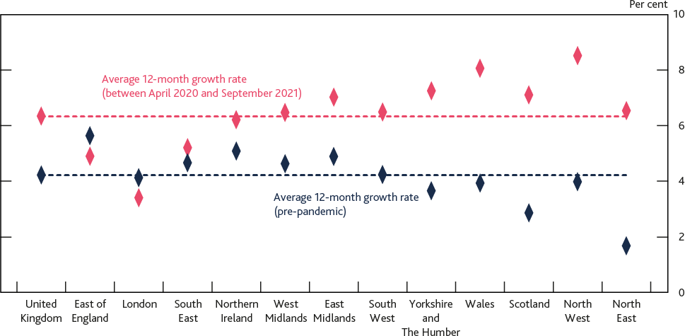

Sources: Land Registry data ©, ONS and Bank calculations. Crown copyright and database right 2020. This data is licensed under the Open Government Licence v3.0.

(a) Pre-pandemic refers to the period from January 2015 to March 2020. Average annual growth rate calculated using the average of the percentage change in UK house prices over the previous 12 months, for the period specified.

### …but so far, there is limited evidence to suggest that recent strength in the housing market presents a risk to financial stability.

Strength in the housing market has historically been associated with riskier lending practices, and could become a source of concern if accompanied by a significant increase in aggregate mortgage debt and the number of highly indebted households. Despite the current strength in the UK housing market, there has been little evidence of a deterioration in lending standards or a material increase in the number of highly indebted households. And the share of new lending at loan to income ratios at or above 4.5 was 8.5% in 2021 Q3, compared to 10.6% in 2021 Q2, well below the FPC’s limit of 15%.

Since 2014, the FPC’s mortgage market Recommendations have been in place to limit a deterioration in underwriting standards, and a rapid build-up in household indebtedness and the share of highly indebted households. The FPC has concluded its review into these Recommendations (see Section 3).

The 2021 SST incorporated a rise in UK unemployment to just under 12% and fall in house prices of around 33% over the course of the stress scenario. The UK banking system was judged to be resilient to these shocks (see [2021 solvency stress test](http://www.bankofengland.co.uk/stress-testing/2021/bank-of-england-stress-testing-results)).

**Domestic debt vulnerabilities – corporate indebtedness**

### The pandemic presented a substantial shock to UK businesses, resulting in a relatively moderate increase in UK corporate debt vulnerabilities.

The aggregate increase in corporate debt from 2019 Q4 to 2021 Q2 now stands at £47 billion, after falling by £20 billion between 2021 Q1 and 2021 Q2 as companies have continued to repay more finance than they raise. The UK’s corporate debt to earnings ratio is broadly similar to its pre-

pandemic level, having declined from 333% in 2021 Q1 to 321% in 2021 Q2, as companies have paid down debt and earnings have recovered. Business insolvencies have increased somewhat since the July 2021 Report, but remain below pre-pandemic levels.

### Debt-servicing remains affordable for most UK businesses and the UK financial system is resilient to vulnerabilities in the UK corporate sector.

Debt servicing remains affordable for most businesses. For example, data for large listed businesses – which account for nearly a quarter of aggregate UK corporate sector turnover and around 40% of aggregate UK corporate sector debt – suggest that the share of large listed businesses with interest coverage ratios (ICRs) – the ratio of earnings before interest and tax to interest expense – below 2.5 was broadly unchanged in 2020 and remains far below historical peaks (Chart 1.4).2 As described in the [October 2021 Financial Stability in Focus](https://www.bankofengland.co.uk/financial-policy-summary-and-record/2021/october-2021/financial-stability-in-focus) (FSiF), staff analysis suggests that it would take a large increase in interest rates or a severe shock to earnings to impair businesses’ ability to service their debt in aggregate.

## Chart 1.4: The share of UK businesses with large interest burdens has fallen over time Share of highly indebted UK businesses as measured by low ICRs, weighted by debt share

**(a)****(b)**

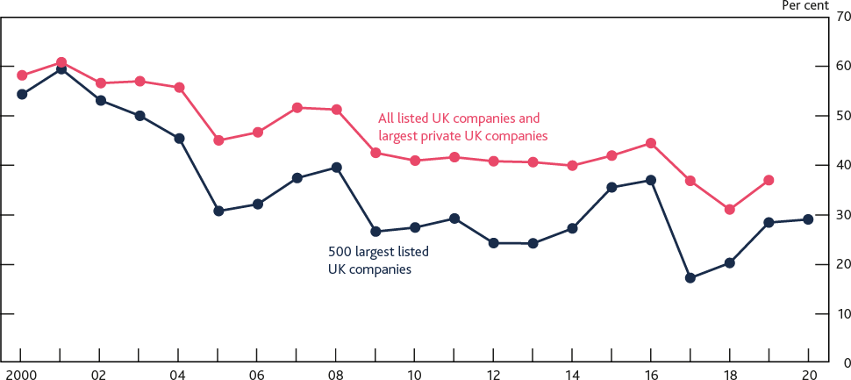

Sources: Fame (Bureau van Dijk), S&P Capital IQ and Bank calculations.

(a) ICRs are calculated as the three-year moving average, where available, of earnings before interest and tax as a share of interest expenses and interest capitalised. Low ICRs defined as below 2.5.

(b) The largest listed companies are those with the highest three-year average turnover in a given year. The largest private companies are defined as those with turnover greater than £10 million in any given year.

Within this aggregate picture, however, pockets of risk remain, and the increase in debt levels at the start of the pandemic is likely to have increased the number and scale of vulnerable businesses.

SMEs are more likely to face financial pressures as they are more likely to operate in sectors affected by the pandemic, and have increased their debt more than larger companies. However, the vast majority of this debt has been issued via government-backed loan schemes, which will limit risks to

2 A low ICR indicates that a company is more likely to experience repayment difficulties which might be exacerbated in the case of shocks that either increase its repayments (such as an interest rate increase) or lower its earnings.

lenders. And most of these loans have low interest rates that are fixed for the duration of the loan, which will limit the burden on borrowers.

In October 2021, the FPC published a detailed assessment of how the Covid pandemic has affected business’ balances sheets and the implications for UK financial stability in its [FSiF](https://www.bankofengland.co.uk/financial-policy-summary-and-record/2021/october-2021/financial-stability-in-focus) publication.

Overall, the FPC continues to judge that the UK financial system is resilient to vulnerabilities in the UK corporate sector.

**Global debt vulnerabilities**

### Global debt vulnerabilities remain material.

As the global financial crisis demonstrated, global vulnerabilities can spill over to the UK through several channels ([Cesa-Bianchi et al (2021)](http://www.bankofengland.co.uk/quarterly-bulletin/2021/2021-q3/no-economy-is-an-island-how-foreign-shocks-affect-uk-macrofinancial-stability)).

As in the UK, the pandemic was a substantial shock to households and businesses in other economies. Government and central bank policy support has helped to limit the disruption from the pandemic. However, across advanced and emerging market economies, corporate debt to GDP ratios have generally increased. By 2021 Q2, estimated global corporate debt to GDP ratios had increased in aggregate by around 7 percentage points since the end of 2019, as output decreased and businesses borrowed more. More recently, advanced economy corporate debt to GDP ratios are likely to have declined in 2021 Q3, driven by the economic recovery. And, as noted in the October 2021 FSiF, corporate debt servicing in advanced economies has generally remained affordable.

Nonetheless, higher leverage abroad could directly increase the risk of losses for UK lenders on their foreign exposures (although UK banks have limited direct exposures to the most vulnerable sectors in advanced economies). Corporate debt vulnerabilities in other countries could also have indirect spillovers to the UK. For example, they could increase the risk of a sharp tightening in global financial conditions and macroeconomic downturns in other countries, which could transmit to the UK.

**There are some concerns over long-standing vulnerabilities in the Chinese property sector…** While residential property price growth in many countries has been strong, there are particular concerns over long-standing vulnerabilities in the Chinese property sector. Many property developers are highly leveraged and house price to income ratios are elevated in a number of cities.

And there have been signs of increased speculative activity over recent years. The proportion of homebuyers who already owned at least one dwelling increased sharply from 30% in 2008 to 87% in 2018 (Chart 1.5).

## Chart 1.5: There have been signs of increased speculative activity in the Chinese property market

**Chinese new homebuyers by number of dwellings already owned**

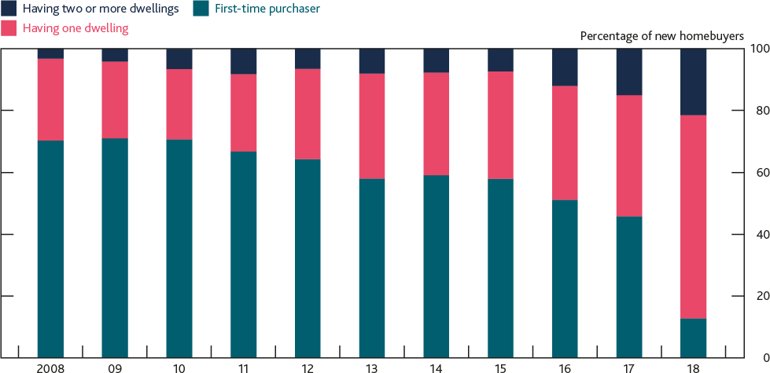

Sources: [Rogoff and Yang (2021), ‘Has China’s Housing Production Peaked?’](https://scholar.harvard.edu/rogoff/publications/peak-china-housing) China and the World Economy 21

(1): 1–31 and Survey and Research Center for China Household Finance.

Some property developers in China have faced liquidity challenges recently, reflecting breaches of Chinese authorities’ limits on property sector leverage, and exemplified by concerns over the ability of Evergrande Group, one of China’s largest property developers, to meet its financial obligations. So far, activity in the property market has slowed considerably, although contagion from these liquidity stresses has been mainly limited to a few small developers in China. But a sharper downturn in the sector could have wider consequences; the real estate sector has been a significant contributor to growth in China over recent years, and is estimated to account for around a quarter of Chinese GDP ([Rogoff and Yang (2021](https://scholar.harvard.edu/rogoff/publications/peak-china-housing)). There could also be additional amplification effects via Hong Kong, to the extent that property markets in mainland China and Hong Kong are closely linked. UK banks have significant exposure to Hong Kong, representing around 160% of their CET1 capital.

Recent developments in the property sector take place against a backdrop of high and rising debt levels in China, which the FPC has highlighted previously (see [December 2019 Report](http://www.bankofengland.co.uk/financial-stability-report/2019/december-2019)). Private non- financial sector debt as a share of GDP has risen to around 220% of GDP, roughly doubling since 2008.

### ...and any crystallisation of vulnerabilities could spill over to the UK.

A serious downturn in China could have a significant impact on the UK economy. Previous Bank [research](https://www.bankofengland.co.uk/quarterly-bulletin/2018/2018-q2/from-the-middle-kingdom-to-the-united-kingdom-spillovers-from-china) estimated that a hypothetical ‘hard landing’ in China that resulted in the level of GDP being 10% lower three years after the shock would reduce the level of UK GDP by 1.3%–1.4% at the peak. Amplification effects through financial markets could lead to the ultimate impact on the UK being potentially more than twice as large.

The 2021 SST embodied sharp falls in output and property prices in both China and Hong Kong. China’s GDP falls by a little under 10% in the first quarter of the stress, while Hong Kong’s output contracts by 9.6%. While there is uncertainty as to how these risks might crystallise, the results of the 2021 SST indicate that the UK banking system is resilient to the direct effects of a severe

downturn in China and Hong Kong, as well as indirect effects through sharp adjustments in global asset prices.

**Risk-taking in the financial system**

### There is some evidence of increased risk-taking among investment banks, and risks in leveraged loan markets globally continue to increase.

There are signs of increased risk-taking in some investment banking businesses. Investment banks currently have large underwriting positions, particularly in leveraged loans and securitisations. If market conditions change quickly, then these banks could incur losses.

Some UK banks (and businesses) participate in leveraged loan markets, where risks globally continue to increase. Investment banks globally hold over half of the now nearly US$4 trillion stock of leveraged loans (typically loans to non-investment grade companies that are highly indebted or are owned by a private equity sponsor), with exposures concentrated in global systemically important banks (see [December 2019 Report](http://www.bankofengland.co.uk/financial-stability-report/2019/december-2019)). The post-global financial crisis trends of increased leveraged loan issuance and loosening in underwriting standards in these markets have continued. For example, the share of new lending with few financial maintenance covenants (so-called

‘covenant-lite’ lending) in these markets is at a record high globally.

These risks can affect UK financial stability through losses for banks and the indirect impact of losses spreading through other parts of the global financial system. Risks may also arise for borrowers if they are unable refinance existing debt were credit conditions to tighten in an adverse shock. Banks were tested against direct losses associated with leveraged lending in the 2021 SST, and the core UK banking system was found to be resilient. The FPC continues to monitor this area closely.

### Risk-taking in certain financial markets remains high relative to historical levels.

Some equity prices have increased since the July 2021 Report, which partly reflects the continued economic recovery, and remain significantly above their pre-pandemic level (notwithstanding some recent market volatility). US equity valuations in particular appear elevated relative to historical norms, based on estimates of equity risk premia for the S&P 500 index. Such estimates of risk premia, which can be used to gauge the compensation for risk embedded in asset prices, appear low relative to historical averages, and might suggest increased risk-taking in US equity markets. Premia for the UK and euro-area equity indices appear relatively less compressed (Chart 1.6). Staff analysis suggests that part of this difference may be explained by the sectoral composition of equity indices across jurisdictions. In particular, the technology sector – which has been a large driver of equity price moves since the start of the pandemic – makes up almost 30% of the US index compared to only 3% of the UK index.

Advanced economy corporate bond spreads remain compressed relative to historical averages, and there has also been evidence of strong demand for lower-grade credit: for example, issuance of high-yield corporate bonds in the UK has outpaced its 2012–19 average so far this year and US leveraged loan market issuance has reached an all-time high.

## The chart shows the current level of selected metrics of asset valuations as a percentile of historical values across the United Kingdom, United States and euro area, expressed as risk-taking. Data shows some equity valuations appear stretched (such as the cyclically adjusted price to earnings ratio), and some corporate bond spreads are low, which could reflect higher risk-taking. Chart 1.6: Risk-taking in certain financial markets remains high relative to historical levels Current level of selected asset valuation metrics as a percentile of historical values (a) (b)

Sources: Bloomberg Finance L.P., ICE BofAML, Refinitiv Eikon from LSEG, Refinitiv I/B/E/S from LSEG, Tradeweb and Bank calculations.

1. Data are as of close of business on 26 November 2021. Risk-taking is shown here using percentiles of the historical distribution calculated since January 2000 (unless stated below) and a five-day rolling average. Equity Risk Premium (ERP), Excess CAPE Yield and corporate bond spreads have been inverted so lower values reflect a higher percentile rank.
2. Cyclically adjusted price to earnings ratio (CAPE) percentiles measure calculated from January 2002. Equity risk premium is calculated using a dividend discount model. Excess CAPE Yield is calculated as the inverse of CAPE minus the respective 10-year government bond yield (measured from October 2004). Investment-grade corporate bond spreads are adjusted for changes in credit quality and duration.

But there has also been some indication of a reduction in risk appetite in financial markets since the [July 2021 Report.](https://www.bankofengland.co.uk/financial-stability-report/2021/july-2021) For instance, the November 2021 Bank of America Global Fund Manager survey indicated that the balance of fund managers taking ‘higher than normal’ levels of risk has fallen back somewhat over the course of this year, after reaching a 20-year high in February 2021.

As described in the [July 2021 Report,](https://www.bankofengland.co.uk/financial-stability-report/2021/july-2021) low compensation for risk could be evidence of investors’ ‘search for yield’ behaviour, which could reflect the current low interest rate environment and higher risk-taking. This creates a vulnerability to a sharp correction in asset prices – if for example market participants re-evaluated materially the prospects for growth, inflation or interest rates. Any such correction could be amplified by existing vulnerabilities in market-based finance (see Section 1.4). This could have adverse consequences for market functioning and financial conditions, and potentially transmit stress to other parts of the financial system and the real economy.

**The UK countercyclical capital buffer (CCyB) rate**

**The FPC judges that vulnerabilities that can amplify economic shocks are at a standard level overall, as was the case just before the pandemic. This would be consistent with the UK CCyB rate returning to the region of 2%.** However, there continues to be uncertainty about the evolution of the pandemic and the economic outlook. Should downside risks crystallise, the economy could require more support from the financial system.

**The FPC is therefore increasing the UK CCyB rate from 0% to 1% (Box A).** This rate will come into effect from 13 December 2022 in line with the usual 12-month implementation period.

**If the UK economic recovery proceeds broadly in line with the MPC’s central projection in the November MPR, and absent a material change in the outlook for UK financial stability, the FPC would expect to increase the rate further to 2% in 2022 Q2.** That subsequent increase would be expected to take effect after the usual 12-month implementation period.

## : Building the resilience of the financial system

**Market-based finance**

### The FPC strongly supports international work, led and co-ordinated by the FSB, to assess and develop policy responses to address the underlying vulnerabilities in market-based finance that amplified the March 2020 ‘dash for cash’.

As set out in the July 2021 Report and accompanying Bank report on ‘Assessing the resilience of market-based finance’, the March 2020 ‘dash for cash’ episode caused severe disruption in market- based finance and threatened to harm the wider economy. This episode exposed a number of underlying vulnerabilities in market-based finance that the FPC and other authorities, including the FCA and the FSB, had previously highlighted.

The FPC reiterates that it remains crucial to analyse, and, as necessary remediate, these structural vulnerabilities. For example, vulnerabilities associated with liquidity mismatches in corporate bond funds remain elevated as those funds have grown in size. Assets under management in US open- ended corporate bond funds are around 140% of their pre-Covid levels (including valuation effects), while in UK-focused funds they are around 110%. Meanwhile, the share of liquid assets held by corporate bond funds has remained broadly below pre-Covid levels. A liquidity mismatch could pose risks to market functioning if it resulted in forced asset sales during a stress.

The FPC welcomes the FSB’s analysis of these vulnerabilities, and it endorses the policy recommendations for money market funds that now need to be implemented in all jurisdictions. In the FPC’s view, further policy measures are needed to enhance the resilience of market-based finance in other areas including open-ended funds, margin, the liquidity structure and resilience of core markets, and leveraged investors and their prime brokers (Box B).

**The transition to robust alternative benchmarks to Libor**

### The FPC emphasises the importance of market participants now being fully prepared for relevant Libor settings to either cease or become unrepresentative, and to cease new use of the continuing US dollar Libor settings, by the end of this year.

The majority of Libor settings will be discontinued at the end of 2021, with some settings continuing for a limited period to support an orderly wind-down of legacy contracts only. In sterling markets, most use of Libor in new contracts has now ceased and been largely replaced by the Sterling Overnight Index Average, a risk-free rate produced by the Bank.

The FCA has confirmed it will allow the temporary use of ‘synthetic’ one, three and six-month sterling and yen Libor rates by UK-supervised entities in all legacy Libor contracts, other than cleared derivatives, that have not transitioned at or ahead of end-December 2021. The FPC supports the

view that synthetic versions of Libor are a temporary solution, and that active transition of legacy contracts provides the best route to certainty for parties to contracts referencing Libor.

The FPC notes that, despite the ongoing progress in the transition to the Secured Overnight Financing Rate (SOFR) in US dollar markets, further work is required to make sure markets cease new use of US dollar Libor by the start of 2022. It is the FPC’s view that SOFR-based rates provide more robust alternatives than recently created credit sensitive rates, and the FPC considers these credit sensitive rates to have the potential to reintroduce many of the financial stability risks associated with Libor (see [July 2021 Report](https://www.bankofengland.co.uk/financial-stability-report/2021/july-2021)).

The FPC will continue to be vigilant to the management of key operational risks associated with the transition over the coming weeks, including those associated with the implementation of fallback measures.

**Risks from cryptoassets**

### Cryptoassets and their associated markets and activities, including decentralised finance, continue to grow and to develop rapidly.

Innovation can bring a number of benefits, including reduced frictions and inefficiencies in financial services. These benefits can only be realised and innovation can only be sustainable if undertaken safely and accompanied by effective public policy frameworks that mitigate risks.

The market capitalisation of cryptoassets has grown tenfold since early 2020 to around US$2.6 trillion as of 24 November 2021, representing around 1% of global financial assets.

The vast majority of this market (around 95%) is made up of ‘unbacked’ cryptoassets that have no underlying assets – essentially non-replicable strings of computer code that can be owned and transferred without intermediaries. Such cryptoassets have no intrinsic value, are vulnerable to major price corrections and investors may lose the entire value of their investment. This price volatility makes them unsuitable to be widely used as money or a store of value.

Many other cryptoassets claim to maintain a stable value against a fiat currency by holding a pool of backing assets, in a bid to make them more suitable for payment and settlement purposes (known as ‘stablecoins’); these have also played a role in facilitating speculative investment in unbacked cryptoassets. However, in many cases there is uncertainty around the transparency and quality of backing arrangements ([Wilkins (2021)](https://www.bankofengland.co.uk/speech/2021/november/carolyn-a-wilkins-keynote-speaker-at-autorite-des-marches-financiers-annual-meeting)).3 The FPC set out two expectations for stablecoins that have the potential to become widely used as a means of retail payments (‘systemic stablecoins’) in December 2019. These aim to ensure that stablecoin arrangements used for payments are regulated to standards equivalent to those applied to traditional payment chains, and that, where used as money, stablecoins maintain standards equivalent to those expected of commercial bank money (see [New forms of digital money](https://www.bankofengland.co.uk/paper/2021/new-forms-of-digital-money)). Some major stablecoin proposals, including from financial services firms, do not appear at present to meet these expectations.

3 As the FPC has previously noted, stablecoins could provide benefits to users but will be adopted widely and become successful as a means of payment only if they meet appropriate standards and confidence in their value is assured (see [December 2020 Report](http://www.bankofengland.co.uk/financial-stability-report/2020/december-2020)).

In addition, there has been rapid growth in decentralised finance (DeFi),4 which can be deployed to replicate a range of financial services including lending, trading and insurance. DeFi demonstrates the increasing complexity, and potential for new risks in the cryptoasset ecosystem ([Cunliffe (2021)](https://www.bankofengland.co.uk/speech/2021/october/jon-cunliffe-swifts-sibos-2021)).

Cryptoassets are becoming increasingly interconnected with the ‘traditional’ financial system. **As the FPC has noted, direct risks to the stability of the UK financial system from cryptoassets are currently limited. However, at the current rapid pace of growth, and as these assets become more interconnected with the wider financial system, cryptoassets will present a number of financial stability risks.**

For example, material growth in banks’ exposures to unbacked cryptoassets would expose them to financial, operational and reputational risks. Although no major UK banks have reported direct exposures to cryptoassets as yet, some UK and global banks are starting to offer a variety of services, such as cryptoasset derivatives trading, and custody services.

Stresses in cryptoasset markets could also spill over to broader financial markets. For example, if institutional investors embed cryptoassets as a core part of their portfolios, a large fall in cryptoasset valuations may cause investors to sell other financial assets and potentially transmit shocks through the financial system. The use of leverage can amplify such spillovers further, should investors be forced to meet margin calls on their cryptoasset positions by selling other assets. While in aggregate, evidence from surveys and market intelligence suggests that cryptoassets represent only a small fraction of institutional investor portfolios at present, they have the potential to grow rapidly.

Greater focus is needed on enhancing the transparency of institutional investor holdings as cryptoasset markets continue to grow.

The FCA’s [‘cryptoasset consumer research’](https://www.fca.org.uk/publications/research/research-note-cryptoasset-consumer-research-2021) estimates 2.3 million adults own cryptoassets in the UK. However, in aggregate, Bank staff estimates suggest that cryptoassets currently account for around 0.1% of UK households’ net financial wealth (based on available data as of January 2021), and so the financial stability risks that would arise directly from household losses are limited. A material loss of value, however, might also have indirect effects on confidence in market integrity and the financial system more broadly. The FCA has [warned consumers](https://www.fca.org.uk/firms/cryptoassets) of the risks of investing in cryptoassets (noting that cryptoassets are considered very high risk, speculative investments) and has also banned the sale of crypto-derivatives to retail customers.

Given their perceived or purported relative stability in value, stablecoins may have greater potential to become widely used in payments, compared to unbacked cryptoassets. Hence, risks could arise if there is an acceleration in the adoption of stablecoins for retail payments before appropriate regulatory frameworks are in place. Uncertainty about, or fluctuations in, the value of instruments being used in systemic payment chains could give rise to financial stability risks, such as risks to users’ ability to meet payment obligations, or a collapse in confidence leading to a run on stablecoins, with potential contagion effects (for example, if large scale redemptions lead to a forced sale of backing assets). Some stablecoins may also have vulnerabilities associated with a mismatch

4 DeFi is essentially a set of alternative financial markets and products that operate through ‘smart contracts’ (autonomous pieces of software) built using blockchain technology and denominated in cryptoassets (primarily stablecoins).

between the liquidity of their backing assets and the redemption terms they offer, similar to those the FPC has previously highlighted in certain open-ended funds.

### Enhanced regulatory and law enforcement frameworks, both domestically and at a global level, are needed to influence developments in these fast-growing markets in order to manage risks, encourage sustainable innovation and to maintain broader trust and integrity in the financial system. The regulatory response will require close international co-ordination, given the global nature of many cryptoassets and their associated markets.

There have been some positive steps in the development of regulatory frameworks to address some of the risks associated with cryptoassets. For example, in June 2021, the Basel Committee on Banking Supervision published a [consultation](https://www.bis.org/bcbs/publ/d519.htm) on preliminary proposals for the prudential treatment of banks’ cryptoasset exposures. The International Organization of Securities Commissions and the Committee on Payments and Market Infrastructures have issued a [consultative report](https://www.bis.org/cpmi/publ/d198.htm) setting out guidance on the application of existing Principles for Financial Market Infrastructures to systemically important stablecoin arrangements. And the FSB has published [high-level recommendations](https://www.fsb.org/2020/10/regulation-supervision-and-oversight-of-global-stablecoin-arrangements/) for the regulation, supervision and oversight of global stablecoin arrangements. The FPC welcomes international work on these issues.

Nonetheless, the development of regulatory frameworks to mitigate the full range of potential risks from cryptoassets is still at an early stage, and it will take time for any international standards to be implemented in domestic frameworks. Given this, there is currently scope for regulatory arbitrage. The FPC also notes that there are currently significant data gaps in cryptoasset markets that impede a fuller assessment of risks. International and domestic effort and co-operation will be essential to remediating these gaps.

Domestically, the FPC welcomes HM Treasury’s proposal to introduce a regulatory regime for stablecoins used as a means of payment, including bringing systemic stablecoins into the Bank’s regulatory remit. The FPC also supports the work of the HM Treasury-FCA-Bank Cryptoassets Taskforce (CATF) on assessing the regulatory approach to unbacked cryptoassets and their associated markets and activities, in order to shape developments in this space and support safe innovation.

The FPC will continue to pay close attention to developments in this area and will seek to ensure that the UK financial system is resilient to systemic risks that may arise from cryptoassets. Any future regulatory regime should aim to balance risk mitigation with supporting innovation and competition. The FPC considers that financial institutions should take an especially cautious and prudent approach to any adoption of these assets until such a regime is in place.

It will be important to ensure other significant risks which lie outside the FPC’s remit – such as consumer and investor protection, market integrity, money laundering and terrorist financing – are mitigated. The FPC supports the ongoing work of other regulatory authorities, including the FCA as well as law enforcement agencies in this regard.

**The supply of productive finance**

The FPC’s primary objective is to protect and enhance stability of the financial system of the UK. Subject to meeting this objective, the FPC has a secondary objective to support the economic policy

of the Government. Addressing issues related to the supply of finance for productive investment (‘productive finance’) is an important aspect of the FPC’s remit.

Box C outlines the FPC's work to facilitate finance for productive investment and sets out the FPC’s current approach to its secondary objective more generally, covering in particular: competition and innovation, openness and competitiveness, environmental sustainability and climate change, and housing.

# Box A: The UK countercyclical capital buffer rate decision

**The countercyclical capital buffer (CCyB) helps the banking system to absorb, rather than amplify, economic shocks. The FPC reviews the UK CCyB rate every quarter.** When it judges that risks to UK financial stability are increasing, the FPC’s approach is to increase the UK CCyB rate so that banks have an additional cushion of capital against potential future losses. When a shock hits the economy, the FPC can release this capital by cutting the UK CCyB rate. This means banks can support households and businesses through lending, while also absorbing losses.

**Before the Covid pandemic, the FPC had established that a UK CCyB rate in the region of 2% is appropriate in a standard risk environment; that is, when risks are judged to be neither elevated nor subdued.** Before the pandemic, a 2% UK CCyB rate was due to come into effect by the end of 2020. In March 2020 – as UK financial stability risks from Covid became apparent – the FPC cut the UK CCyB rate to 0% with immediate effect. In December 2020, the FPC updated its guidance to say that it expected the UK CCyB rate to remain at 0% until at least December 2021.

**The FPC judges that vulnerabilities that can amplify economic shocks are now at a standard level overall, as was the case just before the pandemic**. As outlined in Section 1, UK housing market activity has been strong over the past year, although measures of UK household debt vulnerabilities have remained stable, while UK corporate debt vulnerabilities have increased relatively moderately as a result of the pandemic. Asset valuations and risk-taking in certain financial markets appear high relative to historical norms. And UK banks are also exposed to spillovers from global debt vulnerabilities, which remain material.

**Reflecting the exceptional policy responses of the UK authorities to support the real economy, banks have not suffered losses on the scale that might have been expected given the severe economic impact of the pandemic.** Major UK banks’ and building societies’ capital ratios have in fact increased since the start of the pandemic, and are currently well above regulatory requirements (see Section 2). Under these circumstances, an increase in the UK CCyB rate could be met with existing capital rather than requiring major UK banks and building societies to strengthen their capital positions. For this reason, the FPC does not expect that an increase in the UK CCyB rate would currently have a material impact on prevailing credit, or wider economic, conditions.

**Uncertainty over risks to public health and the economic outlook remains and, as set out in the November Monetary Policy Report (MPR), there are upside and downside risks to the MPC’s economic projections.** There are near-term pressures on supply and inflation; and there could be a greater impact from Covid on activity, especially given uncertainties about whether new variants of the virus reduce vaccine efficacy. Should downside risks to the recovery crystallise, the economy could require more support from the financial system.

**The FPC is therefore increasing the UK CCyB rate from 0% to 1%.** This rate will come into effect from 13 December 2022 in line with the usual 12-month implementation period.

### If the UK economic recovery proceeds broadly in line with the MPC’s central projections in the November MPR, and absent a material change in the outlook for UK financial stability, the FPC

**would expect to increase the rate further to 2% in 2022 Q2**. That subsequent increase would be expected to take effect in 2023 Q2, following the usual 12-month implementation period.

As always, the FPC stands ready to vary the UK CCyB rate in either direction as economic conditions and the overall risk environment evolve.

# Box B: International progress on building the resilience of market-based finance

Market-based finance plays an important and growing role in the financial system and in the provision of services and financing to the real economy. In March 2020, vulnerabilities in the system of market-based finance amplified the initial market reaction to the pandemic, contributing to a severe liquidity shock (the ‘dash for cash’). Significant interventions at pace and at scale from central banks were required to restore market functioning. Absent such interventions, the disruption to market functioning would have worsened the liquidity stress and threatened to harm the wider economy. Although these interventions were necessary and effective, such actions come with potential risks to the broader financial system (for example, by encouraging excessive risk-taking) and public money. It is therefore essential that jurisdictions enhance the resilience of market-based finance.

In July 2021, the Bank published a detailed [report](https://www.bankofengland.co.uk/report/2021/assessing-the-resilience-of-market-based-finance) on the resilience of market-based finance and its potential to amplify and transmit stress. The FPC identified three areas of focus to reduce the likelihood and impact of disruptions to liquidity: reducing the demand from the non-bank financial system for liquidity in stress; ensuring the resilience of the supply of liquidity in stress; and potential additional central bank liquidity backstops for market functioning.

The international nature of market-based finance means that vulnerabilities can only be addressed effectively through globally co-ordinated policy action. Co-ordinated policy action will reduce the risk of regulatory arbitrage and market fragmentation. **The FPC strongly supports international work, led and co-ordinated by the Financial Stability Board (FSB), to assess and develop policy responses to address these underlying vulnerabilities** (see FSB’s [Holistic Review of the March Market Turmoil](https://www.fsb.org/wp-content/uploads/P171120-2.pdf)). The Bank, the FCA and HM Treasury are actively engaged in this work agenda.

The FSB’s report, in November 2021, to G20 leaders, [Enhancing the Resilience of Non-Bank Financial](https://www.fsb.org/wp-content/uploads/P011121.pdf) [Intermediation: Progress Report](https://www.fsb.org/wp-content/uploads/P011121.pdf), set out the progress towards analysing and addressing these issues. The work to date has deepened international authorities’ common understanding of the vulnerabilities in non-bank financial intermediation (NBFI) and has taken steps towards developing policy proposals to address vulnerabilities – in particular for money market funds (MMFs). The international agenda has focused on five areas.

## Money market funds

MMFs, most notably in the US, UK and EU, experienced large redemptions during March 2020, raising the possibility of fund suspensions that could have had direct impact on the ability of companies and other investors to access cash. The FPC welcomes the [agreement](https://www.fsb.org/wp-content/uploads/P111021-2.pdf) by individual FSB members to assess vulnerabilities in MMFs in their jurisdictions and to address them using the FSB’s framework and policy toolkit. The FSB’s implementation and effectiveness reviews in 2023 and 2026 respectively will assess whether the vulnerabilities have been adequately mitigated.

## Open-ended funds (OEFs)

The FSB and the International Organization of Securities Commissions (IOSCO) have examined the behaviour and impact of OEFs during March 2020 to seek to develop a shared view on the

vulnerabilities in OEFs and the effectiveness of liquidity management tools. In particular, there is evidence that liquidity management tools were not used consistently; and that asset sales by OEFs contributed to stress in underlying markets. The FSB also notes that some external analysis links a substantial proportion of outflows from certain types of funds to underlying liquidity mismatches. The FPC has previously highlighted those vulnerabilities in relation to liquidity mismatch in OEFs and urges further steps internationally in 2022 to adequately mitigate vulnerabilities in funds. The FSB’s planned work to assess the effectiveness of its 2017 [Policy Recommendations to Address Structural](https://www.fsb.org/wp-content/uploads/FSB-Policy-Recommendations-on-Asset-Management-Structural-Vulnerabilities.pdf) [Vulnerabilities from Asset Management Activities](https://www.fsb.org/wp-content/uploads/FSB-Policy-Recommendations-on-Asset-Management-Structural-Vulnerabilities.pdf) and IOSCO’s review of the implementation of its 2018 [Recommendations on Liquidity Risk Management for OEFs](https://www.iosco.org/library/pubdocs/pdf/IOSCOPD590.pdf) will contribute to this. Further action by the FSB may be needed to address the vulnerabilities in OEFs.

## Margin

The timely and accurate provision of margin for both cleared and uncleared financial contracts is an essential protection against counterparty credit risk. Market participants need to be prepared for margin calls that put pressure on liquidity. Central counterparties need to ensure the necessary information is available to participants and that margin calls are not unnecessarily procyclical. The Basel Committee on Banking Supervision, the Committee on Payments and Market Infrastructures and IOSCO have jointly published a [consultation report,](https://www.bis.org/bcbs/publ/d526.pdf) analysing the role of margin in the 2020 dash for cash. The report shows that although market participants were generally able to meet increased margin calls successfully, some of them might not have adequately planned for a shock of such amplitude. The report also shows that transparency and predictability in margin modelling might not always have been sufficient to allow participants to prepare for margin calls. The final report is expected to consider next steps, taking into account consultation feedback on potential vulnerabilities related to margin calls in centrally cleared and uncleared derivatives markets and the preparedness of market participants to manage liquidity in a stress. The FPC strongly supports this work in 2022 and appropriate action required to mitigate vulnerabilities.

## Liquidity, structure and resilience of core bond markets

The FPC supports the FSB’s work on analysing the drivers of illiquidity during the ‘dash for cash’, including the behaviour of different types of market participants. At least in some cases, dealers expanded their balance sheets substantially in March 2020 to accommodate liquidity demands, but were overwhelmed by the one-directional demand for liquidity from a range of investors. For example, evidence from the Bank as well as the Bank for International Settlements, Office of Financial Research and Federal Reserve Board highlight that, though not the only contributors, the actions of highly leveraged investors had a material negative impact on government bond market liquidity. The failure of Archegos demonstrated how leveraged investors could also pose risks to systemic institutions. Since the [July Report,](https://www.bankofengland.co.uk/financial-stability-report/2021/july-2021) the functioning of some financial markets was challenged at times, which provides further evidence of the tendency for markets to jump to illiquidity under stress (see Section 1). The FPC strongly encourages the FSB to put further focus on these issues in 2022.

## Emerging market economies (EMEs) and US$ funding

The FSB’s report also sets outs the work it is doing to assess the external funding pressures faced by EMEs during the March 2020 market stress and the severe strains in offshore dollar funding. This considers the increasing role that NBFI plays as a source of cross-border finance for EMEs.

[Bank research](https://www.bankofengland.co.uk/financial-stability-paper/2020/capital-flows-during-the-pandemic-lessons-for-a-more-resilient-international-financial-architecture) shows that non-resident non-bank financial institutions played a role in amplifying outflows from emerging markets during the onset of the pandemic, which go beyond what can be explained by the deterioration in economic and financial sentiment. The FSB’s work should continue in 2022 to provide the basis for assessing the impact of NBFI vulnerabilities on funding for EMEs.

**The FPC welcomes the FSB’s analysis of the vulnerabilities in market-based finance that were exposed in the dash for cash in March 2020, and it endorses the common framework to raise resilience in MMFs that now requires implementation by all jurisdictions.** It is the FPC’s view that further policy measures are needed to enhance the resilience of NBFI across the areas set out above. Absent an increase in the resilience of NBFI, the financial stability vulnerabilities remain and are likely to amplify shocks, as they did in March 2020. **The work planned by the FSB next year therefore represents an important opportunity to develop policies to address those vulnerabilities.** The FPC will continue to monitor progress.

Making progress on mitigating these vulnerabilities is also vital to ensure that interventions by central banks, such as those seen in March 2020, are truly backstops in stress episodes and that risks to the broader financial system and public money are effectively mitigated. The debate around the role of central banks and whether new, more targeted, liquidity tools are needed is under way in a number of jurisdictions, recognising that existing central bank liquidity tools may not always be appropriate or sufficiently targeted to resolve some types of market-based liquidity shocks.

However, **central bank interventions cannot be a substitute for the primary obligation of market participants to manage their own risk,** or for internationally co-ordinated reforms that enhance the resilience of NBFI.

# Box C: The FPC’s secondary objective

**The FPC’s primary objective is to protect and enhance stability of the financial system of the UK.****5** **Subject to meeting this, the FPC has a secondary objective to support the economic policy of the Government.** The Government’s economic policy objective is to achieve strong, sustainable and balanced growth as set out in the [March 2021 Remit letter](https://www.bankofengland.co.uk/-/media/boe/files/letter/2021/march/fpc-remit-and-recommendations-letter-2021.pdf). The letter sets out the Government’s economic policy relating to finance for productive investment, and the Government’s overall strategy for financial services, covering in particular: competition and innovation; openness and competitiveness; environmental sustainability and climate change; and housing.

**The FPC has undertaken work to facilitate finance for productive investment.** It has: i) supported the work programme of the industry-led Working Group on Productive Finance; ii) engaged with aspects of the review of Solvency II relevant to its remit, alongside the Prudential Regulation Committee; and iii) undertaken work on widening the ability for investment funds to invest in long- term assets by seeking ways to reduce the liquidity mismatch in open-ended funds, and ensuring that appropriate vehicles and regulation are in place for investors to access a variety of illiquid asset classes. The FPC has also welcomed the upcoming Bank survey of UK businesses’ financing conditions in 2022.

**The FPC’s work to support finance for productive investment can benefit sustainable investment** in areas such as renewable energy infrastructure and green technologies, which also supports the FPC’s work on the secondary objective in relation to climate.

**The financial sector has an important role to play in managing the financial risks from climate change and supporting the economy-wide transition to net zero**. The FPC notes steps to support the transition by authorities and industry, including those announced at COP26. In June 2021, the Bank launched the [Climate Biennial Exploratory Scenario](https://www.bankofengland.co.uk/stress-testing/2021/key-elements-2021-biennial-exploratory-scenario-financial-risks-climate-change) (CBES) exercise to explore the risks posed by climate change and assess the resilience of major UK banks, insurers, and the wider financial system to different climate scenarios. The exercise aims to increase understanding of the challenges to participants’ business models from these risks, gauge their likely responses and the implications this carries for the provision of financial services, and will assist participants in enhancing their management of climate-related financial risks. In addition, the FPC welcomes the initial findings on the relationship between climate change and the regulatory capital regime as explored in the [PRA’s](https://www.bankofengland.co.uk/prudential-regulation/publication/2021/october/climate-change-adaptation-report-2021) [Climate Change Adaptation Report.](https://www.bankofengland.co.uk/prudential-regulation/publication/2021/october/climate-change-adaptation-report-2021) This work supports the FPC’s primary objective as well as its secondary objective.

To support the Government’s strategy on environmental sustainability, as set out in the Remit letter, the FPC will build on the insights from the CBES and consider the potential relevance of other environmental risks to its objectives. In doing so, it will take account of evidence from existing literature, such as the Dasgupta Review on the economics of biodiversity, and will draw on

5 Section 9C (1) of the Bank of England Act 1998 states: ‘The Financial Policy Committee is to exercise its functions with a view to (a) contributing to the achievement by the Bank of the Financial Stability Objective; and (b) subject to that, supporting the economic policy of Her Majesty’s Government, including its objectives for growth and employment.’

collaborative efforts with other central banks and regulators through the Network for Greening the Financial System and the Sustainable Insurance Forum.

**Subject to pursuing its primary objective, the FPC aims to ensure that innovation in the UK can take place in a sustainable way, and thus support the Government’s strategy on innovation.** The FPC regularly carries out reviews to assess the suitability of the regulatory perimeter and considers how innovation and developments in technology could lead to the build-up of systemic risks. The Committee has noted that, where necessary, it would make Recommendations to HM Treasury regarding gaps in the regulatory perimeter, while providing certainty for regulators and innovators, and ensuring that innovation can take place in the UK with confidence.

The FPC has recognised payments as a focal point for innovation. Consistent with its mandate to protect and enhance the stability of the financial system in the UK, the FPC aims to ensure that systemically important payment systems support financial stability, while allowing, in support of its secondary objective, competition and innovation in payments to thrive. As set out in its previous publications, such as the [August](https://www.bankofengland.co.uk/report/2020/monetary-policy-report-financial-stability-report-august-2020) and [December](https://www.bankofengland.co.uk/financial-stability-report/2020/december-2020) 2020 Financial Stability Reports, the FPC has been undertaking work to assess the risks from new forms of payments; to consider how payment regulation should adapt to reflect the financial stability risks; and to review the Bank’s proposals on the appropriate level of access to its payments infrastructure and balance sheet.

Central to achieving the FPC’s primary objective is the maintenance and implementation of robust prudential standards in the UK, which is one of the world’s largest global financial centres. As the FPC has previously stated, this will require maintaining a level of resilience that is at least as great as that currently planned, which itself exceeds that required by international standards, as well as maintaining UK authorities’ ability to manage UK financial stability risks. **The financial stability benefits of robust regulation underpin the UK’s ability to compete sustainably in global financial markets** and help to ensure that the UK remains an attractive domicile for internationally active financial institutions, in line with the Government’s strategy on openness and competitiveness.

As highlighted by the Committee’s work on climate, payments, and robust prudential standards, the FPC’s pursuit of financial stability often complements its secondary objective. **Financial stability is a precondition for sustainable economic growth – a stable, resilient and innovative financial system helps facilitate a sustainable and efficient flow of funds within the economy and an effective allocation of savings to investment**. The Committee recognises that action to increase resilience may in some circumstances have a short-term effect on financial services activity, and at times on growth, even when that action will make a positive contribution to growth in the medium and longer term and considers this as part of its assessment of the costs and benefits of its policy actions.

**The FPC will continue to consider the costs and benefits of its policy actions in the context of both its objectives.** For example, when the FPC regularly reviews its mortgage market Recommendations (see Section 3), it includes consideration of the impact of its Recommendations on first-time buyers (see Box D). The FPC has considered how its proposed changes to the UK leverage ratio framework supported its secondary objective, as set out in the [Policy Statement PS21/21.](https://www.bankofengland.co.uk/prudential-regulation/publication/2021/june/changes-to-the-uk-leverage-ratio-framework) And in its review of the framework for the other systemically important institutions (O-SII) buffer, the FPC has considered the impact of the O-SII buffer on matters relevant to the FPC’s secondary objective, as set out in its [Consultation Paper.](https://www.bankofengland.co.uk/paper/2021/amendments-to-the-fpcs-framework-for-the-o-sii-buffer)

# 2: In focus – Resilience of the UK banking sector

The FPC continues to judge that the UK banking system is resilient to outcomes for the economy that are much more severe than the Monetary Policy Committee’s (MPC’s) central forecast. The aggregate Common Equity Tier 1 (CET1) capital ratio for major UK banks and building societies (‘banks’)6 has increased since the July Financial Stability Report, indicators of asset quality have remained stable and banks have released some of the provisions made during earlier phases of the pandemic.

Banks’ capital ratios are anticipated to fall towards pre-pandemic levels over the coming quarters, driven by distributions to shareholders and by a range of regulatory changes to the measurement of capital and risk-weighted assets (RWAs). Banks are expected to be able to meet an increase of the UK countercyclical capital buffer (CCyB) rate even as capital ratios fall, without needing to strengthen their capital positions.

The Bank’s 2021 ‘solvency stress test’ (SST) of the major UK banks shows the UK banking system is resilient to a much more severe evolution of the Covid pandemic and consequent economic shock, on top of the economic shock that occurred in 2020.

In the SST, banks’ aggregate CET1 capital ratio falls by 5.5 percentage points to a low point of 10.5%. This low point compares to a 7.6% reference rate, which comprises banks’ minimum requirements and systemic buffers. The aggregate Tier 1 leverage ratio low point of 4.8% is also above the reference rate of 3.7%. All eight participating banks remain above their reference rates for both CET1 capital and Tier 1 leverage ratios.

## : The UK banking sector and the Covid pandemic

### Banks’ capital and liquidity positions remain strong.

Banks’ aggregate capital ratios increased further in 2021 Q3 and the aggregate CET1 ratio now stands at 16.5%, 1.7 percentage points higher than before the beginning of the pandemic. The increase between Q2 and Q3 was driven by profits and reductions in RWAs, which together more than offset the impact of accruals for future distributions. The banks’ aggregate leverage ratio remained at 5.7% at end-Q3. In addition, banks have continued to hold around 1.5 times the liquid asset buffer required to meet severe 30-day stressed outflows underlying the Liquidity Coverage Ratio.

### Indicators of asset quality have remained broadly stable. Banks have released a small amount of the £22 billion of provisions they made during earlier phases of the pandemic.

Banks’ measures of their asset quality have remained broadly stable since the July Report, supported by the economic recovery. In 2021 Q3, the proportion of banks’ loans classed as credit-impaired under IFRS 9 (‘Stage 3’ loans) remained steady, while the share of Stage 2 loans (classed as being at

6 For the purposes of this section, major UK banks and building societies are those which have met the annual cyclical scenario threshold of more than £50 billion of total retail deposits, specifically: Barclays, HSBC, Lloyds Banking Group, Nationwide, NatWest Group, Santander UK, Standard Chartered and, since end-2020, Virgin Money UK.

heightened risk of default) decreased and the share of Stage 1 loans (performing loans) increased (Chart 2.1). Government support schemes such as the Coronavirus Job Retention Scheme, which have now been withdrawn, have helped borrowers to weather the immediate challenges from the pandemic.

Over the course of 2020, banks recognised around £22 billion of expected credit losses. In 2021 Q3, banks released £0.9 billion of these provisions, in light of the improved macroeconomic outlook and better-than-expected credit performance. This brings the total value of provisions released so far in 2021 to £3.6 billion.

The stock of bank provisions currently sits at £31.4 billion. Banks continued to hold more provisions than their models would imply, by making judgement-based adjustments to reflect uncertainty about the macroeconomic outlook and the possibility of borrowers being more financially vulnerable after the withdrawal of government support schemes.

## Chart 2.1: The proportion of major UK banks’ loans classed as at heightened risk of default has continued to fall from the peak seen in mid-2020

**Proportion of loans classed as Stage 2 (heightened risk of default) and Stage 3 (credit impaired) under IFRS 9**

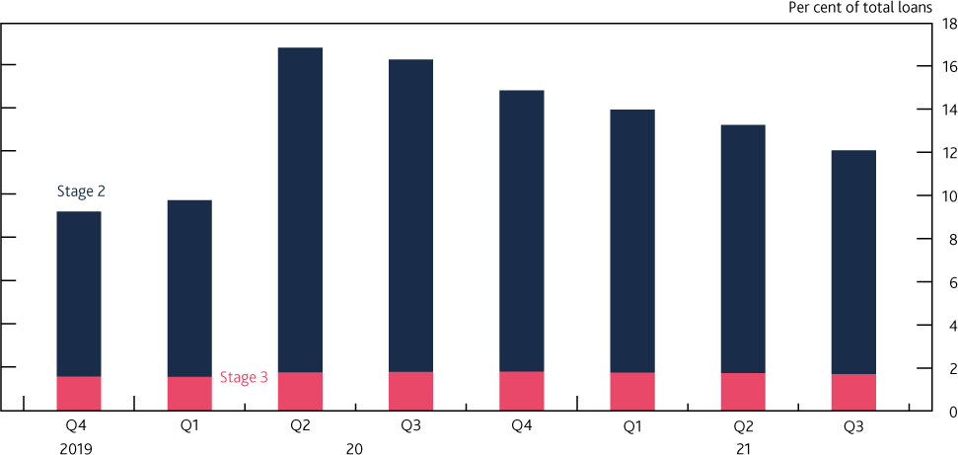

Sources: Prudential Regulation Authority (PRA) regulatory returns and Bank calculations.

**Banks’ capital ratios are anticipated to fall towards pre-pandemic levels over the coming quarters.** Banks’ capital ratios are anticipated to fall over the coming quarters, because of distributions to shareholders and because of a range of regulatory developments. The aggregate bank CET1 capital ratio is expected to fall from 16.5% towards pre-pandemic levels.

One area of regulatory change that will contribute to lowering capital ratios from 2022 H1 reflects changes to the calculation of RWAs.7 The treatment of intangible software assets for regulatory capital will also be updated at the beginning of 2022 and will reduce banks’ measured regulatory capital resources. [The PRA requires](https://www.bankofengland.co.uk/-/media/boe/files/prudential-regulation/policy-statement/2021/july/ps1721.pdf?la=en&hash=4BD47B3FF7D0A9ACBA6A7CBD213AAC25E332975C) all intangible software assets to be fully deducted from 2022, as there is no credible evidence that software assets could absorb losses effectively in stress. Banks will

7 Incoming regulatory changes, designed to strengthen the capital framework, include changes to capital requirements for banks using the internal ratings-based approach to credit risk and implementation of the new Basel standardised approach for measuring counterparty credit risks.

also see a reduction in IFRS 9 relief, in line with transitional timelines. In addition, banks’ distributions to shareholders are anticipated to reduce capital ratios gradually.

Uncertainty around the economic recovery remains. A deterioration in borrower credit quality may weigh on capital ratios and reduce the amount of capital available to be distributed to shareholders, especially if unemployment and business insolvencies were to rise by more than expected following the unwinding of government support schemes such as furlough. Although banks have provisioned against expected losses, any unanticipated deterioration in credit quality could result in additional provisions and increase the average risk weights on banks’ exposures, pushing down on risk- weighted capital ratios.

### Banks are expected to be able to meet an increase of the UK CCyB rate even as capital ratios fall, without needing to strengthen their capital positions.

As explained in Box A, the FPC does not expect that its decision to increase the UK CCyB rate would currently have a material impact on prevailing credit, or wider economic, conditions. Major UK banks and building societies are expected to be able to meet the increase of the UK CCyB rate described in Box A even as capital ratios fall towards pre-pandemic levels, without strengthening their capital positions.

A key aim of the buffer framework, which includes the releasable CCyB described in Box A as well as other buffers such as the Capital Conservation Buffer (CCoB), is to support bank lending during times of stress. The Bank is working with other authorities, including through the Basel Committee for Banking Supervision and the Financial Stability Board, to reflect on the lessons from the pandemic for the buffer framework. This includes considering any evidence that banks might hesitate to use their regulatory capital or liquidity buffers due to factors such as uncertainty about the supervisory response or fear of market stigma. The Basel report on [early lessons from the Covid-19 pandemic](https://www.bis.org/bcbs/publ/d521.pdf) noted some such evidence.

The Basel work also considers the impact of releasing the CCyB. While it is difficult to assess the quantitative effect of releasing the CCyB independent of other measures, the Basel report mentioned above found some cross-country evidence that releasing the CCyB had a positive effect on lending during the pandemic. The Bank has also undertaken analysis showing that banks that benefitted more from the UK CCyB cut increased their CET1 ratios by significantly less than their peers, consistent with the hypothesis that these banks lent more following the cut.8 The Bank continues to reflect on the lessons from the pandemic, including on the effectiveness of releasable elements of the buffer framework and any obstacles to other parts of the framework being used as intended.

## : Results of the 2021 solvency stress test

### The Bank’s 2021 solvency stress test (SST) has acted as a cross-check on the FPC’s judgement that the banking system is resilient to outcomes for the economy that are much more severe than the MPC’s central forecast.

8 The UK CCyB rate applies to banks’ credit exposures within the UK. This meant that banks with a greater share of credit exposures within the UK were more affected than others. For an explanation of the institution- specific CCyB rate see Section 2.3 of [‘The Financial Policy Committee’s approach to setting the countercyclical](https://www.bankofengland.co.uk/statement/2016/the-financial-policy-committees-approach-to-setting-the-countercyclical-capital-buffer) [buffer’](https://www.bankofengland.co.uk/statement/2016/the-financial-policy-committees-approach-to-setting-the-countercyclical-capital-buffer).

The FPC has tested the resilience of the UK banking system against a much more severe evolution of the pandemic and consequent economic shock in its 2021 SST exercise. The [final results of the SST](https://www.bankofengland.co.uk/stress-testing/2021/bank-of-england-stress-testing-results) have been published alongside this Financial Stability Report.

Reflecting the circumstances of the pandemic, the SST differs from the usual annual cyclical scenario (ACS) stress test. The aim of the SST has been to cross-check the FPC’s judgement, made in December 2020 following a ‘reverse stress test’, that banks have sufficient capital to continue to support UK households and businesses even if economic outcomes are considerably worse than expected. The scenario used for the 2021 SST has been designed to assess banks’ end-2020 balance sheets to a very severe macroeconomic stress, representing an intensification of the shocks seen in 2020.

The macroeconomic scenario for the SST is considerably more severe than the MPC’s latest central forecast from the November 2021 Monetary Policy Report. Between end-2020 and the trough of the stress, UK GDP falls by 9% in the SST scenario. When combined with the economic shocks already seen in 2020, the SST scenario implies a cumulative three-year loss over 2020–22 (with respect to the pre-Covid baseline forecast) of 37% of 2019 UK GDP. In the stress scenario, UK residential and commercial property prices fall by around 33% and unemployment rises by 5.6 percentage points to peak at 11.9%.

The pandemic has underlined the importance of banks being able to provide credit to households and businesses. Banks must conduct the test on the basis that they satisfy the demand for credit throughout the scenario, with lending to the UK real economy expanding by 3.1% in total over the five years of the stress. This reflects an important macroprudential goal of stress testing – to help assess whether the banking system is sufficiently capitalised not just to withstand the stress but also to be able to maintain the supply of credit to the real economy in the face of severe adverse shocks.

### The stress reduces banks’ capital positions substantially, but the system and all eight participating banks remain above their reference rates.

The major UK banks’ resilience in the test reflects a strong end-2020 starting point, with an aggregate CET1 capital ratio of 15.9%, and Tier 1 leverage ratio of 5.7% (excluding the software asset benefit that is due to expire at the beginning of 2022). That robust starting position is in part due to the build-up of capital since the global financial crisis, reflecting post-crisis reforms including higher capital requirements. Further support to capital ratios was provided by actions taken during 2020 by the banks, the Bank, including the PRA, and public authorities more broadly in response to the pandemic. These actions included the cancellation of final 2019 dividends.

Each bank’s performance in the test is assessed against reference rates for its risk-weighted CET1 capital and Tier 1 leverage ratio. These reference rates comprise the sum of each bank’s minimum capital requirements and any systemic buffers that they are required to hold, and so are determined in the same way as the hurdle rates used in the 2019 ACS.9 That they are called reference rates instead reflects that they do not inform the setting of capital buffers, since the SST is aimed at assessing banks’ resilience to risks arising from the pandemic and their ability to lend.

9 The only difference is that they have been updated for the changes in IFRS 9 transitional relief announced as part of the Capital Requirements Regulation ‘Quick Fix’, as described in footnote 4 of the [final results of the](https://www.bankofengland.co.uk/stress-testing/2021/bank-of-england-stress-testing-results) [SST.](https://www.bankofengland.co.uk/stress-testing/2021/bank-of-england-stress-testing-results)

Banks’ aggregate CET1 capital ratio falls by 5.5 percentage points in the stress to a low point of 10.5% (Chart 2.2). A significant driver of this reduction is credit impairments, and the majority of these occur on UK-based lending. This low point compares to a 7.6% reference rate. The aggregate Tier 1 leverage ratio low point of 4.8% is also above the reference rate of 3.7%.

## Chart 2.2: Banks started the stress test with a strong capital position in aggregate, and even at the low point remain some way above the reference rate.

**Aggregate CET1 capital ratio of major UK banks and impact of the 2021 SST scenario** **(a)**

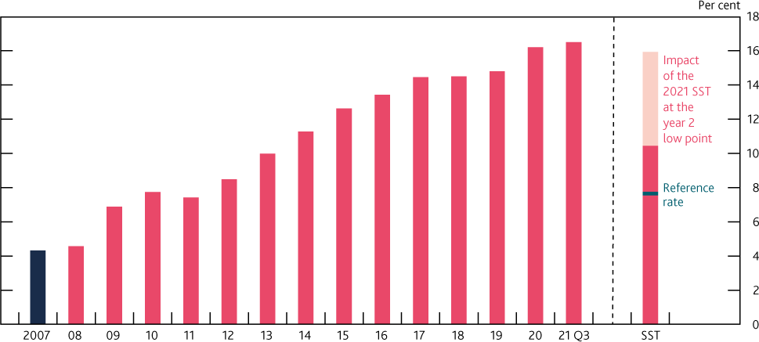

Sources: Participating banks’ Stress Testing Data Framework (STDF) data submissions, PRA regulatory returns, published accounts, Bank analysis and calculations.

(a) The SST starting point is based on end-2020 balance sheets but excludes the software assets benefit. See Chart 1 in the [final results of the SST](https://www.bankofengland.co.uk/stress-testing/2021/bank-of-england-stress-testing-results) for details of the analysis underlying this chart.

No individual bank falls below its reference rate for either CET1 capital (Chart 2.3) or Tier 1 leverage ratios (Table A of the [final results of the SST](https://www.bankofengland.co.uk/stress-testing/2021/bank-of-england-stress-testing-results)). The scale of the drawdown does differ by bank, however. Given the relative severity of the scenario for the UK economy, many of those banks that have a relatively high share of exposures in the UK experience higher impairment rates, which is a key driver of their generally higher capital drawdowns. In addition, aggregate impairment rates are relatively high for those banks that are more active in unsecured and corporate lending, since mortgage losses are estimated to be relatively low in this scenario.

## Chart 2.3: All banks remain above their CET1 capital ratio reference rates in the SST Projected CET1 capital ratios in the stress scenario (a)

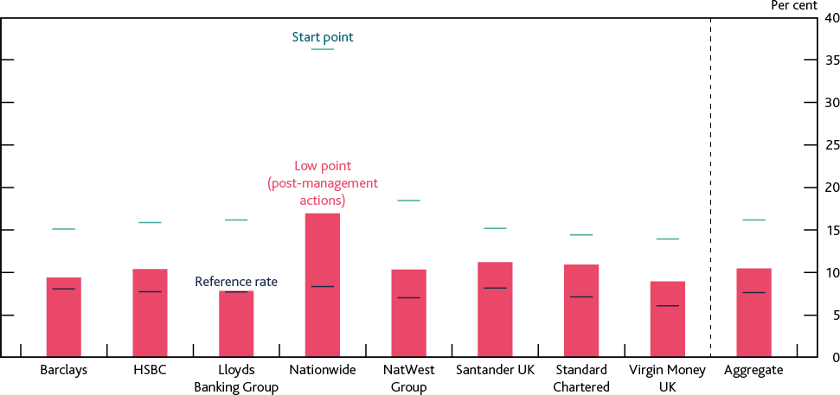

Sources: Participating banks’ STDF data submissions, Bank analysis and calculations.

(a) See Chart 4 in the [final results of the SST](https://www.bankofengland.co.uk/stress-testing/2021/bank-of-england-stress-testing-results) for details of the analysis underlying this chart.

### The FPC continues to judge that the UK banking system remains resilient to outcomes for the economy that are much more severe than the MPC’s central forecast.

The results of the SST confirm the FPC’s previous judgement about the resilience of the UK banking system, in aggregate, to a very severe macroeconomic stress, much more severe than the MPC’s current economic forecast. The FPC continues to judge that UK banks are able to continue to support UK households and businesses even if economic outcomes are considerably worse than expected.

No individual bank is required to strengthen its capital position as a result of the test. As indicated when [the SST was launched,](https://www.bankofengland.co.uk/stress-testing/2021/key-elements-of-the-2021-stress-test) the aim of the SST has been to update and refine the FPC’s assessment of banks’ resilience and their ability to lend in a very severe intensification of the macroeconomic shock arising from the pandemic. Consistent with the nature of the exercise, the FPC and Prudential Regulation Committee will therefore not use the SST as a direct input for setting capital buffers for UK banks.

**For 2022, the Bank intends to revert to the annual cyclical scenario stress-testing framework.** Having used the SST to test the resilience of the UK banking system against a much more severe evolution of the pandemic and consequent economic shock, the Bank intends to revert to the ACS stress-testing framework for the coming year. Due to its broader and countercyclical nature the ACS framework is well suited to informing the setting of capital buffers for the system and its core banks.

Further details of the 2022 ACS will be published in 2022 Q1. When designing the ACS exercise, the Bank will reflect on changes that have occurred since the Bank published its first approach to stress testing in 2015, and any lessons learnt from the Covid pandemic, including on the implications of IFRS 9. Furthermore, the test will assess the ring-fenced subgroups of existing stress-test participant banks on a stand-alone basis for the first time.

# 3: In focus – The FPC’s review of its mortgage market Recommendations

An excessive build-up of mortgage debt, often associated with rapid increases in house prices, has historically been an important source of risk to the UK financial system and to the economy. The FPC therefore introduced two Recommendations in 2014 to guard against a loosening in mortgage underwriting standards which could lead to a material increase in aggregate household debt and the number of highly indebted households: the ‘flow limit’ which limits the number of mortgages that can be extended at loan to income (LTI) ratios higher than 4.5 to 15% of a lender’s new mortgage lending; and the ‘affordability test’ which builds on the FCA’s Mortgage Conduct of Business (MCOB) framework and specifies a stress interest rate for lenders when assessing prospective borrowers’ ability to repay a mortgage (collectively, ‘the measures’).

The FPC reviews these Recommendations regularly, and in its latest review the Committee has concluded that the measures in aggregate continue to guard against a loosening in underwriting standards and a material increase in household indebtedness, which could amplify an economic downturn and financial stability risks. Since the measures were introduced, aggregate mortgage debt relative to income has remained stable, and the share of highly indebted households has not materially increased. In the recent period of high house price growth, there has been little evidence of a deterioration in lending standards, a material increase in aggregate household debt, or the number of highly indebted households.

The Committee also judges that there is no strong evidence that the structural fall in long-term interest rates, that has continued since the measures were put in place, has reduced the overall level of risk associated with household debt. Although interest rates are expected to remain low for longer – which other things equal implies a reduction in debt-servicing costs for households – both the causes and consequence of the fall in long-term interest rates imply an offsetting increase in risks.

In particular, part of the decline in long-term rates since 2014 reflects weaker growth prospects, which are likely to lower household income growth, and so increase the risk from household debt because debt burdens relative to income decline more slowly over time. And if interest rates remain low for longer, there is less scope for them to fall in response to shocks, making indebted households more vulnerable in the event of a shock. Furthermore, evidence suggests that despite the large falls in mortgage interest rates in the recession following the global financial crisis, highly indebted households cut their consumption by more, thereby amplifying the downturn.

The FPC has therefore concluded that the structural decline in interest rates does not, by itself, justify a change in the overall calibration of its mortgage market measures.

The FPC also notes that the measures appear to have had relatively little direct impact on mortgage market access, and that raising a deposit remains the most significant barrier to access, particularly for first-time buyers. In aggregate, there remains a significant degree of headroom below the 15% LTI flow limit, but the FPC’s affordability test has affected a small proportion of borrowers by

reducing the amount they can borrow compared to what would be allowable under the LTI flow limit, operating in combination with affordability testing under the FCA’s MCOB framework.

Since 2014, the FPC has been able to learn how the measures have operated in practice, and has benefited from new analysis and an expanding evidence base. Even though the LTI flow limit of 15% has never been reached in aggregate, the FPC notes evidence that it has played the role intended. It has acted as a guardrail against excessive growth in the share of mortgages with LTI ratios of 4.5 and over, and has formed the basis of some lenders’ own risk management practice to constrain the growth of such lending. But the FPC has noted some concerns with how the affordability test has operated. In particular, the stress rate encapsulated in the test has remained broadly static reflecting stickiness in reversion rates despite the fall in average quoted mortgage rates. This demonstrates that there is considerable uncertainty about how the stress rate encapsulated in the affordability test might move in future, and in turn about the effect the test could have.

The FPC has examined the potential effect of both measures in a scenario of rapidly rising house prices, where, absent policy measures, the risks from excessive household indebtedness would increase sharply. When comparing the effect of each individual Recommendation in isolation, the FPC’s analysis suggests the LTI flow limit is likely to play a stronger role than the affordability test in guarding against an increase in aggregate household indebtedness and the number of highly indebted households when house prices rise rapidly, and that the additional insurance provided by the affordability test would be small. A framework without the FPC’s affordability test Recommendation would therefore be simpler and more predictable. It would also reduce the impact on a small proportion of borrowers, while retaining the affordability testing rules under the FCA’s MCOB framework as an appropriate affordability check.

Reflecting these factors, the FPC judges that, on current evidence, the LTI flow limit, without the FPC’s affordability test Recommendation, but alongside affordability testing under the FCA’s MCOB framework, ought to deliver an appropriate level of resilience to the UK financial system, but in a simpler, more predictable and more proportionate way.

The FPC has therefore decided to maintain the LTI flow limit Recommendation, but to consult in the first half of 2022 on withdrawing its affordability test Recommendation.

## : Background to the mortgage market Recommendations and the scope of the FPC’s review into them

**The mortgage market can be a source of risk to the UK financial system and the economy.** Buying a house is the largest investment that many people will make in their lives, and one which they typically finance through borrowing. In the UK, mortgages are households’ largest financial liability and lenders’ largest loan exposure in aggregate. As set out in more detail in its previous publications, the FPC has identified two channels through which build-ups of excessive mortgage debt, such as those typically coinciding with periods of rapid house price growth have historically been a source of risk to UK financial stability and the broader economy.10

10 See the [June 2014 Report,](https://www.bankofengland.co.uk/financial-stability-report/2014/june-2014) [November 2016 Report,](https://www.bankofengland.co.uk/financial-stability-report/2016/november-2016) [June 2017 Report,](https://www.bankofengland.co.uk/financial-stability-report/2017/june-2017) and the [December 2019 Report.](https://www.bankofengland.co.uk/-/media/boe/files/financial-stability-report/2019/december-2019.pdf)

One is the ‘borrower resilience’ channel. In an economic downturn, the evidence from previous recessions is that highly indebted households are more likely to cut spending sharply. In the past, this has amplified downturns, increasing the risk of losses to lenders on all forms of lending and reducing incomes throughout the economy.

The other is, the ‘lender resilience’ channel. Highly indebted households are more likely to face difficulties making repayments on mortgage and other consumer debt during a downturn. This can lead to losses for lenders and test their resilience.

Risks could be exacerbated when house prices fall during a downturn. Highly indebted borrowers are less likely to be able to borrow against the value of their house to support consumption if it has decreased in value. And if borrowers do default on their mortgages during a downturn, banks are likely to recover a smaller proportion of the outstanding loan from selling the property used to collateralise the mortgage.

### House price booms have historically been associated with significant increases in household debt, and the share of highly indebted households.

Historically, periods of strong demand in the UK housing market have been associated with significant increases in house prices. This reflects an imbalance between supply and demand for housing, which in turn is due to a relatively low elasticity of housing supply with respect to price in the UK. Housing supply in the UK is determined by a wide range of factors, which are outside the control of the FPC or the Bank of England.

Since financial liberalisation in the 1980s, the two major housing booms have been accompanied by an increase in household debt relative to income (Chart 3.1). These booms were followed by recessions and slower growth in the household debt to income ratio. And housing booms have preceded more than two thirds of the 46 systemic banking crises across countries for which house price data are available ([Crowe et al (2011)](https://www.elibrary.imf.org/view/journals/006/2011/002/article-A001-en.xml)). Consistent with its objectives, the FPC’s mortgage market Recommendations aim to ensure that the risks from housing market booms do not spill over into the functioning of the broader financial system through the channels set out above.

## Chart 3.1: Historical booms in house prices have been accompanied by increased household debt

**Aggregate mortgage debt to income and house prices to income ratios**

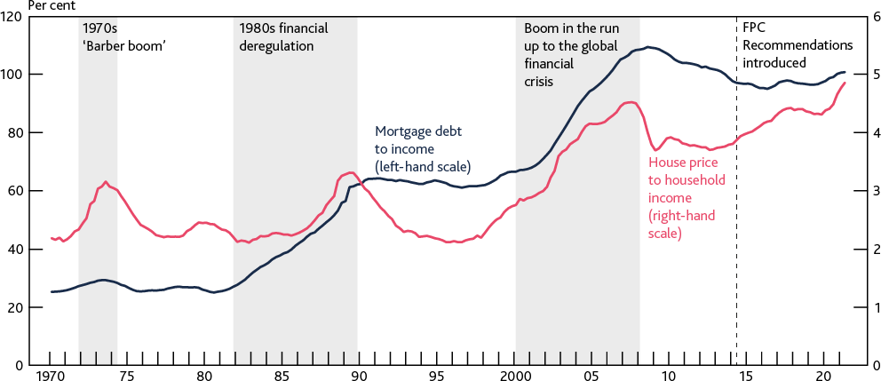

Sources: Bank of England, HM Land Registry, ONS and Bank calculations.

### The FPC introduced two Recommendations in 2014 to guard against the risks associated with aggregate household indebtedness and the share of highly indebted households.

In 2014, the FPC introduced two measures aimed at guarding against a loosening in mortgage underwriting standards, which could lead to a material increase in household indebtedness and the number of highly indebted households.

The FPC’s ‘affordability test’ builds on the FCA’s MCOB framework, which was significantly updated in 2014 following the conclusion of the FCA’s Mortgage Market Review. The assessment of affordability as required under the MCOB responsible lending rules includes a requirement to consider the impact of likely future interest rate increases on affordability, except for mortgages where the interest rate is fixed for five years or more, or the duration of the contract is less than five years. The FPC’s Recommendation specifies that lenders should assess whether borrowers could still afford their mortgage if, at any point over the first five years of the loan, mortgage rates were to be 3 percentage points higher than the contractual reversion rate (usually the lender’s Standard Variable Rate).

The ‘flow limit’ caps the number of mortgages extended at LTI ratios of 4.5 or higher to 15% of a lender’s new mortgage lending. Further details on the operation of both measures can be found in previous editions of the Report (for example, see the [December 2019 Report](https://www.bankofengland.co.uk/financial-stability-report/2019/december-2019)).

The LTI flow limit and the affordability test (collectively ‘the measures’) primarily target the borrower resilience channel by helping to guard against a deterioration in underwriting standards which could lead to a significant increase in aggregate household indebtedness and the number of more highly indebted households, especially when house prices are growing rapidly.

By reducing aggregate household indebtedness and the share of highly indebted households, the measures can also help to reduce the proportion of borrowers who face repayment difficulties on their mortgages during a stress, partially helping to mitigate risks to lender resilience. As such, they are a complement to a range of other measures including the capital framework for banks and the Bank’s stress testing framework. Further detail on the background to the FPC’s mortgage market Recommendations can be found in Section 1 of the Technical Annex to this Report.

### The FPC regularly reviews its mortgage market Recommendations…

The FPC regularly reviews its mortgage market Recommendations and updates its judgements on their effectiveness based on the latest available evidence and data. Since their introduction in 2014, the FPC has carried out three reviews of the measures. These reviews have concluded that the measures play an important role in guarding against the risks associated with rapid growth in household indebtedness and the number of highly indebted households. Previous reviews have also concluded that the measures do not materially constrain borrowers from accessing the mortgage market, including first-time buyers (Box D).

In its most recent review (as published in the December 2019 Report), the Committee concluded that the measures helped to guard against a weakening in underwriting standards that could have led to an increase in household indebtedness and the share of highly indebted households. The Committee further judged that these benefits outweighed the limited macroeconomic costs associated with the measures, and that alternative policies to achieve similar outcomes (such as

monetary policy or changes to banks’ capital requirements) would have been more costly to the wider economy.

### …and in 2020 set out its intention to review its calibration of the measures in light of a structural decline in interest rates.

As set out in the December 2020 Report, the FPC noted its intention to review the calibration of the Recommendations in light of a structural decline in the interest rate environment. In particular, as set out in the [August 2018 Inflation Report,](https://www.bankofengland.co.uk/inflation-report/2018/august-2018) estimates of the ‘equilibrium’ interest rate – the rate that would sustain output at its potential level and inflation at its target – have fallen in advanced economies, including the UK, over the previous 30 years. Since the global financial crisis long-run expectations of interest rates have decreased and this has become more apparent since 2014.

## : Conclusions of the FPC’s most recent review

### The FPC judges that the measures have continued to guard against a material loosening in underwriting standards and an excessive build-up of household debt including during a period of rapid house price growth.

The FPC judges that the measures have played the role intended and have continued to guard against a material loosening in mortgage underwriting standards that could lead to an excessive build-up in household indebtedness and the share of highly indebted households.

Since the measures were introduced, aggregate mortgage debt as a proportion of income has remained broadly stable. And there has been little evidence of a deterioration in mortgage underwriting standards including during the recent period of rapid house price growth relative to income. For example the proportion of new ‘high LTI’ mortgages – those at LTI ratios of 4.5 or over – extended has broadly remained flat at around 10%, despite a small dip recently.11 And the proportion of new mortgages extended at loan to value (LTV) ratios of 90% or higher remains below the levels seen before the global financial crisis (Chart 3.2).

11 The recent dip in the share of ‘high LTI’ mortgages is related to the June 2021 tapering of the Stamp Duty Land Tax holiday in England and the Land Transaction Tax holiday in Wales. Prior to this, the share of ‘high LTI’ mortgages increased in late 2020 and early 2021 potentially due to transactions being brought forward to take advantage of the holiday.

## Chart 3.2: The share of mortgages with high LTI ratios has not increased significantly since 2014, and the share of lending at high LTV ratios remains below its pre financial crisis level

**Share of mortgages with an LTI to ratio of 4.5 or higher LTI and with an LTV ratio of 90% or higher**

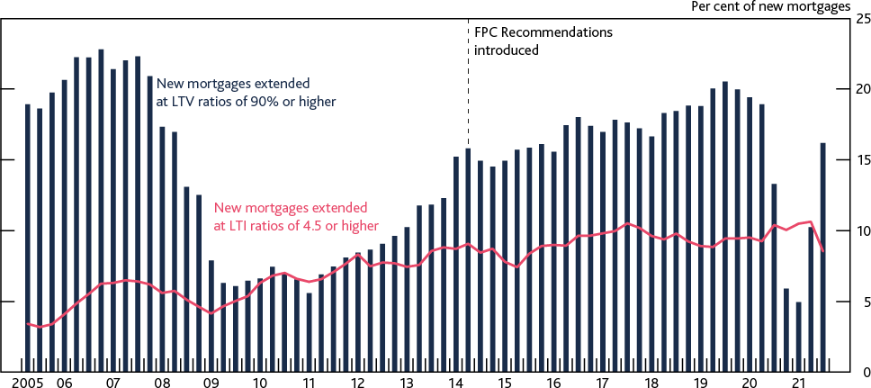

Sources: FCA Product Sales Data and Bank calculations.

There has not been a significant increase in the share of highly indebted households in the stock of outstanding lending. For example, despite a small uptick in 2021, the proportion of households with mortgage debt-servicing ratios at or above 40% has been steady at around 1%–1.5%, and remains significantly below levels seen just prior to the global financial crisis (Section 1).12

### There is no strong evidence that the structural fall in long-term interest rates that has continued since 2014 has reduced the overall level of risk associated with household debt, and so the fall, by itself, does not justify a change in the calibration of the mortgage market measures.

The continued structural decline in long-term interest rates – including a structural reduction in estimates of the ‘equilibrium’ interest rate – could have altered the risks associated with a given level of household debt (Box E). In particular, interest rates are expected to remain low for longer than was expected when the measures were introduced, which other things equal, implies a reduction in households’ debt-servicing costs.

However, both the causes and consequence of the decline in long-term interest rates imply an offsetting increase in risks. While some long-term drivers of the decline in long-term interest rates may support households being able to take on a higher level of debt, other more recent drivers do not. Over several decades, demographic trends are likely to have lowered ‘equilibrium’ interest rates without reducing households’ ability to service their debts, which would tend to support them being able to take on a higher level of debt. However, part of the decline in long-term rates since 2014 is likely to reflect weaker productivity growth, which is likely to have reduced households’ future income growth, and so implies that improved affordability at mortgage origination is offset by increased risks from household debt because debt burdens relative to income decline more slowly over time. In addition, if interest rates remain low for longer, there is less scope for them to fall in response to shocks, making indebted households more vulnerable in the event of a shock.

Furthermore, evidence suggests that despite the large falls in mortgage interest rates in the

12 The proportion of households experiencing repayment difficulties can rise sharply as their mortgage debt- servicing ratio increases beyond 35%–40%.

recession following the global financial crisis, highly indebted households cut their consumption by more than less indebted counterparts, thereby amplifying the downturn.

Overall, the FPC judges that there is no strong evidence that the structural fall in long-term interest rates, that has continued since the measures were introduced, has reduced the overall level of risk associated with household debt. The Committee therefore judges that the structural decline in interest rates, by itself, does not justify a change in the overall calibration of its mortgage market measures, which are intended to guard against these risks.

### Since 2014, the FPC has also been able to learn how the measures have operated, and has benefitted from new analysis and an expanding evidence base. It notes that the effect of the affordability test is more difficult to observe than the LTI flow limit.

Alongside regular reviews of the Recommendations, the FPC monitors their effect on aggregate household indebtedness and the distribution of household debt on an ongoing basis. And since 2014, the Committee has been able to learn more about how the measures have operated, and has benefitted from new analysis and an expanding evidence base.

The Committee judges that the LTI flow limit has played the role intended (see ‘the effect of the Recommendations on mortgage market access’ below for evidence on the effect of the LTI flow limit since 2014). It has acted as a guardrail against excessive growth in the share of ‘high LTI’ mortgages, including during the recent period of high house price growth. It may also have formed the basis of some lenders’ own risk management practices to constrain the risks of such lending.

The effect of the affordability test on indebtedness and the share of highly indebted borrowers cannot be observed directly and is more difficult to infer from the distribution of lending. The affordability test implies a different maximum level of indebtedness for each individual borrower, as each affordability assessment will depend on individual borrower circumstances. This means that, unlike the LTI flow limit, its effect is less likely to be contained to the riskier parts of the distribution of household debt.

### The Committee has noted considerable uncertainty about how the stress rate encapsulated in the affordability test might move in future, so it has assessed the role of the test in more detail.

When the Committee made the affordability test Recommendation in 2014, most major lenders tested whether borrowers could afford their mortgages against a stress mortgage rate of around 7%, a margin of around 250–300 basis points over typical reversion mortgage rates at that time. The Recommendation was calibrated to guard against a relaxation of these standards.

Since then, average quoted mortgage rates have fallen by 180 basis points but the stress rate encapsulated in the affordability test has remained broadly static. This reflects stickiness in reversion rates, despite the drop in average quoted mortgage rates. This stickiness may, in part, reflect commercial decisions by lenders in the face of pressure on their net interest margins. It is not clear how reversion rates will evolve through the interest rate cycle.

This demonstrates there is considerable uncertainty about how the stress rate encapsulated in the affordability test might move in future. In turn, there is therefore considerable uncertainty around the effect that the test could have on the risks associated with household indebtedness.

**Estimating the role of individual Recommendations in guarding against the risks associated with household debt**

### The FPC’s analysis suggests the LTI flow limit is likely to play a stronger role than the affordability test in guarding against an increase in household indebtedness and the share of highly indebted households when house prices rise rapidly.

The FPC has considered how each of the Recommendations has individually contributed towards reducing risks, by assessing how indicators of household indebtedness – namely aggregate household debt (excluding student loans) to income, and the share of highly indebted households – could evolve over the medium term in a scenario of rapid house price growth where, absent policy measures, risks would increase sharply.

Currently, the aggregate household debt to income ratio and the share of households with mortgages at ‘high’ LTI ratios (at or above 4.5) are around 125% and 10% respectively. In a scenario of rapid house price growth, in the absence of both measures, these are projected to increase significantly to over 200% and 31% respectively by the end of 2030. Maintaining either of the measures materially mitigates both of these increases. Relying only on the LTI flow limit by withdrawing the FPC’s affordability test (such that affordability testing would continue under the FCA’s MCOB framework) would result in a smaller reduction in resilience than withdrawing the LTI flow limit. Whereas withdrawing the LTI flow limit and relying on the FPC’s affordability test alone would lead to a larger reduction in resilience (Chart 3.3).

## Chart 3.3: The LTI flow limit is likely to play a stronger role than the affordability test in limiting growth in aggregate indebtedness and the share of highly indebted borrowers in a scenario of rapid house price growth

**Change in the proportion of outstanding mortgages with an LTI ratio of 4.5 or higher and aggregate household indebtedness in an illustrative scenario of rapid house price growth**

**(a)**

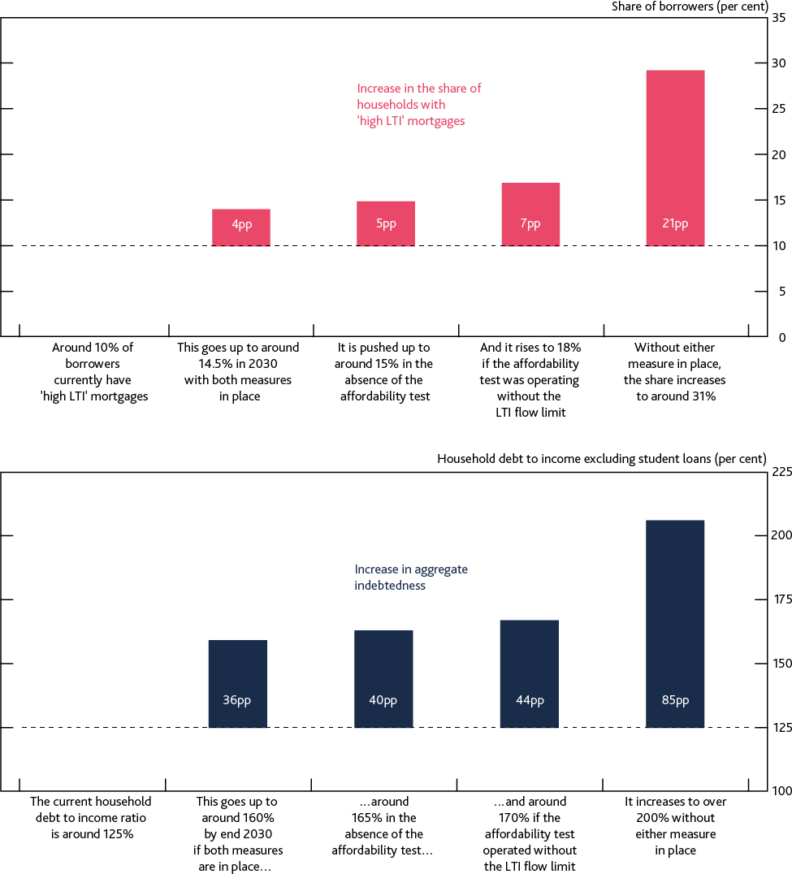

Sources: FCA Product Sales Data, ONS and Bank calculations.

(a) Household debt other than mortgage debt has been assumed to grow as a constant share of household incomes over the scenario.

Overall, this exercise suggests there is a significant degree of overlap between the effects of the two Recommendations during a protracted period of rapid house price growth. But it also suggests that the LTI flow limit is likely to play a stronger role than the affordability test in guarding an increase in aggregate household indebtedness and the share of households with mortgages at high LTI ratios. Further details on this analysis, and the scenario underpinning it are set out in Section 3 of the Technical Annex to this Report.

**The effect of the Recommendations on mortgage market access**

The Committee judges that raising a deposit remains the most significant barrier to access, particularly for first-time buyers (Box D). However, in line with previous reviews, the FPC has considered whether, and to what extent, its Recommendations could have constrained access to the mortgage market in recent years.

### There is significant headroom below the LTI flow limit, and lenders’ incorporation of it in their risk management has resulted in a concentration of loans at LTI ratios immediately below the 4.5 threshold.

There is evidence that some borrowers have been constrained by lenders’ incorporation of the LTI flow limit into their risk management. While there continues to be (and has been since the measures were introduced) significant headroom below the 15% limit on lending at LTI ratios at or above 4.5, the proportion of lending at LTI ratios immediately below the 4.5 threshold has increased substantially.

This reflects lenders managing their own exposures to ‘high LTI’ lending in line with their own risk appetites and within the LTI flow limit. They typically do so by requiring borrowers seeking ‘high LTI’ lending to satisfy a number of additional criteria such as minimum income requirements, minimum credit score requirements, and maximum LTV ratios. Lenders’ individual risk appetite for, and the requirements they place on, ‘high LTI’ lending differ.

For example, intelligence from the largest 13 mortgages lenders in the UK (together accounting for around 90% of all UK mortgage lending) shows that while some are willing to extend nearly the full 15% of ‘high LTI’ lending, others target a significantly lower proportion than the 15% limit.

Analysis of the largest 13 UK mortgage lenders' 2021 Q3 lending suggests a concentration of around 6,000 more mortgages (or about 3% of their total mortgages) at LTI ratios between 4.4 and 4.5 than would be implied by extrapolating the rest of the distribution (Chart 3.4). Around 70% of these 6,000 mortgages did not meet the lenders’ minimum income and LTV ratio criteria for ‘high LTI’ lending.

The FPC therefore considers that headroom below the 15% LTI flow limit (and the concentration of loans immediately below its threshold) is reflective of individual lenders’ practices for managing ‘high LTI’ lending.

## Chart 3.4: Most of the concentration in mortgage lending at LTI ratios of 4.4 to 4.5 would not meet lenders’ requirements for ‘high LTI’ lending

**Number of new mortgages extended in 2021 Q3 by the 13 largest mortgage lenders broken down by LTI ratio** **(a)**

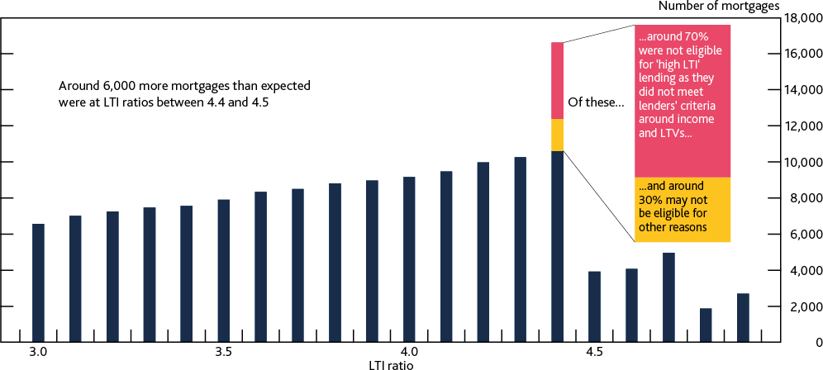

Sources: FCA Product Sales Data and Bank calculations.

(a) The 6,000 mortgages concentrated between LTI ratios of 4.4 and 4.5, shown by the red and yellow bars, is the number greater than would be implied by a linear trend in increase from LTI ratios between 3 and 4.4.

### To date, the measures appear to have had little direct impact on mortgage market access, but the affordability test has affected a small proportion of borrowers by reducing the amount they can borrow.

The Committee judges that the LTI flow limit, and lenders’ incorporation of it into their risk management, has had a limited impact on borrowers’ access to the mortgage market. In addition, its current calibration would allow for an increase in ‘high LTI’ lending, which could further reduce that limited effect.

Bank staff analysis suggests that the affordability test could have caused around 6% of borrowers to take out smaller mortgages than they would have been able to in its absence. The FPC therefore judges that although the measures have had a relatively limited effect on mortgage market access, the FPC’s affordability test does affect a small proportion of borrowers by reducing the amount they can borrow compared to the maximum under the LTI flow limit operating in combination with MCOB.

**Conclusion of the FPC’s review**

### Overall, the FPC judges that, on current evidence, the LTI flow limit, without its affordability test, but alongside the FCA’s affordability testing rules, ought to deliver an appropriate level of resilience to safeguard UK financial stability.

In the absence of the FPC’s affordability test Recommendation, mortgage lenders would still be subject to the affordability testing requirements in the FCA’s MCOB framework. This framework requires that lenders test borrowers against an appropriate stress interest rate, which should take into account market expectations for likely interest rate rises and assume a rise of at least 100 basis points, except for the duration of any fixed interest rate period and unless the mortgage’s interest

rate was fixed for five years or more from the expected start of the mortgage term (or the duration of the contract, if less than five years).

And the LTI flow limit would continue to guard against an excessive increase in overall household indebtedness and the share of highly indebted households.

Lender resilience is also safeguarded through the capital framework for banks, and the Bank’s stress testing framework (Section 2).

**The FPC therefore judges it could deliver its macroprudential objectives in a simpler, more predictable, and more proportionate way by withdrawing its affordability test Recommendation.** The FPC notes that affordability testing plays an important role in financial conduct regulation.

But certain features mean that affordability testing, when implemented as macroprudential regulation, can introduce unwarranted complexity and potential unpredictability in the FPC’s macroprudential framework. For example, and as has been seen since 2014, the link to lenders’ reversion rates introduces uncertainty about how the stress rate encapsulated in the FPC’s affordability test might move in future. The Committee therefore considers that withdrawing its affordability test Recommendation would simplify its macroprudential regulatory framework and make it more efficient without any material reduction in resilience.

Although the effect of the affordability test is unobservable, on the basis of this review, the FPC judges that in a period of rapid house price growth, the affordability test is likely to have a limited marginal effect in addition to the LTI flow limit on both aggregate household indebtedness and the number of highly indebted households. The FPC also considers that the application of the test on each individual prospective borrower not only contrasts with its broader macroprudential focus, but that it can limit the amount a small proportion of borrowers can borrow for limited financial stability benefit beyond that delivered by the LTI flow limit. Withdrawing its affordability test would enable the FPC to achieve its macroprudential objectives in a more proportionate way.

## : Next steps

### As a result of this review, the FPC has decided to maintain the LTI flow limit Recommendation, but to consult on withdrawing its affordability test Recommendation in the first half of 2022.

As a result of this review, the FPC intends to maintain the LTI flow limit Recommendation as it is currently calibrated.

But the Committee is minded to withdraw the affordability test Recommendation to simplify its macroprudential regulatory framework and reduce the impact it has on a small proportion of borrowers’ access to the mortgage market. Withdrawing the Recommendation would mean that affordability testing would continue under the FCA’s MCOB framework. The FCA has confirmed that lenders would clearly be breaching MCOB rules if they only stress tested against a fixed introductory rate where the interest rate would change within five years, there is therefore an expectation that these borrowers would continue to be stress tested using reversion rates in the absence of the FPC’s affordability test Recommendation.

Although the FPC’s review suggests the resilience benefit of its affordability test Recommendation in addition to the LTI flow limit is limited, the precise effect of withdrawing it will depend on lenders’

behaviour. Therefore to gauge lenders’ possible responses, and the implications of these for the UK financial system, the FPC has decided to consult on withdrawing the affordability test in the first half of 2022.

Irrespective of the outcome of this consultation, the Committee will continue its ongoing monitoring of risks related to household indebtedness, and stands ready to act in future if these risks began to build in a way that could impact on UK financial stability.

# Box D: The effect of the mortgage market measures on first-time buyers

### Rapid growth in house prices relative to incomes, particularly in the run-up to the global financial crisis, has led to difficulty for first-time buyers seeking to access the housing market.

From 1995 to the start of the global financial crisis, house prices grew at more than twice the speed of incomes. This increased both the average deposit and average size of the mortgage required to buy a property. Such increases are likely to have been a particular challenge for prospective first- time buyers, as they do not have existing housing equity to contribute to a deposit and, given they tend to be younger, tend to have lower incomes.

As housing became less affordable during this period, home ownership rates among younger households decreased, despite a broader increase in aggregate home ownership. This reflects a decline in the proportion of first-time buyers in the run-up to the global financial crisis. The trend of decreasing home ownership, particularly among younger households, continued in the years immediately after the global financial crisis, even as house price growth relative to income slowed.

### Since the measures were introduced and until the start of the Covid pandemic, home ownership rates among younger households have stabilised, reflecting continued slower growth in house prices and deposit requirements.

Since the measures were introduced in 2014, and until the start of the pandemic, house prices grew slightly more rapidly than income, but their respective growth rates were more closely in line than before the global financial crisis. Growth in the average deposit raised by first-time buyers also slowed to around 3% per year on average for first time buyers. The volume of first-time buyer mortgage approvals stopped falling and remained broadly flat over this period, and consistent with this, home ownership rates among younger households broadly stabilised.

This dynamic has changed during the pandemic. House prices in the UK grew at their fastest annual rate since the global financial crisis in recent months, and significantly more quickly than household income. Deposit requirements also increased materially as lenders withdrew more products at higher LTV ratios at the start of the pandemic. These factors contributed to the share of first-time buyers falling during the pandemic. The availability of high LTV products has partly recovered, supported by the Government’s mortgage guarantee scheme, but the share of first-time buyers has not yet returned to its pre-pandemic levels.

### The FPC continues to judge that raising a deposit remains the most significant barrier to accessing the housing market for first-time buyers across all regions of the UK.

In line with its secondary objective, the FPC has considered the extent to which its mortgage market Recommendations may have prevented first-time buyers from being able to buy the median-valued first-time buyer home in their area.

Bank staff analysis of household level survey data suggests that the vast majority of renters that are unable to buy the median-valued first-time buyer home in their area are constrained by factors other than the FPC’s Recommendations. The analysis shows that 83% of renters currently lack the savings to raise a 5% deposit themselves (Chart A). A further 6% would currently be able to raise a deposit, but are not currently able to meet affordability tests that would apply under the FCA’s

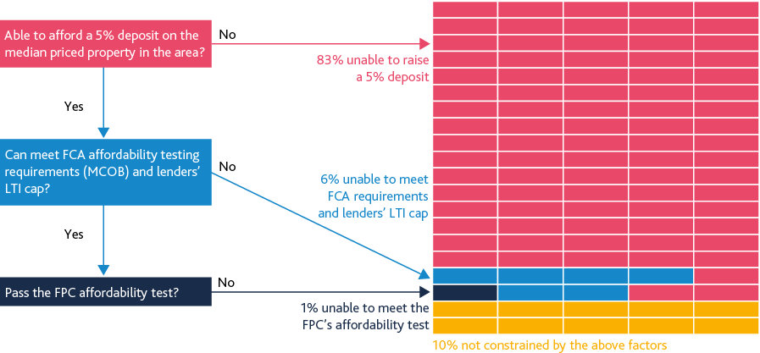

MCOB framework and an assumed LTI ratio cap of 5.5, even without the FPC’s affordability test Recommendation. Around 1% of the remainder would not currently be able to meet the FPC’s affordability test.

## Chart A: Deposit size is the most significant barrier preventing first-time buyers from buying the median-valued first-time buyer home in their area

**Factors constraining first-time buyers from being able to afford the median valued property in their area** **(a)****(b)**

Sources: FCA Product Sales Data and Bank calculations.

1. These figures represent the proportion of renters constrained by given factors assuming that borrowers cannot benefit from sources other than their own savings to raise deposits.
2. The LTI cap is set at 5.5 to reflect an upper bound on lenders’ risk appetite for lending to first-time buyers.

Survey evidence suggests that around 33% of deposits come from sources others than prospective borrowers’ savings, such as inheritance and gifts or loans from family and friends, and so this analysis is likely to overstate the deposit constraint faced by current renters. However, under assumptions that reflect this survey evidence, around 75% would still currently lack the necessary funds to raise a 5% deposit. In this scenario, 1.5% would be constrained by the FPC’s affordability test. Further details on these estimates are set out in Section 2 of the Technical Annex to this Report.

The analysis above assumes that a 5% deposit would be sufficient to obtain a mortgage. But in periods of tighter credit conditions, when the availability of mortgages at high LTV ratios falls, renters are typically required to raise a larger deposit than 5%. Since 1995, the average first-time buyer deposit has been around 20%. The analysis suggests around 95% of renters would currently lack the savings to raise such a deposit, and less than 1% currently could raise the required deposit but would be constrained by the FPC’s measures.

The FPC has also considered whether the barriers to first-time buyers accessing the housing market vary across the regions of the UK. Analysis of household level data suggests that broadly, raising a 5% deposit remains the most significant barrier to housing market access for first-time buyers across the UK. The proportion of renters that currently lack sufficient savings to raise a 5% deposits varies from around 75% to just under 95% across regions, and there is no clear pattern around this spread.

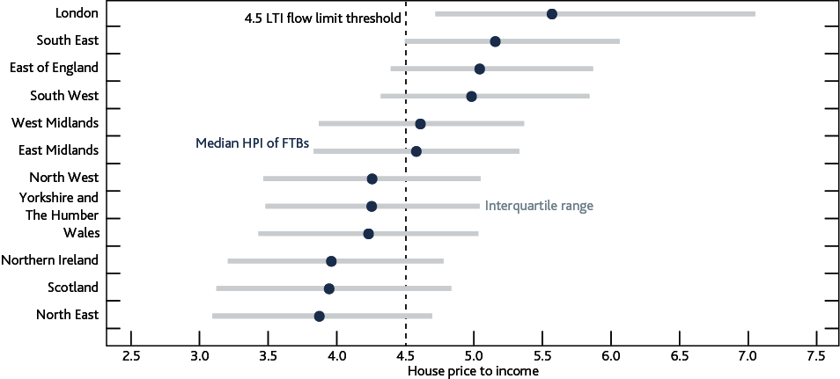

### The LTI flow limit, and lenders’ incorporation of it into their risk management, can constrain the maximum amount that first-time buyers can borrow.

In principle, the LTI flow limit could be expected to have a greater impact on renters in regions where property prices tend to be more expensive. For example, it could constrain renters in regions such as London and southern England where the median first-time buyer property price is more than

4.5 times the median first-time buyer income in those regions (Chart B). Conversely, they might be expected to have less of an impact on renters in less expensive regions.

## Chart B: House price to income ratios for first-time buyers are typically higher in London and the south of England

**Median ratio of property purchase price to income for first-time buyers in UK nations and regions**

Sources: FCA Product Sales Data and Bank calculations.

In practice, the 15% LTI flow limit has not been reached in aggregate and there is a large difference in the proportion of lending carried out at high LTIs across regions. For example, just under a quarter of new mortgages to first-time buyers in London are extended with high LTI ratios, compared to less than 5% in Wales, Scotland, Northern Ireland, and most northern regions of England. This reflects renters in London being more likely to meet lenders’ requirements for ‘high LTI’ lending, and that higher property prices in London means there is greater demand for mortgages at high LTI ratios.

There is also evidence that lenders’ requirements on ‘high LTI’ lending are more likely to impact on renters in more expensive regions, with the exception of London. For example, the proportion of mortgages extended to first-time buyers at LTI ratios between 4.4 and 4.5 ranges from around 20% in the southern regions of England, to around 6% in Northern Ireland and the north east of England. This is largely driven by higher house prices in more expensive regions resulting in higher demand for mortgages at higher LTI ratios, resulting in more renters in these regions being constrained by lenders’ requirements on ‘high LTI’ lending.

### The FPC continues to judge that the measures have had a limited direct effect on first-time buyers’ ability to access the mortgage market, but will continue to monitor their effect.

Since its Recommendations were introduced, the FPC has regularly considered their effect on first- time buyers’ ability to access the mortgage market. The FPC continues to judge that raising a deposit remains the most significant barrier to first-time buyers accessing the housing market, and that its Recommendations have had a relatively limited effect across all regions of the UK.

The Committee will continue to monitor the effect of the measures on first-time buyers’ access to the housing market, consistent with the Government’s objectives around the housing market as set out in the recent remit letter to the Committee (see Box C on the FPC’s secondary objective).

# Box E: What does the structural fall in interest rates mean for the risks from household debt?

### The FPC has considered whether structural changes, notably the fall in the long-run ‘equilibrium’ interest rate, might support a change in policy.

The FPC views its mortgage market Recommendations as structural measures, intended to remain in place through cycles in the housing market (see [December 2019 Report](https://www.bankofengland.co.uk/financial-stability-report/2019/december-2019)). The Committee has noted that, in reviewing the calibration of its measures, it is more likely to be guided by slow-moving, ‘structural’ factors given the long-term nature of mortgages. There could be a case for changing policy if the underlying risks associated with a given level of debt have changed due to structural changes in the interest rate environment.

**Estimates of the long-run or trend ‘equilibrium’ interest rate have declined over the past decades.** Over time, the level of interest rates in the long run will gravitate towards the trend ‘equilibrium’ real interest rate, R*. The trend real rate is determined by slow-moving structural factors that affect the balance between the demand for capital and the stock of wealth available to finance it. For an open economy like the UK, those factors will reflect global influences as well as domestic ones.

Previous Bank analysis published in the [August 2018 Inflation Report](https://www.bankofengland.co.uk/inflation-report/2018/august-2018) estimates that trend R* in the UK has declined by more than 2 percentage points since 1990 to around 0%–1% currently (equivalent to 2%–3% nominal). While there is uncertainty around these estimates, R* is very likely to have decreased over this period. R* is also projected to remain low in the longer term given the drivers of its decline are expected to persist. Long-term interest rates have also fallen since 2014. Despite recent moves in the yield curve, as of November 2021, 10-year forward interest rates were around 1% compared to around 4% in 2014.

### Lower ‘equilibrium’ interest rates could make higher debt levels more affordable, which could support households taking on more debt without an increase in risk.

Lower ‘equilibrium’ interest rates make higher debt levels more affordable at origination as they reduce borrowers’ interest costs for a given mortgage size. This could support households taking on more debt. Indeed, household debt levels have increased over the last 30 years as estimates of long- term ‘equilibrium’ rates have declined.

### But this assessment depends on the causes of the structural fall in interest rates, which help determine whether an increase in debt is sustainable over the longer term.

As described in the August 2018 Inflation Report, R* has been declining for decades. Over the past decade, it has become more apparent that R* has fallen further following the global financial crisis. The factors that explain this decline can be loosely grouped into two categories: slow-moving factors that were evident before the global financial crisis and which continue to push down R*; and factors that emerged or may have been intensified by the global financial crisis.

Globally and in the UK, several factors are likely to have driven an increase in desired wealth accumulation, which has been gradually pushing R* down for decades. This includes demographic factors such as greater longevity, declining birth rates and the transition of the baby-boom generation into retirement ([Carvalho, Ferrero and Nechio (2016)](https://www.sciencedirect.com/science/article/pii/S0014292116300678)), rising inequality ([Mian, Straub and](https://www.kansascityfed.org/documents/8364/mss_jh_word.pdf) [Sufi (2021)](https://www.kansascityfed.org/documents/8364/mss_jh_word.pdf)), and the ‘global savings glut’ ([Bernanke (2005)](https://www.federalreserve.gov/boarddocs/speeches/2005/200503102/)). These factors would tend to support the

argument that households are able to take on more debt because they have lowered R* without reducing households’ ability to service their debts (see [Lisack, Sajedi and Thwaites (2021)](https://www.ijcb.org/journal/ijcb21q2a2.htm) and [Mian,](https://academic.oup.com/qje/article/136/4/2243/6164883) [Straub and Sufi (2021)](https://academic.oup.com/qje/article/136/4/2243/6164883)).

On the other hand, more recent drivers of the decline in R* since the global financial crisis, have likely increased the risks that would be associated with a rise in household indebtedness. Candidate explanations include a decline in trend productivity and economic growth ([Rachel and Smith (2015)](https://www.bankofengland.co.uk/working-paper/2015/secular-drivers-of-the-global-real-interest-rate)), and an increase in the cost of financial intermediation, perhaps driven by an increase in risk ([Caballero, Farhi and Gourinchas (2017)](https://www.aeaweb.org/articles?id=10.1257/aer.p20171036)) or perceived risk ([Kozlowski, Veldkamp and Venkateswaran](https://www.journals.uchicago.edu/doi/full/10.1086/700895) [(2018)](https://www.journals.uchicago.edu/doi/full/10.1086/700895)). Neither of these factors would support an increase in household debt without increasing risks to financial stability. In the case of lower trend productivity growth, for example, that is because slower accompanying income growth means that households’ debt-service burdens relative to income decline more slowly over time.

### In its assessment, the FPC considered the balance of structural factors supporting and opposing higher levels of household debt and the extent to which the setting of the measures already accommodated a rise in debt…

The long-term drivers of lower R* which started before the global financial crisis are likely to have been supportive of some increase in household debt over a number of decades. Indeed, as R* declined, the size of mortgage loans relative to borrowers’ incomes began to increase from the 1980s, before accelerating in the early 2000s (Chart A). The current calibration of the LTI flow limit accommodates a longer-term increase in sustainable debt levels.

Over the past decade, greater attention has been paid to the low interest rate environment and its causes. The fall in R* since the global financial crisis has also become more apparent. In consequence this fall has increasingly been reflected in market expectations. However, as discussed above, there is no strong evidence that the more recent candidate explanations for the fall in R* would support an increase in household debt without an increase in financial stability risk.

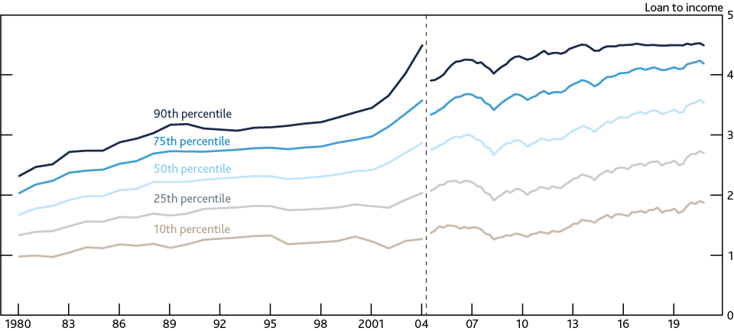

## Chart A: LTI ratios had drifted up significantly between the 1980s and 2014 Distribution of LTI ratios on the flow of new mortgages (a)

Sources: Council of Mortgage Lenders (now UK Finance), FCA Product Sales Data (PSD) and Bank calculations.

(a) PSD only available since 2005 Q2. The PSD include regulated mortgage contracts only, and therefore exclude other regulated home finance products such as home purchase plans and home reversions, and unregulated products such as buy-to-let mortgages. Data from 1993 to 2004 are from the Survey of Mortgage Lenders, which was operated by the Council of Mortgage Lenders, and earlier data are from the 5% Sample Survey of Building Society Mortgages. There is a break in the data between 2004 and 2005 caused by the change in data sources – the PSD cover all regulated mortgage lending whereas the earlier data are a sample of the mortgage market. Data for 1992 are missing, chart values are interpolated for this period.

### …and also took into consideration that the structural decrease in interest rates may reduce the room available for monetary policy to respond to shocks.

In a lower interest rate environment, there may be less room available for monetary authorities to offset economic and financial shocks through cuts to policy rates. This means households would be less able to benefit from rate cuts that could directly support their ability to service their mortgage debt, as some did during the global financial crisis.

The academic literature also suggests that with less space available for rate cuts, the frequency and severity of recessions could increase, thus raising the risk of larger increases in unemployment (see [Kiley and Roberts (2017)](https://www.brookings.edu/wp-content/uploads/2017/08/kileytextsp17bpea.pdf)). This would tend to increase the extent to which debt could exacerbate downturns. In those circumstances, macroprudential policy, including mortgage market measures, has a role to play in mitigating the negative consequence of shocks and in reducing systemic risks that may arise in a low interest rate environment (see [Farhi and Werning (2016)](https://onlinelibrary.wiley.com/doi/abs/10.3982/ECTA11883) for a theoretical description, and [Cunliffe (2019)](https://www.bankofengland.co.uk/-/media/boe/files/speech/2019/financial-stability-and-low-for-long-speech-by-jon-cunliffe.pdf) for a policymaker perspective).

**Overall, the FPC therefore judges that there is no strong evidence the structural decline in long- term interest rates since 2014 has reduced the overall level of risk associated with household debt. The FPC further judges that the structural decline in interest rates does not, by itself, justify a change in the overall calibration of its mortgage market measures, which are intended to guard against these risks.**

# Annex: Macroprudential policy decisions

This annex lists any FPC Recommendations and Directions from previous periods that have been implemented or withdrawn since the previous Report, as well as Recommendations and Directions that are currently outstanding.13 It also includes those FPC policy decisions that have been implemented by rule changes and are therefore still in force.

Each Recommendation or Direction has been given an identifier to ensure consistent referencing over time. For example, the identifier 17/Q2/1 refers to the first Recommendation made at the 2017 Q2 Committee meeting.

## Recommendations and Directions implemented or withdrawn since the previous Report

In September 2021, the FPC made the following Direction (21/Q3/1):

In September 2021, the FPC directed the PRA to implement the following measures (the ‘leverage measures’) in relation to the following firms (each a ‘relevant firm’):

* each major UK bank, building society or investment firm;
* each UK bank, building society or investment firm with significant non-UK assets; and
* any holding company approved or designated by the PRA whose consolidated situation (including, where that holding company is part of a ring-fenced bank (RFB) sub-group, the consolidated situation of that sub-group) is comparable to any other relevant firm.

The leverage measures are to:

* require each relevant firm to hold sufficient Tier 1 capital to satisfy a minimum leverage ratio of 3.25%;
* secure that each relevant firm ordinarily holds sufficient Tier 1 capital to satisfy a countercyclical leverage ratio buffer rate of 35% of its institution-specific countercyclical capital buffer rate, with the countercyclical leverage ratio buffer rate percentage rounded to the nearest 10 basis points;
* secure that if a relevant firm is a global systemically important institution (G-SII) it ordinarily holds sufficient Tier 1 capital to satisfy a G-SII additional leverage ratio buffer rate of 35% of its G-SII buffer rate; and
* secure that if the relevant firm is a relevant other systemically important institution (O-SII) it ordinarily holds sufficient Tier 1 capital to satisfy a O-SII additional leverage ratio buffer rate of 35% of its O-SII buffer rate.

The leverage measures are to be applied:

* on a consolidated basis in respect of the UK consolidation group of the relevant firm;
* on a sub-consolidated basis in respect of any RFB sub-group that contains a relevant firm (‘RFB sub-consolidated basis’); and

13 The previous Report here refers to the Financial Stability Report which was published in July 2021.

* on an individual basis or, at the PRA’s discretion, on a sub-consolidated basis (in respect of the relevant firm and one or more of its subsidiaries), for relevant firms that are not subject to the leverage measures on the basis of their consolidated situation pursuant to the preceding bullet points.

Where the leverage measures are to be applied on a consolidated or RFB sub-consolidated basis, they may be applied to a holding company approved or designated by the PRA, as appropriate.

In designing its approach to exercising its discretion over the appropriate level of consolidation at which to implement the leverage measures, the PRA should have regard to, among other things:

* the desirability of alignment between the levels of application of the leverage measures and measures under the risk weighted capital framework; and
* the potential for the leverage measures applied on an individual basis to disproportionately impact the capital position of relevant firms driven by their group structure, given the potential consequences for the provision of market liquidity in aggregate for the UK financial system.

For the purposes of the leverage measures, the FPC specified the following:

The total exposure measure shall exclude any assets constituting claims on central banks, where they are matched by liabilities accepted by the firm that are denominated in the same currency and of identical or longer maturity.

The minimum proportion of common equity Tier 1 that shall be held is:

* 75% in respect of the minimum leverage ratio requirement;
* 100% in respect of the countercyclical leverage ratio buffer; and
* 100% in respect of the G-SII and O-SII additional leverage ratio buffers. In September 2021, the FPC made the following Recommendation (21/Q3/2):

The FPC recommended to the PRA that in implementing the minimum leverage ratio requirement it specifies that additional Tier 1 capital should only count towards Tier 1 capital for these purposes if the relevant capital instruments specify a trigger event that occurs when the common equity Tier 1 capital ratio of the institution falls below a figure of not less than 7%.

This Direction and Recommendation were made at the FPC’s September 2021 meeting. The explanation of the FPC’s decisions is set out in the Record of that meeting and [the FPC](https://www.bankofengland.co.uk/-/media/boe/files/prudential-regulation/policy-statement/2021/october/ps2121.pdf?la=en&hash=ADB151C29ECD1417EC6CD0BBFF8A3D2193EF7FB5) Response on the UK leverage ratio framework published in October 2021.

## Recommendations and Directions currently outstanding

There are currently no outstanding Recommendations or Directions awaiting implementation.

## Other FPC policy decisions

Set out below are previous FPC decisions, which remain in force, on the setting of its policy tools. The calibration of these tools is kept under review.

**Countercyclical capital buffer (CCyB)**

The FPC agreed at its meeting on 29 November 2021 to increase the UK CCyB rate from 0% to 1%, with binding effect from 13 December 2022. This rate is reviewed on a quarterly basis. See Box A in this Report for more detail.

[The UK has also reciprocated a number of foreign CCyB rate decisions.](https://www.bankofengland.co.uk/financial-stability) Under PRA rules, foreign CCyB rates applying from 2016 onwards will be automatically reciprocated up to 2.5%.

**Recommendation on loan to income ratios**

In June 2014, the FPC made the following Recommendation (14/Q2/2):

The Prudential Regulation Authority (PRA) and the Financial Conduct Authority (FCA) should ensure that mortgage lenders do not extend more than 15% of their total number of new residential mortgages at loan to income ratios at or greater than 4.5. This Recommendation applies to all lenders which extend residential mortgage lending in excess of £100 million per annum. The Recommendation should be implemented as soon as is practicable.

The PRA and the FCA have published their approaches to implementing this Recommendation: [the](https://www.bankofengland.co.uk/prudential-regulation/publication/2014/implementing-the-fpcs-recommendation-on-loan-to-income-ratios-in-mortgage-lending) [PRA has issued a policy statement](https://www.bankofengland.co.uk/prudential-regulation/publication/2014/implementing-the-fpcs-recommendation-on-loan-to-income-ratios-in-mortgage-lending) in October 2014, including rules, and the FCA has issued general guidance.

At its 29 November meeting, the FPC completed a statutory review of the Recommendation. It decided to maintain the Recommendation and not to amend its calibration. See Section 3 of this Report for more detail.

**FPC Recommendation on mortgage affordability tests**

In June 2017, the FPC made the following Recommendation (17/Q2/1), revising its June 2014 Recommendation:

When assessing affordability, mortgage lenders should apply an interest rate stress test that assesses whether borrowers could still afford their mortgages if, at any point over the first five years of the loan, their mortgage rate were to be 3 percentage points higher than the reversion rate specified in the mortgage contract at the time of origination (or, if the mortgage contract does not specify a reversion rate, 3 percentage points higher than the product rate at origination). This Recommendation is intended to be read together with the FCA requirements around considering the effect of future interest rate rises as set out in MCOB 11.6.18(2). This Recommendation applies to all lenders which extend residential mortgage lending in excess of £100 million per annum.

Lenders were required to have regard to the FPC’s June 2017 revision to its June 2014 affordability Recommendation immediately, by virtue of the existing FCA MCOB rule. At its September 2017 meeting the FPC confirmed that the affordability Recommendation did not apply to any remortgaging where there is no increase in the amount of borrowing, whether done by the same or different lender.

At its 29 November meeting, the FPC agreed to consult on withdrawing its affordability test Recommendation in the first half of 2022.

## Other FPC activities since the July 2021 Report

**Corporate resilience**

The FPC published a Financial Stability in Focus in October 2021, which included:

* the role of the FPC in monitoring risks from the UK corporate sector;
* the resilience of the UK corporate sector prior to the Covid pandemic;
* the impact of the Covid pandemic on UK businesses’ indebtedness;
* the FPC’s assessment of the impact of the pandemic on corporate sector vulnerabilities;
* the FPC’s assessment of financial stability risks from the UK corporate sector;
* productive finance: understanding the supply of finance to UK SMEs; and
* corporate debt vulnerabilities in the US and euro area after the Covid pandemic.

In this publication, the FPC continued to judge that the UK financial system was resilient to vulnerabilities in the UK corporate sector. But the evolution of vulnerabilities would depend on the path of the recovery from the pandemic as well as developments in financial markets, including leveraged lending. The FPC would continue to monitor developments closely and remained vigilant to risks building up over the medium term.

**Financial markets**

In September 2021, the FPC discussed recent developments in energy markets. Gas prices had risen markedly and were expected to remain elevated in the near-term. Although financial stability risks were limited, Bank staff would continue to monitor developments in financial markets linked to the energy sector.

The FPC discussed the immediate and longer-term risks relating to fallen angels. These risks had been low in 2021 so far, but the FPC judged that risks were elevated at slightly longer time horizons.

**Other systemically important institutions (O-SII) buffer rates**

The FPC decided in September 2021 that it would consult on a proposal to change the metric used to determine O-SII buffer rates from total assets to the UK leverage exposure measure, effective from the PRA’s 2023 assessment of individual firm buffer rates. Using the UK leverage exposure measure to determine buffer rates would exclude central bank reserves, meaning that the framework would not tighten as a result of an expansion of central bank balance sheets, thereby reducing the risk of the framework introducing a drag on lending. It would also bring in off-balance sheet items, in particular committed but undrawn credit facilities, which were an important component of overall credit supply during the pandemic.

The FPC also judged that the thresholds used to determine O-SII buffer rates should be adjusted alongside the proposed change to the metric, in order to prevent an overall tightening or loosening of the framework relative to its pre-Covid level. More detailed proposals were set out in an FPC [consultation paper](https://www.bankofengland.co.uk/paper/2021/amendments-to-the-fpcs-framework-for-the-o-sii-buffer), published on 15 November.

The FPC welcomed the PRA’s intention to continue to freeze O-SII buffer rates for a further year until 2023, at which point the proposed changes to the FPC’s framework would become effective. This would ensure that the increase in central bank reserves since the start of the pandemic would not result in higher regulatory capital buffers for banks before the FPC’s proposals came into effect.

Rates set in 2023 would then come into effect from January 2025. The freeze, together with the FPC’s proposals for the changes to the framework, should give firms clarity for capital planning and lending decisions, and allow firms time to adapt to the proposed changes should they be implemented.

**Productive finance**

The Committee discussed the supply of productive finance to UK corporates and, in particular, SMEs, and judged this to be important both for financial stability and long-term growth. The Committee noted that a clearer understanding of the provision of finance to SMEs was needed to assess the vulnerabilities associated with SME indebtedness and for the FPC’s secondary objective, but that this was impaired by data gaps. The Committee welcomed a planned Bank survey of UK businesses’ financing conditions, which would start in 2022.

**Critical third parties (CTPs), including cloud service providers (CSPs)**

Regulated firms currently had, and would continue to have, primary responsibility for managing the risks stemming from their outsourcing and other third party dependencies. However, the FPC discussed that additional policy measures, some requiring legislative change, were likely to be needed to mitigate the financial stability risks stemming from concentration in the provision of some third party services to UK firms. These measures would include:

* An appropriate framework for designating certain third party service providers as ‘critical’, including criteria and a governance process.
* Resilience standards for CTPs in respect of any critical services they provided to UK firms, which should build on the operational resilience framework introduced by the UK financial authorities in March 2021.
* Resilience testing of CTPs based on the proposed standards and building on existing testing frameworks and sector exercises developed by the UK financial authorities eg CBEST and SIMEX.

The FPC welcomed the engagement between the Bank, FCA and HMT on how to tackle these risks. The FPC supported the intention of the Bank, PRA and FCA to publish a joint Discussion Paper (DP) in 2022.

The FPC recognised that there were limits to the extent to which financial regulators in any given jurisdiction could mitigate the risks posed by certain CTPs, such as CSPs.

The FPC also strongly supported the UK financial authorities’ continued engagement with initiatives by the UK Government to strengthen cross-sectoral oversight of any CTPs which also provide services to other parts of the UK’s critical infrastructure, international discussions and work-streams of international standard-setting bodies including the Basel Committee on Banking Supervision and FSB, and bilateral engagement with overseas financial supervisory authorities.

**Market-based finance**

The FPC recognised ongoing work to improve liquidity provision beyond the banking system by considering new and targeted tools to tackle future market dysfunction, and noted that the Bank’s liquidity insurance facilities remained fit for purpose from a macroprudential perspective.

**Financial services and the UK’s new relationship with the EU**

The FPC continued to monitor risks to its objectives that could arise from changes to the provision of cross-border financial services in the future. For example the risk of disruption that could arise when the EU’s temporary equivalence and recognition determinations for UK central counterparties expire on 30 June 2022. The FPC noted that on 10 November the EU’s Commissioner for Financial Services, Financial Stability and Capital Markets Union had announced that the European Commission would soon propose an extension of equivalence for UK central counterparties.

**The International Monetary Fund’s Financial Sector Assessment Program**

The FPC will take note of the findings of the International Monetary Fund’s Financial Sector Assessment Program (FSAP) review of the UK’s financial sector. The FSAP would provide a robust independent assessment of standards in the UK.

**Resolvability Assessment Framework**

The FPC welcomed that the first Resolvability Assessment Framework (RAF) cycle had begun. The RAF was the final major piece in the UK’s bank resolution regime, bringing together the Bank and PRA’s resolvability policies that would require major UK banks and building societies to achieve specified outcomes by 1 January 2022 to be considered resolvable. The Bank of England, acting in its capacity as the UK Resolution Authority, will publish its first assessment of firms’ progress on resolvability, alongside public disclosures by firms, in June 2022. Resolvability is an ongoing obligation for firms. It was important firms continue to invest in and sustain their capabilities to support the Bank’s efforts to maintain an effective resolution regime.

**Cyber stress testing**

In March 2021, the FPC had agreed that the 2022 cyber stress test should target the most systemic contributors in the end-to-end payments chain, as in the event of disruption, their ability to resume services in a timely manner was particularly important for UK financial stability. The Committee further agreed to focus the next cyber stress test on retail payments, so that the results from the test could help shed light on the potential financial stability impact of disruption to retail payments.

The FPC welcomed the PRA’s decision to invite some of the largest participants (by volume) in the relevant retail payment system to participate in the 2022 cyber stress test, as well as a limited number of firms with a smaller presence in the retail payment system. As noted by the PRA, participation of smaller firms could yield valuable microprudential insights about this part of the sector. It could also provide information about whether the resilience of smaller firms could contribute to financial stability risks given interconnections with the rest of the system.