**Bank of England** Page 4



Financial Policy Summary



The Financial Policy Committee (FPC) seeks to ensure the UK financial system is prepared for, and resilient to, the wide range of risks it could face – so that the system is able to absorb rather than amplify shocks, and serve UK households and businesses.

The economic outlook and UK fnancial stability

**The economic outlook for the UK and globally has deteriorated materially.**

Following Russia’s illegal invasion of Ukraine, global inflationary pressures have intensified sharply. This largely reflects steep rises in energy and other commodity prices that have exacerbated inflationary pressures arising from the pandemic, and further disruption of supply chains. Household real incomes and the profit margins of some businesses have fallen as a result. Global financial conditions have also tightened significantly, in part as central banks across the world have tightened monetary policy. Market interest rates and corporate bond spreads have risen sharply, reflecting expectations of further policy tightening in response to renewed risks of more persistent elevated inflation and increasing credit risk.

**The outlook is subject to considerable uncertainty and there are a number of downside risks that could adversely affect UK financial stability.**

Developments related to the Russian invasion of Ukraine are a key factor that will affect both the global and UK outlooks, particularly if energy and food prices rise further. Stronger or more persistent inflationary pressures than currently expected might lead to: weaker economic growth globally; a further sharp tightening in global financial conditions; and the potential for further volatility and stress in financial markets. Tighter conditions would increase the pressures already facing households and businesses and the serviceability of public sector debt in some countries, including in the euro area. And risks remain in China around the re-emergence of vulnerabilities in the property sector and potential restrictions to contain further Covid outbreaks.

**Bank of England** Page 5



Financial markets and the resilience of market-based fnance

**Reflecting these developments in the economic outlook, global financial markets have been volatile in recent months.** Risky asset prices have fallen markedly since the beginning of the year, and government bond yields have risen. Risk-taking in financial markets has also fallen globally, and measures of risk premia no longer appear compressed relative to historical levels. In addition, cryptoasset valuations have fallen sharply, exposing a number of vulnerabilities within cryptoasset markets, but not posing risks to financial stability overall. Given downside risks from additional supply shocks, faster-than-expected monetary policy tightening and slower-than-expected economic growth, risky asset prices remain vulnerable to further sharp adjustments.

Amid high volatility, liquidity conditions deteriorated even in usually highly liquid markets such as US Treasuries, gilts and interest rate futures. Core UK financial markets have remained functional, with participants able to execute trades, albeit at a higher cost. However conditions could continue to deteriorate, especially if market volatility increases further.

**In the event of further shocks, impaired liquidity conditions could be amplified by the vulnerabilities in the system of market-based finance previously identified by the FPC.** There is an important programme of work, co-ordinated by the Financial Stability Board (FSB), to understand and, where necessary, remediate the vulnerabilities exposed in the March 2020 ‘dash for cash’, which is due to report its main findings and policy proposals in October. It is crucial that this work results in effective policy outcomes.

Increasing the resilience of Money Market Funds (MMFs) is an important step towards reducing the systemic risks that they pose to the UK and global financial system. In this context, and following agreement by FSB members to assess and address the vulnerabilities that MMFs pose in their jurisdictions, the FPC welcomes the recent publication of the joint UK authorities’ Discussion Paper on Resilience of Money Market Funds.

**Bank of England** Page 6



UK bank resilience

**The FPC judges that major UK banks have considerable capacity to support lending to households and businesses even with the deterioration in the economic outlook.** In line with expectations, capital ratios declined in 2022 Q1 and are expected to fall back slightly over coming quarters. Nevertheless, major UK banks’ capital and liquidity positions remain strong, and profitability has strengthened in aggregate.

**Although downside risks will present headwinds, the FPC judges that UK banks have capacity to weather the impact of severe economic outcomes.** In

such scenarios, banks are likely to manage prudently their lending activity, commensurate with changes in credit quality in the real economy. Setting lending terms to reflect the new risk environment is appropriate. Restricting lending solely to defend capital ratios or capital buffers would be counterproductive and could prevent credit-worthy businesses and households from accessing funding. Such excessive tightening would harm the broader economy and ultimately the banks themselves.

Domestic debt vulnerabilities

**Aggregate household debt relative to income has remained broadly flat in recent quarters, and there is little evidence of a deterioration in lending standards. However, the rise in living costs and interest rates will put increased pressure on UK household finances in coming months.**

Despite this, the share of households with high debt-servicing ratios – those who are typically more likely to experience repayment difficulties – is not expected to increase substantially this year, in part because debt serviceability will be cushioned in the near-term by fiscal support measures. This share is expected to increase above its historical average in 2023, as interest rate rises continue to pass through to households and unemployment rises, but it would remain significantly below the peaks seen ahead of the global financial crisis.

**Debt-servicing remains affordable for most UK businesses. However, higher interest rates and input prices, weaker economic growth, and continued supply chain disruption are expected to weigh on corporate balance sheets.**

These effects will not fall evenly across businesses. Sectors with large exposures

**Bank of England** Page 7



to energy or fuel prices (manufacturing and transport in particular) could face significant cost pressures. And the fall in household real incomes could reduce demand significantly in sectors such as non-essential household goods and services. While these pressures are likely to lead to some business failures, it would take large increases in borrowing costs or severe earnings shocks to impair businesses’ debt-servicing ability in aggregate.

UK small and medium-sized enterprises (SMEs) have more debt than prior to the Covid pandemic, although the vast majority of this new debt was issued at relatively low rates, and the majority was fixed for six years or longer. Despite this, at least 70% of the current stock of outstanding SME debt is estimated to have been issued outside government loan schemes, and a large proportion of this debt is exposed to Bank Rate increases within a year. SME cash buffers are also lower than during the pandemic. SMEs make up a relatively small share of total corporate debt, and therefore pose limited direct risk to the UK financial sector in terms of bank losses, but represent a much larger share of employment.

**The FPC continues to judge that major UK banks are resilient to domestic debt vulnerabilities.**

Global debt vulnerabilities

**Tighter financial conditions and reduced real incomes will weigh on debt affordability for households, businesses and governments in many countries, increasing the risks from global debt vulnerabilities. These pose risks to UK financial stability through economic and financial spillovers.**

Higher interest rates and increases in the price of essential goods such as food and energy will make servicing debt more difficult for households in some countries, and emerging market economies in particular.

The FPC has previously highlighted vulnerabilities associated with riskier corporate borrowing, including in the United States. Weaker demand and higher interest rates will stretch debt affordability for a wider range of businesses. If interest rates were to increase in line with market expectations, the share of listed US companies with low interest coverage ratios could increase significantly by the end of 2022, although it would remain below historical peaks.

**Bank of England** Page 8



Debt vulnerabilities in China remain elevated, particularly in the property market. The Chinese economy faces headwinds from continued Covid disruption, and a crystallisation of debt vulnerabilities would weigh further on activity.

A more severe downturn and tighter financial conditions could also put pressure on public sector debt in some countries, adding to the strains already caused by the pandemic. The FPC has previously highlighted vulnerabilities created by high public debt levels, including in Europe where yields on public sector debt in some countries have risen significantly during 2022.

The UK Countercyclical Capital Bu er (CCyB) rate decision

**The FPC is increasing the UK Countercyclical Capital Buffer (CCyB) rate to 2%.** This rate will come into effect on 5 July 2023, in line with the generally required 12-month implementation period. The FPC noted in December 2021 that since vulnerabilities that can amplify economic shocks had returned to pre-pandemic levels, and global and UK activity was expected soon to return to pre-pandemic levels, it was minded to return the UK CCyB rate to 2%, the level it was due to reach before the pandemic, in 2022 Q2. The global and UK economic outlook has deteriorated significantly since then, but domestic vulnerabilities that can amplify economic shocks remain broadly at their pre-pandemic level.

**Given the considerable uncertainty around the outlook, the Committee will continue to monitor the situation closely and stands ready to vary the UK CCyB rate – in either direction – in line with the evolution of economic conditions, underlying vulnerabilities and the overall risk environment.** In particular, if economic conditions deteriorate by significantly more than currently expected – in a manner that might otherwise lead banks to restrict lending – the FPC will be prepared to cut the UK CCyB rate as necessary.

The 2022 annual cyclical scenario

**To support the FPC’s monitoring and assessment of the resilience of banks to potential downside risks, the Bank will commence its annual cyclical scenario (ACS) stress test in September 2022**, having been delayed in March in light of the Russian invasion of Ukraine and to help lenders focus on managing the associated market disruption. It will test the resilience of the UK banking system to

**Bank of England** Page 9



deep simultaneous recessions in the UK and global economies, real income shocks, large falls in asset prices and higher global interest rates, as well as a separate stress of misconduct costs. Results will be published in Summer 2023.

Commodity market vulnerabilities

**Commodity price volatility following the Russian invasion of Ukraine has further exacerbated price pressures facing households and businesses, and has had implications for the financial system.** The sharp spike in gas and other prices following the invasion led to steep increases in margin requirements, essential for reducing counterparty credit risk, which created challenges for some market participants to raise the liquidity to meet them. Banks faced significant calls on revolving credit facilities from clients to fund higher margin requirements.

**Despite the volatility, commodity and wider financial markets have continued to function**, although the London Metal Exchange temporarily suspended trading in nickel contracts and cancelled trades between 8 and 15 March after a specific set of circumstances contributed to a sharp spike in prices.

**Heightened uncertainty following the Russian invasion means there is a significant risk of further disruption in commodity markets.** Further increases in volatility could increase the credit needs of the commodity sector for a given level of activity. Banks have sufficient capital to continue to meet these needs, although there is uncertainty over the amount of credit that will be supplied since it is subject to banks’ judgements on risk management criteria and appetite.

**The recent disruption has highlighted how vulnerabilities within commodity markets – and interconnections with the wider financial system – could propagate and amplify macroeconomic shocks.**

Some of these are similar to vulnerabilities in the system of market-based finance. Due to opacity and lack of data in some markets, quantifying the size and scale of these fragilities and interconnections remains challenging, and addressing this globally should be a priority.

**Bank of England** Page 10



But some of these fragilities relate to physical markets, non-financial entities, or entities domiciled in other jurisdictions. Addressing them will thus require engagement from a broad range of financial and non-financial authorities, both domestic and global.

**The FSB is undertaking in-depth analysis and assessment of vulnerabilities in commodity markets. Given the global nature of these markets, the FPC welcomes this work.**

**Bank of England** Page 11



Section 1: Overview of risks to UK fnancial stability



The outlook for the UK and global economies has deteriorated materially. Following Russia’s invasion of Ukraine, global inflationary pressures have intensified sharply. These pressures largely reflect the steep rises in energy and other commodity prices, and continued and widespread disruption to global supply chains.

Global financial conditions have tightened significantly. Central banks across the world have tightened monetary policy. Market interest rates and corporate bond spreads have risen sharply, reflecting expectations of further policy tightening in response to renewed risks of more persistent, elevated inflation and increasing credit risk.

Reflecting these developments, financial markets have been volatile and risk appetite has fallen. Core UK financial markets have continued to function. But, in some areas, liquidity conditions have deteriorated (even in usually liquid markets), and there have been pressures in some parts of market-based finance.

The combination of inflationary pressures, slower economic growth and tightening financial conditions will adversely affect households’ and businesses’ finances in the near term. The FPC assesses that UK household and corporate debt vulnerabilities have increased somewhat since December and are likely to increase further.

**Bank of England** Page 12



Globally, tighter financial conditions and the fall in real incomes are also weighing on debt affordability and so increase the risks from global debt vulnerabilities. The Financial Policy Committee (FPC) previously judged that the risks posed by global debt vulnerabilities that could amplify risks to UK financial stability were material. A more severe downturn and tighter financial conditions could put pressure on public sector debt in some countries, including in the euro area, adding to the strains already caused by the Covid pandemic.

Major UK banks’ aggregate common equity Tier 1 capital ratio remains strong. Consistent with the deterioration in the economic outlook, UK banks posted their first impairment charge since the end of 2020. Although downside risks will present headwinds, the FPC judges that major UK banks have capacity to weather the impact of severe economic outcomes. Reflecting its judgements on the risks to the economic outlook, the level of domestic debt vulnerabilities, and the resilience of the UK banking sector, the FPC is increasing the UK countercyclical capital buffer rate from 1% to 2%, to take effect from 5 July 2023.

1.1: The UK and global economic outlook

**Following Russia’s invasion of Ukraine, global inflationary pressures have intensified sharply and the economic outlook for the UK and globally has deteriorated materially.**



In the May Monetary Policy Report (MPR), the Monetary Policy Committee (MPC) set out its latest projections for UK and global activity. These were materially weaker than its previous projections. Higher inflation both in the UK and globally – particularly for commodities and tradable goods – was projected to reduce household real income substantially, lowering demand. UK GDP growth was forecast to slow sharply over the coming year.

Although the labour market is expected to tighten slightly further in the near term, unemployment is expected to rise over the medium term as demand growth is projected to slow sharply.

**Bank of England** Page 13



**Rising prices and interest rates will adversely impact the finances of some UK households and businesses in the year ahead.**



Inflation is expected to reach slightly over 11% towards the end of the year, weighing on real household income. In May, the MPC projected aggregate UK real disposable household income would experience its second largest annual contraction since records began in 1964, largely reflecting increases in the costs of energy and, to a lesser degree, food. This is likely to affect lower-income households disproportionately, for whom essential spending represents a greater [share of their income. The Government has announced a **Cost of Living Support**](https://www.gov.uk/government/news/millions-of-most-vulnerable-households-will-receive-1200-of-help-with-cost-of-living)[**package**, which is expected to support household income and GDP over the next](https://www.gov.uk/government/news/millions-of-most-vulnerable-households-will-receive-1200-of-help-with-cost-of-living)year.



Similarly, some companies’ earnings will come under pressure, particularly in energy-intensive sectors and those in sectors most exposed to the fall in real household incomes.

Higher interest rates will also increase the cost of servicing debt for both households and corporates, with consequences for debt affordability, as described later in this section.

**The FPC is monitoring risks to the outlook in order to protect UK financial stability.**



There is considerable uncertainty around the near-term economic outlook, reflected in a range of downside risks that could adversely affect UK financial stability.

**Developments related to the Russian invasion of Ukraine are a key factor that will affect both the global and UK outlooks.**



Many commodity prices were already rising towards the end of 2021, reflecting the economic recovery from the pandemic and Russia’s build-up of troops on the borders of Ukraine. But these price rises were greatly exacerbated by the Russian invasion of Ukraine in February. Additional shocks to global energy markets, such that prices increase to even higher levels, and supply is constrained, would result in the economic outlook deteriorating further. For economies particularly reliant on Russian gas, this could be significant – though some jurisdictions, such as the European Union, have action in hand to mitigate the impact by reducing their dependency. Although the UK is less directly dependent on Russian gas (imports

**Bank of England** Page 14



from Russia made up less than 4% of total UK gas supply in 2021), the consequences of such disruption in global gas markets and increases in global inflationary pressures would still be expected to result in the UK economic outlook deteriorating further.

Global inflationary pressures could also persist for longer than anticipated for reasons unrelated to global energy markets – for example, if further disruption to other commodity markets, such as agricultural products, or supply chains were to occur. Further upward pressure on inflation might lead to weaker economic growth globally.

Stronger or more persistent inflationary pressures than currently expected might also lead to further sharp tightening in global financial conditions, with the potential for further volatility and stress in financial markets. It would raise debt-servicing costs for both private and public debt in some advanced and emerging market economies, some of which are already experiencing strain due to the tightening in conditions experienced so far (see Section 1.4.2).

In addition to these broader global risks, there are also more specific risks, such as risks to the outlook for the Chinese economy from indebtedness in the property sector and potential Covid-related restrictions. The FPC has previously highlighted long-standing vulnerabilities in the Chinese property sector, which have re-emerged amid high and rising debt levels in China and Hong Kong. And restrictions to contain further Covid outbreaks, given China’s zero-Covid policy, could further disrupt global supply chains and add to global inflationary pressures.

**The FPC also remains focused on other less immediate, but nonetheless important, risks to UK financial stability.**



These include the growth of cryptoassets and their associated markets and services (see Section 1.2) and climate change (see Box A). While such risks do not pose immediate threat to the resilience of the UK financial system, they have the potential to do so in the future.

**Bank of England** Page 15



1.2: Developments in fnancial markets

**Reflecting the macroeconomic and geopolitical developments noted above, global financial conditions have tightened and financial markets have been volatile.**



Central banks across the world have responded to inflationary pressures by tightening monetary policy or signalling their intention to do so.

Market interest rates and corporate bond spreads have risen sharply, reflecting expectations of further policy tightening in response to renewed risks of more persistent, elevated inflation and increasing credit risk. The near-term paths for market-implied policy rates in the US and in the euro area have risen significantly since December, reaching around 3.6% and 1.1% respectively by end-2022. In the UK, the market-implied path for Bank Rate has also risen materially, reaching around 2.8% by end-2022 and peaking at 3.3% in 2023.[1] Global government bond yields increased sharply – for example, UK and US 10-year bond yields reached their highest levels since 2014 and 2011 respectively.

**Risky asset prices have fallen markedly since the beginning of the year.**



UK, US and European equity indices are down 6%, 21% and 19% respectively in the year to date. Spreads on advanced economy high-yield bonds have widened considerably, by 180–215 basis points (spreads on investment-grade bond yields have increased by a smaller range, of 50–90 basis points).

**And, in general, risk appetite has fallen, as shown by increases in some measures of risk premia and also in reduced primary market activity.**



Some measures of risk premia have widened, and now are at or around historical averages (Chart 1.1). Riskier bond and loan markets have remained open for issuance for most firms, but issuance has been subdued – particularly in high-yield markets – and some deals have been unsuccessful.

**Bank of England** Page 16

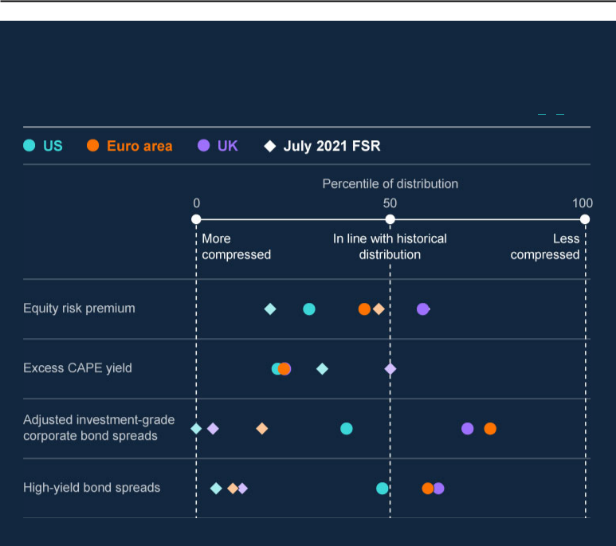

**Chart 1.1: Some measures of risk premia no longer appear compressed relative to historical levels**

Current level of selected risk premia metrics as a percentile of historical values (**a**) (**b**)

Sources: Bloomberg Finance L.P., ICE BofAML, Refinitiv Eikon from LSEG, Refinitiv I/B/E/S from LSEG, Tradeweb and Bank calculations.

1. Latest data are as of close of business on 15 June 2022. July 2021 FSR data are as of close of business on

25 June 2021. Risk-taking is shown here using percentiles of the historical distribution calculated since January 2000 (unless stated below) and a five-day rolling average.

1. Equity risk premium is calculated using a dividend discount model. Excess CAPE Yield is calculated as the inverse of cyclically adjusted price to earnings ratio (CAPE) minus the respective real 10-year government bond yield (measured from October 2004). Investment-grade corporate bond spreads are adjusted for changes in credit quality and duration.

Given downside risks from additional supply shocks, faster than expected monetary policy tightening and slower-than-expected economic growth, risky asset prices remain vulnerable to further sharp adjustments.

**Bank of England** Page 17



**Though movements in risky asset prices have been largely orderly so far, there has been evidence of reduced liquidity across financial markets and pressures in some areas of market-based finance.**



Amid higher volatility, liquidity conditions have deteriorated even in usually liquid markets such as US Treasuries, bond futures and equities (see Section 2). Bid-ask spreads widened and measures of market depth fell significantly. And there were emerging signs of strain in some international sovereign bond markets.

Some financial markets are critical to the smooth functioning of the UK financial system. For example, UK government bonds (or ‘gilts’) provide finance to the UK Government, are a benchmark for other borrowing rates for households and businesses, and are vital to the functioning of financial markets and the transmission of monetary policy. Such core UK financial markets have remained functional so far, with participants able to execute trades, albeit at a higher cost. However, conditions could continue to deteriorate especially if market volatility increased further.

Some riskier and less-liquid corporate bond open-ended funds have seen large outflows in reaction to the falls in asset prices. Higher market volatility has also resulted in elevated margin calls across cleared derivatives markets to protect against an increasein counterparty credit risk. However, there has been no indication that participants in the non-bank sector have been fire-selling liquid assets in order to meet margin calls.

**It is crucial that international work to remediate vulnerabilities in the system of market-based finance results in effective policy outcomes.**



The FPC has previously noted long-standing vulnerabilities in market-based finance (see Section 2). These were exposed in the March 2020 episode, when core markets experienced severe dysfunction, and through subsequent events highlighting the risks associated with leverage, such as the failure of Archegos. More recently, similar vulnerabilities were highlighted during the recent commodity market volatility (see Section 4). In the event of further shocks, the resulting stress could be amplified by these vulnerabilities.

**Bank of England** Page 18



There is an important programme of work, co-ordinated by the Financial Stability Board, to understand and, where necessary, remediate the vulnerabilities exposed in the March 2020 ‘dash for cash’, which is due to report its main findings and policy proposals in October. It is crucial that this work results in effective policy outcomes.

**There was extreme volatility in cryptoasset markets (including some cryptoassets marketing themselves as ‘stablecoins’).**



Cryptoasset valuations have fallen sharply. Market capitalisation of cryptoassets has fallen to US$900 billion, from a peak of almost US$3 trillion in late 2021. A number of vulnerabilities were exposed within cryptoasset markets similar to those exposed by past episodes of instability in more traditional parts of the financial system. These include liquidity mismatches leading to run dynamics and fire sales, and leveraged positions being unwound and amplifying price falls. Investor confidence in the ability of certain so-called ‘stablecoins’ to maintain their pegs was weakened significantly, particularly those with no or riskier backing assets and lower transparency.

These events did not pose risks to financial stability overall. But, unless addressed, systemic risks would emerge if cryptoasset activity, and its interconnectedness with the wider financial system, continued to develop. This underscores the need for enhanced regulatory and law enforcement frameworks to address developments in these markets and activities.

Absent additional regulation, some stablecoins held to be used for payments may not offer similar protections to central bank or commercial bank money. In the UK, the FPC has set out its expectation that stablecoins used as money-like instruments in systemic payment chains – including those used in payments for financial assets and financial market instruments – should meet equivalent standards to commercial bank money in relation to stability of value, robustness of [legal claim and the ability to redeem at par in fiat (see **Financial Stability in**](https://www.bankofengland.co.uk/financial-stability-in-focus/2022/march-2022)[**Focus: Cryptoassets and decentralised finance**).](https://www.bankofengland.co.uk/financial-stability-in-focus/2022/march-2022)



HM Treasury [**has published its proposal**](https://assets.publishing.service.gov.uk/government/uploads/system/uploads/attachment_data/file/1066166/O-S_Stablecoins_consultation_response.pdf) for a regulatory framework for stablecoins used as a means of payments in the UK, which includes bringing systemic stablecoins into the Bank’s payments remit. The Bank plans to consult on the details of the regulatory regime in due course.



**Bank of England** Page 19



1.3: The resilience of UK banks

**Major UK banks’ (banks) CET1 capital ratios declined to 14.5% in Q1, mostly owing to expected regulatory changes.**



In Q1, major UK banks’ capital ratios fell back as anticipated, to 14.5% in aggregate (from 16.3% at the end of 2021). Around three-quarters of the reduction reflected regulatory adjustments; they also reduced capital levels by paying out dividends. Major UK banks plan to draw down capital ratios slightly over coming quarters.

**There are a number of headwinds to banks’ resilience.**



The headwinds to the global and UK economic outlooks pose risks to UK banks. For example, the impact of the Russian invasion of Ukraine on commodity markets could lead to losses on some lending exposures. Continued headwinds to the Chinese economy could adversely affect some internationally focused UK banks. And financial pressures for UK households and businesses could lead to impairments for banks.

Consistent with the deterioration in the outlook, major UK banks posted their first net impairment charge since the end of 2020 in Q1. Banks expect impairments to increase, particularly towards the end of the year. Market intelligence suggests that the deteriorating macroeconomic outlook is leading banks to reassess their risk appetite.

**The FPC judges major UK banks have capacity to weather the impact of severe economic outcomes.**



Reflecting the resilience built up since the global financial crisis, major UK banks are entering this period with strong CET1 ratios and liquidity ratios. This provides them with considerable capacity to support lending to households and businesses even with the deterioration in the economic outlook (see Section 3).

**Bank of England** Page 20



1.4: Debt vulnerabilities

1.4.1: UK debt vulnerabilities

UK households

**Staff have developed a new measure of household debt affordability using the share of income available to repay debt, after adjusting for an estimate of essential spending and taxes. This enables better assessment of the combined impact from rising prices and interest rates.**



Staff have produced a new cost of living adjusted debt-servicing ratio (DSR) measure, which adjusts income for taxes and an estimate of essential spending. Essential spending includes utility and council tax bills, housing maintenance, food and non-alcoholic beverages, motor fuels, vehicle maintenance, public transport and communication. The measure of debt-servicing consists of regular debt repayments (of both interest and capital, where applicable). DSRs are calculated separately for mortgage debt and for consumer credit, where those for consumer credit also include rental and mortgage payments within essential spending.

The share of income spent on taxes and such essential spending varies greatly across the income distribution – for households in the lowest income decile, it accounts for around 90% of their income, relative to around 45% for households in the highest income decile (left-hand side of Chart 1.2). This means lower-income households will find it more difficult to adjust their spending behaviour in response to the rise in prices. These households also save at a lower rate relative to higher income households, and so are less likely to have a cushion of savings to support them in absorbing increased living costs (left-hand side of Chart 1.2).

The latest Wealth and Assets Survey also suggests that, going into the Covid pandemic a typical household in the top 10% of households had around 8x their monthly disposable income in savings, while a typical household in the bottom 10% had around 3x, or less if retirees are excluded. Over the pandemic, higher-income households were more likely to report building savings, widening the saving disparity (see [**Household debt and Covid (2021)**](https://www.bankofengland.co.uk/quarterly-bulletin/2021/2021-q2/household-debt-and-covid)). In addition, higher-income households are more likely to have accumulated housing equity, which could serve as collateral, unlike lower-income households.



**Bank of England** Page 21



These households are, however, likely to hold a smaller share of total outstanding consumer credit and mortgage debt (right-hand side, Chart 1.2).

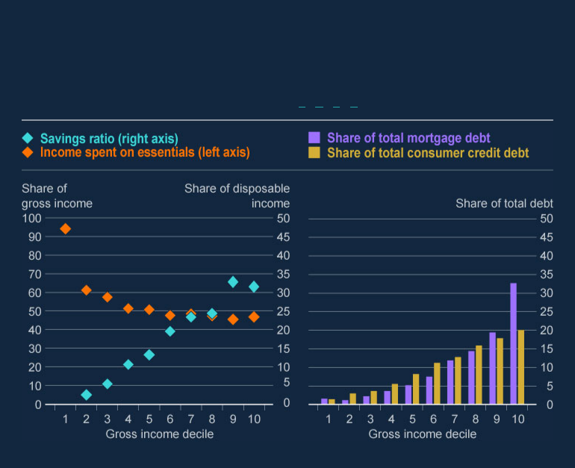

**Chart 1.2: Lower-income households spend more of their income on essentials but hold smaller shares of the total UK household debt stock.**

Share of income spent on taxes and essentials and share of total mortgage and consumer credit debt by gross income decile (**a**) (**b**) (**c**) (**d**)

Sources: ONS and Bank calculations.

1. Share of gross income spent on essentials includes tax payments, spending on essential goods and

services as defined above, and rental and mortgage payments. It is derived using the 2019–20 wave of the Living Costs and Foods Survey.

1. The savings ratio is defined as the proportion of disposable (post-tax) income that is saved. Mortgage principal repayments are included in the measure of savings. On average, households in the lowest income decile report spending more than their income and so are not shown. The data are derived using the 2019–20 wave of the Living Costs and Foods Survey and are calculated on a different basis from the National Accounts measure of the savings ratio.
2. Share of total mortgage and consumer credit debt accounted for by gross income decile is derived using the 2018–20 round of the Wealth and Assets Survey.
3. Total consumer credit debt is defined as the sum of current accounts overdrawn, credit/store/charge card balances, mail order accounts, hire purchase agreements and all formal loans, excluding student loans.

**Bank of England** Page 22



**The share of households with high cost of living adjusted DSRs on either their mortgage or consumer credit has remained significantly below pre-global financial crisis peaks over the past few years (Charts 1.3 and 1.4).**



In Q1, the share of households with high cost of living adjusted DSRs for mortgage debt was 1.7% (from 1.4% in 2020 Q1). This is around the historical average for the series, and significantly below its pre-global financial crisis peak of 2.8% (Chart 1.3). This in part reflects the FPC’s mortgage market Recommendations, which have guarded against a material loosening in underwriting standards and an excessive build-up of household debt.

**Bank of England** Page 23

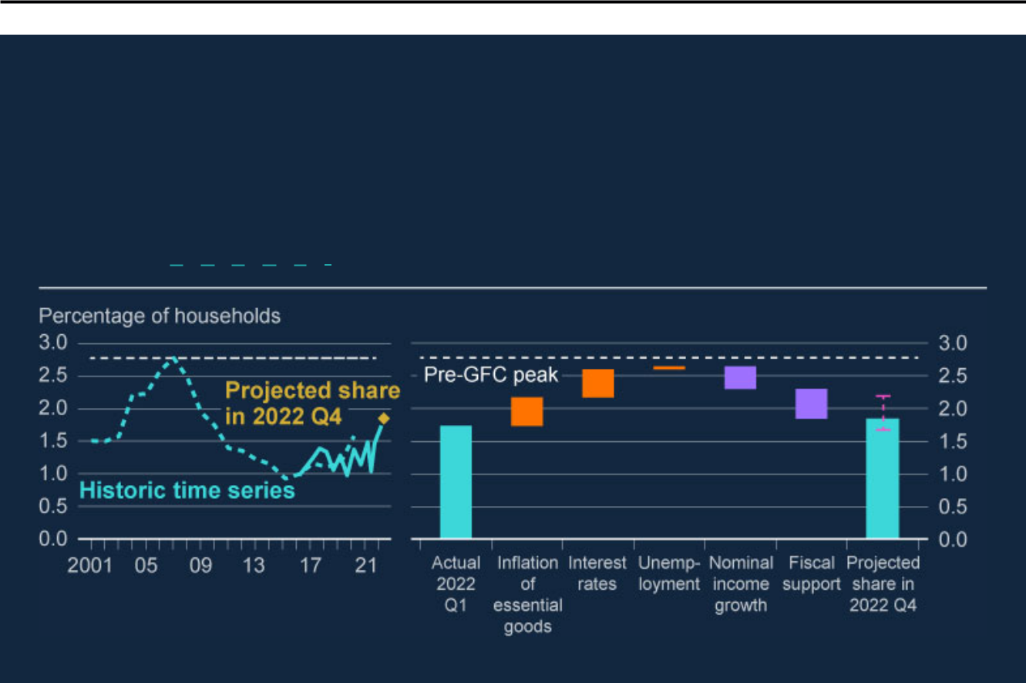

**Chart 1.3: The share of households with high cost of living adjusted DSRs on mortgage debt is projected to remain around current levels by the end of the year.**

Share of households with cost of living adjusted DSRs on mortgage debt of over 70% of

net income (**a**) (**b**) (**c**) (**d**) (**e**) (**f**)

Sources: British Household Panel Survey/Understanding Society, NMG Consulting survey, ONS and Bank calculations.

* 1. The threshold of 70% is estimated by taking the threshold at which households become much more likely to experience repayment difficulties for gross DSRs (40%) and adjusting it to reflect the share of income spent on taxes and essentials (excluding housing costs) by households with mortgages. For more information on the gross threshold, see the [**August 2020 FSR**](https://www.bankofengland.co.uk/report/2020/monetary-policy-report-financial-stability-report-august-2020). The impact of inflation is estimated by assuming the prices of essential goods rise in line with the May MPR projections, and households do not substitute away from this consumption.
  2. The estimate of the impact of fiscal support is based on [**HM Treasury’s analysis**](https://www.gov.uk/government/publications/cost-of-living-support) on the impact of the measures announced on or before 26 May 2022 to address the rising cost of living.
  3. Interest rate projections are based on options-implied market expectations on 15 June 2022. Full pass-through is assumed for mortgages on floating rates or with fixed rates ending within one year.
  4. Unemployment projections are based on the expected one-year unemployment increases set out in the May MPR. Unemployment shocks are applied stochastically to individuals within households.
  5. Nominal income growth is assumed to apply to all households equally.
  6. The illustrative range indicates uncertainties in the estimates, where the upper bound assumes no nominal income growth for impacted households and the lower bound assumes households are able to substitute away c. 20% of the increase in non-energy essential spending, as based on Chart 7 in [**ECB (2022)**](https://www.ecb.europa.eu/pub/economic-bulletin/articles/2022/html/ecb.ebart202203_01~f7466627b4.en.html). This range will not capture the full scope of uncertainties.



The share with high cost of living adjusted DSRs for consumer credit was 6.4% (from 5.5% in 2020 Q1).[2] This is around levels seen since 2016 and is significantly below its estimated pre-global financial crisis peak of 9.5% (Chart 1.4).

**Bank of England** Page 24

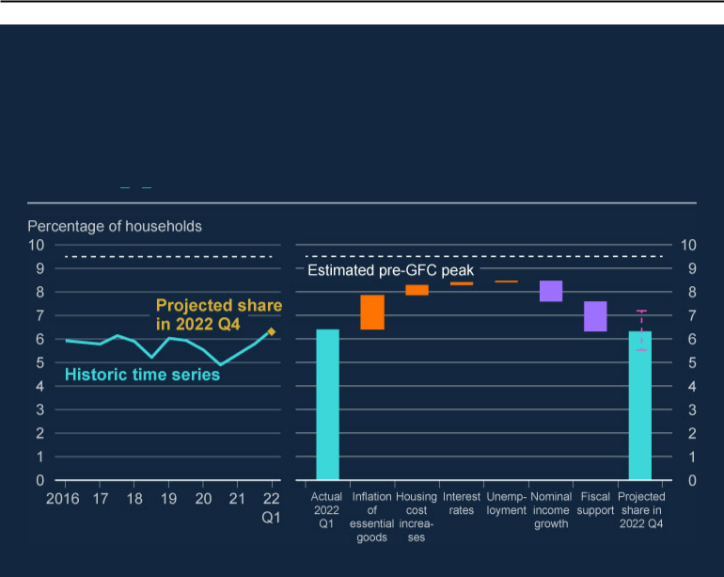

**Chart 1.4: The share of households with high cost of living adjusted DSRs on their consumer credit is projected to remain broadly in line with its current level by the end of the year.**

Share of households with cost of living adjusted DSRs on consumer credit over 80% of net income (**a**) (**b**)

Sources: NMG Consulting survey, ONS and Bank calculations.

1. The threshold of 80% is estimated by taking the threshold for gross DSRs (20%) and adjusting it for the share of income spent on taxes, essentials and housing costs by consumer credit holders. For more information on the gross threshold, see the [**August 2020 FSR**](https://www.bankofengland.co.uk/report/2020/monetary-policy-report-financial-stability-report-august-2020). Interest cost increases are projected to take immediate and complete effect for outstanding consumer credit balances. Other detail on interest rate, unemployment, nominal income growth and fiscal support estimates are as in Chart 1.3.
2. The time series starts in 2016, from when robust data are available in the NMG survey. The pre-GFC share is estimated using a derived net DSR measure from the Wealth and Assets Survey.



Trends in both net measures are also mirrored in the gross DSR measures based on gross, pre-tax income referred to in previous Financial Stability Reports (FSR*s*).

**The shares of households with high cost of living adjusted DSRs on their mortgage debt or consumer credit are not projected to increase substantially.**



**Bank of England** Page 25



Estimates of the share of households with high cost of living adjusted DSRs on their mortgage debt or consumer credit at end-2022 take into account market expectations of interest rates, and May MPR projections for inflation in essential good prices and unemployment – all of which push up the estimated share of vulnerable households. Nominal wage growth as projected in the May MPR (applied to all households) and government support measures announced in May, reduces the impact.

As shown in Charts 1.3 and 1.4, the shares of households with high cost of living adjusted DSRs on their mortgages or consumer credit are likely to remain at around their current levels over the course of 2022, as government support measures relieve some of the pressure on household finances, particularly from the rise in living costs, in the near term.

Moreover, the impact of higher interest rates on mortgage DSRs is less than in the past because, an increasing share of mortgage debt is at fixed rates. As of 2022 Q1, 80% of the outstanding value of residential mortgages was at a fixed rate, compared with 55% five years ago.

The shares of households with high cost of living adjusted DSRs for mortgage debt or consumer credit are nevertheless expected to increase in 2023, but would remain significantly below the peaks seen ahead of the global financial crisis. Market expectations are for interest rates to continue to rise and more of the increases will be passed through to households with mortgages as they come to the end of fixed-rate periods. Unemployment is also projected to increase.

But these estimates are subject to a number of risks, as set out below.

**There are a number of downside risks to this central projection.**



A further deterioration in the macroeconomic outlook relative to the central projections in the May MPR would weigh on real GDP and potentially lead to a greater-than-expected increase in unemployment. This could cause more households to struggle to repay their debts. Such an outcome could arise due to many factors – persistent inflationary pressures, and tighter financing conditions for example, as noted previously. But it could also arise if households (highly indebted households in particular) respond to this period of higher financial pressure by cutting consumption by more than in those projections.

**Bank of England** Page 26



If wage increases are more limited for lower income or stretched borrowers, then they could face greater financial pressures than projected. Greater widening in credit spreads than expected – for example, due to a reduction in risk appetite on the part of lenders – would worsen the impact on households’ debt affordability. Households may also borrow more in order to fund their increased living costs, which would increase their debt-servicing burdens.

UK corporates

**Staff estimate that, at the end of 2021, the share of larger UK corporates with low interest coverage ratios (ICRs) was broadly in line with pre-Covid average levels.**



The debt-weighted share of larger UK businesses[3] with ICRs below 2.5 (a level below which UK companies are materially more likely to experience repayment difficulties) is estimated to have been 36% at end-2021. This is slightly below its average in the period between the global financial crisis and the pandemic of 39%.

**The share of corporates with low ICRs is expected to increase in the near term, largely driven by increasing interest rates.**



Business earnings are assumed to be broadly flat in aggregate. But the impacts of the deterioration in the outlook will be uneven. For example, in some subsectors with large exposures to energy or fuel prices and already relatively narrow profit margins (such as air transport and some manufacturing subsectors) earnings could fall by around a third, even after assuming that businesses can pass through a large proportion of their increases in cost to other businesses and consumers. And the fall in household real incomes could reduce demand significantly in sectors such as non-essential household goods and services. Firms in these more vulnerable sectors are projected to face a large shift in the share of their earnings needed to service debt, and may need to adjust their business strategy, planned leverage and cash flow management accordingly.

The overall debt-weighted share of large UK businesses with ICRs below 2.5 could reach 46% if interest rates evolve in line with market expectations and these increases are passed on immediately to all debt that is not fixed for at least a year (Chart 1.5). However, the band of uncertainty around this is wide (around 3–4 percentage points in each direction) depending on assumptions made about the

**Bank of England** Page 27



distribution of debt that is at floating or fixed rates. To the extent that some businesses have further hedged their exposure to interest rate rises, the figure may yet be lower.

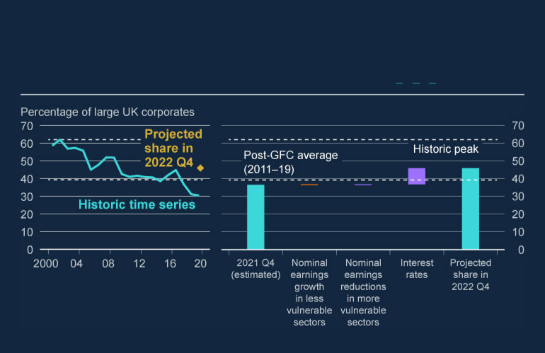

**Chart 1.5: The share of businesses with low ICRs is expected to increase in the year ahead.**

Debt-weighted share of large UK corporates with ICRs below 2.5 (**a**) (**b**) (**c**)

Sources: Bureau van Dijk, S&P Capital IQ and Bank calculations.

1. ICRs are calculated as earnings before interest and tax as a share of interest expenses. Low ICRs are those below 2.5.
2. The sample consists of UK-owned firms with a turnover greater than £10.2 million. The company data between 2000–18 are obtained from a different source than the data between 2019–21. This results in a small sample difference between the two.
3. We lack information on the debt composition for individual corporates, so we estimate a range of interest rate impacts based on varying distributions of fixed and floating-rate debt across the sample, informed by aggregate statistics. The purple bar represents the median of that range.

**Interest rate rises would need to exceed market expectations significantly to return the share of businesses with low ICRs to around its historic peak.**



Bank Rate has increased by 100 basis points to 1.25% since end-2021. Current market expectations are for a further rise of over 150 basis points to just under 3% by the end of the year.

**Bank of England** Page 28



Staff have estimated the increase in businesses’ funding rates that would be required to return the debt-weighted share of large UK businesses with ICRs below 2.5 to its historic high. Such estimates are highly uncertain and depend on a number of factors, in particular the extent to which increases in funding rates pass through into the rates paid on their existing debt.

Assuming that any increase in businesses’ funding rates immediately applies to all of their debt – the highest degree of pass-through of funding rate rises into debt servicing payments – returning the debt-weighted share to its historic high would take an additional 200 basis point increase in businesses’ funding rates by end-2022, on top of the market expectations of a 150 basis point rise. It would entail funding rates increasing by a total of 450 basis points between end-2021 and end-2022.

Assuming instead lower pass-through such that the increases in funding rates are passed on only to floating rate debt, or debt that is at fixed rates for less than a year, returning the debt-weighted share to its historic high would take an additional increase in funding rates of 500 basis points (rather than the 200 basis points above). This would entail funding rates increasing by a total of 750 basis points between end-2021 and end-2022.

**UK small and medium-sized enterprises (SMEs) have more debt than they did before the Covid pandemic. However, the vast majority of new debt was issued at relatively low rates that tended to be fixed for six years or longer.**



SMEs make up a relatively small share of total corporate debt (less than 20%), but around half of UK employment. Over the course of the pandemic, they acquired substantially more debt – while larger businesses’ outstanding debt was broadly flat, total outstanding SME debt increased by over 20% between end-2019 and end-2021. However, the vast majority of new SME debt was issued at relatively low [interest rates via government-guaranteed loan schemes (see **Financial Stability in**](https://www.bankofengland.co.uk/financial-policy-summary-and-record/2021/october-2021/financial-stability-in-focus)[**Focus: The corporate sector and UK financial stability**). These loans are on](https://www.bankofengland.co.uk/financial-policy-summary-and-record/2021/october-2021/financial-stability-in-focus)fixed rates (the majority of which had fixed-rate terms of six years or longer) and include greater repayment flexibility than typical SME loans.



**Rising interest rates and falling SME cash buffers are nevertheless likely to contribute to stress for a number of SMEs.**



**Bank of England** Page 29



The share of SMEs with insufficient cash to cover seven days of turnover was 34% in 2019. SME liquidity positions improved over the pandemic, in part reflecting precautionary borrowing, and the share fell to 21%. Liquidity positions have since deteriorated, and the equivalent share stood at 31% in February, likely largely reflecting the impact of public health measures introduced in the early part of the year to contain the spread of the Omicron Covid variant, as well as the repayment of loan scheme debt.

In addition, SMEs with non-Covid scheme debt likely remain vulnerable to increases in interest rates in the near term. Staff estimate that at least 70% of the current stock of outstanding SME debt was issued outside government loan schemes, and a large proportion of this debt is exposed to Bank Rate increases within a year.

**The FPC assesses that UK corporate debt vulnerabilities are likely to increase in the near term, but major UK banks are resilient to these vulnerabilities.**



Debt servicing remains affordable for most UK businesses. However, the material deterioration in the economic outlook, combined with higher interest rates, will weigh on corporate balance sheets in the near term. And as noted above, these developments will not fall evenly across businesses. While these pressures will likely lead to some business failures, it would take large increases in borrowing costs or severe earnings shocks to impair businesses’ debt servicing ability in aggregate.

Nonetheless, and as noted in Section 1.3, reflecting the resilience built up since the global financial crisis, banks have strong capital and liquidity ratios. The FPC continues to judge that major UK banks are resilient to vulnerabilities in the UK corporate sector.

1.4.2: Global debt vulnerabilities

**The FPC had previously judged that global debt vulnerabilities that could amplify risks to UK financial stability were material.**



Prior to the pandemic, the FPC judged that global debt vulnerabilities were material. Government and central bank policy support was necessary to limit the disruption from the pandemic. However, it has resulted in an increase in aggregate

**Bank of England** Page 30



public and private sector debtacross both advanced and emerging market economies. Higher leverage abroad can increase the risk of losses for UK institutions, most directly on their foreign exposures. It can also affect them indirectly by amplifying shocks to those economies, leading to larger macroeconomic and financial spillovers to the UK.

**Developments in the global outlook have increased the risks associated with global debt vulnerabilities.**



Higher interest rates, slower growth and increases in the price of essential goods, such as food and energy, will make servicing debt more difficult for households in many countries, and emerging market economies in particular. National circumstances differ: in some countries – the US and France for example – mortgages tend to be issued at fixed rates for the majority of their term. Households with such mortgages are, therefore, less exposed to rises in interest rates, though they could still be exposed to other cost of living pressures. In many other countries including the UK and Spain, while fixed rate mortgages are prevalent, they are typically fixed for a much shorter duration.

The FPC has previously highlighted vulnerabilities associated with leveraged corporate borrowing, including in the US. Weaker demand and higher interest rates would stretch debt affordability for a wider range of businesses. Bank staff have considered the effects of increases in energy prices and revenues as projected in the May MPR*,* as well as market expectations for policy rates in 2022, on the share of large, listed businesses with ICRs below 2.5 in the US and the euro area. This analysis suggests that, if the Federal funds rate increases in line with market expectations as at 15 June (a 350 basis points increase by end-2022), the share of US businesses with ICRs below 2.5 could increase from around 30% to up to 44% by the end of this year. This is below its historic high of around 50% during the global financial crisis. This assumes partial pass-through of the increase in the policy rate, to reflect a share of debt being at fixed rates.[4]

Market expectations of interest rate increases in the euro area are lower, at around 160 basis points by end-2022. The impact of energy prices and this path for euro area interest rates would increase the share of businesses with ICRs below 2.5

**Bank of England** Page 31



from 22% to 28% by the end of the year. This remains far below its historic high, of around 60%. But euro-area businesses are more exposed to possible further rises in gas prices.

However, the shares could increase further if downside risks to the outlook were to crystallise – eg inflation stronger or more persistent, global financial conditions tighter, or growth weaker, relative to current expectations. For further detail on [global corporate debt vulnerabilities, see **Financial Stability in Focus: The**](https://www.bankofengland.co.uk/financial-policy-summary-and-record/2021/october-2021/financial-stability-in-focus)[**corporate sector and UK financial stability**.](https://www.bankofengland.co.uk/financial-policy-summary-and-record/2021/october-2021/financial-stability-in-focus)



**Some euro-area countries could experience financial strain as financial conditions tighten.**



Among advanced economies, public sector debt positions vary significantly. Rising interest rates and a weaker growth outlook increase risks related to the affordability of such public sector debt. In aggregate, International Monetary Fund (IMF) projections suggest that the share of government revenue spent on interest payments in advanced economies will fall slightly this year before rising in 2023 and 2024. But some countries – particularly those with high sovereign debt levels – may be more vulnerable.

In the euro area, some countries have seen yields on public sector debt rise particularly sharply. For example, Italian 5–10 year government bond yields had increased by around 100–110 basis points over the previous month. In response, the European Central Bank has announced that it would apply flexibility in the reinvestment of previous asset purchases under the Pandemic Emergency Purchase Programme and accelerate work on an anti-fragmentation instrument in order to preserve the functioning of the monetary policy transmission mechanism.

The FPC had previously highlighted vulnerabilities created by high public debt levels in the euro area, including interlinkages between banks and sovereigns, which could pose a material risk to UK financial stability through economic and financial spillovers.

**Further deterioration in the economic outlook could exacerbate global financial stability risks: for example, an additional tightening in global financial conditions could significantly impact many economies.**



**Bank of England** Page 32



If inflationary pressures become stronger or more persistent than currently expected, it might lead to; weaker economic growth globally; a further sharp tightening in global financial conditions; and the potential for further volatility and stress in financial markets. This could affect both public and private debt sustainability.

**A relatively small number of non-China emerging market economies (NCEMEs) have experienced financial stress so far, but more are likely to be exposed if financial conditions tighten faster than expected.**



The IMF’s projections suggest that major NCEMEs’ interest payments as a share of government revenue will rise by around 2½ percentage points this year and remain high in 2023 and 2024. That could rise further if, for example, sharper-than-expected increases in the Federal funds rate caused the dollar to appreciate relative to NCEME currencies, pushing up debt-servicing costs for those with dollar-denominated sovereign debt. NCEME financial distress could affect major UK banks with exposures to those countries (whose consolidated claims on NCEMEs were equivalent to 136% of major UK banks’ CET1 as at end-2021), and have a wider impact on UK economic activity via lower demand from those countries for UK imports.

**In addition to these risks from an unexpected tightening in financial conditions, the Chinese economy faces headwinds that could weigh on activity, such as from continued Covid disruption and the potential for debt vulnerabilities to crystallise.**



In addition to the risk of new restrictions to contain further Covid outbreaks, noted in Section 1.1, debt vulnerabilities in China – particularly in the property market – remain elevated. A number of highly leveraged property developers are continuing to face liquidity stresses, leading to a slowing of the sector as a whole. A more pronounced downturn in the property sector could have significant economic consequences given that it accounts for around a quarter of Chinese GDP.

1.5: The UK countercyclical capital bu er rate

**The FPC decides on the appropriate rate for the UK countercyclical capital buffer (CCyB) each quarter.**



**Bank of England** Page 33



The FPC’s approach to setting the UK CCyB rate is to vary it in line with system-wide risks to the UK banking sector, and to set it in the region of 2% when the risk environment is judged to be standard (see [**December 2019 FSR**](https://www.bankofengland.co.uk/financial-stability-report/2019/december-2019)). This aims to ensure the buffer is large enough to create capacity for banks to absorb shocks, so they are able to continue to lend through downturns.



**The FPC is increasing the UK CCyB rate from 1% to 2%, with effect from 5 July 2023, in line with the generally required 12-month implementation period.**



The FPC noted [**in December 2021**](https://www.bankofengland.co.uk/financial-stability-report/2021/december-2021) that since debt vulnerabilities had returned to pre-Covid levels and global and UK activity was expected to return to pre-pandemic levels, it was minded to return the UK CCyB to 2%, the level it was due to reach before the pandemic, in 2022 Q2.



The FPC judges that while domestic debt vulnerabilities have increased since the December 2021 FSR, overall they remain at a standard level. The global and UK economic outlooks have deteriorated significantly since December, as noted in Section 1.3, but major UK banks’ capital ratios remain strong. Their aggregate CET1 ratio is expected to fall back slightly over coming quarters, while leaving sufficient headroom to accommodate an increase in the UK CCyB rate to 2%.

Given the considerable uncertainty around the outlook, the Committee will continue to monitor the situation closely. It stands ready to vary the UK CCyB rate – in either direction – in line with the evolution of economic conditions, underlying vulnerabilities, and the overall risk environment. In particular, if economic conditions deteriorate by significantly more than currently expected – in a manner that might otherwise lead banks to restrict lending – the FPC will be prepared to cut the UK CCyB rate as necessary.

**Bank of England** Page 34



Box A: Financial stability risks from climate change

Climate change poses financial risks to businesses and households, via both the physical effects of climate change, and from the transition to a net-zero economy.[5] These risks in turn have the potential to affect adversely the resilience of banks and insurers, the stability of the wider financial system, and its ability to support businesses and households through the economic changes necessary to reach net zero. Risks from climate change are therefore relevant to the FPC’s objective to protect and enhance the stability of the UK financial system. They are also relevant to the FPC’s secondary objective to support HM Government’s objective to deliver a financial system that supports and enables a net-zero economy.

[In May, the Bank published the results of its **Climate Biennial Exploratory**](https://www.bankofengland.co.uk/stress-testing/2022/results-of-the-2021-climate-biennial-exploratory-scenario)[**Scenario** (CBES).](https://www.bankofengland.co.uk/stress-testing/2022/results-of-the-2021-climate-biennial-exploratory-scenario)[6] This exercise explored the financial risks posed byclimate change for the UK’s largest banks and insurers through three, 30-year climate scenarios.[7] These scenarios are not forecasts of the most likely future outcomes.

Two CBES scenarios focus on transition risks. The Early Action scenario assumes ambitious UK and global policy on climate change has been adopted from 2021, delivering an orderly transition to net-zero emissions by 2050. The Late Action scenario assumes a 10-year delay in implementing further climate policy – the shorter window to achieve the necessary reduction in emissions results in a sharper policy adjustment, which causes material short-term macroeconomic and financial market disruption.

The third scenario – No Additional Action (NAA) – explores the physical risks that could materialise if no further action is taken to address climate change beyond policies already in place at the end of 2020. Importantly, while climate risks are managed by the end of the two transition scenarios, the NAA scenario’s adverse effects continue to build beyond that.

Headline findings from the exercise are described below:

**Bank of England** Page 35



**Risk management:** the CBES showed that UK banks and insurers are making good progress in some aspects of their climate risk management, and this exercise has spurred on their efforts further. Nevertheless, there was a range in the quality of different approaches taken by participants to the assessment and modelling of these risks. All participating firms have more work to do to improve their climate risk management capabilities. Where they are reliant on third-party modelling, they need to better identify and understand modelling limitations. The exercise also exposed several important data gaps, such as on the location of corporate counterparties’ assets, in order to assess their vulnerability to physical risk robustly. The FPC supports efforts to help fill these.

**Sizing financial exposures**: climate risks captured in the CBES are likely to create a drag on the profitability of banks and insurers. Loss projections varied across participants and scenarios, but were equivalent to an annual drag on profits of around 10%–15% on average. Overall, costs will be lowest with early, well-managed action. There is however considerable uncertainty around the scale of these risks, and whether firms can identify and manage them effectively. Those risks outside the scope of the CBES (such as trading losses for banks and mortality risk for life insurers) could also be material.

**Responses to the scenarios**: participating firms broadly followed their climate strategies or net-zero transition plans in all scenarios. This included reducing finance, and in some cases insurance, to the most carbon-intensive industries as well as engaging with corporate counterparties to facilitate their transition to net zero.

The collective impact of banks’ and insurers’ plans to address potential challenges to business models could adversely affect the provision of finance, and so the wider economy. Some responses to the NAA scenario implied a material reduction in access to credit and insurance for sectors and households most exposed to physical risks. In the NAA scenario, banks envisaged reducing lending to properties facing greater physical risks (such as flooding). Insurers would substantially increase the premiums they charge to insure against such risks, making insurance coverage unaffordable for many of these households, and in some cases, cut insurance availability completely for the worst-affected properties. In addition, as banks and

**Bank of England** Page 36



insurers reduce exposures to carbon-intensive sectors, some sectors may struggle to access finance. The combined impact of such plans could therefore have negative consequences for the wider economy, over and above the impacts on banks and insurers captured in the CBES.

The Bank is working to understand how the management of transition risks, or the failure to do so adequately, might affect the provision of financial services to the real economy. The FPC will monitor any risks to the financial system as a result of possible large-scale withdrawals of credit from particular sectors. It is in the collective interest of banks and insurers to manage climate-related risks in a way that supports the transition to net zero over time. The FPC is also supportive of wider work to develop standards and frameworks to support the financial sector’s transition to net zero, such as the UK Government’s action on climate policy and green finance, including implementing Sustainability Disclosure Requirements across the economy, supported by the work of the [**Transition Plan Taskforce**](https://www.gov.uk/government/publications/fact-sheet-net-zero-aligned-financial-centre/fact-sheet-net-zero-aligned-financial-centre), and sustainability disclosure standards and requirements put in place by the [**International Sustainability Standards Board**](https://www.ifrs.org/groups/international-sustainability-standards-board/#about). Such standards, and theimproved data they are designed to provide, will be critical foundations to help banks and insurers better understand their customers’ exposure to current and future climate risks, and their plans to transition towards a net-zero economy. The Bank is also working with international counterparts, eg through the Financial Stability Board, Basel Committee, the G20 Sustainable Finance Working Group and the NGFS, to better understand these risks and how best to manage them.

The Chancellor’s March 2021 [**FPC remit and recommendations letter**](https://www.bankofengland.co.uk/letter/2021/march/remit-for-the-fpc-2021) asked the FPC to consider the potential relevance of other environmental risks to its primary objective. In addition to the financial risks posed by climate change, there is growing global attention on the potential for broader nature loss and degradation to cause financial risks (see, for example, the [**NGFS-INSPIRE report**](https://www.ngfs.net/en/central-banking-and-supervision-biosphere-agenda-action-biodiversity-loss-financial-risk-and-system)). Collective understanding of how these changescould give rise to financial risks is in its infancy globally. This includes the vital role that natural capital (eg forests and oceans) plays in mitigating the

**Bank of England** Page 37



risks from climate change. The FPC considers that the Bank should seek to build its understanding of how these risks might arise and their potential materiality for UK financial firms and so the UK financial system.

**Bank of England** Page 38



1. The resilience of market-based fnance



Market-based finance (MBF) is the system of markets, non-bank financial intermediation (NBFI), and infrastructure which, alongside banks, provides credit and other critical financial services to support the wider UK and global economies. That essential role for MBF means that it needs to be resilient so it can absorb, and not amplify, economic shocks. The FPC therefore regularly assesses its resilience.

The ‘dash for cash’ episode in March 2020 exposed a number of vulnerabilities in the sector that the FPC had previously identified. These include, for example, how potential forced asset sales by leveraged investors or funds investing in less liquid assets could interact with markets’ limited capacity to absorb them. These can amplify economic shocks by undermining market functioning and, by tightening credit conditions, impair the provision of credit to the real economy.

As set out in Section 1, volatility in financial, energy, and broader commodity markets has increased recently and financial conditions have tightened. This reflects global factors including geopolitical events, inflationary pressures, deterioration in the macroeconomic outlook, and central banks tightening monetary policy.

Government bond yields have increased significantly since end-2021, and liquidity conditions have deteriorated even in usually highly liquid markets such as US Treasuries, gilts, and interest rate futures. While primary corporate debt markets have largely remained open, issuance has been depressed relative to recent historical levels. There has also been price volatility and liquidity challenges in a range of commodity markets. Core UK financial markets have remained functional, with participants able to execute trades, albeit at a higher cost. There have been no widespread forced sales of government bonds or elevated demand for liquidity via repo borrowing. But there is some evidence of strain in some international funding markets.

**Bank of England** Page 39



These stresses risk being amplified by the previously identified vulnerabilities in the system of MBF, which could lead to greater disruption in global markets. There is an important programme of work, co-ordinated by the Financial Stability Board (FSB), to understand and, where necessary, remediate the vulnerabilities exposed in the ‘dash for cash’. This includes, among others, the FSB’s effectiveness review of its 2017 asset management [**recommendations**](https://www.fsb.org/2017/01/policy-recommendations-to-address-structural-vulnerabilities-from-asset-management-activities/) and the follow-up work contained in the BCBS-CPMI-IOSCO [**consultation report**](https://www.bis.org/bcbs/publ/d526.htm) on margining practices. The FPC also welcomes domestic work to support these international workstreams such as the recent publication of the joint Bank and FCA [**discussion paper**](https://www.bankofengland.co.uk/paper/2022/money-market-fund-discussion-paper) exploring the UK authorities’ initial assessment of the options for enhancing the resilience of money market funds.

**Market-based finance plays a key role in the global and UK financial systems.**



Market-based finance (MBF) refers to the system of markets, non-bank financial intermediation (NBFI), and infrastructure, which, alongside banks, provides financial services to support the wider economy. Such services include providing credit, intermediating between saving and investment, insuring against and transferring risk, and offering payment and settlement services. Between the start of the global financial crisis and end-2020, the non-bank financial system more than doubled in size, compared to banking sector growth of around 60%. As a result, non-banks account for around half the total assets making up the global financial system.

MBF plays a particularly important role in corporate lending. As of end-2021, MBF accounted for £776 billion (around 55%) of all lending to UK businesses, and nearly all of the almost £390 billion net increase in lending to UK businesses between end-2007 and end-2021.

MBF also provides a range of services supporting intermediation between savers and those seeking investment. This includes open-ended funds (OEFs) for investing in equity or bond portfolios, many of which offer daily redemptions while holding assets that can take longer to sell in an orderly way, and money market funds (MMFs), which are a subset of OEFs for investing in money market

**Bank of England** Page 40



instruments. MMFs are predominantly used for liquidity management by pension funds, investment funds, and non-financial corporates. In total, investors, most of which are UK-based, hold around £270 billion in sterling denominated MMFs.

In addition, MBF helps facilitate risk mitigation services via derivatives contracts and insurance companies. Derivatives enable financial institutions to transfer risks they are exposed to in the course of their activities (such as changes in interest rates, exchange rates, equity and commodity prices) to other institutions with different risk profiles and appetites. Derivatives are sometimes used to take a leveraged position in an underlying instrument, and counterparties typically exchange margin on them, which can result in sudden and unexpected spikes in liquidity needs during times of market volatility. As of June 2021 the gross notional value of outstanding over-the-counter derivatives stood at around US$610 trillion. The system of MBF also includes other critical infrastructure, such as central counterparties (CCPs) and payments providers.

Some markets in the system of MBF are critical to the smooth functioning of the UK financial system. For example, UK government bonds (or ‘gilts’) provide finance to the UK Government, a benchmark for other borrowing rates for households and businesses, and are vital to the functioning of financial markets and transmission of monetary policy. Therefore the UK economy benefits from services provided by the system of MBF, making it of importance to UK financial stability.

But, as highlighted in previous episodes of market volatility, previously identified vulnerabilities in the system of MBF can result in dysfunction in core markets, amplifying shocks to the real economy. Therefore, in order for it to continue to serve UK households and businesses, it needs to be sufficiently resilient.

**The FPC has previously identified underlying vulnerabilities in the system of MBF, which could amplify shocks and result in broad-based disruption to market functioning.**



In its previous assessments of MBF resilience, the FPC has noted vulnerabilities that could amplify shocks. These include how potential forced asset sales by leveraged investors or funds investing in less liquid assets could interact with markets’ limited capacity to absorb them. Alongside these structural factors, the

**Bank of England** Page 41



FPC noted particular challenges resulting from data gaps around funds’ exposures and NBFI leverage. A full discussion of vulnerabilities identified by the FPC can be found in the [**2021 report ‘Assessing the resilience of market-based finance’**](https://www.bankofengland.co.uk/report/2021/assessing-the-resilience-of-market-based-finance).



These vulnerabilities have been highlighted during market volatility episodes over [the past two years. For example, as highlighted by the FSB in its **Holistic review**](https://www.fsb.org/2020/11/holistic-review-of-the-march-market-turmoil/)[**of the March Market Turmoil**, the March 2020 ‘dash for cash’ showed how sudden](https://www.fsb.org/2020/11/holistic-review-of-the-march-market-turmoil/)spikes in liquidity needs during a stress can lead to core market dysfunction and the importance of ensuring NBFIs are resilient in stressed periods. Additionally, high levels of leverage through derivatives was a key factor in the March 2021 Archegos default. While the default did not introduce systemic risk, a number of banks incurred significant losses.



**In recent months, financial markets have been volatile, reflecting geopolitical events, inflationary pressures, deterioration in the macroeconomic outlook, and central banks tightening monetary policy. Liquidity has deteriorated, even in typically highly liquid markets.**



Prior to the Russian invasion of Ukraine, financial markets had experienced significant volatility and risky asset prices had fallen. Market volatility has continued to increase significantly over recent months.

As set out in Section 1, since the beginning of the year, risky asset prices have fallen markedly. For example US equity prices are around 21% below their end-2021 level and spreads have widened by around 50–90 basis points and 180–215 basis points on investment-grade and high-yield corporate bonds respectively. Volatility has also continued to increase, such that the VIX index has been on average roughly 25% higher than its average level between January 2019 and January 2022.[8] And a wide range of government bond yields have also increased. For example since the start of February 2022, 10-year UK and US government bond yields have increased from 1.3% and 1.8% to 2.5% and 3.3% respectively, reaching their highest levels since 2014 and 2011.

Commodity market prices also increased sharply at the outset of the invasion and have remained elevated since (Section 4). Despite market volatility, the decrease in risky assets prices has largely been orderly, but they remain vulnerable to further, sharper, adjustments.

**Bank of England** Page 42



Over recent months there has been evidence of reduced liquidity, even in typically highly liquid markets. For example, US Treasury market depth is roughly two to three times lower than at the start of the year, and pressure on short-dated gilts has been particularly acute (Chart 2.1). This reflects elevated volatility in short-term interest rates globally, as well as collateral shortages. Bid-ask spreads on two year gilts peaked in mid-May at around 3.5 basis points, more than double their average level in 2021, and they remain elevated compared to recent historical averages. There have also been emerging signs of strain in other sovereign bond markets.

Despite these pressures, core UK financial markets have broadly continued to function with participants able to execute trades, albeit at a higher cost. But conditions could deteriorate further should market volatility escalate.

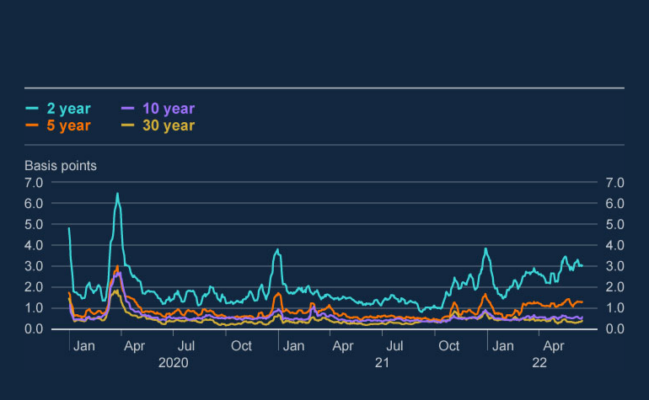

**Chart 2.1: Gilt bid/offer spreads have widened in 2-year and 5-year tenors**

Bid/offer spreads on selected gilt tenors

Sources: Refinitiv Eikon from LSEG and Bank calculations.

Corporate debt markets have remained open for most corporates, but since end-2021 bond issuance has been depressed, especially by riskier firms. For example, year-to-date issuance in investment-grade and leveraged loan markets had been

**Bank of England** Page 43



around 20%–30% lower than its average level over the previous five years, and issuance of riskier high-yield bonds was around 60% lower.

**Recent financial market developments resulted in pressure in parts of the MBF system that could have been exacerbated by long-standing vulnerabilities. But so far pressure has not been broad-based, and there is no evidence of widespread forced asset sales or elevated demand for liquidity through repo borrowing.**



Pressure in some parts of the system of MBF has included outflows from some OEFs, and, as expected, elevated CCP margin calls. However, unlike in March 2020, there has been no evidence of broad-based forced asset sales or elevated demand for repo borrowing to meet increased liquidity needs, or dysfunction in core UK markets.

In part, this reflects the relatively limited exposure to Russian assets, which, even before the invasion, accounted for less than 0.5% of all UK-domiciled funds’ assets. However as the outlook has deteriorated, some riskier and less liquid funds have seen large outflows. For example US high-yield and European corporate bond OEFs have seen outflows of around 9% of their total assets under management since the start of 2022. There has been little evidence to date of stressed outflows from other funds, such as sterling MMFs.

Margin requirements play an important role in mitigating counterparty credit risk, and, as expected, CCPs called for additional margin as market volatility increased. The largest margin calls were concentrated in commodity derivatives (Section 4), and market participants were mostly able to meet them through their usual financing channels rather than through forced asset sales.

Reflecting the less broad-based nature of the stress, UK CCPs’ initial margin requirements increased by up to £40 billion between February and April 2022 (encompassing the start of the Russian invasion), compared with around £60 billion over the same time period in 2020 (encompassing the start of the pandemic). Daily variation margin calls also spiked during the recent volatility: the largest aggregate daily variation margin call was £34 billion between February and April 2022, compared to £29 billion in the same period of 2020 (Chart 2.2).

**Bank of England** Page 44

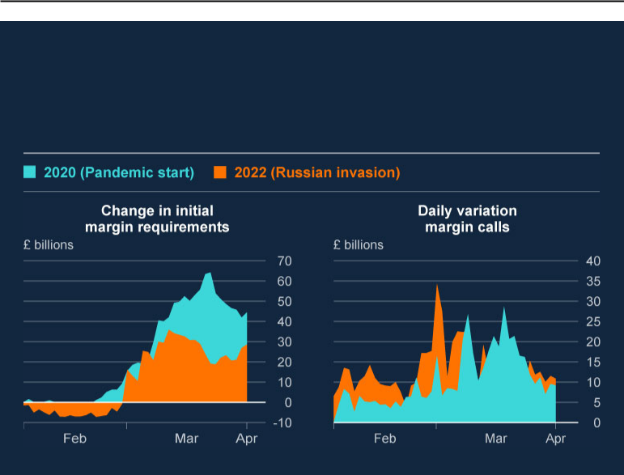

**Chart 2.2: UK CCPs’ initial margin requirements during the recent commodity market volatility increased by less than those between February and April 2020, while daily aggregate variation margin calls were sharper**

Aggregate change in CCP initial margin requirements and daily variation margin calls

Sources: CCP supervisory data and Bank calculations.

**However, key structural vulnerabilities in MBF remain unaddressed, and they could amplify liquidity stresses in financial markets, for example should risks to the UK and global economic outlook materialise. It is therefore crucial that work to understand and, where necessary, address these vulnerabilities leads to effective policy outcomes, and the FPC welcomes both international and domestic efforts to do so.**



Although recent financial market conditions have not resulted in broad-based forced sales of financial assets or dysfunction in core UK markets, given the current economic and geopolitical environment the risks of further disruption are elevated. Many of the recent pressures are similar in nature to those identified in previous episodes. Therefore liquidity stresses could be amplified further by MBF vulnerabilities.

**Bank of England** Page 45



The FPC judges that, given the international nature of MBF, globally co-ordinated policy action is the only way to address vulnerabilities effectively. The FPC therefore strongly supports the important programme of international work, led by the FSB, to understand and, where necessary, address these vulnerabilities. It is crucial this work leads to effective policy outcomes.

To that end, the Bank and FCA are engaged in the FSB’s effectiveness review of its [**2017 asset management recommendations**](https://www.fsb.org/2017/01/policy-recommendations-to-address-structural-vulnerabilities-from-asset-management-activities/), which sets out ways to addressstructural vulnerabilities in asset managers such as OEFs. The FPC has previously set out principles for OEF design to help mitigate the risks they face, and previously noted that further FSB action may be needed to address vulnerabilities in OEFs.



The Bank is also engaged in the BCBS-CPMI-IOSCO review of margining practices. A [**consultative report**](https://www.bis.org/bcbs/publ/d526.htm), published in October 2021, identified potential areas for follow-up work including increasing transparency, predictability and preparedness for margin calls in cleared and uncleared markets. The consultation period ended in 2022 H1, and the FPC strongly supports undertaking the identified follow-up work.



Complexities around data measurement and availability currently restrict authorities’ view of the nature and distribution of the vulnerabilities associated with leverage. The FPC supports international efforts to close data gaps in this area and to develop the oversight of risks to the financial system from non-bank leverage.

The FPC welcomes domestic work to support the international workstreams. This includes the recent joint Bank and FCA [**discussion paper**](https://www.fca.org.uk/publications/discussion-papers/dp22-1-resilience-money-market-funds) on the Resilience of Money Market Funds. Increasing the resilience of MMFs is an important step towards reducing the systemic risks posed to the UK and global financial system. The paper sets out options to address the risks posed by MMFs, including increases in their liquidity requirements, and invites responses from firms, industry groups, and investors.



Both the domestic and international work represent important opportunities to develop policies to address the vulnerabilities underlying MBF. Absent the implementation of such policy measures and a corresponding increase in NBFI resilience, the risks highlighted by previous episodes of market volatility remain.

**Bank of England** Page 46



Central banks have also reviewed the tools available to address market dysfunction [through the BIS Markets Committee Working Group on ‘**Market dysfunction and**](https://www.bis.org/publ/mc_insights.htm)[**central bank tools**’, and are assessing their costs and benefits. One key element](https://www.bis.org/publ/mc_insights.htm)of the insights is that in considering the design of such tools, central banks will need to ensure that they manage how the tools interact with monetary policy. For example, ensuring they will be effective in resolving dysfunction in scenarios where using monetary policy tools such as quantitative easing would not be appropriate given the monetary policy stance. A further key insight that any central bank intervention to restore market functioning is that it should act as a backstop. And any widening of access to central bank facilities should be designed in a way to minimise any increase in moral hazard, and come with a significant increase in private sector liquidity self-insurance.



**Bank of England** Page 47



1. Resilience of the UK banking sector



Major UK bank and building societies’ (banks’) capital and liquidity positions remained strong in 2022 Q1, and profitability strengthened. Although their aggregate Common Equity Tier 1 (CET1) capital ratio fell over the quarter, this was largely the result of expected recent regulatory developments. CET1 capital ratios of major UK banks are expected to fall back slightly over coming quarters, while maintaining sufficient headroom to accommodate the 2% UK countercyclical capital buffer (CCyB) rate that will come into effect next year. Despite the deterioration in the economic outlook, banks continue to have considerable capacity to support lending to UK households and businesses.

Banks reported that asset quality remained broadly stable in Q1. But UK households’ and businesses’ finances are likely to become more stretched due to the combined effects of rising inflation and interest rates, and weaker economic growth. Banks registered their first impairment charge in over a year in 2022 Q1. And the more challenging economic environment is likely to increase impairments further in coming quarters.

UK banks have limited direct exposure to Russia and Ukraine. But the impact of the invasion could lead to losses on some lending exposures, particularly in sectors exposed to higher commodity prices, such as energy. And continued headwinds facing the Chinese economy could adversely affect some internationally focused UK banks. But given the nature of these exposures and strong capital positions, the FPC judges that these developments are not likely to affect materially the resilience of the UK banking sector. UK banks have capacity to weather the impact of severe economic outcomes.

**Bank of England** Page 48



In response to these direct and indirect risks, there are tentative signs that UK banks are reducing risk-taking at the margin. Reflecting changes in the economic environment, banks have adjusted their mortgage affordability tests to account for recent and expected increases in inflation, interest rates and national insurance. Banks have also reduced their appetite to lend to businesses that may be most impacted by the increased costs faced by UK households and businesses.

The FPC will continue to monitor the resilience of banks to further downside risks. To support this, the 2022 annual cyclical scenario (ACS) will commence in September and will include deep simultaneous recessions in the UK and global economies, real income shocks, large falls in asset prices and higher global interest rates, and a separate stress of misconduct costs.

**Banks’ capital and liquidity positions remain strong, and they have sufficient financial resources to continue to support lending to the UK economy, despite a deterioration in the economic outlook.**



The headline aggregate CET1 capital ratio was 14.5% in 2022 Q1, compared with 16.3% at the end of 2021 (Chart 3.1). Three-quarters of the fall was a result of a range of expected regulatory developments, including changes to the calculation of risk-weighted assets and the treatment of intangible software assets for regulatory capital.[9] Part of the reduction in capital levels was also from banks paying out dividends. Banks’ CET1 ratios remain more than three times higher than their pre-global financial crisis levels.

This quarter, the FPC agreed to increase the UK CCyB rate from 1% to 2%, coming into effect from 5 July 2023 (see Section 1). CET1 capital ratios of major UK banks are expected to fall back slightly over coming quarters, but banks are expected to maintain sufficient headroom to accommodate a 2% CCyB.

UK bank leverage ratios also remain strong. The aggregate ratio is 5.3%, having fallen slightly from 5.5% in the previous quarter.

**Bank of England** Page 49



The three-month rolling average aggregate Liquidity Coverage Ratio stood at 146% in April. This is down slightly from the previous quarter, but remains within the normal historical range. Overall, the FPC judges that UK banks continue to have sufficient capital and liquidity to be able to support UK households and businesses.

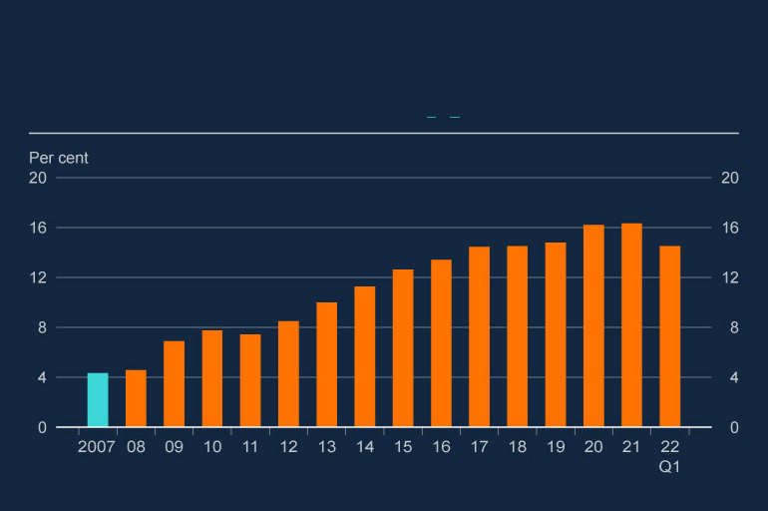

**Chart 3.1: Bank CET1 ratios remain far higher than before the global financial crisis**

Aggregate CET1 capital ratio of major UK banks (**a**) (**b**)

Sources: PRA regulatory returns, published accounts and Bank analysis and calculations.

1. The CET1 capital ratio is defined as CET1 capital as a percentage of risk-weighted assets. Major UK banks are Barclays, HSBC, Lloyds Banking Group, Nationwide, NatWest Group, Santander UK, Standard Chartered and, from end-2020, Virgin Money UK. Prior to 2011, the chart shows Bank estimates of banks' CET1 ratios.
2. Capital figures are year-end, except 2022 Q1.

**Bank profitability has increased.**



Pre-provision bank operating profits increased by 37% between 2021 Q4 and 2022 Q1. This was supported by both stronger non-interest and net interest income. This partly reflects the higher interest rate environment, as in the short term banks have increased interest rates on new lending – particularly in the corporate sector – by more than they have increased the interest rates paid to depositors. Looking

**Bank of England** Page 50



forward, the recent deterioration and considerable uncertainty in the economic outlook is likely to increase impairments and could reduce new lending volumes, weighing on profitability.

UK banks’ price to book ratios remain consistent with investor perceptions of lower profitability in the future. In coming years, banks will need to respond to changes in the environment, for example by integrating new technologies more effectively in their businesses, in order to compete with new market entrants.

**Asset quality reported by banks has remained broadly stable, but is likely to deteriorate in coming quarters.**



The share of non-performing loans remained broadly unchanged in 2022 Q1 for mortgages, consumer credit, and corporates.

While credit performance has been strong, there are signs that this is likely to deteriorate somewhat in coming months. Major UK banks registered a small impairment charge of £1.0 billion in aggregate in Q1, following four consecutive quarters of impairment releases (Chart 3.2).

This impairment charge reflects both higher modelled losses, as well as judgement-based adjustments applied by banks to reflect the current economic outlook. Last year, banks had started to release Covid-related adjustments as the economic outlook improved. But more recently, while banks continue to release Covid-related adjustments, they have started to make further adjustments to reflect a deterioration and considerable uncertainty in the economic outlook. This includes indirect effects from the Russian invasion of Ukraine, the rising cost of living in the UK, and potential spillovers from the Chinese economy.

**Bank of England** Page 51

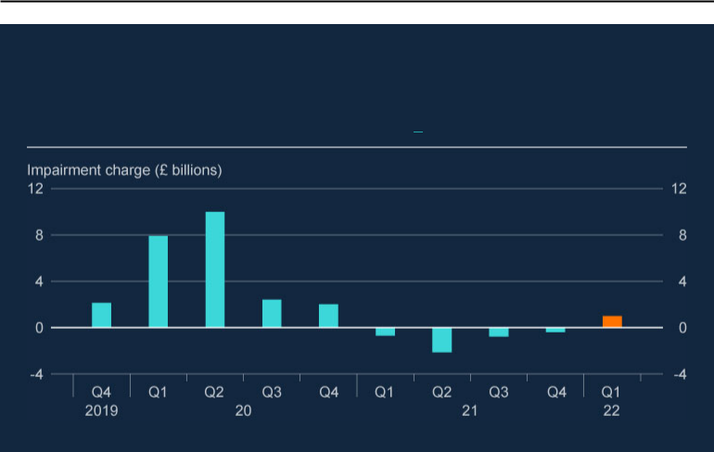

**Chart 3.2: Banks registered an impairment charge in Q1 for the first time since 2020**

Aggregate flow of impairments for major UK banks (**a**)

Source: Banks’ published accounts.

(a) UK major banks are defined as in footnote (a) of Chart 3.1.

**The impact of the Russian invasion of Ukraine including via commodity markets is unlikely to threaten directly the resilience of UK banks.**



UK banks have limited direct exposures to Russian assets, accounting for less than 1% of their total CET1 capital. However, UK banks could face indirect impacts. For example, if liquidity pressures related to the spike in commodity prices were to become particularly acute, it could trigger default concerns for affected commodity counterparties including traders, producers and suppliers. And some commodity counterparties may also face direct threats to their solvency. For example, companies that have to buy commodities at the prevailing market price and supply them to users at a capped price may face weaker profitability as a result of the spike in prices.

Some UK banks have material exposures to these affected commodity counterparties, and so could face losses. However, the majority of bank exposures are to less vulnerable commodity market counterparties and those with investment-

**Bank of England** Page 52



grade credit ratings. This means that UK bank resilience is unlikely to be challenged by direct losses on these exposures (see Section 4).

**UK banks also remain resilient to other headwinds facing the global economy.**



As discussed in Section 1, there are a number of risks to the global economic outlook. Rising interest rates and a weaker growth outlook increase risks related to the affordability of public sector debt in highly indebted countries. In the euro area, some countries have seen yields on public sector debt rise particularly sharply.

Elsewhere, while so far only a few non-China emerging market economies (NCEMEs) have experienced financial stress, more are likely to be exposed, especially if financial conditions tighten faster than expected. NCEME financial stress could affect major UK banks with exposures to those countries, whose consolidated claims on NCEMEs were equivalent to 136% of major UK banks’ CET1 as at end-2021.

Developments in China could also pose risks to the global outlook. The FPC has previously highlighted long-standing vulnerabilities in the Chinese property sector, which have re-emerged amidst high and rising debt levels in China and Hong Kong. The Chinese economy could be further challenged by Covid developments: restrictions to contain further Covid outbreaks, given China’s zero-Covid policy, could impact Chinese growth, further disrupt global supply chains and contribute to global inflationary pressures. These stresses could adversely impact those UK banks that have large exposures to companies and banks that operate in China and Hong Kong.

UK banks remain resilient to the challenging global economic outlook. And given strong capital and liquidity positions, UK banks have capacity to weather further deterioration.

**In response to the deteriorating outlook, there are tentative signs that banks are reducing risk-taking at the margin.**



After disruption as a result of the pandemic, credit conditions on bank lending to households and businesses had largely normalised in 2021 as the Covid shock faded. But recent market intelligence suggests that that banks are now beginning to

**Bank of England** Page 53



reassess their risk appetite. This could result in a tightening of credit conditions over coming quarters for households and businesses.

In response to changes in the economic environment, banks are adjusting mortgage affordability tests to account for recent and expected increases in inflation and interest rates. And in the consumer credit market, intelligence suggests that given the considerable uncertainty in the economic outlook, banks are looking to target new lending towards borrowers with higher credit scores.

Banks have also tightened their risk appetites on lending to businesses, mostly to sectors viewed as vulnerable to commodity price shocks, expected falls in discretionary spending and supply chain disruption, such as the retail, hospitality and manufacturing sectors. The risk of stress to businesses operating in emerging market economies has also increased, which has led to internationally focused banks tightening their risk appetites on lending to exposed businesses.

**Although downside risks will present headwinds to UK banks’ resilience, the FPC judges UK banks have capacity to weather the impact of severe economic outcomes.**



Reflecting the resilience built up since the global financial crisis, banks are entering this period with strong CET1 ratios and strong liquidity ratios. Although further downside risks will present headwinds to UK banks’ resilience, the FPC judges that UK banks have capacity to weather the impact of severe economic outcomes. In such scenarios, banks are expected to manage prudently their lending activity commensurate with changes in credit quality in the real economy. Setting lending terms to reflect the new risk environment is appropriate. Restricting lending solely to defend capital ratios or capital buffers would be counterproductive and could prevent credit-worthy businesses and households from accessing funding. Such excessive tightening would harm the broader economy and ultimately the banks themselves.

**Bank of England** Page 54



**To support the FPC’s monitoring and assessment of the resilience of banks to potential downside risks, the Bank will commence its annual cyclical scenario (ACS) stress test in September 2022.**



In March, the Bank announced that it would delay the launch of the 2022 ACS, in light of uncertainty related to the Russian invasion of Ukraine, and in order to help lenders focus on managing the ongoing financial markets disruption associated with the invasion. The 2022 ACS will now be launched in September and will test the resilience of the UK banking system to deep simultaneous recessions in the UK and global economies, real income shocks, large falls in asset prices and higher global interest rates, as well as a separate stress of misconduct costs.

**Bank of England** Page 55



1. In focus – The implications of commodity market volatility for the fnancial system



Commodities such as gas, oil, metals, and agricultural products play a vital role in the economy. They provide raw materials for manufactured goods, and meet demand for energy and food. Producing, supplying and trading physical commodities are therefore essential to global economic activity, and so disruption to these activities can have significant economic impacts. The financial system supports commodity markets by providing financing, intermediation and risk management services to the wide range of entities involved.

The production, transport and delivery of physical commodities are more exposed to some risks than the wider financial system. For example, they are more directly affected by weather fluctuations and geopolitical developments. Exposure to these risks needs to be managed to ensure the uninterrupted supply of commodities, and to reduce the likelihood of severe price fluctuations. The financial system facilitates this by supporting commodity market participants to insure against and hedge their risks.

Financial markets and physical commodity markets are therefore interconnected and disruption in one can affect the other. Commodity market disruption can also indirectly affect the financial system through its impact on the wider economy.

**Bank of England** Page 56



A range of commodity prices increased in late 2021, reflecting both ongoing supply constraints and the global recovery in demand as the effects of the pandemic receded. This price volatility intensified following the Russian invasion of Ukraine, particularly for those commodities of which Russia and Ukraine are significant producers and where uncertainty around sanctions could have led to unintentional operational consequences. In part as a result of these higher prices, the economic outlook for the UK and globally has deteriorated materially. Higher commodity prices have significantly contributed to the price pressures facing households and businesses. These pressures are expected to lower real disposable income and demand (Section 1).

This recent volatility affected commodity markets and the broader financial system. Unexpected and sharp increases in margin requirements, essential for reducing counterparty credit risk, created challenges for some market participants to raise the liquidity to meet them. And banks faced significant calls on revolving credit facilities from clients, in part to fund margin requirements, as well as credit risk exposure from intermediating in the derivatives market. Among these conditions, the London Metal Exchange temporarily suspended trading in nickel contracts and cancelled trades between 8 and 15 March, after a specific set of circumstances, including a squeeze on an oversized short position, led to a sharp spike in prices.

The heightened level of uncertainty following the ongoing Russian invasion, and how the macroeconomic shock related to it will progress, means there is a significant risk of further disruption in commodity markets. Further increases in volatility could increase the credit needs of the commodity sector for a given level of activity. Banks have sufficient capital to continue to meet these needs, although there is uncertainty over the amount of credit that will be supplied since it is subject to banks’ judgements on risk management criteria and appetite.

The disruption has highlighted a number of vulnerabilities within commodity markets – including the presence of highly leveraged participants, and the liquidity mismatch at the centre of some participants’ business models. Alongside the interconnections with the broader financial system, it has also

**Bank of England** Page 57



highlighted the large interconnections within commodity markets. Given the vital role of commodities in the economy, these vulnerabilities can pose risks to the UK financial system, particularly via the impact of commodity market disruption on the broader economy and commodity markets’ potential to amplify macroeconomic shocks.

Some of these vulnerabilities are similar to those in the system of market-based finance (MBF) previously identified by the FPC and highlighted by recent periods of financial market volatility. Due to opacity, lack of data, and the global nature of commodity markets, quantifying the size and scale of these vulnerabilities and interconnections remains challenging and addressing this globally should be a priority.

While some vulnerabilities relate to financial entities operating in both physical and financial commodity markets, many relate to non-financial entities, or entities domiciled in other jurisdictions. Addressing them will thus require engagement from a broad range of financial and non-financial authorities, both domestic and global. The Financial Stability Board (FSB) is undertaking in-depth analysis and assessment of vulnerabilities in commodity markets. Given the global nature of these markets, the FPC welcomes this work. The FPC will continue to monitor signs of stress building in commodity markets that could impact on financial stability and will engage with other authorities as necessary to ensure the resilience of the UK financial system to such stress, and seek to increase transparency in commodity markets.

4.1: Commodity markets and their interlinkages with the fnancial system

**The commodity markets are an essential part of the global economy and comprise a wide range of institutions.**



Commodities such as gas, oil, metals and agricultural products play a vital role in the economy providing raw materials for manufactured goods, and meeting demand for energy and food. Producing, supplying and trading physical commodities is therefore an essential part of global economic activity. These

**Bank of England** Page 58



activities are more exposed to some risks than the wider financial system. For example, weather fluctuations and geopolitical events can directly affect both demand for and supply of commodities.

Broadly, commodity markets consist of physical markets, where buyers and sellers come together to arrange transfers of tangible commodities, and financial markets, which provide financial services, such as lending and risk management (including hedging), that facilitate the uninterrupted supply of commodities. Commodity market participants therefore comprise producers, physical commodity traders, retail suppliers and wholesale distributors as well as financial institutions – such as banks, central counterparties (CCP) and funds (Figure 4.1).

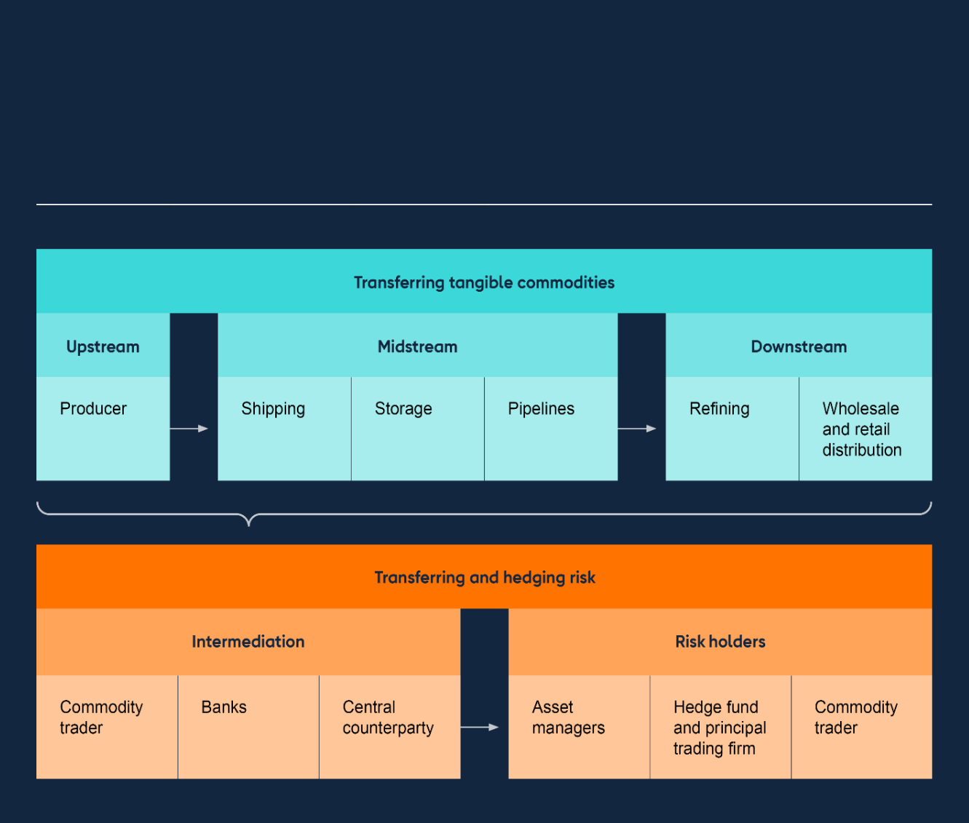

**Figure 4.1: Financial commodity markets, such as that for oil in this example, provide risk mitigation and intermediation services to physical commodity markets**

Stylised example of participants in oil markets

**Bank of England** Page 59



**Financial commodity markets, and the wider financial system, facilitate the smooth functioning of physical commodity markets.**



The interconnections between physical and financial commodity markets, and the wider financial system are varied and complex (Figure 4.2). Within these connections, the financial system facilitates non-financial participants’ commodity market activities in three key ways.

**Figure 4.2: There is a complex range of interlinkages between commodity markets and the financial system**

**Interlinkages between commodity markets and the financial system**

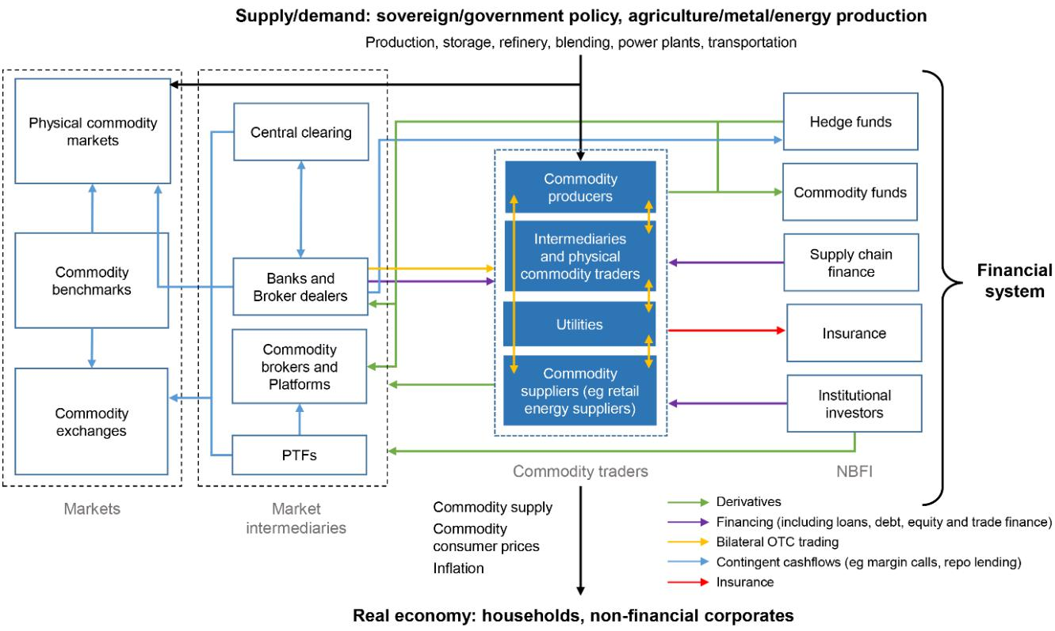

First, the financial system provides risk management to physical commodity markets. For example, through derivatives used to hedge exposures to commodity price fluctuations, or through providing insurance. Parties to derivatives contracts exchange margin on their exposure to mitigate the risk of counterparty default. Banks and specialised brokers intermediate the commodity derivatives market to facilitate trading.

**Bank of England** Page 60



Second, the financial system provides infrastructure to commodity markets. For example, some commodity derivatives are traded on exchanges such as metals derivatives on the London Metal Exchange (LME) and energy derivatives on the Intercontinental Exchange (ICE). The financial system also provides central clearing services via CCPs primarily for exchange-traded commodity derivatives.[10]

Third, banks and non-bank financial institutions (NBFI) provide financing through revolving credit facilities, trade finance, and term loans. Broadly, most physical commodity traders tend to meet their financing needs with credit lines from banks, but some are able to access a more diverse range of sources, such as issuing into debt capital markets.

Alongside the facilitating role played by the financial system, some entities within it also invest in commodity-linked assets. Globally, fixed-income funds hold around US$960 billion (9%) of their total assets under management (AUM) in fixed-income assets within the commodity related sectors of energy, industrials, and utilities.[11] UK domiciled funds hold around US$30 billion (12%) of their total AUM in these sectors.

**The macroeconomic shock resulting from the Russian invasion of Ukraine has exacerbated pre-existing pressure on commodity prices.**



Due to their interlinkages, developments in commodity markets can impact the financial system and vice versa. A range of commodity prices rose from 2021 Q3. This reflected the global recovery in demand as the effects of the pandemic receded, alongside supply-chain constraints in the energy sector in particular.

The Russian invasion that began in February 2022 has exacerbated these pressures, resulting in sharp price increases for a wide range of commodities. For example in early March, European and UK gas prices peaked at over eight times their average level between January 2019 and January 2022. Around the same time, wheat prices peaked at roughly twice their average level. Prices have remained elevated across a range of commodities, and in some cases they remain more than double their average level between January 2019 and January 2022 (Chart 4.1).

**Bank of England** Page 61

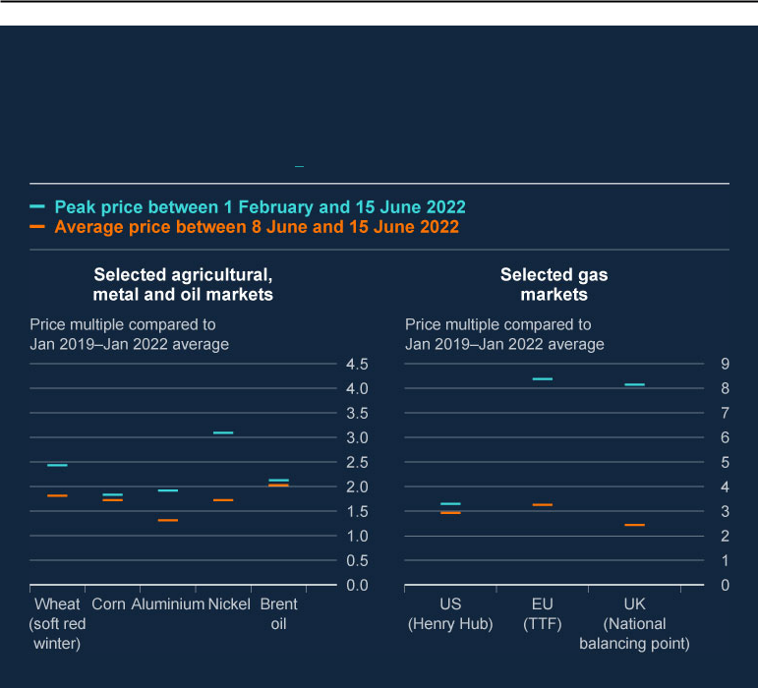

**Chart 4.1: A range of commodity prices peaked sharply, and remain elevated compared to their average levels in recent years**

Price changes in selected commodity markets, relative to their average level between January 2019 and January 2022 (**a**)

Sources: Bloomberg Finance L.P. and Bank calculations.

(a) Price multiples are comparisons against the average price between 2 January 2019 and 31 January 2022.

Alongside substantial increases, prices have also become significantly more volatile in many markets and liquidity conditions have deteriorated. In particular, since February 2022, the level of volatility in Title Transfer Facility (TTF – a major European natural gas price benchmark) gas prices more than doubled compared to the average level between January 2019 and January 2022, and volatility in Brent oil and aluminium increased by around 40% over a similar period. Liquidity in these markets also decreased over the same period, with bid-ask spreads in TTF gas increasing almost eightfold and more than doubling for Brent oil. Reflecting these changes, activity in a range of commodity markets has been more muted than usual.

**Bank of England** Page 62



**As expected, CCPs increased their margin requirements on commodity derivatives. Although there was disruption in the nickel market driven by a specific set of circumstances, broadly commodity markets continued to function in the recent volatility.**



Exchanging margin on derivatives helps prevent counterparty credit risk building by ensuring transactions are adequately collateralised. During the global financial crisis, an opaque and poorly collateralised web of derivatives trades amplified stress as market participants rushed to manage counterparty credit risk. Reforms to margining practices were therefore a key element of the post-crisis package of reforms. CCPs are also a key mechanism to reduce counterparty credit risk as they net exposures across participants. CCP margin requirements protect them against counterparty credit risk, allowing them to perform this key function.

As such, increases in margin requirements during a stress are a necessary and expected element of risk management typically associated with centrally cleared trades. However, as was seen in March 2020, sharp increases in margin requirements can lead to CCP clearing members and their clients facing difficulty raising the liquidity to meet them.

Reflecting the deteriorating market conditions, CCPs globally sharply increased their margin requirements on some energy, agricultural and metals derivatives. In the UK markets, this contributed to substantial increases in margin calls at ICE Clear Europe (ICEU) and LME Clear. From February to April 2022 (encompassing the start of the Russian invasion), the cumulative rise in ICEU initial margin requirements on its Futures and Options service peaked at £30 billion.[12] The equivalent for LME Clear’s base metals clearing service was around £5 billion. Both peaks in cumulative increases at these particular CCPs were far larger than those over the same period in 2020, at the outset of the pandemic (Chart 4.2). Alongside CCP margin calls, some banks applied higher multipliers on margin add-ons they called from their market clients.

**Bank of England** Page 63

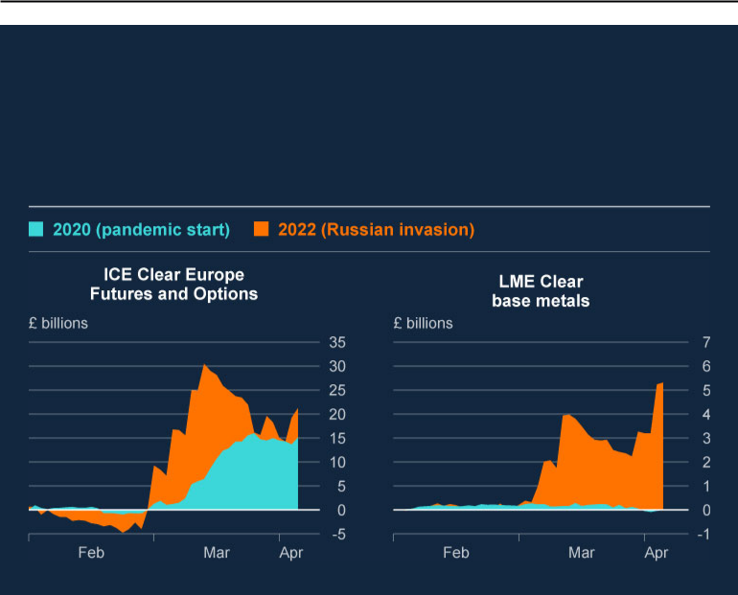

**Chart 4.2: Between February and April 2022, ICE Clear Europe and LME Clear’s cumulative initial margin calls increased significantly more than they did over the same period in 2020**

Change in ICE Clear Europe and LME Clear’s initial margin requirements between February to April 2020 and 2022

Sources: CCP supervisory data and Bank calculations.

Commodity market participants can be particularly vulnerable to such increases, due to an inherent mismatch between the timing of daily, or intraday, margin payments on their derivatives and the less frequent receipts on their exposures to physical commodities, which gives rise to a ‘liquidity mismatch’. Since the start of the invasion, banks have been generally willing to extend additional credit to fund this liquidity mismatch to commodity market counterparties they perceive as less risky, albeit often with additional restrictive covenants and at higher interest rates than previously. They have been less willing to do so for counterparties they perceive as more risky. If disruption is prolonged and uncertainty increases, banks may become even less willing to extend credit to commodity market participants.

While commodity markets have broadly continued to function, there was disruption in the nickel market traded on the LME during March 2022. A specific set of circumstances, including a squeeze on an oversized short position, led to the three-

**Bank of England** Page 64



month nickel contract price increasing by around 60% on 7 March from an open of US$29,770 per tonne to a close of US$48,000. By the early morning of 8 March the price had more than doubled to US$101,000 per tonne. In response, the LME voided all contracts traded on 8 March and temporarily suspended trading in nickel contracts between 8 and 15 March while it restored orderly market functioning. LME Clear margin calls increased significantly over this period and have remained elevated (Chart 4.2). As a result of this episode, both the [**Bank**](https://www.bankofengland.co.uk/news/2022/april/joint-statement-from-uk-financial-regulation-authorities-on-london-metal-exchange-and-lme-clear) and [**FCA**](https://www.fca.org.uk/news/statements/uk-financial-regulation-authorities-london-metal-exchange-lme-clear) have commissioned reviews into operations at the LME and its associated CCP LME Clear.



4.2: Implications for the fnancial system

**Commodity market volatility could have a range of implications for the wider financial system.**



Commodity market disruption can affect the wider financial system, in particular through its impact on the broader macroeconomy and its potential to amplify macroeconomic shocks, as well as through the interlinkages between commodity and wider financial markets set out above. There is a significant risk of further commodity market disruption given the considerable uncertainty following the ongoing Russian invasion and how the macroeconomic shock related to it will progress.

**The current commodity market volatility has not yet challenged UK banks’ resilience, but the FPC remains vigilant to the risks of more significant losses or spillovers from the global banking system.**



The major UK banks (‘UK banks’) are active in providing both credit and risk management services to non-financial commodity market participants. In total, the UK banks have up to £140 billion (up to 50% of their total CET1 capital) of gross exposure to commodity producers, suppliers and traders, and to commodity derivatives.

Around £110 billion of UK banks’ exposures are on their lending books. The majority of these loans are to large, relatively highly rated non-financial corporates and around one-third of them will mature within one year. In many cases these

**Bank of England** Page 65



exposures are to firms who may face temporary liquidity pressures from margin calls resulting from higher commodity prices, but whose underlying profit margins could ultimately benefit from those higher prices.

Some global financial institutions’ exposures to commodity market participants are larger both in absolute size and as a proportion of CET1 capital than those of the UK banks. Therefore, international banks could face more substantial losses from their commodity market counterparty exposures than UK banks, and these losses could spill over to the UK financial system and economy more broadly.

Looking ahead there remains significant uncertainty around how geopolitical developments will evolve and what their impact will be. UK banks could incur larger losses on their direct exposures should the current disruption increase in severity or if it is prolonged.

**The recent commodity market volatility has not resulted in broad-based disruption of core financial markets like that seen in March 2020.**



Despite pockets of stress brought on by geopolitical events, macroeconomic developments and tighter financial conditions, the most acute stress has been in commodity markets. Although there have also been adjustments in asset prices and reductions in market liquidity across a range of financial markets, there is no evidence that commodity market volatility has spread to core UK financial markets (Section 2).

The recent volatility highlighted that some market participants, particularly in commodity markets, were less prepared than others to accommodate sharp increases in margin requirements and other liquidity needs. If the current volatility worsens or is prolonged, then participants could face further increases in liquidity needs. This could result in increased demand for bank lending and potentially asset sales that may cause contagion to a broader range of markets and investors.

**Commodity market volatility can indirectly affect the financial system through its significant impact on both the UK and global real economy.**



Commodity price volatility has had a significant impact on the real economy (Section 1). For example in the UK, the MPC projects that inflation will reach slightly over 11% towards the end of the year, largely reflecting rises in energy and, to a lesser extent, food costs. As set out in the May 2022 Monetary Policy Report,

**Bank of England** Page 66



increases in energy commodity prices push up businesses’ production costs, especially in energy intensive sectors such as manufacturing and transport. A recent survey by the Bank’s agents suggests that on average, businesses have passed on around 80% of the rise in non-labour, including energy, costs to consumers.

These pressures will increase households’ living costs, and so reduce their real disposable income. This will have consequences for their ability to service existing debts. As set out in Section 1, Government fiscal support announced in May is projected to offset some of this pressure in 2022. The share of households with stretched debt affordability is nevertheless likely to increase in 2023. The FPC judges that the UK financial system is resilient to domestic debt vulnerabilities.

**A shock can be amplified by interconnections between commodity markets and with the wider financial system, if disruption leads to liquidity strains and insolvencies among commodity market participants.**



Interconnections between commodity markets, the wider financial system, and the real economy could result in a feedback loop, which amplifies macroeconomic stress. For example, should commodity market disruption result in insolvencies among commodity market participants, that could further increase commodity prices and worsen disruption to physical commodity supply. Those higher energy and food costs would squeeze households’ real disposable income even more, especially if businesses continue to pass on additional commodity price rises. If businesses are unable to do so, and profit margins fall to an unsustainably low level, then insolvencies could rise by more than currently expected.

Such an outcome could arise if commodity market participants are unable to access sufficient bank credit to meet their liquidity needs. Although the UK banks have sufficient capital to meet commodity market participants’ credit needs, there is uncertainty over the amount of credit that will be supplied since it is subject to banks’ judgements on risk management criteria and appetite. For example, commodity market volatility could increase such that banks change their assessment of the risk of lending to specific commodity market participants, or reduce their risk appetite for commodity market exposures in general. In both cases commodity market participants may be unable to raise sufficient credit to meet their

**Bank of England** Page 67



financing needs or margin requirements. They then may be forced to reduce their activities in commodity markets, which could have knock-on effects for commodity prices and supply to the broader economy.

4.3: Vulnerabilities in commodity markets

**The recent disruption has highlighted vulnerabilities in commodity markets that are relevant to both financial and non-financial market participants.**



Although a large proportion of commodity market participants are non-financial entities, or are domiciled outside of the UK, some commodity market vulnerabilities are similar to those in the system of MBF previously highlighted by authorities such as the FSB in its [**Holistic Review of the March Market Turmoil**](https://www.fsb.org/2020/11/holistic-review-of-the-march-market-turmoil/). Others are more specific to commodity markets.



**A range of highly levered financial and non-financial commodity market participants are vulnerable to sudden increases in liquidity demand.**



The widespread use of derivatives to hedge exposures to physical commodities and for speculative purposes means there are various highly leveraged participants in the commodity markets, including NBFIs such as hedge funds. The FPC has previously highlighted the risks associated with high leverage in some NBFIs, most recently in the Bank’s [**Assessment of the resilience of market-based finance**](https://www.bankofengland.co.uk/report/2021/assessing-the-resilience-of-market-based-finance).



Non-financial commodity market participants can be as highly levered as these NBFIs. For example some commodity traders are levered to between 1.1 times and 4 times, which they typically rely on bank credit to finance. There is no globally consistent regulatory framework for commodity traders, meaning in some jurisdictions they are largely unregulated. Market resilience is therefore in large part reliant on their counterparties’ approach to mitigating risks as these exposures build.

**Some non-financial commodity market participants face a liquidity mismatch between their cash flows, and are reliant on bank lending to fund shortfalls.**



Participants involved in the physical supply of commodities are exposed to price fluctuations in these commodities and will often hedge these exposures using derivatives. Participants usually receive cash flows on the physical side of their

**Bank of England** Page 68



exposure on a monthly, or sometimes quarterly, basis. But they face daily, or sometimes intraday, requirements to pay margin on their hedges. This therefore creates a ‘liquidity mismatch’ between their cash flows.

During the recent commodity market volatility, the sharp increase in margin requirements exacerbated this liquidity mismatch, increasing non-financial participants’ reliance on bank credit lines to fund their liquidity shortfalls, for example by drawing down on revolving credit facilities.

**Commodity markets can be concentrated among a few large, opaque and, highly interconnected participants, meaning shocks can propagate quickly.**



There can be a high degree of concentration and interconnectedness within commodity markets which means that stress can be transmitted rapidly both within individual markets and through commodity markets more broadly.

Stress could spread within individual markets through two channels: first, some markets are dominated by a small number of large participants. For example data reported to Ofgem on physical volumes suggests that the 10 largest participants in the UK OTC gas market account for 53% of the total market. If one of these entities defaults, their counterparties, potentially including financial institutions active in wider financial markets, could face substantial losses. Second, intermediation activities also tend to be concentrated in a small number of banks and brokers. If one of these participants failed, liquidity in the individual market could be significantly impaired.

Some large commodity market participants are active in a range of markets. For example, Bank staff estimates and published literature suggest that five firms that are among the largest commodity traders intermediated volumes equivalent to just under a quarter of global oil production, and historically around 75%–90% of global grain production.[13] If a large non-financial market participant enters into distress, the stress could propagate through commodity markets more broadly. This risk is exacerbated by the relatively limited resolution arrangements in a wide range of commodity markets.[14]

**Bank of England** Page 69



**Opacity in some markets restricts authorities’ and counterparties’ views of risks building in them.**



Similar to the challenges highlighted with the lack of data from some NBFIs, some commodity markets are particularly opaque.[15]

Consequently, authorities and participants do not have a clear view of counterparties’ positions in aggregate. Recent episodes, such as the nickel market disruption and more generally the Archegos default, have demonstrated how this opacity can contribute to counterparties being exposed to unexpectedly large losses and sudden demands for liquidity in the form of margin calls. Moreover, opacity and lack of data make it challenging for global authorities, including the FPC, to assess the size and scale of commodity market vulnerabilities.

**The FPC remains vigilant to the risks from commodity market disruption and it supports international work led by the FSB to assess and, where necessary, address vulnerabilities in the financial system.**



Commodities play an essential role in the wider domestic and global economies, and commodity markets link to the broader financial system in many varied ways. As such, the FPC considers that ensuring commodity market resilience is important for maintaining financial stability, and in particular to reduce the risk of commodity markets amplifying macroeconomic shocks. Disruption in commodities markets has not yet significantly impacted the broader financial system. Nevertheless the FPC will continue to monitor signs of stress building up in commodity markets closely. But the opacity of, and data gaps in, some commodity markets impedes authorities’ and counterparties’ views of risks as they build. The recent disruption, and potential for it to spread further via the broader macroeconomy to the wider financial system, underscores the importance of building greater transparency in commodity markets.

There are three key factors related to data that hinder authorities’ view of risks in commodity markets. First, there remain significant data gaps around activity in OTC and physical markets, where some transactions are excluded from reporting obligations and data are often not of sufficient granularity to identify the underlying commodity being transacted. Second, relatively little data are reported on the resilience of large commodity market participants to relevant authorities. Third,

**Bank of England** Page 70



reporting of data tends to be fragmented between a range of different authorities and jurisdictions. Reviewing the completeness of data in commodity markets will be a key step in assessing and addressing commodity market vulnerabilities.

Some commodity market vulnerabilities are similar to, or could be amplified by, previously identified vulnerabilities in the non-bank financial system. Enhancing the resilience of MBF and NBFIs is likely to have a significant impact on commodity market resilience, given the interlinkages between the two.

And like the system of MBF, the global nature of commodity markets means that vulnerabilities are present across the jurisdictions they operate in, rather than limited to individual jurisdictions. Addressing them will thus require engagement across a broad range of financial and non-financial authorities, both domestic and global. The FSB is undertaking in-depth analysis and assessment of vulnerabilities in commodity markets, and given the global nature of these markets, the FPC welcomes this work.

**Bank of England** Page 71



Annex: Macroprudential policy decisions



This annex lists any FPC Recommendations and Directions from previous periods that have been implemented or withdrawn since the previous Report, as well as Recommendations and Directions that are currently outstanding.[16] It also includes those FPC policy decisions that have been implemented by rule changes and are therefore still in force.

Each Recommendation or Direction has been given an identifier to ensure consistent referencing over time. For example, the identifier 17/Q2/1 refers to the first Recommendation made at the 2017 Q2 Committee meeting.

Recommendations and Directions implemented or withdrawn since the previous Report

FPC Recommendation on mortgage a ordability tests

In June 2017, the FPC made the following Recommendation (17/Q2/1), revising its

June 2014 Recommendation:

When assessing affordability, mortgage lenders should apply an interest rate stress test that assesses whether borrowers could still afford their mortgages if, at any point over the first five years of the loan, their mortgage rate were to be 3 percentage points higher than the reversion rate specified in the mortgage contract at the time of origination (or, if the mortgage contract does not specify a reversion rate, 3 percentage points higher than the product rate at origination). This Recommendation is intended to be read together with the FCA requirements around considering the effect of future interest rate rises as set out in MCOB

11.6.18(2). This Recommendation applies to all lenders which extend residential mortgage lending in excess of £100 million per annum.

Lenders were required to have regard to the FPC’s June 2017 revision to its June 2014 affordability Recommendation immediately, by virtue of the existing FCA MCOB rule. At its September 2017 meeting the FPC confirmed that the affordability

**Bank of England** Page 72



Recommendation did not apply to any remortgaging where there is no increase in the amount of borrowing, whether done by the same or different lender.

At its 29 November 2021 meeting, the FPC agreed to consult on withdrawing its affordability test Recommendation in the first half of 2022.

At its 16 June 2022 meeting, the FPC withdrew the affordability test Recommendation, with effect from 1 August. The FPC judged that the loan to income flow limit Recommendation, in tandem with the FCA’s affordability testing under its Mortgage Conduct of Business framework, ought to deliver the appropriate level of resilience to the UK financial system, but in a simpler, more predictable and more proportionate way.

Recommendations and Directions currently outstanding

The FPC has no Recommendations or Directions that have not already been implemented. However, the withdrawal of the mortgage affordability test recommendation that was agreed on 16 June 2022 will come into effect on 1 August 2022 (see above).

Other FPC policy decisions

Set out below are previous FPC decisions, which remain in force, on the setting of its policy tools. The calibration of these tools is kept under review.

Countercyclical capital bu er rate

The FPC agreed at its meeting on 16 June 2022 to increase the UK CCyB rate from 1% to 2%, with binding effect from 5 July 2023. This rate is reviewed on a quarterly basis.

The UK has also reciprocated a number of foreign CCyB rate decisions – for more details see [**Financial stability**](https://www.bankofengland.co.uk/financial-stability). Under PRA rules, foreign CCyB rates applying from 2016 onwards will be automatically reciprocated up to 2.5%.



**Bank of England** Page 73



Mortgage loan to income ratios

In June 2014, the FPC made the following Recommendation (14/Q2/2): The Prudential Regulation Authority (PRA) and the Financial Conduct Authority (FCA) should ensure that mortgage lenders do not extend more than 15% of their total number of new residential mortgages at loan to income ratios at or greater than

4.5. This Recommendation applies to all lenders which extend residential mortgage lending in excess of £100 million per annum. The Recommendation should be implemented as soon as is practicable.

The PRA and the FCA have published their approaches to implementing this Recommendation: the PRA has issued a [**Policy Statement**](https://www.bankofengland.co.uk/prudential-regulation/publication/2014/implementing-the-fpcs-recommendation-on-loan-to-income-ratios-in-mortgage-lending), including rules, and the FCA has issued [**general guidance**](https://www.fca.org.uk/publications/finalised-guidance/fg17-2-fpc-recommendation-loan-income-ratios-mortgage-lending).



Leverage ratio

In September 2021, the FPC finalised its review of the UK leverage ratio framework, and issued a Direction and Recommendation to implement the outcome of the review as set out in its [**October 2021 Record**](https://www.bankofengland.co.uk/-/media/boe/files/financial-policy-summary-and-record/2021/october-2021.pdf).



The PRA has [**published its approach**](https://www.bankofengland.co.uk/prudential-regulation/publication/2021/june/changes-to-the-uk-leverage-ratio-framework) to implementing this Direction and Recommendation.



Other FPC activities since the December 2021 Report

Since the last Report, the FPC:

supported the Bank’s condemnation in Russia’s unprovoked invasion and welcomed the international co-ordination to ensure alignment of financial sanctions and industry engagement;



welcomed the National Cyber Security Centre’s actions aimed at ensuring that the UK financial system was well prepared for the risk of cyber threats; welcomed the joint statement by UK financial regulation authorities regarding the application of sanctions to cryptoassets since the start of the Russian invasion; supported the work of the Financial Stability Board as it co-ordinates the international approach to unbacked cryptoassets;



welcomed the Dear CEO letter issued by the PRA reminding banks of their obligations with respect to cryptoasset exposures, and the FCA statement



**Bank of England** Page 74



reminding firms of their obligations when interacting with or exposed to cryptoassets;

noted HM Treasury’s proposal for a regulatory regime for stablecoins, including bringing systemic stablecoins into the Bank’s regulatory remit;



judged that a systemic stablecoin issued by a non-bank without a resolution regime and deposit guarantee scheme could meet its expectations, provided the Bank applies a regulatory framework that is designed to mitigate relevant risks to financial stability;



judged that a systemic stablecoin that is backed by a deposit with a commercial bank would introduce undesirable financial stability risk;



agreed the scenario for the exploratory cyber stress test planned for 2022; welcomed and supported the International Monetary Fund’s 2021 Financial Sector Assessment Program;



continued to welcome the engagement between the Bank, FCA and HM Treasury on how to tackle these risks arising from increased reliance on critical third parties and supported their intention to publish a joint Discussion Paper in 2022;



agreed to publish the previously redacted October 2019, August 2020 and July 2021 discussions on risks to financial stability posed by the continued reliance on Libor beyond end-2021;



amended the Other Systemically Important Institutions (OSII) buffer framework following a consultation period;



welcomed the publication of the Bank’s first assessment of the eight major UK banks’ preparations for resolution under the Resolvability Assessment Framework in June 2022;



welcomed the Bank and PRA’s Discussion Paper on liquid asset usability that was published in March 2022;



maintained the UK Countercyclical Capital Buffer rate at 1% in 2022 Q1. The rate will come into effect from 13 December 2022 in line with the 12-month implementation period;



agreed that, as required by statute, provide a formal written response to the recommendation in relation to the Government’s energy security strategy when appropriate, in the usual way, as part of its response to the annual remit and recommendations letter;



**Bank of England** Page 75



welcomed the smooth transition of sterling markets through the cessation of GBP panel bank Libor at the end of 2021 and emphasised that supervised firms should have ceased new use of continuing USD Libor benchmarks by, 1 January 2022, with limited exceptions; and



discussed the potential relevance of other environmental risks (in addition to those posed to climate change) to its primary objective.



[Full details of these activities are in the **Financial Stability in Focus:**](https://www.bankofengland.co.uk/financial-stability-in-focus/2022/march-2022)[**Cryptoassets and decentralised finance**, **Financial Policy Summary and**](https://www.bankofengland.co.uk/financial-policy-summary-and-record/2022/march-2022)[**Record – March 2022**), and](https://www.bankofengland.co.uk/financial-policy-summary-and-record/2022/march-2022) [**Financial Policy and Record – July 2022**](https://www.bankofengland.co.uk/financial-policy-summary-and-record/2022/july-2022)[.](https://www.bankofengland.co.uk/financial-policy-summary-and-record/2022/march-2022)



