# Financial Policy Summary

The Financial Policy Committee (FPC) seeks to ensure the UK financial system is prepared for, and resilient to, the wide range of risks it could face – so that the system is able to absorb rather than amplify shocks, and serve UK households and businesses.

## Financial market developments and global debt vulnerabilities

**The global economic outlook has deteriorated further since the July 2022 Financial Stability Report and financial conditions have tightened significantly.** Monetary authorities have been responding to high levels of inflation, driven by higher and more volatile energy prices, domestic inflationary pressures and global supply chain issues following the pandemic. Higher central bank policy rates, alongside expectations of further rises, have led to very material and rapid increases in yields on long-term government bonds globally.

**The deterioration in the global economic outlook, together with heightened uncertainty and the potential for further adverse geopolitical developments, has also led to falls in risky asset prices and a reduction in investor risk appetite.** Financing conditions for households and businesses have tightened significantly. Financial market volatility has been elevated. Overall, moves in risky asset prices have been generally orderly, but the risk of sharp adjustments from further developments in the outlook remains.

**Sharp increases in prices, including of energy, tighter financial conditions, and the worsening outlook for growth and unemployment will continue to weigh on debt affordability for households, businesses and governments globally. The FPC judges that the risks of global debt vulnerabilities crystallising have increased.**

**In the current environment, the FPC is monitoring geopolitical and other risks very closely and taking them into account when assessing the resilience of the UK financial system, including in the context of the 2022 annual cyclical scenario (ACS) stress test.** It will work with other authorities at home and abroad, including the Prudential Regulation Authority (PRA), to consider whether any further action is required to enhance the resilience of UK banks to such risks.

## UK household and corporate debt vulnerabilities

**Household finances are being stretched by increased living costs and rising mortgage payments.** Households are adjusting spending behaviour as real income is squeezed, although widespread signs of financial difficulty among UK households with debt have yet to emerge. The risk that indebted households default on loans, or sharply reduce their spending, has increased.

**Pressures on household finances will increase over 2023.** In total around half of owner occupier mortgages (around 4 million) will be exposed to rate rises over the next year. Falling real incomes, increases in mortgage costs and higher unemployment will place significant pressure on household finances. The share of households with high cost of living adjusted mortgage debt-servicing ratios would increase over 2023 to 2.4%, assuming current market pricing of Bank Rate, but remain lower than in the global financial crisis (GFC). Households are also experiencing increased pressure on their ability to service other types of consumer debt, such as credit cards and personal loans.

**While pressures will increase, the FPC judges that households are more resilient now than in the run-up to the GFC in 2007 and the recession in the early 1990s.** Households are in aggregate less indebted compared to the peak that preceded the GFC. And the proportion of disposable income spent on mortgage payments in aggregate is projected to rise but remain below the peak levels during the GFC and the 1990s recession. The core UK banking system is also more resilient, in part due to lower risk lending to households. The greater resilience of banks, and the higher standards around conduct, also means they are expected to offer a greater range of forbearance options. As such, the increased pressure on UK households is not expected to challenge directly the resilience of the UK banking system.

**In aggregate, UK businesses are entering the period of stress in a broadly resilient position, but are under increased pressure from economic and financial developments.** Earnings have risen and leverage has fallen in 2022 as the effects of the Covid pandemic have abated. But within the aggregate, there are a number of vulnerable companies with low liquidity, weak profitability, or high leverage. And some businesses are facing other pressures from higher costs of servicing debt, weaker earnings, and continued supply chain disruption. **These pressures are expected to continue to increase over 2023, especially for smaller companies that are less able to insulate themselves against higher rates.**

**Increased pressure on the corporate sector is not expected to pose material risks to the resilience of the UK banking system, but will leave businesses more vulnerable to future shocks.** There are some emerging signs of stress among corporate borrowers. Corporate insolvencies have increased, in particular among small and medium-sized enterprises. Financing conditions have tightened, particularly for risky firms, with some funding markets closed. But businesses are not yet showing signs of reducing employment or investment sharply in response to the economic downturn.

## UK external balance sheet vulnerabilities

**Reflecting its position as one of the most financially open economies in the world, many UK assets are held by overseas investors, meaning the UK is exposed to external financing risks.** The UK’s external liabilities are significantly higher than for other G7 economies. The size of these liabilities means that the behaviour of foreign investors, and their perceptions of the UK macroeconomic policy framework, can have a material impact on UK financial conditions.

There were signs that foreign investor demand for UK assets weakened in

September and early October, but this has since reversed. Over the second half of 2022 as a whole, UK asset prices have moved broadly in line with euro-area equivalents. Any future UK-specific shock to investor appetite for UK assets would likely reduce their prices. Some of the impact of such a move on the UK’s external balance sheet could be offset by moves in the exchange rate. This is in part because the UK’s external assets at current market value are estimated to be worth significantly more than its liabilities.

**A particularly large and rapid fall in foreign investor demand for UK assets could pose a more acute risk to UK financial stability if it led to difficulties refinancing UK external liabilities, but the FPC judges that this risk at present is low.** UK banks have robust foreign currency liquidity positions in aggregate and liquidity regulations require greater liquidity buffers for greater exposures to refinancing risk.

## UK bank resilience

**The FPC continues to judge that the UK banking system is resilient to the current economic outlook and has capacity to support lending, even if economic conditions are worse than forecast.** Major UK banks’ capital and liquidity positions remain strong and pre-provision profitability has increased. They are therefore well placed to absorb shocks and continue meeting the credit needs of households and businesses. In aggregate smaller lenders are also well capitalised and have strong liquidity positions.

Asset quality remains relatively strong – although some forms of lending, such as buy-to-let, higher loan to value and higher loan to income mortgage lending, and lending to lower rated and highly leveraged corporates, are more exposed to losses – as are those lenders that are more concentrated in those assets.

There is evidence that the major UK banks are tightening their lending standards by adjusting their appetite for lending to riskier borrowers as risks have increased, consistent with the worsening macroeconomic outlook. Excessive restrictions on lending would prevent creditworthy households and businesses from accessing funding. This would be counterproductive, harming both the wider economy and ultimately the banks themselves. **The FPC will continue to monitor UK credit conditions for signs of unwarranted tightening.**

**The FPC has previously judged that the UK banking system is resilient to a wide range of severe economic outcomes, and is assessing major UK banks against a further severe shock in the 2022 ACS.** The results will be published in Summer 2023.

## The UK countercyclical capital bu er rate

**The FPC is maintaining the UK countercyclical capital buffer (CCyB) rate at 2%, due to come into effect on 5 July 2023.** The global and UK economic outlooks have deteriorated and financial conditions have tightened. The FPC judges that the UK banking system can absorb the impact of the expected weakening in the economic situation while continuing to meet credit demand from creditworthy households and businesses.

Vulnerabilities that could amplify future economic shocks remain. Maintaining a neutral setting of the UK CCyB rate in the region of 2% helps to ensure that banks continue to have sufficient capacity to absorb further unexpected shocks without restricting lending in a counterproductive way.

## Cryptoassets

**Cryptoasset prices have continued to decline sharply.** The sudden failure of FTX – a large conglomerate offering cryptoasset trading and other associated services – has highlighted a number of vulnerabilities. **The FPC continues to judge that direct risks to UK financial stability from cryptoassets remain limited. But these events have highlighted how systemic risks could emerge if cryptoasset activity and interconnectedness with the wider financial system increase. They underscore the need for enhanced regulatory and law enforcement frameworks to address developments in crypto markets and activities.** Financial institutions and investors should take an especially cautious and prudent approach to any adoption of these assets until the necessary regulatory regimes are in place.

## The resilience of market-based finance

**Tightening financing conditions and greater volatility, alongside a number of economic shocks, have caused long-standing vulnerabilities in market-based finance (MBF) to crystallise in a number of areas over the past three years.**

These episodes underline the need to develop and adopt policy reforms to increase resilience across the system of MBF. The Financial Stability Board (FSB) has a comprehensive international work programme in train focused on increasing the resilience of money market funds and open-ended funds, improving margin practices and understanding drivers of illiquidity in core funding markets, including non-bank financial institution (NBFI) leverage.

**The FPC welcomes the FSB’s recent progress report to G20 leaders and the proposed work plan for 2023, which includes developing policy recommendations that seek to address vulnerabilities.** The Bank and FPC continue to support strongly this programme of international work. **In 2023 international and domestic regulators urgently need to develop and implement appropriate policy responses to address the risks from MBF.**

Absent an increase in resilience, the sharp transition to higher interest rates and currently high volatility increases the likelihood that MBF vulnerabilities crystallise and pose risks to financial stability.

**Alongside this international work, the Bank will continue to work to reduce vulnerabilities domestically where it is effective and practical.** To support this, there is a need to develop stress-testing approaches to understand better the resilience of NBFIs to shocks and their interconnections with banks and core markets. **The Bank will run, for the first time, an exploratory scenario exercise focused on NBFI risks, to inform understanding of these risks and future policy approaches. Further details will be set out in the first half of 2023.**

## The resilience of liability-driven investment funds

**In late September, UK financial assets saw severe repricing, particularly affecting long-dated UK government debt. The rapid and unprecedented increase in yields exposed vulnerabilities associated with liability-driven investment (LDI) funds in which many defined benefit pension schemes invest. This led to a vicious spiral of collateral calls and forced gilt sales that risked leading to further market dysfunction, creating a material risk to UK financial stability.** This would have led to an unwarranted tightening of financing conditions and a reduction in the flow of credit to households and businesses. In response to this threat to UK financial stability, the FPC recommended that action be taken, and welcomed the Bank’s plans for a temporary and targeted programme of purchases of long-dated UK government bonds to restore market functioning and give LDI funds time to build their resilience to future volatility in the gilt market.

**This episode demonstrated that levels of resilience across LDI funds to the speed and scale of moves in gilt yields were insufficient, and that buffers were too low and less usable in practice than expected, particularly given the concentrated nature of the positions held in the long-dated gilt market.** While it might not be reasonable to expect market participants to insure against the most extreme market outcomes, it is important that shortcomings are identified and action taken to ensure financial stability risks can be avoided in future. **There is a clear need for urgent and robust measures to fill regulatory and supervisory gaps to reduce risks to UK financial stability, and to improve governance and investor understanding.**

**The FPC is of the view that LDI funds should maintain financial and operational resilience to withstand severe but plausible market moves, including those experienced during the recent period of volatility. This should include robust risk management of any liquidity relied upon outside LDI funds, including in money market funds. The FPC welcomes, as a first step, the recent guidance published by The Pensions Regulator (TPR) in this regard. The FPC also welcomes the recent statements by the Financial Conduct Authority (FCA) and overseas regulators on the resilience of LDI funds.**

**Given the identified shortcomings in previous levels of resilience and the challenging macroeconomic outlook, the FPC recommends that regulatory action be taken, as an interim measure, by TPR, in co-ordination with the FCA and overseas regulators, to ensure LDI funds remain resilient to the higher level of interest rates that they can now withstand and defined benefit pension scheme trustees and advisers ensure these levels are met in their LDI arrangements.**

**Following this, regulators should set out appropriate steady-state minimum levels of resilience for LDI funds including in relation to operational and governance processes and risks associated with different fund structures and market concentration.** Further steps will also need to be taken to ensure regulatory and supervisory gaps are filled, so as to strengthen the resilience of the sector. The Bank will continue to work closely with domestic and international regulators so that LDI vulnerabilities are monitored and tackled.

Banks, as providers of funding to the LDI sector, should apply a prudent approach when providing finance to LDI funds, taking into account the resilience standards set out by regulators and likely market dynamics in relevant stressed conditions. **The FPC supports further work by the PRA and FCA to understand the roles of firms that they regulate in the recent stress, focusing particularly on their risk management, and to investigate lessons learned.**

# 1: Developments in financial markets and global debt vulnerabilities

The global economic outlook has deteriorated further since the July 2022 Financial Stability Report (FSR) and financial conditions have tightened significantly. Monetary authorities have been responding to high levels of inflation, driven by higher and more volatile energy prices, domestic inflationary pressures, and global supply chain issues following the pandemic. Higher central bank policy rates, alongside expectations of further interest rate rises, have led to very material and rapid increases in yields on long-term government bonds globally.

Following the UK Government’s announcement of a set of fiscal policy measures in September 2022, yields on long-dated UK government debt rose more sharply than on equivalent US and German government bonds. The speed and scale of the rise in gilt yields resulted in stress in the liability driven investment funds sector, which itself reinforced the upward pressure on gilt yields (see Section 5). This resulted in a material risk to UK financial stability. In response, the FPC recommended action be taken and welcomed the Bank’s plan for a temporary and targeted programme of purchases of long-dated UK government bonds to restore market functioning. Market functioning has since improved and overall, changes in gilt yields since July 2022 are now comparable with international peers, but liquidity conditions remain challenging.

The deterioration in the global economic outlook, together with heightened uncertainty and the potential for further adverse geopolitical developments, has also led to falls in risky asset prices and a reduction in investor risk appetite. Risky asset prices are materially below their 2021 levels, and financing conditions for households and businesses have tightened significantly. Volatility has been elevated across a range of asset classes, given the macroeconomic uncertainty and geopolitical backdrop. Overall, moves in risky asset prices have been generally orderly, but the risk of sharp adjustments from further developments in the outlook remains.

Sharp increases in prices (including of energy and food), tighter global financial conditions, and the worsening outlook for growth and unemployment will continue to weigh on debt affordability for households, businesses and governments globally. The Financial Policy Committee (FPC) judges that the risks of global debt vulnerabilities crystallising have increased, and that they continue to pose a material risk to UK financial stability through economic and financial spillovers.

In the current environment, the FPC is monitoring geopolitical and other risks very closely and taking them into account when assessing the resilience of the UK financial system, including in the context of the 2022 annual cyclical scenario (ACS) stress test. It will work with other authorities at home and abroad, including the Prudential Regulation Authority (PRA), to consider whether any further action is required to enhance the resilience of UK banks to such risks.

## 1.1: The global economic outlook

**The global economic outlook has deteriorated further since the July 2022 FSR.**

In the [**November 2022 Monetary Policy Report (MPR),**](https://www.bankofengland.co.uk/monetary-policy-report/2022/november-2022) the Monetary Policy

Committee set out its projections for UK and global activity. These were materially weaker than its projections in the [**May 2022 MPR**](https://www.bankofengland.co.uk/monetary-policy-report/2022/may-2022). Global activity is expected to

continue growing but at a significantly slower rate than at the time of the May 2022 MPR.[1] Monetary authorities have been raising interest rates in response to elevated inflation rates. This, alongside expectations of future interest rate rises, has led to a significant increase in long-term interest rates, and associated repricing of other financial market assets.

Global inflation rose sharply in 2021, with higher and more volatile energy prices in 2022 providing further upward pressure on inflation. Energy prices increased sharply in the immediate aftermath of Russia’s invasion of Ukraine. Although they have broadly decreased from their peaks, some energy prices have remained elevated and are expected to remain so in the long term. For example, prices across the UK natural gas futures curve are on average around 85% higher than they were before the start of the invasion.

Energy prices have also remained volatile. There have been large intraday swings in prices of energy futures contracts, and required levels of initial margin remain elevated compared to their pre-invasion levels. Activity and liquidity in these markets remains muted, as the total number of outstanding exchange traded European Union (EU) and UK gas derivatives contracts has fallen by around 50% compared to 2021.

There is a continuing risk that energy prices could be pushed higher, and that volatility in prices could increase further. This would have a significant knock on effect to financial markets and to UK and global activity. The Bank and HM Treasury put in place the Energy Market Financing Scheme in October 2022 to help avoid the risk that extraordinary market conditions could result in energy firms of good credit quality being unable to meet margin calls. The Scheme will support wider confidence in the market, and help to reduce eventual energy costs for consumers and businesses.

## 1.2: Recent financial market conditions

**Policymakers’ responses to heightened inflationary pressures have led to a rapid and material tightening in financial conditions across a range of economies.**

Policy rates across a range of jurisdictions have increased sharply in response to inflationary pressures. For example, the US federal funds rate has increased by 300 basis points since May 2022, the fastest six-month increase in over four decades. And the European Central Bank (ECB) deposit rate has increased by 200 basis points over the same period, its fastest six-month increase since the euro was introduced in 1999.

As a result, there have been very material and rapid increases in interest rates on long-term government debt globally, and financial conditions have tightened considerably. Since the start of 2022, yields on 10-year UK, US, and German government debt have all increased by over 200 basis points, and are now all around two times higher than their post global financial crisis averages. Between July and October 2022, the increases in yields on both UK and US government debt were the sharpest seen since the 1990s, although these increases were not as pronounced as in the US 1979 rate tightening episode. Government bond yields have subsequently fallen back a little, or remained broadly flat, whereas in other notable tightening episodes, interest rate rises have tended to persist over a longer period (Chart 1.1).

**Chart 1.1: The tightening in 10-year UK and US government bond yields was**

**particularly sharp, and in line with historical episodes back to the 1980s**

Basis point change from minima on 10-year UK (left panel) and US (right panel)

government debt

(

**a**

)

(

**b**

)

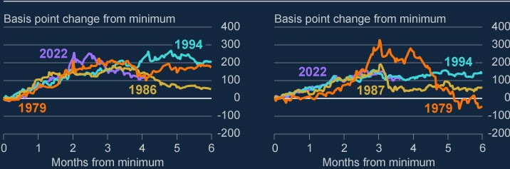

Sources: Bloomberg Finance L.P and Bank calculations.

1. Tightening episodes were identified by the largest three-month (US) and two-month (UK) moves in yieldscombined with other qualitative historical sources.
2. The minimum for each series, at which the series is indexed, represents the lowest yield within the timeperiod spanned by an identified tightening period.

Amid broader market volatility, UK assets – particularly long-term UK government debt – saw a further severe repricing in late September. On 23 September, the UK government announced a set of fiscal policy measures. In the days that followed, gilt yields increased sharply. For instance, between 1 August and their peak on 14 October, yields on 30-year gilts rose significantly, briefly exceeding 5% – a more than 270 basis point increase. During this period, yields on 30-year US Treasuries and German bunds peaked at around 150 basis points higher than their starting points, respectively. The increase in gilt yields during this episode was more than twice the size of that seen during the March 2020 ‘dash for cash’, which itself was the largest increase since 2000.

The speed and scale of the rise in gilt yields resulted in stress in the liability driven investment funds sector, which itself reinforced the upward pressure on gilt yields (see Section 5). This risked leading to further market dysfunction, creating a material risk to UK financial stability. In response, the FPC recommended action be taken and welcomed the Bank’s plans for a temporary and targeted programme of purchases of long-dated UK government bonds to restore market functioning. Since this episode, gilt yields have fallen, such that since July the overall change in gilt yields is in line with global peers and gilt market functioning has improved.

Gilt market liquidity is yet to fully recover. One commonly used headline measure of market liquidity is the bid-offer spread; the difference between the price at which an asset can be sold by a client (the bid) and that which it can be purchased (the offer). As reflected in the spike in bid-offer spreads in September, liquidity conditions in gilt markets have been exceptionally challenging since the July 2022 FSR. And despite improving over recent weeks, bid-offer spreads on 10-year gilts remain elevated compared to equivalent US and German government bonds (Chart 1.2). Should liquidity conditions remain challenging, there is a higher risk of future shocks resulting in sharp moves in yields.

**Chart 1.2: Bid-offer spreads remain particularly elevated in the 10-year gilt**

**market**

Bid-offer spreads on 10-year government bonds

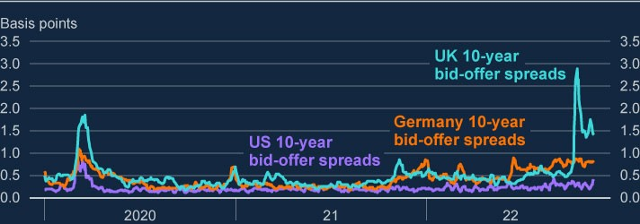

Sources: Refinitiv Eikon from LSEG and Bank calculations.

In September and early October, during the period of heightened volatility and severe repricing in UK markets, there were signs that foreign investor demand for

UK assets weakened. While this has since reversed, foreign investor appetite for UK assets could be vulnerable to future shocks (see Box A).

**The deterioration of expected global growth, together with heightened uncertainty, has led to sharp falls in risky asset prices, a reduction in investor risk appetite, and elevated financial market volatility.**

There is evidence of weaker risk appetite across financial markets. Against the backdrop of higher interest rates and the weakening macroeconomic outlook, risky asset prices have decreased sharply and are materially below their 2021 levels. Since the start of 2022, major equity indices in the US and euro area, and those most exposed to the deteriorating UK economic outlook, have fallen by around 10%–20%. Investment-grade corporate bond spreads have widened by around 45– 90 basis points. Overall, movements in risky asset prices have been generally orderly, but the risk of sharp adjustments from further developments in the economic outlook remains, for example from potential further adverse geopolitical developments. These could be amplified by existing vulnerabilities in the system of market-based finance and continued challenging market liquidity conditions.

Market volatility has remained elevated, reflecting uncertainty around the macroeconomic outlook and geopolitical developments. For example, the equity volatility index (VIX) has been nearly two thirds higher than its post global financial crisis average since July 2022, but around half the peak level observed during the ‘dash for cash’. Volatility in the bond market has also been heightened; since July 2022 the Merrill Lynch options volatility estimate (MOVE) index has on average been roughly double its post-crisis average and higher than its level observed during the ‘dash for cash’.

Weaker risk appetite is also reflected in primary credit markets, both in the higher cost of issuing corporate debt, as well as in subdued primary debt issuance volumes. Issuance has been particularly weak for some riskier borrowers. For example, there has been no issuance of sterling high-yield debt since April 2022, the longest period without issuance since 2011. More broadly, year-to-date issuance of advanced economy high-yield corporate bonds is between 10%–35% of its five-year average level. Leveraged lending and collateralised loan obligation issuance have also slowed relative to historical averages, albeit to a lesser extent (Chart 1.3).

**Chart 1.3: Year-to-date issuance of high-yield corporate bonds has been**

**subdued, relative to average issuance in Q1–Q3 over the past five years**

Year-to-date issuance in corporate financing markets as a proportion of averages over

Q1–Q3 in the past five years

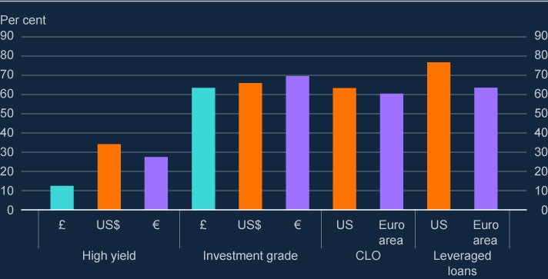

Sources: Leveraged Commentary & Data, Refinitive Eikon from LSE and Bank calculations.

The recent financial market volatility, and in particular the recent dysfunction in the long-dated gilt market, further highlights previously identified vulnerabilities in the system of market-based finance. Going forward, the adjustment to an environment of higher interest rates and heightened market volatility could expose further risks to UK financial stability from this source (see Section 4).

**Cryptoasset prices have continued to decline sharply and the sudden failure of FTX has highlighted a number of vulnerabilities. But the FPC continues to judge that direct risks to UK financial stability from cryptoassets remain limited.**

Cryptoasset prices have declined more sharply than other risky asset prices. The market capitalisation of cryptoassets has fallen to around US$800 billion, from a peak of almost US$3 trillion in late 2021. More recently, the sudden failure of FTX – a large conglomerate offering cryptoasset trading and other associated services – has highlighted [**a number of vulnerabilities**](https://www.bankofengland.co.uk/speech/2022/november/jon-cunliffe-keynote-speech-and-panel-at-warwick-conference-on-defi-digital-currencies) within the cryptoasset ecosystem

including:

lack of requirements and transparency around corporate structures and the relationships between them;

lack of controls to mitigate or prevent exposures to credit, liquidity, and market risk;

high volatility associated with unbacked cryptoassets;

the potential for extreme ‘wrong way’ risk when firms accept their own unbacked cryptoasset as collateral; and lack of client fund protection.

The FPC continues to judge that direct risks to UK financial stability from cryptoassets are limited, reflecting their current limited size and interconnectedness with the financial system (see [**March 2022 Financial Stability in Focus**](https://www.bankofengland.co.uk/financial-stability-in-focus/2022/march-2022)).

Consistent with this, the sharp decline in cryptoasset prices and the recent collapse of FTX have not posed material risk to broader financial stability. However, given the speed of developments in this area it is important to be forward-looking. These events have highlighted how systemic risks could emerge, particularly if cryptoasset activity and interconnectedness with the wider financial system increase.

Recent events further underscore the need for enhanced regulatory and law enforcement frameworks to address developments in crypto markets and activity. Financial institutions and investors should take an especially cautious and prudent approach to any adoption of these assets until the necessary regulatory regimes are in place. In March, the Financial Conduct Authority issued a [**statement**](https://www.fca.org.uk/news/statements/notice-regulated-firms-exposure-cryptoassets) to all

regulated firms highlighting certain risks such as financial crime and custody risks related to crypto activities.

## 1.3: Global debt vulnerabilities

**The FPC judges that the risks of global debt vulnerabilities crystallising have increased in light of the weakening in the global economic outlook and the tightening financial conditions. Geopolitical tensions are also elevated and could increase further. These developments continue to pose a material risk to UK financial stability.**

A deterioration in global growth prospects and a tightening in global financial conditions, like that observed, has the potential to affect UK financial stability through a number of channels.

As global financial conditions tighten, foreign borrowers may struggle to service their debts and defaults could increase. UK banks could incur material losses on their exposures to foreign borrowers, since around 45% of major UK banks’ outstanding lending was to non-UK borrowers as of June 2022. If the likelihood of foreign borrower default and global risk aversion increases further, risky asset prices may be vulnerable to further falls. Banks could therefore directly incur losses on their holdings of risky assets, and global financial conditions could tighten further. In turn, this could result in tightening UK financial conditions. More broadly, global debt vulnerabilities can also amplify economic shocks in foreign economies and lead to spillovers to the UK, for example through lower demand for UK exports (Figure 1.1).

**Figure 1.1: Tightening global financial conditions can affect UK financial**

**stability through numerous channels**

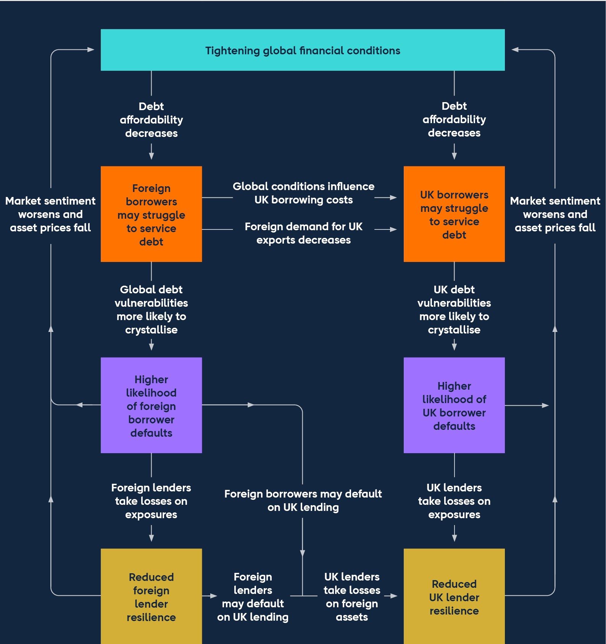

The FPC continues to judge that global debt vulnerabilities pose material risks to UK financial stability through these channels and that they are now more likely to crystallise in light of the further weakening in the global economic outlook, and the material tightening in global financial conditions. Additionally, geopolitical tensions are elevated and there is potential for them to increase further.

Authorities in other jurisdictions have also noted vulnerabilities in their domestic financial systems. For instance, in September 2022 the European Systemic Risk Board issued a warning about pockets of vulnerability in the EU financial system, including risks that could be associated with a sharp adjustment in EU house prices.

**Sharp increases in prices and tighter global financial conditions will continue to weigh on debt affordability for some businesses in advanced economies, particularly those with high leverage or high exposure to energy prices.**

Increased prices, including energy prices, have reduced consumer demand and increased the cost of production for a range of businesses. This, along with the higher interest rate environment, is likely to weigh on debt affordability. In turn this could lead to both corporate borrowers defaulting on their debt, and a further weakening in the economic outlook due to a further contraction in demand. Similar to the UK, authorities in many jurisdictions have responded by introducing measures to mitigate the effect of high and volatile energy prices on corporate finances, as well as to support households. Corporates in energy intensive sectors may, however, still find that their finances are particularly squeezed.

The FPC has previously highlighted vulnerabilities from highly leveraged corporate borrowing, particularly in the US. The stock of outstanding leveraged lending in the US has increased from around US$2 trillion in 2017 to roughly US$3.5 trillion as of end-September 2022. This lending is typically floating rate and therefore sensitive to increasing interest rates.

**The material tightening global financial conditions will also weigh on households’ ability to service their debt in some countries.**

Tighter global financial conditions have led to tighter household credit conditions, and reduced activity in global housing markets. Mortgage rates have risen sharply in the United States. The average quoted rate on 30-year fixed-rate US mortgages has increased from around 3% in 2021 Q4 to around 7% in November 2022. Meanwhile the value of new US mortgage originations fell to around US$680 billion in 2022 Q2, which is just half the 2020 Q4 peak but still significantly higher than pre-pandemic. Moreover, during the summer, US house prices recorded their first month-on-month falls since February 2012. Euro-area mortgage market conditions have tightened too, but by less than in the US.

In the US, most households are likely to be shielded from increasing interest rates as most household debt is fixed rate, typically with long terms. Mortgage debt accounts for two thirds of US household debt and 80% was originated on fixed terms of more than 15 years. And nearly all outstanding mortgages are at loan to value ratios of 80% or less. As a result, most US households are likely to be able to absorb even a 20% fall in house prices before falling into negative equity and potential losses on defaulting US mortgages should therefore be limited.

A slowdown in the US housing market could have knock-on effects to the wider financial system. In line with moves in broader asset prices, prices of financial assets tied to the US housing market have fallen sharply. For example, over 2022 the S&P US mortgage-backed securities (MBS) index has fallen by 11%, and the Wilshire US real estate investment trust index has also fallen by 25%. UK investors’ holdings of these assets are relatively limited, as they hold significantly less than US$100 billion of US government agency backed MBS, for example (Chart 1.4). But US banks’ exposures to these assets are sizable, at US$3.2 trillion and nonbank financial institutions (NBFIs) exposures are also substantial. Should NBFIs need to liquidate their holdings quickly over a similar timeframe to one another, for example to raise liquidity to meet margin calls in other markets or as investors seek to reduce exposure to the US housing market, they could amplify price falls.

**Chart 1.4: UK holdings of US mortgage-backed securities are relatively**

**small**

Holders of US mortgage-backed securities as end-2022 Q2

(

**a**

)

(

**b**

)

(

**c**

)

(

**d**

)

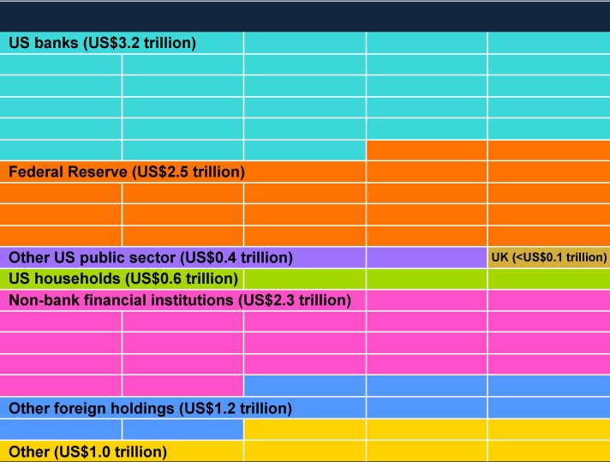

Sources: Federal Reserve Bank of New York, Federal Reserve Board – Treasury International Capital reports, US Federal Reserve flow of funds, joint US Treasury and Bank calculations.

1. Each square represents 1% of the total holdings of US mortgaged-backed securities.
2. UK holdings are estimated based on June 2021 data.
3. Other includes US corporates, holding companies, and an accounting adjustment reflecting mismatches inthe reporting of US agency assets and liabilities.
4. ‘Other foreign holdings’, and ‘UK’ could include both private and public sector holdings.

Although mortgage rates have increased by less in the euro area than the US, some euro-area borrowers are likely to be exposed to rising rates. Across the euro area, just under 25% of new mortgage lending in September 2022 was extended at either floating rates or with a fixed term of less than one year. There are also differences in the degree of exposure to rising mortgage rates within the euro area.

The take up of floating rate products over the past 10 years has been proportionally greater in Spain and Italy than in France and Germany, for example. Analysis by the [**European Banking Authority**](https://www.eba.europa.eu/banks-exposed-downside-risks-residential-real-estate-markets-get-overheated-eba-report-finds) shows that 17% of outstanding mortgages in the

euro area were at loan to value ratios of 80% or higher in 2022 Q1, suggesting they may be at risk of falling into negative equity if euro-area house prices fall significantly.

Despite these potential vulnerabilities, analysis from euro-area and US authorities show their banking systems are likely to remain resilient to prospective increases in [losses on lending. For example, the **November 2022 ECB Financial Stability**](https://www.ecb.europa.eu/pub/financial-stability/fsr/html/index.en.html)

[**Review** shows that the major euro-area banks have robust capital positions, w](https://www.ecb.europa.eu/pub/financial-stability/fsr/html/index.en.html)ith

[an average CET1 capital ratio of around 15% as of 2022 Q2. The **November 2022**](https://www.federalreserve.gov/publications/2022-november-financial-stability-report-purpose-and-framework.htm)

[**Federal Reserve Board Financial Stability Report** notes that the US banking](https://www.federalreserve.gov/publications/2022-november-financial-stability-report-purpose-and-framework.htm)

system maintains an aggregate capital position within its usual range over the previous decade, and the Federal Reserve Board’s 2022 stress test indicates that large US banks would maintain capital ratios well above minimum risk-based requirements during a substantial economic downturn.

**Government support measures to mitigate the impact of high energy prices on households and businesses are likely to raise public debt levels, and vulnerabilities associated with high public debt levels could intensify in an environment of tightening financial conditions.**

The support measures introduced in many jurisdictions to reduce pressures on households and businesses, particularly from heightened and more volatile energy prices, are likely to increase public debt levels. For instance, Germany is borrowing €200 billion (6% of its 2021 GDP) to implement a cap on gas and electricity prices.

The FPC has previously highlighted vulnerabilities created by high public debt levels in the euro area, including interlinkages between banks and sovereigns. Yields on euro-area government bonds have increased since July 2022. For example, yields on 10-year German bunds have increased by about 1.3 percentage points to around 2%. Following a widening in spreads to German bunds earlier in year, yields on 10-year Italian government debt had increased to over 4% in mid-October, but have decreased since. The spread against bunds remains narrower than its post financial crisis peak of around 500 basis points in November

2011. If this spread rises further, however, could increase the risk of previously identified euro-area vulnerabilities crystallising. The ECB’s Transmission Protection Instrument might help to mitigate this risk. It allows the ECB to make secondary market purchases of securities issued in jurisdictions that are experiencing a deterioration in financing conditions not warranted by country-specific fundamentals.

**The Chinese economy is slowing down, reflecting an increase in the number of Covid cases, as well as debt vulnerabilities in the Chinese property market crystallising. A sharper slowdown could pose risks to UK financial stability.**

A slowdown in the Chinese economy could impact UK financial stability through various trade and financial market channels, as well as UK banks’ direct exposures. This reflects the size of the Chinese economy, its trading links with a range of global economies including the UK, and the UK banks’ exposures to China, including indirectly via Hong Kong.

The Chinese economy has slowed, in part due to ongoing Covid restrictions as Covid cases have increased. In addition to the risks to public health associated with increases in Covid cases, further lockdowns are likely to weigh on economic activity. The slowdown has also been driven partly by debt vulnerabilities in the Chinese property sector crystallising. Property prices have continued to fall and are now on average 2.6% lower than their 2021 Q3 peak. Property investment also fell by around 16% in the year to October. But recently announced policy measures to support the property sector may reduce near-term risks to some extent. The likely effect of the current slowdown on UK financial stability appears limited, but a sharper or broader slowdown in China could have more significant spillovers to the UK.

**Tighter financial conditions and the stronger US dollar will weigh on debt affordability in some non-China emerging market economies (NCEMEs), but this currently poses limited risk to UK financial stability.**

High energy costs, tighter global financial conditions, and the stronger US dollar, will also weigh on debt serviceability in some NCEMEs. In particular, energy importers and those with high levels of dollar-denominated debt or large current account deficits are likely to be most exposed. Non-resident portfolio flows to NCEMEs have continued to be volatile, with a small cumulative inflow since the July 2022 FSR. There has been evidence of stress in some NCEMEs. For example, NCEME exchange rates have generally depreciated against the US dollar. Additionally, dollar-denominated government bonds of around 14 smaller NCEMEs are trading at ‘distressed levels’, indicating they are at a higher risk of default than other NCEMEs.[2]

The larger and more established NCEMEs, such as Brazil and India, have been less affected so far. If a number of these larger NCEMEs were to enter into stress, there would likely be a significant negative effect on the global risk environment. Stress in larger and more established NCEMEs would therefore be more likely to impact negatively on UK financial stability.

There are signs that external vulnerabilities in some larger NCEMEs are increasing, as their current account deficits are rising while their foreign currency reserves are falling. A significant proportion of this decrease in reserves is related to valuation effects, which have likely been driven by falling US government bond prices. The tightening in external financing conditions has not, as yet, led to significant stresses in the larger NCEMEs, and as a result spillovers to the wider financial system have so far been limited. On average, the spreads over US government bonds for dollar denominated debt of a group of 12 larger NCEMEs have decreased by around 70 basis points since the July 2022 FSR.

**In the current environment, the FPC is monitoring geopolitical and other risks very closely and taking them into account when assessing the resilience of the UK financial system, including in the context of the 2022 ACS stress test.**

It will work with other authorities at home and abroad, including the PRA, to consider whether any further action is required to enhance the resilience of banks to such risks.

|  |
| --- |
| Box A: UK external balance sheet vulnerabilities  **The UK has a large external balance sheet associated with large gross capital flows that exposes it to external financing risks.**  TheUK is one of the most financially open economies in the world. It has external liabilities (UK assets held by overseas residents) of over 550% of GDP (Chart A).This is significantly higher than other G7 economies, although lower than the level of the Netherlands and Switzerland. The size of these liabilities mean that the behaviour of foreign investors, and their perceptions of the UK’s macroeconomic policy framework and its long-term growth prospects, can have a material impact on UK financial conditions.  **A decline in foreign investor appetite for UK assets, all else equal, could lead to large falls in UK asset prices and tighter domestic credit conditions, as well as a weaker sterling exchange rate.**  Foreign investors’ perceptions about the riskiness of UK assets affect their willingness to hold them and the return they require. Foreign investors will demand a higher risk premium on UK assets when sterling exchange rate volatility is expected to be higher, for example. This can exacerbate falls in UK asset prices in response to shocks and ultimately contribute to tighter UK financial conditions.  Foreign investors’ decisions are likely to have a larger influence on prices in markets where they have a larger presence. Foreign investors are estimated to own around 50% of UK equity and private sector debt and around 30% of UK government bonds. They also typically account for over 40% of the value of UK CRE transactions in any given year. |

Based on an international comparison across financial market variables, it

appears that foreign investor sentiment towards UK assets deteriorated

markedly in September. This was related to increased uncertainty around the

UK’s economic prospects including the UK’s fiscal position. For example,

between the start of September and mid-October, UK government bond term

premia and corporate bond spreads rose by more than their counterparts in

the US and euro area. Since then, indicators of the perceived riskiness of UK

assets have generally fallen back in line with euro-area economies.

Any future UK specific shock to investor appetite for UK assets would likely

result in some combination of a weaker sterling exchange rate and lower UK

asset prices. This would likely tighten domestic financing conditions (ie

higher borrowing costs for the government, households and businesses),

**Chart A: The UK has large external liabilities**

UK gross external liabilities by type

(

**a**

)

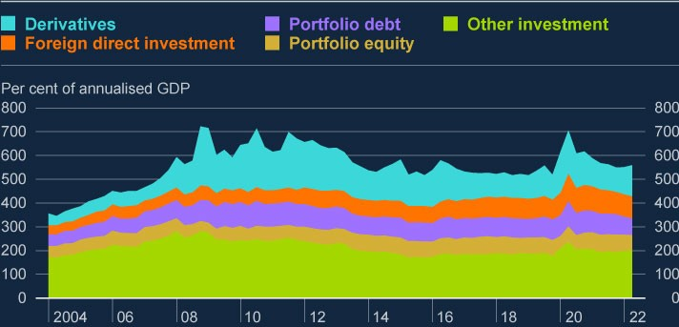

Sources: ONS and Bank calculations.

(

a) Other investment is mostly composed of loans, currency and deposits.

**There were signs that foreign investor demand for UK assets**

**weakened in September and early October, but this has since**

**reversed. Over the second half of 2022 as whole UK asset prices have**

**moved broadly in line with euro-area equivalents.**

|  |
| --- |
| and lead to downward pressure on real incomes through higher domestic prices for goods and services related to a weaker value of sterling. Both of these factors would make it harder for indebted UK households and corporates to service their debt (see Section 2).  One potential shock could come in the form of a downgrade to the UK’s credit rating, after several rating agencies downgraded the outlook for the UK’s rating to negative in September and October. Although there is some uncertainty, the underlying effects of a one notch downgrade are already likely to be priced in to some extent. Forced selling, due to investment mandates which stipulate certain minimum credit ratings, for example, is not expected to be material.  Currency mismatches between the assets and liabilities of UK resident nonfinancial businesses can amplify external risks. Unlike the UK as a whole, non-financial businesses hold more foreign currency liabilities than assets because some choose to borrow in more liquid foreign currency corporate debt markets to fund sterling assets. They do this because it can be cheaper for them to raise finance in these markets and swap the proceeds back into sterling. For UK businesses with a currency mismatch, the cost of servicing foreign currency debt can rise when sterling depreciates without this being fully offset by a rise in their foreign currency revenues. This can affect their profitability or solvency. That said, large companies are generally able to hedge these risks.  **A particularly large and rapid fall in foreign investor demand for UK assets could pose a more acute risk to UK financial stability if it led to difficulties refinancing UK external liabilities, but the Financial Policy Committee judges that this risk at present is low.**  ‘Other investment’ liabilities, mostly composed of currency, deposits and loans, account for around 35% of total external liabilities (Chart A). A significant portion of these could, in theory, be withdrawn at short notice. But this risk appears low. At least 35% of these ‘other investment’ liabilities are estimated to consist of intragroup bank transactions, and where that is the case, a sudden withdrawal in stress is much less likely. Direct risks to UK banks from this channel appear limited. While there is no regulatory |

|  |
| --- |
| requirement for individual banks to match their short-term foreign currency liabilities on a currency-by-currency basis, UK banks have robust foreign currency liquidity positions in aggregate. Furthermore, liquidity regulations stipulate that the more exposed they are to refinancing risk, the greater the liquidity buffer they are required to have in place. Overall, the risk of an acute increase in refinancing difficulties giving rise to an impact on UK financial stability remains low.  **One feature of the UK’s external financing position is that the UK has run a persistent current account deficit over past decades. That necessitates consistent net inflows of capital from abroad. The UK’s ability to attract these inflows at current levels of sterling has been supported by the fact that the estimated value of UK external assets are significantly larger than the value of UK external liabilities.**  The annual current account deficit has averaged around 3¼% of GDP since 2000, which has required net inflows of capital of the same magnitude. While these net inflows can be funded by UK residents selling foreign assets, ultimately their long-term sustainability will rely on foreign investors’ willingness to finance them.  The net value of the stock of the UK’s external assets and liabilities (the UK’s net international investment position (NIIP)) is estimated to be strongly positive (Chart B). This should support investor confidence when investing in UK assets. The strength of the UK’s NIIP is the result of a positive net rate of return on its external balance sheet over previous decades. This has more than offset the capital flows associated with funding its persistent current account deficit, which other things equal, would have eroded the UK’s NIIP over time.  The positive net rate of return on the UK’s NIIP has been partly due to compositional effects, although these may have lessened recently. Historically, the UK has had more equity and long-term debt assets than liabilities, which generated positive net returns. But this compositional feature has reversed over the past two decades. |

The currency composition of the UK’s external balance sheet can also

influence investors’ perceptions around the sustainability of net capital

inflows to the UK. UK liabilities tend to be denominated in sterling and UK

assets tend to be denominated in foreign currencies so that, other things

equal, a sterling depreciation increases the value of the UK’s NIIP.

**Chart B: The UK’s net international investment position has improved**

**in recent years, in part due to a fall in the value of sterling**

Estimates of the UK net international investment position

(

**a**

)

(

**b**

)

(

**c**

(

)

**d**

)

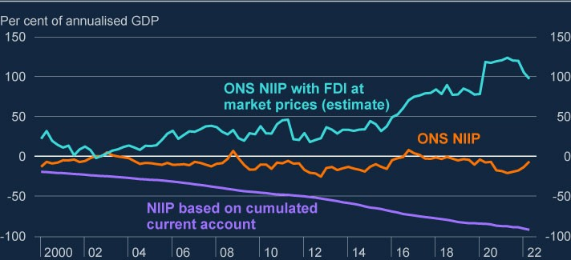

Sources: Bloomberg Finance L.P., ONS and Bank calculations.

(

a) Data are not seasonally adjusted.

(

b) For details on how foreign direct investment estimates are adjusted for changes in market value,

see footnote (3) on page 23 of the

[**May 2014 Inflation Repor**](http://www.bankofengland.co.uk/inflation-report/2014/may-2014)

[**t**](http://www.bankofengland.co.uk/inflation-report/2014/may-2014)

[.](http://www.bankofengland.co.uk/inflation-report/2014/may-2014)

(

c) The current account is cumulated from

1970.

[(](https://www.ons.gov.uk/economy/nationalaccounts/uksectoraccounts/articles/understandingtheuksnetinternationalinvestmentposition/2020-04-27#impact-of-revaluations-and-other-changes-on-the-uks-niip)

[d) The](https://www.ons.gov.uk/economy/nationalaccounts/uksectoraccounts/articles/understandingtheuksnetinternationalinvestmentposition/2020-04-27#impact-of-revaluations-and-other-changes-on-the-uks-niip)

[**ONS NIIP re-evaluates portfolio debt and equity at regular intervals but it values FDI a**](https://www.ons.gov.uk/economy/nationalaccounts/uksectoraccounts/articles/understandingtheuksnetinternationalinvestmentposition/2020-04-27#impact-of-revaluations-and-other-changes-on-the-uks-niip)

[**t**](https://www.ons.gov.uk/economy/nationalaccounts/uksectoraccounts/articles/understandingtheuksnetinternationalinvestmentposition/2020-04-27#impact-of-revaluations-and-other-changes-on-the-uks-niip)

[**purchase pric**](https://www.ons.gov.uk/economy/nationalaccounts/uksectoraccounts/articles/understandingtheuksnetinternationalinvestmentposition/2020-04-27#impact-of-revaluations-and-other-changes-on-the-uks-niip)

[**e**](https://www.ons.gov.uk/economy/nationalaccounts/uksectoraccounts/articles/understandingtheuksnetinternationalinvestmentposition/2020-04-27#impact-of-revaluations-and-other-changes-on-the-uks-niip)

[.](https://www.ons.gov.uk/economy/nationalaccounts/uksectoraccounts/articles/understandingtheuksnetinternationalinvestmentposition/2020-04-27#impact-of-revaluations-and-other-changes-on-the-uks-niip)

# 2: UK household and corporate debt vulnerabilities

UK economic conditions have worsened and financial conditions have tightened over 2022. Household finances are being stretched by increased living costs and rising mortgage payments. Households are adjusting spending behaviour as real income is squeezed, although widespread signs of financial difficulty among UK households with debt have yet to emerge. The risk that indebted households default on loans, or sharply reduce their spending, has increased.

Pressures on household finances will increase over 2023. Falling real incomes, increases in mortgage costs and higher unemployment will place significant pressure on household finances. The FPC judges that households are more resilient now than in the run-up to the global financial crisis in 2007 and the recession in the early 1990s. In aggregate, the proportion of disposable income spent on mortgage payments is projected to rise but remains below the peak levels during the global financial crisis (GFC) and the 1990s recession.

The core UK banking system is also more resilient, in part due to lower risk lending to households. The greater resilience of banks, and higher standards around conduct, also mean they are expected to offer a greater range of forbearance options. As such, the increased pressure on UK households is not expected to challenge directly the resilience of the UK banking system.

In aggregate, UK businesses are entering the period of stress in a broadly resilient position. Earnings have risen and leverage has fallen in 2022 as the effects of the Covid pandemic have abated. But within the aggregate, there a number of vulnerable companies with low liquidity, weak profitability or high leverage. And some businesses are facing other pressures from higher costs of servicing debt, weaker earnings, and continued supply chain disruption. Pressures on businesses are expected to continue to increase over 2023, especially for smaller companies which are less able to insulate themselves against higher rates. The risks that firms default on debt, or cut employment or investment sharply, have increased.

There are emerging signs of some corporate borrowers facing difficulty. Corporate insolvencies have increased, driven in particular among micro and small and medium-sized enterprises (SMEs). Financing conditions have tightened, particularly for risky firms, with some funding markets closed. But businesses are not yet showing signs of reducing employment or investment sharply in response to the economic downturn. Increased pressure on the corporate sector is not expected to pose material risks to the resilience of the UK banking system, but will leave businesses more vulnerable to future shocks.

## 2.1: UK economic and financial market developments

**Household and corporate indebtedness impact UK financial stability in two key ways.**

Although borrowing helps households and businesses to smooth consumption and investment, high indebtedness can pose risks to UK financial and economic stability. The FPC has previously identified two main channels through which high levels of household or corporate debt can pose risks to the UK financial system or wider economy:

1. Lender resilience. Highly indebted households and businesses are more likely toface difficulties making debt repayments. If borrowers default, this can lead to losses for lenders and test their resilience.
2. Borrower resilience. In an economic downturn, more highly indebted andsavings-constrained households may cut back more sharply on other spending to make debt repayments, and highly indebted corporates may reduce investment and employment by more than those with less debt. These behaviours can amplify macroeconomic downturns, further affecting household and corporate resilience, and potentially also increasing losses for lenders on other forms of lending (see Figure 2.1).

**Figure 2.1: UK household and corporate debt vulnerabilities can affect UK**

**financial stability**

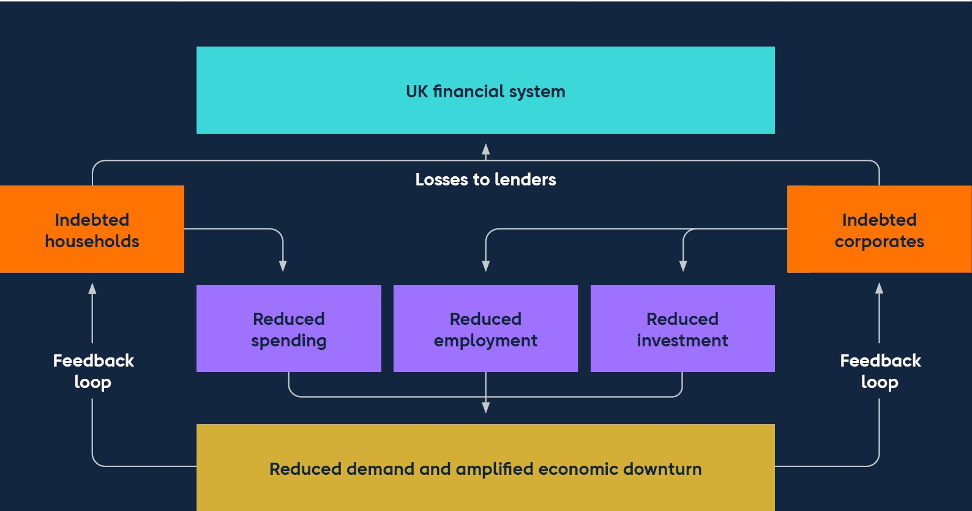

**UK economic conditions have deteriorated and financial conditions have**

**tightened significantly over 2022.**

[The outlook for the UK economy has worsened significantly since the **July 2022**](https://www.bankofengland.co.uk/financial-stability-report/2022/july-2022)

[**FSR**. High food and energy costs continue to feed through into producer and](https://www.bankofengland.co.uk/financial-stability-report/2022/july-2022)

consumer prices. CPI inflation rose to 11.1% in the 12 months to October 2022. Within this, food price inflation stood at 16%, and domestic energy price inflation was just under 90%. Domestic inflationary pressures are expected to remain strong over the next year. The MPC’s latest projections are for the UK economy to be in recession for a prolonged period.

There has been a significant increase in household and corporate borrowing costs (see Box B). Market interest rates, which underpin the cost of borrowing for households and businesses, have risen over 2022. This has been driven in large part by increases in Bank Rate, and market expectations that the MPC will continue to increase Bank Rate in order to meet the inflation target, in the context of persistently high global inflationary pressure. For example, the two-year overnight index swap rate has risen to around 4.4% from 0.9% in December 2021.

Rising mortgage rates are putting pressure on house prices, and house price growth has started to slow (see Box B). Changes in house prices affect the loan to value ratios on lenders’ mortgage portfolios, which are an important driver of the losses they would face if mortgagors were to default.

Economic and financial conditions are stretching household and corporate finances. Debt has become more difficult to obtain for some borrowers, and more costly to service. Higher input prices, labour market shortages and supply chain disruption are putting pressure on corporate balance sheets, and household finances are stretched by increases in costs of essential goods, especially energy and food. Pressures on household and corporate finances will increase over 2023.

## 2.2: UK household debt vulnerabilities

**Household finances are being stretched by economic and financial developments.**

Increased living costs and rising mortgage payments have made it harder for households to service debt. Households are adjusting spending behaviour as real income is squeezed, although widespread signs of financial difficulty among UK households with debt have yet to emerge.

One of the ways the FPC assesses household debt vulnerabilities is by considering how much of their income, adjusted for tax and essential spending,[3] households need to spend on debt repayments. Specifically, the FPC monitors the proportion of households with cost of living adjusted mortgage debt-servicing ratios (COLADSRs) over 70%. Households with levels of COLA-DSRs above this point are more likely to face difficulties in meeting debt repayment costs, so are more likely to default, or cut back sharply on other consumption to manage repayments. The share of households with high mortgage COLA-DSRs has increased over 2022 H2, but currently remains around historic averages at 1.6%. One factor currently helping to limit household debt vulnerabilities is that the UK unemployment rate remains very low by historical standards, at 3.6%.

**Pressures on household finances will increase over 2023, making it harder for households to service their debt.**

Pressures on household finances will increase over 2023. The cost of essential goods is expected to remain high, and around half of owner-occupier mortgagors will experience increases in mortgage costs (see Box B). These factors will increase the proportion of households with high COLA-DSRs. The expected rise in unemployment should also increase the proportion of households under pressure from debt, though by a less significant amount. This is because unemployment is projected to remain well below levels seen in previous large recessions, and because mortgagors tend to be dual-income households so they are likely to still have some earnings if one earner becomes unemployed. For those in work, nominal wage growth will also help to offset some of the upward pressures on COLA-DSRs.

The share of households with high mortgage COLA-DSRs is projected to increase over 2023 to 2.4%, or around 670,000 households. These levels are significantly higher than those observed in recent years and are starting to approach levels comparable to the proportion of households with high debt-servicing burdens around the start of the GFC (Chart 2.1). In 2007, 2.8% of households (equating to around 710,000 households at that time) had high COLA-DSRs.

The overall COLA-DSR distribution is also projected to change in a way that signals that households will have greater difficulty servicing debt over 2023. The numbers of households with the lowest levels of COLA-DSRs is expected to fall, as households move into higher COLA-DSR groups. And the number of households with COLA-DSRs just below the threshold at which the FPC identifies a COLA-DSR as high, and therefore more likely to struggle to make payments on their debt, is projected to increase (Chart 2.1). Taken together, these expected changes imply that households will be more vulnerable to future shocks. But the proportion of households with high COLA-DSRs is expected to remain below the pre-GFC peak.

**Chart 2.1: The share of households with high debt-servicing burdens is**

**projected to increase over 2023**

Share of households with high cost of living-adjusted DSRs, and share of households in

each COLA-DSR group

(

**a**

)

(

**b**

)

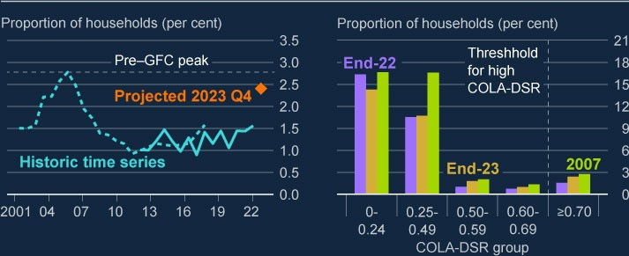

Sources: British Household Panel Survey/Understanding Society (BHPS/US), Bank of England, NMG Consulting survey, ONS and Bank calculations.

1. The threshold of 70% is estimated by taking the threshold at which households become much more likely toexperience repayment difficulties for gross DSRs (40%) and adjusting it to reflect the share of income spent on taxes and essentials (excluding housing costs) by households with mortgages. For more information on the gross threshold, see the [**August 2020 FSR**.](https://www.bankofengland.co.uk/report/2020/monetary-policy-report-financial-stability-report-august-2020) The impact of inflation is estimated by assuming the prices of essential goods rise in line with the [**November 2022 MPR**](https://www.bankofengland.co.uk/monetary-policy-report/2022/november-2022) projections and the extended Energy Price Guarantee, and households do not substitute away from this consumption.
2. Interest rate projections are applied based on market expectations for Bank Rate as at 25 November 2022.

Projections are conditioned on announced fiscal policy for households over 2023 as at 25 November 2022. Proportions refer to number of households with respective COLA-DSR (excluding non-mortgagors) as a proportion of all households in the UK. A greater number of households had mortgages in 2007.

Households are also experiencing increased pressure on their ability to service other types of consumer debt, such as credit cards and personal loans. Relative to mortgage rates, interest rates on consumer credit products are typically higher but are not as sensitive to increases in Bank Rate, so interest rates on these products have not increased as sharply. That said, households’ ability to service consumer credit debts will also be affected by increases in the costs of essential goods and rises in unemployment. And households with both mortgages and consumer credit tend to default on consumer credit before they stop paying their mortgage. In response to affordability concerns, some banks have tightened lending criteria on consumer credit products.

Thus far, widespread signs of financial difficulty among UK households with debt have yet to emerge. While the major UK banks have reported an increase in arrears on some types of lending this year, mortgage arrears overall remain subdued by historic standards and lenders have not realised large losses or changed the levels of forbearance they have extended. The proportion of mortgages in arrears of six months or more is around 0.5%, which is comparable to pre-Covid levels and much lower than peaks of 3.5% in 1992 and 1.4% in 2009. The share of consumer credit loans which have not yet defaulted, but which have had impairments raised against them by banks due to a significant increase in credit risk, has picked up somewhat over 2022, but remains around pre-pandemic levels. And evidence from Citizens Advice suggests more households are seeking help with budgeting to cope with the cost of living, but does not yet point to a material increase in people struggling to access credit or service debts.

**The risk that households default on debt, or sharply reduce their spending, has increased. But the increased pressure on UK households is not expected to challenge directly the resilience of the UK banking system.**

Pressures on household finances will increase the risk that households default on debt, or sharply reduce their spending. Historically, some periods of household distress have resulted in significant losses for banks. For example, household finances were put under pressure by high levels of unemployment and interest rates in the early 1990s, resulting in material loss rates for banks. Loss rates on mortgages in this period peaked at 1.8% for UK banks and building societies, and up to 2.8% when taking into account losses incurred by the UK insurance industry on mortgage loans originated by banks and building societies.

Household finances were also put under pressure during the global financial crisis, but loss rates on mortgages were more contained, at 0.6%. This reflects the sharp fall in interest rates in response to the GFC that cushioned the impact on households, combined with a strong recovery in house prices in the period following the crisis.

There are several factors that are likely to mitigate the impacts of the current economic downturn on households and lenders. The FPC judges that households are more resilient now than in the run-up to the financial crisis in 2007 and the recession in the early 1990s. Households are in aggregate less indebted; the ratio of aggregate debt to income has been broadly stable over recent years at around 125%, well below the peak of around 150% preceding the GFC (but more than in the 1990s). In aggregate, the proportion of disposable income spent on mortgage payments (or DSR) is currently at 5.4%, compared to just below 9% and 10% in the periods preceding the 1990s recession and the GFC respectively. The aggregate DSR is projected to rise, but remain below historic peak levels (Chart 2.2). Unemployment levels, which are a strong indicator of household distress, are currently very low in historical terms at 3.6%, though the projection in the November 2022 MPR is for the unemployment rate to rise by around three percentage points by end-2025. And a greater proportion of households have fixedrate mortgages than was the case going into previous periods of stress, meaning households have more time to adjust before rate rises start to affect their finances.

**Chart 2.2: The aggregate household mortgage DSR is projected to remain**

**below the peaks seen in previous crises**

Aggregate UK household mortgage DSR with illustrative projection to end-2025

(

**a**

)

(

**b**

)

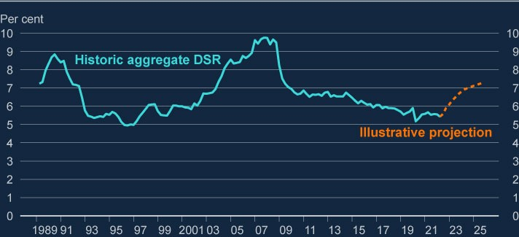

Sources: Bank of England, Bloomberg Finance L.P., FCA Product Sales Data, ONS and Bank calculations.

1. Calculated as interest payments plus mortgage principal repayments as a proportion of nominal householdpost-tax income. Household income has been adjusted to take into account the effects of Financial

Intermediation Services Indirectly Measured. Mortgage interest payments before 2000 are adjusted to remove the effect of mortgage interest relief at source.

1. For the illustrative projections to end-2025, projections for household post‑tax income consistent with the [**November 2022 MPR**](https://www.bankofengland.co.uk/monetary-policy-report/2022/november-2022). Payment increases are projected using market expectations for Bank Rate based on

the overnight index swap curve as at 25 November, take into account the distribution of fixed-deal terms from the FCA Product Sales Data and assume the aggregate mortgage debt to income ratio remains constant.

There are now higher standards for lenders around conduct with respect to supporting households. Other things equal, this should lead to lower household defaults and property repossessions than in previous downturns. Since 2021, lenders have been expected to give borrowers in financial difficulty appropriately tailored forbearance that is in their interests, and takes account of their individual circumstances. This could include extending terms on mortgages or moving households onto interest only repayments in times of stress. Lenders are also required to use repossessions only as a last resort, with the present repossession

rate very low at less than 0.04%.[4] The repossessions rate reached nearly 0.8% of all mortgages in the early 1990s, significantly higher than the historical average of around 0.2%.

Nevertheless, many households will find it challenging to manage higher interest rates alongside the ongoing rises in the cost of essentials, and pressures on UK households will increase. As household debt-servicing burdens continue to rise over the next year, arrears and defaults are likely to rise.

The FPC judges that the core UK banking system is more resilient than in historic downturns, even if the rise in household borrower defaults turns out to be greater than expected. Increased pressure on households is therefore not expected to challenge directly the resilience of the UK banking system. This is in part due to lower risk lending to households. The loan to value (LTV) profile of the major UK banks’ mortgage portfolios is very strong, following a long period of house price growth and prudent lending practices. For example, less than 10% of lenders’ current owner-occupier mortgage exposures are at LTVs of greater than 75%, compared to around 25% preceding the GFC. As such, very few existing borrowers are expected to be pushed into negative equity. This also reflects significantly stronger lending practices than those preceding historic crises; around 40% of new lending was at 90% LTV or above in 1991, compared to less than 20% over 2022.

Stronger lender resilience also, in part, reflects the impact of the FPC’s mortgage market Recommendations since their implementation in 2014. These Recommendations have guarded against a material loosening in underwriting standards and have dampened the build-up of household debt despite a prolonged period of recent house price growth.

However, the risk that households with the highest borrowing costs relative to incomes cut back on consumption by more than anticipated has increased. Some households, in particular those with lower income, fewer savings, or greater debt, may be forced to cut back on spending as their stretched finances mean they will not be able to maintain current levels of consumption.

Households might also increase precautionary savings in response to the economic downturn, which risks amplifying it. Should downside risks to businesses crystallise, this will have knock on effects for households through increased

unemployment (see Section 2.3). Unemployment is expected to rise over the next year, but remain well below levels seen following the GFC or in the early 1990s.

There is evidence that households with debt have started to adjust spending behaviour as real income is squeezed. The latest NMG survey shows the number of households putting off spending due to debt concerns rose sharply over 2022, now standing at over a third of households with debt, compared to levels of around a quarter from 2015 to 2020. Furthermore, based on the November 2022 MPR forecast, the saving ratio is likely to rise over the next three years from around 7½% to 9%. If households reduced consumption by more than expected over 2023, this would act to amplify the current economic downturn. This would increase the pressures faced by businesses and households, and pose additional risks to lenders.

## 2.3: UK corporate debt vulnerabilities

**In aggregate, UK businesses are in a broadly resilient position, but are under increased pressure from economic and financial developments.**

In aggregate, UK businesses are entering the period of stress in a broadly resilient position. Corporate balance sheets have strengthened as stresses associated with the Covid pandemic have abated. Latest data at end-June 2022 show the aggregate corporate debt to earnings ratio for UK businesses had fallen to around 315% in 2022 Q2, below the pandemic peak of 345% and the GFC peak of nearly 370%. This reflects a fall in aggregate leverage and an increase in aggregate earnings over this year (Chart 2.3).

**Chart 2.3: The aggregate corporate debt to earnings ratio has fallen slightly**

**since the pandemic peak**

Aggregate debt of UK corporates, split into bank and market-based debt (left axis)

Aggregate debt to earnings ratio of UK corporates (right axis)

(

**a**

)

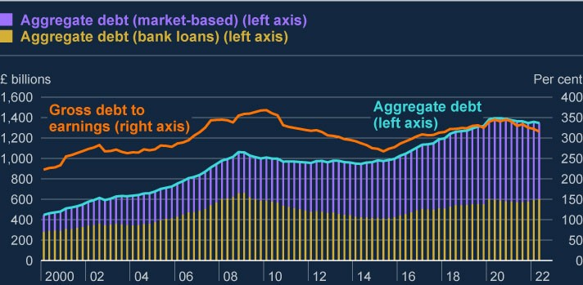

Sources: Association of British Insurers, Bank of England, Bayes CRE Lending Report (Bayes Business School

(formerly Cass)), Deloitte, Financing & Leasing Association, firm public disclosures, Integer Advisors estimates,

LCD an offering of S&P Global Market Intelligence, London Stock Exchange, ONS, Peer-to-Peer Finance Association, Eikon from Refinitiv and Bank calculations.

(a) These data are for private non-financial corporates, which exclude public, financial and unincorporated businesses. Earnings are defined as businesses’ aggregate gross operating surplus, adjusting for financial intermediation services indirectly measured.

Within the aggregate, there are however a number of companies with low liquidity, weak profitability or high leverage. These indicators are associated with a greater probability of corporate distress, and firms with these characteristics may also find it more difficult to refinance debt.

In particular, SMEs have more debt than prior to the Covid pandemic and their liquidity positions have fallen back in recent months. Total outstanding SME debt has increased by around 20% since 2019, and high debt payments and rising costs have started to run down SME cash buffers. The share of SMEs with less than seven days turnover in cash has fallen back to pre-Covid levels as firms have drawn down on liquidity built up through pandemic-era borrowing.

The significant and rapid tightening in corporate borrowing conditions over 2022 is putting additional pressure on indebted corporates. Corporate funding costs have increased; the effective rate on new lending from banks to private non-financial corporations (PNFC) is currently 3.8%, up from 2.0% at end-2021, and the highest seen since 2008. Similarly, the cost of new SME bank debt rose to 4.7% from 2.5% at end-2021.

In aggregate, corporates are now more reliant on debt sourced from financial markets than on bank funding, with the share of outstanding market-based debt rising to 55% of total corporate debt, up from 40% before the GFC (Chart 2.4). But the volume of market-based finance extended to UK corporates has fallen over this year as volatility and risk aversion in financial markets has risen, and uncertainty over the economic outlook has increased. Net sterling corporate bond issuance over 2022 has been materially lower than historic averages for investment-grade bonds and there has been no new sterling high-yield bond issuance since April (see Section 1). Furthermore, there has been no new leveraged loan issuance this year from firms with more than six times debt to earnings before interest, tax, depreciation and amortisation (EBITDA), with these companies having constituted around 10% of new issuance over 2020 and 2021. Collateralised loan obligation issuance has also remained lower over 2022 at around 60% of averages seen over recent years. This suggests riskier firms are finding it harder to access finance at an affordable price.

A significant contraction in the supply of corporate finance from banks or from financial markets would amplify pressures on businesses. Capital market investor deleveraging or large increases in the cost of borrowing and issuance would challenge corporate resilience, and push down on investment and employment, should firms be unable to roll over or refinance existing debt or issue new finance as needed at an affordable price. This risk is heightened for firms which would find it harder to access other sources of lending, such as SMEs which tend to be more reliant on bank relationships.

Vulnerabilities in the system of market-based finance can amplify financial stability risks through corporates. For example, large negative shocks to asset values, or episodes of rapid repricing, can force lenders to sell assets to generate liquidity. This can push down the price of corporate bonds and equities, further amplifying shocks and affecting corporate valuations and access to finance (see Section 4). There is evidence that these channels may already be affecting some sectors, for instance, UK commercial real estate investment trusts are currently trading at around a 25% discount, which is much greater than recent averages of around 5%. And ‘fallen angels’ – businesses that lose their investment grade status – might pose risks if investors are forced to sell their holdings of many such downgraded bonds at the same time (eg due to investment mandates to only hold investmentgrade debt, or higher capital charges associated with lower-rated bonds).

**Pressure on corporates’ ability to service debt has risen, and is expected to continue to increase into 2023. Some sectors will be especially vulnerable.**

Pressure on corporate earnings, combined with the rising cost of credit, will reduce companies’ ability to service debts. One of the ways that the FPC assesses corporate debt vulnerabilities is monitoring the debt-weighted proportion of companies with interest coverage ratios (ICRs) below 2.5, which is calculated by dividing a business’ earnings before interest and tax (EBIT) by its interest expense. Companies with ICRs below 2.5 are materially more likely to experience repayment difficulties. And as businesses experience distress, they are more likely to take defensive action such as cutting spending (eg investment or hiring). The aggregate debt-weighted share of corporates with ICRs of below 2.5 is estimated to have increased over 2022, primarily driven by increases in debt funding costs.

The deterioration in the UK macroeconomic outlook since the July 2022 FSR suggests that pressure on corporate earnings will continue into 2023 through increased input costs, reduced demand, and rising costs of servicing bank and market-based debt. More than 70% of corporate (including SME) bank loans are floating rate. This means that increases in Bank Rate are likely, on average, to flow through into corporate debt-servicing costs more quickly than for household debt, which over recent years has tended to be fixed rate. That said, larger corporates tend to be able to hedge against interest rate risk. Higher input costs and lower demand are expected to put further pressure on earnings for many businesses, especially those in sectors with large exposure to energy and fuel prices, or which provide non-essential household goods and services. Firms are able to mitigate these pressures by passing some cost increases through to consumers, but contacts of the Bank's Agents reported that companies saw reduced demand as a barrier to increasing prices further.

As a result, borrowers in the hardest hit sectors may have reduced capacity to repay loans. The share of corporates with low ICRs is expected to increase further into 2023, as credit conditions remain tight, input costs rise, and demand falls. Earnings and interest rate paths consistent with the November 2022 MPR imply that the debt-weighted share of corporates with ICRs below 2.5 could rise from 30% in 2022 to around 40% in 2023. This would remain, however, well below the GFC peak of over 50%.

The impacts of tightening financial conditions and higher input prices will be felt unevenly across sectors, bringing opportunities for some firms but putting significant financial pressure on others. Companies in the utilities and oil, gas and mining sectors have recorded strong increases in earnings, and the debt-weighted proportion of companies with low ICRs in these sectors is relatively low and projected to fall (see the purple bars in Chart 2.4). But companies in some other sectors will come under pressure. The fall in household real incomes could reduce demand significantly in sectors that provide non-essential household goods and services. And sectors with large exposures to energy or fuel prices, such as transport and manufacturing, could come under significant cost pressures. These factors will increase the share of firms with ICRs below 2.5 for firms in more vulnerable sectors.

**Chart 2.4: Impact of increases in debt costs and earning shocks are felt**

**unevenly across sectors**

Debt weighted share of large firms with an ICR below 2.5 at end-2022 Q1, and

projected share at end-2023 Q1, compared to GFC peaks

(

**a**

)

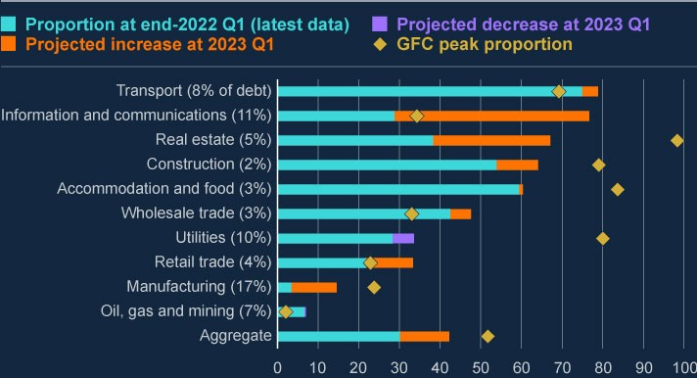

Sources: Moody’s BvD, S&P Global Market Intelligence and Bank calculations

(a) These data refer to UK PNFCs only. The purple bars on some sectors signify that these sectors are projected to see an improvement in the debt-weighted proportion of firms with low ICR. The projection applies the most severe shock to debt servicing costs, input energy prices, and earnings growth seen in the first year of the November 2022 MPR projections to end-2021 balance sheets. Not all sectors are shown in this chart so proportion of debt shown on the x-axis does not sum to 100. The ‘Aggregate’ bar refers to all UK PNFCs including those in sectors not shown.

**The risk that indebted corporates cut back on investment or employment sharply has increased. The risk that businesses will default on debt has also increased. Greater pressure on the corporate sector is not expected to pose material risks to the resilience of the UK banking system, but will leave businesses more vulnerable to future shocks.**

Corporates that struggle to service debt or are unable to roll over existing debt, including debt sourced through market-based finance, may reduce leverage in response. If deleveraging were to be associated with sharply reducing employment or investment this could be damaging to the economy and amplify economic downturns. For example, this would increase pressures on households through higher unemployment, and could have knock-on impacts to other businesses through supply chains.

SMEs pose a particular risk as they have increased their indebtedness over recent years, and also account for around 60% of UK private sector employment. There is evidence that SMEs that entered the GFC with higher leverage reduced investment more, and had lower employment growth over the following years.[5] Highly leveraged large companies also pose risks through these channels, particularly those operating in energy intensive sectors such as transport and manufacturing. These risks could also be triggered by refinancing challenges if financial markets remain closed for riskier and more highly leveraged borrowers.

The risk that businesses will default on debt has increased, with signs that business credit quality is already falling. Some firms may be able to respond to debt pressures through other actions, such as raising new equity, partial writedowns or debt restructuring. But other firms will be forced to default. The proportion of SME debt in arrears has increased to 2.4% from 2.0% over the past year, according to new data sourced by the Bank on two million limited company SMEs.[6]

Corporate insolvencies have risen above their pre-Covid levels and are expected to rise further over the coming quarters, reflecting the deteriorating economic outlook. Thus far however, the insolvency rate remains relatively low at 46 per 10,000 firms in Q3. This compares to historic peaks of 88 and 265 per 10,000 firms in 2009 and 1993, respectively. A large majority of the recent increase in insolvencies is among very small, younger businesses that hold little debt. And rising SME arrears are largely on government scheme debt, meaning banks will not face significant losses on these exposures.

The major UK banks’ strong capital and liquidity positions, supported by their current profitability, mean they are well placed to absorb shocks and continue meeting the credit needs of households and businesses, even if conditions are worse than forecast (see Section 3). For a number of years, the FPC has been stress testing major UK banks to severe domestic stress scenarios, involving much more significant rises in household and corporate defaults than expected based on

the November 2022 MPR forecast. The FPC continues to judge that major UK banks are resilient to the current economic outlook and have capacity to support lending.

Box B

:

Implications of mortgage market

developments for UK households

Mortgage rates have increased materially over 2022, with particularly rapid

increases in the second half of the year. The pricing of fixed rate mortgages

is closely related to overnight index swap (OIS) rates, which largely reflect

expectations for the path of Bank Rate. There has been a sharp increase in

the two-year OIS rate over 2022, which rose in September to over 5% but

has since fallen to 4.4%. This has fed through to higher mortgage rates. For

example, the average quoted rate for a new two-year fixed-rate 75% loan to

value (LTV) mortgage has increased to around 6%, compared with below 2%

over recent years (Chart A).

**Chart A: Average quoted mortgage rates have picked up sharply**

Average quoted rate on two-year fixed-rate mortgages at 75% and 90% LTV, and

the two-year OIS rate

(

**a**

)

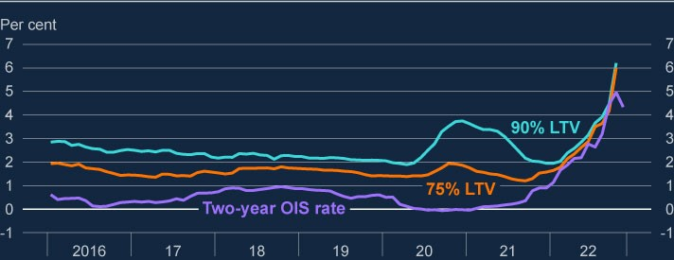

Sources: Bank of England, Eikon by Refinitiv and Bank calculations.

(

a) The Bank’s quoted rates series are weighted monthly average rates advertised by all UK banks and

building societies with products meeting the specific criteria. In February 2019 the method used to

[calculate these data was changed. For more information, see](https://www.bankofengland.co.uk/statistics/articles/2019/introduction-of-new-quoted-rates-data)

[‘](https://www.bankofengland.co.uk/statistics/articles/2019/introduction-of-new-quoted-rates-data)

[**Introduction of new Quoted Rate**](https://www.bankofengland.co.uk/statistics/articles/2019/introduction-of-new-quoted-rates-data)

[**s**](https://www.bankofengland.co.uk/statistics/articles/2019/introduction-of-new-quoted-rates-data)

[**data – Bankstats article**](https://www.bankofengland.co.uk/statistics/articles/2019/introduction-of-new-quoted-rates-data)

[**’**](https://www.bankofengland.co.uk/statistics/articles/2019/introduction-of-new-quoted-rates-data)

[. OIS rates are monthly averages of tw](https://www.bankofengland.co.uk/statistics/articles/2019/introduction-of-new-quoted-rates-data)

[o](https://www.bankofengland.co.uk/statistics/articles/2019/introduction-of-new-quoted-rates-data)

[‑](https://www.bankofengland.co.uk/statistics/articles/2019/introduction-of-new-quoted-rates-data)

[year OIS rates](https://www.bankofengland.co.uk/statistics/articles/2019/introduction-of-new-quoted-rates-data)

[.](https://www.bankofengland.co.uk/statistics/articles/2019/introduction-of-new-quoted-rates-data)

|  |
| --- |
| Around 30% of UK households have an owner-occupier mortgage, which is around eight and a half million households. Other things equal, the rise in mortgage rates will feed through to higher monthly payments for mortgagors. The last time rates increased significantly going into a period of household distress was in the early 1990s. Many households will not have experienced significant increases in their mortgage payments before, so may find it challenging to adjust to the higher costs.  Around 20% of owner-occupier mortgagors (or 1.7 million households) are on variable rate mortgages, which have interest rates that change with Bank Rate. These households are already experiencing higher mortgage costs. This share is significantly smaller though than it was before the 2008 and early 1990s recessions. At present, the impact on repayments for households currently on, or refinancing onto variable rates, is smaller than it is for those refinancing onto new fixed-rate mortgages.  Based on market interest rates at the end of November 2022, mortgagors currently on fixed rates set to expire by the end of 2023 are facing average monthly repayment increases of around £250 upon refinancing to a new fixed rate. For an average mortgagor household, this would mean that their monthly payments would increase from £750 to £1,000. That equates to around 17% of their average pre-tax income, up from 12% at the end of June 2022. Some mortgagors also have very low levels of savings, which means these households will only have a limited cushion against further shocks to their real incomes. Within the mortgagor population, those adversely affected by rate rises are typically younger, have lower incomes, and are the most leveraged.  In total, around half of owner-occupier mortgages (around four million) will be exposed to rate rises over the next year. This number includes those on variable rates, and those coming to the end of fixed-rate products during this period. Around a third of mortgagors, or 2.7 million households, are expected to face increases in monthly repayments of over £100 by end-2023, and around half by end-2025 (Chart B). |

Increases in monthly mortgage payments may lead to greater defaults on

mortgages, but also on other forms of credit such as credit cards and

unsecured loans, as well as sharp consumption cuts. Absent a significant

downward adjustment in house prices, the substantially higher mortgage

rates on offer will also make it more difficult for first time buyers to enter the

property market.

**Chart B: Over six million households, or 70% of owner-occupier**

**mortgagors, will experience monthly mortgage payment increases by**

**end-2025**

Number of mortgages which will experience increases in monthly mortgage costs

(

**a**

(

)

**b**

)

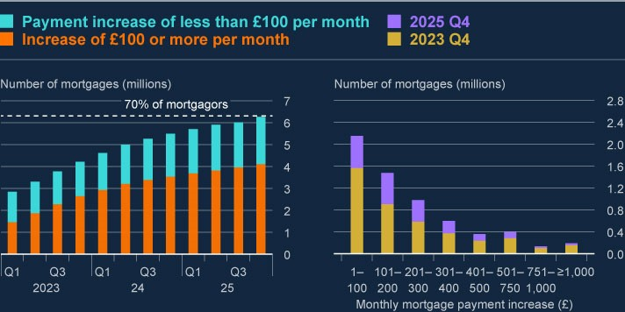

Sources: Bloomberg Finance L.P., FCA Product Sales Data and Bank calculations.

(

a) Numbers of mortgages exposed to rate rises includes those on variable rates (around 20% of

mortgagors, or 1.7 million households), and those rolling off fixed-rate contracts. Mortgages with less

than £1,000 outstanding are excluded. These data do not include buy-to-let mortgages or mortgages

that are off balance sheet of authorised lenders, such as securitised loans or loan books sold to third

parties.

(

b) Payment increases are calculated by applying market expectations for Bank Rate based on the OIS

curve as at 25 November 2022 to outstanding mortgages based on latest available data as at 30 June

2022

. Payments on variable-rate mortgages increase by the implied uplift in the OIS curve and

payments increase for fixed-rate mortgages by assuming that mortgagors refinance onto a typical fixed

rate at the point their fixed-rate contract ends.

|  |
| --- |
| Rising mortgage rates are putting downward pressure on house prices. UK house prices have risen substantially over recent years, but this growth has started to slow. The UK house price index remained unchanged between August and September, and more timely indicators such as Halifax, Nationwide and Rightmove data indicate that UK house price growth has slowed sharply over recent months. Contacts of the Bank’s Agents expect house price growth to continue to fall, primarily reflecting reduced affordability as a result of materially higher mortgage rates.  The behaviour of buy-to-let mortgagors is also likely to have an influence on house prices, and there is some uncertainty about how they will act. There are currently two million buy-to-let mortgages outstanding, which is around 8% of the housing stock. Buy-to-let mortgagors are particularly vulnerable to interest rate rises as around 85% of buy-to-let mortgages issued by major UK banks are interest only, so tighter financial conditions have a greater proportional impact. By end-2023, monthly repayments for buy-to-let mortgagors are forecast to rise on average by around £175, and around 20% of buy-to-let mortgagors will face increases of over £300.  One way landlords can meet these increased repayments is by passing on some costs. It is estimated that landlords would need to increase rental incomes by around 20% to offset the projected rise in buy-to-let mortgage costs. This would increase the cost of housing for renters, which may affect their resilience. This might lead them to default on unsecured credit, or cut consumption sharply, which could amplify the economic downturn.  Some landlords might choose to sell properties rather than bear the greater costs of mortgages, and evidence from the Bank’s Agents suggests that a growing number of buy-to-let landlords are choosing to sell properties, due in part to rising borrowing costs. If significantly large numbers of buy-to-let mortgagors choose to sell properties, this could place additional downwards pressure on house prices. Absent a change in landlord behaviour through selling properties or passing on costs, around 15% of buy-to-let mortgagors will have interest coverage ratios (ICRs) of less than 125% (the current |

|  |
| --- |
| industry standard for affordability of buy-to-let mortgages) by the end of 2023, rising to around a fifth by the end of 2025. The current share of buy-tolet mortgagors with an ICR below 125% is just 3%. |

# 3: The resilience of the UK banking system

The FPC continues to judge that the UK banking system is resilient to the current economic outlook and has capacity to support lending, even if conditions are worse than forecast. Major UK banks’ and building societies’ (‘major UK banks’) capital and liquidity positions remain strong and preprovision profitability has increased. They are therefore well placed to absorb shocks and continue meeting the credit needs of households and businesses. Banks’ profitability was largely driven by growth in their net interest income (NII), which itself largely reflects higher interest rates. In aggregate, smaller lenders are also well capitalised and have strong liquidity positions.

Asset quality remains relatively strong. Major UK banks’ provisions have increased somewhat in 2022 as banks have recognised impairments in anticipation of credit losses, but their provision coverage remains below recent averages. There is evidence that the major UK banks are tightening their lending standards by adjusting their appetite for lending to riskier borrowers as risks have increased, consistent with the worsening macroeconomic outlook. Credit demand is also likely to fall as a result of higher interest rates and the weaker and more uncertain macroeconomic outlook. Excessive restrictions on lending would prevent creditworthy households and businesses from accessing funding. This would be counterproductive, harming both the wider economy and ultimately the banks themselves. The FPC will continue to monitor UK credit conditions for signs of unwarranted tightening.

Alongside its role providing credit to the real economy directly, the UK banking system also supports the provision of market-based finance (MBF) to the real economy. While the banks’ role in facilitating market-based finance can provide them with significant additional sources of revenue, it can also expose them to additional risks. Those include counterparty credit risks, which can increase in response to abrupt tightening in financing conditions and higher volatility, leading to potential losses.

Following the recent dysfunction in the gilt market and stress in liability-driven investment (LDI) funds, the FPC welcomed the Bank’s plans for a temporary and targeted programme of purchases of long-dated UK government bonds to restore market functioning. Absent this intervention, the dysfunction would have likely resulted in further contagion from the system of MBF to banks and the real economy. In turn this would have led to an unwarranted tightening of financial conditions and a reduction in the flow of credit to households and businesses.

The FPC has previously judged that the UK banking system is resilient to a wide range of severe economic outcomes and it continues to regularly assess its resilience to severe but plausible scenarios through its regular stress tests. Most recently, the FPC has, alongside the Prudential Regulation Committee (PRC), launched the 2022 annual cyclical scenario (ACS) stress test which incorporates a severe macroeconomic scenario featuring higher interest rates globally, a related traded risk scenario, and a misconduct stress. The results of the test will be published in Summer 2023 and, along with other relevant information, will be used to help inform banks’ capital buffers (both the UK countercyclical capital buffer (CCyB) rate and the Prudential Regulation Authority (PRA) buffers).

This quarter, the FPC agreed to maintain the UK CCyB rate at 2%, due to come into effect on 5 July 2023. Maintaining a ‘neutral’ setting of the UK CCyB rate in the region of 2% helps to ensure that banks continue to have sufficient capacity to absorb unexpected future shocks without restricting lending in a counterproductive way.

## 3.1: Recent developments in UK banks’ capital, liquidity, and profitability

**UK banks’ capital and liquidity positions remain strong.**

The major UK banks remain well capitalised with an aggregate Common Equity Tier 1 (CET1) capital ratio of 14.2% in 2022 Q3 (Chart 3.1).[7] The aggregate CET1 capital ratio has fallen back over 2022, in part as a result of a range of regulatory changes, rather than falls in major UK banks’ capital resources.

**Chart 3.1: Major UK banks’ CET1 capital ratios remain far higher than before**

**the global financial crisis, although they have decreased over 2022, in part**

**due to regulatory changes**

Changes in the aggregate CET1 capital ratio of the major UK banks

(

**a**

)

(

**b**

)

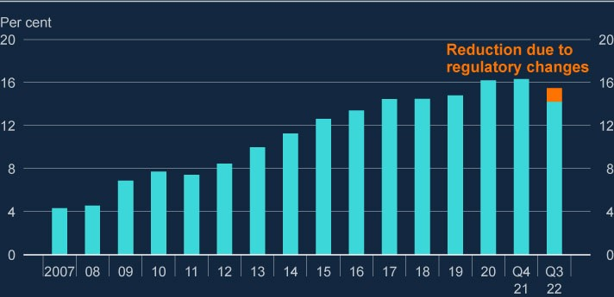

Sources: PRA regulatory returns, published accounts and Bank analysis and calculations.

1. The CET1 capital ratio is defined as CET1 capital as a percentage of risk-weighted assets (RWAs). Themajor UK banks are Barclays, HSBC, Lloyds Banking Group, Nationwide, NatWest Group, Santander UK, Standard Chartered, and from end-2020, Virgin Money UK. Prior to 2011, the chart shows Bank estimates of banks’ CET1 ratios.
2. Capital figures are year-end, except 2022 Q3.

These changes include adjustments related to the implementation of hybrid modelling of risk-weighted assets for mortgages and a stricter treatment of intangible assets for regulatory capital. When fully implemented, the change to mortgage risk-weight modelling means that mortgage risk-weights should increase by less in a downturn than they otherwise would have done, which should dampen the impact on banks’ risk-weighted capital ratios.

Following a period of volatility during the Covid pandemic, where the major UK banks built up capital positions by reducing or ceasing distributions to shareholders, they have been managing down their capital to their publicly stated targets through such distributions. The banks are now broadly at, or close to, these targets and their aggregate CET1 capital ratio has remained unchanged since the July 2022 Financial Stability Report was published.

Banks also maintain strong liquidity positions. Major UK banks’ aggregate threemonth rolling average Liquidity Coverage Ratio (LCR) stood at 144% (representing average liquid asset buffers of just over £1.4 trillion) in 2022 Q3, around its average level since 2015.

Banks are also required to ensure they maintain a stable funding profile that covers the duration of their long-term assets under the requirements of the Net Stable Funding Ratio (NSFR). Since 2022 Q1, the finalised reporting regime for the NSFR has been in operation and the major UK banks have maintained an aggregate NSFR of 137% on average.

In aggregate, smaller UK lenders are also well capitalised and have strong liquidity positions, with a weighted-average CET1 capital ratio of 18.3% and a weighted average LCR of 230%.

**Major UK banks’ capital positions have been supported by a rise in preprovision profits relative to 2021, largely driven by expanding lending margins.**

Banks’ pre-provision profitability influences their ability to absorb losses as they arise, by supporting their capital positions over time. The major UK banks have earned year-to-date pre-provision profits of £41 billion, a 29% increase compared to the same period in 2021. Should pre-provision profitability continue to support banks’ capital positions, then it should bolster their ability to supply credit, as well as offsetting impairments as they arise.

Banks’ recent profitability reflects increases in their NII. Banks earn NII by receiving higher interest on assets, such as loans, than they pay out on liabilities, such as deposits. Total NII earned by the banks is the product of the net interest margin (NIM) they earn on interest bearing assets, and the total volume of these assets the bank has available. The increase in NII has been driven primarily by higher policy and market interest rates, which have allowed banks to increase NIMs, as well as by strong lending growth. NIMs typically increase as interest rates rise since the interest banks pay on their liabilities (such as current account balances) is typically less sensitive to policy and market interest rates than the interest they receive on their assets.

The average margin on major UK banks’ lending across all currencies fell at the start of the global financial crisis and they fluctuated around a broadly flat level between 2011 and 2019. The average margin then fell again between 2019 and end-2020 due to the major UK banks reducing their typically higher-margin unsecured retail lending and further falls in global interest rates at the start of the Covid pandemic.

Since end-2021, the average margin has partially recovered, reaching 2.9% in 2022 Q3, largely as a result of the higher interest rate environment. It is now above its post global financial crisis (2011–19) average, but below levels observed before the start of the crisis (Chart 3.2).

**Chart 3.2: The average loan margin on major UK banks’ lending margins has**

**increased with recent interest rate rises**

Evolution of the average margin on major UK banks’ lending since 2005

(

**a**

)

(

**b**

)

(

**c**

)

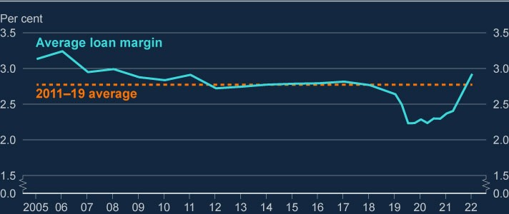

Sources: Published accounts, Refinitiv Eikon and Bank calculations.

1. Loan margin is calculated as net interest income received on lending, divided by total lending. Loan marginsin this chart are calculated across all currencies. Net interest income is income from loan interest minus funding costs.
2. Figures between 2005 and 2019 exclude Virgin Money UK.
3. Figures from 2020 Q1 onwards are annualised loan margin per quarter.

Market measures of major UK banks’ future profitability, such as their average price to tangible book (PtTB) ratio, have increased recently but remain subdued at around 0.7x, despite the recent improvement in pre-provision profits.[8] The relatively small positive impact on banks’ persistently low PtTB ratios might reflect concerns that current higher interest margins and profitability could be a short-term phenomenon that may be competed away over time. More broadly it could reflect a negative view of the UK economic outlook, driving investors to demand a higher risk premium for holding UK assets. By contrast, US banks’ average PtTB ratios have remained broadly around 1.5x since the start of 2022.

**Asset quality remains relatively strong. Major UK banks’ provisions have increased somewhat in 2022, as banks have recognised impairments in anticipation of credit losses, but their provision coverage remains below recent averages.**

The share of non-performing loans on major UK banks’ books remains in line with its historical average and significantly below highs observed during the global financial crisis and previous recessions. That said, some forward-looking indicators of asset quality have deteriorated recently. For example, the proportion of loans in International Financial Reporting Standard 9 stage 2 (classed as being at heightened risk of default) has increased from 9.5% to 10.7% since the start of 2022.

On the household side, arrears on variable-rate mortgages and on some unsecured lending portfolios have also started to increase over 2022, albeit from a low level.

And on the corporate side, market intelligence suggests the major UK banks have also seen increased numbers of corporates needing to restructure their debt due to financial difficulties. However, the major UK banks have not yet reported a material increase in the value of corporate lending in default. Small and medium-sized enterprises (SMEs) are typically more likely to default than larger corporates, and the proportion of SME debt in arrears has increased significantly over the past year.

The major UK banks will be shielded to some extent, particularly from increasing

SME defaults, as rising SME arrears are largely on debt extended with a Government guarantee (see Section 2).

Some forms of lending are more exposed to losses – for example, buy-to-let (BTL), higher loan to value (LTV) and loan to income mortgages, and lending to lowerrated and more highly leveraged corporates. Lenders that are more concentrated in these types of lending are therefore also more exposed to losses.

Banks’ impairments on loans are based on the evolution of their expectations of credit losses. This reflects both backward-looking measures such as payment arrears and information about household and business finances, as well as forward-looking measures, such as expectations about the outlook for the economy. The major UK banks have reported around £4.5 billion of impairments since the start of 2022, currently below their pre-pandemic level of around £5.2 billion over an equivalent period in 2019.

Impairments flow through to banks’ stock of provisions against expected losses. Major UK banks’ current provisions are around 1% of their total outstanding lending, a slight increase relative to 2022 Q2, but still below their average level between 2015 and 2019 (Chart 3.3).

**Chart 3.3: Major UK banks’ provisions as a proportion of total lending has**

**increased in 2022 Q3, although provisions remain below their pre-pandemic**

**level**

Evolution of major UK banks’ stock of provisions since 2019 as a proportion of total

lending, compared to its average between start-2015 and end-2019 and evolution of

provisions split by asset class

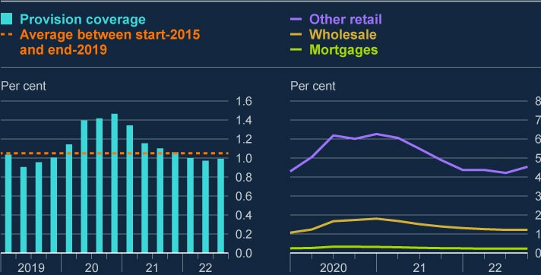

Sources: PRA regulatory returns, S&P Capital IQ and Bank calculations.

The current, relatively low, level of provisions reflects the healthy LTV profile of [banks’ mortgage exposures, which has benefited from significant **house price**](https://www.bankofengland.co.uk/financial-stability-paper/2022/how-much-of-the-housing-price-increase-during-covid-was-driven-by-a-change-in-household-preferences)

[**growth since 2020** . Banks have increased their provisions in most other asse](https://www.bankofengland.co.uk/financial-stability-paper/2022/how-much-of-the-housing-price-increase-during-covid-was-driven-by-a-change-in-household-preferences)t

classes relative to their pre-pandemic levels (Chart 3.3).

An increasing number of borrowers are likely to struggle to continue servicing their debt as the macroeconomic outlook worsens, particularly given pressures from higher food and energy prices and interest rates on their finances (see Section 2).

Reflecting this possibility, consensus forecasts are for banks’ impairments to rise to around £11 billion per year in 2023 and 2024.[9] There is a risk that impairments may increase further than expected, if economic developments are more adverse than currently expected in the Monetary Policy Committee’s latest projections. In particular, if unemployment increases to a higher peak than expected, impairments on unsecured lending could be materially higher than currently anticipated.

**The FPC continues to judge that the UK banking system is resilient to the current economic outlook and have capacity to support lending, even if conditions are worse than forecast.**

The major UK banks have strong capital positions, supported by their current profitability, and are therefore well placed to absorb shocks and to continue meeting the credit needs of households and businesses, even if conditions are worse than forecast.

The outlook for major UK banks’ capital positions and profitability, implied by consensus forecasts, suggests that the further expected increases in credit losses will not impact on banks’ capital positions. Instead they are likely to be absorbed by the banks’ profits. Impairments would need to increase materially above current expectations before they started to adversely impact on major UK banks’ capital positions.

Consensus forecasts, and intelligence from the major UK banks, suggest that growth in their net lending will slow significantly over the next two years. This is likely to be driven by both the banks tightening credit supply, and a reduction in demand for credit over the period.

There is evidence that the major UK banks are tightening their lending standards by adjusting their appetite for lending to riskier borrowers as risks have increased, consistent with the worsening macroeconomic outlook. For example, market intelligence suggests they are tightening their affordability testing on their new mortgage lending, as well as reducing their appetite for high LTV mortgage lending. Moreover, they have already begun reducing lending to corporates that are more exposed to risks from the deteriorating macroeconomic outlook, as well as to smaller SMEs in general.

Credit demand is also likely to fall as a result of higher interest rates and the weaker and more uncertain macroeconomic outlook. During periods of macroeconomic contraction and uncertainty, businesses are likely to delay or cancel investment and households are likely to put off buying homes or making other large purchases, reducing the demand for credit (see Section 2). Market intelligence further suggests there has been a significant drop in demand for new mortgage lending, including a sharp drop in demand for BTL mortgages.

Major UK banks’ capital and liquidity positions, supported by recent profitability, mean they are well placed to absorb shocks and continue meeting the credit needs of households and businesses. Excessive restrictions on lending would prevent creditworthy households and businesses from accessing funding. This would be counterproductive, harming both the wider economy and ultimately the banks themselves. The FPC will continue to monitor UK credit conditions for signs of unwarranted tightening.

## 3.2: Risks from banks’ interlinkages with market-based finance

**Alongside its role providing credit to the real economy directly, the UK banking system also supports the provision of MBF.**

Banks provide a range of services facilitating the provision of financing to the real economy through the system of MBF. For example, banks with investment banking operations underwrite corporate bond and equity issuance and provide financing for corporate mergers and acquisitions such as in leveraged buyouts. They also provide broader services to non-bank financial institutions (NBFIs), such as prime brokerage services.

Other banks without investment banking operations also facilitate MBF. Many of the major UK banks are involved in supplying liquidity to NBFIs, for example, by intermediating markets NBFIs are active in, such as the gilt repo market.

**Banks’ role in facilitating MBF can provide them with significant additional and diversified sources of revenue, but it can also expose them to additional risks.**

As seen during the period of heightened market volatility in 2020, these revenue streams can sometimes increase significantly during a stress, particularly client fees related to trading activity, for example. But returns on these operations can be volatile, as demonstrated by the fact that income from loan syndication and underwriting has fallen in 2022, driven by persistently weak issuance and underwriting conditions.

Banks involved in facilitating MBF are exposed to additional risks, which could lead to potential losses if not managed well (Figure 3.1).

**Counterparty credit risk.** Banks operating in the UK hold around £1.5 trillion of exposures to NBFIs globally, split roughly evenly between lending (including gilt repo and other securities financing transactions) activities and derivatives. Following post global financial crisis reforms to the derivatives market, many derivative exposures are now centrally cleared, while the remaining bilateral exposures are usually collateralised. Nevertheless, these exposures tend to spike in value at the outset of a stress due to increased volatility, and often resulting in large margin calls for NBFIs. There is a continuing body of work both domestically and internationally to improve the resilience of liquidity supply and improve margin practices (see Section 4).

**Mark-to-market losses**. These could arise on banks’ own holdings of assets that are also widely held as collateral if those assets are subject to a fire sale, for example to liquidate collateral after a counterparty default. They could also arise for banks that continue to intermediate markets in which NBFIs are active during periods of extreme volatility, as the banks could be left with a large value of assets on their balance sheets that may be falling in value. Similarly, banks can incur these types of losses on their loan origination, underwriting, and syndication activity in leveraged lending markets. If appetite for riskier credit declines, for example as financial conditions tighten, banks may be left holding assets which are falling in value on their balance sheets, that they are no longer able to securitise.

**Liquidity and funding stress**. As of end-2021, the major UK banks sourced around £850 billion of repo and deposit funding from NBFIs, with repo accounting for 35% of this. Data from their 10 largest sources of funding suggests that the majority of their repo funding had maturity of three months or less. Stress in short-term funding markets can make it more difficult and costly for banks to fund themselves and can also impact their cost of capital. These risks are partly mitigated, however, by major UK banks’ reserves of high-quality liquid assets, and their ability to access central bank liquidity facilities.

**Figure 3.1: Stress in financial markets could propagate to banks through**

**their interlinkages with MBF**

Interlinkages between banks and MBF

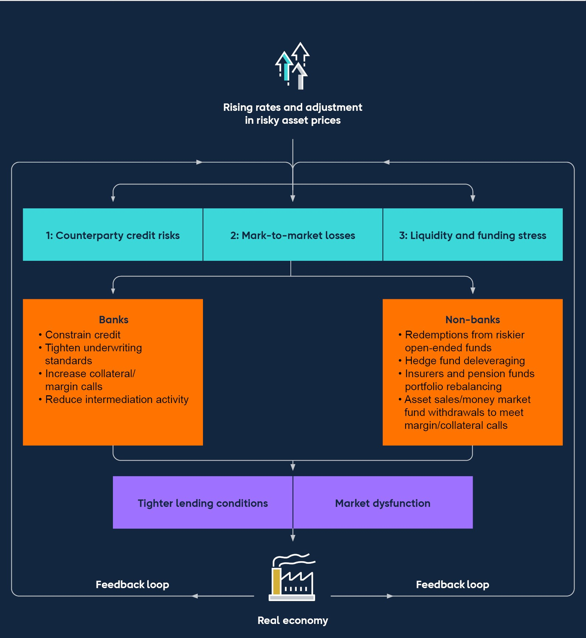

While many of these risks are reflected in existing regulatory frameworks, in some cases they can still have a material impact on banks. For example, in part due to inadequate margining practices and weak risk management, the Archegos default resulted in around US$10 billion of losses spread among global investment banks with exposures to the firm.

The potential increase in liquidity demand, and the large-scale fire sale of assets to meet it, could be exacerbated by pre-existing vulnerabilities in the system of MBF. In response to such a shock affecting the system of MBF, the major UK banks could take a range of defensive actions (Figure 3.1). The key role banks play in facilitating the system of MBF means that doing so would likely exacerbate a stress on NBFIs, and reduce the supply of credit to corporates through MBF even further.

This could ultimately have knock-on effects on the banks’ own resilience.

**Banks could reduce their willingness to supply liquidity to NBFIs**. Activity in some bank-intermediated markets is concentrated among a small number of banks. For example, the four banks offering the largest prime brokerage services in the repo market account for around 75% of repo provision to hedge funds. Banks are also significant counterparties of LDI funds in the gilt repo market, with around £200 billion of outstanding repo lending to these counterparties alone.

Practices around requesting extra collateral vary between banks. Some may seek to **increase collateral requirements or call for additional margin** from NBFIs during a stress. For example during the recent dysfunction in the gilt market, banks required LDI funds to meet additional margin calls as their net asset value decreased (see Section 5). And during the 2022 H1 commodity market disruption, numerous banks that provide clearing services to NBFIs increased their multipliers on clients’ margin requirements for cleared trades. Should fire sales of widely held assets occur to meet additional margin calls, banks could incur further mark-to-market losses on their own holdings of these assets.

More broadly, banks could **reduce their risk appetite for lending to NBFIs**. This may hinder NBFIs’ ability to lend to their own counterparties, which would likely tighten further credit conditions in corporate debt markets. In turn, this could increase pressure on corporates that rely on NBFIs for their financing needs, particularly if they are unable to source alternative financing, and they may default on their borrowing.

## 3.3: The outlook for UK banks’ resilience

**The FPC has previously judged that the UK banking system is resilient to a wide range of severe economic outcomes, and is assessing banks against a further severe shock in the 2022 ACS.**

The FPC regularly assess the resilience of the UK banking system to a wide range of severe but plausible scenarios with its stress-testing framework. Most recently, the FPC judged the system to be resilient to the scenario in the 2021 Solvency Stress Test, which highlighted that the major UK banks had sufficient capital to continue meeting the credit needs of the UK economy through a severe economic scenario.

The FPC continues to assess the resilience of the UK banking system against such severe shocks. It has, alongside the PRC, launched the 2022 ACS which incorporates a severe macroeconomic scenario featuring higher interest rates globally, a related traded risk stress, and a misconduct stress (see Box C). The results of the test will be published in Summer 2023 and, along with other relevant information, will be used to help inform the setting of banks’ capital buffers (both the UK CCyB rate and the PRA buffers).

This quarter, the FPC agreed to maintain the UK CCyB rate at 2%, due to come into effect on 5 July 2023. Maintaining a neutral setting of the UK CCyB rate in the region of 2% helps to ensure that banks continue to have sufficient capacity to absorb further unexpected shocks without restricting lending in a counterproductive way.

|  |
| --- |
| Box C: The 2022 annual cyclical scenario  **On 26 September, the Bank of England (the Bank) launched its 2022 annual cyclical scenario (ACS) stress test.**[10] This represented a return to the Bank’s ACS stress-test framework following two years of Covid pandemic crisis-related stress testing, and the decision to postpone the test in March 2022 following Russia’s invasion of Ukraine. The 2022 ACS will test the resilience of the UK banking system to deep simultaneous recessions in the UK and global economies, large falls in asset prices and higher global interest rates, and a separate stress of misconduct costs.  The eight banks taking part in the 2022 ACS account for around 75% of lending to the UK real economy.[11] For the first time in the ACS framework, the Bank is including selected ring‑fenced bank subgroups of the existing stress-test participants on a stand-alone basis.[12]  The stress applied under the ACS is not a forecast of macroeconomic and financial conditions in the UK or abroad. It is not a set of events that is expected, or likely, to materialise. Rather, as per previous ACS exercises, it is a coherent ‘tail risk’ scenario designed to be severe and broad enough to assess the resilience of UK banks to a range of adverse shocks.  In line with previous exercises, the 2022 ACS contains three types of stress, which are assumed to be synchronised:  **A UK and global macroeconomic stress**, spanning a five-year period from 2022 Q3 to 2027 Q2.  **A traded risk stress**, linked to a financial market scenario consistent with the content and calibration of the macroeconomic stress.  **A misconduct costs stress**, where banks will be assessed against potential misconduct fines and other costs beyond those already paid or provisioned for. |

|  |
| --- |
| Overview of the scenario  While previous stress tests have incorporated scenarios involving higher interest rates in the UK, the 2022 ACS also tests UK banks’ resilience to higher global interest rates in the face of a series of global cost shocks and high and persistent global inflation. In the scenario, annual UK inflation peaks at 17% before slowly returning towards the 2% target. Bank Rate is assumed to rise rapidly to 6% in early 2023 before later being reduced gradually to under 3.5%. The Federal Reserve and the European Central Bank also increase policy rates by a similar magnitude in the stress.  Across a range of indicators, the stress scenario is more severe than the global financial crisis as weaker household real income growth, lower confidence and tighter financial conditions result in severe domestic and global recessions (Table 1). UK GDP contracts significantly, unemployment more than doubles, and residential property prices fall sharply. The effects of rising costs disproportionately impact low-income borrowers and importintensive businesses. Global economies also experience a severe shock with a significant contraction of world GDP. |

|  |  |  |  |  |  |  |  |  |  |  |  |  |  |  |  |  |  |  |  |  |  |  |  |  |  |  |  |  |  |  |  |  |  |  |  |  |
| --- | --- | --- | --- | --- | --- | --- | --- | --- | --- | --- | --- | --- | --- | --- | --- | --- | --- | --- | --- | --- | --- | --- | --- | --- | --- | --- | --- | --- | --- | --- | --- | --- | --- | --- | --- | --- |
| **Table 1: The stress scenario is broadly similar to the 2019 ACS and more severe overall than the global financial crisis**  **Changes in key variables (a) (b) (c) (d)**   |  |  |  |  | | --- | --- | --- | --- | | **Variable** | **2022 ACS** | **2019 ACS** | **Global financial crisis** | | UK real GDP | -5.0% | -4.7% | -5.9% | | World real GDP | -2.5% | -2.6% | -1.9% | | UK unemployment (change) | 4.7% | 5.2% | 3.2% | | UK unemployment (peak level) | 8.5% | 9.2% | 8.4% | | UK residential property prices | -31% | -33% | -17% | | UK commercial real estate prices | -45% | -41% | -42% | | UK Bank Rate | 5.1% | 3.3% | -5.2% | | UK equity prices | -45% | -41% | -40% |   Sources: Bank of England, Bloomberg Finance L.P., Eikon from Refinitiv, Eurostat, Halifax/Markit, IMF World Economic Outlook, MSCI Investment Property Databank, National Bureau of Statistics of China, Nationwide, ONS, US Bureau of Economic Analysis and Bank calculations.   1. Data are quarterly or quarterly averages. 2. Figures for 2022 and 2019 ACS show start-to-trough changes. Figures for the global financial crisisare peak to trough. 3. Global financial crisis data for UK residential property prices are a combination of the quarterlyHalifax/Markit and Nationwide house price indices. 4. Bank Rate figures show the start-to-peak change for 2022 ACS, and the start-to-trough change forthe global financial crisis.   Global financial conditions tighten significantly as central banks tighten monetary policy. Equity prices fall and corporate bond spreads rise, reflecting an increase in risk aversion, increased perceptions of risk and weaker corporate profitability. |

|  |
| --- |
| The traded risk scenario is consistent with the macroeconomic scenario and takes account of the liquidity of banks’ trading book positions. This will principally affect the investment banking operations of UK banks. The traded risk element of the test will also capture the main risks to stress-test participants from lending to large highly leveraged companies.  The FPC and the Prudential Regulation Committee (PRC) judged the scenario to be appropriately calibrated in light of the FPC’s assessment of the underlying level of risks and vulnerabilities in the UK and global economies and financial markets in the July Financial Stability Report. The Committees also took account of downside risks facing UK and global economies as well as the heightened uncertainty in the months prior to the launch.  [Further information on the scenario can be found in the **Key Elements of**](https://www.bankofengland.co.uk/stress-testing/2022/key-elements-of-the-2022-stress-test)  [**the 2022 Stress Test.**](https://www.bankofengland.co.uk/stress-testing/2022/key-elements-of-the-2022-stress-test)  Using the results of the 2022 ACS  The FPC and PRC will use the test to assess the resilience of bank balance sheets as well as that of the UK banking system. The Bank aims to ensure that banks have the ability to withstand adverse scenarios while continuing to support households and businesses.  A key determinant of whether a bank may be required to take action to strengthen its capital position in light of the ACS results is how far its riskweighted Common Equity Tier 1 capital ratio and Tier 1 leverage ratio fall in the stress. Each bank has a level of capital – or hurdle rate – that they are expected to maintain in the test.  Banks that fall below their hurdle rate will generally be required to take action to strengthen their capital position, if they have not already done so.  The aggregate system-wide impact on banks’ capital ratios of the UK economic part of the stress can also be used by the FPC to help calibrate the setting of the UK countercyclical capital buffer rate, which is applicable to banks’ UK exposures. |

|  |
| --- |
| As in previous tests, however, there is no mechanical link between the stress-test results and the setting of individual bank or system-wide capital buffers, with other factors such as the FPC’s assessment of prevailing conditions also taken into account. Nor is the stress test a mechanical pass/fail regime.  As part of the annual stress test, the Bank also conducts a review of participants’ stress-testing practices. The findings of that qualitative review are then fed back to banks. The Bank expects participants to demonstrate sustained improvements in their capabilities over time.  The results of the 2022 ACS will be published in Summer 2023. |

# 4: The resilience of market-based finance

|  |
| --- |
| Market-based finance (MBF) is the system of markets, non-bank financial market participants, and infrastructure which, alongside banks, provides credit and other critical financial services to support the wider UK and global economies. Since the global financial crisis, the importance of MBF has grown. This means that it needs to be resilient so it can absorb, and not amplify, economic shocks. The FPC therefore regularly assesses its resilience.  Vulnerabilities in MBF have crystallised during several stress episodes in recent years.  The ‘dash for cash’ in March 2020 showed how sudden spikes in liquidity needs during a stress can be amplified by vulnerabilities in MBF, and led to core market dysfunction and the need for significant central bank intervention.  High levels of hidden leverage through equity derivatives was a key factor in the default of Archegos in March 2021, leading to sizeable losses for banks.  Significant volatility in commodity markets earlier this year highlighted vulnerabilities in these markets, with unexpected and sharp increases in margin requirements. Hidden concentration risks in commodity derivatives markets contributed to extreme price spikes in nickel markets specifically.  Most recently, the episode involving liability-driven investment (LDI) funds demonstrated how market moves can be amplified by vulnerabilities in MBF, creating material risks to financial stability and requiring action to be taken in response (see Section 5).  Over 2023, international and domestic regulators urgently need to develop and implement appropriate policy responses to address the risks from MBF, as highlighted in these episodes. The Financial Stability Board (FSB) has a comprehensive international work programme in train focused on increasing the resilience of money market funds and open-ended funds; improving |

margin practices and understanding drivers of illiquidity in core funding markets; and addressing the risks arising from leveraged non-bank investors, building on the lessons of Archegos and the LDI fund episode. This work programme is developing policy actions to help address identified vulnerabilities. The Bank and FPC continue to support strongly the programme of international work.

Until this policy work is complete – and the policy responses agreed and implemented across different jurisdictions – the underlying risks remain significant and could resurface. In particular, the sharp transition to higher interest rates and currently high volatility increases the likelihood that MBF vulnerabilities crystallise and pose risks to financial stability. International and domestic regulators therefore need to develop and implement appropriate policy responses to address these risks urgently.

Alongside this international work, the Bank will continue to assess and respond to vulnerabilities domestically where it is effective and practical, for example in the context of LDI funds. To support this, there is a need to develop stress testing approaches to understand better the resilience of nonbank financial institutions (NBFIs) to shocks and their interconnections with banks and core markets. The Bank will run, for the first time, an exploratory scenario exercise focused on NBFI risks, to inform understanding of these risks and future policy approaches. Further details will be set out in the first half of 2023.

## 4.1: The importance of market-based finance

**Market-based finance plays a key role in the global and UK financial systems.**

MBF is the system of markets, NBFIs and infrastructure, which, alongside banks, provides financial services to support the wider UK and global economies. Such services include providing credit, intermediating between saving and investment, insuring against and transferring risk, and offering payment and settlement services. Between the start of the global financial crisis and end-2020, the nonbank financial system more than doubled in size, compared to banking sector growth of around 60%. As a result of this growth, non-banks now account for around half of the total assets making up the global financial system.

There are significant interlinkages between different NBFIs, and between NBFIs and the banking system (see Section 3). These interlinkages are frequently across borders, as NBFIs often serve jurisdictions outside those they are domiciled in. For example, over 90% of sterling-denominated money market funds (MMFs) by asset value are domiciled in Luxembourg and Ireland. The global nature of the system of MBF adds to its complexity and makes addressing vulnerabilities more challenging.

Some markets are critical to the smooth functioning of the UK financial system. For example, UK government bonds (‘gilts’) are an instrument through which the UK Government raises finance. Government bond yields act as a benchmark for other borrowing rates for households and businesses and, because of gilts’ widespread use as collateral, the market is vital to the functioning of financial markets more broadly and the transmission of monetary policy. Repo markets – in which gilts are commonly used – are another crucial part of the system of MBF, facilitating the flow of cash and securities around the financial system. They facilitate the low-risk investment of cash, as well as the efficient management of liquidity and collateral by market participants. MBF also plays an important role in facilitating corporate lending. As of end-2021, MBF accounted for £776 billion (around 55%) of all lending to UK businesses, and nearly all of the almost £390 billion net increase in lending to UK businesses between end-2007 and end-2021.

The system of MBF is therefore important to the UK economy and UK financial stability. This importance has grown with the size of the non-bank financial sector in recent years. Risks in the system of MBF can stem from highly concentrated markets, interconnections between market participants, and correlated behaviour by these market participants, particularly under stress. These risks are amplified by existing vulnerabilities in NBFIs, for example related to leverage and liquidity mismatch, which can lead to forced selling. A materialisation of these vulnerabilities can amplify shocks to households and businesses by causing dysfunction in the core markets that are critical to the smooth functioning of the financial system and tighter financial conditions. Interlinkages between banks and non-banks can also propagate shocks through the real economy.

## 4.2: International work to improve the resilience of marketbased finance

**Tightening financial conditions and greater volatility, alongside a number of economic shocks, have caused long-standing vulnerabilities in MBF to crystallise in recent years, most recently in LDI funds.**

The recent market stress faced by LDI funds exposed vulnerabilities in the core funding markets set out by the FPC in July 2021, creating a material risk to UK financial stability (see Section 5). In particular, it was an example of the contagion risks that can stem from leveraged non-bank investors and illiquidity in some core markets (eg long-dated index-linked gilts).

The FPC, and financial stability authorities globally, have previously identified broader underlying vulnerabilities, a number of which have crystallised in other recent periods of market volatility:

The ‘dash for cash’ in March 2020 demonstrated the importance of ensuring the system of MBF is resilient enough to manage liquidity risk in times of stress. It showed how a combination of liquidity mismatch in money market funds and open-ended funds, margin practices and leveraged investors that are forced to unwind their positions, can lead to core market dysfunction.

High levels of hidden leverage through equity derivatives was a key factor in the default of Archegos in March 2021, and highlighted the transmission channels through which the behaviour of leveraged investors can affect both markets and the banking sector.

In the early stages of Russia’s illegal invasion of Ukraine, significant volatility in commodity markets highlighted a number of vulnerabilities in these markets, similar to those in MBF. Unexpected and sharp increases in margin requirements – which were essential for reducing counterparty credit risk – created challenges for some market participants to raise the liquidity to meet them. Hidden concentration risks in commodity derivatives markets led to extreme price spikes in nickel markets specifically. This threatened the safety and soundness of some market participants, while transmitting stress to other counterparties and the broader market.

These episodes underline the need to develop and implement policy reforms to [increase resilience across the system of MBF. The Bank issued **a report on the**](https://www.bankofengland.co.uk/report/2021/assessing-the-resilience-of-market-based-finance)

[**resilience of market-based finance in July 2021** setting out three areas of foc](https://www.bankofengland.co.uk/report/2021/assessing-the-resilience-of-market-based-finance)us:

Preventing undue rises in the demand for liquidity in stress periods. This includes work with the FSB to manage the risks from liquidity mismatch in openended funds, and to build understanding of the risks leveraged non-bank investors and margining practices could pose to the financial system.

Increasing the resilience of liquidity supply in stress. This includes considering the merits of greater central clearing capacity in government bond and repo markets, and further work assessing the usability of buffers for banks that act as dealers.

Considering what can, or should, be done by central banks to backstop market functioning, including considering central bank liquidity tools that could be an effective backstop in the event of a market stress.

Alongside these areas of focus, the FPC noted particular challenges resulting from data gaps around, for example, funds’ exposures and the use of leverage in MBF.

**The high degree of interconnectedness and cross-border activity associated with MBF means that risks are most effectively addressed through internationally co-ordinated reforms. Over 2023, international and domestic regulators urgently need to develop and implement appropriate policy responses to address these risks.**

These reforms can reduce the risks of cross-border spillovers, regulatory arbitrage and market fragmentation. The recent market volatility episodes set out above are a reminder of the underlying structural vulnerabilities in MBF and their potential to spill over risks into other markets. They underscore the importance of developing and implementing global policies to mitigate these cross-border risks.

International work has been led and co-ordinated by the FSB together with standard setting bodies to analyse, assess and develop policy responses to [address the underlying vulnerabilities (see FSB’s **Holistic Review of the March Market Turmoil** and FSB’s](https://www.fsb.org/wp-content/uploads/P171120-2.pdf) [**NBFI progress report**](https://www.fsb.org/wp-content/uploads/P011121.pdf) [in 2021). The FPC supports](https://www.fsb.org/wp-content/uploads/P171120-2.pdf)

strongly the international work and judges that further policy measures are needed to enhance the resilience of NBFI across the areas set out above. The FPC therefore welcomes the [**FSB’s most recent NBFI progress report**](https://www.fsb.org/wp-content/uploads/P101122.pdf) to G20 leaders

published on 10 November 2022, and the proposed work plan for 2023, which includes developing policy recommendations that seek to address vulnerabilities:

[**MMF resilience:** The FSB published **Policy Proposals to Enhance Money**](https://www.fsb.org/wp-content/uploads/P111021-2.pdf)

[**Market Fund Resilience**, to address the structural vulnerabilities and ‘run ris](https://www.fsb.org/wp-content/uploads/P111021-2.pdf)ks’ associated with MMFs. The FSB will undertake a stock take by the end of 2023 on jurisdictions’ progress in adopting MMF reforms. It is important that jurisdictions take steps to implement the agreed reforms. In the recent stress episode, some MMFs used by LDI funds saw outflows that were bigger than during the ‘dash for cash’ in March 2020. And much of the cash raised by LDI funds in the period after the Bank’s intervention has been placed in MMFs. In the event that LDI funds need to withdraw this cash at short notice, this could create liquidity management challenges for MMFs. These developments reinforce the need for robust policy action to improve the resilience of MMFs to shocks. There is also a need to ensure that funds managed overseas provide adequate protection for UK investors and markets. The Bank and FCA have published a [**discussion paper**](https://www.fca.org.uk/publication/discussion/dp22-1.pdf) on MMF resilience and will publish a consultation paper next

year.

**Open-ended funds**: The FSB has undertaken an effectiveness review of their

[2017 **Policy Recommendations to Address Structural Vulnerabilities from Asset Management Activities**. This concluded that authorities have made](https://www.fsb.org/wp-content/uploads/FSB-Policy-Recommendations-on-Asset-Management-Structural-Vulnerabilities.pdf) meaningful progress in implementing the recommendations. Nevertheless, lessons learnt since their publication, including during the March 2020 market turmoil, have produced new insights into the need to address structural liquidity mismatches, ensure funds have sufficient robust liquidity management tools that take market impact into account, and enhance data availability and stress testing. Building on these findings, the FSB and IOSCO will conduct follow-up policy work to enhance the effectiveness of the FSB recommendations.

**Margin practices**: The [**BCBS-CPMI-IOSCO report on margin practices**](https://www.iosco.org/library/pubdocs/pdf/IOSCOPD686.pdf)

highlighted six areas for further work to address vulnerabilities arising from procyclicality in margin models and insufficient predictability, transparency, and preparedness to meet margin calls. The Bank will work with international standard setting bodies to develop specific policy proposals in 2023 to address these vulnerabilities.

**NBFI Leverage**: The FSB is undertaking analytical work to understand the vulnerabilities associated with leverage in MBF, including the use of leverage that is not visible to other counterparties and authorities. This should [complement the FSB’s earlier findings. With respect to **liquidity in government**](https://www.fsb.org/wp-content/uploads/P201022.pdf)

[**bond markets**, it was found that hedge funds contributed to the illiquidity in](https://www.fsb.org/wp-content/uploads/P201022.pdf)

government bond markets during the dash for cash in March 2020. And with respect to Archegos, the FSB [**identified the need for further policy measures**](https://www.fsb.org/wp-content/uploads/P101122.pdf)

to reduce risks from leveraged investors.

Over 2023, international and domestic regulators urgently need to develop and implement appropriate policy reforms to address the risks from MBF, and to reduce the likelihood and impact of future stresses. It will also be important to complement the FSB’s policy work on these issues with measures to enhance the supply of liquidity in times of stress. Until this policy work is complete – and the policy responses agreed and implemented across different jurisdictions – the underlying risks remain significant and could resurface. In particular, the sharp transition to higher interest rates and currently high volatility increases the likelihood that MBF vulnerabilities crystallise and pose risks to financial stability.

## 4.3: Domestic work to improve the resilience of marketbased finance

**It is important that vulnerabilities that could pose risks to UK financial stability are monitored closely, and resilience is enhanced. This is made more difficult by the complexity and international nature of the system of MBF.**

Recent events have demonstrated that the system of MBF poses significant risks to financial stability. Tackling these risks is made difficult by the complexity, both within and across jurisdictions, of MBF. Across MBF, insufficient granularity and availability of data is a key issue. There is therefore a need for ongoing global cooperation in horizon scanning and vulnerability assessments, alongside policy development to mitigate risks, including to ensure that any NBFI failures are able to happen in an orderly fashion and without contagion to other parts of the financial system. Further effort is needed internationally and domestically to enhance data gathering for monitoring and transparency, and to explore potential enhancements to cross-border supervisory co-operation.

**While international policy action is crucial to reducing vulnerabilities in the system of MBF, the Bank will continue to work to reduce vulnerabilities domestically where it is effective and practical.**

In particular, the 2022/23 Financial Services and Markets Billincludes powers for the Bank to regulate systemic payment systems and service providers using digital settlement assets for payments (ie stablecoins), and for the Bank, PRA and FCA to oversee the services provided by critical third parties to UK firms and financial market infrastructures. The Bill also gives the Bank greater rule-making powers over central counterparties (CCPs) and Central Securities Depositories (CSDs). These expansions of the regulatory perimeter are important to ensuring financial stability.

The FPC also welcomes the publication of the [**FCA’s Perimeter Report**](https://www.fca.org.uk/publications/annual-reports/perimeter-report), which

describes specific issues they see around the regulatory perimeter and action that is being taken in response.

**The Bank will run an exploratory scenario exercise focused on exploring NBFI risks, to inform understanding of these risks and future policy approaches. There is also a need to develop stress-testing approaches to understand better the resilience of NBFIs to shocks and their interconnections with banks and core markets.**

Given the complex nature of MBF, it is necessary to undertake horizon scanning to spot emerging risks. This horizon scanning should be complemented with deep dives into specific risks to assess their scale and propose solutions. Since 2014, the FPC has carried out horizon scans across a wide range of non-bank activities and markets, within and outside the regulatory perimeter, to spot emerging risks as well as changes in previously identified risks to UK financial stability. The FPC will continue to develop and strengthen its approach to horizon scanning.

To complement horizon scanning, and understand better the resilience of NBFIs to shocks and their interconnections with banks and core markets, there is a need to improve approaches to stress testing risks associated with NBFIs for plausible but severe scenarios. These need to take into account the systemic consequences of forced selling, concentrations and correlated strategies amongst market participants, as well as potential scenarios which go beyond historical experience, as is the case for bank stress testing.

In support of this, the Bank will run, for the first time, an exploratory scenario exercise focused on NBFI risks, to inform understanding of these risks and future policy approaches. Further details will be set out in the first half of 2023.

# 5: In focus – The resilience of liability-driven investment funds

In late September, UK financial assets saw severe repricing, particularly affecting long-dated UK government debt. The resulting impact on leveraged liability-driven investment (LDI) funds – used by defined benefit (DB) pension schemes to hedge their exposure to long-term interest rates and inflation – created a material risk to UK financial stability, requiring the Bank to intervene to restore market functioning.

While DB pension schemes generally benefit from rises in bond yields, their LDI strategies came under short-term pressure to meet collateral calls resulting from falling gilt prices. This led to a vicious spiral of collateral calls and forced gilt sales that risked leading to further market dysfunction. This would have led to an unwarranted tightening of financing conditions and a reduction in the flow of credit to households and businesses.

In response to this threat to UK financial stability, the FPC recommended that action be taken by the Bank, and welcomed the temporary and targeted programme of purchases of long-dated UK government bonds. The aim of these purchases was to restore market functioning and give LDI funds time to build their resilience to future volatility in the gilt market. The facility provided by the Bank ended on 14 October as planned, having enabled a significant increase in the resilience of the LDI sector, and with the sector significantly better prepared to manage gilt market volatility in the future.

This episode demonstrated that levels of resilience across LDI funds to the speed and scale of moves in gilt yields were insufficient to protect the LDI funds collectively, and financial stability more widely. During the stress episode, the buffers held by LDI funds were too low and less usable in practice than expected, particularly given the concentrated nature of the positions held in the long-dated gilt market, and the limits on operational capabilities that became apparent in the stressed environment. While it might not be reasonable to expect market participants to insure against the most

|  |
| --- |
| extreme market outcomes, it is important that shortcomings are identified and action taken to ensure financial stability risks can be avoided in the future. There is a clear need for urgent and robust measures to fill regulatory and supervisory gaps to reduce risks to UK financial stability, and to improve governance and investor understanding.  The FPC is of the view that LDI funds should maintain financial and operational resilience to withstand severe but plausible market moves, including those experienced during the recent period of volatility. This should include robust risk management of any liquidity relied upon outside LDI funds, including in money market funds. The FPC welcomes, as a first step, the recent guidance published by the Pensions Regulator (TPR) in this regard. The FPC also welcomes the recent statements by the Financial Conduct Authority (FCA) and overseas regulators on the resilience of LDI funds.  Given the identified shortcomings in previous levels of resilience and the challenging macroeconomic outlook, the FPC recommends that regulatory action should be taken, as an interim measure, by TPR, in co-ordination with the FCA and overseas regulators, to ensure LDI funds remain resilient to the higher level of interest rates that they can now withstand, and that DB pension scheme trustees and advisers ensure these levels are met in their LDI arrangements.  Following this, regulators should set out appropriate steady-state minimum levels of resilience for LDI funds including in relation to operational and governance processes and risks associated with different fund structures and market concentration. In addition, the Bank should further refine its understanding of how failures in parts of the non-bank financial institution (NBFI) sector can spread to the wider financial system, and continue its work to improve its preparedness for risks stemming from NBFIs. The Bank will continue to work closely with domestic and international regulators so that LDI vulnerabilities are monitored and tackled.  Banks, as providers of funding to the LDI sector, should apply a prudent approach when providing finance to LDI funds, taking into account the resilience standards set out by regulators and likely market dynamics in |

relevant stressed conditions. The FPC supports further work by the Prudential Regulation Authority (PRA) and FCA to understand the roles of firms that they regulate in the recent stress, focussing particularly on their risk management, and to investigate lessons learned.

## 5.1: Liability-driven investment funds

**Liability-driven investment is an investment approach used by definedbenefit pension schemes to manage interest rate and inflation risks.**

There is currently over £1 trillion invested in LDI products in the UK. Large DB pension schemes run these strategies themselves or have their own segregated accounts with an asset manager. Smaller pension schemes invest alongside other pension schemes in ‘pooled’ LDI funds run by asset managers.

DB pension schemes use LDI strategies to help match the duration profile of their assets to that of their liabilities. This helps ensure that the value of their investments (their assets) moves more in line with the value of their commitments to pay out to pensioners in the future (their liabilities). Having exposure to long-term gilts and derivatives, which DB pension schemes gain via their investment in LDI funds, is an effective way for them to hedge interest rate and inflation risk. That is because when long-term interest rates fall – and gilt prices rise – the present value of DB pension schemes’ liabilities (ie the payments it has committed to make to policyholders in the future) also rises. Conversely, when long-term interest rates rise, the present value of DB pension schemes’ liabilities falls.

Many UK DB pension schemes have been in deficit, meaning their liabilities exceeded their assets. In addition to allowing pension schemes to hedge interest rate and inflation risks associated with their liabilities, LDI strategies enable DB pension schemes to use leverage to increase their exposure to long-term gilts. They also allow pension schemes to hold riskier and higher-yielding ‘growth’ assets such as equities in order to boost their returns and so reduce their deficits.

LDI funds generate leverage either through repo borrowing or via derivatives. For example, if a DB pension scheme invests in an LDI fund, which uses this cash to buy gilts, the LDI fund is then able to use these gilts as collateral to borrow more cash, and purchase additional gilts. Alternatively, LDI funds can use interest rate swaps to mimic the type of exposure to long-term interest rates offered by holding gilts, typically paying a variable interest rate in return for receiving a fixed interest rate from the market. LDI funds’ leverage means they are particularly exposed to sharp increases in gilt yields, as observed in late September.

LDI funds target a duration profile in their assets that matches their liabilities. This exposes them to risk, as rises in gilt yields reduce the value of the long-dated gilts they hold as assets, which can lead to losses. To guard against losses, LDI funds seek to maintain a liquidity buffer between the value of the assets and liabilities of the LDI fund, intended to absorb these losses. The smaller this buffer, the riskier the fund and the higher its implied leverage. For example, the LDI fund illustrated in Figure 5.1 is operating at a 2x leverage ratio (its total assets are twice the value of its liabilities). This implied leverage ratio is not the only measure of the riskiness of an LDI fund. This also depends on the assets that it chooses to invest in – some gilts (eg those with longer durations) are much more sensitive to interest rate moves than others.

When movements in the value of gilts held by the LDI fund lead to an increase in implied leverage (or wipe out their liquidity buffer entirely), the DB pension scheme investor is asked to provide additional funds, in a process known as rebalancing. From the perspective of the DB pension scheme, the impact of this will be offset by a fall in the value of its liabilities. But this rebalancing has implications for other parts of the non-bank sector. For example, DB investors may need to sell positions in other ‘growth’ funds (eg investments in corporate bond funds or equities) in order to raise cash to support their LDI fund investments.

**Figure 5.1: Illustrative example of the impact of gilt prices on LDI leverage**

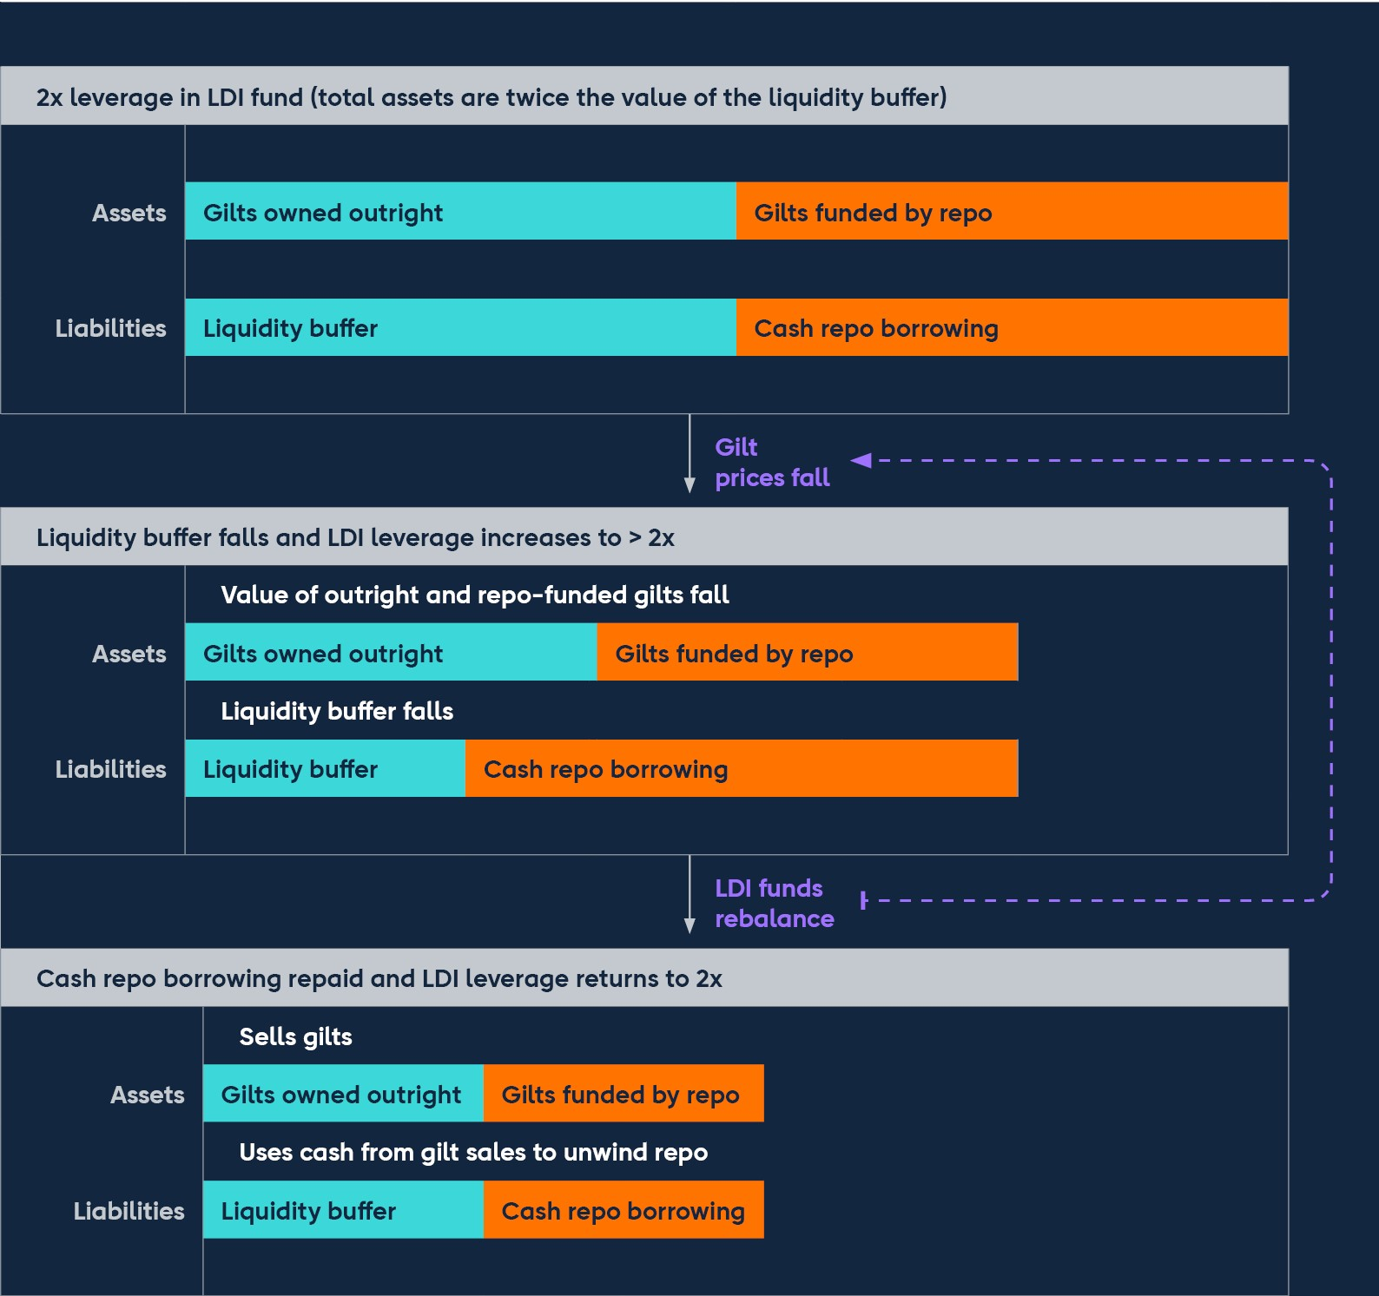

Source: Bank calculations.

## 5.2: The impact of the stress to UK government bond markets on LDI funds

**In late September – amid broader market volatility – UK financial assets saw severe repricing, particularly affecting long-dated UK government debt.**

Market volatility was elevated during Q3, particularly in core UK financial markets, in part reflecting the very challenging outlook for UK economic growth and an uncertain political environment at the time (see Section 1).

In late September, UK government bond yields increased significantly over a short period (Chart 5.1). The speed and scale of the moves in gilt yields were unprecedented, amplified by already volatile market conditions. There were two daily increases in 30-year gilt yields of more than 35 basis points, while the biggest daily increase since 2000 prior to this had been 29 basis points. Measured over a four-day period from 21 September 2022, the increase in 30-year gilt yields of 140 basis points was more than twice as large as the largest move since 2000, which occurred during the ‘dash for cash’ in March 2020. It was more than three times larger than any other historical move. Gilt market functioning was severely challenged, particularly for bonds with the longest maturities (20 years and above).

**Chart 5.1: The yields on long-term UK government bonds increased rapidly**

**in late September**

Basis point change in 30-year government bond yields since 1 August 2022

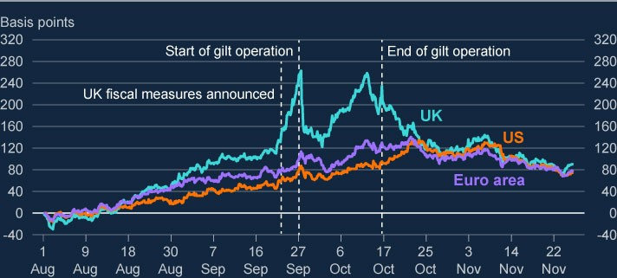

Sources: Bloomberg L.P. and Bank calculations.

**Leveraged LDI funds came under particular pressure as a result of the increase in gilt yields.**

These large increases in gilt yields caused significant falls in the prices of longdated conventional and inflation-linked gilts held by LDI funds. And because of their leverage, the large falls in gilt prices caused large falls in the net asset value of LDI funds, increasing their leverage further (Figure 5.1). The sharp fall in the value of gilts and rise in the level of long-term interest rates also resulted in LDI funds having to post additional collateral on their secured borrowing or pay margin calls on interest rate derivatives positions.

To meet these margin and collateral calls, as well as re-establish their liquidity buffers and so reduce leverage, LDI funds had to rebalance their portfolios urgently. In the event that this rebalancing could not be achieved quickly enough by selling other liquid assets or asking their DB investors to provide more funds, LDI funds would have been forced to sell gilts into an illiquid market. Some LDI funds were able to raise additional funds quickly, for example as fund managers were able to sell other ‘growth’ assets. However raising additional funds quickly was a particular problem for many pooled LDI funds, given operational lags and the large number of smaller investors.

Where additional funds could not be raised quickly enough, pooled LDI funds in particular faced the prospect of forced deleveraging into an illiquid market, selling gilts at volumes far exceeding the normal daily level of gilt trading. This risked reinforcing the downward pressure on gilt prices, and so put further upward pressure on sterling long-term interest rates.

More detail on the stress faced by LDI funds in this period can be found in the [**letters from Sir Jon Cunliffe, Deputy Governor of Financial Stability at the**](https://committees.parliament.uk/publications/30136/documents/174584/default/)

[**Bank of England to the Chair of the Treasury Committee dated 5 October** a](https://committees.parliament.uk/publications/30136/documents/174584/default/)nd [**18 October**.](https://committees.parliament.uk/publications/30347/documents/175455/default/)

**Against the backdrop of an unprecedented repricing in UK assets, the Bank announced a temporary and targeted intervention to restore market functioning in long-dated government bonds.**

With the gilt market unable to absorb further large sales, there was a risk of yields pushing even higher, forcing further gilt sales by LDI funds in an attempt to reestablish target buffer levels. Such forced selling into illiquid markets would lead to a vicious spiral of falling prices, collateral calls and further forced gilt sales that risked leading to further market dysfunction. Had dysfunction in the market to continued, it would have presented a material risk to UK financial stability, leading to an unwarranted tightening of financing conditions and a reduction of the flow of credit to the real economy.

In response to the material risks posed to UK financial stability, the FPC recommended that action be taken, and welcomed the Bank’s plans for a temporary and targeted programme of purchases of long-dated UK government bonds until 14 October. Under the programme, the Bank acted as a backstop purchaser of bonds, and the scheme was priced accordingly. This pricing ensured that the facility did not unduly interfere with price discovery or substitute for the need for market participants to manage their own risks going forward. In line with the Bank’s statutory financial stability objective, the purpose of the operation was to reduce risks to financial stability via contagion to credit conditions for UK households and businesses (see Section 2), and possible risks to bank resilience (see Section 3). The facility would achieve this by restoring market functioning, thereby giving LDI funds time to deleverage through rebalancing and so build their resilience to future volatility in the gilt market.

The introduction of the facility improved market conditions and allowed LDI funds to deleverage (Chart 5.2). LDI funds did this by obtaining more funding from the DB pension schemes that had invested in them, repaying repo borrowing and selling some of their gilt holdings. In the index-linked portion of the gilt market, demand from LDI funds to sell exceeded liquidity. And some pooled LDI funds continued to face time lags in receiving cash from DB scheme investors – many of which needed to sell corporate bonds or other assets to do so. In response to these pressures, in the final week of the programme, the Bank widened the scope of its support facilities. Since operational lags in rebalancing meant that any gilt sales were likely to be concentrated in the final week in which the Bank’s temporary programme was operational, on Monday 10 October, the Bank increased the maximum size of the gilt purchase auctions from £5 billion to £10 billion in each auction. This ensured that the market had sufficient support to allow LDI funds to rebalance their portfolios, which was evidenced by the fact that on no occasion during the period of support was the auction fully allocated. On the same day, the Bank launched a Temporary Expanded Collateral Repo Facility (TECRF), temporarily expanding the range of collateral accepted in its regular liquidity facilities, enabling banks to further support lending to LDI funds. And from 11 October, the Bank included long-term index-linked gilts in its temporary purchase facility alongside conventional gilts, to restore functioning to that part of the gilt market and meet LDI funds demand to deleverage by selling those assets.

In total, DB pension schemes were responsible for around £14 billion of gilt sales between 23 September and 14 October, compared to around £23 billion of sales from LDI funds over the same period.[13] These gilt sales are smaller than the total margin and collateral calls faced by LDI funds and pension schemes in this period, which Bank staff estimate to be in excess of £70 billion.[14] This reflects the fact that LDI funds and pension schemes were also able to sell assets other than gilts and use existing cash buffers in order to meet these obligations.

The facility provided by the Bank stopped on 14 October as planned, having enabled a significant increase in the resilience of the LDI sector, and with the sector significantly better prepared to manage gilt market volatility in the future.

More detail on the decisions taken by the Bank in this period can be found in the [**letter from Sir Jon Cunliffe, Deputy Governor of Financial Stability at the**](https://committees.parliament.uk/publications/30347/documents/175455/default/)

[**Bank of England to the Chair of the Treasury Committee dated 18 October**.](https://committees.parliament.uk/publications/30347/documents/175455/default/)

**Chart 5.2: Action taken by the Bank of England gave LDI funds time to build**

**resilience**

Cumulative net gilt sales by LDI funds and pension schemes with an open gilt repo or

interest rate derivative position, between 22 September and 21 October 2022, and

cumulative gilt purchases by the Bank of England

(

**a**

)

(

**b**

)

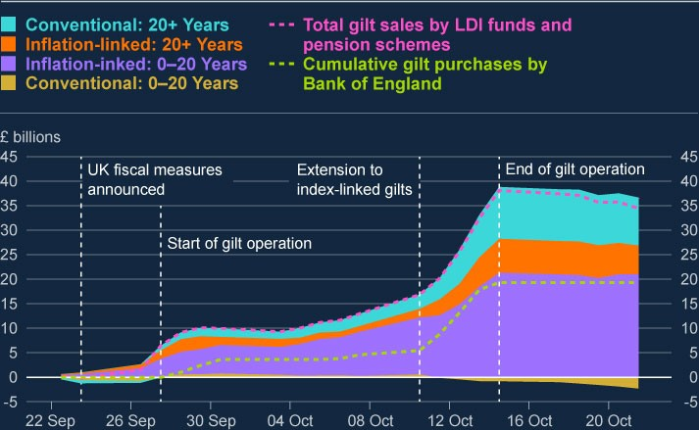

Sources: Bloomberg L.P., MiFID and Bank calculations.

1. The chart captures total net sales of gilts by LDI and pension funds that reported an outstanding open giltrepo or interest rate derivatives position between 22 September and 21 October 2022. LDI funds have been identified within the broader fund category by combining existing sectoral classifications and entity-level name screening. Gilt sales are calculated on a best-endeavours basis and expressed in market-value terms. Market values are estimated using the nominal amount transacted (available in MiFID data), intraday Bloomberg prices and Index Ratio data from the Debt Management Office.
2. The green dashed line shows cumulative gilt purchases by the Bank of England as part of its temporary giltoperation.

## 5.3: Lessons learned on the resilience of LDI funds

**The episode demonstrated that levels of resilience across LDI funds to the speed and scale of moves in gilt yields were insufficient, and that buffers were too low and less usable in practice than expected.**

The FPC is responsible for identifying, monitoring and taking action to remove or reduce systemic risks, with a view to protecting and enhancing the resilience of the UK financial system. This includes systemic risks posed by pension schemes and the LDI funds they invest in. Microprudential regulation of pension schemes, LDI managers and LDI funds is primarily undertaken by The Pensions Regulator (TPR), the FCA and overseas regulators. The PRA regulates bank counterparties of LDI funds.

Prior to the LDI episode, the FPC had taken steps alongside these regulators to better understand risks to financial stability from pension scheme investors, including through their use of their LDI strategies. In 2018, the FPC conducted an assessment of the risks from leverage in the non-bank financial system, and highlighted the need to monitor risks associated with the use of leverage by pension schemes using LDI strategies. The Bank also worked with TPR on a survey of DB pension schemes in 2019, which prompted some work by TPR to assess and improve DB pension liquidity risk management.

Nonetheless, this episode demonstrated that levels of resilience across LDI funds to the speed and scale of moves in gilt yields were insufficient, and that buffers were too low and less usable in practice than expected, particularly given the concentrated nature of the positions held in the long-dated gilt market. The significant financial stability risk posed in this episode demonstrated a need for the Bank to further refine its understanding of how stress in parts of the NBFI sector can spread to the wider financial system, and improve its preparedness for risks stemming from NBFIs (see Section 4).

**It is important to ensure that non-banks, particularly those that use leverage, are resilient to shocks.**

The recent episode showed that more work is needed to reduce risks stemming from LDI funds to ensure that their behaviour under stress does not pose a risk to financial market functioning and UK financial stability.

It should be recognised that the scale and speed of repricing in September far exceeded historical moves, and therefore exceeded price moves that were likely to have been part of risk management practices or regulatory stress tests. While it might not be reasonable to expect market participants to insure against the most extreme market outcomes, it is important that shortcomings from this episode are identified and action taken to ensure financial stability risks can be avoided in future. In particular, the episode highlighted:

Many LDI funds and pension schemes lacked resilience to shocks, having not adequately adjusted resilience levels in response to changes in gilt yields through the year. The episode also highlighted deficiencies in internal stress testing. For example, in failing to account for extreme shocks to the gilt market, and the correlated responses of other market participants to stress episodes.

The replenishment of LDI funds’ liquidity buffers was hindered by firms’ operational arrangements, and in some cases by the governance processes at pension schemes, exacerbating their liquidity issues and need to sell assets in stressed conditions. In addition, some custodian banks which provide services to these funds (and especially those which were more reliant on manual processing) struggled to keep pace with the volume and complexity of requests.

Banks are exposed to counterparty risks from LDI funds through gilt repo borrowing and interest rate swap contracts. Losses could arise if LDI funds fail to meet margin or collateral calls in the event of extreme market moves. The episode highlighted deficiencies in how banks monitor and manage risks with respect to LDI funds. For example, there were shortcomings in their understanding of the ability of LDI funds to meet margin calls in stressed scenarios.

Assessing and monitoring risks in the LDI fund sector is currently considerably hampered by a lack of data on the sector, including on interconnections between LDIs and pension schemes. This is exacerbated by a complex and fragmented regulatory regime.

## 5.4: Policy action to improve the resilience of LDI funds

**The resilience of LDI funds has improved since the recent stress. The FPC welcomes recent guidance and statements by regulators on LDI resilience. The FPC recommends that regulatory action should be taken, as an interim measure, by TPR, in co-ordination with the FCA and overseas regulators, to ensure LDI funds remain resilient to the level of interest rates that they can currently withstand.**

The actions the Bank took gave stressed market participants time to build their resilience to insure themselves against any further disruption in long-dated gilt markets. As a result of funds injected by investors and the falls in long-term gilt yields, the resilience of sterling LDI funds across Europe has subsequently improved, with an average yield buffer in the region of 300–400 basis points being built up, though many funds have resilience in excess of this.[15] This would currently imply resilience to long-term gilt yields of around 7%.

The FPC is of the view that LDI funds should maintain financial and operational resilience to withstand severe but plausible market moves, including those experienced during the recent period of volatility. This should include robust risk management of any liquidity relied upon outside LDI funds, including in money [market funds. The FPC welcomes, as a first step, the recent **guidance published by TPR** in this regard. The FPC also welcomes](https://www.thepensionsregulator.gov.uk/en/document-library/statements/maintaining-liability-driven-investment-resilience) [**recent statements by the FCA**](https://www.fca.org.uk/news/statements/statement-liability-driven-investment-ldi)

and overseas regulators on the resilience of LDI funds.[16] TPR intends to issue a further update in 2023 setting out longer-term expectations on scheme liquidity requirements.

Given the identified shortcomings in previous levels of resilience and the challenging macroeconomic outlook, the FPC recommends that regulatory action should be taken, as an interim measure, by TPR, in co-ordination with the FCA and overseas regulators, to ensure LDI funds remain resilient to the higher level of interest rates that they can now withstand, and defined benefit pension scheme trustees and advisers ensure these levels are met in their LDI arrangements.

**Following this, regulators should also set out appropriate steady-state minimum levels of resilience for LDI funds.**

The regulatory regime is complex and fragmented. Further steps will need to be taken to ensure regulatory and supervisory gaps are filled, so as to strengthen the resilience of the sector, and improve governance and investor understanding. For example, it is important for DB pension schemes to improve their liquidity management practices, and appropriate reporting and data collection is likely to be needed to monitor the resilience of LDI funds. The Bank will continue to work closely with domestic and international regulators so that LDI vulnerabilities are monitored and tackled.

Banks, as providers of funding to the LDI sector, should apply a prudent approach when providing finance to LDI funds, taking into account the resilience standards set out by regulators and likely market dynamics in relevant stressed conditions. As a next step in tackling risks posed by LDI funds, the FPC supports further work by the PRA and FCA to understand the roles of the firms that they regulate in the recent stress, focussing particularly their risk management, and to investigate lessons learned.

Investment consultants play an important role by providing unregulated services that can significantly influence the investment strategies of asset owners and asset managers, including pension schemes. In particular, investment consultants advise pension fund trustees on issues such as strategic asset allocation and asset manager selection. Currently, they are not required to be FCA-authorised for those activities. The FCA have recommended that HM Treasury considers bringing investment consultants into the FCA’s regulation, which would improve the effectiveness of intermediaries. In this regard, the FPC supports this recommendation by the FCA.

Building on the steps taken to maintain current levels of resilience of LDI funds, regulators should also set out appropriate steady-state minimum levels of resilience for LDI funds more broadly including in relation to operational and governance processes and risks associated with different fund structures and market concentration.

# Annex: Macroprudential policy decisions

This annex lists any FPC Recommendations and Directions from previous periods that have been implemented or withdrawn since the previous Report, as well as Recommendations and Directions that are currently outstanding.[17] It also includes those FPC policy decisions that have been implemented by rule changes and are therefore still in force.

Each Recommendation or Direction has been given an identifier to ensure consistent referencing over time. For example, the identifier 17/Q2/1 refers to the first Recommendation made at the 2017 Q2 Committee meeting.

## Recommendations and Directions implemented or withdrawn since the previous Report

On 28 September, the Bank of England’s Financial Policy Committee noted the risks to UK financial stability from dysfunction in the gilt market. It recommended that the Bank take action (22/Q3/1), and welcomed the Bank’s plans for temporary and targeted purchases in the gilt market on financial stability grounds at an urgent pace.

## Recommendations and Directions currently outstanding

On 30 November, the FPC recommended (22/Q4/1) that regulatory action be taken, as an interim measure, by The Pensions Regulator (TPR), in co-ordination with the Financial Conduct Authority (FCA) and overseas regulators, to ensure liability-driven investment (LDI) funds remain resilient to the higher level of interest rates that they can now withstand and defined benefit pension scheme trustees and advisers ensure these levels are met in their LDI arrangements.

## Other FPC policy decisions

Set out below are previous FPC decisions, which remain in force, on the setting of its policy tools. The calibration of these tools is kept under review.

### Countercyclical capital bu er rate

The FPC agreed to maintain the UK CCyB rate at 2% on 28 November 2022, unchanged from its 30 September 2022 Policy meeting. At its July 2022 Policy meeting, the FPC agreed to increase the UK CCyB to 2%, with binding effect from

5 July 2023. This rate is reviewed on a quarterly basis. The UK has also reciprocated a number of foreign CCyB rate decisions – for more details see [**Financial Stability**.](http://www.bankofengland.co.uk/financial-stability) Under Prudential Regulation Authority (PRA) rules, foreign

CCyB rates applying from 2016 onwards will be automatically reciprocated up to

2.5%.

### Mortgage loan to income ratios

In June 2014, the FPC made the following Recommendation (14/Q2/2): The PRA and the FCA should ensure that mortgage lenders do not extend more than 15% of their total number of new residential mortgages at loan to income ratios at or greater than 4.5. This Recommendation applies to all lenders which extend residential mortgage lending in excess of £100 million per annum. The Recommendation should be implemented as soon as is practicable.

The PRA and the FCA have published their approaches to implementing this Recommendation: the PRA has issued a [**Policy Statement**](https://www.bankofengland.co.uk/prudential-regulation/publication/2014/implementing-the-fpcs-recommendation-on-loan-to-income-ratios-in-mortgage-lending), including rules, and the FCA has issued [**general guidance**.](https://www.fca.org.uk/publications/finalised-guidance/fg17-2-fpc-recommendation-loan-income-ratios-mortgage-lending)

### Leverage ratio

In September 2021, the FPC finalised its review of the UK leverage ratio framework, and issued a Direction and Recommendation to implement the outcome of the review as set out in its [**October 2021 Record**](https://www.bankofengland.co.uk/financial-policy-summary-and-record/2021/october-2021).

In line with its statutory obligations, the FPC completed its first annual review of its

Direction to PRA in October 2022. The FPC revoked its existing Direction to the PRA in relation to the leverage ratio regime, and issued a new Direction on the same terms as in September 2021 with the addition of discretion for the PRA to set additional conditions to the central bank claims exclusion.

The full text of the FPC’s new Direction to the PRA on the leverage ratio is set out in the Annex of the [**October 2022 Record**](https://www.bankofengland.co.uk/-/media/boe/files/financial-policy-summary-and-record/2022/fpc-summary-and-record-october-2022.pdf), together with the explanation of the

FPC’s decisions and the original Recommendation (now implemented).

The PRA has [**published its approach**](https://www.bankofengland.co.uk/prudential-regulation/publication/2021/june/changes-to-the-uk-leverage-ratio-framework) to implementing this Direction and

Recommendation.

### Other FPC activities since the July 2022 Report

Other FPC activities since the July 2022 Report not included elsewhere in this Report are set out in the [**Financial Policy Summary and Record – October 2022**](https://www.bankofengland.co.uk/-/media/boe/files/financial-policy-summary-and-record/2022/fpc-summary-and-record-october-2022.pdf),

and [**Financial Policy Summary and Record – December 2022**](https://www.bankofengland.co.uk/-/media/boe/files/financial-policy-summary-and-record/2022/fpc-summary-and-record-december-2022.pdf). These include:

noting the publication of the Financial Services and Markets Bill on 20 July and welcoming the Future Regulatory Framework measures contained in it; continuing to judge that UK financial stability will require levels of resilience at least as great as those put in place since the global financial crisis and required by international standards and in some cases greater;

welcoming the launch of the 2022 annual cyclical scenario stress test, the results of which are expected to be published in Summer 2023;

welcoming the publication of the joint Bank, PRA and FCA Discussion Paper on potential ways for the regulators to manage systematic risks posed by critical third parties (CTPs) to the UK financial sector;

judging that additional policy measures, some potentially requiring legislative change, would be needed to mitigate financial stability risks from CTPs, and encouraged the Bank, PRA and FCA to continue engaging with overseas financial regulators on this issue;

supporting international work on cryptoassets, as well as the work of the HM Treasury-FCA-Bank Cryptoassets Taskforce on assessing the regulatory approach to unbacked cryptoassets and their associated markets and activities; discussing the results of the Bank’s first public Supervisory Stress Test of UK central counterparties;

welcoming the Bank’s plans for temporary and targeted purchases in the gilt market on financial stability grounds at an urgent pace;

reviewing the findings from the first phase of the exploratory cyber stress test and advised on the areas for staff to focus on for the second phase of the test, and on the approach;

welcoming the recent work of the Productive Finance Working Group; noting HM Treasury’s consultation response setting out the final reforms for Solvency II; and

agreeing the Committee’s response to the letter from the Chancellor on 17 November 2022 specifying the economic policy of HM Government and setting out HM Treasury’s recommendations to the Committee.