# Financial Policy Summary

The Financial Policy Committee (FPC) seeks to ensure the UK financial system is prepared for, and resilient to, the wide range of risks it could face – so that the system is able to absorb rather than amplify shocks, and serve UK households and businesses.

## Key developments since the December 2022 FSR

**Since the December 2022 Financial Stability Report, global interest rates have risen further, reflecting actual and expected increases in central bank policy rates in response to continued inflationary pressure**. Returning inflation to target sustainably will support the FPC’s objective of protecting and enhancing UK financial stability.

**The sharp transition to significantly higher interest rates and greater market volatility over the past 18 months has, however, created stress in the financial system through a number of channels.** The failure of three mid-sized US banks – and the failure of a global systemically important bank (G-SIB), Credit Suisse, due to long-running concerns about its risk management and profitability – caused a material rise in financial market risk premia and volatility earlier this year. The impact on the UK banking system through lower bank equity prices and increases in funding costs was limited, and market risk sentiment has stabilised since then. Nonetheless, elements of the global banking system and financial markets remain vulnerable to stress from increased interest rates, and remain subject to significant uncertainty, reflecting risks to the outlook for growth and inflation, and from geopolitical tensions.

In the UK, given the prevalence of variable-rate and short-term fixed-rate mortgages and other loans, the impact of higher interest rates is relatively lower in the financial system than in the real economy, compared to some other jurisdictions.

**The UK economy has so far been resilient to interest rate risk, though it will take time for the full impact of higher interest rates to come through.** In the financial system, interest rate risks crystallised in Autumn 2022, with stress in liability-driven investment (LDI) funds requiring a temporary and targeted intervention by the Bank. The ability of those funds to absorb shocks has since been reinforced through the setting of new standards, and the rest of the UK financial system has so far been resilient to higher interest rates. This is partly due to the range of regulatory measures introduced after the global financial crisis to manage interest rate risk and to build resilience into the financial system more generally.

## The impact of higher interest rates on UK household and corporate debt vulnerabilities

Higher interest rates increase debt-servicing costs facing household and business borrowers. This makes them more likely to cut back on spending, worsening the economic environment, and increases the risk that they will default on loans. Both these factors increase credit risks for lenders.

**In the UK, more households are being affected by higher interest rates as fixed-rate mortgage deals expire. The proportion of households with high debt service ratios, after accounting for the higher cost of living, has increased and is expected to continue to do so through 2023. But it is projected to remain some way below the historic peak reached in 2007.**

**There are several factors that should limit the impact of higher interest rates on mortgage defaults.** Given robust capital and profitability, UK banks have options to offer forbearance and limit the increase in repayments faced by borrowers, including by allowing borrowers to vary the terms of their loans. There are now stricter regulatory conduct standards for lenders with respect to supporting households in payment difficulties. And on 23 June, the principal mortgage lenders, the Chancellor and the Financial Conduct Authority (FCA) agreed new support measures for mortgage holders.

The FPC’s mortgage market measures, introduced in 2014 – including its loan to income flow limit on lending to borrowers with high loan to income ratios at or above 4.5 – and the FCA’s responsible lending requirements, have limited the build-up of household indebtedness in the mortgage market. This has increased borrower resilience and played a role in reducing payment difficulties for residential mortgagors.

Buy-to-let mortgagors are also experiencing increases in mortgage interest payments, and other structural factors are also likely to put pressure on their incomes. This could cause landlords to sell, putting downward pressure on house prices. Alternatively, they may seek to continue to pass on higher costs to renters. Similar to other forms of borrowing, buy-to-let mortgages are subject to affordability testing. In 2016, the PRA issued a supervisory statement outlining its expectations for underwriting standards in the buy-to-let market to safeguard against a deterioration in such standards.

The overall number of mortgages in arrears increased slightly over the first quarter of 2023 but remained low by historical standards. It will take time for the full impact of higher interest rates to come through.

**The UK corporate sector is expected to remain broadly resilient to higher interest rates and weak growth. Nevertheless, higher financing costs are likely to put pressure on some smaller or highly leveraged firms.** The debtweighted proportion of medium and large corporates with low interest coverage ratios is projected to continue to increase throughout 2023 as debts are refinanced at higher rates, although it is expected to remain some way below previous peak levels.

While corporate insolvency rates have risen above pre-Covid rates, they remain low relative to longer-term average levels. The large majority of the increase in insolvencies has been among very small firms that hold little debt, and a high proportion of the debt they do hold is fixed at low rates and government guaranteed. More broadly, the corporate sector has been repaying debt and its near-term refinancing needs appear limited.

## UK banking sector resilience in the context of higher interest rates

**The UK banking system is well capitalised and maintains large liquidity buffers. Asset quality overall remains relatively strong, with higher interest rates having had a limited impact on credit risk so far. However, the overall risk environment is challenging.** Some forms of lending, such as to finance commercial real estate investments, buy-to-let, and highly leveraged lending to corporates – as well as lenders that are more concentrated in those assets – are more exposed to credit losses as borrowing costs rise.

**Major UK banks’ capital and liquidity positions remain robust and profitability has increased, which enables them both to improve their capital positions and to support their customers.**

In aggregate, smaller lenders are also well capitalised and maintain strong liquidity positions. These lenders typically hold greater amounts of capital as a share of their risk-weighted assets, relative to regulatory requirements, than larger firms and maintain significant liquidity buffers.

**The results of the 2022/23 stress test indicate that the major UK banks are resilient to a severe stress scenario that incorporates persistently higher advanced economy inflation, increasing global interest rates, deep simultaneous recessions in the UK and global economies with materially higher unemployment, and sharp falls in asset prices.** The stress test scenario is not a forecast of macroeconomic and financial conditions in the UK or abroad. Rather, it represents a ‘tail risk’ scenario designed to be severe and broad enough to assess the resilience of UK banks to a range of adverse shocks.

**The rise in interest rates from a low level has increased bank net interest margins in aggregate. But the fact that higher rates also reduce the market value of banks’ fixed-rate assets can present risks to all banks.** UK banks manage these risks through their hedging practices within a regulatory framework that includes rules designed to ensure that UK banks have capital against interest rate risks in their banking book, the maintenance of substantial liquid asset buffers, supervision by the PRA, and regular stress testing.

**The FPC continues to judge that the UK banking system is resilient, and has the capacity to support households and businesses through a period of higher interest rates, even if economic and financial conditions were to be substantially worse than expected.**

**The FPC judges that the tightening of lending standards seen over recent quarters does not reflect banks restricting lending primarily to protect their capital positions. The FPC will continue to monitor UK credit conditions for signs of tightening that are not warranted by changes in the macroeconomic outlook.**

**The FPC agreed to maintain the UK countercyclical capital buffer (CCyB) rate at 2%.** This will help to ensure that banks have sufficient capacity to absorb future shocks without unduly restricting lending. The FPC stands ready to vary the UK CCyB rate, in either direction, in line with the evolution of economic and financial conditions, underlying vulnerabilities, and the overall risk environment.

## The impact of higher interest rates on global vulnerabilities

**Higher interest rates have affected households and businesses in other advanced economies in similar ways.** Jurisdictions where long-term fixed-rate mortgages are more prevalent are likely to have financial sectors that are more naturally exposed to interest rate risk. **Riskier corporate borrowing in financial markets – such as private credit and leveraged lending – appears particularly vulnerable, and global commercial real estate markets face a number of short and longer-term headwinds that are pushing down on prices and making refinancing challenging.**

## Lessons from the recent global banking sector stress

**The UK’s regulatory and institutional framework has supported UK financial stability through recent stresses in parts of the global banking system, underlining the importance of maintaining robust macroprudential, regulatory and supervisory standards. Nevertheless, the FPC will draw lessons from the episode.**

For example, the impact of the stress underscored how contagion can spread across and within jurisdictions, even where smaller institutions are involved. It also highlighted that while an individual institution may not be considered systemic, if a risk is common – or perceived to be common – among similar institutions, the collective impact can pose a systemic risk.

The stress highlighted the need for all banks to be adequately capitalised against the risks they are exposed to, including interest rate risk. This is consistent with the PRA’s current regulatory frameworks, as well as its initiative to maintain the resilience of the smallest UK banks while considering measures to simplify regulatory requirements for these lenders, known as ‘Strong and Simple’.

Deposit outflows at some regional US banks were large and rapid, with digital banking technology and social media playing a role in increasing the speed at which information was shared and deposits withdrawn. The Bank will contribute to relevant international work to consider whether lessons can be learnt for the liquidity framework for banks, or components of it, in the light of the size and pace of outflows witnessed in recent events.

These events also showed the importance of being able to resolve firms effectively and of maintaining confidence in resolution frameworks. **In co-ordination with HM Treasury, the Bank is seeking to ensure that for small banks, which do not need to hold additional resources to meet the minimum requirement for own funds and eligible liabilities (MREL), there are resolution options that improve continuity of access to deposits and so outcomes for depositors.** The FPC supports this work. The stress also demonstrated the importance of international authorities’ commitment to ensuring that the resolution framework and plans for GSIBs, in line with Financial Stability Board (FSB) standards, remain credible.

## The resilience of market-based finance

**Vulnerabilities in certain parts of market-based finance (MBF) remain. These could crystallise in the context of the current interest rate volatility, amplifying any tightening in financial conditions.**

**Although the business models of some non-bank financial institutions (NBFIs), such as pension funds and insurance companies, mean that they can benefit from the impact of higher interest rates, the use of derivatives to hedge their interest rate exposures can create material liquidity risk. Liquidity risks also arise when NBFIs use derivatives and repo to create leverage. These liquidity risks must be managed, as evidenced by the LDI stress seen in September 2022.**

The risks from higher interest rates can also be amplified by NBFIs deleveraging and rebalancing their portfolios. The FPC will continue to develop its approach to monitoring such risks as the financial system adjusts to higher interest rates.

**There continues to be an urgent need to increase resilience in MBF globally. Alongside international policy work led by the FSB, the UK authorities are also working to reduce vulnerabilities domestically where it is effective and practical.**

For example, in March 2023, the FPC recommended that The Pensions Regulator (TPR) take action as soon as possible to mitigate financial stability risks by specifying the minimum levels of resilience for the LDI funds and LDI mandates in which pension scheme trustees may invest. Since then, both the FCA and TPR have published detailed guidance on LDI resilience. **The FPC welcomes this guidance and the steps taken by TPR and the FCA to ensure the continued resilience of LDI funds.** In recent months as interest rates have risen further, funds have in general maintained levels of resilience consistent with the minimum levels recommended by the FPC in March, and have initiated recapitalisation at higher levels of resilience than previously. **The Bank will continue working with the FCA, TPR and overseas regulators to monitor the resilience of LDI funds closely.**

**The Bank has recently launched its system-wide exploratory scenario (SWES) exercise, which will be the first exercise of its kind. It aims to improve understanding of the behaviours of banks and non-bank financial institutions in stressed financial market conditions.** It will explore how these behaviours might interact to amplify shocks in financial markets that are core to UK financial stability. In bringing together information from various parts of the financial system to develop system-wide (and sector-specific) insights, it will be able to account for

interactions and amplification effects within and across the financial system that individual financial institutions working alone cannot assess. The FPC supports the SWES and considers it an important contribution to understanding and addressing vulnerabilities in market-based finance.

# 1: Developments in financial markets

Since the December 2022 Financial Stability Report, global interest rates have risen further. This reflects actual and expected increases in central bank policy rates in response to continued inflationary pressure. The outlook for global growth has improved slightly, despite stress in the global banking system and continued heightened geopolitical uncertainty. Although UK growth prospects remain subdued, they have also improved somewhat since December, supported by lower energy prices.

UK government bond yields have risen sharply in recent months, mainly reflecting increases in the expected path of Bank Rate given recent inflation outturns. US and European government bond yields have also increased, but by less than UK gilt yields.

The failure of three mid-sized US banks – and the failure of a globally systemically important bank, Credit Suisse, due to long-running concerns about its risk management and profitability – caused a material rise in financial market risk premia and volatility earlier this year. US bank equity prices fell significantly as a result, and have not recovered. UK and European bank equity prices fell by a smaller amount, and have since partially recovered.

Market risk sentiment has since stabilised. But global financial markets remain subject to significant uncertainty, reflecting underlying uncertainties about the outlook for growth, inflation and interest rates. Volatility in some interest rate markets – such as gilts and short-dated US Treasuries – has been particularly elevated.

Global risky asset valuations look broadly in line with their recent historical distributions, with the possible exception of US equities, where certain technology stocks in particular are highly valued relative to historical distributions. However, given the current level of macroeconomic uncertainty, there is a risk that further unanticipated increases in market interest rates and interest rate volatility, or a deterioration in the economic outlook, could lead to sharp reductions in risky asset prices, further tightening financial conditions for UK households and businesses.

**Global interest rates have risen further as inflationary pressure has continued, but the outlook for global growth has improved slightly.**

Since the December 2022 FSR, the global outlook for growth has improved slightly, despite stress in the global banking system and continued heightened geopolitical uncertainty. But global growth is still expected to remain subdued, and risks to the outlook remain. UK growth prospects also remain subdued.

UK and European wholesale gas spot prices are around a quarter of the level seen at the time of the December 2022 FSR. This is below the level seen before Russia’s invasion of Ukraine in February 2022 but still well above their pre-Covid average.

However, despite lower energy prices in the UK and Europe, global inflationary pressures have continued. Central bank policy rates in advanced economies have increased in response. The market-implied near-term path for UK Bank Rate has increased further since the December FSR, and is now expected to peak at around

6.2% in early 2024.

Yields on 10-year UK government bonds have risen sharply since the December FSR, particularly in May. This mainly reflects increases in market expectations for the path of Bank Rate given recent inflation data. Yields on US and European government bonds are also higher than at the time of the December FSR, but have increased by less than UK gilt yields (Chart 1.1).

**Chart 1.1: Since the December FSR, yields on 10-year government bonds**

**have increased by more in the UK than in the US and euro area**

Changes in 10-year government bond yields since the beginning of 2022

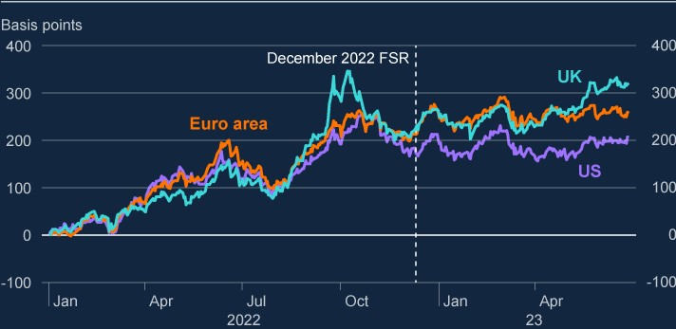

Sources: Bloomberg Finance L.P. and Bank calculations.

**At the beginning of 2023, stronger risk appetite was evident in credit markets, but volatility in rates markets had remained elevated.**

Stronger risk appetite had been evident in movements in global corporate bond and leveraged-loan spreads at the start of 2023. Liquidity in UK gilt markets had largely recovered from the disruption in Autumn 2022 (Chart 1.2). But volatility in interest rates markets remained elevated globally (Chart 1.3). In part, this reflected the fact that uncertainty over the path of policy rates remained high.

**Chart 1.2: Liquidity conditions became more challenging in March reflecting**

**heightened market volatility**

10-

year cash gilt bid-ask spread and price impact for gilt futures

(

**a**

)

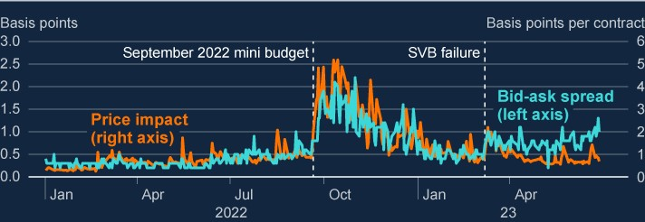

Sources: Bloomberg Finance L.P., BMLL Technologies and Bank calculations.

(a) Price impact measures how gilt futures prices change in response to changes in the orderbook, eg when futures contracts are bought or sold. The measure is calculated using BMLL data in line with methodology set out in [**Cont, Kukanov and Stoikov (2014)**.](https://academic.oup.com/jfec/article/12/1/47/816163)

**Chart 1.3: Volatility in US Treasury markets has been highly elevated**

Five day average of Merrill Lynch Option Volatility Estimate for interest rates (MOVE

index)

(

**a**

)

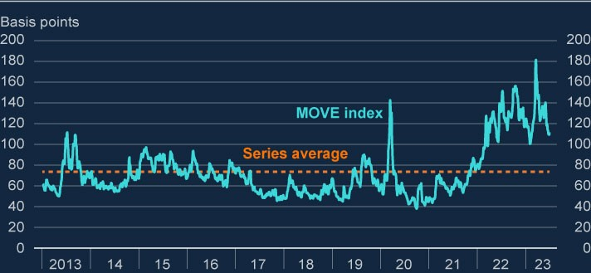

Sources: ICE data indices and Bank calculations.

(a) The MOVE index is a yield curve weighted index of the normalised implied volatility on one-month US Treasury options.

**US bank equity prices fell following the failure of three US banks, impacting wider financial markets.**

In the first half of this year, three US banks – Silicon Valley Bank (SVB), Signature Bank, and First Republic Bank – failed, following substantial deposit outflows prompted by concerns over poor management of interest rate risk and liquidity risk. Credit Suisse, which had previously experienced a series of risk-management, business model and profitability concerns, came under renewed pressure, and was ultimately taken over by UBS, following an intervention by the Swiss authorities (see Section 4).

Aggregate US bank equity prices fell sharply following these events. There were particularly large falls among smaller regional banks where investor concerns were concentrated, with equity prices falling by around 30% in March (Chart 1.4). UK and European bank equities fell by 17% and 18% respectively.

Following this stress – and against a backdrop of broader market uncertainty – there was a material increase in spreads on high-yield and investment-grade corporate bonds and leveraged loans (Chart 1.5). Credit default swap index spreads also widened. Volatility in equities, and credit markets increased sharply, and remained somewhat elevated due the uncertainty around the raising of the US government debt ceiling, which has since been resolved. Gilt market liquidity conditions became more challenging during this period given broader volatility in financial markets.

**Chart 1.4: US regional bank equity prices fell sharply in March and have**

**failed to recover, while UK and European bank equities have partially**

**recovered**

Global bank equity price indices

(

**a**

)

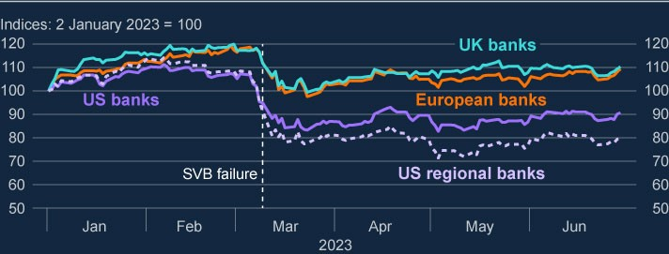

Sources: Bloomberg Finance L.P., Refinitiv Eikon from LSEG and Bank calculations.

(a) The banking sector series for the UK, Europe and US are the FTSE UK Banks Index, the Stoxx Europe 600 Banks Index, the S&P 500 Banks Index and the KBW Regional Banking Index.

**Chart 1.5: Credit spreads increased after the market disruption in March;**

**most remain slightly above their historical average**

Current levels of credit spreads as a percentile of historical values

(

**a**

)

(

**b**

)

(

**~~c~~**

)

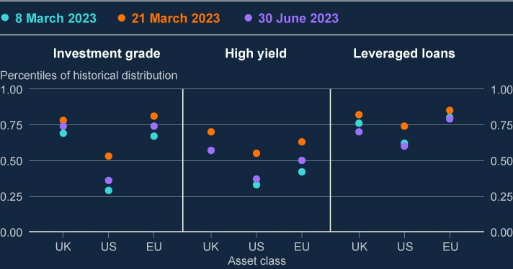

Sources: Datastream from LSEG, ICE data indices, LCD, a part of PitchBook, and Bank calculations.

1. Data points for high-yield and investment-grade spreads are five-day rolling averages as at 30 June 2023,21 March 2023 (when the impact of the global banking stress on spreads peaked) and 8 March 2023 (prior to the stress). For leveraged-loan spreads, the averages are taken to the previous Friday in each case (3 March, 17 March and 30 June 2023).
2. Data series go back to 1998 (investment-grade and high-yield spreads), 2000 (US leveraged-loan spreads),and 2002 (UK and European leveraged-loan spreads).
3. For high-yield and investment-grade spreads, UK, US and EU represent spreads on debt issued in sterling,US dollars and euros, respectively.

**Market conditions have partly recovered from the disruption in March, but global financial markets remain subject to significant uncertainty around interest rates, related to the outlook for growth and inflation.**

US bank equity prices have failed to recover from the March stress (Chart 1.4).

Meanwhile, European and UK bank equity prices have partly recovered.

Spreads on corporate bonds have also partly retraced to lower levels. That said, spreads are still slightly elevated and risky debt issuance is subdued, especially in the leveraged-loan market, which may reflect a lasting increase in risk aversion among investors. If the economic outlook were to deteriorate, then spreads could widen sharply again.

Volatility in equity and credit markets has fallen back, but remains high in some rates markets – particularly for gilts and shorter-dated US treasuries – reflecting uncertainty in the expected path of global growth and inflation (Chart 1.3). Since March, gilt market liquidity conditions have improved overall, but bid-ask spreads for 10-year UK gilts have remained somewhat elevated (Chart 1.2).

**Global equity market valuations look broadly in line with their recent historical distributions.**

So far, equity prices have been largely resilient to the recent increases in global interest rates. The market capitalisation of the S&P 500 has increased by around 11% since the December FSR, while the EuroStoxx 600 has increased by around 5%. The UK stock market has been broadly flat. In the US, recent gains have been concentrated in large technology companies, which have been trading at over 26 times forward earnings, 44% above the four-year average for that metric. In Europe, the equity market gains have been more broad-based, supported by recent falls in energy prices.

Excess cyclically adjusted price-to-earnings (CAPE) yield – a measure of the excess return that investors expect from equities relative to risk-free investments – on US equities is now around the lowest it has been since before the global financial crisis, driven in large part by the recent gains among large technology companies. However, valuations appear less stretched relative to a longer time series (Chart 1.6).

**Chart 1.6: US equity valuations are high relative to recent history, but appear**

**less stretched relative to a longer time series**

Excess cyclically adjusted price-to-earnings yield

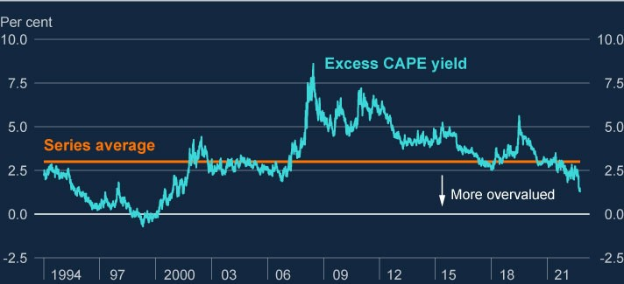

Sources: Bloomberg Finance L.P., Federal Reserve Bank of St Louis and Bank calculations.

**Nonetheless, if market participants were to re-evaluate materially the prospects for growth, inflation or interest rates, this could lead to sharp reductions in asset prices, further tightening financial conditions for households and businesses.**

Higher interest rates combined with an uncertain outlook for growth can trigger a revaluation of asset prices. Sharp decreases in asset prices could amplify financial stability risks to the UK by tightening financial conditions further, impairing businesses’ ability to raise finance, and increasing the cost of bond and equity issuance.

A sharp reduction in asset values could also directly affect the financial system; for example through direct losses on asset holdings; by reducing the value of collateral securing existing loans; or by creating sharp increases in the demand for liquidity. Any such moves could be amplified by vulnerabilities in market-based finance, and would tighten financial conditions for UK households and businesses. The Financial Policy Committee continues to work with the international policy community to improve the resilience of market-based finance (see Section 5).

# 2: UK household and corporate debt vulnerabilities

Higher interest rates increase debt-servicing costs for household and business borrowers. This increases the likelihood that they will default on loans, which in turn increases credit risks for lenders. This is the main channel through which households and businesses can affect financial stability.

Higher interest rates are affecting more households as fixed-rate mortgage deals expire, pushing up the aggregate mortgagedebt-servicing burden. In the private rented sector, buy-to-let landlords are also being affected by higher rates, which, along with other pressures, has caused some to sell up or pass on higher costs to renters. Households’ use of consumer credit has increased, which could in part reflect these trends. Mortgage and consumer credit arrears rates have, however, remained low so far.

There are several factors that should limit the impact of higher interest rates on mortgage defaults. Given robust capital and profitability, UK banks have options to offer forbearance and limit the increase in repayments faced by borrowers, including by allowing borrowers to vary the terms of their loans. There are now stricter regulatory conduct standards for lenders with respect to supporting households in payment difficulties. And on 23 June, the principal mortgage lenders, the Chancellor and the Financial Conduct Authority (FCA) agreed new support measures for residential mortgage holders.

The FPC’s mortgage market measures, introduced in 2014, including its loan to income (LTI) flow limit on lending to borrowers with LTIs at or above 4.5, have limited the build-up of household indebtedness in the mortgage market. This has increased borrower resilience and played a role in reducing payment difficulties for mortgagors.

Higher interest rates are also putting some firms under pressure, but the UK corporate sector is expected to remain broadly resilient to higher interest rates and weak growth. Nevertheless, higher financing costs are likely to put pressure on some smaller or highly leveraged firms. The debt-weighted proportion of medium and large corporates with high interest payments relative to earnings is projected to continue to increase throughout 2023 as debts are refinanced at higher rates, although that proportion is expected to remain some way below previous peak levels. In aggregate, corporates’ near-term market-based debt refinancing needs are relatively limited.

Corporate insolvencies have increased, although the rate remains low compared to historical levels. The large majority of this recent increase in total insolvencies has been among smaller companies, and much of these firms’ debt is government-guaranteed, acquired during the pandemic at low, fixed rates of interest.

The 2022/23 annual cyclical scenario (ACS) results indicate that the UK banking system would be resilient to its exposures to UK households and corporates in the event of a severe macroeconomic scenario involving large falls in GDP and asset prices, high interest rates globally and large increases in unemployment.

**Inflation has shown further persistence and the MPC has increased Bank Rate.**

The Monetary Policy Committee (MPC) has increased Bank Rate by two percentage points to 5% since the December 2022 FSR, and market expectations are for Bank Rate to average around 5.5% over the next three years. Headline CPI inflation has recently begun to fall from recent peaks, but core inflation has been persistent, and the MPC judges that the risks to its May inflation projection are skewed significantly to the upside.

The outlook for UK economic growth remains subdued but has improved since the December 2022 FSR, consistent with stronger global growth and lower energy prices. The MPC now expects UK GDP growth to be slightly positive across its

three-year forecast period and it expects unemployment to be lower than previously forecast, remaining below 4% until the end of 2024.

These macroeconomic variables inform the FPC’s assessment of the outlook for household and corporate debt vulnerabilities. For example, higher interest rates make debt-servicing more expensive, while lower expected unemployment reduces the number of households likely to experience sharply reduced incomes – unemployment has historically been a key driver of defaults.

The FPC has previously identified two main channels through which high levels of household or corporate debt can pose risks to the UK financial system or wider economy:

1. Lender resilience. If highly indebted households and businesses get intodifficulties making debt repayments and default, this can lead to losses for lenders and test their resilience.
2. Borrower resilience. Highly indebted households and businesses may cut backsharply on consumption, investment, or employment to make debt repayments, and hence amplify macroeconomic downturns.

Both borrower and lender resilience can be adversely affected by a number of factors, including higher debt-servicing costs, lower business and household incomes, and higher unemployment.

## 2.1: UK household debt vulnerabilities

There was a fall in the volume of mortgage approvals around the turn of the year, following significant increases in mortgage rates in late 2022. Mortgage approvals have since somewhat recovered but remain below their historical average. Against this backdrop, house prices have seen a decline, but they are still substantially above pre-Covid levels given the significant price growth since 2020 (Chart 2.1).

**Chart 2.1: Indicators of UK house prices have declined from 2022 peaks**

House price indices

(

**a**

)

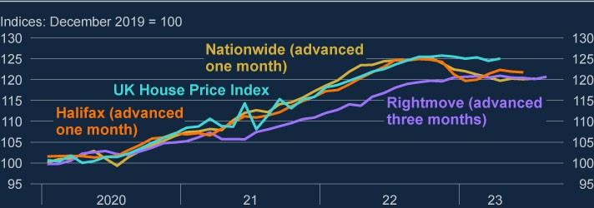

Sources: UK House Price Index from the HM Land Registry, Registers of Scotland, Land and Property Services Northern Ireland and Office for National Statistics, Halifax, Nationwide, Rightmove.co.uk and Bank calculations.

(a) The latest data point for the UK House Price Index is April 2023. Halifax, Nationwide and Rightmove data are advanced to reflect the respective timing of each data source in the house-buying process.

Changes in market expectations around the path of Bank Rate are reflected in the overnight index swap rate (OIS). The OIS is used by lenders to price their mortgage products. Rates on a 75% loan to value (LTV) mortgage fixed for five years stood at around 5% in June, and for an equivalent two-year fixed-rate mortgage rates were around 5.5% (Chart 2.2).

Mortgage lenders take time to adjust their pricing as market interest rates change. Spreads widened appreciably in 2022 Q4, as lenders responded to heightened volatility and rapid increases in market rates. Spreads have subsequently fallen back.

**Chart 2.2: Mortgage rates have recently increased**

Average quoted rates on two-year and five-year fixed-rate mortgages with 75% LTV, and

the two-year and five-year OIS rates

(

**a**

)

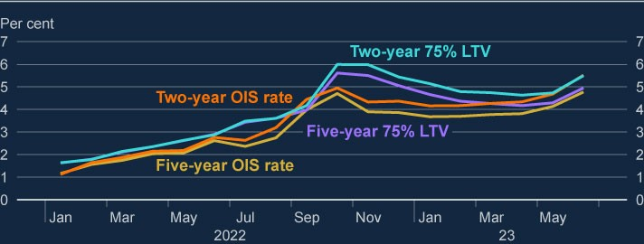

Sources: Eikon by Refinitiv, Bank of England and Bank calculations.

(a) The Bank’s quoted rates series are weighted monthly average rates advertised by all UK banks and building societies with products meeting specific criteria. OIS rates are monthly averages of daily rates to 30 June.

**Higher interest rates are impacting more households as fixed-rate mortgage deals expire.**

The majority of mortgages taken out over recent years have been at a fixed interest rate for a period of time (most commonly two or five years), so higher interest rates affect mortgagor households in aggregate with a lag. Around half of mortgage accounts (around 4.5 million) are estimated to have seen increases in repayments since mortgage rates started to rise in late 2021. And higher rates are expected to affect the vast majority of the remainder by the end of 2026 (around 4 million accounts). For the typical mortgagor rolling off a fixed-rate deal over the second half of 2023, monthly interest payments would increase by around £220 if their mortgage rate rises by the 325 basis points implied by current quoted mortgage rates. Chart 2.3 shows a projection of the distribution of payment increases across all mortgages (including variable rate) to the end of 2026.

**Chart 2.3: Mortgage payments will increase for many households**

Number of owner-occupier mortgages which will experience increases in monthly

mortgage costs, for end-2023 and end-2026

(

**a**

)

(

**b**

)

(

**c**

)

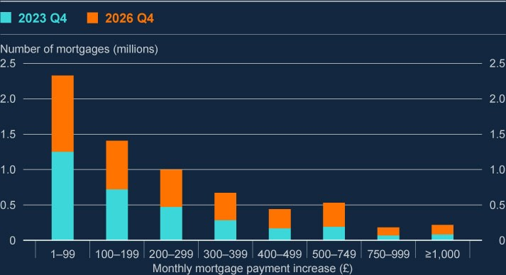

Sources: Bloomberg Finance L.P., FCA Product Sales Data and Bank calculations.

1. The projection uses the OIS curve as at 30 June 2023 and the latest available data (end-2022) on the stockof outstanding mortgages.
2. Increases in payments on variable-rate mortgages are calculated using the implied uplift in the OIS curveand payments increase for fixed-rate mortgages are calculated by assuming that mortgagors refinance onto a typical fixed rate at the point that their fixed-rate contract ends.
3. Mortgages with less than £1,000 outstanding are excluded. These data do not include buy-to-let mortgagesor mortgages that are off balance sheet of authorised lenders, such as securitised loans or loan books sold to third parties.

**Households’ aggregate mortgage debt-servicing burden is expected to increase but remain below historical peaks…**

Higher mortgage rates increase the mortgage servicing burden on UK households. The aggregate mortgage debt-servicing ratio (DSR), which measures the proportion of post-tax income spent on mortgage payments across all households (both mortgagor and non-mortgagor), is projected to increase from 6.2% to around

8% by mid-2026. If that were the case, this share would remain below the peaks seen in both the 2007–08 global financial crisis (GFC) and the early 1990s recession (Chart 2.4), despite interest rates now being at a similar level to those prior to the GFC.[1]

**Chart 2.4: Aggregate mortgage debt-servicing burdens are expected to**

**increase but to remain below previous peaks**

Aggregate UK household mortgage DSR with illustrative projection to mid-2026

(

**a**

)

(

**b**

)

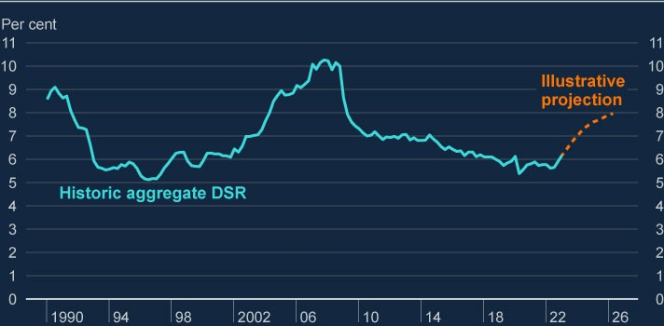

Sources: Bank of England, Bloomberg Finance L.P., FCA Product Sales Data, ONS and Bank calculations.

1. Calculated as interest payments plus mortgage principal repayments as a proportion of nominal householdpost-tax income. Household income has been adjusted to take into account the effects of Financial

Intermediation Services Indirectly Measured. Mortgage interest payments before 2000 are adjusted to remove the effect of mortgage interest relief at source.

1. For the illustrative projections to mid-2026, projections for household post‑tax income consistent with the [**May 2023 MPR**.](https://www.bankofengland.co.uk/monetary-policy-report/2023/may-2023) Payment increases are projected using market expectations for Bank Rate based on the OIS

curve as at 30 June, taking into account the distribution of fixed-deal terms from the FCA Product Sales Data and assuming the aggregate mortgage debt to income ratio remains constant.

Relatedly, the aggregate UK household debt to income ratio, which measures total indebtedness, is now materially lower, at 118% in 2023 Q1, than the GFC peak, where it reached around 150% (Chart 2.5).

**Chart 2.5: Overall household indebtedness is significantly below its**

**previous high**

Household debt as a share of income, excluding student debt

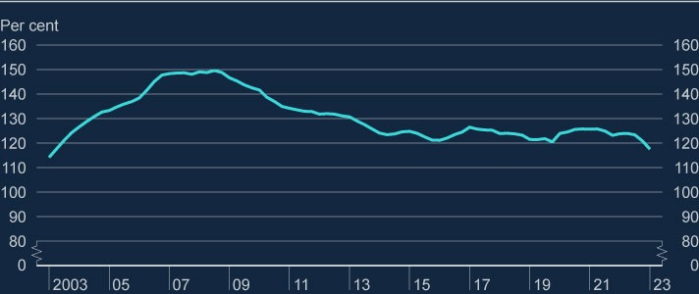

Sources: Bank of England, ONS, and Bank Staff Calculations.

**…and the proportion of individual households facing the highest mortgage repayments is also expected to increase, but to stay below previous highs.**

Another way of tracking household debt vulnerabilities is by measuring how much of their income, after tax and essential spending, individual households need to spend on mortgage or consumer credit debt repayments. Households with higher mortgage cost-of-living-adjusted debt-servicing ratios (COLA-DSRs), and in particular those with mortgage COLA-DSRs over 70%, are more likely to face difficulties in meeting their debt repayments. A significant increase in borrower defaults could have implications for lender resilience.

Rising mortgage costs have led to an increase in the proportion of ‘high’ mortgage

COLA-DSRs as a percentage of total households, from 1.6% in 2022 Q3 to 2.0% in 2023 Q1 (Chart 2.6).[2] Consistent with this, the number of owner-occupier mortgages in arrears (of 2.5% or more of the outstanding balance) increased slightly over the first quarter of 2023, but, at 0.9% of outstanding mortgages, it remained low by historical standards. However, it will take time for the full impact of higher interest rates to come through.

The proportion of households with high mortgage COLA-DSRs is expected to continue to increase throughout 2023 to around 2.3%, or around 650,000 households, by the end of the year (Chart 2.6). But it should stay below the recent peak reached in 2007 of 3.4%, or around 870,000 households.[3] To reach that peak level by the end of 2024, it would require mortgage rates to be around three percentage points higher relative to current expectations, other things equal.

**Chart 2.6: The share of total households with high mortgage debt-servicing**

**burdens is projected to increase this year**

Share of households with mortgage COLA-DSRs above 70%, with projection to end-

2023

(

**a**

)

(

**b**

)

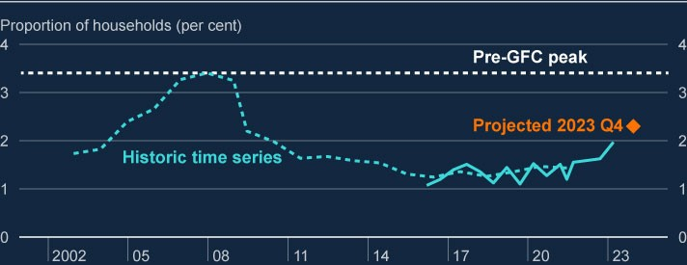

Sources: Bank of England, Bloomberg Finance L.P., British Household Panel Survey/Understanding Society (BHPS/US), NMG Consulting survey, ONS and Bank calculations.

1. The threshold of 70% is estimated by taking the threshold at which households become much more likely toexperience repayment difficulties for gross DSRs (40%) and adjusting it to reflect the share of income spent on taxes and essentials (excluding housing costs) by households with mortgages. For more information on the gross threshold, see the [**August 2020**](https://www.bankofengland.co.uk/report/2020/monetary-policy-report-financial-stability-report-august-2020) FSR.
2. The impact of inflation is estimated by assuming the prices of essential goods rise in line with the May 2023 MPR inflation projection, and that households do not substitute away from this consumption. Interest rate projections are applied based on OIS rates as at 30 June 2023.

**There are several factors that should limit the impact of higher interest rates on mortgage defaults.**

Given robust capital and profitability, UK banks have options to offer forbearance and limit the increase in repayments faced by borrowers, including by allowing borrowers to vary the terms of their loans. There are now stricter regulatory conduct standards for lenders with respect to supporting households in payment difficulties. And on 23 June, the principal mortgage lenders, the Chancellor and the Financial Conduct Authority (FCA) agreed new support measures for residential mortgage holders.[4]

The FPC’s mortgage market measures, introduced in 2014, including its flow limit on lending to borrowers with LTIs at or above 4.5, have limited the build-up of household indebtedness in the mortgage market. This has increased borrower resilience and played a role in reducing payment difficulties for mortgagors.[5]

The FCA’s Mortgage Conduct of Business (MCOB) rules continue to guard against the risk that mortgage repayments become unaffordable. Lenders have recently been stressing borrowers at higher interest rates of around 8.5% compared to 7% in 2022 Q1. This has led to a reduction in aggregate mortgage lending, and lending at high LTIs has fallen.

There is evidence that some households are taking up the option to borrow over longer terms, as they attempt to offset the impact of higher mortgage rates by reducing monthly capital repayments. New lending at terms longer than 35 years has increased from around 5% in 2022 Q1 to 11% in 2023 Q1. And of those borrowers who remortgaged in 2023 Q1, around 15% extended their existing term.

**Higher interest rates, together with other factors, are also putting pressure on buy-to-let landlords’ profitability, which has caused some to sell up or pass on higher costs to renters.**

The private rented sector is an important part of the UK housing market, covering around 19% of households. Many private landlords finance their investment through mortgage borrowing: around 7% of the total UK housing stock has a buyto-let (BtL) mortgage on it and this type of lending comprises around 18% of the overall mortgage market by value.

Landlords are currently subject to a combination of factors that are putting pressure on their profitability: higher interest rates and structural changes – including adjustments to income and capital gains tax rules and proposed changes to building energy efficiency regulations and tenancy protection. The interest coverage ratio (ICR), which is a measure of rental income relative to interest payments, shows the extent to which a landlord’s rental income covers their cost of borrowing. A landlord with high debt-servicing costs relative to their rental income (ie a low ICR) is more likely to experience repayment difficulties. As with owneroccupier mortgages, higher interest rates mean an increase in mortgage servicing costs when fixed rate deals need to be refinanced, and most BtL mortgages are interest only, which increases the relative impact of higher rates. The average increase in monthly repayments on BtL mortgages by the end of 2025 is projected to be around £275. If landlords were to entirely absorb higher mortgage costs (ie without passing any of them on to renters), the share of BtL mortgages with ICRs below 125% would increase significantly from around 3% at the end of 2022 to just over 40% by the end of 2025.

Falling profitability could, in principle, cause landlords to sell their property investments and exit the BtL market. If this were to happen in large enough volumes, it could put downward pressure on house prices. Sales by some landlords might be offset by purchases by other landlords, and market intelligence suggests that larger-scale, professional landlords are taking up an increasing share of the market as smaller landlords exit. It is difficult to establish a comprehensive view of the net balance, as inflows are harder to measure than outflows and can be lagged. However, available evidence suggests that recent market exit by some landlords has caused a certain degree of shrinkage of the private rented sector as a whole, but not on a scale likely to have a material impact on house prices overall. A range of external estimates suggests that net sales of BtL properties in 2022 are unlikely to have exceeded around 100,000, representing up to around 8% of total house sales that year (and less than 0.4% of the total UK housing stock).

Many landlords are likely to seek to raise rents to offset their higher costs. National rent inflation in the private rental market was 5% year-on-year to May, with one industry estimate indicating a 10% price increase in new lets in the year to June. Renter households tend to have lower incomes than homeowners (including relative to housing costs) and they are likely to have low savings. Higher costs relative to incomes may lead to an increased reliance on consumer credit, or difficulties paying off existing consumer credit or other types of debt. It may also increase their vulnerability to future adverse shocks.

**Usage of consumer credit has recently increased, following a contraction during the pandemic.**

Consumer credit accounts for around one eighth of total lending to households, with mortgage lending comprising the other seven eighths. Credit card debt makes up a large share of the consumer credit total.

Consumer credit growth has increased after its pandemic-era contraction, with 12% annual growth in credit card lending in the most recent data and total consumer credit lending rising broadly in line with nominal incomes over the past year. Consumer credit is used across the income spectrum. Recent survey data indicates that 15% of adults reported increasing their borrowing in response to cost-of-living pressures at the end of 2022. However, the stock of outstanding debt as a share of incomes remains a little below pre-pandemic levels at around 12% in 2023 Q1.

For households with outstanding consumer credit debts, a consumer credit debtservicing ratio, adjusted for cost-of-living (COLA-DSR), can be calculated. It measures how much income after taxes, essentials and housing costs is spent on servicing consumer credit debts.[6] The threshold beyond which households are understood to be more likely to get into financial difficulties (‘high’ consumer credit COLA-DSR), is estimated to be 80%. The proportion of total households with high consumer credit COLA-DSRs has slightly increased over the past year, from around 9% to around 10%, and, assuming constant levels of debt, it is expected to remain broadly flat for the remainder of 2023.[7]

Aggregate arrears figures for consumer credit have been largely low and stable since 2022, with around 1% of UK banks’ lending in arrears of more than three months. However, within the aggregate, distress among the most indebted may have increased. Contacts in the debt advice charity sector indicate that the scale of difficulties faced by those seeking debt advice has increased, and among households in difficulty recent survey data shows ‘increased balance on credit card’ and ‘increased overdraft’ to be the second and third most cited issues (after ‘behind on bills/utility payments’).

Further deterioration of households’ finances, including higher mortgage or rental payments, could increase pressures on households, potentially leading to higher consumer credit arrears or default rates.

**The UK banking system is resilient to its household debt exposures.**

As part of the 2022/23 ACS, major UK banks were stress tested against a severe macroeconomic scenario that would put pressure on the ability of households to service their debts, including unemployment rising to 8.5%. Banks have been found to be resilient to expected losses, including a five-year consumer credit impairment rate of 27%.

Banks’ losses (or expected losses) on mortgage lending can depend not only on borrowers’ ability to repay but also on house prices, given mortgage lending is collateralised against the value of the property. A material fall in house prices could increase the LTV ratio on banks’ lending books, reducing their resilience to further declines.

The FPC judges that the UK banking sector is resilient to its mortgage exposures, including in the event of house price falls significantly in excess of external central case projections. The ACS scenario includes a house price fall of more than 30%. Mortgage lenders’ aggregate LTVs are robust, with 87% of their stock of owner occupier mortgages below 75% LTV, helping to provide a sizable buffer against significant house price falls.

For BtL mortgages, 94% of lenders’ stock is below 75% LTV. Similar to other forms of borrowing, BtL mortgages are subject to affordability testing. In 2016, the PRA issued a Supervisory Statement outlining its expectations for underwriting standards in the BtL market to safeguard against a deterioration in such standards.

## 2.2: UK corporate debt vulnerabilities

Bond finance makes up a significant proportion of large corporates’ total debt. Bonds generally have a fixed interest rate, and corporate issuers will face higher costs when they need to refinance.

For many corporate borrowers, however, and especially small to medium sized enterprises (SMEs), bank credit is their main, or even only, source of finance. Bank loans to corporates are generally floating rate. This means that increases in Bank Rate are likely, on average, to flow through into corporate debt-servicing costs more quickly than for household debt, which over recent years has tended to be fixed rate. Between January 2022 and May 2023 the average interest rate on the stock of floating rate bank loans to corporates rose by over 400 basis points to around 6.5%.

**The overall level of corporate indebtedness is relatively low…**

In aggregate, the amount of outstanding UK corporate debt relative to corporate earnings, has continued to fall since its recent Covid-era peak. This picture is reinforced if corporates’ holdings of cash are subtracted from their stock of debt. At the end of 2023 Q1, the *net* debt to earnings ratio stood at around 120%, its lowest point in the past 20 years. This has been driven by both strong growth in nominal earnings and a fall in aggregate leverage. However, debt and cash holdings are not spread evenly and for those companies more reliant on debt, the rise in interest rates has made it more expensive for them to service existing debt and obtain new finance.

**…and near-term refinancing needs from financial markets are limited.**

The structure of corporate funding in the UK has changed materially over time. Market-based finance now makes up over 50% of the total stock of debt, up from around 40% in 2009. And it accounts for nearly all of the £425 billion net increase in lending to UK corporates since the end of 2007. Market-based finance can, in theory, help provide diversification of funding sources, and hence increase the resilience of the supply of finance to corporates. But it can also introduce additional vulnerabilities: investor sentiment can change rapidly in response to adverse shocks, triggering widening credit spreads and making it harder or more expensive for borrowers to roll-over their debts, even if risk free rates are unchanged. These risks are heightened in riskier credit markets such as leveraged loans, private credit and high-yield bonds. Available deal-level data indicate that these markets account for around 40% of all market-based debt.

The maturity profile of their debt affects the speed with which corporates are exposed to higher interest rates, and the extent to which refinancing pressures could pose risks to financial stability. In aggregate, refinancing needs for marketbased term debt in 2023 are relatively limited (Chart 2.7). Even by the end of 2025, refinancing needs appear to be limited in aggregate, with 22% of debt falling due. A slightly higher 30% of leveraged loans are due for refinancing by the end of 2025. And although leveraged lending represents a much smaller proportion of total debt than bonds, the riskier borrowers that rely on it are more likely to find it harder to access credit in the event of unexpected shocks and could be unable easily to access alternative markets. Firms that do not need to refinance in the near-term have time to adjust their balance sheets to the higher interest rate environment.

**Chart 2.7: Market-based refinancing needs of UK corporates are relatively**

**limited in the near-term**

Percentage of bonds and leveraged loans maturing by end-2023 and end-2025, by debt

type

(

**a**

)

(

**b**

)

(

**c**

)

(

**d**

)

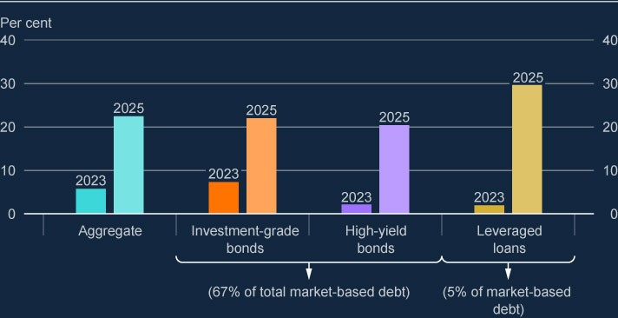

Sources: Refinitiv Eikon for bonds, Bloomberg for leveraged loans and Bank staff calculations.

1. Investment-grade bonds have a rating of BB+ and above.
2. High-yield bonds are BBB and below.
3. Leveraged loans are defined as the borrower having a debt to EBIT ratio of 4.5 or above and/or a privateequity sponsor.
4. Other types of market-based debt, not shown in the chart, are private credit, direct lending funds, loans frominsurers and security dealers and finance leasing.

**But higher interest rates are putting some firms under pressure.**

A company’s ICR is calculated by dividing its earnings before interest and tax (EBIT) by its interest expense. A company with high debt-servicing costs relative to its earnings (ie a low ICR) is materially more likely to experience repayment difficulties. As would be expected against a backdrop of rising borrowing costs, the debt-weighted proportion of medium and large corporates with low ICRs increased in 2022 (Chart 2.8). Assuming that corporates do not deleverage any further, this share is expected to continue to increase during 2023, although it is still expected to remain below previous peak levels.

Unexpected further rate rises would increase the percentage of vulnerable corporates further. An upward shock to funding costs of around 200 basis points above market expectations for Bank Rate would be required for the share of low ICRs to reach the pre-GFC peak (again assuming that corporates take no mitigating actions, such as deleveraging). And the required increase in rates would need to be greater still (around 800 basis points) for the share to match the estimated historical peak in 2000.

Within the aggregate, medium-sized corporates are more likely to have low ICRs than large corporates, although the share of low ICRs for large corporates is projected to increase during 2023, as fixed-rate bonds are refinanced. In practice, however, some companies may choose to repay rather than refinance their debt.

**Chart 2.8: Debt-servicing burdens are increasing**

Debt weighted share of medium and large UK firms with an interest coverage ratio

below 2.5, projected to end-2023

(

**a**

)

(

**b**

)

(

**c**

)

(

**d**

)

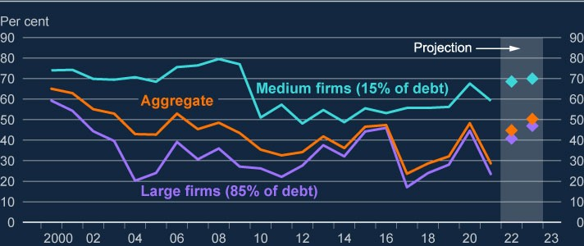

Sources: Moody’s BvD, S&P Global Market Intelligence and Bank calculations.

1. These data refer to UK private non-financial corporations (PNFCs) only.
2. The projection uses the May 2023 MPR projections for earnings and credit spreads, and OIS rates as at 30 June 2023; these are applied to latest published balance sheet data.
3. Firms with turnover less than £10 million are excluded. ‘Medium’ is defined as firms with turnover between£10 million and £500 million, and ‘large’ as greater than £500 million.
4. Bank staff have updated the data used to calculate the low ICR share. Consequently, the figures presentedhere are not directly comparable to those previously published.

**Corporate insolvency rates have risen, driven by smaller firms with limited debts.**

Historically, higher interest rates have tended to be associated with a lagged [increase in the rate of insolvencies (see **Financial Stability in Focus: Interest rate risk in the economy and financial system**). Since the December FSR,](https://www.bankofengland.co.uk/financial-stability-in-focus/2023/july-2023) monthly corporate insolvencies have continued to increase (to around 2,500 in May, up from a Covid-era low of below 700 in early 2021) and have exceeded their pre-Covid level (of around 1,500). Nevertheless, the insolvency rate, as a share of companies, remains low compared to historical levels.

The large majority of this recent increase in total insolvencies has been among smaller ‘micro’ companies.[8] Many of these firms hold little debt and available evidence indicates that a high proportion of the debt they do hold is governmentguaranteed loans from the Covid period, which had low interest rates fixed for six years. This suggests that the subdued macroeconomic environment is leading to the crystallisation of vulnerabilities at some of these firms, as opposed to the direct impact of higher interest rates. And part of the increase is likely to be due to numbers catching up with the historical trend following the end of the covid-era temporary insolvency protections. The insolvency rate for medium and large firms, which account for the vast majority of corporate debt, was largely muted over 2022 but more recently has begun to increase slightly.

Insolvencies are likely to rise further, as pressures caused by higher interest rates and the relatively subdued economic outlook continue to feed through. The UK banking system is well capitalised to withstand increases in corporate distress. As part of the 2022/23 ACS, major UK banks have been stress tested against a broad and severe macroeconomic scenario. The results indicate that they would be resilient to significant credit losses across their portfolios, including on their UK corporate lending (including commercial real estate lending), which had an aggregate projected five-year impairment rate of 8.3%. For context, the current annual corporate loan write-off rate is very low by historical standards at around

0.2%.

|  |  |
| --- | --- |
| Box A: Vulnerabilities in UK and global commercial real estate markets   |  | | --- | | Global commercial real estate (CRE) markets are facing headwinds that are putting downward pressure on prices and making refinancing challenging. But, relative to the 2007–08 global financial crisis (GFC), there has been a reduction in the aggregate amount of leverage used by investors in UK CRE, and less reliance on UK bank funding. Major UK banks are resilient to their CRE exposures, as shown by the results of the 2022/23 annual cyclical scenario (ACS), which included very large CRE price falls. Stress in non-UK CRE markets could also a ect the UK indirectly, for example if stresses in overseas banks caused by, or exacerbated by, actual losses or expected losses in CRE markets were to spill over and a ect funding conditions for UK banks. |   **The commercial real estate market faces a number of short- and longer-term headwinds.**  CRE in the UK is a major investment class: the total stock is estimated to be worth over £1 trillion. Around two thirds of this is held by investors, with the remainder being owner-occupied. Relative to the size of the UK economy, however, the market has shrunk from an estimated 65% of GDP in 2007 to 45% in 2022. Although the leverage of investors has also declined (with their debt relative to assets falling from around 60% in 2008 to 40% now), debt remains an important source of funding for investors, and CRE-related debt stands at around 12% of UK GDP. CRE is also an important asset class globally. In the United States, CRE debt as a proportion of GDP is around 17%. |

|  |
| --- |
| UK CRE prices have fallen by nearly 20% since their mid-2022 peak (Chart A). Higher interest rates are a key factor weighing on prices: absent rent increases, they reduce the profitability of CRE investments relative to other assets such as bonds and increase the servicing costs on any debt. In addition, office and retail investments face specific structural challenges, and these make up around 60% of the total UK CRE stock. The post-pandemic shift to more remote working has contributed to a rise in office vacancy rates, from around 10% in 2018 to over 15% now, and retail has seen a longer-term price decline, partly as a result of more online shopping. The costs of upgrading buildings to meet stricter minimum energy efficiency standards by 2030 is also pushing down on prices.  These challenges for CRE are shared across some advanced economies. CRE prices in the United States and the euro area have so far fallen by less than in the UK, relative to their recent peaks (Chart A). Historically, the UK market has tended to react more quickly than elsewhere. Although real estate investment trusts (REITs) indices suggest that further price falls are likely to come in the UK, they also indicate that further declines in the United States and the euro area are likely to be bigger. |

Price falls can present a risk to lenders if they materially reduce the value of

the collateral held against their loans. Investors are impacted by a decline in

the value of their assets, and especially when investors who use leverage

need to refinance. Fire-selling by investors would exacerbate any existing

market downturn, which would heighten risks to the core financial system.

There has been a structural shift in CRE investors’ funding sources, with UK

banks’ share of outstanding debt declining from over 60% in 2008 to just over

30

% now. This was partly driven by stricter capital requirements in relation to

such loans.

Over the same period, the aggregate loan to value (LTV) ratio of major UK

banks’ CRE lending has improved and almost all of it is currently below 75%

LTV (as of mid-2022). The results of the 2022/23 ACS, which included a 45%

decline in UK CRE prices (as of end of 2022 Q2), suggest that major UK

**Chart A: Commercial real estate values have declined recently in the**

**UK and elsewhere**

CRE price indices for the UK, United States and euro area

(

**a**

)

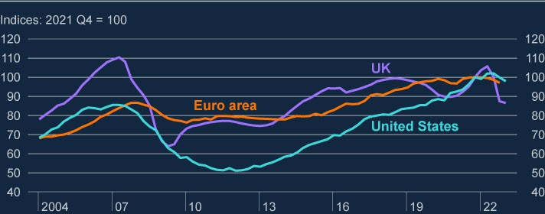

Sources: MSCI, Federal Reserve Board, European Central Bank and Bank calculations.

(

a) The data for the euro area is to 2022 Q4; the data for the UK and US is to 2023 Q

1.

**UK banks are resilient to their exposures to UK CRE.**

banks would be resilient to significant further falls in CRE prices. In

aggregate, their losses on UK and non-UK CRE exposures were less than

7

% of their total impairments in the 2022/23 ACS.

As a proportion of their total assets, some smaller UK lenders are more

exposed to CRE than larger banks. However, the majority of this exposure is

to residential CRE – this sub-sector is less volatile and not facing the same

structural challenges as the wider CRE sector, such as offices and retail.

The trend away from UK bank lending to CRE investors has been associated

with a broadening of funding sources. Investors are now more reliant on

market-based finance and international banks (Chart B). The resilience of

this new funding mix has, however, yet to be tested in a severe CRE market

stress event.

**The profile of lenders and investors in UK CRE has changed over**

**time, with more foreign investment than before the global financial**

**crisis.**

**Chart B: UK banks are still important for CRE investor funding, but**

**bonds now account for a similar share**

Share of CRE investor debt by source, 2022

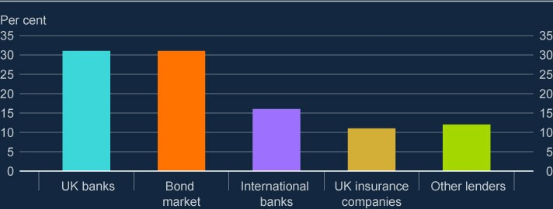

Sources: Bayes survey, PRA, Stress Test Data Framework and Bank calculations.

|  |
| --- |
| The likelihood of price falls triggering rapid market exit by investors depends to a large extent on the nature of the investor. The majority of UK CRE investors, including institutional investors, have long-term investment horizons and are generally diversified, with UK CRE only comprising a small proportion of their total exposures.  Close-ended REITs (or similar foreign-listed funds) are estimated to hold around 20% of UK CRE investments (around 13% of the total UK CRE market, including owner-occupied). They use debt to boost returns, and if worsening LTVs and profitability make it harder for them to refinance when existing loans fall due in the coming years, they could be forced to take out costlier debt, deleverage or default.[9] Open-ended funds are more vulnerable to rapid redemptions in the event of market stress (although they can suspend or defer redemptions to avoid fire sales). However, the market share of these funds has declined since 2016, and they now hold less than 8% of UK CRE investments (around 5% of the total UK CRE market), limiting the impact they could have on the wider market.  A major structural change since the GFC has been growth in the importance of foreign investors, whose share of the total UK CRE stock has increased markedly (Chart C). The appetite of foreign investors for UK assets will be influenced by a number of factors, including the strength of their domestic market and the exchange rate. Foreign investors might be more likely to react sharply to a market stress in UK CRE and retrench, which could amplify potential risks related to leveraged investors and open-ended funds. |

CRE markets in other jurisdictions share commonalities with the UK,

including current challenges for prices, although the funding and investor mix

may vary. Banks are the most important source of finance across the euro

area, the US and the UK. Smaller and mid-sized banks play a particularly

important role in the US. The openness of the UK CRE market, and UK

financial markets more generally, exposes the UK financial system to risks

originating elsewhere.

Some UK banks have material direct exposures to overseas CRE markets,

and in particular China and Hong Kong where property markets have faced

specific challenges related to Covid policies and policy-driven deleveraging.

As part of the 2022/23 ACS, relevant banks have been stress tested against

**Chart C: Over half the UK CRE stock is owned by investors, and**

**foreign investors’ share has increased since 2007**

Share of CRE stock by ownership type, 2007 and 2022

(

**a**

(

)

**b**

)

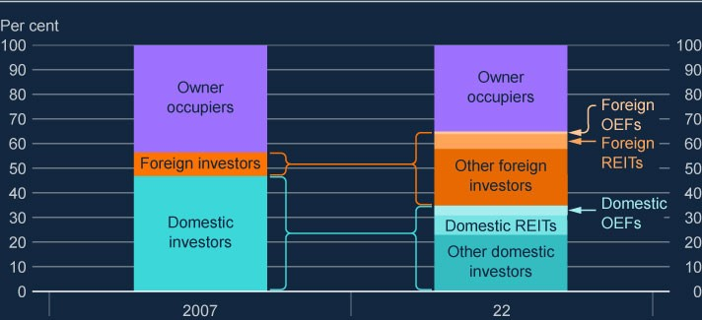

Sources: CAPIQ, Investment Association, Investment Property Forum, MSCI/AREF UK Property Fund

Index, MSCI RCA and Bank calculations.

(

a) Real estate investment trusts (REITs) data includes other, similar listed funds.

(

b) Open-ended funds (OEFs) data includes both public and private funds.

**There are important global linkages which mean that CRE stresses in**

**other markets could spill over to affect the UK CRE market or the**

**wider UK financial system.**

|  |
| --- |
| severe real estate price falls in these markets (including CRE values falling by 53% in Hong Kong), demonstrating that they are resilient to risks from these exposures.  Foreign banks hold a significant proportion of UK CRE investor debt. Some of these banks also have significant exposures to CRE elsewhere – this is the case for certain European banks, for example. Losses or risk aversion in those other markets could cause them to retrench rapidly from their UK exposures, exacerbating refinancing challenges for investors. Sources of foreign investment in UK CRE are relatively diversified across regions and investor types, reducing the risk posed by stress in specific markets. But a widespread, global CRE stress could risk triggering contagion to the UK.  Stress in non-UK CRE markets could also affect the UK indirectly, if stresses in overseas banks caused by, or exacerbated by, actual losses or expected losses in CRE markets were to spill over and affect funding conditions for UK banks. |

# 3: The resilience of the UK banking system

Actual and expected increases in interest rates – which have led to tighter financial conditions – along with subdued economic growth, can create risks to the UK banking sector. The recent stresses in parts of the global banking system also highlighted channels through which risks from other jurisdictions could be propagated to UK financial stability.

The FPC continues to judge that the UK banking system is resilient and has the capacity to support households and businesses through a period of higher interest rates, even if economic and financial conditions were to be substantially worse than expected.

Asset quality continues to be relatively strong. The share of credit impaired loans within major UK banks’ overall lending remained stable.

Major UK banks’ capital and liquidity positions remain robust and preprovision profitability has increased. However, the overall risk environment is challenging. Some forms of lending such as commercial real estate and highly leveraged lending – as well as lenders that are more concentrated in those assets – are more exposed to credit losses as borrowing costs rise.

The results of the 2022/23 annual cyclical scenario (ACS) stress test indicate that the major UK banks would be resilient to a severe stress scenario that incorporated persistently higher advanced economy inflation, increasing global interest rates, deep and simultaneous recessions in the UK and global economies with materially higher unemployment, as well as sharp falls in asset prices.

The failure of three US banks and Credit Suisse earlier this year had a limited impact on UK banks. The FPC judges that the tightening of lending standards over recent quarters reflects increased credit risk, rather than defensive actions by banks to protect their capital positions. The FPC will continue to monitor UK credit conditions for signs of tightening that are not warranted by changes in the macroeconomic outlook. The FPC agreed to maintain the UK countercyclical capital buffer (CCyB) rate at its neutral setting of 2%.

The FPC has considered initial lessons for UK financial stability from recent stresses in the global banking sector and supports the work being undertaken by the relevant authorities.

## 3.1: Recent developments in the UK banking system in the context of higher interest rates

**Major UK banks’ capital and liquidity positions remain robust.**

Since the global financial crisis (GFC) of 2007–08, the UK authorities have put in place a range of robust prudential standards, including for bank capital and liquidity, designed to ensure levels of resilience which are at least as great as those required by international baseline standards. This has supported UK financial stability through recent stresses.

The major UK banks remain well capitalised, with an aggregate Common Equity Tier 1 (CET1) capital ratio of 14.6% in 2023 Q1 (Chart 3.1). Their aggregate CET1 ratio remained flat relative to 2022 Q4, as robust pre-provision profits were offset predominantly by the distributions banks made and by impairments.

UK banks maintain strong liquidity and long-term stable funding positions with comfortable headroom above regulatory standards. Major UK banks’ aggregate three-month rolling average Liquidity Coverage Ratio (LCR) stood at 146% in April 2023, up from 144% in December 2022. These banks held high-quality liquid assets (HQLA) of £1.4 trillion in May 2023, of which around 60% was held in central bank reserves. On average, only 10% of their liquid assets are hold-tocollect securities. In 2023 Q1, major UK banks had a Net Stable Funding Ratio (NSFR) of 137% on average. The aggregate loan to deposit ratio for the major UK banks also remains well below levels reached during the GFC.

The results of the 2022/23 ACS stress test indicate that the major UK banks would be resilient to a severe stress scenario that incorporated persistently higher advanced economy inflation, increasing global interest rates, deep and

simultaneous recessions in the UK and global economies with materially higher unemployment, as well as sharp falls in asset prices.

The stress test scenario is not a forecast of macroeconomic and financial conditions in the UK or abroad. Rather, it represents a ‘tail risk’ scenario designed to be severe and broad enough to assess the resilience of UK banks to a range of adverse shocks.

In the stress test, the aggregate CET1 ratio of major UK banks is projected to fall from 14.2% at the end of 2022 Q2 to a low point of 10.8% in the first year of the stress, which compares to an aggregate hurdle rate of 6.9% (Chart 3.1). Hurdle rates in the ACS comprise banks’ minimum capital requirements and systemic buffers. For more details on the ACS see Box B.

**Chart 3.1: Major UK banks start the 2022/23 ACS with a robust aggregate**

**capital position, which remains well above the aggregate hurdle rate at the**

**low point**

**(**

**a) (**

**b)**

Aggregate CET1 capital ratio of major UK banks and impact of the 2022/23 ACS

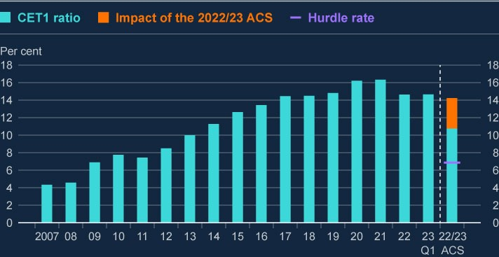

Sources: PRA regulatory returns, published accounts and Bank calculations.

(a) The CET1 capital ratio is defined as CET1 capital expressed as a percentage of risk-weighted assets. Major

UK banks are Barclays, HSBC, Lloyds Banking Group, Nationwide, NatWest Group, Santander UK, Standard Chartered and (from December 2020) Virgin Money. From 2011, data are CET1 capital ratios as reported by banks. Prior to 2011, data are Bank estimates of banks' CET1 ratios. (b) The balance sheet cut-off date for the 2022/23 ACS was 2022 Q2.

**The small and medium-sized UK bank sector as a whole is well capitalised and maintains strong liquidity positions.**

In aggregate, small and medium-sized UK banks are well capitalised and have strong liquidity positions, with a CET1 capital ratio of 18.5% in 2023 Q1 (up from 18.3% in 2022 Q4) and an average LCR of 251%.

There is a wide range of business models among smaller and medium-sized UK banks. Some are specialised in particular activities or serve particular sectors. In a more challenging environment, these business models will be impacted by different risks in different ways.

Smaller lenders typically have greater amounts of capital as a share of their riskweighted assets, relative to regulatory requirements, than larger lenders, and maintain significant liquidity buffers. Members of the Sterling Monetary Framework can borrow liquidity from the Bank of England against a broad range of eligible collateral.

**Impacts from the recent overseas banking stress on UK banks have been limited. The FPC continues to monitor developments in overseas banks closely.**

Starting in March 2023, three US banks and Credit Suisse failed and a number of smaller banks in the US came under stress. In response, bank equity prices declined sharply across jurisdictions, including for major UK banks. However, major UK bank valuations quickly stabilised and recovered somewhat. Changes since the start of 2023 are broadly in line with the change in the FTSE All-Share index over that period. In contrast, in the US, the S&P 500 regional banks index remains around 30% lower than prior to the March stress. For more information on global banking sector equity performance see Section 4.

In March, major UK banks’ wholesale funding spreads relative to risk-free interest rates rose sharply, reaching 240 basis points, up from 160 basis points at the start of the month. But they have since fallen back to around 185 basis points. In the US, funding spreads for major US banks remain elevated at around 170 basis points, up from 130 basis points in early March.

The recent stress, concentrated in the US regional banking sector, confirms and underscores a number of key risks around the potential impact of distressed banks.

First, it has demonstrated how contagion could spread across and within jurisdictions, even where smaller institutions are involved. It also highlighted that while an individual institution may not be considered systemic, if a risk is common – or perceived to be common – among similar institutions, the collective impact could pose a systemic risk.

Second, these events confirmed the importance of robust macroprudential, regulatory and supervisory standards, and in particular the need for all banks to be adequately capitalised against the risks they are exposed to, including interest rate risk.

Finally, these events underscored the importance of being able to resolve firms effectively and of maintaining confidence in resolution frameworks. In co-ordination with HM Treasury, the Bank is seeking to ensure that for small banks, which do not need to hold additional resources to meet the minimum requirement for own funds and eligible liabilities, there are resolution options that improve continuity of access to deposits and so outcomes for depositors. The FPC supports this work and continues to monitor developments in the global banking sector closely. For more information on lessons from the recent stress see Box C.

**Profitability has increased, enabling major UK banks both to improve their capital positions and to support the economy.**

The major UK banks earned pre-provision profits of £17.9 billion in 2023 Q1, a 21% increase compared to 2022 Q4, supported by continued strong net interest income as well as an increase in non-interest income. The increase in profitability enabled banks to improve their capital positions, while supporting their customers.

Major UK banks’ non-interest income increased by 25% due to strong trading income, while impairments decreased. Impairments totalled £1.4 billion in 2023 Q1, compared to £2.6 billion in each of 2022 Q3 and Q4, as banks factored moderate improvements to the economic outlook and changes in market interest rates, over Q1, into their provisions.

Major UK banks’ net interest income was broadly flat on the quarter at £21 billion, but this was 30% higher than in 2022 Q1. Banks’ loan margins, which are closely related to broader net interest margins, have risen sharply since interest rates began to rise. But consensus estimates suggest that loan margins may be approaching their peak and are expected to remain around these levels in 2024 and 2025 (Chart 3.2).

There are likely to be factors affecting major UK banks’ net interest margins that will work in opposite directions. On the one hand, previous increases in interest rates will continue to put upward pressure on net interest margins as existing fixed-rate assets mature, and cash associated with banks’ non-interest-bearing liabilities is reinvested at higher rates.

But there are signs of increased competition in the deposit rates offered by UK banks, with higher pass-through of changes in Bank Rate and market interest rates to deposit rates than was observed at the time of the December 2022 FSR. Major UK banks’, which held around 70% of total UK household deposits, had quoted rates on sight deposits and time deposits that were below market average rates at the end of 2022. But their quoted rates on time deposits in particular have since moved closer to the rest of the market, which includes smaller UK banks and building societies and overseas banks operating in the UK. The extra competition for deposits should put downward pressure on major UK banks’ net interest margins.

In recent months, more depositors have shifted from lower paying sight deposits towards better remunerated time deposits, which is another factor that may put some downward pressure on banks’ net interest margins, and which increases the stability of bank funding. In the 2022/23 ACS, depositors are assumed to switch to interest bearing accounts in greater numbers as interest rates rise (see Box B).

Market measures of major UK banks’ future profitability, such as their average price to tangible book (PtTB) ratios, have remained subdued, despite strong profitability. This might reflect several factors, including the potential that current higher net interest margins and profitability could be a short-term phenomenon due to competition or, for example, an increase in impairments.

**Chart 3.2: The average loan margin for major UK banks has increased with**

**recent interest rate rises but is expected to peak in 2023**

Evolution of the average margin on major UK banks’ lending since 2000

(

**a**

)

(

**b**

)

(

**~~c~~**

)

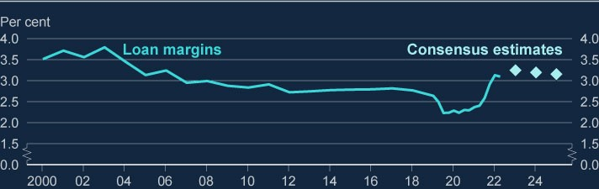

Sources: Published accounts, Refinitiv Eikon and Bank calculations.

1. Loan margin is calculated as net interest income divided by total lending. Loan margins in this chart arecalculated across all currencies. Net interest income is interest income minus interest expense.
2. Figures between 2000 and 2019 exclude Virgin Money UK, and figures before 2006 exclude StandardChartered.
3. The aqua diamonds show market analyst expectations of loan margins 2023–25.

**Asset quality remains relatively strong despite higher interest rates.**

Major UK banks’ asset quality was broadly unchanged in 2023 Q1. The share of credit impaired loans (IFRS 9 ‘stage 3’ loans) within major UK banks’ overall lending remained at 1.8% in 2023 Q1. The proportion of defaulted mortgages remained stable, while the share of defaults on retail unsecured lending declined. And although the share of credit impaired loans for corporate lending increased slightly, this was largely driven by the volume of these exposures declining.

The deterioration in major UK banks’ forward-looking indicators of asset quality seen in the second half of 2022 did not persist in 2023 Q1. In fact, the share of loans for which there has been a material increase in credit risk since origination (IFRS 9 ‘stage 2’) fell slightly to 11.6% from 12.1% in 2022 Q4 (Chart 3.3). This is consistent with the improvement in the economic outlook between 2022 Q4 and 2023 Q1. Nevertheless, the outlook for asset quality remains uncertain.

Relatedly, provision coverage remained broadly stable over 2023 Q1 at 1.1%, slightly above pre-pandemic levels.

**Chart 3.3: Major UK banks’ credit impaired loans remained stable in 2023**

**Q1; and the deterioration in forward-looking indicators of asset quality did**

**not persist**

Proportion of loans classed as stage 2 and stage 3 under IFRS 9

(

**a**

)

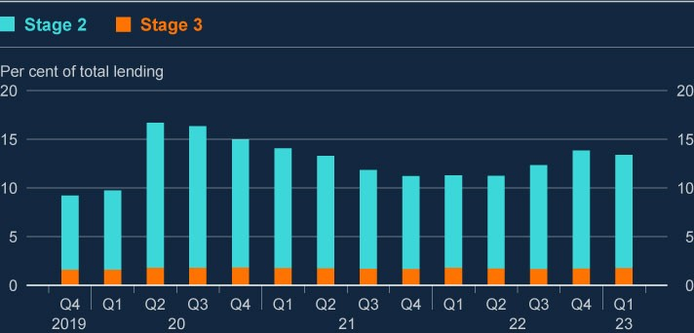

Source: PRA regulatory returns.

(a) Stage 2 loans are loans at a heightened risk of default since origination, and stage 3 loans are credit impaired.

**The overall risk environment is challenging. Some forms of lending, such as commercial real estate and highly leveraged lending – as well as lenders that are more concentrated in those assets – are more exposed to credit losses as borrowing costs rise.**

Commercial real estate (CRE) remains a potentially vulnerable sector, as higher interest rates and structural shifts in demand reduce property values, along with borrowers’ ability to service debt. Globally, CRE prices have fallen and continue to experience downward pressure. Large UK banks’ UK CRE-related exposures amount to 1% of total assets, while their global exposures are slightly larger, around 1.5% of total assets. Smaller UK banks have a greater relative exposure to CRE investors amounting to 10% of these banks' total assets, consistent with their generally more concentrated business models. But nearly 70% of this is to the less volatile residential investment sector. The PRA's supervisory work includes ensuring exposures of this type are assessed through banks’ own stress tests and supervisory analysis.

The FPC judges that direct risks to the UK banking sector from losses on lending to the CRE sector are limited. This is supported by the results of the 2022/23 ACS, which show that the major UK banks would be resilient to a shock which included a 45% reduction in UK CRE prices from their mid-2022 levels. This assumption is significantly more severe than the falls in prices implied by forward-looking market measures. In the stress test, credit impairments on CRE loan portfolios account for a reduction in major UK banks’ CET1 ratios of 0.3 percentage points at the year one low point. For more information, see Box A.

Globally, leveraged loan issuance fell and default rates have increased over the past year (see Section 4). In 2022 Q4, major UK banks active in leverage lending markets had global holdings worth around 12% of their corporate loan book in aggregate (around 64% of CET1 capital). UK banks also have small indirect exposures (amounting to £9 billion at 2022 Q2) through their holdings of collateralised loan obligations. The 2022/23 ACS stress test captures risks to major UK banks from leveraged lending. In the stress test scenario, the five-year impairment rate for UK, US and Europe was 10.5%. By comparison, actual aggregate impairment rates on US and European leveraged loans in the GFC were 8%.

**Banks are interconnected with the system of market-based finance.**

The UK banking system supports the provision of market-based finance (MBF) through investment banking activities and through facilitating MBF, including by supplying liquidity to non-bank financial institutions (NBFIs).

A stress in financial markets could be propagated to banks through their [interlinkages with market-based finance, as discussed in the **December 2022**](https://www.bankofengland.co.uk/financial-stability-report/2022/december-2022)

[**Financial Stability Report**. For example, if appetite for riskier credit assets](https://www.bankofengland.co.uk/financial-stability-report/2022/december-2022)

continues to decline, banks may incur mark-to-market losses on their loan origination, underwriting and syndicating activities in leveraged loan markets.

Vulnerabilities in MBF also expose banks to risks in other ways. For example, the behaviour of NBFIs in a market stress has the potential to interact with and amplify shocks in UK financial markets core to UK financial stability, such as the gilt market. The Bank is running a system-wide exploratory scenario, which will investigate the behaviours of banks and non-bank financial institutions following a severe but plausible stress to financial markets (see Section 5).

## 3.2: Resilience of the UK banking system to interest rate risk

**Higher interest rates have so far increased UK bank profitability, but interest rate risk is an inherent part of banking.**

The profitability of the UK banking system has increased as policy rates have risen, primarily driven by increases in net interest income. Aggregate net interest margin has risen as the interest banks pay on their liabilities (such as deposits) has risen by less than the interest they receive on their assets (including mortgages). The increase in net interest margins has been boosted by the move away from interest rates that were close to zero.

Changes in interest rates also affect the value of banks’ assets relative to their liabilities. Higher rates reduce the present value of assets with fixed payments, including government bonds, other fixed-rate securities, and most mortgages.

Therefore, interest rate risk is an inherent part of banking.

**Banks manage this interest rate risk via hedging.**

Banks adopt a range of hedging approaches to manage volatility in their income and balance sheet. In general, banks convert some of their fixed-rate assets (coloured orange in Figure 3.1 on the left-hand side) into floating-rate assets (coloured aqua in Figure 3.1 on the left-hand side), to match their floating-rate liabilities (coloured aqua in Figure 3.1 on the right-hand side). They might do that, for example, by using interest rate swap contracts in which they pay a fixed rate and receive a floating rate which is linked to market interest rates.

Banks also tend to hold fixed-rate assets against a portion of their liabilities that are interest rate insensitive or fixed. This reduces the volatility of their net interest income as interest rates change in either direction. Banks’ specific approaches to hedging their interest rate risk depend on their business model. As well as using interest rate swaps, they can, for example, rely on the underlying fixed and floating nature of their assets.

Banks make assumptions in the process of hedging interest rate risk. A key assumption relates to depositor stability; when there is no contractual maturity for a liability, such as a current account, banks make behavioural assumptions on how those liabilities will respond to higher interest rates.

So long as the interest rate sensitivity of banks’ assets and liabilities are well matched, reductions in the value of banks’ fixed-rate assets arising from changes in interest rates will not be realised if those assets are held to maturity. As such, banks hold some assets, such as mortgages and ‘held to collect’ securities on an amortised cost basis meaning when interest rates rise the accounting value of such assets used in the calculation of regulatory capital is typically not adjusted.

These assumptions, and banks’ risk management processes around them, are closely supervised by the PRA.

Banks also manage interest rate risks related to their trading activities, but typically do not seek to take interest rate risk positions on their trading book for a prolonged length of time.

**UK banks’ interest rate risk is regulated and supervised through firms’ Pillar 2A capital requirements, supervision by the PRA, and stress testing.**

**Figure 3.1: Stylised bank balance sheet**

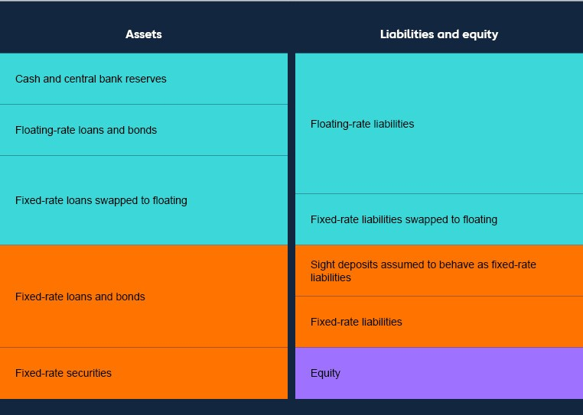

Even after hedging has been taken into account, most banks will retain some degree of exposure to interest rate risk. The PRA assesses all UK banks on their need to have capital against the interest rate risk on their banking book, including assets held at amortised cost or fair value. This is done via an explicit capital requirement in the Pillar 2A part of the capital framework, against ‘interest rate risk in the banking book’ (IRRBB).

The capital requirement is calibrated on forward-looking estimates of the impact of large shocks to the interest rate yield curve on the net position of banks’ banking books. The process for calibrating the IRRBB Pillar 2A requirement involves an interest rate shock. For smaller firms, the interest rate shock is typically a ±200 basis points parallel shock of the yield curve, with assets and liabilities revalued at the new rate. Larger banks calibrate their own material yield curve shocks, with the results then compared to a PRA benchmark to ensure that banks are adequately prudent. Pillar 2A requirements are assessed annually for large firms.

The 2022/23 ACS also stresses major UK banks to higher interest rates through a combination of channels. It captures the impact of higher rates on net interest income, credit impairments and losses through fair value banking and trading book assets (see Box B).

Smaller firms are subject to Internal Capital Adequacy Assessment Process stress tests, where the scenarios are derived from the ACS, including through higher rates scenarios.

**Liquidity regulation, supervision and resources increase the UK banking system’s resilience to large outflows of deposits.**

Recent overseas banking stresses were associated with large-scale withdrawal of depositor funding. In the case of Silicon Valley Bank (SVB), this led to the realisation of unrecognised losses on assets that had fallen in value as interest rates had risen (see Section 4).

UK banks’ holdings of liquid assets, reduce the likelihood that any hold-to-maturity assets would need to be sold as a result of depositor outflows. In the UK, banks are subject to LCR and NSFR liquidity requirements. The LCR promotes the short-term resilience of the liquidity risk profile of banks, by requiring them to hold a large enough stock of high-quality liquid assets to meet their payment obligations to survive specified stressed liquidity outflows. The NSFR is intended to ensure that banks maintain a stable funding profile in relation to the composition of their assets and off balance sheet activities. In aggregate both major and smaller UK banks comfortably exceed 100% on both their LCR and NSFR.

UK banks also have access to a range of Bank of England liquidity facilities. The Bank accepts a wide range of collateral, which can include assets that are less liquid and harder to sell quickly, such as mortgages or other loans. Banks can ‘preposition’ these less liquid assets with the Bank of England, enabling due diligence and valuation in advance. The additional amount the Bank could lend to UK Banks through its market operations based on excess pre-positioned collateral is around £300 billion.

The Bank is participating in international work to consider lessons for the liquidity framework for banks, or components of it, in light of the size and pace of outflows witnessed in recent events (see Box C).

All UK banks are also subject to prudential standards, designed to ensure levels of resilience which are at least as great as those required by international baseline standards. This includes regular reviews of firms' capital and liquidity positions as well as sensitivities to interest rate changes on firms' assets and liabilities.

**There are also risks to banks from increased loan defaults as a result of higher interest rates.**

Banks also remain exposed to credit losses on their loan portfolios as interest rates increase. This could be through greater direct risk of borrower default as their debtservicing costs increase, or through the effect of higher interest rates on macroeconomic variables including GDP, unemployment and property prices. The results of the 2022/23 ACS stress test show that the major UK banks are resilient to risks from these channels (see Box B).

## 3.3: Credit conditions and the outlook for UK banks’ resilience in the context of higher interest rates

**Higher interest rates have reduced the demand for credit. The FPC will continue to monitor UK credit conditions for signs of tightening that are not warranted by changes in the macroeconomic outlook.**

Lending growth has been weak since the December FSR, driven by lower borrower demand. Over 2023 Q1, demand for secured lending for house purchase, unsecured household lending and corporate lending all decreased, according to the Bank’s [**Credit Conditions Survey**.](https://www.bankofengland.co.uk/credit-conditions-survey/2023/2023-q1) The primary drivers of these trends are likely to

be higher interest rates, which have affected affordability, as well as uncertainty around the outlook for house prices, and on the corporate side, economic uncertainty and lower demand from small and medium-sized enterprises that received significant funding during the pandemic.

After rising in 2022 Q4 and subsequently falling back, new mortgage rates have been rising again in recent months, reflecting increases in the market expected path of Bank Rate. Rates on new private non-financial corporation loans have also continued to rise. The increase in wholesale bank funding spreads, discussed in Section 3.1, has so far had a limited impact on UK real economy credit conditions.

Reduced affordability given higher borrowing costs is affecting the amount of mortgage lending at higher loan to income ratios. Indeed, there was a decrease in the share of mortgages at a loan to income greater than or equal to 4.5 from 8.4% in 2022 Q4 to 6.0% in 2023 Q1, and a smaller decrease in the share of new mortgages with a loan to value (LTV) greater than or equal to 90%.

The number of mortgage products on offer decreased in May and June as lenders withdrew some products after sharp increases in UK Bank Rate expectations. During those episodes, lenders withdrew some products at all LTV ratios to adjust pricing and ease operational constraints. The FPC will continue to monitor the availability of credit as pricing and rates adjust.

The FPC judges that the tightening of lending standards over recent quarters reflects increased credit risk, rather than defensive actions by banks to protect their capital positions. The FPC will continue to monitor UK credit conditions for signs of tightening that are not warranted by changes in the macroeconomic outlook.

**The UK banking system is resilient and has the capacity to support households and businesses through a period of higher interest rates, even if economic and financial conditions were to be substantially worse than expected.**

The results of the 2022/23 ACS stress test support this judgement. For more information on the ACS results, see Box B.

**The FPC agreed to maintain the UK CCyB rate at its neutral setting of 2%.**

UK banks’ resilience is supported by continued profitability, relatively strong asset quality and robust capital positions. In light of this, the FPC judged at its July Policy meeting that the UK banking system was in a position to continue to meet credit demand from creditworthy households and businesses. Maintaining a neutral setting of the UK CCyB rate in the region of 2% should help to ensure that banks continue to have capacity to absorb unexpected future shocks without restricting lending in a counterproductive way.

The FPC will continue to monitor developments closely and stands ready to vary the UK CCyB rate, in either direction, in line with the evolution of economic and financial conditions, underlying vulnerabilities, and the overall risk environment.

|  |
| --- |
| Box B: Results of the 2022/23 annual cyclical scenario stress test of the UK banking system  **The results of the 2022/23 annual cyclical scenario (ACS) stress test confirm that the major UK banks have capacity to support households and businesses through a stress that is substantially more severe than the current outlook.**  The results of the 2022/23 ACS[10] stress test have been [**published**](https://www.bankofengland.co.uk/stress-testing/2023/bank-of-england-stress-testing-acs-results-2022-23), and  indicate that the major UK banks would have capacity to support households and businesses through a stress that is more severe than the current macroeconomic outlook. As such, the results of the stress test support the FPC’s judgement that the banking system would have the capacity to support households and businesses in a period of higher interest rates even if economic and financial conditions were to be substantially worse than expected.  The ACS is a countercyclical stress test of banks’ capital resilience. The test assessed the resilience of the eight major UK banks and building societies (henceforth ‘banks’) to a severe hypothetical, countercyclical stress scenario. [11] For the first time, the test extended its scope to assess the ring-fenced subgroups of the existing participating banks on a standalone basis, where these differ materially from the group as a whole.  In order to help ensure that banks have the capacity to support households and businesses in the face of severe adverse shocks, banks conducted the test on the basis that they meet the credit demand of creditworthy households and businesses in the stress.  **The resilience of the UK banking system has been tested against a severe hypothetical stress scenario.**  The hypothetical stress scenario incorporated persistently higher advancedeconomy inflation, increasing UK and global interest rates, deep and simultaneous recessions in the UK and global economies and high unemployment, as well as sharp falls in asset prices (Table 1). |

|  |
| --- |
| It is substantially more severe than the current macroeconomic outlook, given that it combines increasing interest rates with considerably higher inflation than that observed in the current climate, along with severe stresses on other key variables, such as GDP and unemployment. The scenario is also more severe than the global financial crisis (GFC).  The severity of the scenario was calibrated according to the FPC’s assessment of underlying vulnerabilities in the UK and global economies, taking into account the FPC’s assessment of the downside risks facing the economy.  The stress test scenario is not a forecast of macroeconomic and financial conditions in the UK or abroad. Rather, it is a coherent ‘tail risk’ scenario designed to be severe and broad enough to assess the resilience of UK banks to a range of severe adverse shocks. |

|  |  |  |  |  |  |  |  |  |  |  |  |  |  |  |  |  |  |  |  |  |  |  |  |  |  |  |  |  |  |  |  |  |
| --- | --- | --- | --- | --- | --- | --- | --- | --- | --- | --- | --- | --- | --- | --- | --- | --- | --- | --- | --- | --- | --- | --- | --- | --- | --- | --- | --- | --- | --- | --- | --- | --- |
| **Table 1: Features of the 2022/23 ACS scenario and credit impairment**  **rates (a) (b)**   |  |  |  |  | | --- | --- | --- | --- | | **Features of the scenario** |  | **Results: Five-year credit impairment rates** | | | UK unemployment peak | 8.5% | UK household: mortgages | 0.9% (38%) | | UK real GDP start-to-trough | -5.0% | UK household: consumer credit | 27.2% (3%) | | Bank Rate peak | 6% | UK corporate: excluding CRE | 8.4% (7%) | | UK CPI peak | 17% | UK corporate: CRE only | 7.5% (1%) | | UK residential property prices start-totrough | -31% | – |  | | UK CRE prices start-to-trough | -45% | Global household | 6.3% (11%) | | World real GDP start-to-trough | -2.5% | Global corporate | 5.8% (17%) |   Sources: Participating banks’ Stress Test Data Framework data submissions, Bank analysis and calculations.   1. Figures in parentheses denote the share of banking book assets accounted for by each portfoliogroup. 2. Other wholesale lending is excluded from the corporate impairment rates in Table 1. As a result, thefigures in parenthesis do not sum to 100%. Other wholesale lending consists of lending to financial institutions, housing associations, sovereigns, quasi-sovereigns and other wholesale counterparties.   **Banks begin the stress test with improved asset quality and higher deposit balances relative to the previous cyclical stress test performed in 2019.**  Banks begin the 2022/23 ACS at the end of 2022 Q2, with improved asset quality relative to that at the start of the 2019 ACS test. This is due to an increase in residential property prices between these two periods, more conservative lending standards, higher-risk pre-GFC mortgages maturing, and the impact of Government support schemes for corporates during the Covid pandemic.  There have also been changes in the composition of loan portfolios, through a shift in business models towards less risky products and withdrawals from certain geographies that were less profitable, which have made banks more |

|  |
| --- |
| resilient to stress.  Banks also begin the stress test with higher deposit balances than in recent years, as a result of inflows of deposits during the Covid pandemic which led to an improvement in funding positions for some banks.  Regulatory actions have also contributed towards lower risk-weight inflation during the stress for some banks, leading to a smaller impact on their Common Equity Tier 1 (CET1) capital ratios[12] [13]. Changes to regulatory requirements for internal credit capital models resulted in higher starting average risk weights, and less sensitivity to stress for some banks. Ahead of future model changes, temporary post-model adjustments were also included at the start of the test for some banks, which has also reduced how much further risk weights rise under stress.  **The results show that the UK banking system has the capacity to support households and businesses through a stress that is more severe than the current macroeconomic outlook.**  Reflecting the resilience built up by banks in recent years, the results indicate that the UK banking system would be able to withstand the severe macroeconomic scenario and would have the capacity to support households and businesses throughout the stress.  Banks started the test with an aggregate CET1 capital ratio of 14.2% of riskweighted assets (RWAs), and an aggregate Tier 1 leverage ratio of 5.3%. Under the stress scenario, all participating banks are projected to remain above their CET1 and Tier 1 leverage ratio hurdle rates, and no bank is required to strengthen its capital position as a result of the test.[14] As in previous stress tests, the results of the 2022/23 test continue to reflect internationally agreed transitional arrangements for the IFRS 9 accounting standard.[15]  **At the CET1 low point of the test, banks’ aggregate CET1 capital ratio falls to 10.8%, well above the aggregate hurdle rate, and substantially above its pre-GFC level.** |

|  |
| --- |
| In the first year of the test, when banks’ CET1 capital ratios are lowest, the aggregate CET1 capital ratio falls to 10.8%, which is more than twice its preGFC level. The aggregate CET1 hurdle rate in the test is 6.9% (See Section 3, Chart 3.1). The aggregate Tier 1 leverage ratio falls to a low point of 4.7% in the first year, against an aggregate hurdle rate of 3.5%.[16]  The aggregate capital drawdown is smaller than in the 2019 ACS, despite the overall severity of the scenario being broadly similar. This reflects a combination of factors, including improvements in asset quality and higher deposit balances since 2019 which have boosted banks’ loan margins in the 2022/23 test relative to the 2019 exercise.[17]  **Credit impairments are a key driver of the weakening in banks’ capital position during the stress, although these are lower than in the 2019 test.**  Credit impairments are projected to increase substantially during the stress (Table 1). This includes judgements that the cost of living and higher interest payments on debt would increase impairments, while improvements in asset quality over the past few years would work in the opposite direction, dampening the effect of the scenario on retail impairments. Overall, five-year UK retail impairments total £41 billion (corresponding to a 3.0% impairment rate), which is £6 billion lower than in the 2019 test.  UK five-year corporate impairments total £22 billion in the 2022/23 test, corresponding to an 8.3% impairment rate. These reflect the impact of rising higher interest rates, inflation, cost-of-living pressures and supply chain issues on corporates, with seventy per cent of reported impairments coming from sectors that banks had identified as vulnerable to these features of the scenario. UK corporate impairments are nonetheless lower than the £27 billion total impairment charge in the 2019 test (which corresponded to a 9.5% impairment rate). This reflects the impact of Government support schemes related to Covid. Excluding lending via such schemes, the corporate impairment charge in the 2022/23 test is broadly the same as that projected in 2019. |

|  |
| --- |
| Recent years have seen a decrease in the size of participating banks’ UK commercial real estate (CRE) lending. UK CRE is therefore a smaller asset class for participating banks than seen in previous years. The impairment rate on those exposures (7.5%) is broadly similar to that projected in the 2019 test.  Non-UK corporate impairments are broadly the same as in 2019, with comparatively smaller impairments in sterling terms as result a material depreciation of sterling having been a feature of the 2019 test. The test also continues to capture the main risks to participating banks from leveraged lending. The five-year impairment rate for UK, US and Europe is 10.5%. By comparison, actual aggregate impairment rates on US and European leveraged loans in the GFC were 8%.  Impairments over the five years of the scenario amount to £125 billion, which translates to an aggregate impairment rate of 4.7%.[18] This is £26 billion less than in the 2019 test, but if assumptions about exchange rate movements were standardised across the two tests, the difference would be £9 billion.[19]  **Net interest income (NII) increases over the stress, but this is constrained by banks being required to assume that a rising share of their overall deposits are interest bearing, and that the interest paid on deposits increases by more than in recent experience.**  Rising interest rates in the stress scenario lead to higher NII for banks in aggregate over the scenario horizon. This is driven by banks’ ability to deploy their non interest bearing liabilities (such as zero-interest current account deposits and equity) in assets with increasing interest rates, and by increasing the spread between the rates paid on their deposits and the yield earned on their assets.  However, the NII benefit that banks receive is constrained by the assumption that rising interest rates and the higher cost of living in the scenario would result in competitive pressure in deposit markets. It is therefore assumed in the test that many customers would move deposits from current accounts that pay no interest to deposit accounts that do pay interest. It is also assumed that banks pass changes in risk-free rates through to deposit rates to a greater degree than observed over the recent period. In the second year |

|  |
| --- |
| of the scenario, the spread between the rate on household interest-bearing sight deposits and Bank Rate is around 220 basis points. That is consistent with its average over 2000–07.  **The traded risk scenario reduces banks’ capital ratios in the first year of the stress.**  In the test, equity prices fall and corporate bond spreads rise. These moves in financial markets lead to a projected reduction in banks’ CET1 capital ratios through three main channels: lower investment banking income, trading book losses and valuation adjustments, and an increase in stressed  RWAs.  The increase in interest rates in the 2022/23 scenario also cause the value of fixed-rate assets held on the banking book to decline. This includes fair value assets held as part of firms’ liquid asset buffers. The change in the value of those held at fair value feed through to lower capital, reducing the aggregate CET1 ratio by 0.8 percentage points.  **The results of the stress test support the FPC’s judgement that the banking system has the capacity to support households and businesses in a period of higher interest rates, even if economic and financial conditions were to be substantially worse than expected.**  The ACS captures the effect of higher interest rates on banks’ capital position through a number of channels, including net interest income, credit impairments, the impact on securities held on a fair-value basis on the banking and trading books, and the associated changes in risk-weighted assets. Overall, the effect of higher interest rates in the stress test is judged to be negative for bank profitability and CET1 ratios. An important reason for this is the effect on impairments that comes about because of the impact of rising interest rates on macroeconomic variables including GDP, asset prices and unemployment.  The results of the stress test – in which the aggregate CET1 ratio remains above the aggregate CET1 hurdle ratio, and all banks remain above their individual hurdle rates – supports the FPC’s judgement that the banking |

|  |
| --- |
| system would have the capacity to support households and businesses in a period of higher interest rates even if economic and financial conditions were to be substantially worse than expected.  The ACS is, by design, a stress test of banks’ capital positions – individually and in aggregate – over a number of years following a severe macroeconomic and financial market shock. It does not include an additional liquidity stress as part of the scenario. As set out in Section 3, however, a combination of regulation, supervision and firms’ risk management means that the major UK banks have substantial liquid asset buffers which would be available to be drawn upon if a liquidity stress did occur alongside a scenario such as the one in the ACS.  **As in previous stress tests, banks’ resilience relies in part on their ability in stress to take actions to support their capital positions.**  As banks’ capital positions deteriorate in a stress, they are able to take management actions to support their capital positions. These might include cutting dividend payments, employee variable remuneration, or coupon payments on Additional Tier 1 instruments.  The Bank assesses all proposed management actions, for credibility and appropriateness under the specific stress scenario. Only actions that could be credibly executed are permitted in the ACS and the FPC judges that it is important for investors to be aware that banks would take such actions as necessary if such a stress were to materialise.  **The FPC and PRC use the results of the ACS to inform the setting of banks’ regulatory capital buffers.**  The FPC and PRC use the results of the ACS, along with other relevant information, to help inform the setting of banks’ regulatory capital buffers. In setting the UK countercyclical capital buffer (CCyB) rate, the FPC takes into account the extent of financial vulnerabilities and the associated risk that the banking system could experience losses on its UK exposures that may result in a restriction in credit supply that is not warranted by the macroeconomic outlook. The ACS informs the Committee’s view of the resilience of the banking system to cyclical risks. The PRC sets individual banks’ additional |

|  |
| --- |
| Prudential Regulation Authority buffers which some banks are expected to hold in addition to the UK CCyB. The results of the ACS provides information on the appropriate balance between system-wide and individual bank resilience. |

# 4: Global vulnerabilities

Uncertainties around the global financial and economic outlook remain elevated. The outlook for global growth has improved slightly, despite stress in the global banking system and continued heightened geopolitical uncertainty.

The sharp transition to higher interest rates in other jurisdictions could pose risks to UK financial stability via a range of economic and financial channels.

The failure of three mid-sized US banks – and the failure of a globally systemically important bank, Credit Suisse, due to long-running concerns about its risk management and profitability – caused a material rise in financial market risk premia and volatility earlier this year. The impact on the UK banking system through lower equity prices and increases in funding costs was limited, and market risk sentiment has stabilised since then.

Those parts of the global banking system most directly linked to the UK financial system appear resilient. Nonetheless, elements of the global banking system and financial markets remain vulnerable to stress from increased interest rates, and remain subject to significant uncertainty, reflecting risks to the outlook for growth and inflation. The recent banking stress has also underscored how contagion can spread across borders even where smaller institutions are involved. It also highlighted that, while an individual institution may not be considered systemic, if a risk is common – or perceived to be common – among similar institutions, the collective impact can pose a systemic risk.

Actual and expected increases in interest rates continue to weigh on the ability of households and businesses in advanced economies to service their debts. Riskier corporate borrowing in financial markets – such as private credit and leveraged lending – appears particularly vulnerable and global commercial real estate markets face a number of short and longer-term headwinds.

Other external shocks – such as risks from China’s property market – could impact on UK financial stability via trade or financial spillovers, and heightened geopolitical tensions have the potential to increase the likelihood of vulnerabilities crystalising.

The 2022/23 Annual Cyclical Scenario (ACS) stress test of major UK banks includes stress scenario profiles for the key regions of the world to which UK banks are exposed and where spillover effects back to the UK are possible, including the US, euro area, and China and Hong Kong. The results of the test indicate that major UK banks can continue to serve the real economy in a severe global macroeconomic stress, including when interest rates are elevated.

## 4.1: The global economic outlook

**Uncertainties around the global financial and economic outlook remain elevated.**

In the [**May 2023 Monetary Policy Report**](https://www.bankofengland.co.uk/monetary-policy-report/2023/may-2023), the Monetary Policy Committee (MPC)

set out its projections for global activity. Global GDP is expected to grow at a moderate pace throughout the MPC’s forecast period, albeit a little faster in the near term than expected previously. This reflects upside news to demand in advanced economies, partly as a result of lower energy prices, and a shallower and shorter-lived hit to activity in China following the lifting of Covid restrictions. Nonetheless, global growth is expected to remain weak relative to its average between 2010 and 2019, reflecting tighter monetary and financial conditions.

Headline inflation has been falling in the US and euro area, and lower gas prices combined with reduced supply chain pressures should ease global inflationary pressures further in the near term. Core inflation has been slower to decline, reflecting both the indirect effects of higher energy costs and the continued tightness of labour markets.

Central banks have tightened monetary policy since the December 2022 FSR, and market participants’ policy rate expectations in advanced economies have increased since then.

The outlook is subject to considerable uncertainty and there are a number of downside risks that could adversely affect UK financial stability. For example, continued strength in inflation globally might lead to a further sharp tightening in global financial conditions and the potential for further volatility and stress in financial markets. There is also a downside risk to global activity if recent overseas banking sector stresses were to spread more widely through the global financial system, or if any further stresses were to have material impacts on activity in overseas economies, including via broader channels onto business and household confidence. This could have a significant knock-on effect on financial markets and financial stability.

## 4.2: Global risks to UK financial stability

**The sharp transition to higher rates in other jurisdictions could pose risks to UK financial stability via a range of economic and financial channels.**

[**Global vulnerabilities can spill over to the UK through several channels**](https://www.bankofengland.co.uk/quarterly-bulletin/2021/2021-q3/no-economy-is-an-island-how-foreign-shocks-affect-uk-macrofinancial-stability) (Figure 4.1). In particular, a combination of weak global growth and higher interest rates (associated with tighter global financial conditions more generally) can impact UK financial stability in a number of ways:

Banks could incur losses in the event of an increase in global risk aversion and falls in asset prices (including property prices), and UK financial conditions could also tighten in response. The recent US banking stress has also illustrated how contagion could spread across borders even where there are no direct connections or common links between institutions.

Increases in debt servicing costs for foreign borrowers could increase defaults. UK banks could therefore also incur losses on their lending to non-UK borrowers.

A reversal in risk appetite among global investors can increase the cost or reduce the availability of funding for UK institutions. Foreign investors’ decisions are likely to have a larger influence in markets where they have a larger presence, such as commercial real estate (see Box A).

More broadly, global vulnerabilities can also amplify economic shocks in foreign economies and lead to spillovers to the UK, through for example lower demand for UK exports.

**Figure 4.1: Global shocks can affect UK financial stability in a number of**

**ways**

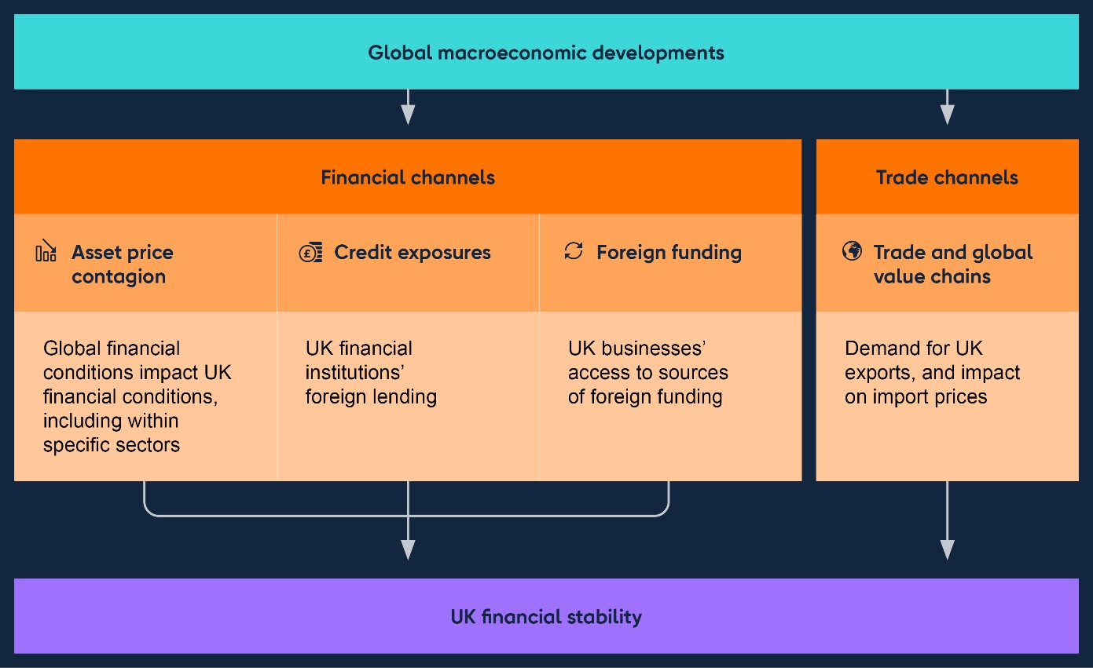

### 4.2.1: The impact of higher rates on the global banking system

**Recent events in the global banking sector highlight the importance of managing the adjustment to higher interest rates.**

Higher interest rates allow banks to expand their loan margins and increase profits, [though higher rates can also pose risks (see **Financial Stability in Focus: Interest rate risk in the economy and financial system**). The profitability](https://www.bankofengland.co.uk/financial-stability-in-focus/2023/july-2023) of major US and euro-area banks has so far benefited from higher net interest margins, but interest rate risk is inherent in banking.

The failure of three mid-sized US banks – and the failure of a globally systemically important bank, Credit Suisse, due to long-running concerns about its risk management and profitability – caused a material rise in financial market risk premia and volatility earlier this year. The impact on the UK banking system through lower bank equity prices and increases in funding costs was limited, and market risk sentiment has stabilised since then. Nonetheless, elements of the global banking system and financial markets remain vulnerable to stress from increased interest rates, and remain subject to significant uncertainty, reflecting risks to the outlook for growth and inflation, and from geopolitical tensions.

Those parts of the global banking system most directly linked to the UK financial system appear resilient. Direct interlinkages between smaller banks overseas and the UK financial system are limited. But the March banking stress underscored how contagion can spread across and within jurisdictions, even where smaller institutions are involved. It also highlighted that, while an individual institution may not be considered systemic, if a risk is common – or perceived to be common – among similar institutions, the collective impact can pose a systemic risk. There are therefore important lessons to be drawn from these events (see Box C).

**The stress in March saw the failure of three mid-sized US banks, following substantial deposit outflows prompted by concerns over poor management of interest rate risk and liquidity risk.**

Silicon Valley Bank (SVB), the 16th largest bank in the US, failed on 10 March following a rapid and very large withdrawal of uninsured deposits. Over previous quarters, higher interest rates had led to significant falls in the value of long-dated bonds held at cost, the risks of which were not hedged. These significant depositor withdrawals led to a need to sell assets quickly, at losses greater than the bank’s capital could absorb. As a US Category IV bank, SVB was not subject to full application of some international regulatory standards for capital and liquidity.[20] [21] Signature Bank, a much smaller US bank, was also closed by the authorities on 12 March.

By 2023 Q1, US banks had accumulated $516 billion of unrealised losses on their held to maturity and available for sale securities (AFS) portfolios through their exposure to interest rate risk.

Following the events in March, to strengthen public confidence in the US banking system, the Federal Reserve, the Federal Deposit Insurance Corporation and the US Department of Treasury jointly announced measures to protect all bank depositors of SVB and Signature Bank, and provide an additional source of liquidity to banks and other eligible depository institutions. Nonetheless, some firms continued to experience significant deposit outflows, which contributed to the failure of First Republic Bank (the 14th largest bank in the US as of end-2022) on 1 May.

**Market risk sentiment and deposit outflows have since generally stabilised.**

Overall, the market reaction to the recent bank failures has been limited to a small number of other US regional banks, with limited impact on UK banks (see Section 3).

Deposit outflows have stabilised recently, including for smaller US banks (Chart

4.1). US banks’ emergency borrowing from the Federal Reserve’s Discount Window and the new Bank Term Funding Program in aggregate has declined from its peak at end-March, and was relatively stable in June. Federal Home Loan Bank advances were an important source of liquidity over this period, increasing to over $1 trillion by 2023 Q1, up from around $800 billion in 2022 Q4.

**Chart 4.1: Deposit outflows from US banks have stabilised**

Level of deposits, seasonally adjusted

(

**a**

)

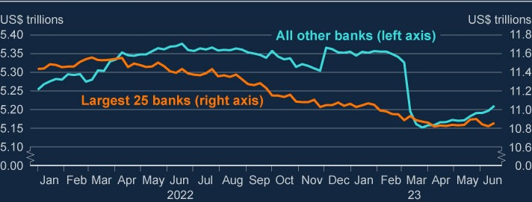

Source: Federal Reserve Board.

(a) Latest data point week ending 21 June (these data are 1.5 weeks lagged).

The Federal Reserve has also published: [**a report**](https://www.federalreserve.gov/publications/files/svb-review-20230428.pdf) examining the factors that

contributed to the failure of SVB, including the role of supervision and regulation; it’s [**May 2023 Financial Stability Report**](https://www.federalreserve.gov/publications/files/financial-stability-report-20230508.pdf) assessing the resilience of the US banking sector; and the results of its [**2023 stress test**](https://www.federalreserve.gov/publications/files/2023-dfast-results-20230628.pdf). The Federal Reserve has judged that the US banking sector remains sound and resilient overall, helped by the actions of the authorities. Some institutions continue to be vulnerable, and monitoring of these institutions has increased.

**Banks in other jurisdictions also have exposures to interest rate risk.**

In the latest [**Global Financial Stability Report**,](https://www.imf.org/en/Publications/GFSR/Issues/2023/04/11/global-financial-stability-report-april-2023) IMF staff estimate that the impact

on CET1 capital ratios of unrealised losses in held-to-maturity portfolios for the median bank in Europe, Japan, and emerging markets would likely be modest, although there could be outliers for which the impact could be material.

In the euro area, bank share prices declined sharply in March as volatility and default risk premia increased sharply. These measures have since stabilised. In its [**May 2023 Financial Stability Report**,](https://www.ecb.europa.eu/pub/financial-stability/fsr/html/ecb.fsr202305~65f8cb74d7.en.html#toc16) the ECB judged that the euro-area banking

sector is resilient overall, with robust capital and liquidity positions and strong fundamentals. However, there are headwinds: asset quality concerns – given the impact of higher interest rates on debt serviceability – and competition for deposits may weigh on future profitability. The European Banking Authority, in co-operation with the ECB, the European Systemic Risk Board and the supervisory authorities, will publish the results of its 2023 EU-wide stress test by end-July.

While interest rates have risen further in many advanced economies, the Bank of

[Japan has maintained its yield curve control policy. In its **April 2023 Financial**](https://www.boj.or.jp/en/research/brp/fsr/data/fsr230421a.pdf)

[**System Report**, the Bank of Japan noted that yen interest rate risk associated](https://www.boj.or.jp/en/research/brp/fsr/data/fsr230421a.pdf) with

banks’ securities investments remained near its historical peak, particularly for regional and shinkin (local financial co-operative) banks. Banks could incur further losses should interest rates rise, but the Bank of Japan stated that, even if a large part of the interest rate risk on securities were to materialise in the form of realised losses, Japanese banks would have adequate capital to absorb such losses.

Against this backdrop, aggregate capital ratios of global banks remain high, and close to post-global financial crisis averages (Chart 4.2).

**Chart 4.2: Aggregate capital ratios of global banks remain high**

Common Equity Tier 1 (CET1) ratios of a sample of global banks

(

**a**

)

(

**b**

)

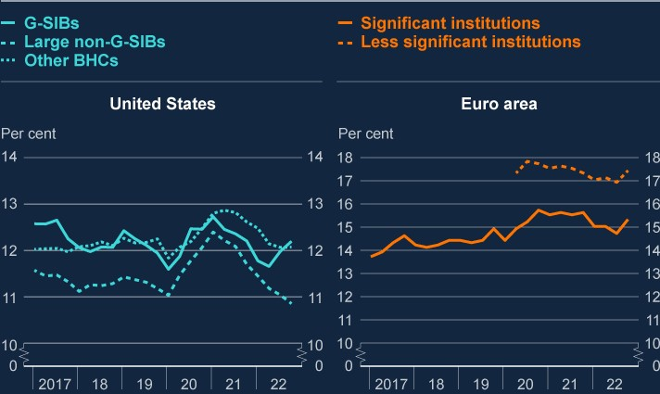

Sources: European Central Bank and Federal Reserve Board (Financial Stability Report – May 2023).

1. Sample consists of US domestic bank holding companies (BHCs) and intermediate holding companies

(IHCs) with a substantial US commercial banking presence. G-SIBs are global systematically important banks. Large non-G-SIBs are BHCs and IHCs with greater than $100 billion in total assets that are not G-SIBs. Other BHCs refers to all other banks in the sample.

1. Significant institutions fall under the ECB’s direct supervision if they meet certain criteria: the bank’s size(exceeds €30 billion), its economic importance and the significance of its cross-border activities. Less significant institutions are small and medium-sized banks that are supervised by national central banks.

### 4.2.2: The impact of higher rates on global households and businesses

**Higher interest rates continue to weigh on the ability of households and businesses in advanced economies to service their debts…**

Credit conditions in the US and euro area have continued to tighten since the December FSR, largely due to tightening monetary policy. The ECB’s 2023 Q1 bank lending survey reported that demand for new lending remained low and had weakened further. Similarly, in the Federal Reserve’s April 2023 Senior Loan Officers Opinion Survey, banks reported weaker demand and tightening lending standards for both households and businesses.

In the US, most existing mortgage borrowers are likely to be shielded from higher interest rates as most household debt is fixed rate, typically with long terms. Mortgage debt accounts for around two thirds of US household debt and 80% was originated on fixed terms of more than 15 years. And nearly all outstanding mortgages are at loan to value ratios of 80% or less.

In the euro area, some borrowers are likely to be exposed to rising rates in the near term. Across the euro area, just under 25% of new mortgage lending in April 2023 was extended at either floating rates or with a fixed term of less than one year. Despite these potential vulnerabilities, as noted above, analysis from the ECB and US authorities show their banking systems are likely to remain resilient to prospective increases in losses on lending.

**…with riskier corporate borrowing in financial markets appearing particularly vulnerable.**

In aggregate, the leveraged loan and private credit markets have roughly doubled in size over the past decade. Within that, estimates suggest that private credit – defined as lending bilaterally negotiated between borrowers and lenders and typically arranged by non-banks – has grown much faster (to an estimated $1.8 trillion in 2023), though it remains relatively small compared to the market for leveraged loans (estimated to be around $4.6 trillion).

Private credit and leveraged loans are both floating-rate instruments, and so borrowers are more sensitive to interest rate rises and could be particularly vulnerable to any further tightening of financial conditions. Such forms of lending – as well as lenders that are more concentrated in these markets – are more exposed to credit losses as borrowing costs rise. Any crystallisation of risks in these markets could spill over to the UK given the role of riskier credit markets in financing UK businesses , and through UK financial institutions’ exposures to affected global counterparties, including foreign banks.

Signs of stress in leveraged loan markets could cause a rapid re-assessment of risks by investors, potentially resulting in sharp revaluations which could drive fire sales on the part of non-bank financial institutions. In 2022 Q4, those major UK banks active in leveraged lending markets had global holdings worth around 12% of their corporate loan book in aggregate. The 2022/23 ACS stress test captures risks to major UK banks from leveraged lending.[22]

Private credit exposures of UK banks are limited. The closed-ended nature of funds investing in private credit, their low leverage, and extended lifespan, may help to limit fire sale risks. The Federal Reserve has therefore [**noted**](https://www.federalreserve.gov/publications/files/financial-stability-report-20230508.pdf) that risks to US

financial stability from private credit funds appear low. Nonetheless, parts of the US market use riskier fund structures with greater leverage to boost returns compared to the UK.[23] This suggests that risks in the US could be more substantial.

Given the common features of leveraged loans and private credit – such as the floating rate nature of lending and links to private equity sponsored activity – there is a risk that stress in one market could spill over to the other.

The commercial real estate sector is also a particularly vulnerable sector globally, as higher interest rates and structural factors have reduced property values along with borrowers’ ability to service debt (see Box A).

### 4.2.3: Other sources of global disruption that could spillover to the UK

**Other external shocks – such as risks from China’s property market – could impact on UK financial stability via trade or financial spillovers…**

There were some tentative signs of recovery in the Chinese property market in early 2023, likely due to some release of pent-up demand following the end of the zero-Covid policy in December 2022, and policy measures to support the sector. However, momentum has slowed in the most recent data. Monthly residential property prices, which had increased for three consecutive months since January, weakened in May, with secondary market prices now 4.1% below their 2021 Q3 peak. Underlying vulnerabilities remain significant given structural issues of oversupply and developer indebtedness. Policy support for the sector has so far had limited success in reviving demand.

**…and heightened geopolitical tensions have the potential to increase the likelihood of vulnerabilities crystalising.**

Russia’s invasion of Ukraine last year led to volatility in energy prices and disrupted supply chains. A further escalation of the war could increase volatility and risk aversion.

Similarly, increased geopolitical tensions, including between the US and China, could disrupt global trade. This could generate financial market volatility and put further upward pressure on inflation leading to higher interest rates and depressing activity around the world, including the UK. Such tensions could particularly affect the UK’s internationally focused banks.

**Financial conditions in emerging markets could also come under pressure.**

Large non-China emerging market economies (NCEMEs), such as Brazil and India, entered the current period of policy tightening with smaller external imbalances than in previous tightening cycles. This has boosted their resilience to recent shocks and helped them avoid a “sudden stop” in capital flows. NCEME banks also do not appear to have been materially affected by the recent global banking stresses.

However, a renewed material deterioration in external financing conditions could yet lead to financing problems. This could come with the risk of potentially destabilising asset sales for a wider group of emerging market economies. NCEME financial distress could affect major UK banks with exposures to those countries, as well as having a wider impact on UK economic activity via lower demand for UK exports.

### 4.2.4: The resilience of the UK financial system to global shocks

**The FPC has assessed the resilience of the UK banking system to risks from global vulnerabilities in its stress test.**

The 2022/23 ACS includes stress scenario profiles for the key regions of the world to which UK banks are exposed and where spillover effects back to the UK are possible, including the US, euro area, and China and Hong Kong. The stress scenario incorporates persistently higher advanced-economy inflation, increasing global interest rates, deep simultaneous recessions in the UK and global economies with materially higher unemployment, and sharp falls in asset prices (including global residential and commercial property prices).

The results of the test indicate that major UK banks can continue to serve the real economy in a severe global macroeconomic stress, including when interest rates are elevated (see Box B).

**However, there continues to be an urgent need to increase resilience in market-based finance (MBF) globally.**

There remain vulnerabilities in certain parts of MBF globally, which could crystallise in the context of the current interest rate volatility, amplifying any tightening in financial conditions. Alongside international policy work led by the Financial Stability Board, the UK authorities are also working to reduce vulnerabilities domestically where it is effective and practical (see Section 5).

|  |
| --- |
| Box C: Initial lessons from the recent overseas banking sector stress  Earlier this year, the resilience of the international banking system was tested when three mid-sized US banks and one global systemically important bank (G-SIB) failed. The UK banking system remained resilient, and the UK’s regulatory and institutional framework, including reforms made since the global financial crisis (GFC), generally worked well during this period of stress. It is nevertheless important that lessons be drawn from these events. Other jurisdictions are also considering lessons from this episode – for example, the Federal Reserve Board published the findings of the review of the supervision and regulation of Silicon Valley Bank, led by Michael Barr, on 28 April 2023.  **Some parts of overseas banking sectors came under stress towards the end of 2023 Q1.**  In March 2023, Silicon Valley Bank (SVB) – the 16th biggest US bank – and Signature Bank of New York both failed following rapid and very large withdrawals of deposits, most of which were uninsured. The withdrawals were prompted by concerns over the scale of their exposure to interest rate risk. This led to pressure on some other US banks, notably First Republic Bank which failed in May. The failure of SVB led to a rapid withdrawal of deposits from its UK subsidiary, Silicon Valley Bank UK (SVB UK). The Bank of England’s resolution regime worked as intended, and the Bank exercised its stabilisation powers to effect the transfer of SVB UK to HSBC.  Last autumn, Credit Suisse experienced significant outflows of client funds. This was associated with long-running concerns about the bank’s risk management and profitability. When client outflows intensified in March following the failures of SVB and Signature Bank of New York, the Swiss authorities intervened. Resolution of Credit Suisse involved a takeover by  UBS. |

|  |
| --- |
| **These events showed the importance of robust macroprudential, regulatory and supervisory standards.**  Since the global financial crisis of 2008, the UK authorities have put in place a range of robust prudential standards, including for bank capital and liquidity, designed to ensure levels of resilience which are at least as great as those required by international baseline standards.  The PRA assess UK banks on their need to maintain capital against interest rate risk on banking book assets, including any net open bond positions – regardless of whether they are held at cost or fair value. This is done via an explicit capital charge in the Pillar 2A part of the capital framework, against ‘interest rate risk in the banking book’ (IRRBB). It is calibrated on forwardlooking estimates of the impact of large shocks to the interest rate yield curve on the net position of banks’ banking books.  This regulatory framework has supported UK financial stability through the recent period of stress. The events serve to underline the need to maintain robust macroprudential, regulatory and supervisory standards – including ensuring a robust prudential regime for small firms, even if simplified – as well as the importance of resolution.  **Some banks experienced large and rapid deposit outflows. Bank staff will contribute to international discussions to consider whether lessons can be learnt for the UK’s liquidity framework.**  In the case of SVB, which had a large concentration of depositors in the technology industry, the prevalence of digital banking and social media networks of depositors and investors appear to have contributed to the speed and magnitude of the outflows experienced.  The UK’s liquidity framework for banks has been designed in line with international standards and includes regular supervisory reviews of banks’ liquidity positions. The framework also provides for access to Bank of England liquidity insurance facilities, which allow banks to access liquidity against a wide range of collateral. As a result, the UK banking system has significant liquidity on which to draw in the event of stress (see Section 3). |

|  |
| --- |
| Nevertheless, Bank staff will consider whether lessons can be learnt for the UK’s liquidity framework, or components of it, in the light of the size and pace of outflows witnessed during the recent stress. Staff will also contribute to relevant work in international fora such as the Basel Committee on Banking Supervision (BCBS) and the Financial Stability Board (FSB).  **The resolution of SVB UK showed the importance of being able to resolve firms effectively and, in so doing, being able to draw on a range of flexible and credible resolution tools for domestic banks and G-SIBs. Internationally, confidence in the resolution framework, especially for G-SIBs, should be maintained.**  Work to enhance resolvability, such as the Bank’s Resolvability Assessment Framework, is important. Last year, the Bank judged that the major UK banks could enter resolution safely: remaining open and continuing to provide vital banking services to the economy.  In co-ordination with HM Treasury, the Bank is seeking to ensure that for small banks, which do not need to hold additional resources to meet the minimum requirement for own funds and eligible liabilities (MREL), there are resolution options that improve continuity of access to deposits and so outcomes for depositors.  The stress also demonstrated the importance of international authorities’ commitment to ensuring that the resolution framework and plans for G-SIBs, in line with FSB standards, remain credible.  **Recent stress in overseas banking sectors highlighted a number of channels through which risks to financial stability could be propagated given the UK has a large and open financial system.**  The failure of SVB brought other US mid-sized banks with similar funding profiles and with large unrealised losses on portfolios of fixed-rate assets into focus, and their share prices fell sharply. This highlighted that while an individual institution might not be considered systemic, if a risk is common – or perceived to be common – among similar institutions the collective impact could pose a systemic risk. In addition, the stress had highlighted how banks |

|  |
| --- |
| largely operating in a domestic market could potentially impact the wider international financial system, even where there was no direct connection between institutions.  As investor sentiment on the US banking sector turned increasingly negative, what initially appeared to be isolated events in the US regional banking sector quickly impacted banks and financial markets across the world, as evidenced by a material fall in bank equity prices and rise in bank funding costs globally, though these have recovered somewhat since then (see Section 4).  The FPC will continue to monitor these and other channels through which risks to financial stability could be propagated and assess any implications for the resilience of the UK financial system. |

# 5: The resilience of market-based finance

The sharp transition to significantly higher interest rates and greater market volatility over the past 18 months has created pressures in some parts of the financial system. Vulnerabilities in certain parts of market-based finance (MBF) remain. These vulnerabilities could crystallise in the context of the current interest rate volatility, amplifying any tightening in financial conditions.

As such, there continues to be an urgent need to increase resilience in MBF globally. Alongside international policy work led by the Financial Stability Board, the UK authorities are working to reduce vulnerabilities domestically where it is effective and practical.

For example, in March 2023, the FPC recommended that The Pensions

Regulator (TPR) take action as soon as possible to mitigate financial stability risks by specifying the minimum levels of resilience for the LDI funds and LDI mandates in which pension scheme trustees may invest. Since then, both the FCA and TPR have published detailed guidance on LDI resilience. The FPC welcomes this guidance and the steps taken by TPR and the FCA to ensure the continued resilience of LDI funds. In recent months as interest rates have risen further, funds have maintained overall levels of resilience consistent with the minimum levels recommended by the FPC, and have initiated recapitalisation at higher levels of resilience than previously. The Bank will continue working with the FCA, TPR and overseas regulators to monitor the resilience of LDI funds closely.

The Bank has recently launched its system-wide exploratory scenario (SWES) exercise, which will be the first exercise of its kind. It aims to improve understanding of the behaviours of banks and non-bank financial institutions (NBFIs) in stressed financial market conditions, and explore how those behaviours might interact to amplify shocks in UK financial markets that are core to UK financial stability. The Bank is also taking action to ensure it has an effective framework for monitoring and assessing risks, and that it has appropriate tools effectively to address market dysfunction where necessary.

## 5.1: The importance of market-based finance

**Market-based finance plays a key role in the UK and global financial systems.**

Market-based finance is the system of markets, non-bank financial institutions (NBFIs) and infrastructure which, alongside banks, provides financial services to support the wider economy.

Since the global financial crisis, NBFIs have grown to account for around half of UK financial sector assets. More than half of the total stock of UK corporate debt, and nearly all of the net increase in lending to UK corporates since 2007, is in the form of non-bank loans or debt securities (Chart 5.1). This has diversified the supply of finance for UK businesses. But it also makes it important that market-based finance is resilient enough to absorb, and not amplify, financial and economic shocks, so that it can continue to support the provision of financial services to UK households and businesses.

**Chart 5.1: Market-based finance is an important source of funding for UK**

**corporates**

Composition of the current stock of UK corporate debt

(

**a**

)

(

**b**

)

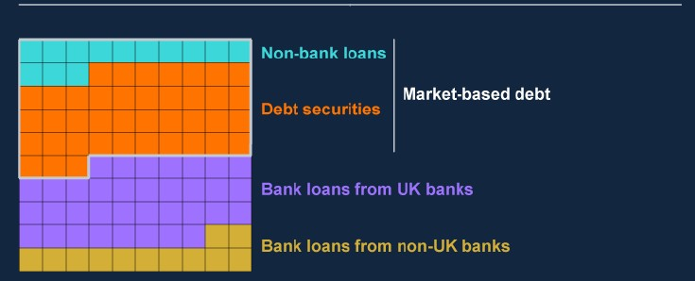

Sources: Bank of England, Bayes CRE Lending Report (Bayes Business School (formerly Cass)), Deloitte, Eikon from Refinitiv, Financing and Leasing Association, firm public disclosures, LCD a part of PitchBook, ONS, Peer-to-Peer Finance Association and Bank calculations.

1. One square represents approximately £14billion. There are 100 squares, each representing 1% of the totalcurrent stock of UK corporate debt, rounded to the nearest 1%. Debt securities include bonds, private placements and commercial paper. Non-bank loans to large corporates includes lending by securities dealers and insurers, non-monetary financial institution syndicated loans, asset finance provided by the non-bank sector, and direct lending funds. These data are for private non-financial corporates using ONS consistent national accounts definitions, and excludes public, financial and unincorporated businesses.
2. Previous Bank of England analysis estimated the share of outstanding market-based debt to be around55% of total UK corporate debt. Some improvements in the calculation of this figure mean that this proportion is now estimated to be around 53%. This does not reflect a substantive change in the total proportion of marketbased debt over 2023, rather an improvement to the methodology used to calculate this proportion.

**The FPC has identified vulnerabilities in market-based finance that could threaten financial stability, a number of which have crystallised in recent years.**

As part of its regular review of risks originating outside the core UK banking sector, the FPC identified and undertook in-depth assessments of risks originating from [**investment funds**, **market liquidity**, **the investment behaviour of insurance**](https://www.bankofengland.co.uk/financial-stability-report/2016/november-2016) [**companies**, **derivatives networks** and **the role of leverage in the non-bank**](https://www.bankofengland.co.uk/financial-stability-report/2018/november-2018)

[**sector**. The FPC has also endorsed the conclusions of the Bank and FCA’s join](https://www.bankofengland.co.uk/financial-stability-report/2018/november-2018)t

[reviews into financial stability risks from **open-ended funds** and **money market**](https://www.fca.org.uk/publication/discussion/dp22-1.pdf)

[**funds**.](https://www.fca.org.uk/publication/discussion/dp22-1.pdf)

A number of long-standing vulnerabilities in MBF have crystallised in recent years. Most recently, vulnerabilities in LDI funds, in which many pension funds invest, were exposed by the rapid and unprecedented increase in UK gilt yields in September 2022. This led to a spiral of collateral calls and forced gilt sales that risked further market dysfunction and quickly created a material risk to UK financial stability. In response, the Bank took temporary and targeted action to restore market functioning, whilst working with LDI funds and other regulators to increase LDI funds’ resilience to further shocks. In March 2020, vulnerabilities in the nonbank financial sector amplified the initial market reaction to the pandemic to create a severe liquidity shock (‘the dash for cash’). This rapidly disrupted market functioning and threatened to harm the wider economy. Significant policy action from central banks was needed in response. And in March 2021, high levels of hidden leverage in equity derivatives was a key factor in the default of Archegos; an episode that highlighted the transmission channels through which the behaviour of leveraged investors can affect both markets and the banking sector.

The underlying vulnerabilities in the system of MBF, identified by the FPC and financial stability authorities globally, remain largely unaddressed and, absent actions to mitigate them, could rapidly resurface. In particular, the recent sharp [transition to higher interest rates and currently high volatility (see **Financial Stability in Focus: Interest rate risk in the economy and financial system**](https://www.bankofengland.co.uk/financial-stability-in-focus/2023/july-2023)) increases the chance that vulnerabilities in MBF could crystallise and pose risks to financial stability.

## 5.2: Recent developments in the resilience of market-based finance

**Over recent months, interest rates have continued to rise globally, and financial markets have been volatile. This has created pressures in some parts of the financial system.**

Over 2023, interest rates have continued to increase, and volatility has been high, especially in interest rates markets, reflecting the uncertainty in the expected paths of inflation and growth (see Section 1).

Market participants have been impacted by this volatility and uncertainty. For instance, following the failure of Silicon Valley Bank (SVB), a sharp fall in yields and rise in volatility meant some macro hedge funds faced severe losses and margin calls, and needed to unwind positions rapidly, which amplified the moves in US rates and government bond markets.

The recent market volatility associated with sharp changes in interest rates has led to increased margin and collateral requirements on both cleared and uncleared [exposures (see **Financial Stability In Focus: Interest rate risk in the economy and financial system**). For example, initial margin received on cleared interest](https://www.bankofengland.co.uk/financial-stability-in-focus/2023/july-2023) rate swaps by London Clearing House (LCH) – which accounts for the majority of clearing in these markets – has averaged about £180 billion daily so far over 2023, compared to an average of about £140 billion over the first half of 2021. In part, this reflects greater uncertainty and volatility in these markets. And, there have been several sharp spikes in variation margin calls on cleared interest rate swaps during periods of particular volatility (Chart 5.2). Heightened volatility also increases margin calls on some bilateral trades, placing liquidity pressures on market participants outside cleared markets. Increases in margin requirements during volatile periods are a necessary and expected element of risk management. Market intelligence suggests that in general, counterparties have not had difficulty in providing initial margin over 2023, or in meeting high variation margin calls on cleared interest rate swaps.

However, as was seen during the ‘dash for cash’ in March 2020, sharp increases in margin requirements can lead to difficulties raising the liquidity to meet them, which can pose risks to financial stability. Continued increases in volatility and uncertainty would place further liquidity pressures on market participants, in both cleared markets and through collateral calls on uncleared bilateral trades.

**Chart 5.2: Initial margin and variation margin on cleared interest rate swaps**

**have increased, and there have been sharp spikes in variation margin calls**

**in periods of particular volatility**

Initial margin (left) and daily variation margin (right) required by LCH Ltd on cleared

interest rate swaps

(

**a**

)

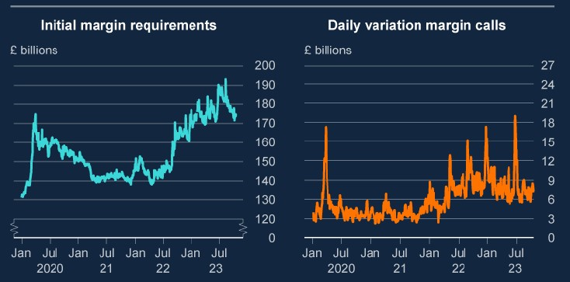

Sources: CCP supervisory data and Bank calculations.

(a) The initial margin series (left-hand panel) shows daily initial margin called on cleared interest rate swaps by LCH Ltd. One outlier in November 2022, reflecting very large calls to cover US public holidays, has been excluded from this series. The y-axis in this chart does not start at zero. The variation margin series (right-hand panel) shows the five-day rolling average of daily variation margin calls on cleared interest rate swaps by LCH Ltd.

**Investors have shifted to less risky investments following recent periods of uncertainty, and riskier funds have seen outflows.**

Investors have increased investments into cash-like and less risky funds over 2023, especially at times of particular uncertainty. US government money market funds (MMFs) saw inflows of around 10% of assets under management (AUM) following the failure of Silicon Valley Bank, as investors responded to stress in the US banking system. AUM in these funds has remained elevated since March. This pattern was also seen in Sterling MMFs following the LDI episode in 2022 where AUM increased by around 30%, though on a much smaller absolute scale (Chart

5.3). This was mostly driven by LDI fund managers increasing their liquid assets, though Sterling MMF holdings have since fallen. US-dollar MMF holdings are currently high by historical standards, which may also reflect greater immediate pass-through of higher interest rates offered to investors by MMFs than offered to depositors by banks.

**Chart 5.3: MMFs have seen inflows following recent periods of stress**

Change in net asset value of sterling (left axis) and US government (right axis) MMFs

(

**a**

)

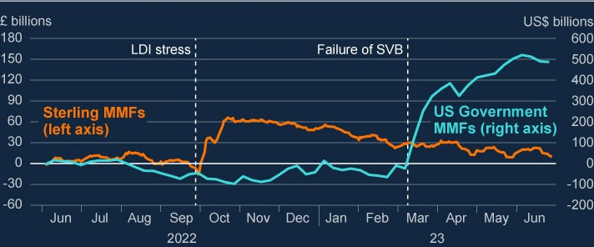

Sources: CRANE data, Investment Company Institute data and Bank calculations.

(a) Change in net asset value relative to 1 June 2022.

As interest rates have risen and the macroeconomic outlook has remained subdued, there is evidence that investors have shifted away from riskier funds. There have been consistent outflows from UK equity and leveraged loan funds over the past year. UK open-ended high-yield bond funds saw significant outflows over 2022, and though these outflows have started to reverse somewhat in more recent data, total assets under management remain well below the levels seen at the start of last year. UK commercial real estate investment trusts have been trading at a discount since mid-2022, and are currently trading at around 25% below their net asset value, suggesting investors are pricing in large downward adjustments to some asset values. In contrast, less risky funds have benefited from the more cautious risk sentiment and increased risk-free rates. For instance, UK and US government bond funds and less risky open-ended corporate bond funds have seen net inflows so far over 2023.

**The system of MBF has broadly been able to absorb these developments.**

While there have been outflows from many riskier open-ended funds, these outflows have been orderly, and there has been no evidence that redemptions have triggered fire-sales of assets or run dynamics. Open-ended funds have held strong liquidity positions over 2023, increasing their resilience to further outflows; the proportion of cash held by funds responding to the Bank of America Fund Manager Survey has averaged around 5.4% since February, relative to a long-term average of 4.7%.

The FPC has previously identified the fragility of market liquidity as a key risk to the resilience of MBF, and market intelligence has highlighted concerns about dealers’ capacity to provide robust liquidity in stress, which could pose risks to financial stability. Market conditions became more challenging during the overseas banking stress in March, but market participants were still able to access liquidity, albeit at wider bid-ask spreads than recent averages.

Recent inflows into MMFs, as well as their importance as a source of liquidity in a stress, have meant that the resilience of MMFs has become more important. Holdings of liquid assets form an important part of MMF resilience, and Sterling

Low Volatility Net Asset Value MMFs have maintained strong liquidity positions over

2022 and 2023 with an average of around 35% of total assets maturing daily, and 50% within a week. These holdings are well above current regulatory minima for assets maturing daily (10%) and within a week (30%). The FPC has previously judged that significantly more liquid assets were an effective way to address financial stability risks from MMFs.

Some firms have seen improvements to their funding positions as interest rates have risen, improving their resilience. UK defined benefit pension fund funding ratios have improved rapidly; their aggregate funding position is now positive, following an extended period in deficit. Life insurers also have long term liabilities that have decreased in value, and their solvency positions remain strong. Positive funding positions support resilience because in response to a deficit, firms might be encouraged to employ high levels of leverage or gain exposure to riskier and higher yielding assets, as was seen in pension funds’ use of LDI strategies prior to the LDI stress in 2022. As well as reducing this incentive to take risks, when NBFIs have strong funding positions, it makes their balance sheets more resilient to shocks.

**LDI funds have generally maintained the resilience they were able to build following the stress in 2022.**

In March 2023, the FPC judged that LDI funds should be resilient to a gilt yield shock of around 250 basis points, at a minimum, and in addition should maintain resilience to manage other risks and day-to-day movements in yields. Gilt yields have risen in recent months, which has tested the resilience of LDI funds. Whilst recent moves have been significant, the speed and scale of these moves has been lower than during the stress period in 2022; 30-year gilt yields rose by over 120 basis points in three days in September 2022, whereas they have risen by around 80 basis points over several weeks between the end of March and late May this year. The largest recent three-day increase has been 23 basis points.

The recent volatility in market interest rates has demonstrated that the resilience framework recommended by the FPC is functioning broadly as intended. Overall, funds have maintained levels of resilience above the minimum levels recommended by the FPC in March, and well above the levels estimated prior to the LDI stress episode in September 2022, and have initiated recapitalisation at far higher levels of resilience (Chart 5.4). The resilience of segregated mandate and single-client LDI funds remains well above the minimum resilience levels recommended by the FPC, with resilience to an interest rate shock of around 500 basis points. The FPC will assess whether there are further lessons to be learned from the recent experience for the implementation of the FPC recommendations.

**Chart 5.4: Overall, the resilience of pooled LDI funds remains above the**

**minimum resilience levels set out by the FPC, and well above levels**

**estimated prior to the LDI stress episode**

Median basis points move in gilt yields that would cause leveraged UK pooled LDI funds

to default

(

**a**

)

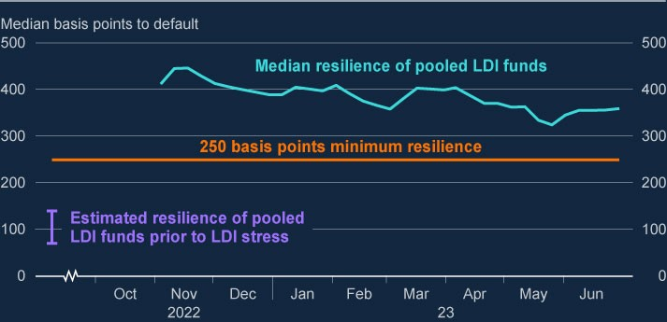

Sources: FCA supervisory data and Bank calculations.

(a) LDI funds refers to leveraged LDI funds and LDI mandates in which many pension schemes invest. The 250 basis points minimum resilience refers to the FPC’s recommendation in March that that LDI funds should be resilient to stresses which account for both historical volatility in gilt yields, and the potential for their forced sales to amplify market stress and disrupt gilt market functioning. The FPC judged that these factors imply that LDI funds should be resilient to a yield shock of around 250 basis points, at a minimum, in addition to the resilience required to manage other risks and day-to-day movements in yields. Estimated resilience is based on supervisory data.

**However, there remain vulnerabilities in the system of MBF, which could crystallise in the context of the current interest rate volatility.**

Vulnerabilities remain in the system of MBF. For instance, over recent months, leveraged hedge funds have built up large positions in US Treasury futures, which market intelligence suggests are relative to bonds or swaps (Chart 5.5). If these markets were to move sharply, deleveraging these positions could further amplify stress.

These risks, and other underlying vulnerabilities in the system of MBF identified by the FPC and financial stability authorities globally, remain largely unaddressed and could resurface rapidly. In particular, the sharp transition to higher interest rates and currently high volatility increases the likelihood that MBF vulnerabilities crystallise and pose risks to financial stability.

**Chart 5.5: Leveraged hedge funds have recently built up large short**

**positions in US treasury futures**

Leveraged hedge funds’ net positioning in selected US bond futures contracts

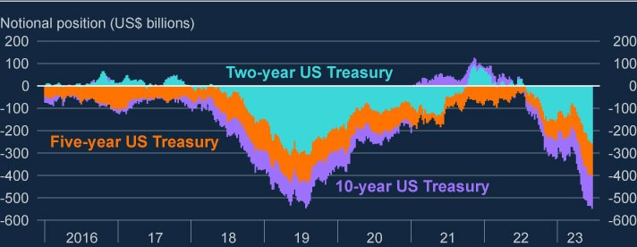

Sources: Commodity Futures Trading Commission data and Bank calculations.

## 5.3: Improving the resilience of market-based finance

**International and domestic regulators need to develop and implement policy responses to build resilience in MBF.**

Given the increasing importance of MBF to the UK economy, and the potential for vulnerabilities in the non-bank financial system to threaten UK financial stability, there is a need to build resilience in MBF and address these vulnerabilities.

The high degree of interconnectedness associated with MBF, both within jurisdictions and across borders, means that risks are most effectively addressed through internationally co-ordinated reforms in the first instance. International work has been led and co-ordinated by the FSB, together with standard setting bodies.

This work aims to analyse, assess and develop policy responses to address underlying vulnerabilities (see the [**FSB’s most recent NBFI progress report**](https://www.fsb.org/wp-content/uploads/P101122.pdf) to

G20 leaders). The FPC strongly supports the international work to improve the resilience of MBF. Key areas for action include:

[**Increasing MMF resilience**: The FSB published **Policy Proposals to Enhance**](https://www.fsb.org/wp-content/uploads/P111021-2.pdf)

[**Money Market Fund** Resilience to address the structural vulnerabilities and ‘run](https://www.fsb.org/wp-content/uploads/P111021-2.pdf) risks’ associated with MMFs. As sterling and dollar-denominated MMFs are also domiciled in Luxembourg and Ireland, there is a need to ensure that MMFs globally are resilient. Further action is needed across jurisdictions in implementing the agreed FSB MMF policy proposals to ensure risks from MMFs are sufficiently mitigated. In the UK, authorities will launch a consultation paper in 2023 H2 on MMF reform.

**Non-bank leverage**: It is important to enhance authorities’ ability to identify and monitor risks from leverage across the system, and the FPC supports the FSB’s ongoing work to assess and take policy action to address vulnerabilities arising from leverage in NBFIs. Authorities need to develop their understanding of systemic risks arising from build-up in NBFI leverage, as well as strengthen the risk management in providers of leverage. The Bank will work with international institutions and authorities to develop policy reforms to address these vulnerabilities.

[**Open-ended fund (OEF) resilience**: The FSB **has issued a consultation**](https://www.fsb.org/2023/07/addressing-structural-vulnerabilities-from-liquidity-mismatch-in-open-ended-funds-revisions-to-the-fsbs-2017-policy-recommendations-consultation-report/)

[**paper** proposing revised policy recommendations to address structural](https://www.fsb.org/2023/07/addressing-structural-vulnerabilities-from-liquidity-mismatch-in-open-ended-funds-revisions-to-the-fsbs-2017-policy-recommendations-consultation-report/) vulnerabilities from liquidity mismatch in OEFs. In particular, the FSB proposes that funds better align their redemption terms with the underlying liquidity of their assets through a more consistent categorisation approach. The proposals also promote greater use, and consistency in use, of anti-dilution Liquidity Management Tools in both normal and stressed market conditions. In parallel, IOSCO [**has published a consultation paper**](https://www.iosco.org/library/pubdocs/pdf/IOSCOPD739.pdf) on guidance for the effective

implementation of anti-dilution tools. The FSB’s and IOSCO’s policy proposals [are both consistent with the **FPC’s principles on liquidity risk management**](https://www.bankofengland.co.uk/report/2021/assessing-the-resilience-of-market-based-finance)

[**for OEFs**.](https://www.bankofengland.co.uk/report/2021/assessing-the-resilience-of-market-based-finance)

**Margin practices**: The FPC supports the ongoing work by BCBS-CPMI-IOSCO and the FSB to develop policy proposals to increase transparency and address vulnerabilities arising from procyclicality of initial margin calls, as well as to streamline variation margining practices in centrally and non-centrally cleared markets. The [**BCBS-CPMI-IOSCO report on margin practices**](https://www.iosco.org/library/pubdocs/pdf/IOSCOPD686.pdf) highlighted six

areas for further work to address vulnerabilities arising from pro-cyclicality in margin models and insufficient predictability, transparency, and preparedness to meet margin calls. Policy proposals are needed to reduce sudden and unexpected liquidity demands across the financial system, and there is also a need to strengthen market participants’ preparedness to meet margin calls by strengthening their internal risk and liquidity management.

Further action is needed by international and domestic regulators to increase the resilience of MBF. Policy reforms need to be finalised and consistently implemented at domestic level across all relevant jurisdictions internationally for them effectively to address vulnerabilities in MBF, and should be complemented by policies to enhance the supply of liquidity in stress. Given the underlying risks remain significant and could resurface, completing this policy work and implementing it across jurisdictions is urgent.

**The Bank continues to work to reduce vulnerabilities domestically where it is effective and practical, including in co-ordination with domestic and overseas authorities.**

[The Bank issued **a report on the resilience of market-based finance in July**](https://www.bankofengland.co.uk/report/2021/assessing-the-resilience-of-market-based-finance)

[**2021** setting out areas of focus in addressing vulnerabilities in the system of](https://www.bankofengland.co.uk/report/2021/assessing-the-resilience-of-market-based-finance)

market-based finance. These are: preventing undue rises in the demand for liquidity in stress periods, increasing the resilience of liquidity supply in stress, and considering what can, or should, be done by central banks to backstop market functioning.

The FPC is focused on domestic implementation of internationally agreed policy proposals to enhance the resilience of MMFs. The FPC judged in March that increasing the resilience of MMFs is necessary to reduce systemic risk in the UK and global financial system, and that MMFs should be able to withstand severe but plausible levels of investor outflows without amplifying stress and increasing risks to financial stability. MMFs should be resilient to outflows at least as large as those seen in the dash for cash and LDI stress events, when central bank actions also helped to limit outflows. Such central bank interventions increase risks to public funds and should not be relied upon. MMF redemption policies should be consistent with the liquidity of the underlying assets held by a fund, and redeeming investors should bear the full liquidity costs of any asset sales needed to meet redemptions. As MMFs generally hold assets to maturity, significantly more liquid assets are an effective way to increase MMF resilience and so reduce risks to financial stability. UK authorities will launch a consultation paper on MMF reform later this year to explore these issues.

In March, the FPC recommended that The Pensions Regulator (TPR) take action as soon as possible to mitigate financial stability risks by specifying the minimum levels of resilience for the LDI funds and LDI mandates in which pension scheme trustees may invest. This resilience should capture both systemic and idiosyncratic risk. As noted above, the FPC judged that these factors implied LDI funds should be resilient to a yield shock of around 250 basis points, at a minimum, in addition to having the resilience required to manage other risks and day-to-day movements in yields. To better allow TPR to implement and enforce guidance on LDI resilience over the long term, and in the context of TPR’s other objectives, the FPC also recommended that TPR should have the remit to take into account financial stability considerations on a continuing basis. This might be achieved, for example, by including a requirement to have regard to financial stability in its objectives, which should be given equal weight alongside other factors to which TPR is required to have regard. The FPC noted that in order to achieve this, TPR would need appropriate capacity and capability.

Since March, both the FCA and TPR have taken action to improve the resilience of LDI funds. In April, TPR published [**guidance on using leveraged LDI**,](https://www.thepensionsregulator.gov.uk/en/document-library/scheme-management-detailed-guidance/funding-and-investment-detailed-guidance/liability-driven-investment) which sets

out detail on practical steps trustees can take to manage risks when using [leveraged LDI. On the same date, the FCA published **guidance on enhancing**](https://www.fca.org.uk/publications/multi-firm-reviews/further-guidance-enhancing-resilience-liability-driven-investment/)

[**resilience in LDI**, which sets out further recommendations to address specific](https://www.fca.org.uk/publications/multi-firm-reviews/further-guidance-enhancing-resilience-liability-driven-investment/)

vulnerabilities within LDI managers. The FPC welcomes this guidance and the steps taken by TPR and the FCA to ensure the continued resilience of LDI funds, and will continue working with the FCA, TPR and overseas regulators to monitor the resilience of LDI funds closely.

**The Bank is also taking action to ensure it has an effective framework for monitoring and assessing risks, and that it has appropriate tools effectively to address market dysfunction where necessary.**

In June, the Bank [**launched**](https://www.bankofengland.co.uk/financial-stability/boe-system-wide-exploratory-scenario-exercise) its system-wide exploratory scenario (SWES)

exercise, which is the first exercise of its kind. The exercise aims to improve understanding of the behaviours of banks and NBFIs in stressed financial market conditions. It will explore how those behaviours might interact to amplify shocks in UK financial markets that are core to UK financial stability. In bringing together information from various parts of the financial system to develop system-wide (and sector-specific) insights, it will be able to account for interactions and amplification effects within and across the financial system that individual financial institutions working alone cannot assess. The FPC supports the exercise, and considers it an important contribution to understanding and addressing vulnerabilities in the system of MBF.

International and domestic workstreams to build resilience in the non-bank financial system are important for ensuring that financial markets and institutions take steps to manage their own risk, and are resilient to severe but plausible stresses. But it is not realistic to expect market participants to self-insure against every possible risk. Central banks need to play a role in backstopping the system in the event of a market stress that threatens financial stability. It is one of the FPC’s priorities to review the Bank’s crisis toolkit, including working to ensure the Bank has the tools to address dysfunction in market-based finance when it threatens UK financial stability. These tools must be designed in a way that minimises moral hazard, and must be accompanied by a significant increase in private sector liquidity resilience.

The Bank is reviewing and considering its capabilities in this area.

# Annex: Macroprudential policy decisions

This annex lists any FPC Recommendations and Directions from previous periods that have been implemented or withdrawn since the previous Report, as well as Recommendations and Directions that are currently outstanding. [24] It also includes those FPC policy decisions that have been implemented by rule changes and are therefore still in force.

Each Recommendation or Direction has been given an identifier to ensure consistent referencing over time. For example, the identifier 17/Q2/1 refers to the first Recommendation made at the 2017 Q2 Committee meeting.

## Outstanding FPC Recommendations and Directions (as at the date of the FPC’s meeting on 3 July 2023)

On 23 March 2023, the FPC made the Recommendation (23/Q1/1) that:

The severe but plausible stresses to which liability-driven investment (LDI) funds should be resilient should account for historic volatility in gilt yields, and the potential for forced sales to amplify market stress and disrupt gilt market functioning. If LDI funds were not resilient to such a shock, their defensive actions could cause financial instability, tightening credit conditions for UK households and businesses. The FPC judged that these factors meant that the size of the yield shock to which LDI funds should be resilient should be, at a minimum, around 250 basis points.

Liquid assets held to ensure resilience in the event of such a shock should be unencumbered and immediately available. Fund managers should have scope to consider additional assets, which investors had authorised them to use to meet collateral demands. Managers should apply appropriate prudence in doing this, for example by applying suitable haircuts.

This minimum level of resilience should be maintained in normal times but could be drawn down on in stress. Minimum resilience around this level would ensure that funds could absorb a severe but plausible historical stress and still have a

remaining level of headroom necessary to operate during a period of recapitalisation. This approach was consistent with the regulatory approaches in place for some systemically important financial institutions, where their standards were designed to allow institutions to continue operating after withstanding a severe stress.

Funds should take into account the nature of their exposures, including duration, leverage, and concentration of holdings, and the liquidity, duration, and convexity of collateral, in modelling their resilience to yield moves.

Pension schemes using leveraged LDI should be expected to be able to deliver collateral to their LDI vehicles within five days. Funds and schemes unable to implement these operational standards should be required to be resilient to a larger shock, calibrated to their own operational timelines.

LDI funds should maintain additional resilience over and above the minimum to manage day-to-day volatility in yields and account for other risks they might face, including operational risks, in order to be able to maintain the minimum level of resilience in normal times. The amount of additional liquidity held should be calibrated by funds according to their own assessments of their exposures and operational capabilities and other regulatory requirements, as well as interest rate trends and levels of market volatility. While this additional liquidity was expected to vary between funds, when combined with the minimum resilience to yield shocks, overall resilience levels should be broadly consistent with those currently prevailing in current market conditions (ie 300–400 basis points). Liquid asset holdings might be safely reduced over time if fund managers were able to demonstrate increased resilience through operational improvements.

In addition, the FPC made the Recommendation (23/Q1/2) that:

The Pensions Regulator (TPR) takes action as soon as possible to mitigate financial stability risks by specifying the minimum levels of resilience for the LDI funds and LDI mandates in which pension scheme trustees may invest. To ensure that they were able in practice to do this, it was important that trustees had a simple mechanism for monitoring, and LDI funds disclosing, levels of resilience in dynamic markets.

TPR should have the ability to employ effective monitoring tools, and to enforce as appropriate in cases of non-compliance with this resilience level. The FPC asked TPR to report back on how it intended to implement the Recommendation.

TPR should have the remit to take into account financial stability considerations on a continuing basis. This might be achieved, for example, by including a requirement to have regard to financial stability in its objectives, which should be given equal weight alongside other factors to which TPR is required to have regard. The FPC noted that in order to achieve this, TPR would need appropriate capacity and capability.

## Other FPC policy decisions which remain in place

The following text sets out previous FPC decisions, which remain in force, on the setting of its policy tools. The calibration of these tools is kept under review.

### Countercyclical capital buffer rate

The FPC agreed to maintain the UK CCyB rate at 2% on 3 July 2023, unchanged from its 23 March 2023 Policy meeting. At its July 2022 Policy meeting, the FPC agreed to increase the UK CCyB to 2%, with binding effect from 5 July 2023. This rate is reviewed on a quarterly basis. The UK has also reciprocated a number of foreign CCyB rate decisions – for more details see [**Financial Stability**](http://www.bankofengland.co.uk/financial-stability). Under

Prudential Regulation Authority (PRA) rules, foreign CCyB rates applying from 2016 onwards will be automatically reciprocated up to 2.5%.

### Liability-driven investment funds

On 30 November 2022, the FPC recommended (22/Q4/1) that regulatory action be taken by TPR, in co-ordination with the Financial Conduct Authority (FCA) and overseas regulators, to ensure LDI funds remain resilient to the higher level of interest rates that they can now withstand and defined benefit pension scheme trustees and advisers ensure these levels were met in their LDI arrangements.

### Mortgage loan to income ratios

In June 2014, the FPC made the following Recommendation (14/Q2/2): The PRA and the FCA should ensure that mortgage lenders do not extend more than 15% of their total number of new residential mortgages at loan to income ratios at or greater than 4.5. This Recommendation applies to all lenders which extend residential mortgage lending in excess of £100 million per annum. The Recommendation should be implemented as soon as is practicable.

The PRA and the FCA have published their approaches to implementing this Recommendation: the PRA has issued a [**policy statement**](http://www.bankofengland.co.uk/pra/Documents/publications/ps/2014/ps914.pdf), including rules, and the FCA has issued [**general guidance**](https://www.fca.org.uk/publications/finalised-guidance/fg17-2-fpc-recommendation-loan-income-ratios-mortgage-lending).

### Leverage ratio

In September 2021, the FPC finalised its review of the UK leverage ratio framework, and issued a Direction and Recommendation to implement the outcome of the review as set out in its [**October 2021 Record**](https://www.bankofengland.co.uk/financial-policy-summary-and-record/2021/october-2021).

In line with its statutory obligations, the FPC completed its annual review of its Direction to PRA. The FPC revoked its existing Direction to the PRA in relation to the leverage ratio regime, and issued a new Direction on the same terms as in September 2021 with the addition of discretion for the PRA to set additional conditions to the central bank claims exclusion.

The full text of the FPC’s new Direction to the PRA on the leverage ratio is set out in the Annex of the [**October 2022 Record**](https://www.bankofengland.co.uk/-/media/boe/files/financial-policy-summary-and-record/2022/fpc-summary-and-record-october-2022.pdf) (see Annex), together with the original

Recommendation (now implemented).

The PRA has [**published its approach**](https://www.bankofengland.co.uk/prudential-regulation/publication/2021/june/changes-to-the-uk-leverage-ratio-framework) to implementing this Direction and

Recommendation.

### Other FPC activities since the December 2022 Report

Other FPC activities since the July 2022 Report not included elsewhere in this Report are set out in the [**Financial Policy Summary and Record – March 2023**](https://www.bankofengland.co.uk/-/media/boe/files/financial-policy-summary-and-record/fpc-summary-and-record-march-2023.pdf), and [**Financial Policy Summary and Record – July 2023**](https://www.bankofengland.co.uk/financial-policy-summary-and-record/2023/july-2023). These include:

Welcoming the timely and orderly unwind of the Bank’s portfolio of conventional and index-linked gilts purchased during the temporary and targeted financial stability operations between 28 September and 14 October 2022, by written procedure in January 2023.

Welcoming the very good progress made to date by the Bank and other UK authorities in addressing the recommendations in the International Monetary Fund’s (IMF’s) 2021 Financial Sector Assessment Program, with the vast majority judged to be on track for implementation within the IMF’s proposed timelines.

Judging, given the results of the 2022 cyber stress test, that firms should plan, prepare and test for such situations where disruption caused by an incident was such that, despite prior planning, attempting to recover by the end of the value date could have a more adverse impact on financial stability than failing to do so, and invest so that their response can effectively mitigate any impact on financial stability until service delivery is restored. The FPC also set its impact tolerance with regard to all operational disruptions to firms’ ability to make critical payments, whether they arise from a cyber incident or otherwise: that the financial system should be able to make payments on the date they are due (ie by the end of the ‘value date’).

Judging that firms that are required to consider risks to UK financial stability under Bank, PRA and FCA operational resilience policies should consider the FPC’s impact tolerance for critical payments when formulating their own payment impact tolerances, alongside other applicable requirements. Mitigating actions that could limit impacts on financial stability could also help meet the requirement under those policies to consider the risks to consumers and to safety and soundness.

Noting the findings from the Insurance Stress Test conducted over 2022 and welcoming the result that the UK insurance sector was found to be resilient to the PRA specified scenarios.

Expressing concerns around the potential financial stability implications of certain management actions life insurers were likely to take in stress, in particular, the concurrent sale of sub-investment grade credit assets that could amplify market shocks.

Continuing to judge that direct risks to UK financial stability from cryptoassets remained limited, reflecting their current limited size and interconnectedness with the financial system.

Welcoming HM Treasury’s consultation and call for evidence for a financial services regulatory regime for cryptoassets, and its aim to achieve the same [regulatory outcome for equivalent risks consistent with the **FSB’s proposed**](http://www.fsb.org/2022/10/regulation-supervision-and-oversight-of-crypto-asset-activities-and-markets-consultative-report/)

[**recommendations**, and noting the regime would not achieve the outcome o](http://www.fsb.org/2022/10/regulation-supervision-and-oversight-of-crypto-asset-activities-and-markets-consultative-report/)f

market integrity to the same degree as in traditional securities markets, and that further development of the regime would be needed in future to capture the activities discussed in the [**call for evidence**](https://assets.publishing.service.gov.uk/government/uploads/system/uploads/attachment_data/file/1133404/TR_Privacy_edits_Future_financial_services_regulatory_regime_for_cryptoassets_vP.pdf).

Continuing to support international work on crytoasset issues, including that of the FSB in its role co-ordinating the international approach to cryptoassets, and the work of international standard-setting bodies.

Continuing to judge that financial institutions and investors should take an especially cautious and prudent approach to any adoption of these assets and they should not expect any kind of compensation to cover any losses from investment in cryptoassets and associated markets or failure of related infrastructure.

[Welcoming the joint consultation by HM Treasury and the Bank, **The digital pound: a new form of money for households and businesses?**, that had](https://www.bankofengland.co.uk/paper/2023/the-digital-pound-consultation-paper) been published on 7 February 2023.

Receiving an update on the transition away from Libor, and continuing to support the view that synthetic versions of Libor were a temporary solution, and that active transition of legacy contracts provided the best route to certainty for parties to contracts referencing Libor.

Welcoming the further reduction in the stock of legacy GBP Libor exposures, and consequently judged that the financial stability risk associated with GBP Libor had effectively been mitigated.

Noting progress with active transition of legacy USD Libor exposures, and encouraging market participants to maintain momentum on transition efforts to minimise remaining exposures by end-June 2023, including taking effective actions to manage any operational challenges from the upcoming central counterparty conversion events for cleared derivatives.

Re-iterating its views that secured overnight financing rate (SOFR) based rates provided more robust alternatives than USD credit sensitive rates, and that these latter rates had the potential to reintroduce many of the financial stability risks associated with Libor, and cautioning on the use of term SOFR, outside of the specific use cases recommended by industry working groups, to ensure markets transition to the most robust benchmarks.