# Financial Policy Summary

The Financial Policy Committee (FPC) seeks to ensure the UK financial system is prepared for, and resilient to, the wide range of risks it could face – so that the system is able to absorb rather than amplify shocks, and serve UK households and businesses.

## The overall risk environment

**The overall risk environment remains challenging, reflecting subdued economic activity, further risks to the outlook for global growth and inflation, and increased geopolitical tensions.** Long-term interest rates in the UK and US are now around their pre-2008 levels. The full effect of higher interest rates has yet to come through, posing ongoing challenges to households, businesses and governments, which could be amplified by vulnerabilities in the system of marketbased finance. So far, and while the FPC continues to monitor developments, UK borrowers and the financial system have been broadly resilient to the impact of higher and more volatile interest rates.

## Financial market developments

**Current market pricing suggests that policy rates in the US, UK and euro area are at or near their peaks, and central banks have emphasised that they expect rates will need to remain at these levels for an extended period, in order to continue to address inflationary pressures.** Returning inflation to target sustainably supports the FPC’s objective of protecting and enhancing UK financial stability.

**Long-term interest rates are high and remain volatile in major advanced economies.** Despite falling back somewhat since Q3, US long-dated government bond yields have risen since the July Financial Stability Report (FSR), with UK, euro area and Japanese long-term government bond yields following a similar pattern. Most of the recent upward move in US long-dated yields can be attributed to estimated term premia – the additional compensation that investors require to hold longer term rather than short-term bonds – which have increased from previously low levels. A number of factors could explain the rise in term premia

across major advanced economies, including increased uncertainty around the longer-term economic outlook and interest rates, as well as evolving investor expectations of future supply and demand in government bond markets.

**The full impact of higher interest rates will take time to come through. Given the impact of higher and more volatile rates, and uncertainties associated with inflation and growth, some risky asset valuations continue to appear stretched.** Credit spreads are broadly unchanged since Q3, with the exception of leveraged loan spreads which have widened a little. Some measures of equity risk premia remain compressed, particularly in the US.

## Global vulnerabilities

**The adjustment to higher interest rates continues to make it more challenging for households and businesses in advanced economies to service their debts. Riskier corporate borrowing in financial markets, such as private credit and leveraged lending, appears particularly vulnerable.** Although there are few signs of stress in these markets so far, a worsening macroeconomic outlook, for example, could cause sharp revaluations of credit risk. Higher defaults could also reduce investor risk appetite in financial markets and reduce access to financing, including for UK businesses.

**Some banks in a number of jurisdictions have been impacted by higher interest rates.** They also remain exposed to property markets, including commercial real estate where prices in some countries have fallen significantly.

**High public debt levels in major economies could have consequences for UK financial stability, especially if market perceptions for the path of public sector debt worsen.** The FPC will take into account the potential for these to crystallise other financial vulnerabilities and amplify shocks when making its assessment of the overall risk environment.

**Vulnerabilities in the mainland China property market have continued to crystallise, and significant downside risks remain.** This could lead to broader stresses in other sectors of the mainland Chinese economy, and materially affect Hong Kong. **The results of the 2022/23 annual cyclical scenario indicated that major UK banks would be resilient to a severe global recession that included very significant falls in real estate prices in mainland China and Hong Kong.**

**Geopolitical risks have increased following the events in the Middle East, increasing uncertainty around the economic outlook, particularly with respect to energy prices.** If these risks crystallised, resulting in significant shocks to energy prices, for example, this could impact on the macroeconomic outlook in the UK and globally, as well as increasing financial market volatility.

## UK household and corporate debt vulnerabilities

Since the July FSR, household income growth has been greater than expected. This has reduced the share of households with high cost of living adjusted debtservicing ratios, and a lower expected path for Bank Rate has reduced the extent to which that share is projected to rise. **Nevertheless, household finances remain stretched by increased living costs and higher interest rates, some of which has yet to be reflected in higher mortgage repayments.** Arrears for secured and unsecured credit remain low but are rising as the impact of higher repayments is felt by borrowers.

**In aggregate, UK corporates’ ability to service their debts has improved due to strong earnings growth and the sector is expected to remain broadly resilient to higher interest rates and weak growth.** But the full impact of higher financing costs has not yet passed through to all corporate borrowers, and will be felt unevenly, with some smaller or highly leveraged UK firms likely to remain under pressure. Corporate insolvency rates have risen further but remain low.

## UK banking sector resilience

**The UK banking system is well capitalised and has high levels of liquidity. It has the capacity to support households and businesses even if economic and financial conditions were to be substantially worse than expected.** The overall risk environment remains challenging, however, and asset performance deteriorated among some loan portfolios in Q3. Some forms of lending, such as to finance commercial real estate investments, buy-to-let, and highly leveraged lending to corporates – as well as lenders that are more concentrated in those assets – are more exposed to credit losses as borrowing costs rise.

Aggregate net lending remains subdued, driven by reduced demand for credit and a tightening in banks’ risk appetites. **The tightening in credit conditions over the past two years appears to have reflected the impact of changes to the macroeconomic outlook, rather than defensive actions by banks to protect their capital positions.**

There is some evidence that net interest margins (NIMs) have peaked. The aggregate profitability of the major UK banks is nevertheless expected to remain robust, with NIMs expected to remain higher than in recent years when Bank Rate had been close to the effective lower bound, and similar to levels seen before the global financial crisis when Bank Rate was comparable to its current level.

**Alongside the higher risk-free interest rate environment, a number of systemwide factors are likely to affect funding and liquidity conditions in the UK banking sector over the coming years, including as central banks normalise their balance sheets.** Those factors will affect sources of bank funding and could affect their cost – for example through continued competition for deposits and greater use of some forms of wholesale funding. **Banks will need to factor these system-wide trends into their liquidity management and planning over the coming years.**

The impact on individual banks will depend, amongst other things, on their funding structure and business model. Banks have a range of ways in which they can adjust to changing trends in funding and liquidity, including through their mix of funding and liquid assets, and through the nature, quantity, and pricing of lending they undertake.

**The FPC will monitor the implications of these trends for financial stability.**

## The UK countercyclical capital bu er rate decision

**The FPC is maintaining the UK countercyclical capital buffer (CCyB) rate at its neutral setting of 2%. The FPC will continue to monitor developments closely and stands ready to vary the UK CCyB rate, in either direction, in line with the evolution of economic and financial conditions, underlying vulnerabilities, and the overall risk environment.**

## The resilience of market-based finance

**Vulnerabilities in certain parts of market-based finance remain significant, and in some sectors have increased since the July FSR.** Funds investing in riskier corporate credit have seen outflows. Hedge fund net short positioning and asset managers’ leveraged net long positions in US Treasury futures have also increased further, which could contribute to market volatility if hedge funds needed to unwind their positions rapidly. While the financial system has so far been broadly resilient to the higher interest rate environment, vulnerabilities in market-based finance could crystallise in the context of higher and more volatile interest rates or sharp movements in asset prices, leading to dysfunction in core markets and amplifying any tightening in credit conditions.

**Alongside international policy work led by the Financial Stability Board, the UK authorities are also working to reduce vulnerabilities domestically where this is effective and practical.** The FPC welcomes proposals by UK authorities to increase the resilience of UK-based money market funds, which have been published today.

In November, the Bank released the hypothetical scenario for its [**system-wide**](https://www.bankofengland.co.uk/financial-stability/boe-system-wide-exploratory-scenario-exercise)

[**exploratory scenario (SWES) exercise**](https://www.bankofengland.co.uk/financial-stability/boe-system-wide-exploratory-scenario-exercise). **The SWES will assess the behaviours**

**of banks and non-bank financial institutions during stressed financial market conditions, and how they might interact to amplify shocks to markets core to UK financial stability.** Under the stress scenario, participating firms will model the impact of a shock that is faster, wider ranging and more persistent than those observed in recent events in financial markets.

# 1: Developments in financial markets

|  |
| --- |
| Current market pricing suggests that policy rates in the US, UK and euro area are at or near their peaks, and central banks have emphasised that they expect them to remain elevated for an extended period in order to continue to address inflationary pressures.  There has been arise in estimated term premia on long-term government bonds, and volatility in rates markets remains elevated.  Given the impact of higher and more volatile rates, and uncertainties associated with inflation and growth, some risky asset valuations, particularly in the US, continue to appear stretched. Credit spreads are broadly unchanged since July, although there has been a recent widening of leveraged loan spreads. Some measures of equity risk premia remain compressed, particularly in the US.  Should growth weaken or additional risks crystallise, a reduction in investor risk appetite could further impact riskier borrowers in advanced economies when they refinance their debts, especially if signs of a slowdown in private credit and private equity financing persist.  A sharp reduction in asset prices could also directly affect the financial system by reducing the value of collateral securing existing loans, or by creating sharp increases in the demand for liquidity. Any such moves could be amplified by vulnerabilities in market-based finance (MBF), potentially tightening financial conditions for UK households and businesses. |

**Current market pricing suggests that policy rates in the US, UK and euro area are now at or near their peaks, and central banks have emphasised that they expect them to remain elevated for an extended period.**

In the UK, Bank Rate is currently 5.25%. While at the time of the July FSR the expectation was for Bank Rate to peak at 6.2%, current market pricing now implies that market participants are not expecting further rises. This reduction in short-term expectations for peak policy rates has been reflected in a slight decline in yields on

UK government bonds of maturities out to 10 years. In the US and the euro area, market pricing similarly implies that market participants expect that policy rates have broadly peaked.

Central banks have emphasised that they expect rates to remain at these levels for an extended period, in order to continue to address inflationary pressures. Returning inflation to target sustainably supports the FPC’s objective of protecting and enhancing UK financial stability. Globally, potential sources of further inflationary pressures remain. In particular, recent events in the Middle East have increased uncertainty around future oil prices (see Section 2). In addition, US growth projections have been revised up since July, with the economy expected to expand by around 2¼% in 2023, although the outlook for global growth generally remains subdued.

**Some longer-term interest rates have continued to rise since the July FSR…**

Yields on 30-year government bonds are now close to 4.6% in both the UK and the US, which is around their levels prior to the global financial crisis (GFC) (Chart 1.1, left panel). Since July, the upward shift has been most pronounced in the US, with the UK and other advanced economies following a broadly similar pattern (Chart

1.1, right panel).

**Chart 1.1: In advanced economies long-term bond yields have risen**

**significantly**

Yields on UK, US and German 30-year government bonds

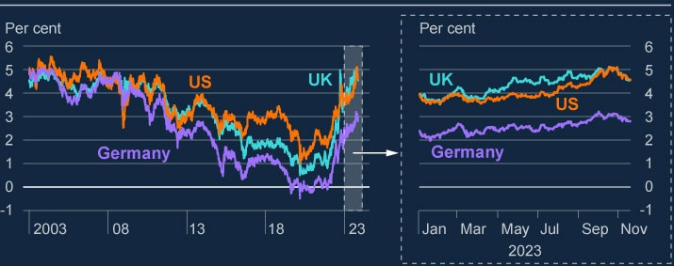

Source: Bloomberg Finance L.P.

Long-term interest rates in part reflect market expectations of future policy rates. For example, current market pricing implies that Bank Rate in ten years’ time is expected to be around 4%, up from around 3.5% at the end of Q2. This means that financing costs for households, businesses and governments could remain higher further into the future than had been previously anticipated (see Section 3). It is possible that market perceptions of the equilibrium real interest rate have risen.

**…in part reflecting an increase in term premia.**

Interest rates on long-term government bonds can also be affected by the amount of additional compensation that investors require to hold these instruments rather than rolling over short-term assets. This compensation, referred to as ‘term premia’, cannot be observed directly and estimates are sensitive to the model used. Model estimates indicate that the roughly 60 basis point increase since the July FSR in the 10-year US Treasury bond yield – a globally important benchmark – is attributable to an increase in the term premium (Chart 1.2). Although the term premium has increased, it remains low relative to its long-run average level. The term premium is also estimated to have risen on 10-year UK gilts since July. A number of factors could explain the rise in term premia, including increased uncertainty around the longer-term economic outlook and interest rates, and evolving investor expectations of future supply and demand in government bond markets (because, other things equal, increased net supply of government debt can increase term premia).

**Chart 1.2: Term premia have pushed up interest rates on some long-term**

**government bonds**

Decomposition of changes in the 10-year US Treasury bond yield into expected rates

and term premium

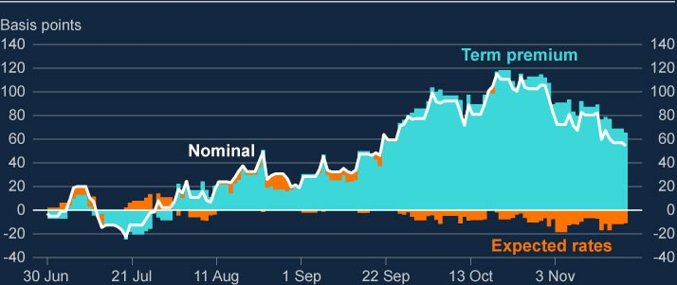

Sources: Federal Reserve Bank of New York and Bank calculations.

**Volatility in core rates markets remains elevated, but they are functioning normally.**

Volatility in rates markets has been elevated by historical standards during 2023. For example, the MOVE index of implied volatility in US Treasury markets is in the top quartile of its historical range. Market volatility, if severe enough, can cause a deterioration in market functioning and interact with vulnerabilities in market-based finance to create risks to financial stability. But market contacts and liquidity metrics, such as bid-offer spreads (Chart 1.3), suggest that liquidity in core markets is within a normal range. Nonetheless, liquidity conditions could deteriorate quickly, especially if market volatility were to increase further, or if vulnerabilities in MBF were to crystalise.

**Chart 1.3: Core market liquidity is within its normal historical range**

Bid-offer spread versus realised volatility for the 10-year benchmark gilt, since 2019

(

**a**

)

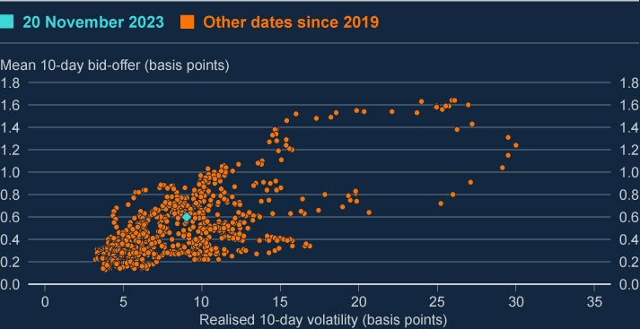

Sources: Bloomberg Finance L.P. and Bank calculations.

(a) Realised volatility is calculated as the 10-day average of the high-low intraday range in the 10-year benchmark gilt yield.

**Despite rising interest rates, corporate credit spreads are broadly unchanged since July…**

Rising yields on government debt have fed through into higher yields on riskier lending to corporates. Higher yields push up refinancing costs, increasing pressure on corporates. However, the **additional** yield – the ‘spread’ that investors demand in return for credit risk – has been broadly unchanged for investment grade and high-yield bonds since the July FSR (Chart 1.4). These spreads are slightly wider than their long-run average levels in the UK, and slightly tighter in the US.

**Chart 1.4: Credit spreads are broadly unchanged since July**

Investment grade and high-yield bond spreads over risk-free rates

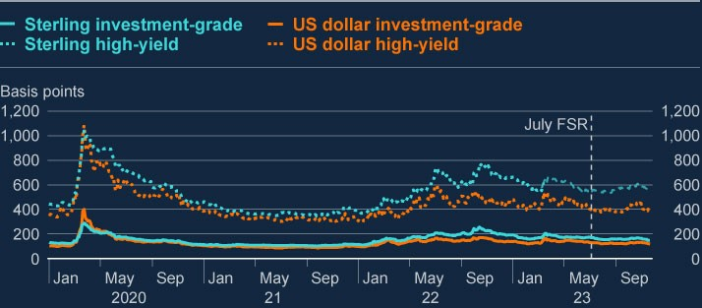

Sources: ICE BofA USD High Yield Index (Ticker: H0A0), USD Investment Grade Index (Ticker: C0A0), GBP High Yield Index (Ticker: HL00), GBP Investment Grade (Ticker: UR00).

For leveraged lending, spreads have widened a little over recent months. In the UK, they are around 550 basis points, broadly in line with their 10-year historical average. See Box B for further discussion of leveraged lending.

Market intelligence suggests that market participants are in general relatively sanguine about credit risk, in part because the perceived likelihood of recession has reduced since the start of the tightening cycle, and because of a perception that corporates have generally been proactive with their refinancing needs. And while default rates on riskier credit have recently increased, in particular for leveraged loans, they remain well below their GFC peaks. Nonetheless, the relative stability in credit valuations has taken place against a backdrop of elevated and more volatile interest rates and uncertainty over their impact on borrowers and on the macroeconomy.

**…and US equity valuations appear stretched…**

The FPC judges that given the impact of higher interest rates, and uncertainties associated with inflation and growth, the valuations of some risky assets continue to appear stretched, particularly in the US. Since the July FSR, the US, UK and European stock markets have been broadly flat. However, in the context of rising long-term interest rates, the excess cyclically adjusted price-to-earnings (CAPE) yield – a measure of the excess return that investors expect from equities relative to government bond yields – on US equities has continued to fall, and is approaching its lowest level since around the time of the dotcom crash in the early 2000s (Chart 1.5). This could imply that US equity valuations have become more stretched.

**Chart 1.5: US equity valuations are high relative to risk-free alternatives**

Excess cyclically adjusted price-to-earnings yield (excess CAPE) for the S&P 500

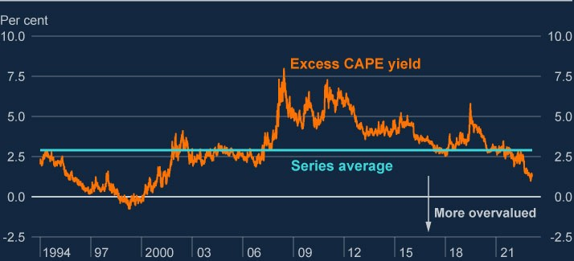

Sources: Bloomberg Finance L.P., Federal Reserve Bank of St Louis and Bank calculations.

**.…increasing the risk of sharp reductions in asset prices, and an associated tightening of financial conditions for households and businesses.**

Should growth weaken or other risks crystallise, a reduction in investor risk appetite could trigger a revaluation of assets, particularly since a deterioration in demand or corporate earnings would negatively impact debt servicing capacity. Sharp decreases in asset prices could further tighten financial conditions, especially for riskier borrowers when they refinance their debts and if signs of a slowdown in private markets (such as private credit and private equity) persist (see Box B). This could impair businesses’ ability to raise finance, by increasing the cost of bond and equity issuance.

A sharp reduction in asset values could also directly affect the financial system – for example through direct losses on asset holdings, by reducing the value of collateral securing existing loans, or by creating sharp increases in the demand for liquidity. Any such moves could be amplified by vulnerabilities in MBF, potentially tightening financial conditions for UK households and businesses (Section 5).

|  |
| --- |
| Box A: Developments in cryptoasset markets  The FPC conducts regular horizon scanning to identify emerging risks to the financial system. As part of this, the Committee has been monitoring risks from cryptoassets and associated activities. Cryptoassets are a digital representation of value or contractual rights that can be transferred, stored or traded electronically, and which typically use cryptography, distributed ledger technology or similar technology.  **In** [**March 2022,**](https://www.bankofengland.co.uk/financial-stability-in-focus/2022/march-2022) **the FPC judged that direct risks to the stability of the UK financial system from cryptoassets and associated markets and activities, including decentralised finance (DeFi) were limited, but that risks would emerge if cryptoasset activity and its interconnectedness with the wider financial system developed.**  That assessment reflected their small size and limited interconnectedness with the wider financial system. The FPC stated that it was monitoring risks to financial stability that could arise through four risk channels: risks to systemic institutions; risks to core financial markets; risks to the ability to make payments; and the impact on real economy balance sheets.  **The FPC also judged that enhanced regulatory frameworks, both domestically and at a global level, were needed to address developments related to cryptoassets.**  In accordance with the principle of ‘same risk, same regulatory outcome’, the FPC judged that where cryptoasset technology is performing an equivalent economic function to one performed in the traditional financial sector, this should take place within existing regulatory frameworks, and that the regulatory perimeter should be adapted as necessary to ensure an equivalent regulatory outcome. Innovation from cryptoassets and DeFi can only be sustainable if undertaken safely and accompanied by effective regulation that mitigate risks. |

|  |
| --- |
| The FPC stated that it would pay close attention to developments in cryptoasset markets to ensure the UK financial system was resilient to systemic risks that might arise. The rest of this box outlines the developments in cryptoassets and associated markets and activities since the [**March 2022 Financial Stability in Focus**](https://www.bankofengland.co.uk/financial-stability-in-focus/2022/march-2022), including an update on  financial stability risks, and on the development of regulatory frameworks to address these.  **The systemic risks that the FPC previously said could arise in future from cryptoasset activities have not materialised thus far.**  The market capitalisation of the cryptoasset ecosystem declined by more than 70% from a peak of around US$3 trillion in November 2021 to US$800 billion in November 2022, before increasing to around US$1.4 trillion in November 2023 – (Chart A). This remains very small in the context of global capital markets: by way of comparison, the market capitalisation of the [**global equity**](https://www.sifma.org/wp-content/uploads/2023/07/SIFMA-Research-Quarterly-Equity-and-Related-3Q23.pdf) market is estimated to be just above US$100 trillion, and  outstanding global [**fixed-income**](https://data.bis.org/topics/TDDS/tables-and-dashboards/BIS,SEC_C1,1.0) securities around US$130 trillion in 2023.  Associated cryptoasset markets and activities have also declined over the same period: the total monetary value locked in the smart contracts of DeFi protocols has declined by 74% from its peak in November 2021 to US$47 billion; the average (mean) daily trading volume of bitcoin on exchanges in October 2023 was 44% of the daily average in November 2021; and the market capitalisation of stablecoins has declined from a peak of around US$180 billion in April 2022 to US$125 billion at present (Chart A). |

The bankruptcies of the cryptoasset exchange FTX and cryptoasset lending

firms such as Celsius, BlockFi and Voyager Digital have demonstrated that

cryptoasset institutions are prone to a number of vulnerabilities that

regulation in the conventional financial system is designed to avoid. For

example, a number of centralised crypto trading platforms operate as

conglomerates, bundling products and functions within one firm, whereas in

conventional finance these functions are either separated into different

entities or managed with tight controls and ring-fences and independent

governance. The collapse of the algorithmic stablecoin TerraUSD, and the

temporary depegging of the largest fiat-backed stablecoins USD Coin and

Tether, have demonstrated risks in existing stablecoin arrangements. And to

date, no so-called stablecoin has been able to maintain parity with its peg at

all times.

[1]

**Chart A: The size of the cryptoasset ecosystem has declined since**

**March 2022**

Market capitalisation of: all cryptoassets

(

**a**

)

and stablecoins

(

**b**

)

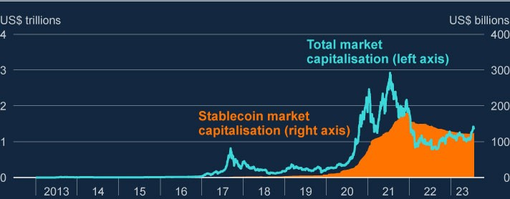

Sources: Coinmarketcap and Bank Calculations.

a) Total crypto market capitalisation.

(

b) Market capitalisation of 11 of the largest stablecoins currently accounting for around 99% of total

(

stablecoin market capitalisation.

**Events since November 2021 have also illustrated the need to bring**

**cryptoassets and their associated activities within the regulatory**

**perimeter.**

|  |
| --- |
| **Systemic financial institutions’ involvement in cryptoassets remains very limited, but may grow in future.**  A survey of wholesale banks conducted by the FCA in February 2023 found that around three quarters of survey respondents did not conduct any activities in relation to cryptoassets at that time, nor did they intend to conduct any activities in the future. Among those firms that indicated some involvement in cryptoasset markets, dealing – particularly as an agent – was by far the most common activity. A small number of firms not currently offering cryptoasset services plan on acting as dealers, offering custodial services, or issuing a stablecoin in future. The PRA [**reminded**](https://www.bankofengland.co.uk/-/media/boe/files/prudential-regulation/letter/2022/march/existing-or-planned-exposure-to-cryptoassets.pdf) firms of their  obligations with respect to cryptoasset exposures in March 2022, and [**clarified**](https://www.bankofengland.co.uk/-/media/boe/files/prudential-regulation/letter/2023/november/innovations-in-the-use-of-deposits-emoney-and-regulated-stablecoins.pdf) its expectations of deposit takers with respect to new forms of  digital money in November 2023 in ‘Dear CEO’ letters.  Banks are more positive about the use of cryptoasset technologies (eg programmable ledgers and smart contracts) for the tokenisation of money and assets. Current applications are very limited in scope, and a significant share of projects are taking place on permissioned ledgers that do not involve the use of cryptoassets. However, some projects are also taking place on public blockchains. The growth of asset tokenisation on public blockchains could contribute to greater systemic risks from stablecoins and unbacked cryptoassets: it could increase the size of the cryptoasset ecosystem (eg by increasing the demand for cryptoassets to pay blockchain transaction fees, or stablecoins to act as a settlement asset); increase the interconnectedness of markets for cryptoassets and traditional financial assets (since they are represented on the same ledger); and create direct exposures for systemic institutions.  **Risks to core financial markets from cryptoassets and associated market activities remain limited by the degree of institutional cryptoasset adoption. But this adoption could accelerate as regulatory frameworks and market infrastructures develop.**  Institutional adoption of cryptoassets and associated derivatives remains small. In the market for Chicago Mercantile Exchange (CME) bitcoin futures  (an institutional market owing to its relatively large contract size and regulated nature) the number of contracts held by market participants |

|  |
| --- |
| reached an all-time high in November 2023. However, the notional value at US$3.8 billion remains very low. By comparison, CME E-MINI S&P 500 futures contracts have an outstanding notional value of around US$490 billion.  According to market intelligence, the largest barriers to investment in cryptoassets for institutional investors include: price volatility; lack of fundamentals for valuation; regulatory challenges; challenges around security (eg adequate custody solutions); and market manipulation. However, developments in regulation and market infrastructure may catalyse greater institutional investment in cryptoassets in future.  **Use of cryptoassets for payments in the UK remains very small, but this could change if a sterling-denominated stablecoin used for retail payments emerges.**  There is currently no widely used sterling denominated stablecoin used for payments or in the cryptoasset ecosystem, and the use of cryptoassets for payments is extremely low. However, payment companies with large established networks have the potential to accelerate the adoption of stablecoins for payments quickly. Some payment service providers (eg PayPal) have recently launched services supporting stablecoins. The Bank will continue to monitor payment activities in relation to cryptoassets and stablecoins.  **UK households’ cryptoasset holdings remain limited but are increasing.**  An [**FCA consumer survey**](https://www.fca.org.uk/publication/research-notes/research-note-cryptoasset-consumer-research-2023-wave4.pdf) conducted in August 2022 found that 9% of UK  adults owned cryptoassets at that time, up from 4.4% in 2021. While the mean holding was around £1,600, 40% of owners held less than £100 of cryptoassets.  **Against this backdrop, the UK authorities have taken important steps towards putting in place a regulatory regime for the sector.[2]**  The FCA has introduced money laundering and counter-terrorism financing rules for cryptoassets businesses in the UK ([**January 2020**](https://www.fca.org.uk/news/press-releases/fca-establishes-temporary-registration-regime-cryptoasset-businesses#:~:text=Since%2010%20January%202020%2C%20existing,be%20registered%20with%20the%20FCA.) and [**September 2023**)](https://www.fca.org.uk/news/statements/fca-sets-out-expectations-uk-cryptoasset-businesses-complying-travel-rule). In October 2023, the FCA [**put into place a regime for the marketing**](https://www.fca.org.uk/news/news-stories/guidance-crypto-firms-help-them-comply-marketing-rules#:~:text=Since%208%20October%202023%2C%20firms,Financial%20promotions%20rules%20for%20cryptoassets.) |

|  |
| --- |
| [**of crypto to UK**](https://www.fca.org.uk/news/news-stories/guidance-crypto-firms-help-them-comply-marketing-rules#:~:text=Since%208%20October%202023%2C%20firms,Financial%20promotions%20rules%20for%20cryptoassets.) consumers, ensuring that any marketing to retail consumers  is clear, fair, not misleading and subject to approval by a regulated firm. The rules for marketing cryptoassets are aligned with existing rules for other highrisk investments. The FPC has urged investors to take a cautious approach to cryptoassets.[3]  In November 2023, the [**Bank**](https://www.bankofengland.co.uk/paper/2023/dp/regulatory-regime-for-systemic-payment-systems-using-stablecoins-and-related-service-providers) and the [**FCA**](https://www.fca.org.uk/publications/discussion-papers/dp23-4-regulating-cryptoassets-phase-1-stablecoins) published discussion papers on  their proposed approach to regulating stablecoins, which will support safe innovation in retail payments. HM Treasury (HMT) now intends to bring forward secondary legislation to bring stablecoins into the regulatory perimeter by early 2024.  **HMT has also set out its approach to regulating broader cryptoasset activities and the FCA will develop the regulatory regime.**  Beyond the proposals to regulate stablecoins, HMT recently [**finalised its**](https://assets.publishing.service.gov.uk/media/653bd1a180884d0013f71cca/Future_financial_services_regulatory_regime_for_cryptoassets_RESPONSE.pdf)  [**proposals to**](https://assets.publishing.service.gov.uk/media/653bd1a180884d0013f71cca/Future_financial_services_regulatory_regime_for_cryptoassets_RESPONSE.pdf) regulate a number of trading and investment activities related  to cryptoassets, which were set out in a [**February 2023**](https://assets.publishing.service.gov.uk/media/63d94ea68fa8f51881c99eb4/TR_Privacy_edits_Future_financial_services_regulatory_regime_for_cryptoassets_vP.pdf) consultation paper.  Secondary legislation and FCA rules will be required to implement the regime. The FPC [**noted**](https://www.bankofengland.co.uk/financial-policy-summary-and-record/2023/march-2023) that while this regime would not achieve the  outcome of market integrity to the same degree as in traditional securities markets, it considered the consultation to be an important step in developing a regulatory regime, with further work anticipated as cryptoasset markets evolved and international standards were developed.  **The high degree of interconnectedness and cross-border activity associated with cryptoassets mean that global risks are most effectively addressed through internationally co-ordinated reforms.**  Many cryptoasset service providers, such as wallets and exchanges, as well as some issuers, operate from offshore jurisdictions while providing services globally.[4] International co-ordination can reduce the risks of cross-border spillovers, regulatory arbitrage, and market fragmentation.  **Internationally, standard setters have made good progress in developing a global baseline for regulating cryptoassets.** |

|  |
| --- |
| This has been in line with the principle of ‘same risk, same regulatory outcome’. In July 2023, the Financial Stability Board (FSB) finalised its [**global regulatory framework**](https://www.fsb.org/wp-content/uploads/P170723-2.pdf) for cryptoassets and stablecoins, focused on  addressing risks to financial stability. Alongside this overarching framework, standard setters are establishing sectoral standards on [**market integrity and investor protection**,](https://www.iosco.org/library/pubdocs/pdf/IOSCOPD747.pdf) on [**systemically important stablecoin arrangements**](https://www.bis.org/cpmi/publ/d206.htm), and on the [**treatment of banks’ exposures to cryptoassets**](https://www.bis.org/bcbs/publ/d545.pdf).  **Ensuring a wide and timely implementation of the international regulatory baseline will be key to mitigating the financial stability risks from cryptoassets.**  The FSB will conduct a review of the implementation of its recommendations by end-2025. Given the cross-border nature of these markets, it will be important to ensure that both the FSB recommendations and sectoral international standards are implemented by the widest possible set of jurisdictions particularly those markets with the largest cryptoasset activity. Given the risks of regulatory arbitrage, this should include jurisdictions with currently limited regulation and jurisdictions with large crypto activity.  The FPC welcomes these developments and will seek to ensure that the UK financial system is resilient to systemic risks that may arise from cryptoassets and associated activities. |

# 2: Global vulnerabilities

|  |
| --- |
| The outlook for global growth remains subdued and long-term interest rates have risen further. Geopolitical risks have increased following events in the Middle East.  Higher interest rates in advanced economies continue to pose challenges to UK financial stability through their impact on households, businesses, sovereigns and financial institutions.  Riskier corporate borrowing, such as private credit and leverage lending appears particularly vulnerable.  Some overseas banks could also be vulnerable to higher interest rates, including through their exposures to property markets, including commercial real estate, where prices in some countries have fallen significantly.  Vulnerabilities in the mainland China property market have continued to crystallise since the July 2023 FSR.  Major UK banks could experience spillovers from a materialisation of global risks, including in China. The results of the 2022/23 ACS indicated that major UK banks can continue to serve the UK economy in a severe global stress with elevated interest rates and very significant falls in real estate prices in mainland China and Hong Kong. |

## 2.1: The global economic outlook

**The outlook for global growth remains subdued, partly reflecting higher interest rates.**

Projections in the [**November Monetary Policy Report (MPR)**](https://www.bankofengland.co.uk/monetary-policy-report/2023/november-2023) indicate that global

growth over the next year is expected to remain below its 2010–19 average, reflecting tighter monetary and financial conditions. However, US growth projections have been revised upwards since July, with the economy expected to expand by around 2¼% in 2023.

Headline inflation remains elevated in advanced economies, but is declining. This largely reflects lower energy price inflation, although food and goods price inflation have also declined, particularly in the US. Global services inflation, however, remains elevated.

The paths for policy rates implied by current financial market pricing suggest rates are now expected to be at or near their peaks in the UK, US and euro area. Central banks have emphasised that they will need to remain high for an extended period in order to continue to address inflationary pressures. Long-term interest rates in advanced economies have increased since the July FSR, particularly in the US, where yields on 30-year government bonds are now around pre-GFC levels (see Section 1).

**Geopolitical developments continue to add uncertainty to the economic outlook, and can pose risks to UK financial stability through a number of channels.**

Geopolitical risks have increased following events in the Middle East. These events led to a relatively limited rise in energy prices, which has since retraced. However, uncertainty around future oil prices has increased. Further escalation of geopolitical tensions in the region could cause disruption to oil and gas markets and trade flows. A larger shock to energy prices would lead to higher inflation and increased cost of living pressures on households and businesses.

Other geopolitical risks remain. For example, in 2022, following Russia’s invasion of Ukraine, there was significant volatility in commodity markets, as well as increased volatility and risk aversion in financial markets more generally. And tensions between the US and China could disrupt global trade. Further escalation of geopolitical risks would increase the likelihood of vulnerabilities crystallising, which could impact the macroeconomic outlook in the UK and globally through trade and other channels, increase financial market volatility, and could particularly affect the UK’s internationally focused banks. Geopolitical developments are consistently cited by market participants as one of the biggest sources of risk to the UK financial system in the [**Bank’s Systemic Risk Survey**](https://www.bankofengland.co.uk/systemic-risk-survey/2023/2023-h2).

## 2.2: The impact of higher interest rates on the global financial system

**The adjustment to higher interest rates in advanced economies continues to pose challenges to UK financial stability.**

As set out in [**Financial Stability in Focus: Interest rate risk in the economy and financial system**,](https://www.bankofengland.co.uk/financial-stability-in-focus/2023/july-2023) and in Figure 2.1, higher interest rates (and associated weaker global growth) could impact UK financial stability in a number of ways.

Banks could incur losses in the event of an increase in global risk aversion and falls in asset prices (including property prices), and UK financial conditions could tighten in response. The US banking stress earlier in the year illustrated how contagion could spread across borders even where there are no direct connections between institutions.

Increases in debt-servicing costs for foreign borrowers could increase defaults.

UK banks could therefore also incur losses on their lending to non-UK borrowers.

A reversal in risk appetite among global investors can increase the cost or reduce the availability of market-based finance for UK institutions (see Section 1).

More broadly, global vulnerabilities can also amplify economic shocks in foreign economies and lead to spillovers to the UK, for example through lower demand for UK exports.

If rates remain higher for longer, it will pose particular refinancing challenges for highly leveraged corporates (see Box B).

**Figure 2.1: Global shocks can affect UK financial stability in a number of**

**ways**

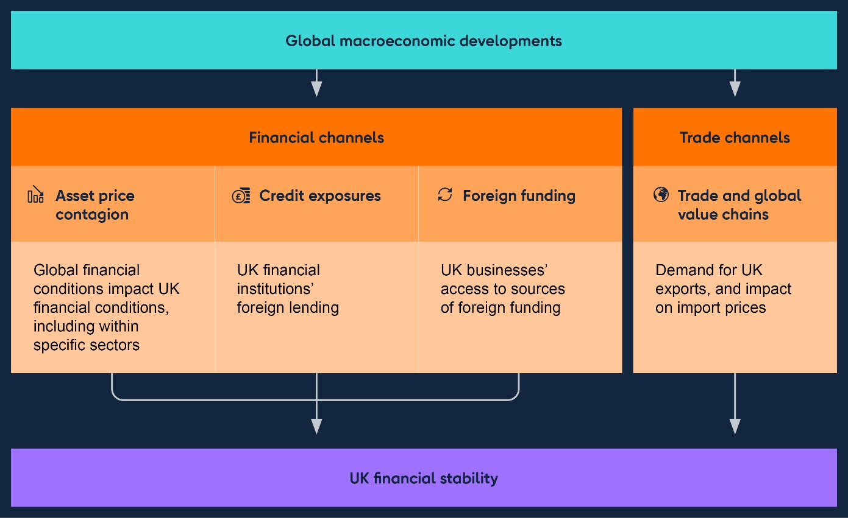

### 2.2.1: The impact of higher rates on the global banking system

**Some banks in a number of jurisdictions have been impacted by higher interest rates.**

The overseas banking sector stress earlier this year demonstrated how contagion could spread within jurisdictions and across borders via financial market pricing, affecting banks’ funding costs and share prices. US bank equity prices recovered slightly over the summer, but have since weakened as long-term interest rates have risen, particularly for regional banks (Chart 2.1).

Following the stress, a number of mid-sized US banks have been downgraded by credit rating agencies. Recent rises in long-term US bond yields could pose increased challenges for some US banks, which are likely to continue to struggle with large unrealised losses on portfolios of fixed-rate assets that have fallen in value as a result of higher market interest rates. Banks with significant CRE exposures may also be vulnerable given recent rises in long-term interest rates and falls in CRE prices (see Section 2.2.3). However, immediate risks in the US banking sector appear to have stabilised: deposits held in smaller US banks have continued to recover, and though there have been marginal increases in usage of the Federal Reserve’s Bank Term Funding Program in recent weeks, overall usage has remained largely stable since the July 2023 FSR.

Since the July FSR, the US authorities have proposed measures that are designed to increase the resilience of US banks with over US$100 billion in assets (capturing most of the largest regional banks), as part of their implementation of Basel III. In addition, in August, US authorities outlined proposals to strengthen the resolution framework.

Euro-area banks have so far appeared largely resilient to the higher interest rate environment. Indeed, these banks have generally benefitted from rising net interest margins in the first half of 2023. However, as in the US, there are vulnerabilities in a number of banks related to higher interest rates and asset quality – including with respect to real estate exposures (see [**ECB Financial Stability Review**](https://www.ecb.europa.eu/pub/pdf/fsr/ecb.fsr202311~bfe9d7c565.en.pdf)). Generally,

US and euro-area bank profitability has been supported by rising interest rates. But for some banks in both regions, a combination of low-yielding assets and rising funding costs pose longer-term challenges to profitability.

**Chart 2.1: US bank equity prices recovered slightly over the summer, but**

**have weakened since, particularly for regional banks**

Global bank equity prices

(

**a**

)

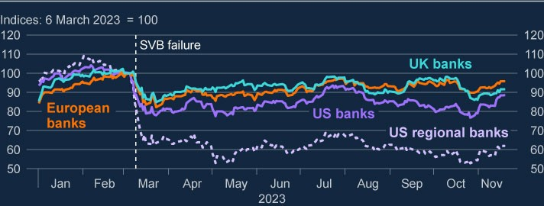

Sources: LSEG Eikon and Bank calculations.

(a) The banking sector series for the UK, Europe and US are the FTSE UK Banks Index, the Stoxx Europe 600 Banks Index, the S&P 500 Banks Index and the KBW Regional Banking Index.

### 2.2.2: The impact of higher rates on the global real economy

**Higher interest rates continue to make it more challenging for households and businesses in advanced economies to service and refinance their debts.**

Higher rates continue to put pressure on households globally. Interest rates on new lending to households have increased sharply since the beginning of 2022 and have increased further since the July 2023 FSR. While some borrowers in the euro area will be shielded from the impact of higher rates on mortgages repayments due to long-term fixed deals, other borrowers will be exposed to the impact of rising rates in the near term. In the US, most existing mortgage borrowers – unless they move home – are likely to be shielded from higher interest rates as most mortgage debt is fixed rate, typically with long terms. Higher interest rates have therefore led to a significant fall in existing home sales in the US. A slowdown in the US housing market could have knock-on effects to the wider financial system (see below).

Credit conditions in the US and euro area have continued to tighten since the July

FSR. The [**ECB’s October 2023 euro-area bank lending survey**](https://www.ecb.europa.eu/stats/ecb_surveys/bank_lending_survey/html/ecb.blsurvey2023q3~b960111b2d.en.html) and the [**Federal**](https://www.federalreserve.gov/data/sloos/sloos-202310.htm)

[**Reserve’s October 2023 Senior Loan Officer Opinion Survey**](https://www.federalreserve.gov/data/sloos/sloos-202310.htm) both reported tightening lending standards for both households and businesses. In both jurisdictions, a significant share of banks also reported that demand for new lending had weakened further since Q2.

Highly leveraged corporates – particularly in the US – could be vulnerable to higher interest rates as it becomes more expensive to service their debt. The default rate on leveraged loans has increased further since the July FSR, from 5.0% to 5.4%, and up from 1.8% a year ago. Although there are few signs of stress in these markets so far, a worsening in the macroeconomic outlook could cause sharp revaluations of credit risk. Higher defaults could also reduce investor risk appetite in financial markets and could reduce access to financing, including for UK businesses (see Box B).

**Global commercial and residential real estate valuations have faced significant downward pressure.**

Global CRE prices have fallen further since data available at the time of the July 2023 FSR, with aggregate prices down 10% on a year earlier in both the euro area and the US (Chart 2.2). This partly reflects long-term structural challenges in the sector, including the post-pandemic shift to more remote working. Residential real estate price growth has also fallen since 2022, with annual growth turning slightly negative in the euro area (Chart 2.3).

Higher interest rates are a key factor weighing on prices, reducing affordability for residential homebuyers. Absent rent increases, higher interest rates also reduce the profitability of real estate investments relative to other assets such as bonds, and increase the cost of servicing related debt. Investors – many of whom are leveraged – may face losses as result of a decline in the value of their assets. This could result in fire-sales, exacerbating any downturn, and heightening risks to the core financial system. Price falls can also present risks to lenders by reducing the value of the collateral held against their loans.

The results of the 2022/23 ACS, which included very sharp falls in global property prices well beyond those seen to date, suggest that major UK banks are resilient to their global real estate exposures. However, as noted above, some banks in the US and euro area may be more exposed to the sector, which could create spillovers to the UK via banking and financial market channels.

**Chart 2.2: CRE prices are falling sharply across regions**

Nominal CRE price growth

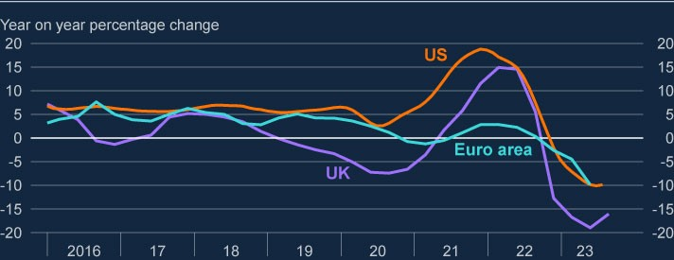

Sources: European Central Bank, Federal Reserve Board, MSCI and Bank calculations.

**Chart 2.3: Global residential real estate price growth has slowed markedly**

Nominal residential property price growth

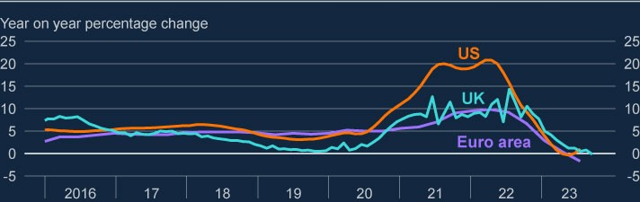

Sources: European Central Bank, LSEG Eikon, ONS and Bank calculations.

**Vulnerabilities associated with high public debt levels could pose challenges in an environment of tightening financial conditions.**

The FPC has previously highlighted vulnerabilities created by high public debt levels in major economies, including through interlinkages between banks and sovereigns. These vulnerabilities, the extent of which are in part related to the level of interest rates, could have several consequences for UK financial stability.

Higher servicing costs on public sector debt could reduce governments’ capacity to respond to future shocks, which could make global GDP more volatile.

There may be more pronounced volatility in government bond prices if market perceptions for the path of public sector debt deteriorate. This could interact with vulnerabilities in market-based finance, resulting in a tightening in credit conditions for households and businesses.

Concerns about the sustainability of government debt in some countries could prompt capital outflows. This could lead to increased market volatility and losses for financial market participants, including banks.

The FPC will continue to monitor these risks and take into account the potential for them to crystalise other financial vulnerabilities and amplify shocks when making its assessment of the overall risk environment.

### 2.2.3: The impact of higher rates on other parts of the global financial system

**Markets reacted in an orderly manner to announcements by the Bank of Japan that it would conduct its yield curve control policy with greater flexibility.**

In July, the Bank of Japan made a surprise adjustment to its yield curve control policy. Then, in October, the Bank of Japan introduced further flexibility into the 1% ceiling on 10-year yields. Yields on 10-year Japanese government bonds are now

0.8%, up from under 0.5% at the time of the July 2023 FSR.

So far, markets have reacted in an orderly manner to these announcements. But there remains a risk that further policy changes could trigger larger or more volatile price adjustments in Japan, which could lead to losses on domestic government bond holdings for some Japanese banks. Major UK banks’ holdings of Japanese government bonds are limited, accounting for only 5% of major UK banks’ overall holdings of debt securities. However, asset price moves in Japan could spill over to other countries, for example if they lead to substantial reallocations of bond holdings across jurisdictions, which could affect financial conditions in the UK.

**Financial conditions in emerging markets could also come under pressure.**

Financial conditions have tightened in most major non-China emerging market economies (NCEMEs) since the July 2023 FSR. But most major NCEMEs have been resilient to the higher interest rate environment so far. Reflecting this, the spread between dollar-denominated NCEME government bond yields and US Treasury yields – a key indicator of stress – has been relatively flat.

NCEMEs could still be vulnerable, however, to a sharp repricing of NCEME assets and sudden capital outflows in response to a deterioration of risk sentiment, for example as a result of a further escalation of geopolitical risks. Spillovers to the UK from NCEME distress are likely to be limited, however, they could affect exposures of some major UK banks, and have a wider impact on UK economic activity via lower demand for UK exports.

## 2.3: Risks from developments in China

**Property market vulnerabilities in mainland China have continued to crystallise since the July 2023 FSR.**

Activity in the mainland Chinese property sector has been contracting since mid2021 (Chart 2.4) and property prices have been falling since late 2021 for both new and existing property.

Chinese developers have continued to default in the face of falls in sales and tighter financial conditions. Since the July 2023 FSR, Country Garden – China’s largest property developer by sales in 2021 – officially entered default on some of its offshore bond repayments. And significant concerns remain around the ability of Evergrande – the world’s most indebted property developer – to successfully restructure and meet its debt obligations.

In light of these developments, the Chinese authorities have put in place measures to provide some support, aimed at limiting spillovers from losses being borne by creditors, against the backdrop of a longer-term strategy to reduce speculation in the sector.

The outlook for the mainland Chinese economy more broadly remains subdued. Further deterioration in property activity and prices could pose additional risks to the mainland Chinese economy and its financial sector, making the policy response more challenging. This could impact the UK via trade or financial spillovers, including through disorderly asset price adjustments that could be amplified by vulnerabilities in market-based finance.

**Chart 2.4: Real estate activity in mainland China has continued to weaken**

Twelve-month rolling sum of floor space sold in mainland China

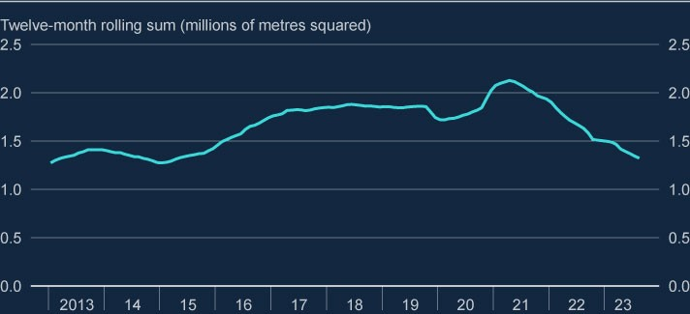

Sources: CEIC and Bank calculations.

**Hong Kong could be materially affected by the crystallisation of risks in mainland China. But UK banks remain resilient to a severe downturn in the region.**

In common with mainland China, Hong Kong also has high private sector debt levels and elevated property prices. UK banks’ exposures to Hong Kong are larger than those to mainland China. And while direct trade links with the UK are relatively modest, a materialisation of risks could propagate through financial market channels.

Despite differences between the risk profiles of the two property sectors, should current challenges in mainland China’s property sector lead to a significant downturn in the broader Chinese economy, spillovers to Hong Kong’s property market could be material.

Some UK banks have material direct exposures to property markets in mainland China and Hong Kong, though the greater security and seniority on Hong Kong exposures relative to Chinese exposures helps to mitigate the impact of any potential losses on UK banks. The 2022/23 ACS indicated that major UK banks would be resilient to a severe global recession that included severe real estate price falls in mainland China and Hong Kong. The FPC will continue to monitor closely developments in China, and the potential for spillovers to UK financial stability.

|  |
| --- |
| Box B: Highly leveraged corporates  **Highly leveraged corporates are particularly vulnerable to the global tightening of financing conditions. This could present risks to UK financial stability through a number of channels (Figure A).**  Higher interest rates continue to weigh on the ability of businesses in advanced economies to service and refinance their debts (see Section 2). Businesses that have borrowed in risker credit markets, including through leveraged loans and private credit, are particularly vulnerable to higher interest rates because their debt tends to be floating rate and because they tend to be highly leveraged. As interest coverage ratios (ICRs) (a business’ earnings relative to its interest payments) are a key variable in determining their creditworthiness to lenders, a decrease in ICRs as interest rates rise may make it harder for some businesses to refinance their debt, or mean they face less favourable terms when they do. In addition, some of these businesses will have experienced weaker earnings because of subdued economic growth.  As a result of these pressures, affected businesses may reduce investment and employment and, in some circumstances, may default on their debt, creating direct losses to lenders and other financial market participants. If these losses are significant, this could cause an excessive tightening in risk appetite, disrupting the functioning of some markets and tightening credit conditions in the real economy. This box assesses these risks to UK financial stability. |

Leveraged loans and high-yield bonds are typically used by firms who are

highly indebted, have a sub-investment grade rating or are owned by a

private equity (PE) sponsor. In recent years, private credit (lending bilaterally

negotiated between borrowers and lenders and typically arranged by non-

bank financial institutions (NBFIs)) has been growing as an alternative

source of finance for highly leveraged firms. The different features of these

forms of lending are set out in Table 1.

**Figure A: A crystallisation of risks in highly leveraged corporates can**

**impact UK financial stability through a number of channels**

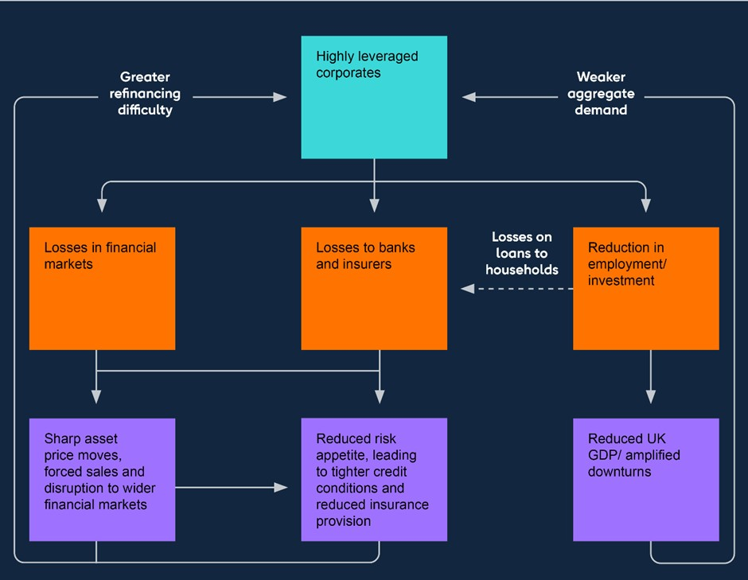

**Many of these more vulnerable businesses are reliant on funding from**

**the private credit, leveraged loan and high-yield bond markets.**

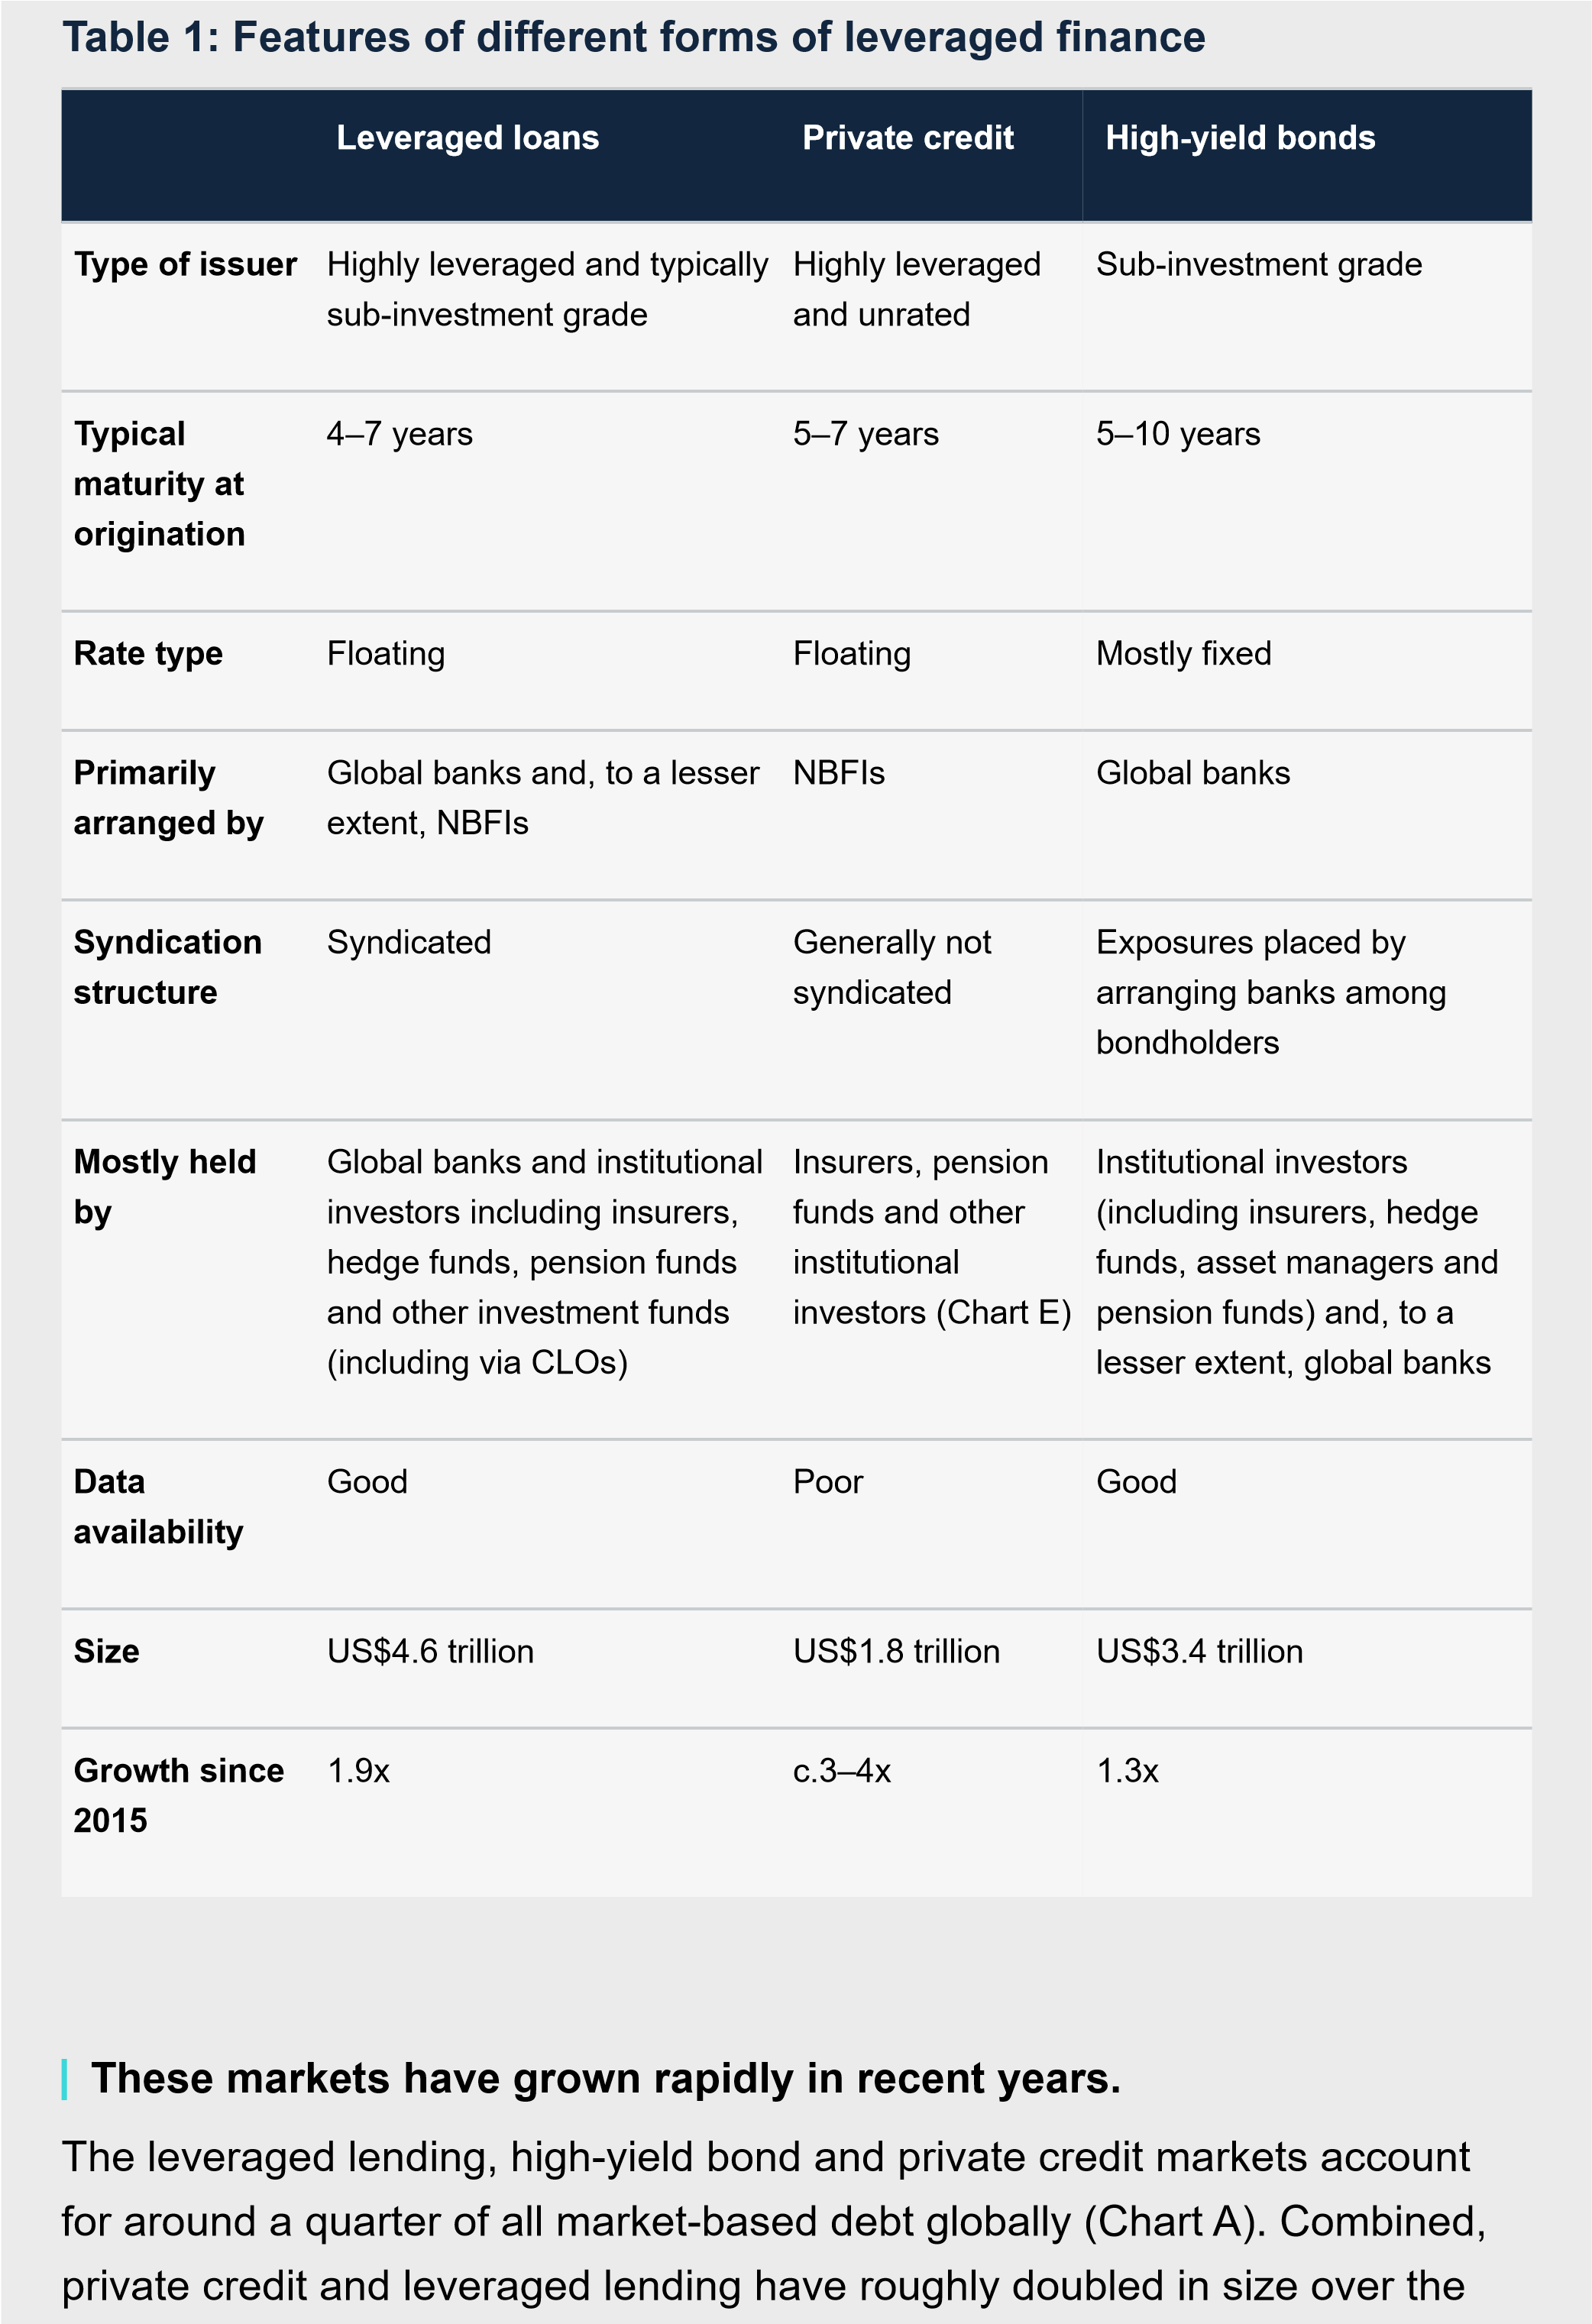

past decade. Within that, although it remains relatively small, estimates

suggest that private credit has grown much faster, picking up volumes from

PE sponsors and lower-rated companies looking to access financing more

quickly.

The default rate on leveraged loans has increased further since the July

FSR, from 5.0% to 5.4%, up from 1.8% a year ago.

[5]

The default rate is less

than half the peak of 12.2% in the aftermath of the global financial crisis. In

contrast, headline default rates in the private credit and high-yield bond

markets remain low, despite a slight pickup in the latter since July.

**Chart A: Private credit and leveraged loans have grown rapidly in**

**recent years**

Estimated breakdown of total outstanding market-based corporate debt globally

(

in US dollars)

(

**a**

)

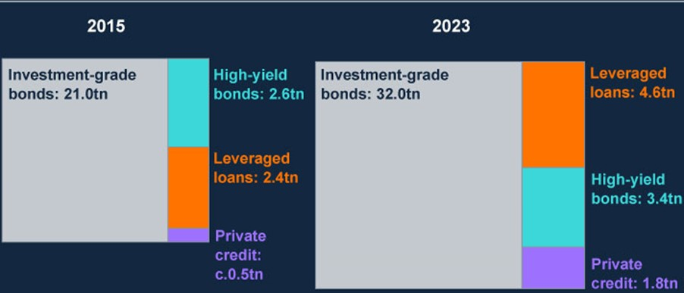

Sources: Bloomberg Finance L.P., LSEG Eikon, Preqin Ltd, and Bank calculations.

(

a) Preqin data puts the size of the private credit market at US$0.4 trillion in 2015. However, historical

data on the size of the private credit market is sparse, and the estimates of market size that exist are

likely to underestimate – in some cases significantly – the actual size of the market.

**Risks have continued to crystallise in the leveraged lending market,**

**and there are further risks to highly leveraged corporates on the**

**horizon.**

|  |
| --- |
| There is evidence that borrowers in these markets have seen a sharp fall in their interest coverage ratios over the past year. And while the outlook for defaults is highly dependent on the outlook for the global economy, they may increase in coming quarters. Default rates could rise further, beyond current market expectations, should risks of weaker economic growth materialise or if there are further large increases in borrowing rates.  **Issuance in leveraged finance markets has been relatively weak in 2023, though there are signs of a shift in issuance towards private credit.**  Although both high-yield bond and leveraged loan spreads have risen slightly in recent months, they have remained relatively flat since the July FSR, broadly in line with their historical average. There is also some evidence that non-price credit conditions are yet to tighten. For example, the proportion of new leveraged loan issuance which is covenant-lite – that is, lending for which investors do not require borrowers to maintain certain financial ratios – is approaching historical highs at around 66%, despite the additional risks posed to borrowers by higher interest rates.  Nevertheless, global debt issuance to highly leveraged corporates in 2023 to date has been weak, at just over half the levels seen over the same period in recent years (Chart B). This partially reflects the impact of tighter financial conditions on mergers, acquisitions and leveraged buyout activity by PE funds.  Market intelligence suggests that private credit funds have helped to fill some of the funding gap left by challenging conditions in leveraged loan markets, particularly for lower-rated corporates, and are likely to continue to do so in the future, despite recent signs of slowing. |

Typically, the structure of leveraged finance requires the entire principal to be

repaid at maturity. This creates a risk in the event that lenders are unwilling to

extend credit on the same terms. While there is limited data available on the

maturity profile of outstanding private credit, 24% of global leveraged loans

and 29% of high-yield bonds are due to be refinanced by the end of 2025

(

Chart C

).

High-yield bonds are fixed rate, meaning that refinancing these bonds once

they mature could leave borrowers facing much higher interest payments.

And in floating rate leveraged lending and private credit markets, many

companies will have seen an increase in debt servicing costs already, which

could lead to perceptions of higher credit risk that result in less favourable

**Chart B: Year to date issuance in 2023 has been weak relative to**

**recent years**

Year to date deal value in corporate financing markets as a proportion of

averages over the same period in the past five years

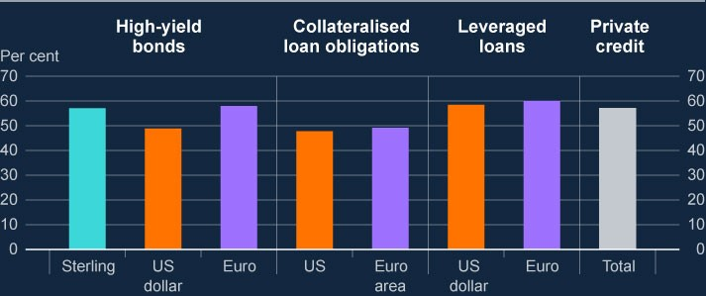

Sources: LCD, a part of Pitchbook, LSEG Eikon, Preqin Ltd and Bank calculations.

**Some highly leveraged companies could struggle to refinance their**

**debt as a result of higher rates and market perceptions of higher**

**credit risk, which could lead them to reduce investment and**

**employment, and in some cases default.**

lending terms when they come to refinance. Primary market financing

conditions may also be tighter, making it more challenging to secure

financing at an affordable rate.

Indeed, the share of leveraged loans at the highest debt multiples has fallen

to its lowest level in the past decade, suggesting that some lenders may now

be less willing than they were previously to extend loans at higher leverage

ratios. This could lead to some businesses needing to cut back on

investment and employment as a result of refinancing their debt on less

favourable terms, or in some circumstances defaulting on their debt.

**Chart C: Many highly leveraged corporates will need to refinance in**

**coming years**

Percentage of outstanding global bonds and leveraged loans maturing, by debt

type

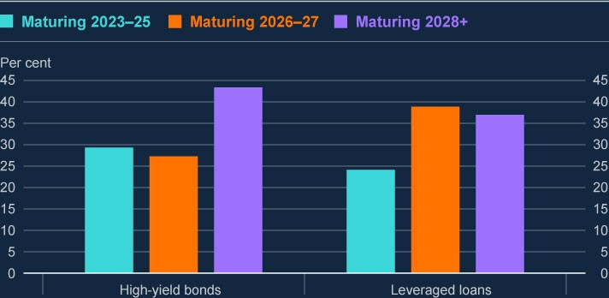

Sources: Bloomberg Finance L.P., LSEG Eikon, and Bank calculations.

**There are signs that borrowers and lenders are taking action to reduce**

**near-term pressure on debt burdens, which could create refinancing**

**risks in the future.**

|  |
| --- |
| Some businesses are able take action to reduce their exposure to higher interest rates. For example, while data on the full extent of hedging activity is limited, some larger businesses have been able protect themselves from interest rate risk by using derivatives to hedge their exposures. This includes businesses borrowing in floating rate debt markets (eg leveraged loan and private credit markets).  There is also increasing evidence that borrowers and lenders are using more innovative approaches to managing interest rate risk. For example, ‘amend and extend’ agreements – in which lenders agree to push back a loan’s maturity, often in return for a higher yield and tighter financial controls – have become increasingly popular in leveraged loan and private credit markets. This year, these agreements have helped to push out the maturity wall for about 75% of leveraged loans that were due to be refinanced in 2024 (Chart D). These agreements allow firms to avoid refinancing in potentially challenging primary market financing conditions and, in some situations, may help avoid credit rating downgrades. However, some firms may come under financial pressure as a result of the higher yields and tighter financial controls that come with the agreements. And if financing conditions remain tight, these agreements just push refinancing risks into the future.  Some lenders have also resorted to riskier methods to manage their growing debt burdens. For example, ‘payment-in-kind’ – where borrowers with low liquidity issue new debt in order to meet interest payments – has become increasingly common. Payment-in-kind is usually undertaken by highly leveraged companies in poor financial condition and, in many cases, is likely to increase the risk of default in the future. |

If highly leveraged corporates are unable to meet repayments, banks could

face direct losses on their exposures, and indirect losses through their

exposures to counterparties, including global banks and NBFIs. And if

appetite for riskier credit assets declines, banks may incur mark-to-market

losses on their loan origination, underwriting and syndicating activities.

Major UK banks active in leveraged lending markets have global holdings of

leveraged loans worth around 12% of their corporate loan book in aggregate

(

around 65% of common equity Tier 1 (CET1) capital). Recent underwriting

activity by UK banks has been limited, reflecting weak market issuance more

broadly. Some overseas banks have more material exposures to leveraged

loans than UK banks.

While some UK and overseas banks are looking to increase their

involvement in the private credit sector, exposures are limited at present and

are likely to remain small. Private credit exposures are largely held by a

**Chart D: ‘Amend and extend’ agreements are delaying the need to**

**refinance leveraged loans in primary markets**

Value of outstanding leveraged loans in US and euro area due to mature 2024–

26

, as of December 2022 and September

2023

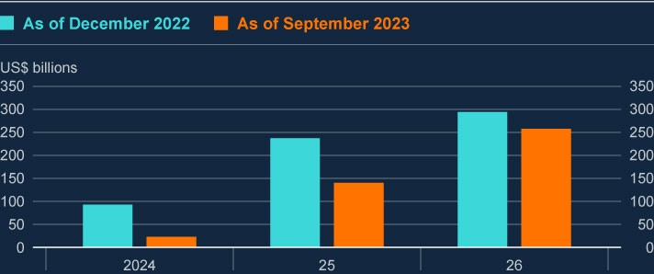

Sources: LCD, a part of Pitchbook, and Bank calculations.

**Some systemic financial institutions have large exposures to highly**

**indebted corporates. These include some major UK banks.**

|  |
| --- |
| range of institutional investors (Chart E). Given that the asset class has grown rapidly in recent years, it is unclear how these investors may react to a downturn.  Many leveraged loans, and increasingly some private credit exposures, are ultimately packaged into securities sold as collateralised loan obligations (CLOs). Major UK banks have small holdings of CLOs – with the latest available data suggesting they amount to around £10 billion, or 4% of CET1 on average across banks with exposures[6]. But some overseas banks – particularly Japanese banks – have much larger exposures.  The 2022/23 ACS stress test captured risks to major UK banks from highly leveraged corporates. The aggregate projected five-year impairment rate for UK, US and European leveraged loans was 10.5%. By comparison, actual aggregate impairment rates on these exposures in the GFC were around 8%.  Whereas banks are partially shielded from losses on their CLO exposures by generally holding the highest quality tranches, riskier CLO tranches are held by a range of systemic NBFIs. UK insurers’ direct exposures to leveraged loans and private credit, including via CLOs, are small. But UK insurers could also be indirectly exposed due to their growing interconnectedness with nonUK reinsurers, which have exposures to highly leveraged corporates that are increasing. US insurance companies’ exposures are also large and have grown rapidly in recent years. |

A number of the vulnerabilities in the system of market-based finance

highlighted in

[**Financial Stability in Focus: The FPC’s approach t**](https://www.bankofengland.co.uk/financial-stability-in-focus/2023/october-2023)

[**o**](https://www.bankofengland.co.uk/financial-stability-in-focus/2023/october-2023)

[**assessing risks in market-based financ**](https://www.bankofengland.co.uk/financial-stability-in-focus/2023/october-2023)

[**e**](https://www.bankofengland.co.uk/financial-stability-in-focus/2023/october-2023)

are evident in riskier corporate

lending markets.

**Chart E: Private credit exposures are held by a range of investors**

Estimated breakdown of investors in US private credit funds

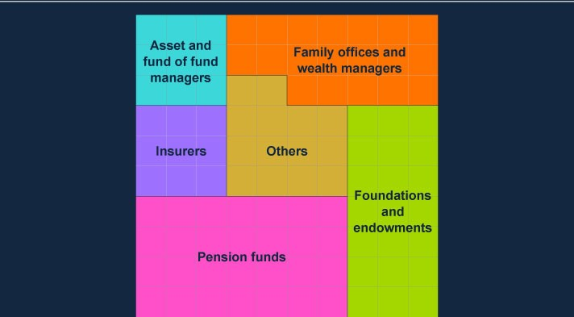

Sources: IMF April 2023 Global Financial Stability Report.

**More broadly, a crystallisation of risks could lead to losses for**

**investors. This could result in sharp asset price moves, forced asset**

**sales and wider market disruption, leading to reduced investor risk**

**appetite and tighter financial conditions.**

**Interconnectedness and opacity**

. While there is good visibility of risks in

leveraged lending and high-yield bond markets, the opacity of private

credit markets makes risks in the sector challenging to monitor in the UK

and globally. This opacity and the lack of frequent repricing of private credit

assets increases their vulnerability to sharp and correlated falls in value. If

material enough, this could trigger a broader reduction in risk appetite that

spills over to UK financial stability through banks and financial markets, or

directly through financing conditions for UK households and businesses.

|  |
| --- |
| **Leverage, and maturity and liquidity mismatch**. Some holders of corporate debt use leverage to boost returns – for example, some hedge funds have large holdings of leveraged loans and riskier tranches of CLOs. Other holders of these assets, such as open-ended funds, have redemption periods that are not aligned with the liquidity of the underlying assets. The involvement of these institutions in leveraged finance markets therefore creates the risk that fund managers have to conduct forced sales of these assets to meet redemptions or rebalance their portfolios in response to sharp moves in prices. And because some highly leveraged corporate debt (such as private credit exposures) can be illiquid, market participants may also choose to sell other financial assets to reduce their credit risk exposure, reducing asset prices and tightening financial conditions more broadly.  **Contingent risk.** This occurs when changes in external factors lead to sudden shifts in the nature of a firm’s exposures. In the case of highly leveraged corporates, rating downgrades in one or a group of businesses may lead to sharp ‘cliff-edge’ changes in asset valuations, which may be difficult to hedge and could prompt wider selling behaviour.  **The FPC will continue to monitor risks from highly leveraged corporates.** |

# 3: UK household and corporate debt vulnerabilities

|  |
| --- |
| Many UK households and corporates remain under pressure, with borrowers continuing to face higher interest rates as they refinance.  Since the July FSR, inflation has fallen, real incomes have recovered by more than expected, and new mortgage rates have decreased. While debt-servicing costs are likely to continue to increase as more mortgagors refinance at higher rates, they are expected to rise by less than previously expected, and fewer households are expected to have high debt burdens as a result.  In aggregate, the UK corporate sector is expected to remain broadly resilient to higher interest rates and weak growth, in part due to robust earnings growth. But the full impact of higher financing costs has not yet passed through to all corporate borrowers, and will be felt unevenly, with some smaller or highly leveraged UK firms likely to be under greater pressure. |

**Household and corporate indebtedness can impact UK financial stability through two key channels.**

The FPC previously identified two main channels through which high levels of household and corporate debt can pose risks to the UK financial system:

1. Lender resilience: If highly indebted households and businesses get intodifficulties making debt repayments and default, this can lead to losses for lenders and test their resilience.
2. Borrower resilience: Highly indebted households and businesses may cut backsharply on consumption, investment or employment to make debt repayments, and hence amplify macroeconomic downturns and losses for lenders.

Both borrower and lender resilience can be adversely affected by several factors, including higher debt-servicing costs and lower business and household incomes, in particular when weakness in household income is driven by higher unemployment.

## 3.1: Overview of UK economic developments

**Inflation has fallen, real incomes have recovered by more than expected, and mortgage interest rates have decreased since the July FSR. But many households and businesses remain under pressure from higher interest rates, increases in the cost of living, and a subdued macroeconomic outlook.**

While CPI inflation fell to 4.6% in October 2023, it remains well above target and increases in living and debt-financing costs continue to impact upon households. For some households, increases in nominal earnings will have helped to relieve this pressure. Overall, while real incomes have recovered by more than expected, they remain lower than two years ago.

The outlook for UK economic growth has deteriorated slightly since the July 2023 FSR. In the November MPR, annual UK GDP growth was projected to average around 0.5% over the three-year forecast period. Consistent with that, UK unemployment was projected to rise, but to remain low by historical standards, peaking at around 5.1% in 2026 Q4.

Relatively short-term market interest rates typically underpin the cost of borrowing for businesses and mortgagors. These had been rising from the end of 2021, alongside steady increases in Bank Rate. Since the July FSR, however, short-term market interest rates have fallen back somewhat. And that has been associated with a fall in quoted mortgage rates.

The UK House Price Index shows that house prices have declined by 0.5% since their peak in November 2022, though they remain 26% above 2019 levels. Indicators suggest that prices could fall slightly further over 2024. Relatedly, mortgage approvals for house purchases averaged 44,000 per month in

September, lower than at the time of the July FSR, and significantly lower than preCovid monthly averages of around 65,000. This has been driven by a combination of factors, including the increase in mortgage rates, the higher cost of living, and higher house prices, which have all affected affordability.

## 3.2: UK household debt vulnerabilities

**The debt-servicing burdens for some UK mortgagors continue to increase.**

Most mortgages taken out over recent years have been at a fixed interest rate, so higher interest rates tend to affect mortgagor households with a lag. Although average quoted mortgage rates have decreased since the July 2023 FSR, they remain higher than in the recent past. Rates on 75% loan to value (LTV) mortgages fixed for five years were around 5.0% in October, and around 5.4% for 90% LTV mortgages fixed for five years.

Around 55% of mortgage accounts (around 5 million), have repriced since rates started to rise in late 2021. And higher rates are expected to affect around 5 million households by 2026. For the typical owner-occupier mortgagor rolling off a fixed rate between 2023 Q2 and the end of 2026, their monthly mortgage repayments are projected to increase by around £240, or around 39% (Chart 3.1). As higher mortgage rates continue to flow through to UK households, the average debtservicing burden will increase.

**Chart 3.1: Mortgage payments will increase for many households**

Number of fixed-rate owner-occupier mortgages which will experience increases in monthly

mortgage costs, for end-2024 and end-2026 relative to 2023 Q2

(

**a**

)

(

**b**

)

(

**c**

)

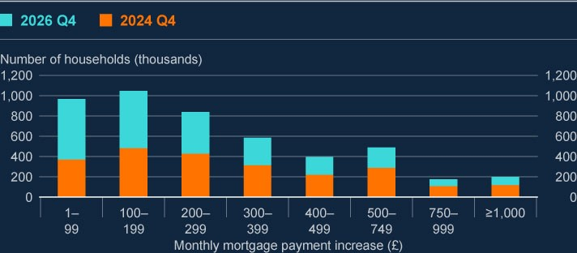

Sources: FCA Product Sales Data and Bank calculations.

1. The projection uses the overnight index swap (OIS) curve as at 20 November 2023 and the latest available data (mid2023) on the stock of outstanding mortgages.
2. Increases in payments on fixed-rate mortgages are calculated by assuming that mortgagors refinance onto a typical fixedrate at the point that their fixed-rate contract ends.
3. Mortgages with less than £1,000 outstanding are excluded. These data do not include buy-to-let mortgages or mortgagesthat are off balance sheet of authorised lenders, such as securitised loans or loan books sold to third parties.

The aggregate mortgage debt-servicing ratio (DSR), which measures the proportion of posttax income spent on mortgage payments across households, is projected to increase from 6.8% in 2023 Q2 to almost 9% by the end of 2026. This would mean that the average household DSR would remain below the peaks seen in both the global financial crisis (GFC) and the early 1990s recession (Chart 3.2). While interest rates are now at a similar level to those prior to the GFC, unemployment is around 0.7 percentage points lower than prior to the GFC and is expected to remain relatively low. Should unemployment rise by more than projected, more borrowers would face increased difficulty in servicing their debt.

**Chart 3.2: Aggregate mortgage debt-servicing burdens are expected to**

**increase but to remain below previous peaks**

Aggregate UK household mortgage DSR with illustrative projection to end-2026

(

**a**

)

(

**b**

)

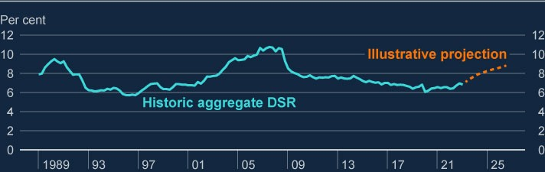

Sources: Bank of England, Bloomberg Finance L.P., FCA Product Sales Data, ONS and Bank calculations.

1. Calculated as mortgage interest payments plus principal repayments as a proportion of nominal householdpost-tax income. Household income is defined as disposable (post-tax) income adjusted for changes in pension entitlements and excludes the effects of financial intermediation services indirectly measured. Relative to the July FSR, household income is additionally adjusted to exclude gross operating surplus and to add back in interest paid. These changes broadly result in a level shift of the series upwards. Mortgage interest payments before 2000 are adjusted to remove the effect of mortgage interest relief at source.
2. For the illustrative projections to end-2026, projections for household post-tax income consistent with the

November 2023 MPR. Payment increases are projected using market expectations for Bank Rate based on the

OIS curve as at 20 November, taking into account the distribution of fixed-deal terms from the FCA Product Sales Data and assuming the aggregate mortgage debt to income ratio remains constant.

The overall household debt to income ratio was 139%[7] in 2023 Q2, its lowest level since 2002. The fact that the number of households with mortgage debt has fallen since the GFC has reduced the debt to income ratio, and more recently it has fallen further due to higher aggregate nominal income growth.

**The share of households with high mortgage debt-servicing burdens is now projected to increase by less than expected at the time of the July 2023 FSR.**

One of the ways the FPC assesses household debt vulnerabilities is by measuring how much of their income, adjusted for tax and essential spending, households need to spend on debt repayments. Households with higher mortgage cost of living adjusted debt-servicing ratios (COLA-DSRs), and in particular those with mortgage COLA-DSRs over 70%, are more likely to face difficulties meeting their debt repayments. A significant increase in borrower defaults could have implications for lender resilience.

The proportion of all households with high mortgage COLA-DSRs decreased from 1.8%[8] (in 2023 Q1) to 1.4% in 2023 Q3. This was driven by a stronger-thanexpected recovery in real incomes, as described above. The share of high COLADSR households is now projected to remain broadly flat by the end of 2023 at 1.4%

(400,000 households), and to increase to 1.6% (440,000 households) by the end of 2024. This is lower than the 2.3%, and 2.5% projected at the time of the July FSR for end-2023 and end-2024, respectively. This is also lower than levels seen during the GFC (3.4%). However, upside risks to inflation remain, including via the potential for higher commodity prices related to geopolitical developments.

**Chart 3.3: The proportion of households with the highest mortgage**

**repayments relative to their incomes decreased slightly in Q3, and is**

**projected to increase by less than previously expected**

The share of households with high COLA-DSRs

(

**a**

)

(

**b**

)

(

**c**

)

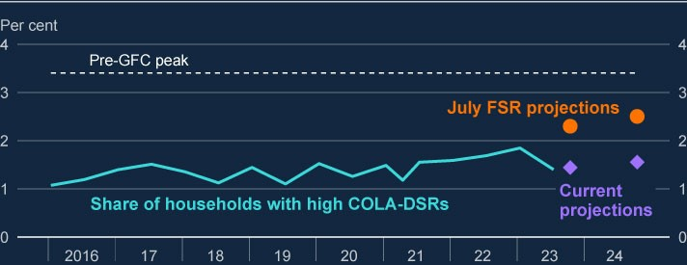

Sources: Bank of England, Bloomberg Finance L.P., British Household Panel Survey/Understanding Society (BHPS/US), NMG Consulting survey, ONS and Bank calculations.

1. The threshold of 70% is estimated by taking the threshold at which households become much more likely toexperience repayment difficulties for gross DSRs (40%) and adjusting it to reflect the share of income spent on taxes and essentials (excluding housing costs) by households with mortgages. For more information on the gross threshold, see the August 2020 FSR.
2. The impact of inflation is estimated by assuming the prices of essential goods rise in line with the November2023 MPR overall CPI inflation projection, and that households do not substitute away from this consumption.

Interest rate projections are applied based on OIS rates as at 20 November 2023.

1. The end-2024 projection of the share of households with high COLA-DSRs was not published in the JulyFSR.

Bank staff analysis shows that even for households with COLA-DSRs below 70%, an increase in DSRs is associated with a higher probability of households missing their repayments. For this reason, the FPC also monitors other metrics that consider all mortgagors, such as the aggregate mortgage DSR (Chart 3.2), as well as a broader distribution of households’ COLA-DSRs. Other factors associated with a higher probability of mortgage arrears include being in arrears for unsecured debt (eg credit card debt).

**There are several factors that should limit the impact of higher interest rates on mortgage defaults.**

Robust capital and profitability, and strict regulatory conduct standards for lenders, overseen by the FCA, mean UK banks are both able and expected to offer forbearance and support to borrowers concerned at the impact of the increase in their repayments.

Lenders representing approximately 90% of the mortgage market have also signed up to offer options agreed under the [**Mortgage Charter**.](https://www.gov.uk/government/publications/mortgage-charter/mortgage-charter) Take-up from borrowers

has so far been quite limited, compared to Covid payment holidays for example.

Borrowers are also taking action to offset the near-term impact of higher mortgage rates. There is evidence that some households are opting to borrow over longer terms to reduce monthly repayments. Indeed, new mortgage lending at terms longer than 35 years have increased from around 5% in 2022 Q1 to 12% in 2023 Q3 (Chart 3.4). In addition, 28% of new owner-occupier mortgages were extended on terms longer than 30 years in 2023 Q3. And of those borrowers who remortgaged in 2023 Q3, around 11% extended their existing term. A small number of households have also moved to interest only mortgages (at least temporarily).

While longer mortgage terms and forbearance measures could reduce pressures on borrowers in the short term, they could increase debt burdens over the longer term. Potential risks from such lengthening of debt burdens are mitigated somewhat by the FCA’s responsible lending rules. These require lenders to take account of likely future changes to income and expenditure, such as those associated with borrowers retiring, where this is expected to happen during the mortgage term.

**Chart 3.4: Borrowers are taking out longer-term loans, thus reducing**

**monthly capital payments**

Per cent of new mortgage debt by term length

(

**a**

)

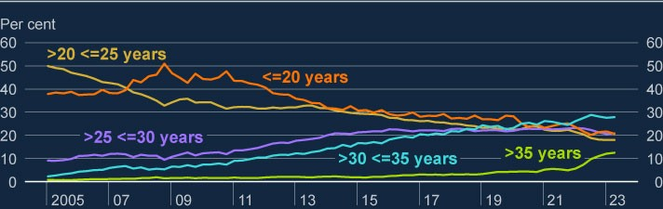

Sources: FCA Product Sales Data and Bank calculations.

(a) Mortgages include first-time buyers, homemovers and non-internal remortgages. Internal remortgages, further advances, mortgages flagged as a business loans, and lifetime mortgages are excluded.

**Many buy-to-let landlords are passing on higher costs to renters, thus increasing financial pressure on these households.**

Higher interest rates and structural factors are putting pressure on profitability in the buy-to-let sector (see [**July 2023 FSR**](https://www.bankofengland.co.uk/financial-stability-report/2023/july-2023)). Many landlords have sought to raise rents,

or sell their properties, to offset their higher costs. Given limited supply, renters have continued to face rapidly rising costs, with annual new-lets rental inflation at

10.5% in September, and annual inflation on the rental stock at 6.1% in October.

Consistent with this, survey evidence suggests that the share of renters in arrears has increased. Recent Bank staff analysis shows that renters tend to be less financially resilient than other households. Indeed, renter households tend to have lower incomes than homeowners and they are likely to have lower savings. Higher costs relative to incomes could lead to an increased reliance on consumer credit, or difficulties paying off existing consumer credit or other types of debt. This could also increase renters’ vulnerability to future adverse shocks (see: [**What do pressures**](https://www.bankofengland.co.uk/bank-overground/2023/what-do-pressures-on-renters-mean-for-financial-stability#:~:text=Higher%20debt%20and%20lower%20savings,worsen%20a%20wider%20economic%20downturn.)

[**on renters mean for financial stability?**)](https://www.bankofengland.co.uk/bank-overground/2023/what-do-pressures-on-renters-mean-for-financial-stability#:~:text=Higher%20debt%20and%20lower%20savings,worsen%20a%20wider%20economic%20downturn.).

**The rise in interest rates since the start of 2022 appears to have reduced higher risk new mortgage borrowing.**

The flow of high loan to income (LTI) mortgage lending as a share of new lending remains low by historical standards at 5.5%. This is consistent with rising interest rates and costs, which are limiting the amount households can borrow.

The FPC’s LTI flow limit, which restricts a lender’s share of new mortgages with LTI ratios at 4.5 or higher to a maximum of 15%, and the FCA’s responsible lending rules, continue to guard against the risk that mortgage repayments become unaffordable, limiting the impact of further increases in rates on borrower resilience. Meanwhile, the FPC observes that the withdrawal of the Affordability Test Recommendation in 2022 has so far had a limited effect on borrower resilience, given that these other measures remain in place (Box C).

**Mortgage and consumer credit arrears have risen slightly but remain low.**

**The UK banking sector is well capitalised and able to support households.**

In 2023 Q3 the number of owner-occupier and buy-to-let mortgages in arrears (of 2.5% or more of the outstanding balance) rose slightly, but remained low by historical standards, at around 1% and 0.6% of outstanding mortgages respectively. Indeed, buy-to-let mortgages in arrears remained less than a third of their GFC peak. Arrears are expected to continue to increase moderately, as it will take time for the full impact of higher interest rates and increases in the cost of living to come through. Mortgage arrears are expected to stay well below GFC peaks, although this could be challenged if there were a significant rise in unemployment.

The annual growth rate for total consumer credit was 8.0% in September, marginally higher than the preceding months. Within that, the annual growth rate for credit card borrowing was 12.5%. Consumer credit arrears have increased somewhat over the past year to 1.3% in 2023 Q2 and are expected to continue to increase but remain low relative to historical averages.

In the 2022/23 annual cyclical scenario (ACS), major UK banks were stress tested against a severe macroeconomic scenario that would put pressure on the ability of households to service their debts, including unemployment rising to 8.5%. The results indicated that they would be able to continue to support households, and were resilient to significant losses on consumer credit and mortgage lending, well above those observed after the GFC.

## 3.3: UK corporate debt vulnerabilities

**In aggregate, the UK corporate sector is expected to remain broadly resilient to higher interest rates and weak growth, in part due to robust earnings growth.**

In aggregate, the amount of outstanding UK corporate debt relative to corporate earnings has continued to fall since its recent peak during the Covid pandemic. The latest data covering 2023 Q2 show that the corporate gross debt to earnings ratio stood at 276%, down from 345% in 2020 Q4 with the net debt to earnings ratio reaching its lowest point in the last 20 years at around 118% (Chart 3.5). This was driven by both strong growth in nominal corporate earnings and a small fall in aggregate debt. However, debt and cash holdings are not spread evenly across corporates, so these aggregates can mask vulnerabilities for particular firms or sectors.

**Chart 3.5: The aggregate corporate net debt to earnings ratio has continued**

**to fall**

Aggregate debt of UK corporates split into bank and market-based debt (left axis).

Aggregate net debt to earnings ratio of UK corporates (right axis)

(

**a**

)

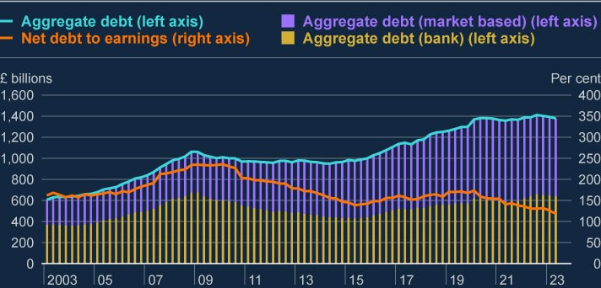

Sources: Association of British Insurers, Bank of England, Bayes CRE Lending Report (Bayes Business School

(formerly Cass)), Deloitte, Finance & Leasing Association, firm public disclosures, Integer Advisors estimates,

LCD an offering of S&P Global Market Intelligence, London Stock Exchange, ONS, Peer-to-Peer Finance Association, Eikon from Refinitiv and Bank calculations.

(a) These data are for private non-financial corporates (PNFCs), which exclude public, financial and unincorporated businesses. Earnings are defined as businesses’ aggregate gross operating surplus, adjusting for financial intermediation services indirectly measured.

**Higher interest rates continue to put some firms under pressure.**

A company’s interest coverage ratio (ICR) is calculated by dividing its earnings before interest and tax by its interest expense.

Aggregate corporate financial statement data for 2022 showed the debt-weighted portion of medium and large corporates with ICRs below 2.5 (a level below which UK companies are materially more likely to experience repayment difficulties) decreased slightly to 28%, as higher earnings offset the impact of higher debt payments (Chart 3.6). Assuming corporates do not adjust their balance sheets, this share is expected to increase in 2023 to 37%. This is less than was expected at the time of the July 2023 FSR, and significantly lower than the peak of 65% reached in the early 2000s. This reflects the robust earnings growth in 2022, along with a fall in the market-implied path for Bank Rate since July.

The debt-weighted share of firms with low ICRs in sectors most vulnerable to the macro environment is expected to increase. These include firms reliant on discretionary consumer spending, such as wholesale trade, or in energy intensive sectors, such as real estate and construction, which are likely to come under more pressure. However, firms with low ICRs within these vulnerable sectors represent a small proportion of aggregate corporate debt (Chart 3.6). This means that risks from these corporates through the lender resilience channel are relatively limited.

**Chart 3.6: The debt-weighted share of firms with low ICRs in sectors most**

**vulnerable to the macro environment is expected to increase**

Debt-weighted share of corporates with ICR <2.5 in select sectors and for aggregate

corporate debt

(

**a**

)

(

**b**

)

(

**c**

)

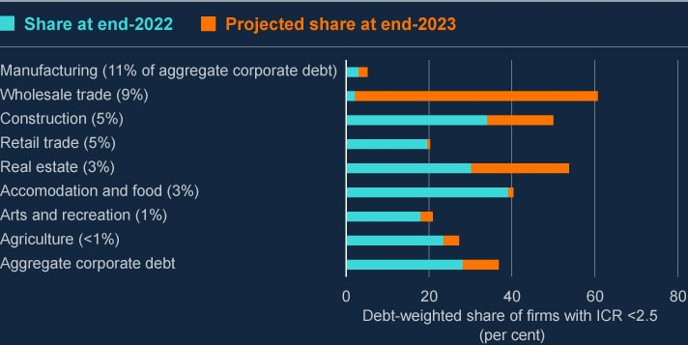

Sources: Bureau van Dijk, S&P Capital IQ and Bank calculations.

1. These data refer to UK PNFCs only.
2. The projection uses the November 2023 MPR projections for earnings and credit spreads. To estimate thecost of borrowing, the projection also uses market expectations for peak Bank Rate based on the OIS curve as at 24 October. These assumptions are applied to latest (end-2022) published balance sheet data.
3. Not all sectors are shown in this chart so the proportion of debt shown on the y-axis does not sum to 100.

The ‘Aggregate’ bar refers to all UK PNFCs including those sectors not shown.

**The share of corporates at higher risk has fallen from its pandemic peak.**

While corporates with low ICRs are more likely to experience repayment difficulties, staff analysis suggests a number of other factors are also associated with a higher probability of firm failure. These include: the amount of liquidity a firm has; the amount of profit a firm can generate from its assets (return on assets); its revenue growth; its leverage growth; and the relative amount of leverage it has. Bank staff have identified the respective threshold for each factor beyond which the likelihood of firm failure increases. For example, if a firm’s return on assets is negative, it is associated with a significantly higher likelihood of failure.

As more thresholds are crossed simultaneously by a firm, the probability of the firm’s failure increases. Corporates that simultaneously breach the three thresholds associated with the greatest likelihood of firm failure (ICR, liquidity, and return on assets) are considered to be at higher risk. The share of corporates at higher risk, weighted by their levels of debt, termed ‘debt at risk’, is represented by the orange line (Chart 3.7). The aqua swathe represents a sensitivity to corporates’ debt at risk, with firms breaching different combinations of thresholds. This debt at risk measure peaked in 2020, at the time of the pandemic, and decreased in 2022 to around pre-pandemic levels, partially reflecting corporates’ robust earnings growth.

Corporates at higher risk are materially more likely to fail within three years than corporates that do not breach any thresholds. These firms are also more likely to take defensive actions such as significantly cutting investment and employment, creating risks through the borrower resilience channel mentioned at the start of this section.

**Chart 3.7: The share of UK corporate debt at risk has fallen from its**

**pandemic level**

Debt-weighted share of UK corporates at higher risk

(

**a**

)

(

**b**

)

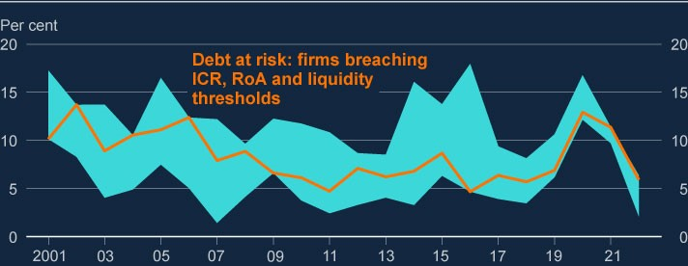

Sources: Bureau van Dijk and Bank calculations.

1. The orange line represents the debt weighted share of UK corporates that simultaneously breach the threethresholds associated with the highest likelihood of firm failure (corresponding to: ICR, liquidity and return on assets).
2. The aqua swathe represents a sensitivity to firms’ riskiness: alternatives capture firms that breach any threethresholds within the six factors and firms that breach the thresholds with the highest marginal effects.

**Market-based finance is now the source of around half of UK corporate borrowing.**

The share of debt from market-based finance has increased over the past decade (Chart 3.5). Market-based finance has the potential to diversify corporates’ funding sources and improve the resilience of lending. However, increased reliance on it could introduce additional vulnerabilities because credit supply from these sources may be more cyclical. Indeed, investor sentiment can change rapidly in response to adverse shocks, triggering widening credit spreads and making it harder or more expensive for borrowers to roll over their debts. These risks are heightened in riskier credit markets such as the leveraged loan, private credit, and high-yield bond markets (Box B).

**Higher interest rates have not yet passed through to all corporates, and refinancing pressures will increase as corporates refinance maturing debt.**

For corporates with debt on fixed rates, the maturity profile of their debt affects how soon they will be exposed to higher interest rates, and the extent to which refinancing pressures could pose risks to financial stability.

The bulk of UK corporate debt on fixed rates is due to mature in or after 2025. This is mostly debt from market-based finance. Within market-based finance debt, around 80% of high-yield corporate bonds, and around 80% of leveraged loans are due to mature after 2025. Refinancing needs for these predominantly larger firms has been relatively limited so far, and is likely to remain limited in the very near term. These firms have had time to adjust their business plans to take account of higher borrowing costs, which may limit risks associated with refinancing and higher debt-servicing costs.

Firms that would potentially need to refinance at higher rates may use their cash buffers to deleverage. They may also take defensive action by cutting back on investment and employment, leading to risks through the borrower resilience channel. But certain borrowers may have fewer options than others when their existing debt matures to cushion the impact of higher interest rates. Relatedly, small and medium-sized enterprises (SMEs) and highly leveraged firms may have fewer alternative funding sources, and may also be more exposed to refinancing risk for this reason.

**Some SMEs’ debt-servicing burdens have increased.**

One of the ways the FPC assesses vulnerabilities associated with SME debt is by looking at what proportion of SMEs' revenues goes to servicing debt . SMEs that borrowed under the Bounce Back Loan Scheme (a government guaranteed loan scheme) are currently insulated from higher rates at least until the end of their sixyear fixed term. But the majority of SME debt is advanced on commercial terms by banks and tends to be floating rate.

Overall, the median SME DSR has remained broadly flat, indicating that income growth has offset the impact of higher interest payments. But looking further into the tail at the 75th percentile, DSRs of SMEs that did not use government guaranteed loan schemes have increased since 2022 Q3 (Chart 3.8). Consistent with this, SME arrears for commercial loans have been rising moderately from low levels since 2023 Q1 and now stand at 1.3% in August 2023.

Arrears on government guaranteed loans have decreased since 2023 Q3 but remain high. These loans do not pose a direct risk to bank balance sheets. But pressures on SMEs could pose a risk indirectly through the real economy as SMEs comprise around 60% of UK employment.

**Chart 3.8: SMEs’ debt-servicing pressures have increased**

Debt-servicing ratio of small and medium-sized enterprises with commercial loans –

75

th percentile

(

**a**

)

(

**b**

)

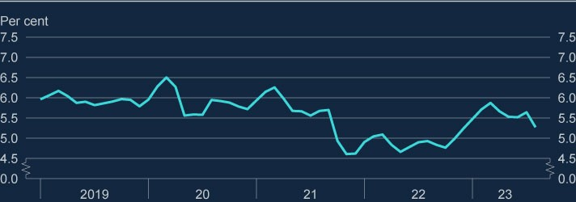

Sources: Experian and Bank calculations.

1. SMEs are defined as any organisation that has a turnover of less than £25 million. This sample is limited toindebted UK limited liability SMEs that did not borrow from government schemes.
2. DSRs for SMEs are calculated as expected monthly payments over turnover (proxied by current accountinflows).

**Vulnerabilities in commercial property markets remain, but major UK banks are resilient to their exposures to commercial real estate.**

A number of headwinds continue to face the UK commercial real estate (CRE) market, in common with global CRE markets (Section 2). These are putting downward pressure on prices and making refinancing challenging, despite borrowers having lower leverage than in previous stress periods. These headwinds include structural challenges such as the post-pandemic shift to more remote working, the ongoing shift from physical to online shopping, and the cost of upgrading buildings to reduce carbon emissions, as well as cyclical pressure. There has been a structural shift in CRE investors’ funding sources, with UK banks’ share of outstanding debt declining significantly since 2008 (see Box A of the [**July 2023**](https://www.bankofengland.co.uk/financial-stability-report/2023/july-2023)

[**FSR**)](https://www.bankofengland.co.uk/financial-stability-report/2023/july-2023).

Since their mid-2022 peak, UK CRE prices have fallen by nearly 20%, with the US and euro area also experiencing significant price falls. Further price falls could present a risk to lenders if they materially reduce the value of the collateral held against their loans. Stress in non-UK CRE markets could also affect the UK indirectly – for example, if stresses in overseas banks caused, or exacerbated, by actual or expected losses in CRE markets affect developments in UK CRE or funding conditions more generally. The 2022/23 ACS included a severe stress to the UK and global economies, which included large falls in property prices (for example, a 45% decline in UK CRE prices from their mid-2022 levels), and a significant increase in UK banks’ funding costs. The results of the test suggest that major UK banks would have been resilient to such a scenario.

**Corporate insolvency rates have risen, driven by small firms with limited debt, but remain low relative to historical averages. UK banks are resilient to their exposures to the UK corporate sector.**

Corporate insolvency rates have risen to around 52 per 10,000 firms in the 12 months to September 2023. However, they remain well below their long-term average level of around 100 per 10,000 firms. The increase in insolvencies is dominated by very small firms with limited debts. Nevertheless, the number of insolvencies of medium and large corporates rose through 2023, also from very low levels. Insolvencies are likely to rise further, as pressures from tighter financial conditions and the subdued economic outlook continue to feed through.

The UK banking system is well capitalised to withstand increases in corporate distress. As part of the 2022/23 ACS, major UK banks have been stress tested against a broad and severe macroeconomic scenario. The results indicate that they would be resilient to significant credit losses across their portfolios, including on their UK corporate lending, which had high projected levels of impairment in the stress scenario (an aggregate projected five-year impairment rate of 8.3%).

|  |
| --- |
| Box C: The withdrawal of the FPC’s A**ff**ordability Test  Recommendation  The FPC withdrew its Affordability Test Recommendation (ATR) with effect from 1 August 2022. This box provides a summary of the estimated effect so far of the withdrawal on borrower resilience and borrowers’ access to the mortgage market.  **The FPC introduced two mortgage market Recommendations in 2014.**  Consistent with its primary objective of protecting UK financial stability, the FPC introduced two mortgage market Recommendations in 2014 to guard against a loosening in mortgage underwriting standards that could lead to a material increase in aggregate household debt and the number of highly indebted households, in a period of rapid increases in house prices.[9] The loan to income (LTI) flow limit restricts a lender’s share of new mortgages with LTI ratios at 4.5 or higher to a maximum of 15%. The ATR required lenders to assess if a borrower could still afford their mortgage if the mortgage rate were to be 3 percentage points higher than the contractual reversion rate.[10] Mortgages with an interest rate fixation period of five years or more were exempt from the ATR. In addition, the FCA’s mortgage conduct of business (MCOB) lending rules require lenders to take account of future interest rates when applying an appropriate stress rate and to assume that, at a minimum, interest rates rise by 1 percentage point.  **Following a review in 2021, the FPC withdrew the ATR with effect from 1 August 2022.**  The FPC has regularly reviewed its mortgage market Recommendations with regard to its primary objective of protecting UK financial stability and its secondary objective of supporting the Government’s economic policy. In its latest review, published in the [**December 2021 Financial Stability Report**](https://www.bankofengland.co.uk/financial-stability-report/2021/december-2021),  the FPC concluded that, given the impact of the FPC’s Recommendations in conjunction with the FCA’s MCOB rules, the LTI flow limit was likely to play a stronger role than the ATR in guarding against an increase in aggregate household indebtedness and the number of highly indebted households |

|  |
| --- |
| when house prices rise rapidly. It also concluded that withdrawing the ATR would create a simpler, more predictable, and more proportionate framework with less overlap with FCA rules, in which the LTI flow limit, in combination with the FCA’s MCOB, would ensure an appropriate level of resilience. Following its review, and after consultation, the FPC withdrew the ATR with effect from 1 August 2022.  **The withdrawal of the ATR has limited the increase in lenders’ stress rates as Bank Rate has risen.**  When assessing borrowers’ affordability, lenders tend to set stress rates by applying a stress buffer onto reversion rates such as standard variable rates (SVRs). Average SVRs increased from 4.4% to 7.8% between August 2022 and September 2023, as lenders passed through most of the increase in Bank Rate over that period (Chart A). The increase in SVRs has led to an increase in lenders’ stress rates. The withdrawal of the FPC’s ATR has meant that this increase was smaller than it would otherwise have been. Intelligence from lenders suggests stress buffers above reversion rates fell from around 3 percentage points at the time of the withdrawal, to around 1 percentage point in 2023. The median stress rate used in affordability testing of new lending in September 2023 was 8.8%. Had the ATR remained, the typical required stress rate could have reached almost 11%, which would have made it harder for some borrowers to pass affordability checks. |

The share of new high-LTI lending has decreased noticeably since 2022 Q2,

as rising interest rates have tightened affordability constraints and thus

reduced the amount that households can borrow. In 2023 Q3, the share of

new mortgages with LTI ratios of 4.5 or above stood at 5.5%, compared with

10.0

% in 2022 Q2; well below the FPC’s flow limit of 15%. It is estimated that

the share of new high-LTI lending would have declined a little further to

between 4.5% and 4.9% if the ATR had remained, reflecting the fact that

mortgagors who would have been rejected under the ATR would have been

more likely to have high LTI ratios.

The FPC also closely monitors the share of households with high debt-

servicing ratios (DSRs) (Section 3). In 2023 Q3, the share of new lending at

gross DSRs at or above 40% was estimated to be only 0.1 to 0.3 percentage

points higher as a result of the withdrawal, and remained very low at 0.8%.

Overall, the estimates suggest that the withdrawal of the ATR has had a

limited effect on borrower resilience in aggregate, as the FPC expected.

**Chart A: Interest rates have increased since the FPC withdrew the ATR**

Bank Rate, SVRs, actual stress rates and stress rates required by the FPC’s ATR

(

**a**

)

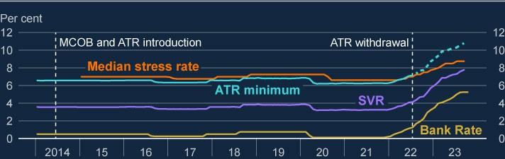

Sources: Bank of England, FCA Product Sales Data and Bank calculations.

(

a) The ATR minimum is constructed by adding 3 percentage points to average SVRs.

**So far, the withdrawal has had a limited effect on borrower resilience,**

**as expected.**

Raising a deposit remains the biggest barrier to accessing the mortgage

market.

[11]

The increase in interest rates since the withdrawal of the ATR has

also made it harder for households to afford a mortgage. At the same time,

the withdrawal has slightly improved borrowers’ access to the mortgage

market in two ways: first, it has allowed households to borrower larger

amounts than they would have had the ATR remained, as the FPC expected;

and second, as Bank Rate rose, it has allowed some borrowers to afford a

mortgage who would otherwise not have been able to borrow at all.

**Chart B: The withdrawal of the FPC’s ATR has had a limited effect on**

**the share of new high-LTI lending**

Share of new mortgages with LTI ratios of 4.5 and above (actual and assuming

ATR had remained)

(

**a**

)

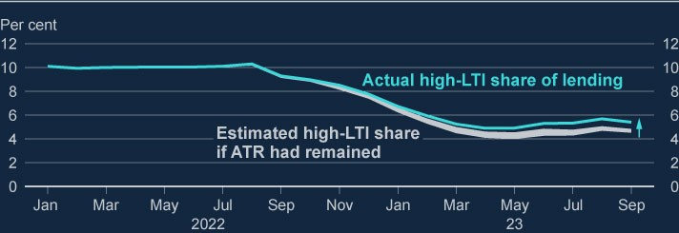

Sources: Bank of England, FCA Product Sales Data and Bank calculations.

a) Based on FCA Product Sales Data, excluding pure and internal remortgages, further advances,

(

second charge mortgages, business loans and lifetime mortgages. The hypothetical share of high-LTI

lending is estimated based on an adjusted flow of mortgages, excluding mortgagors that would have

likely been rejected if the ATR had remained. Those mortgagors are identified by calculating a

hypothetical stressed DSR for each mortgage issued after the withdrawal, assuming that the ATR was

still in place. Mortgages are assumed to not have been issued if mortgagors would have exceeded pre-

defined critical high stressed DSR thresholds. The shaded area reflects the range of estimates under

different modelling assumptions with regards to banks’ rejection rules and borrowers’ adjustments of

mortgage terms when their stressed DSR exceeds a critical threshold.

**So far, the withdrawal of the ATR has led to a small increase in**

**borrowers’ access to the mortgage market.**

|  |
| --- |
| Staff analysis suggests that by reducing the minimum stress buffer that banks need to apply when assessing affordability, the withdrawal has allowed households to borrow larger amounts on average. Loan-level data suggests that, so far, the withdrawal is associated with an increase in loan size of 2% to 4% for mortgages that were previously in scope of the Recommendation. This was broadly consistent with staff estimates at the time of the withdrawal that suggested the ATR could have caused some mortgagors to take out smaller loans than they would have in its absence. The ATR withdrawal has thus partially offset the overall fall in average loan size since the withdrawal, which has been driven by higher interest rates.  A counterfactual analysis based on mortgage-level data suggests that until the end of 2022, the withdrawal of the ATR had increased total approvals by less than 1%, consistent with staff estimates at the time of the withdrawal. As Bank Rate rose, the effect increased to an estimated 1% to 5% by August 2023, as the ATR would have become more binding. This is equivalent to less than 0.5% of the current stock and small in the context of the 44% fall in total approvals seen since the withdrawal.  **The effect of the withdrawal is sensitive to the level of Bank Rate.**  Bank staff analysis simulating how changes to the FPC’s housing tools could affect the number of mortgage approvals under different scenarios supports the idea that the effect of the withdrawal is sensitive to the level of Bank Rate (Chart C). This reflects the fact that a higher level of Bank Rate leads to higher reversion rates, which would in turn make the ATR more binding if it was still in place. In a scenario that is consistent with the market-implied path for Bank Rate at the time of the November 2023 MPR, for example, the withdrawal is estimated to increase the total number of mortgage approvals between the time of the withdrawal and 2025 Q2 by around 5%. The effect would have been only around 3% with a lower Bank Rate path consistent with the market-implied path at the time of the August 2022 MPR (when the ATR was withdrawn). Had Bank Rate not changed since December 2021 when the FPC decided to consult on withdrawing the ATR, the effect would have been very much smaller, at less than 1%. |

The FPC regularly reviews its mortgage market Recommendations to ensure

that they remain effective at insuring against a deterioration in lending

standards. As part of this, the FPC will continue to monitor the impact of its

measures and make further adjustments if necessary.

**Chart C: The effect of the ATR withdrawal is sensitive to the interest**

**rate environment**

Impact of the withdrawal on mortgage approvals by 2025 Q2 for different Bank

Rate scenarios

(

**a**

(

)

**b**

)

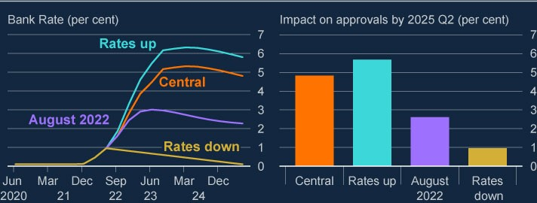

Sources: Bank of England, FCA Product Sales Data and Bank calculations.

(

a) Estimates are based on a model that simulates how changes to the FPC’s housing tools could

affect the flow of mortgages under different macroeconomic scenarios. The model was used in housing

tools reviews, including a review in 2021. The results of the 2021 review were published in the

[**December 2021 FS**](https://www.bankofengland.co.uk/financial-stability-report/2021/december-2021)

[**R**](https://www.bankofengland.co.uk/financial-stability-report/2021/december-2021)

and the accompanying

[**Technical Anne**](https://www.bankofengland.co.uk/-/media/boe/files/financial-stability-report/2021/technical-annex-evidence-on-the-fpcs-mortgage-market-recommendations.pdf?la=en&hash=4C41933F3DE4069EBBC92C4129748231E79888E5)

[**x**](https://www.bankofengland.co.uk/-/media/boe/files/financial-stability-report/2021/technical-annex-evidence-on-the-fpcs-mortgage-market-recommendations.pdf?la=en&hash=4C41933F3DE4069EBBC92C4129748231E79888E5)

which also includes additional details

about the model.

(

b) The ‘central’ scenario is based on the path of Bank Rate since the withdrawal, extended forward

using the November 2023 MPR. Relative to the ‘central’ scenario, in the ‘rates up’ scenario, Bank Rate

increases by 25 basis points more during the first four quarters after the withdrawal. The ‘August 2022’

scenario is based on the August 2022 MPR and reflects expectations at the time of withdrawal. In the

‘rates down’ scenario, Bank Rate decreases gradually after the withdrawal until it reaches its previous

minimum. All scenarios account for the effect of Bank Rate on house prices and mortgage approvals.

# 4: UK banking sector resilience

|  |
| --- |
| The UK banking system is well capitalised and has high levels of liquidity. It has the capacity to support households and businesses even if economic and financial conditions prove to be substantially worse than expected.  The overall risk environment remains challenging. Asset performance deteriorated among some loan portfolios in Q3. But forward-looking indicators of UK banks’ asset quality remained stable overall suggesting that the deterioration in performance was broadly as banks had expected.  Aggregate net lending remains subdued, primarily driven by reduced demand for credit as well as tightening in banks’ risk appetites. The FPC continues to judge that the tightening in UK credit conditions over the past two years has reflected the impact of changes to the macroeconomic outlook rather than defensive actions by banks to protect their capital positions.  The FPC has maintained the UK countercyclical capital buffer (CCyB) rate at its neutral setting of 2%.  Over the past 18 months, risk-free rates have returned to levels last seen prior to the global financial crisis and this has been a key driver of changes in bank funding costs. Alongside this, a number of system-wide trends are likely to impact bank funding and liquidity in the coming years, including as central banks normalise their balance sheets. These factors will affect sources of bank funding and could affect their cost. Banks will need to factor these system-wide trends into their liquidity management and planning over the coming years. |

## 4.1: Recent developments in UK banks’ capital, liquidity and profitability

**UK banks’ capital and liquidity positions remain robust.**

Major UK banks and building societies (‘major UK banks’) remain well capitalised, with an aggregate Common Equity Tier 1 (CET1) capital ratio of 14.8% in 2023 Q3 (Chart 4.1). Major UK banks’ CET1 ratios have been broadly flat over 2023, as strong pre-provision profits have been distributed to shareholders and, to a lesser extent, have been offset by impairments. Similarly, small and medium-sized UK banks and building societies (‘small and medium-sized UK banks’) have in aggregate maintained strong capital positions with an aggregate CET1 ratio of

18.5%.

UK banks also maintain strong liquidity positions. Major UK banks’ aggregate threemonth moving average Liquidity Coverage Ratio (LCR) has increased slightly over 2023, standing at 149% in September, compared with 146% as at the July FSR. Major UK banks’ total high-quality liquid assets (HQLA) have remained flat at £1.4 trillion, with the majority held in central bank reserves. These HQLA are equivalent in size to around 40% of total deposits.

In aggregate, small and medium-sized UK banks maintain strong liquidity positions with an aggregate LCR of 260% in September and £154 billion of HQLA, equivalent in size to around 30% of total deposits.

**Chart 4.1: Both larger and smaller UK banks have robust aggregate CET1**

**ratios**

Aggregate CET1 ratio of UK banks and building societies

(

**a**

)

(

**b**

)

(

**c**

)

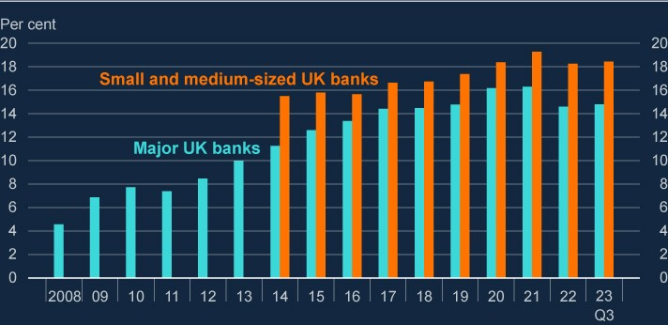

Sources: PRA regulatory returns, published accounts and Bank calculations.

1. The CET1 capital ratio is defined as CET1 capital expressed as a percentage of risk-weighted assets.

Yearly values are at the end of that year, except for 2023 where latest data as at Q3 has been used.

1. Major UK banks are Barclays, HSBC, Lloyds Banking Group, Nationwide, NatWest Group, Santander UK,Standard Chartered and (from December 2020) Virgin Money. From 2011, data are CET1 capital ratios as reported by banks. Prior to 2011, data are Bank estimates of major UK banks' CET1 capital ratios.
2. The small and medium-sized UK banks series represents the aggregate of a group of approximately 110 non-systemic UK banks and building societies, within which are a large range of sizes and business models.

This series starts at 2014 owing to data limitations before this point.

**Major UK banks’ profitability remains strong but there is some evidence that net interest margins have peaked.**

Major UK banks’ pre-provision profits have declined over the past two quarters, but at £16.2 billion in Q3, remain robust and significantly larger than impairment charges. The decline in profits is relative to a peak of £17.9 billion in Q1, and was driven by lower non-interest income and higher operating costs.

Banks’ net interest margins have risen sharply since interest rates began to rise, but there is some evidence that net interest margins (NIMs) have peaked, due to the more competitive funding environment and compressed spreads on new lending (see Box D for consideration of this in the context of broader trends in banks’ funding and liquidity). Q3 saw a reduction in NIMs across major UK banks. Several banks have downgraded their NIM guidance for the future, citing higher deposit pricing and increased competition in the mortgage market, leading consensus estimates of UK banks’ loan margins over the coming years to fall (Chart 4.2). Greater income from banks’ structural hedge positions, however, has somewhat offset downward pressures on NIMs. This income has increased due to rising interest rates, which has led to higher rates of return on banks’ new long-term fixed-rate assets.

The publication of major UK banks’ Q3 results containing a weaker outlook for future profitability may have contributed to declines in UK bank share prices, with the FTSE Bank index falling by 12% over the second half of October. Major UK banks’ price to tangible book ratios, which are indicators of the market value of future profitability, remain subdued. Having declined from an average of 0.7 at the start of September, the average ratio fell to 0.6 at the end of October.

Despite some evidence that NIMs have peaked, profitability of the major UK banks is expected to remain robust and to significantly outweigh expected impairments. Net interest margins are expected to remain higher than recent years when Bank Rate had been close to the effective lower bound, and similar to levels seen before the global financial crisis when Bank Rate was comparable to its current level.

**Chart 4.2: Major UK banks’ net interest margins remain above long-term**

**averages, but there is some evidence that they have peaked**

Average margin on major UK banks’ lending since 2000

(

**a**

)

(

**b**

)

(

**c**

)

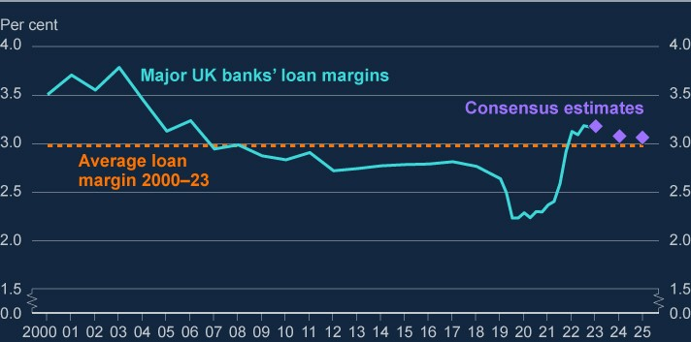

Sources: LSEG Eikon, published accounts and Bank calculations.

1. Loan margin is calculated as net interest income divided by total lending. Loan margins in this chart arecalculated across all currencies. Net interest income is interest income minus interest expense.
2. Figures between 2000 and 2019 exclude Virgin Money UK, and figures before 2006 exclude StandardChartered.
3. Consensus estimates are scaled based on analysts’ expectations of loan margins for Barclays, HSBC,Lloyds Banking Group, NatWest Group, Standard Chartered and Virgin Money.

While the announcement of Metro Bank’s capital raise and debt refinancing package on 9 October was preceded by movements in its share and debt prices, other UK banks did not see similar movements, indicating that any broader impacts on the banking sector were limited.

**Asset performance deteriorated among some loan portfolios in Q3 in line with banks’ expectations, reflecting the impact of the macroeconomic environment.**

The overall risk environment remains challenging as high interest rates and inflation continue to put pressure on households and corporate borrowers, and certain global risks have continued to crystallise (see Sections 2 and 3). Some forms of lending, such as to finance commercial real estate investments, buy-to-let (BTL), and highly leveraged lending to corporates – as well as lenders that are more concentrated in those assets – are more exposed to credit losses as borrowing costs rise.

Reflecting the challenging macroeconomic environment, indicators of UK banks’ asset quality have continued to deteriorate somewhat since the July FSR, though UK banks’ overall asset quality remains strong in an historical context. The share of UK mortgages in early arrears has increased for both major and smaller banks, albeit from very low starting levels. BTL portfolio arrears have also increased this year, with smaller and more specialist UK banks experiencing a greater deterioration in the proportion of BTL mortgages in arrears than larger banks. And UK SME insolvencies and loan arrears have also increased, though overall corporate loan book performance has remained relatively robust.

Risks continue to crystallise in Chinese property markets (see Section 2), and UK banks exposed to these markets have incurred impairment charges of £0.7 billion in Q3. But the results of the 2022/23 ACS indicated that UK banks would be resilient to a severe global recession that included very significant falls in real estate prices in mainland China and Hong Kong (for example, a fall of 53% in Hong Kong CRE prices).

Global leveraged loans have seen some further deterioration in performance as default rates continue to rise sharply and are now near Covid peaks (see Box B). But default levels in leveraged loan markets remain significantly below those seen in the 2022/23 ACS. UK banks have reduced their direct leveraged loan exposures somewhat over 2023, and so far, have not seen a material increase in defaults on their portfolios.

Consistent with these developments, the share of credit impaired loans (IFRS 9

‘stage 3’ loans) within major UK banks’ overall lending has increased slightly over

2023. It currently stands at just over 1.8% in Q3, compared to just below 1.7% in Q3 of last year. Within this total, the share of mortgage and consumer credit loans in stage 3 increased, whereas the share of wholesale loans in stage 3 remained broadly stable.

The share of total loans for which there has been a significant increase in credit risk, but not yet considered in default (IFSR 9 ‘stage 2’ loans), has remained broadly flat in aggregate for both larger and smaller UK banks since the July FSR. Reflecting the slight deterioration in asset quality, major UK banks’ aggregate impairment charge was £2.4 billion in Q3.

Overall provision coverage has remained broadly flat over recent quarters for both major and smaller banks at around 1.1% and 0.55% of loans respectively. This suggests that the deterioration in asset performance was broadly in line with lenders’ expectations. Consistent with the challenging macroeconomic outlook, total provision coverage is higher than before the pandemic for both major and smaller banks.

## 4.2: UK banks’ provision of credit

**Aggregate net lending remains subdued, primarily driven by reduced demand for credit as well as tightening in banks’ risk appetites.**

The volume of net lending to households and businesses increased in Q3 from low levels seen earlier in 2023, but it remains below recent averages (Chart 4.3). The reduction in credit volumes over the past year has come alongside a weakened outlook for GDP and rising interest rates.

Low levels of net lending appear to be primarily due to reduced demand for credit. For instance, demand for secured lending for house purchases and remortgaging decreased in the Q3 Credit Conditions Survey (CCS), consistent with a peak in quoted mortgage rates in August. Banks also reported reduced demand for corporate lending from both private non-financial corporations and small businesses. The drivers of these trends in demand for credit continue to be higher interest rates, which have affected affordability, as well as uncertainty around the outlook for house prices and economic conditions more broadly.

The only form of lending for which net volumes extended have consistently been positive is unsecured retail credit. This has been driven by strong demand for unsecured lending by households, despite increases in quoted rates for credit cards and personal loans; the average quoted rate on credit cards is currently around 25%, compared to below 20% in 2019. This demand may reflect the increasing cost of goods owing to high levels of inflation, combined with an increasing proportion of credit cards issued in initial short-term deals at 0% interest.

**Chart 4.3: Aggregate net lending to the real economy remains subdued**

UK monetary financial institutions’ net lending to UK households and businesses

(

**a**

)

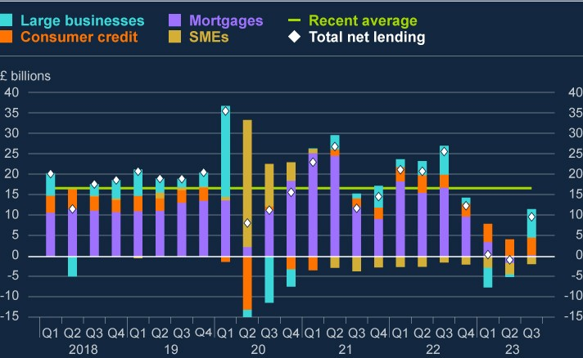

Sources: Bank of England and Bank staff calculations.

(a) Recent average is from 2018 Q1 to 2023 Q3. Net lending refers to the volume of lending extended by UK monetary institutions to UK households and businesses, less the amount of lending repaid by UK households and businesses to those institutions. These data are seasonally adjusted.

As well as weak demand for credit, subdued net lending volumes have also been driven by banks’ identification of increased credit risk associated with lending to some households and businesses as a result of the challenging macroeconomic environment. Reflecting this, the proportion of prospective borrowers able to meet banks’ lending standards has fallen. Credit conditions remain tighter for smaller businesses and those sectors most exposed to the macroeconomic outlook – including construction, retail and hospitality. And since the July FSR, intelligence from the Bank’s Agents includes some reports of a further reduction in credit supply for small businesses. Banks also reported a slight decrease in secured credit availability to households for the second quarter in a row in the 2023 Q3 CCS, citing the uncertain economic environment and the weakened outlook for UK house prices as important factors. Given the increase in reference rates, affordability testing is also having an impact on mortgage availability.

In its assessment of what has driven changes in credit conditions, the FPC considers a range of factors. These include the quantity, quality and price of credit available; indicators of the macroeconomic environment including GDP, gilt yields, unemployment, expectations of Bank Rate and bond premia; and indicators of demand including from the CCS. The FPC also considers the resilience of the UK banking system, which remains well capitalised with headroom over regulatory requirements and buffers.

Taking these factors into consideration, the FPC continues to judge that the tightening in credit conditions over the past two years, including a marginal tightening in Q3, appears to reflect the impacts of changes to the macroeconomic outlook rather than defensive actions by banks to protect their capital positions. The FPC will continue to monitor UK credit conditions for signs of an unwarranted tightening.

**The FPC has maintained the UK CCyB rate at its neutral setting of 2%.**

The FPC sets the UK CCyB rate to help ensure that the UK banking system is better able to absorb shocks without an unwarranted restriction in essential services, such as the supply of credit, to the UK real economy. The FPC has decided this quarter to maintain the UK CCyB rate at its neutral setting of 2%.

Maintaining a neutral setting of the UK CCyB rate in the region of 2% should help to ensure that banks continue to have capacity to absorb unexpected future shocks without restricting lending in a counterproductive way.

The FPC will continue to monitor developments closely and stands ready to vary the UK CCyB rate, in either direction, in line with the evolution of economic and financial conditions, underlying vulnerabilities, and the overall risk environment.

|  |
| --- |
| Box D: Trends in bank funding and liquidity  Over the past 18 months, UK risk-free rates have returned to levels last seen prior to the global financial crisis, and this has been a key driver of changes in bank funding costs. Alongside this, a number of system-wide factors are likely to affect bank funding and liquidity in the coming years, including as central banks normalise their balance sheets following the period since the global financial crisis and the Covid pandemic. This box sets out these trends and their implications.  Taken together, these factors will affect sources of bank funding, and could affect their cost. Banks will need to factor these system-wide trends into their liquidity management and planning over the coming years. The FPC will monitor the implications of these trends for financial stability.  **Deposit growth is likely to remain subdued over coming years.**  UK banks’ sterling deposit holdings have grown steadily since the global financial crisis but started to fall from 2023 Q3. Within the stock of deposits held by UK banks, there has been a shift from sight to time deposits; and relatedly from non-interest bearing to interest-bearing deposits (Chart A). |

One reason for lower deposit growth over recent quarters is subdued credit

growth. Annual sterling credit growth in the UK banking system has been

negative since early 2023, with the most recent data covering September

showing a reduction of 2.7%, compared to an average of around +4.5%

2023

over 2016–19. The weakness in recent quarters reflects a combination of

higher interest rates weighing on credit demand, and banks tightening their

lending conditions to reflect increased credit risk resulting from the

challenging macroeconomic outlook (see Section 4.2). Given that new

lending leads to the creation of new deposits (see the

[**y**](https://www.bankofengland.co.uk/quarterly-bulletin/2014/q1/money-creation-in-the-modern-economy)

[**Q1 Quarterl**](https://www.bankofengland.co.uk/quarterly-bulletin/2014/q1/money-creation-in-the-modern-economy)

[**2014**](https://www.bankofengland.co.uk/quarterly-bulletin/2014/q1/money-creation-in-the-modern-economy)

[**Bulleti**](https://www.bankofengland.co.uk/quarterly-bulletin/2014/q1/money-creation-in-the-modern-economy)

[**n**](https://www.bankofengland.co.uk/quarterly-bulletin/2014/q1/money-creation-in-the-modern-economy)

[)](https://www.bankofengland.co.uk/quarterly-bulletin/2014/q1/money-creation-in-the-modern-economy)

, this subdued growth has contributed to a slowing in the rate of

deposit creation.

**Chart A: Aggregate Sterling deposit holdings have fallen, and the**

**composition has shifted from sight towards time deposits**

Twelve-month growth rate of Sterling deposits held by UK financial institutions

(

**a**

)

(

**b**

)

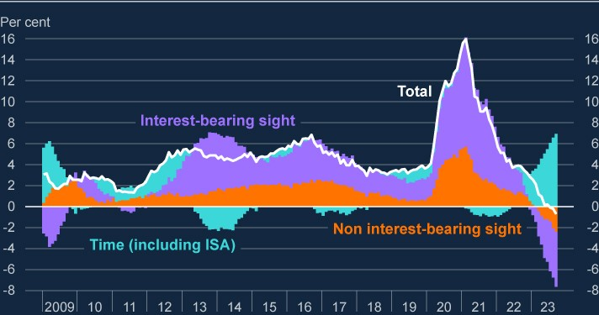

Sources: Bank of England and Bank staff calculations.

a) Data shown covers sterling deposits from UK households and private non-financial corporates. This

(

chart does not include non-sterling deposits held by UK financial institutions, sterling deposits held by

non-UK entities, or sterling deposits held by other UK financial corporations.

(

b) The 12-month growth rate is computed as aggregate changes over 12-month periods relative to the

amounts outstanding from the previous year. Data is not seasonally adjusted.

|  |
| --- |
| Consistent with the broader UK macroeconomic outlook, expectations for major UK banks’ lending volumes are positive but muted over the next few years, and so deposit growth is expected to remain subdued. In aggregate, lower credit growth (growth on the asset side of a bank’s balance sheet) and lower deposit growth (on the liabilities side of a bank’s balance sheet) should offset, leaving the aggregate funding position for banks broadly unchanged. However, individual banks may be affected differently within this aggregate picture.  **Some other trends may influence banks’ funding as central bank balance sheets normalise.**  The Bank of England has started to unwind the extraordinary measures put in place following the global financial crisis and to support economic activity during the Covid pandemic, in line with the approach set out by the MPC. Unwinding holdings in the Bank’s Asset Purchase Facility is likely, all else equal, to put downward pressure on the overall level of bank deposits in the system relative to the stock of lending, though there is some uncertainty around the exact impact.  Similarly, funding provided by the Bank as part of the Term Funding scheme with additional incentives for SMEs (TFSME) is coming to an end, and so some banks may seek replacement funding as they repay drawdowns. The TFSME was introduced as a temporary scheme designed to provide low-cost funding to incentivise the provision of credit to businesses and households to bridge through the period of economic disruption during the Covid pandemic. Banks have a number of options as TFSME funding matures. They could choose to repay the funding by reducing their stock of liquid assets, or to replace it with other forms of funding by competing for deposits, through more wholesale issuance, or through use of the Bank of England’s facilities.  The costs of deposit funding have increased over recent years as increases in Bank Rate have been passed on to customers and competition for term funding has increased. The average quoted rate on instant access deposit accounts is currently 2.8%, and the average quoted rate on a fixed-rate ISA with a one-year term is currently 5.3%. This compares to 0.1% and 0.5%, respectively, when Bank Rate was lower at the start of 2022. Consistent with |

|  |
| --- |
| these trends, deposits have moved between banks. Smaller banks in particular have offered higher rates on both sight and time deposits, and so have in aggregate attracted significant deposit inflows over the past year. This compares to major UK banks, which have in aggregate seen falls in their deposit holdings over the same period.  **Banks should factor these trends into their liquidity management and planning over the coming years.**  The stock of central bank reserves – which currently make up about 80% of sterling HQLA – remains very high but will reduce as central bank balance sheets return to more normal levels. All else equal this would put downward pressure on banks’ liquidity buffers, but banks have a number of options available to them to maintain their liquid assets above their target levels. These include obtaining other HQLA such as gilts, or using Bank of England’s facilities, which supply central bank reserves in exchange for a wide range of liquid and less liquid collateral. As such, while demand from the banking system for central bank reserves is likely to be some way below the current level of reserves, it is also likely to be materially higher at any given level of Bank Rate than it was before the financial crisis, given a range of developments over that period such as changes to funding markets and liquidity regulation. The level of reserves that will be demanded is highly uncertain, and will vary in response to financial and economic conditions.  Banks can also manage their liquidity resilience through changes in the mix of their funding. For instance, a further shift in deposit composition to longerterm deposits should improve the resilience of banks’ funding, or banks could choose to rely more heavily on longer-term funding (including some forms of wholesale funding), which would make managing liquidity positions easier.  These changes though would typically also increase banks’ funding costs.  **The FPC will continue to monitor trends in bank funding and liquidity.**  Taken together, these trends will affect sources of bank funding, and could affect their cost – for example, through continued competition for deposits, and greater use of some forms of wholesale funding. The impact on individual banks would depend on their funding structure and business models. |

|  |
| --- |
| Banks will need to monitor their liquidity positions closely and should factor these system-wide trends into their liquidity management over the coming years. Banks have a range of ways in which they can continue to adjust to these changes over time, including through choices around their funding and liquid asset mix, as well as through the nature, quantity, and pricing of lending they undertake. The FPC will monitor the implications of trends in banks’ funding and liquidity for financial stability.  Banks’ management of their liquidity positions will also be influenced by lessons from the stress experienced by some parts of the global banking system in early 2023. In particular, the experience illustrated the speed at which liquidity outflows can take place and the importance of being able to monetise liquidity buffers in a stress. In this context, maintaining collateral pre-positioned in central bank facilities is an important source of resilience for banks that experience short-term liquidity stress. Bank staff are contributing to the relevant international work to consider whether lessons can be learnt for the bank liquidity framework.  Over the medium term, new forms of digital money could also influence banking system liquidity. The Bank of England has recently issued a [**discussion paper**](https://www.bankofengland.co.uk/paper/2023/dp/regulatory-regime-for-systemic-payment-systems-using-stablecoins-and-related-service-providers#:~:text=This%20discussion%20paper%20sets%20out,be%20used%20widely%20for%20payments.) setting out its proposed regulatory framework for systemic  payment systems using stablecoins. It was published alongside a [**discussion paper**](https://www.fca.org.uk/publications/discussion-papers/dp23-4-regulating-cryptoassets-phase-1-stablecoins) from the FCA on their regulatory approach to stablecoin  issuers, custodians and payment arrangers, and a [**letter**](https://www.bankofengland.co.uk/prudential-regulation/letter/2023/innovations-in-the-use-of-deposits-emoney-and-regulated-stablecoins) from the PRA to  bank chief executive officers on innovations in the use by banks of deposits, e-money and stablecoins (see Box A). Earlier this year, the Bank and HM Treasury issued a [**consultation paper**](https://www.bankofengland.co.uk/paper/2023/the-digital-pound-consultation-paper) on the case for a retail central bank  digital currency. The UK authorities have been considering the policy design choices accompanying those new forms of digital money, and this has included how to mitigate financial stability risks arising from the potential for a greater proportion of deposits to be withdrawn from a banking system in a stress. |

# 5: The resilience of market-based finance

|  |
| --- |
| Vulnerabilities in certain parts of the system of market-based finance (MBF) remain significant. MBF has so far been broadly resilient to the higher interest rate environment. However, there remains a risk that these vulnerabilities crystallise in the context of elevated and volatile interest rates, which would amplify any tightening in financial conditions.  As such, there continues to be an urgent need to increase resilience in  MBF globally. Alongside international policy work led by the Financial Stability Board (FSB), the UK authorities are working to reduce vulnerabilities domestically where this is effective and practical.  The FPC welcomes the proposals currently under consultation to increase the resilience of UK-based money market funds (MMFs). It is important that this is complemented by further work internationally to build resilience across jurisdictions.  Following the gilt market stress in autumn 2022, in March 2023 the FPC recommended a minimum resilience standard for liability-driven investment (LDI) funds. This has been functioning broadly as intended in a higher interest rate environment, although there remain some areas for improvement for some funds to implement the relevant guidance fully.  The system-wide exploratory scenario (SWES) exercise will improve understanding of the behaviours of non-bank financial institutions (NBFIs) and banks in stressed market conditions. The scenario underpinning the SWES was published in November 2023. |

## 5.1: The FPC’s approach to assessing risks from marketbased finance and building resilience

**MBF plays a key role in the provision of credit to the real economy, so it is important that vulnerabilities in it are identified and addressed.**

MBF is the system of markets, NBFIs and infrastructure which, alongside banks, provides financial services to support the wider economy. NBFIs such as investment funds and insurers are connected to each other and other parts of the financial system, including banks. They have come to play an increasingly central role in the UK financial system, now accounting for around half of total financial sector assets and responsible for more than half of the lending to UK corporates. This has diversified the supply of finance for UK businesses. But it also makes it important that MBF is resilient enough to absorb, and not amplify, financial and economic shocks, so that it can continue to support the provision of financial services to UK households and businesses. Policy measures to improve resilience can help reduce the likelihood that vulnerabilities in MBF cause wider disruption, and also reduce the impact of such disruption if it occurs.

**The FPC** [**recently set out**](https://www.bankofengland.co.uk/financial-stability-in-focus/2023/october-2023) **its approach to identifying and assessing risks**

**associated with MBF, building resilience, and responding when disruption occurs.**

In particular, it detailed the types of vulnerabilities that the FPC considers (see Figure 5.1). ‘Microfinancial’ vulnerabilities relate to particular NBFI business models that can make individual firms vulnerable to shocks. For example, liquidity mismatch – where a firm’s assets are less liquid than its liabilities – is a type of vulnerability inherent in some business models, which can amplify shocks to the demand for liquidity. This type of vulnerability can interact with ‘macrofinancial’ vulnerabilities, which relate to market structure and the collective behaviour of firms. An example of this type of vulnerability is correlated positions, which can mean a whole sector has similar strategies and therefore acts in the same way during stress, thus amplifying it. Vulnerabilities can be of concern from a financial stability perspective if they have the capacity to adversely impact systemic markets, [12] institutions or the provision of vital services.

**Figure 5.1: How vulnerabilities in MBF can affect financial stability**

Vulnerabilities in MBF and transmission channels to financial stability

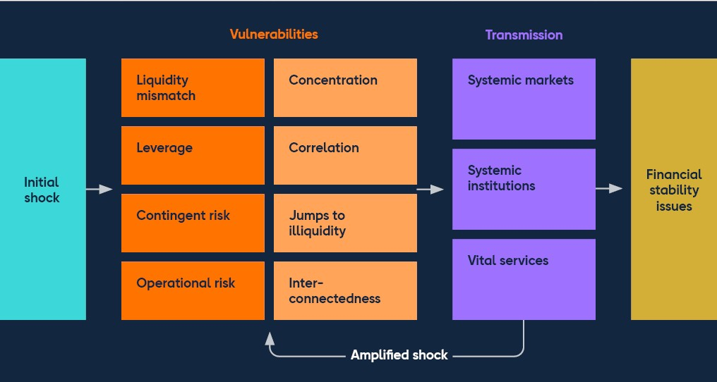

## 5.2: Developments in vulnerabilities in market-based finance

Using the analytical framework above, the FPC has previously identified several vulnerabilities in the system of MBF, which remain significant. These include:

liquidity mismatch in MMFs and open-ended funds (OEFs);

leverage in NBFIs, for example in LDI funds and the US Treasury cash-futures basis trade;

liquidity demands from margin calls in times of stress; and the capacity of markets to intermediate in stress, so-called jump-to-illiquidity risk.

These vulnerabilities could crystallise in the context of the current environment of elevated and volatile interest rates, amplifying any tightening in financial conditions. That said, MBF has so far been broadly resilient to recent market volatility and higher interest rates.

**OEFs for riskier corporate credit, such as high-yield bonds and leveraged loans, have seen investor outflows over the past two years. These have so far been orderly.**

Liquidity mismatches can arise when assets are less liquid than longer-dated liabilities, as is the case for many OEFs. This liquidity mismatch creates a risk of investor outflows overwhelming their capacity to liquidate assets in an orderly manner, without forced selling.

OEFs for riskier corporate credit, such as high-yield bonds and leveraged loans, have seen investor outflows over the past two years. For example, sterling highyield bond funds have seen outflows of around 10% of assets under management since January 2022. These outflows have so far been orderly. See Box B for further discussion of high-yield bonds and leveraged loans.

Open-ended property funds invest in illiquid commercial real estate (CRE) assets while offering much shorter-term redemptions. They remain challenged by the headwinds facing the CRE market, and some have suspended redemptions due to the level of outflows. Suspensions or redemption deferrals are used by funds to limit the risk of outflows triggering forced selling, but these tools can have the potential adverse effect of worsening market sentiment, hence triggering further redemptions or sales. So far these developments have not spilled over to the wider CRE market.

As set out in the July FSR, OEFs comprise only a small proportion of the total investor base in UK CRE, which limits the market impact that their asset disposals might have.

**A sharp investor reappraisal of credit risk among highly leveraged corporates could crystallise vulnerabilities in the system of MBF and have implications for the real economy.**

The opacity and the lack of frequent re-pricing of private credit assets increases their vulnerability to sharp and correlated falls in value. And given the common features of private credit and leveraged loans – such as the floating rate nature of the lending and links to private equity activity – there is a risk of correlated stresses in these and other interconnected markets, such as private equity. Fire selling and reductions in risk appetite could be amplified by NBFIs with liquidity mismatches and leveraged positions. See Box B for further discussion of this topic.

**Hedge fund net short positioning in US Treasury futures has recently increased, as asset manager net long positions have continued to grow…** As an alternative to investing directly in US Treasury bonds, asset managers can gain similar exposures via futures contracts linked to the underlying bonds. The synthetic leverage provided by futures requires less initial cash outlay, freeing up resources for other purposes, such as meeting redemptions or investing in higher yielding assets. This demand for futures pushes up their prices relative to the prices of corresponding cash bonds. The ‘cash-futures basis trade’ exploits these price differences. In normal market conditions, the basis trade plays a useful role by intermediating between different types of market participants, helping to keep the cash and futures markets broadly aligned, thus improving market liquidity and efficiency.

This intermediation can, however, amplify market stress. To boost returns, hedge funds tend to use significant amounts of leverage, supported by short-term borrowing in the repo market. And relatively low initial margin requirements for the futures contracts enable potentially high degrees of leverage. Sharp increases in volatility in market interest rates could lead to increases in margin required on the futures positions, or hedge funds may find it harder to refinance their borrowing in the repo market. This, combined with any breaches of risk- or loss-limits, could force funds rapidly to unwind their positions (as seen in the March 2020 ‘dash for cash’ episode), which could amplify the market volatility. Since the July FSR, hedge funds’ net short positioning in US Treasury futures has increased further, from around US$650 billion to around US$800 billion (Chart 5.1), now exceeding in nominal terms its size prior to the 2020 market stress. This trend has, as expected, largely mirrored asset managers’ increased net long positioning.

**Chart 5.1: Hedge fund net short positioning in US Treasury futures has**

**recently increased further, as asset manager net long positions have**

**continued to grow**

Aggregate net positioning across US Treasury futures

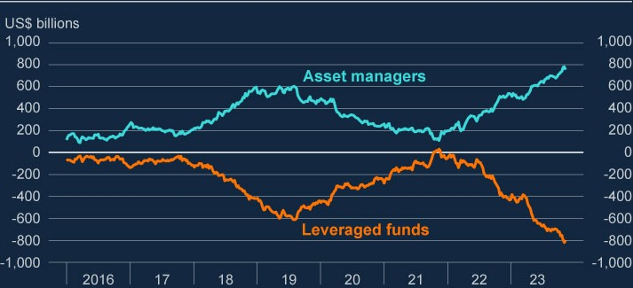

Sources: CFTC data and Bank calculations.

**…and although the recent volatility in rates has not crystallised financial stability risks, vulnerabilities associated with it remain.**

Structural changes could have mitigated some of the vulnerabilities associated with the trade since 2020. Higher initial margin requirements on Treasury futures, in response to increased market volatility, have had the effect of reducing the effective (synthetic) leverage available to market participants, since more cash is required upfront for a given level of exposure. For example, the [**BIS**](https://www.bis.org/publ/qtrpdf/r_qt2309w.htm) estimates that allowed

leverage, defined as the contract price divided by initial margin, in five-year Treasury futures remains elevated but has fallen from around 175x prior to the pandemic to around to 70x. Nonetheless it remains an important vulnerability which continues to be monitored by the FPC. There are potential spillover risks to the UK. These could be via the participation of the same hedge funds in both US Treasury and gilt markets, and also more indirectly via disruption to the systemically important US Treasury market.

The FPC routinely monitors hedge fund activity in core UK markets,[13] although there is no direct read-across of this trade to the UK gilt market, due to structural differences. For example, asset managers are more likely to use repo borrowing and swaps directly to gain leveraged exposure to interest rates.

## 5.3: Improving the resilience of market-based finance

Given the potential for vulnerabilities in MBF to pose risks to UK financial stability, the FPC seeks to build resilience in MBF in order to address them. The high degree of interconnectedness in MBF, including across borders, means that risks are most effectively addressed through internationally co-ordinated reforms. The FPC also works to reduce vulnerabilities domestically where this is effective and practical. See Table 5.A for an overview of progress in building resilience against key vulnerabilities in MBF.

**Liquidity mismatch in MMFs has been identified as an important vulnerability and is a continued area of focus for the FPC.**

The FPC judged [**in March 2023**](https://www.bankofengland.co.uk/financial-policy-summary-and-record/2023/march-2023) that MMFs holding more liquid assets would

reduce financial stability risks associated with rapid investor redemptions. And Bank staff analysis suggests that around 50%–60% of total assets falling within the shorter-maturity ‘weekly liquid assets’ category would give sterling-denominated MMFs a high level of resilience to severe but plausible stress events. This analysis is based on the levels of investor redemptions seen during both the 2020 dash for cash and the 2022 gilt market stress.

The FPC welcomes the [**proposals currently under consultation**](https://www.fca.org.uk/publications/consultation-papers/cp23-28-updating-regime-money-market-funds) to increase the

resilience of UK-based MMFs, including increasing daily and weekly liquidity requirements to 15% and 50% respectively.

Many MMFs operate cross-border, and indeed around 90% of total sterling MMF assets are domiciled in the EU and hence are not subject to UK regulation and Financial Conduct Authority (FCA) supervision. It is therefore important that domestic policy work is complemented by work across jurisdictions, and in particular that relevant measures set out by the FSB to enhance MMF resilience are implemented by member jurisdictions. This will help to ensure an adequate level of resilience and mitigate the potential risks from cross-border spillovers and regulatory arbitrage. The forthcoming stocktake by the FSB should help highlight progress made to date and areas where further work is required, ahead of a fuller assessment in 2026.

**Against a backdrop of rising long-term interest rates, LDI funds have maintained their resilience to further rates shocks in accordance with FPC Recommendations.**

LDI is an investment approach used by defined-benefit (DB) pension schemes to help ensure that the value of their assets (ie their investments) moves more in line with the value of their liabilities (ie the pensions they have promised to pay in the future). Following the gilt market stress in autumn 2022, in March 2023 the FPC judged that LDI funds should be resilient to a shock to the gilt yield curve of 250 basis points, at a minimum. This is additional to maintaining sufficient resilience to manage other risks and day-to-day movements in yields.

This resilience framework for LDI funds has been functioning broadly as intended in an environment of higher market interest rates. Long-dated gilt prices fell significantly over the first half of 2023, pushing up yields, and they have continued to display volatility since the July FSR (Section 1). Other things equal, falling gilt prices can reduce the resilience of LDI funds to further shocks as they result in margin and collateral calls and reduce the net asset value of the fund. Meeting these calls and rebalancing their portfolios may require additional capital to be injected by individual or groups of investor pension schemes. LDI funds in aggregate have maintained their resilience above the 250 basis point resilience standard by recapitalising in response to falling gilt prices (Chart 5.2). While resilience levels vary across funds, on average levered fixed and real pooled funds are resilient to an almost 400 basis point increase in yields.

**Chart 5.2: While long-term gilt yields have risen, LDI funds have maintained**

**sufficient resilience to shocks**

Median basis points move in gilt yields that would cause leveraged UK pooled LDI funds

to default and yields on 30-year gilts

(

**a**

)

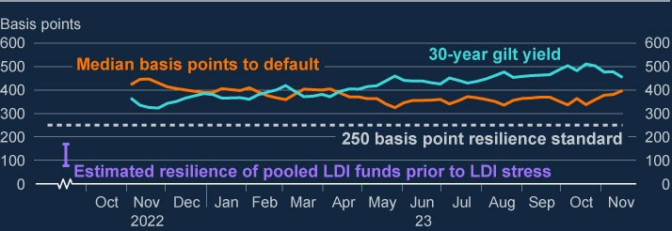

Sources: Bloomberg Finance L.P., FCA supervisory data and Bank calculations.

(a) The 250 basis point minimum resilience refers to the FPC’s Recommendation in March 2023 that that LDI funds should be resilient to stresses that account for both historical volatility in gilt yields, and the potential for their forced sales to amplify market stress and disrupt gilt market functioning. The FPC judged that these factors imply that LDI funds should be resilient to a yield shock of around 250 basis points, at a minimum, in addition to the resilience required to manage other risks and day-to-day movements in yields. Estimated resilience is based on supervisory data.

While LDI funds are resilient in aggregate, there remain some areas for improvement for some funds to implement the relevant guidance fully. Some LDI managers’ recapitalisation in response to falling gilt prices has been slower than the expected five days. Funds must also ensure that their management buffers and triggers take into account the length of time they need to recapitalise. It is therefore important that the work to put in place a monitoring and enforcement framework for pooled funds by the FCA and relevant international regulators continues.

While rising interest rates can require DB pension schemes to recapitalise LDI funds they may be invested in, as set out above, they nonetheless have the effect of improving the financial position of the pension schemes. This is because higher rates reduce the present value of a scheme’s future liabilities (ie payments to pensioners) relative to its assets. As a result of this dynamic, the funding position of DB pension schemes has improved considerably since interest rates began to rise, from being in deficit to being in surplus in aggregate.[14]

**The forthcoming SWES exercise will aid the FPC’s understanding of how market-based finance behaves as an interconnected system.**

An important aspect of the FPC implementing the framework in Figure 5.1 is developing a system-wide view that covers the interconnections between parts of the system of MBF, links from MBF to other parts of the financial system, and the response of the system as a whole to shocks (see [**Kroszner (2023)**](https://www.bankofengland.co.uk/speech/2023/november/randall-kroszner-keynote-speech-at-the-reserve-bank-of-clevelands-2023-fs-conference)). The SWES

exercise will provide the FPC with new information about the behaviours of nonbank financial institutions and banks during stressed financial market conditions, and how those behaviours might interact to amplify shocks to UK financial markets that are core to UK financial stability. It will do so by testing the ability of market participants to anticipate liquidity demands in stresses, their strategies for meeting those demands, the impact of leverage in amplifying liquidity imbalances during periods of market stress, and whether participating sectors’ expectations of one another in periods of stress would be met. See Box E for more discussion of the recently published scenario underpinning the SWES exercise.

**The Bank is working to expand its toolkit to backstop market functioning in core sterling markets to support financial stability in exceptional circumstances.**

The priority of the FPC and authorities internationally is for individual market participants, and their regulators, to maintain appropriate resilience standards that allow the system of MBF to absorb and not amplify severe but plausible shocks that could threaten financial stability. But it is not feasible for MBF to maintain a level of resilience that would insure against all of the most extreme system-wide liquidity stresses. In such circumstances of system-wide stress, where reasonable levels of resilience in the market are likely to be exhausted, central bank tools can support financial stability by providing backstop liquidity.

The Bank is working to develop the tools to enable it to intervene where liquidityrelated dysfunction in core sterling markets threatens financial stability (see [**Ramsden (2023)**](https://www.bankofengland.co.uk/speech/2023/november/dave-ramsden-remarks-at-the-7th-annual-conference-of-the-european-systemic-risk-board) and [**Hauser (2023)**](https://www.bankofengland.co.uk/speech/2023/september/andrew-hauser-speech-at-market-news-international-connect-event)). In system-wide stress scenarios where

NBFIs are seeking temporary liquidity, it is preferable to backstop market functioning by lending directly to NBFIs against high quality collateral, rather than with asset purchases. This presents less risk to public funds and to the stance of monetary policy, and less potential moral hazard. However, in some stress scenarios, such as where system-wide stress is driven by NBFIs’ need to reduce exposures or deleverage, it may instead be appropriate to use temporary and targeted asset purchases. For example, during the Autumn 2022 stress in longdated gilt markets, which involved fire selling by some NBFIs, no parties were able or willing to borrow from the Bank at sufficient speed to stop the fire-sale dynamic. On that basis, the Bank launched a targeted programme of asset purchases, which was fully unwound by January 2023 after the stress had abated.

The FPC considers that resilience standards for MBF should be developed in coordination with work to enhance central bank tools to respond in stress. This should ensure that public backstops do not substitute for a failure to achieve the appropriate level of private insurance.

**Overall, the underlying vulnerabilities in the system of MBF, identified by the FPC and other financial stability authorities internationally, remain largely unaddressed. Absent actions to mitigate them, they could amplify any future shocks.**

Table 5.A summarises the current status of policy initiatives to address identified key vulnerabilities in MBF domestically and internationally. The FPC continues strongly to support the FSB’s international work programme to increase the resilience of MBF.

**Table 5.A: Overview of progress on building resilience against key vulnerabilities in MBF**

|  |
| --- |
| **Vulnerability Financial stability implications Policy recommendations and next steps** |
| **Maturity mismatch** arises when assets are less liquid or longer dated than liabilities. |
| **Money market** MMFs are used by UK corporates, investment In order to be sufficiently resilient, **funds (MMFs)** funds, and other NBFIs as a way of managing sterling MMFs should be able to  cash balances. Investors hold £260 billion in withstand severe but plausible levels of sterling-denominated MMFs. outflows, without triggering runs or  contagion that would create risks to  Liquidity mismatch between the redemption  financial stability. terms and the liquidity of some of their assets makes MMFs vulnerable to sharp redemptions The FSB has agreed an [**international**](https://www.fsb.org/2021/10/policy-proposals-to-enhance-money-market-fund-resilience-final-report/) from investors in stress and so risks both runs [**approach to MMFs**,](https://www.fsb.org/2021/10/policy-proposals-to-enhance-money-market-fund-resilience-final-report/) suggesting a and contagion across the sector. This could range of measures such as higher amplify shocks, impact financial stability if liquid asset requirements or liquidity investors cannot access cash, and lead to management toolsto be implemented tighter financial conditions for the economy. by national authorities globally. The FSB is due to publish a stocktake of progress in December 2023.  UK authorities have launched a [**consultation paper on enhancing MMF resilience measures**,](https://www.fca.org.uk/publications/consultation-papers/cp23-28-updating-regime-money-market-funds) including increasing daily and weekly liquidity requirements to 15% and 50% respectively. |

|  |
| --- |
| **Vulnerability Financial stability implications Policy recommendations and next steps** |
| **Open-ended** Globally, the assets under management of In order to be sufficiently resilient, **funds (OEFs)** OEFs primarily investing in UK equities, redemption terms in OEFs should be  sterling government bonds and sterling more closely aligned with the corporate bonds and UK property total £210 underlying liquidity of funds’ assets. In billion, £38 billion, £90 billion and £8 billion 2023, the FCA [**published findings**](https://www.fca.org.uk/publications/multi-firm-reviews/liquidity-management-multi-firm-review)  respectively as of October 2023. and [**wrote to asset manager CEOs**](https://www.fca.org.uk/publication/correspondence/dear-ceo-letter-liquidity-management-multi-firm-review.pdf) on liquidity management frameworks.  Some OEFs offer daily redemptions while holding less liquid assets. This means in The FSB published a [**consultation**](https://www.fsb.org/2023/07/addressing-structural-vulnerabilities-from-liquidity-mismatch-in-open-ended-funds-revisions-to-the-fsbs-2017-policy-recommendations-consultation-report/)  stress, there is an incentive for investors to [**paper**](https://www.fsb.org/2023/07/addressing-structural-vulnerabilities-from-liquidity-mismatch-in-open-ended-funds-revisions-to-the-fsbs-2017-policy-recommendations-consultation-report/) in July seeking to better align  [**redeem ahead of others, or for funds to**](https://www.bankofengland.co.uk/report/2021/assessing-the-resilience-of-market-based-finance)funds’ redemption terms with the [**struggle to meet redemption demands**](https://www.bankofengland.co.uk/report/2021/assessing-the-resilience-of-market-based-finance)underlying liquidity of their assets. [**without fire selling assets, leading to**](https://www.bankofengland.co.uk/report/2021/assessing-the-resilience-of-market-based-finance)[**IOSCO has also consulted**](https://www.iosco.org/library/pubdocs/pdf/IOSCOPD739.pdf) on  [**contagion across markets**.](https://www.bankofengland.co.uk/report/2021/assessing-the-resilience-of-market-based-finance) implementing anti-dilution tools to  complement this approach. FSB and IOSCO are due to finalise their recommendations by the end of 2023 for individual jurisdictions to implement. |
| **Leverage** involves a firm increasing its exposure to a risk factor beyond what would be possible through a direct investment of its own funds. |

|  |  |
| --- | --- |
| **Vulnerability** | **Financial stability implications Policy recommendations and next steps** |
| **Non-bank leverage** | Leverage creates counterparty risks and can More comprehensive and consistent lead to sudden spikes in demand for liquidity – monitoring by authorities is needed to either to support the financing of leveraged mitigate the financial stability risks from positions, or as de-leveraging leads to forced non-bank leverage and ensure it is sales, which in turn could amplify shocks and appropriately managed (see lead to market dysfunction and a potential [**November 2018 FSR**](https://www.bankofengland.co.uk/financial-stability-report/2018/november-2018)).  tightening in financial conditions for households  The PRA has published Dear CEO and businesses. While estimating leverage is letters reviewing [**global equity**](https://www.bankofengland.co.uk/prudential-regulation/publication/2021/december/supervisory-review-global-equity-finance-businesses) very difficult, the notional amount of non-bank [**finance businesses**](https://www.bankofengland.co.uk/prudential-regulation/publication/2021/december/supervisory-review-global-equity-finance-businesses) (2021) and [**fixed**](https://www.bankofengland.co.uk/prudential-regulation/letter/2023/fixed-income-financing-thematic-review) investors’ OTC derivatives is estimated at [**income financing businesses**](https://www.bankofengland.co.uk/prudential-regulation/letter/2023/fixed-income-financing-thematic-review) (2023) almost US$90 trillion in 2022, and global NBFI including recommendations for firms to financial debt is estimated at approximately review their internal risk cultures. The US$48 trillion, or 50% of global GDP.  PRA will follow up on firms’ remediation plans via ordinary supervisory channels.  The [**FSB has recently published**](https://www.fsb.org/2023/09/the-financial-stability-implications-of-leverage-in-non-bank-financial-intermediation/) a  report on NBFI leverage. In 2024, it plans work to enhance monitoring, close data gaps and to consider the wider set of policy measures to contain leverage outlined in that report. |

|  |  |
| --- | --- |
| **Vulnerability** | **Financial stability implications Policy recommendations and next steps** |
| **Liabilitydriven investment**  **(LDI)** | LDI funds’ use of leverage makes them In March 2023, the FPC set out vulnerable to gilt yield shocks which, in the [**recommendations on steady-state**](https://www.bankofengland.co.uk/financial-policy-summary-and-record/2023/bank-staff-paper-ldi-minimum-resilience) absence of recapitalisation, can trigger fire sale [**minimum levels of resilience for LDI**](https://www.bankofengland.co.uk/financial-policy-summary-and-record/2023/bank-staff-paper-ldi-minimum-resilience) dynamics and amplify shocks, as seen during [**funds**](https://www.bankofengland.co.uk/financial-policy-summary-and-record/2023/bank-staff-paper-ldi-minimum-resilience) to ensure that they can absorb a the September 2022 gilt market stress. This severe but plausible historical stress, risked further market dysfunction and an over the period of time needed to excessive tightening of financing conditions to recapitalise the fund, without the need UK households and businesses. The total for forced asset sales.  volume of UK Defined Benefit scheme liabilities  The FPC Recommendations have hedged via LDI products is over £700 billion.  been reflected in [**TPR**](https://www.thepensionsregulator.gov.uk/en/document-library/scheme-management-detailed-guidance/funding-and-investment-detailed-guidance/liability-driven-investment) and [**FCA**](https://www.fca.org.uk/publications/multi-firm-reviews/further-guidance-enhancing-resilience-liability-driven-investment)  guidance to firms.  [**The resilience framework for LDI has been functioning as intended**](https://www.bankofengland.co.uk/financial-policy-summary-and-record/2023/october-2023) in a higher interest rate environment, although there remain some areas for further improvement. Work is underway to put in place a monitoring and enforcement framework for pooled funds by the FCA and relevant international regulators. |

|  |  |
| --- | --- |
| **Vulnerability** | **Financial stability implications Policy recommendations and next steps** |
| **Margin calls** | Margin can increase rapidly in stress to match There is a need to strengthen market the increase in expected losses and risks. This participants’ preparedness to meet ensures that counterparty risk is properly margin calls, as identified by a [**joint**](https://www.bis.org/bcbs/publ/d537.htm) mitigated but requires counterparties to find [**BCBS-CPMI-IOSCO report on**](https://www.bis.org/bcbs/publ/d537.htm) additional liquid assets at a time when it is [**margin practices.**](https://www.bis.org/bcbs/publ/d537.htm)  more difficult for them to do so.  Further policy work is ongoing to Increases in margin that are unpredictable or improve initial and variation margining unexpectedly large can cause liquidity strains practices, to both limit the potential on market participants and the financial impacts of margin procyclicality, and system. For example, during the March 2020 better prepare market participants for ‘dash for cash’, initial margin requirements at jumps in margin requirements.  UK central counterparties (CCPs) grew by Standard-setting bodies are developing around £58 billion, with a maximum daily recommendations and best practice increase of £10 billion; and average daily guidance across cleared and nonvariation margin calls were five times higher cleared markets.  than in January and February 2020.  The FSB has committed to issuing policy recommendations for consultation in 2024 on the liquidity preparedness of market participants for margin and collateral calls. |

|  |
| --- |
| Box E: The system-wide exploratory scenario  **The Bank of England has begun the scenario phase of the systemwide exploratory scenario exercise.**  In June 2023 the Bank of England [**launched**](https://www.bankofengland.co.uk/financial-stability/boe-system-wide-exploratory-scenario-exercise) the system-wide exploratory  scenario (SWES) exercise. The SWES will provide the FPC with new information about the behaviours of non-bank financial institutions and banks during stressed financial market conditions, and how those behaviours might interact to amplify shocks to UK financial markets that are core to UK financial stability. There are more than 50 participants in the SWES including banks, insurers, central counterparties, funds managed by asset managers, hedge funds and pension funds, and the Bank is working closely with the Financial Conduct Authority, The Pensions Regulator, and other domestic and international regulators.  [**The next phase of the SWES**](https://www.bankofengland.co.uk/financial-stability/boe-system-wide-exploratory-scenario-exercise/launch-of-the-scenario-phase-of-swes) was launched in November. Participating  firms have been asked to model the impact of a hypothetical scenario on their businesses and to consider the actions they would take in response. This box summarises the most important features of that hypothetical scenario. The scenario is not a forecast by the Bank, nor does it represent the Bank’s expectations of the consequences for financial markets of such a set of shocks. The SWES will allow the Bank to explore the impact of this set of shocks on a range of market participants.  **The aggregate shock in the SWES is faster, wider ranging, and more persistent than those observed in recent events in financial markets.**  Chart A summarises the key shocks included in the scenario, which unfolds over 10 business days. It shows how the scenario incorporates elements from recent events in financial markets. For example, shocks to yields on 10year gilts are roughly 90% as great as those observed during the  September/October 2022 liability-driven investment (LDI) episode, while the shock to sterling investment-grade corporate bond spreads is comparable to the March 2020 dash for cash. The scenario also includes global shocks, such as a shock to yields on 10-year US Treasury notes that is comparable |

to the largest observed shock since 2001. As well as directional moves in

financial markets, the scenario shocks the relative basis between selected

financial instruments. This includes the basis between government bonds

and futures, which is relevant to some funds employing relative value

strategies.

The aggregate shock is more severe and wide ranging than either the dash

for cash or the LDI episodes. It is also sharper overall than the shocks in

those episodes, with large price moves taking place early in the 10-day

**Chart A: The SWES hypothetical scenario combines shocks to rates**

**and risky asset prices**

Comparison of 10-day moves in selected SWES variables against the largest

observed since 2001, and those observed during the dash for cash and LDI

episode

(

**a**

(

)

**b**

)

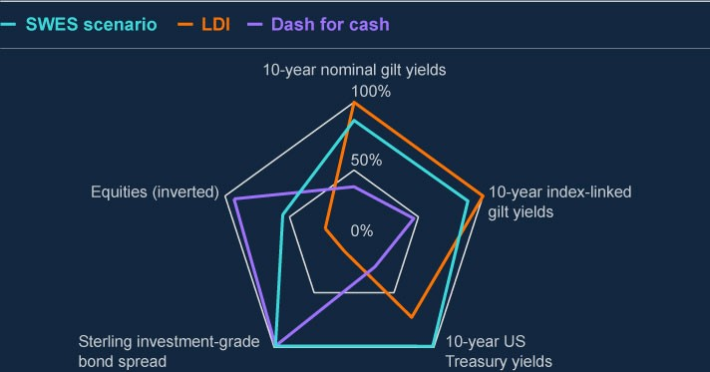

Sources: Bank of England, Bloomberg Finance L.P, Board of Governors of the Federal Reserve

System (US), Refinitiv Eikon from London Stock Exchange Group and Bank calculations.

(

a) The gilt yield, US Treasury yield, corporate bond, and equity back data start from 1 January

2000.

(

b) The increase in yields on US Treasuries is similar to that applied to all non-UK advanced economy

government debt of similar maturity. This chart displays yields on 10-year US Treasury notes for

indicative purposes.

scenario. For instance, the Day 1 increase in yields on 10-year nominal gilts

is greater than seen in any recent stress period (Chart B).

Alongside price paths, the Bank also provided SWES participants with a

narrative explaining the catalyst for the scenario and its consequences for

financial markets. These include expectations of longer-term shocks to

economic fundamentals and the failure of a mid-sized hedge fund due to the

stress, which increases counterparty credit concerns in markets. The

narrative document also emphasises the high levels of uncertainty

participants would face in the scenario. These elements should help ensure

SWES participants’ responses are realistic given a context of heightened and

protracted uncertainty that is difficult to quantify in short-term price paths.

This uncertainty relates not only to market rates and counterparty concerns,

but also to operational frictions and constraints.

**Chart B: Day 1 moves in some asset prices are roughly in line with, or**

**more severe than, the largest one day moves observed historically**

Day 1 moves of selected SWES variables compared to the largest historical

observations

(

**a**

)

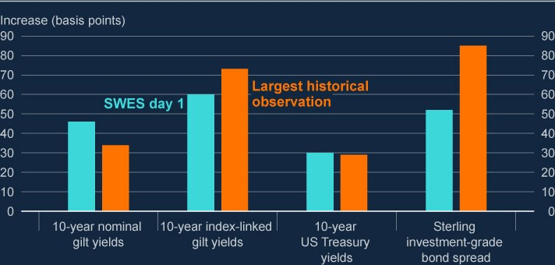

Sources: Bank of England, Bloomberg Finance L.P, Board of Governors of the Federal Reserve

System (US) and Bank calculations.

(

a) The gilt yield, US Treasury yield, corporate bond, and equity back data start from 1 January

2000.

|  |
| --- |
| **The Bank will publish findings from the SWES by the end of 2024.**  In January 2024, SWES participants will submit estimates of how the scenario would affect their businesses, and their expectations about what actions they would take in response.  The Bank will analyse participants’ submissions to assess the collective impact of their expected actions on a number of core UK markets. This will inform the design of Round 2 of the scenario phase, which will consider the dynamic effects of SWES participants’ behaviours and their dependencies on each other. For example, during the stress, firms may take steps to limit their exposures to certain counterparties or reduce or exit positions in certain markets. Firms may additionally have mandates or internal limits that prevent them holding certain types of instruments, or that require them to maintain a certain balance between holdings; firms may have to act to maintain compliance with these during the stress. These actions could impact market prices for some assets, or place constraints on counterparties who expect a firm to provide a service which it is in fact unwilling or unable to provide in these circumstances. The Bank expects to run Round 2 later in 2024 and to publish a final report on the SWES by the end of 2024. Updates will also be provided in the Records of FPC meetings. |

# Annex: Macroprudential policy decisions

|  |
| --- |
| This annex lists any FPC Recommendations and Directions from previous periods that have been implemented or withdrawn since the [**July 2023**](https://www.bankofengland.co.uk/financial-stability-report/2023/july-2023)  [**Report**,](https://www.bankofengland.co.uk/financial-stability-report/2023/july-2023) as well as Recommendations and Directions that are currently  outstanding. It also includes those FPC policy decisions that have been implemented by rule changes and are therefore still in force. |

Each Recommendation or Direction has been given an identifier to ensure consistent referencing over time. For example, the identifier 17/Q2/1 refers to the first Recommendation made at the 2017 Q2 Committee meeting.

## Outstanding FPC Recommendations and Directions (as at the date of the FPC’s meeting on 21 November 2023)

On 23 March 2023, the FPC made the Recommendation (23/Q1/1) that:

The severe but plausible stresses to which liability-driven investment (LDI) funds should be resilient should account for historic volatility in gilt yields, and the potential for forced sales to amplify market stress and disrupt gilt market functioning. If LDI funds were not resilient to such a shock, their defensive actions could cause financial instability, tightening credit conditions for UK households and businesses. The FPC judged that these factors meant that the size of the yield shock to which LDI funds should be resilient should be, at a minimum, around 250 basis points.

Liquid assets held to ensure resilience in the event of such a shock should be unencumbered and immediately available. Fund managers should have scope to consider additional assets, which investors had authorised them to use to meet collateral demands. Managers should apply appropriate prudence in doing this, for example by applying suitable haircuts.

This minimum level of resilience should be maintained in normal times but could be drawn down on in stress. Minimum resilience around this level would ensure that funds could absorb a severe but plausible historical stress and still have a

remaining level of headroom necessary to operate during a period of recapitalisation. This approach was consistent with the regulatory approaches in place for some systemically important financial institutions, where their standards were designed to allow institutions to continue operating after withstanding a severe stress.

Funds should take into account the nature of their exposures, including duration, leverage, and concentration of holdings, and the liquidity, duration, and convexity of collateral, in modelling their resilience to yield moves.

Pension schemes using leveraged LDI should be expected to be able to deliver collateral to their LDI vehicles within five days. Funds and schemes unable to implement these operational standards should be required to be resilient to a larger shock, calibrated to their own operational timelines.

LDI funds should maintain additional resilience over and above the minimum to manage day-to-day volatility in yields and account for other risks they might face, including operational risks, in order to be able to maintain the minimum level of resilience in normal times. The amount of additional liquidity held should be calibrated by funds according to their own assessments of their exposures and operational capabilities and other regulatory requirements, as well as interest rate trends and levels of market volatility. While this additional liquidity was expected to vary between funds, when combined with the minimum resilience to yield shocks, overall resilience levels should be broadly consistent with those currently prevailing in current market conditions (ie 300–400 basis points). Liquid asset holdings might be safely reduced over time if fund managers were able to demonstrate increased resilience through operational improvements.

In addition, the FPC made the Recommendation (23/Q1/2) that:

The Pensions Regulator (TPR) takes action as soon as possible to mitigate financial stability risks by specifying the minimum levels of resilience for the LDI funds and LDI mandates in which pension scheme trustees may invest. To ensure that they were able in practice to do this, it was important that trustees had a simple mechanism for monitoring, and LDI funds disclosing, levels of resilience in dynamic markets.

TPR should have the ability to employ effective monitoring tools, and to enforce as appropriate in cases of non-compliance with this resilience level. The FPC asked TPR to report back on how it intended to implement the Recommendation.

TPR should have the remit to take into account financial stability considerations on a continuing basis. This might be achieved, for example, by including a requirement to have regard to financial stability in its objectives, which should be given equal weight alongside other factors to which TPR is required to have regard. The FPC noted that in order to achieve this, TPR would need appropriate capacity and capability.

## Other FPC policy decisions which remain in place

The following text sets out previous FPC decisions, which remain in force, on the setting of its policy tools. The calibration of these tools is kept under review.

### Countercyclical capital bu er rate

The FPC agreed to maintain the UK CCyB rate at 2% on 21 November 2023, unchanged from its 5 October 2023 Policy meeting. This rate is reviewed on a quarterly basis. The UK has also reciprocated a number of foreign CCyB rate decisions – for more details see [**The countercyclical capital buffer**](https://www.bankofengland.co.uk/financial-stability/the-countercyclical-capital-buffer). Under

Prudential Regulation Authority (PRA) rules, foreign CCyB rates applying from 2016 onwards will be automatically reciprocated up to 2.5%.

### Liability-driven investment funds

On 28 November 2022, the FPC recommended (22/Q4/1) that regulatory action be taken by TPR, in co-ordination with the Financial Conduct Authority (FCA) and overseas regulators, to ensure LDI funds remain resilient to the higher level of interest rates that they can now withstand and defined benefit pension scheme trustees and advisers ensure these levels were met in their LDI arrangements.

### Mortgage loan to income ratios

In June 2014, the FPC made the following Recommendation (14/Q2/2): The PRA and the FCA should ensure that mortgage lenders do not extend more than 15% of their total number of new residential mortgages at loan to income ratios at or greater than 4.5. This Recommendation applies to all lenders which extend residential mortgage lending in excess of £100 million per annum. The Recommendation should be implemented as soon as is practicable.

The PRA and the FCA have published their approaches to implementing this Recommendation: the PRA has issued a [**policy statement**](https://www.bankofengland.co.uk/prudential-regulation/publication/2014/implementing-the-fpcs-recommendation-on-loan-to-income-ratios-in-mortgage-lending), including rules, and the

FCA has issued [**general guidance**.](https://www.fca.org.uk/publications/finalised-guidance/fg17-2-fpc-recommendation-loan-income-ratios-mortgage-lending)

### Leverage ratio

In September 2021, the FPC finalised its review of the UK leverage ratio framework, and issued a Direction and Recommendation to implement the outcome of the review as set out in its [**October 2021 Record**](https://www.bankofengland.co.uk/financial-policy-summary-and-record/2021/october-2021).

In line with its statutory obligations, the FPC completed its annual review of its Direction to PRA. The FPC revoked its existing Direction to the PRA in relation to the leverage ratio regime, and issued a new Direction on the same terms as in September 2021 with the addition of discretion for the PRA to set additional conditions to the central bank claims exclusion.

The full text of the FPC’s new Direction to the PRA on the leverage ratio is set out in the Annex of the [**October 2022 Record**](https://www.bankofengland.co.uk/financial-policy-summary-and-record/2022/october-2022) (see Annex), together with the original

Recommendation (now implemented).

The PRA has [**published its approach**](https://www.bankofengland.co.uk/prudential-regulation/publication/2021/june/changes-to-the-uk-leverage-ratio-framework) to implementing this Direction and

Recommendation.

### Other FPC activities since the July 2023 Report

Other FPC activities since the July 2023 Report not included elsewhere in this Report are set out in the [**Financial Policy Summary and Record – October 2023**](https://www.bankofengland.co.uk/financial-policy-summary-and-record/2023/october-2023),

and [**Financial Policy Summary and Record – December 2023**](https://www.bankofengland.co.uk/financial-policy-summary-and-record/2023/december-2023). These include:

Agreeing, with the Prudential Regulation Committee (PRC), that the Bank would run a desk-based stress-test exercise in 2024 to support the FPC’s and PRA’s monitoring and assessment of the resilience of the UK banking system to potential downside risks.

Agreeing, with the PRC, not to extend participation in the 2025 concurrent stress-test exercise.

Welcoming the Bank’s [**discussion paper**](https://www.bankofengland.co.uk/paper/2023/dp/regulatory-regime-for-systemic-payment-systems-using-stablecoins-and-related-service-providers) exploring the proposed regulatory

model for stablecoins, and related publications from the FPC on the regime for non-systemic stablecoin issuers and custodians; the PRA on risks that arise for deposit-takers from innovations in new forms of digital money and money-like instruments; and HMT on the new regulatory regime for fiat-backed stablecoins.

Supporting work that the Bank was undertaking, in co-ordination with HMT, that sought to ensure that for small banks, which were not required to hold additional resources to meet the minimum requirement for own funds and eligible liabilities (MREL), there were resolution options that improved continuity of access to deposits and so outcomes for depositors.

Reviewing its Direction and Recommendation to the PRA over the leverage ratio. The FPC continued to consider a leverage ratio to be an essential part of the framework for capital requirements for the UK banking system, and judged that the aspects of the leverage ratio set out in the 2022 Direction remained appropriate.

Reviewing the O-SII buffer framework and deciding that no changes to the framework were necessary at this time.

Being briefed on the continued adoption of artificial intelligence (AI) and machine learning (ML) in financial services, and potential financial stability implications. The FPC would further consider the financial stability risks of AI and ML in 2024, and alongside other relevant authorities would seek to ensure that the UK financial system is resilient to risks that may arise from widespread adoption of AI and ML.

Welcoming the publication of the [**results**](https://www.bankofengland.co.uk/stress-testing/2023/2023-ccp-supervisory-stress-test-results-report) of the Bank’s second public

Supervisory Stress Test of UK central counterparties (CCPs), which confirmed the continued resilience of the three UK CCPs to stress scenarios that were of equal and greater severity than the worst-ever historical market stresses.

Welcoming the PRA’s [**consultation**](https://www.bankofengland.co.uk/prudential-regulation/publication/2023/november/funded-reinsurance-consultation-paper) paper on its expectations of UK life insurers

holding or entering into funded reinsurance arrangements in the bulk purchase annuities market, where there was a risk of creating a systemic vulnerability in the form of a large concentrated exposure to correlated, credit-focused counterparties.

Noting it would respond to the Chancellor’s letter setting out the economic policy of His Majesty’s Government and Treasury’s Recommendations under Sections 9D-9E of the Bank of England Act 1998 in due course.