Recursive Reasoner: A Multi-Agent System for Second-Order Financial Analysis

Project Summary

Wong Tsz Hei Charlie
57141182

Aim
1. Solving the "Second Order" Analysis Gap
Most investors only use simple AI tools to react to direct news (e.g., "Nvidia stock rose because they launched a chip"). My aim is to bridge the "Reasoning Gap".

Goal: To develop a Recursive Multi-Agent System that identifies second-order market beneficiaries through automated supply-chain reasoning.
(e.g., AI boom More users use chatbots services energy consumption increases beneficial for energy companies that provide 24/7 energy sources)

2. Mitigating Information Overload with Watchdogs
In a 24/7 market, significant market moves (sudden rise/drop) often occur without immediate news, leading to "panic selling" or "FOMO buying".

Goal: To implement an Event-Driven Anomaly Detection system that automatically triggers deep-dive RAG analysis during periods of high volatility, providing users with instant "Explainable Alpha".

3. Enhancing AI Reliability in High-Stakes Finance
AI hallucinations are a critical barrier to using LLMs for stock trading.

Goal: To create a Self-Correcting Agentic Workflow using LangGraph and RAG. This system will validate its own logic against factual historical data stored in a Vector Database to ensure 100% factual grounding for all investment advice.
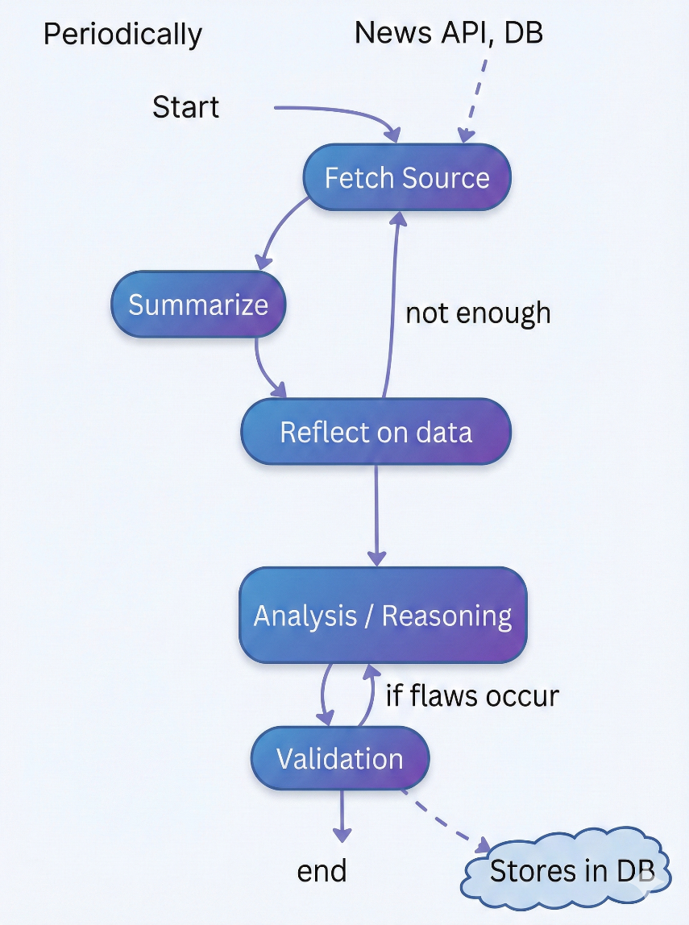
High-level LangGraph workflow

Start Periodically (e.g. Weekly): Sets the context of users interested areas.
Fetch Source (RAG/News API): Use an agent to decide which tools to call (News API vs. SEC Filings).
Summarize: Condenses raw data into actionable insights for the next agent.
Reflect on Data: Checks for "Information Sufficiency." If data is missing, it triggers a "Re-query".
Analysis: Decomposes the task into sub-steps (e.g., Second-Order logic).
Validation: A separate agent (the "Critic") looks for logical flaws or numerical errors.
Stores all the analysis into DB for further analysis.
Generates a news report on of users interested areas periodically.
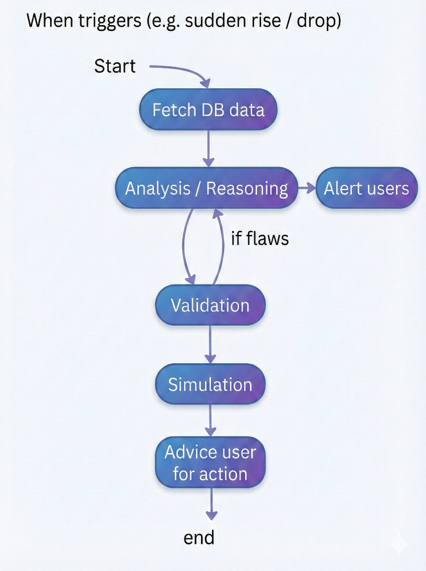

Trigger: Uses statistical thresholds (e.g., Z-score > 2 or high-volume rules) to identify "Significant Deviations".
Fetch Data: Pulls the "Now" state from APIs (like Finnhub/Yahoo Finance) and the "Historical" state from the Vector DB to find the "Why" behind the move.
Analysis: Breaks the move into technical vs. fundamental causes (e.g., "Earnings Leak" vs. "Fat Finger Trade").
Validation: Cross-references the reasoning with raw SEC filings or peer-company performance to catch hallucinations.
Simulation: Uses LLM-based agents to simulate "Buy/Sell/Hold" scenarios over 12 months to see the likely trend.
Action: Provides the user with a "High-Conviction Alert," a risk score, and specific "Advice" (e.g., "Hedge with Puts" or "Wait for RSI cooling").
Anti-Hallucination Strategy
Layer 1: Source Grounding (Prevention)
- Every piece of data fed to the analyst agent must have a source_url and retrieval_timestamp
- The analyst prompt must include: "Only make claims supported by the provided data. Cite [SOURCE_ID] for every factual claim."
Layer 2: RAG Validation (Detection)
- After the analyst produces output, the Validator agent queries the vector DB for each claim
- Uses cosine similarity threshold (e.g., > 0.75) to confirm factual grounding
- If any claim has no supporting document → flag as UNVERIFIED
Layer 3: Numerical Cross-Check (Verification)
- Extract all numbers from the analysis (revenue, growth %, margins)
- Compare against structured data (SEC XBRL, Yahoo Finance)
- If deviation > 5% → flag as NUMERICAL_ERROR
Layer 4: Self-Correction Loop (Remediation)
- If Validator finds flaws → return to Analyst with specific correction instructions
- Maximum 3 correction loops before escalating to user with transparency report
- Log all correction iterations for benchmarking hallucination rate
Layer 5: Confidence Scoring
- Each output gets a confidence score (1–10) based on:
A. Number of corroborating sources (more = higher)
B. Recency of data (older = lower)
C. Consensus alignment (contrarian = lower confidence, not lower validity)

Why This Project
1. 2026 Is the Most Complex Financial Era in Modern History
- AI Spending Bubble Uncertainty: By early 2026, investors are debating whether AI capex (led by Microsoft, Google, Meta, and Amazon spending $200B+ collectively) will yield returns or become the next dot-com bust. CNBC reports the "AI market is splintering" as investors scrutinize who is spending wisely vs. recklessly. A system that can perform second-order reasoning on AI supply chains is no longer a luxury — it's a necessity.
- Geopolitical Supply-Chain Disruption: Ongoing US-China tech sanctions, shifting trade tariffs, and energy policy changes create cascading second-order effects that are invisible to first-order analysis tools. When a tariff changes on rare earth minerals, the impact ripples through semiconductors → data centers → AI companies → energy providers. No existing tool traces this chain.
2. The "Reasoning Gap" Is Widening
- Most AI tools provide "Nvidia stock rose because they launched a chip", which is a first-order observation anyone can see. What investors need is "Nvidia's new chip will increase power consumption by 40% per data center, which benefits stocks like “Constellation Energy”, whose nuclear plants provide 24/7 baseload power, and their PPA contracts lock in revenue for 10+ years." This is the "Reasoning Gap" my FYP aims to bridge.
3. AI Hallucination in Finance Is a Critical Unsolved Problem
- In 2025–2026, multiple high-profile cases of AI-generated financial misinformation have eroded trust. AI tools that fabricate earnings numbers, cite non-existent SEC filings, or invent analyst opinions pose real financial risk to users who act on them.
- No existing open-source project treats hallucination as a first-class architectural concern. FinGPT and FinRobot generate outputs without validation. My project's 5-layer anti-hallucination pipeline (with RAG grounding, numerical cross-checks, and self-correction loops) positions it as a pioneering contribution to trustworthy financial AI.
4. Local LLMs Have Finally Reached "Good Enough" Quality
- As recently as 2024, running a capable reasoning model locally was impractical. But by early 2026:
  - DeepSeek-R1 (32B) delivers reasoning quality comparable to GPT-4 for structured analytical tasks
  - RTX 5070 Ti (16GB VRAM) can run Q4-quantized 32B models at practical speeds
  - Ollama has matured into a production-ready local inference server
- This means the "low cost" constraint is newly achievable. A year ago, this project would have required $100+/month in API costs. Today, it can run for $0/month, making it feasible as a student FYP.

