**1 Create a table called Employee & execute the following.**

**Employee(EMPNO,ENAME,JOB, MANAGER_NO, SAL, COMMISSION)**

1. **Create a user and grant all permissions to the user.**
2. **Insert the any three records in the employee table contains attributes**

**EMPNO,ENAME JOB, MANAGER_NO, SAL, COMMISSION and use rollback.**

**Check the result.**

1. **Add primary key constraint and not null constraint to the employee table.**
2. **Insert null values to the employee table and verify the result.**

**1.Create a user and grant all permissions to the user.**

SQL> CREATE USER <USERNAME> IDENTIFIED BY <PASSWORD>;

EX: CREATE USER csb093 IDENTIFIED BY csb093;

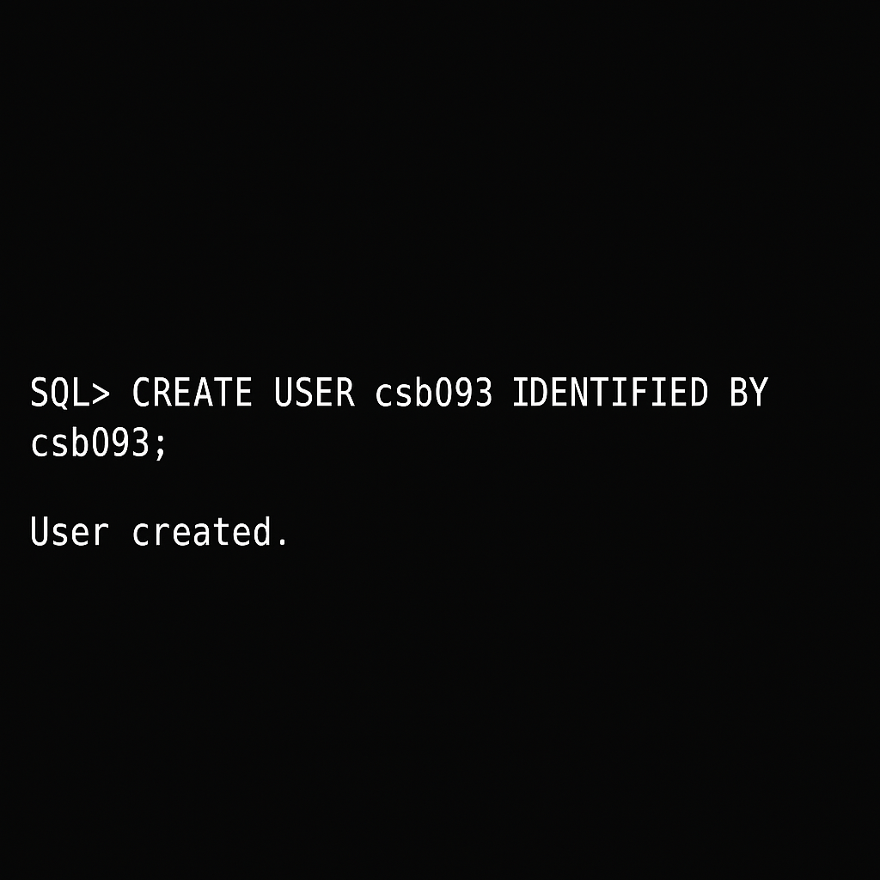

SQL> GRANT CONNECT, RESOURCE TO <USERNAME>;

EX: GRANT CONNECT, RESOURCE TO csb093;

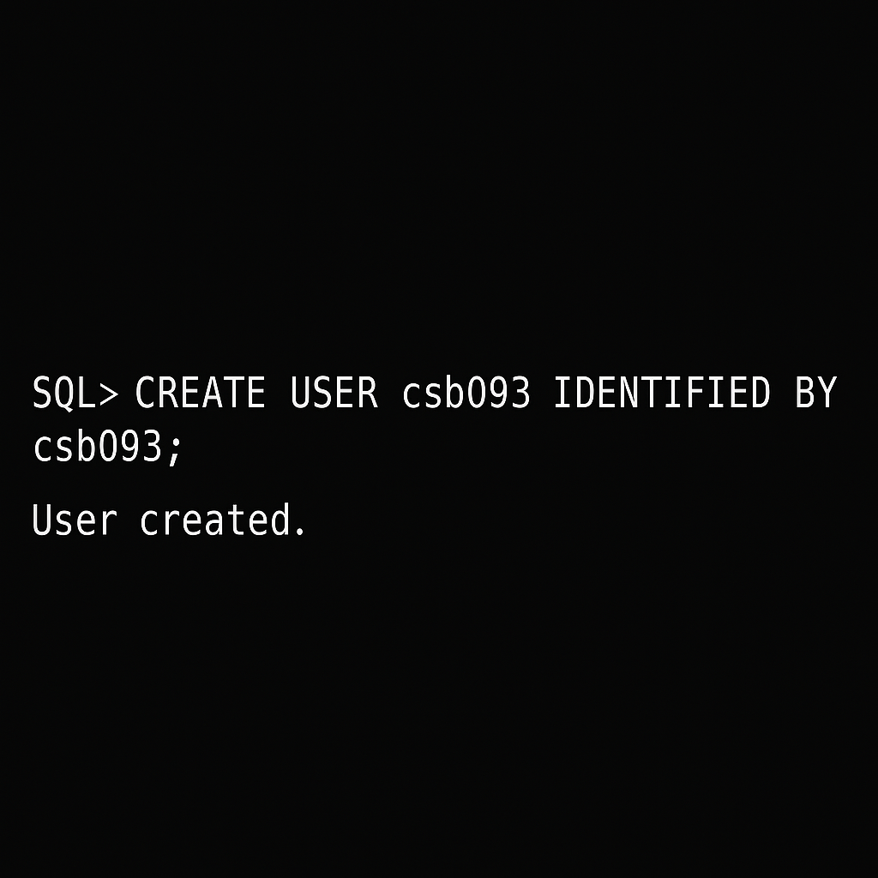

SQL> CREATE TABLE EMPLOYEE (

EMP_NO varchar(25),

ENAME varchar(25),

JOB varchar(25),

MANAGER_NO varchar(25),

SAL varchar(25),

COMISSION varchar(25) );

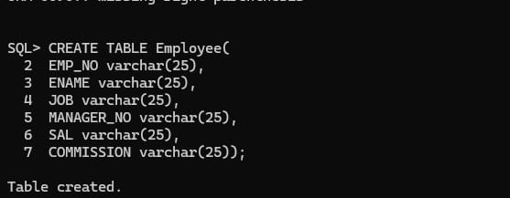

SQL> desc employee;

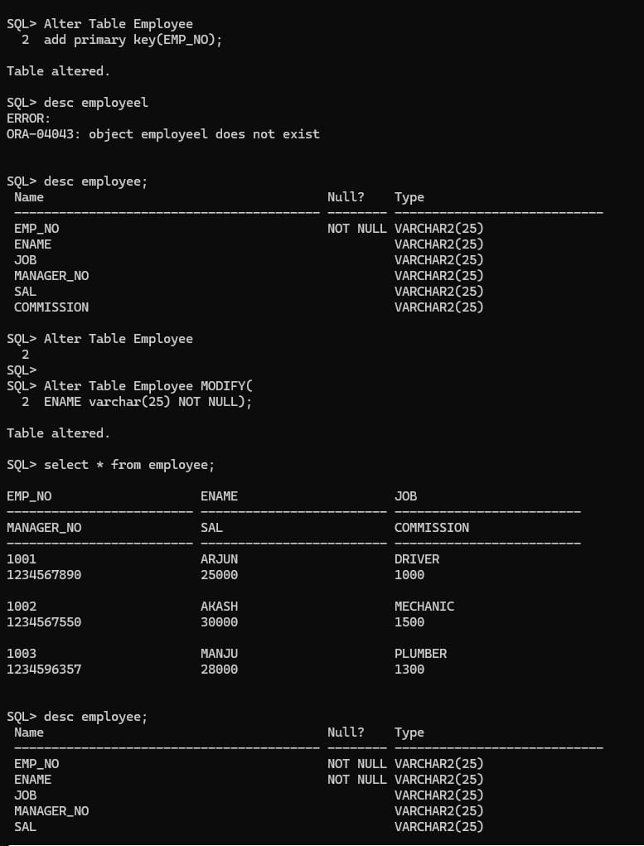

**2. Insert the any three records in the employee table contains attributes**

SQL> INSERT INTO Employee

VALUES('1001','ARJUN','DRIVER','1234567890','25000','1000');

1 row created.

SQL> INSERT INTO Employee

VALUES('1002','AKASH','MECHANIC','1234567550','30000','1500';

1 row created.

SQL> INSERT INTO Employee

VALUES('1003','MANJU','PLUMBER','1234596357','28000','1300');

1 row created.

SQL> select * from employee;

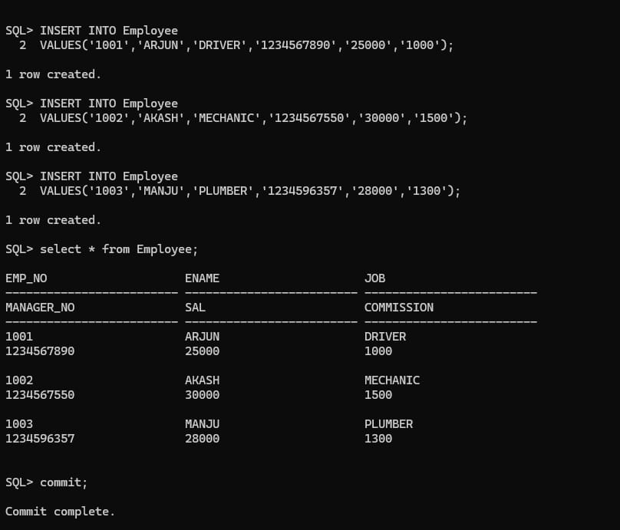

SQL> COMMIT;

Commit complete.

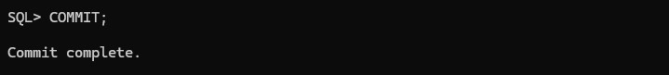

SQL> INSERT INTO Employee

VALUES('1004','FAHAD','ELECTRICIAN','9010256858','35000', '2100'); 1 row created.

SQL> INSERT INTO Employee

VALUES('1005','SUMANTH','CLEANER','9010253395','12000','600');

1 row created.

SQL> select * from employee;

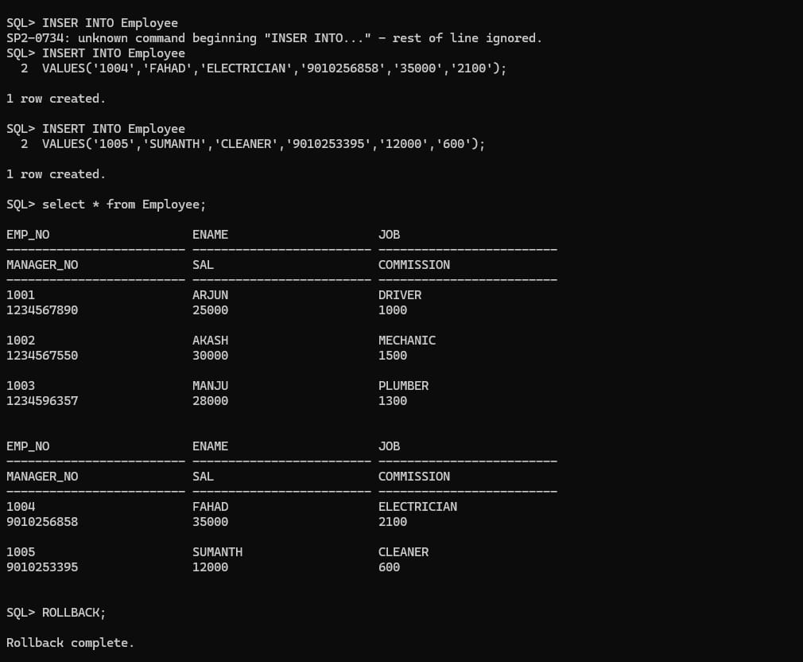

SQL> ROLLBACK;

Rollback complete.



SQL> SELECT * FROM EMPLOYEE;



1. **Add primary key constraint and not null constraint to the employee table.**

SQL> Alter Table Employee MODIFY(

Add primary key(EMP_NO);

Table altered.



SQL> desc employee;



SQL>Alter Table Employee MODIFY(

ENAME varchar(25) NOT NULL);

Table altered.SQL>select * from employee;



1. **Insert null values to the employee table and verify the result.**

SQL> insert into Employee

2 VALUES('1005','RAJU’,NULL,NULL,NULL,NULL);

1 row created.

SQL> select * from employee;

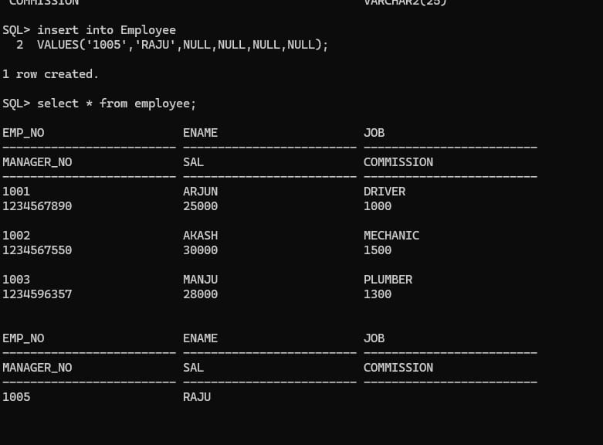

**2 Create a table called Employee that contains attributes EMPNO,ENAME,JOB,MGR,SAL & execute the following.**

**1.Add a column commission with domain to the Employee table.**

**2.Insert any 5 records into the table.**

**3.Updates the column details of job.**

**4.Rename the column of Employee table using alter command.**

**5.Delete the employee whose EMPNO is 105.**

**1.Add a column commission with domain to the Employee table.**

SQL> create table Employee (

EMPNO varchar(10),

ENAME varchar(10),

JOB varchar(10),

MANAGER varchar (10),

SALARY varchar(10),

);

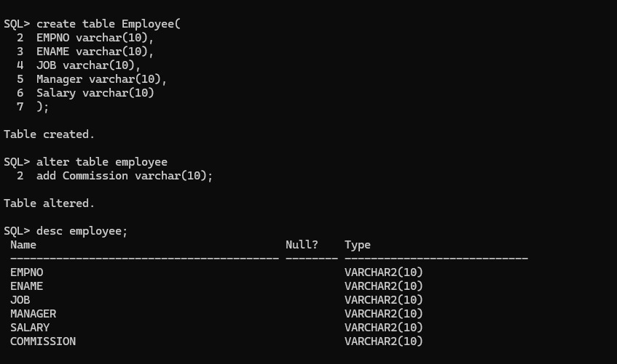

SQL>alter table employee

Add commission varchar(10);

Table altered.



SQL>desc employee;



**2.Insert any 5 records into the table.**

SQL> insert into employee

values('101','Rohith','CEO,'Mokshith','110000','4500');

1 row created.

SQL> insert into employee

values('102','Rohan','Cashier','Dilan','31000','1200');

1 row created.

SQL> insert into employee

values('103','Rakshith','Backend','Sachin','64000','27000);

1 row created.

SQL> insert into employee

values('104','Dilan','Designer','Akshara','69000','2200');

1 row created.

SQL> insert into employee

values('105','Monish','HR,'Jitesh','74000','3300');

1 row created.

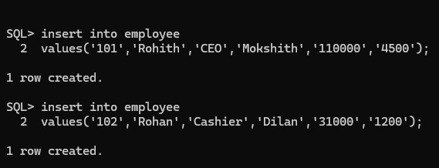

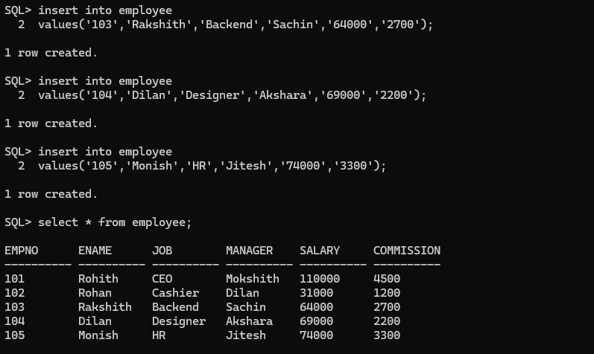

SQL> select * from employee;



**3.Updates the column details of job.**

SQL> update employee

set JOB=’FRONTEND’

where EMPNO=’103’;

1 row updated.

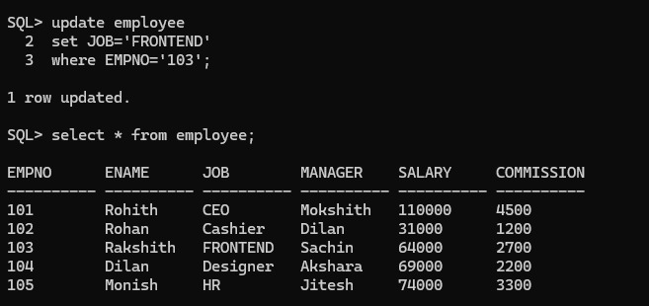

SQL> select * from employee;



**4.Rename the column of Employee table using alter command.**

alter table employee

rename column empno to SSN;

Table altered.

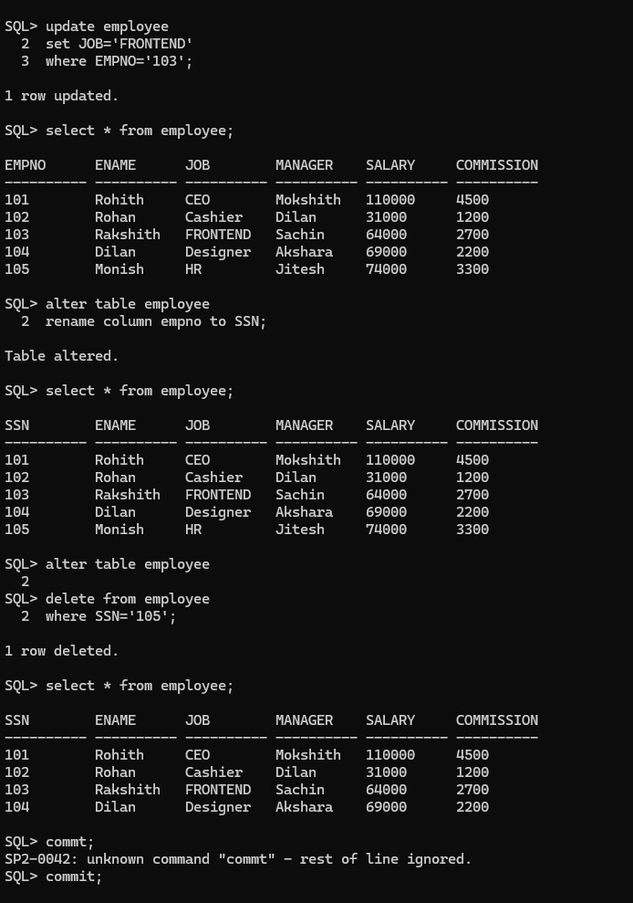

SQL>select * from employee;



**5.Delete the employee whose EMPNO is 105.**

SQL> delete from employee

where SSN=’105’;

1 row deleted.



SQL>select * from employee;



SQL>commit;

commit complete.

