**Analysis: AI vs Manual Code Completion**

In this task, I developed a Python program to sort and search car data from a Kaggle dataset containing fields such as *year, make, model, odometer, color,* and *selling price.* The program allows sorting by any key and lets the user input a specific year and model to display matching car details.

Using GitHub Copilot as the AI-powered code completion tool made the development process faster and more efficient. Copilot automatically suggested the correct syntax for data loading with Pandas, sorting using sort_values(), and even handling invalid user inputs. This saved time that would otherwise be spent recalling function names or syntax details.

The manual implementation required more thinking and debugging, especially when filtering by user input and managing case sensitivity. While the manual version offered deeper understanding and flexibility, the AI-generated version was more concise and optimized.

Overall, the AI-assisted code was more efficient because it minimized coding time, reduced syntax errors, and provided accurate function structures. However, manual coding was essential for logic customization and understanding the workflow behind the AI-generated code.

**Code Snippets**

**GitHub Copilot**

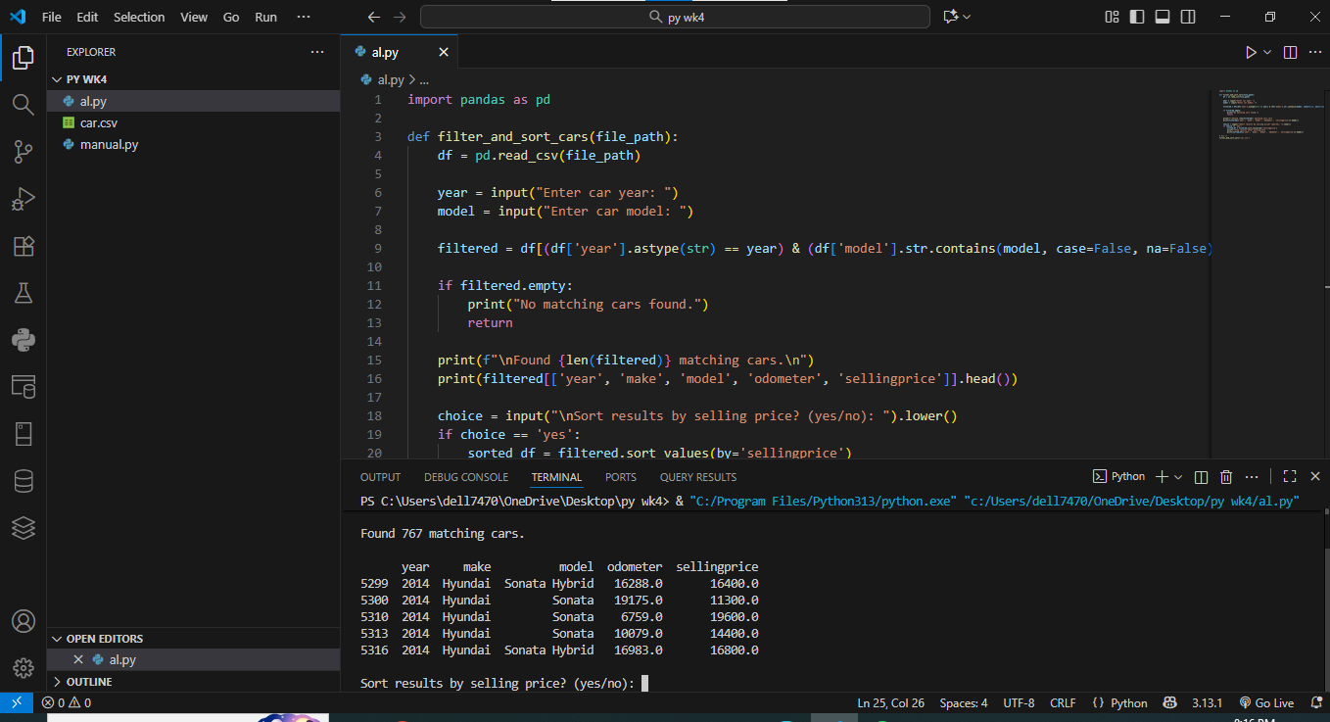

**Manual code**

