

GREAT ZIMBABWE UNIVERSITY
School of Natural Sciences
Department of Mathematics and Computer Science

HCS221: MACHINE LEARNING
FINAL PROJECT REPORT
Predicting Food Commodity Prices in Zimbabwe Using Machine Learning Techniques
Student Name: CHARLOME T MAMIRE
Student Number:M252012
Programme: BSc (Hons) Computer Science
Module: HCS221 Machine Learning
Submission Date: 26/10/2026

Abstract
This project investigates whether supervised machine learning regression can estimate historical prices of Roller Maize Meal in Zimbabwe. The study uses the Africa FEWS NET Staple Food Price Data for Zimbabwe monthly dataset, accessed through the Hugging Face dataset repository. The complete repository dataset contains 4,878 records and 17 fields. After selecting Roller Maize Meal and separating prices by currency, the modelling experiment uses 169 valid USD-denominated observations from April 2004 to February 2019. Calendar features and lagged prices were engineered, leaving 166 observations for the improved experiment. Linear Regression and Random Forest Regression were trained and evaluated using a chronological split, with a previous-observation baseline included for comparison. The tuned Random Forest achieved a test MAE of 0.0455 USD/kg, RMSE of 0.0678 USD/kg and R² of 0.5013. The baseline performed better, achieving MAE 0.0350, RMSE 0.0539 and R² 0.6855. The results show that recent observed prices provided a strong reference for this test period, while the selected machine learning models did not improve on that reference. Because the data are historical and relatively limited, the prototype is not suitable for quoting current market prices.
1. Introduction and Problem Definition
Food affordability is an important issue for households and businesses in Zimbabwe. Changes in the prices of staple foods can affect household budgets, purchasing decisions and planning by retailers and other stakeholders. Historical price information can help researchers understand how prices have changed, although historical observations alone cannot explain every cause of price movements.
The project focuses on Roller Maize Meal and asks: to what extent can historical dates and previously observed prices be used to estimate a later recorded price? This is a supervised machine learning problem, specifically regression, because the target variable is a continuous numerical value: the recorded price in USD per kilogram. The explanatory variables are year, month, the previous available observed price and the price three observations earlier.
Machine learning is worth investigating because it can learn statistical relationships from labelled examples and can represent relationships that may not be captured by a single manually specified rule. However, complexity does not guarantee better accuracy. Therefore, this project compares two machine learning algorithms with a simple previous-observation baseline. The baseline is important because prices often persist over nearby observations, and a more complex model should demonstrate measurable value before being preferred.
2. Data Source, Collection and Ethical Considerations
The data source is the Africa FEWS NET Staple Food Price Data for Zimbabwe — Monthly dataset hosted on Hugging Face. The repository identifies the original source as the Famine Early Warning Systems Network (FEWS NET), distributed through the Humanitarian Data Exchange (HDX). The dataset was obtained programmatically in Google Colab using the Python datasets library. The repository provides separate training and testing partitions; these were combined for initial exploratory inspection because the project subsequently creates its own time-ordered training, validation and test partitions.
The combined dataset contains 4,878 records and 17 columns, including country, market, administrative area, coordinates, product, observation date, price type, unit, currency and value. The dataset includes several commodity types and both USD and Zimbabwe-dollar prices. Roller Maize Meal was selected because it is a relevant staple-food product for a Zimbabwe-focused investigation. It had 396 records, of which 373 had non-missing prices: 169 in USD and 204 in Zimbabwe dollars.
The modelling subset was restricted to USD prices to avoid treating values expressed in different currencies as directly comparable. The selected USD observations covered April 2004 to February 2019. The dataset contains market-price information rather than personal records, so direct personal-data privacy risks are limited. Nevertheless, the data source must be acknowledged, the repository's current licence and attribution requirements must be checked before redistribution, and the prototype must not be represented as a source of current prices.
3. Data Cleaning and Preparation
The observation-date field was converted to a datetime type so that records could be sorted consistently and calendar features could be extracted. Roller Maize Meal records with missing target prices were excluded from price summaries and modelling. The currency filter retained only USD records. The selected USD subset contained 169 observations with no missing price values. Records were sorted from earliest to latest before feature engineering and splitting.
The original Roller Maize Meal data contained 23 missing price values across currencies. These were not imputed because the modelling target was the recorded market price and inventing a price could distort the learning task. Instead, records without a target value were excluded from the selected modelling series. Potential outliers were considered through price summaries and the historical price plot. No price was removed solely because it was unusually high or low: in economic time series, extreme values may represent real market conditions or currency-related effects. A stronger future analysis could investigate flagged observations against their source records before deciding whether they are errors.
No categorical encoding was required for the final models because the selected predictors were numeric. The project did not apply normalisation or standardisation. Random Forest does not require feature scaling, and scaling is not essential for ordinary Linear Regression to fit its coefficients, although transformations may be useful in other workflows. The year feature has a larger numerical scale than month and lagged prices; future experiments could compare a scaled linear-model pipeline, fitted using training data only, to assess whether it changes performance.
4. Exploratory Data Analysis
Exploratory Data Analysis (EDA) was used to inspect the dataset structure, product categories, currency distribution, missing values, price summaries and historical price movement. The first inspection showed 12 product categories and confirmed that the dataset includes commodities such as maize meal, maize grain, wheat flour, sugar, cooking oil and other products. Filtering to Roller Maize Meal narrowed the analysis to 396 records and then to 373 records with valid prices across currencies.
Currency-specific summaries showed why currency separation was necessary. The Zimbabwe-dollar series includes large nominal values that cannot be compared directly with USD values without a conversion approach and suitable exchange-rate information. The USD subset contained 169 observations, with recorded prices ranging from approximately USD 0.02 to USD 0.96 per kilogram. A line graph of prices over time was generated to observe variation and identify gaps in the observations.
The selected series is not a perfectly complete monthly sequence. Missing months mean that the previous row in the dataset may not correspond to the immediately preceding calendar month. The analysis therefore describes lagged variables as previous observations rather than assuming that every row represents a consecutive month.
5. Feature Engineering
Feature engineering created inputs intended to provide the models with useful time information. The year and month were extracted from the observation date. Two lag features were added after sorting chronologically: the price in the previous available observation and the price three observations earlier. The shift operation creates missing values at the start of the series where earlier observations do not exist. Removing those rows reduced the USD series from 169 to 166 usable observations.
The target remained the current recorded price. The lag features provide historical context that year and month alone cannot express. They also introduce a practical limitation: when the series has gaps, the lags refer to earlier recorded observations, not guaranteed calendar-month offsets. For a real forecasting service, this distinction should be handled explicitly, for example by constructing a complete monthly index and defining a policy for missing months.
6. Model Selection, Training and Tuning
The initial experiment compared Linear Regression and Random Forest Regression using year and month as predictors. Linear Regression provides a simple statistical baseline for representing a linear relationship between predictors and price. Random Forest Regression combines predictions from multiple decision trees and can capture nonlinear relationships. The observations were sorted by date and split chronologically, with the first 80% used for training and the final 20% reserved for testing. This avoids randomly mixing later observations into the training data when the intended use is estimation of later prices.
The initial experiment found that Random Forest performed better than Linear Regression, but both models had negative R² values on the test period. Negative R² indicates that, on those test observations, the model performed worse than a predictor based on the mean of the actual test targets. This suggested that year and month alone were insufficient for reliable estimates in this small series.
The second experiment added the two lagged-price features and compared the machine learning models against a previous-observation baseline. The data remained in chronological order. A separate validation subset from the training period was used to compare Random Forest settings. The tested configurations varied the number of trees (100 or 200) and maximum depth (3, 5 or unrestricted). The configuration with 100 trees and maximum depth 5 was selected because it produced the lowest validation MAE among the tested settings. The final test partition was reserved for evaluation rather than hyperparameter selection.
7. Evaluation Metrics and Results
Three evaluation metrics were used. Mean Absolute Error (MAE) is the average absolute difference between recorded and predicted prices, expressed here in USD per kilogram. Root Mean Squared Error (RMSE) is the square root of the average squared error and gives relatively greater influence to larger errors. The coefficient of determination (R²) compares model error with variation around the mean target; higher values generally indicate better fit, while negative values indicate performance worse than the mean-target reference on the evaluated data.

The previous-observation baseline was the strongest of the three approaches on the reserved test period. It had the lowest MAE and RMSE and the highest R². The lagged-feature Random Forest improved on Linear Regression in MAE, but its RMSE was slightly higher and its R² slightly lower. Tuning did not change the Random Forest's reported test metrics in this run. These results do not support claiming that machine learning outperformed the baseline. Instead, they indicate that the most recent observed price was a strong predictor for this particular test period.
The metrics should be interpreted in context. An MAE of 0.0350 means that the baseline's predictions differed from the actual test prices by an average absolute amount of about 3.5 US cents per kilogram. It does not mean that every prediction was wrong by that amount, and it does not guarantee similar accuracy in another period or currency.

8. Prototype Demonstration

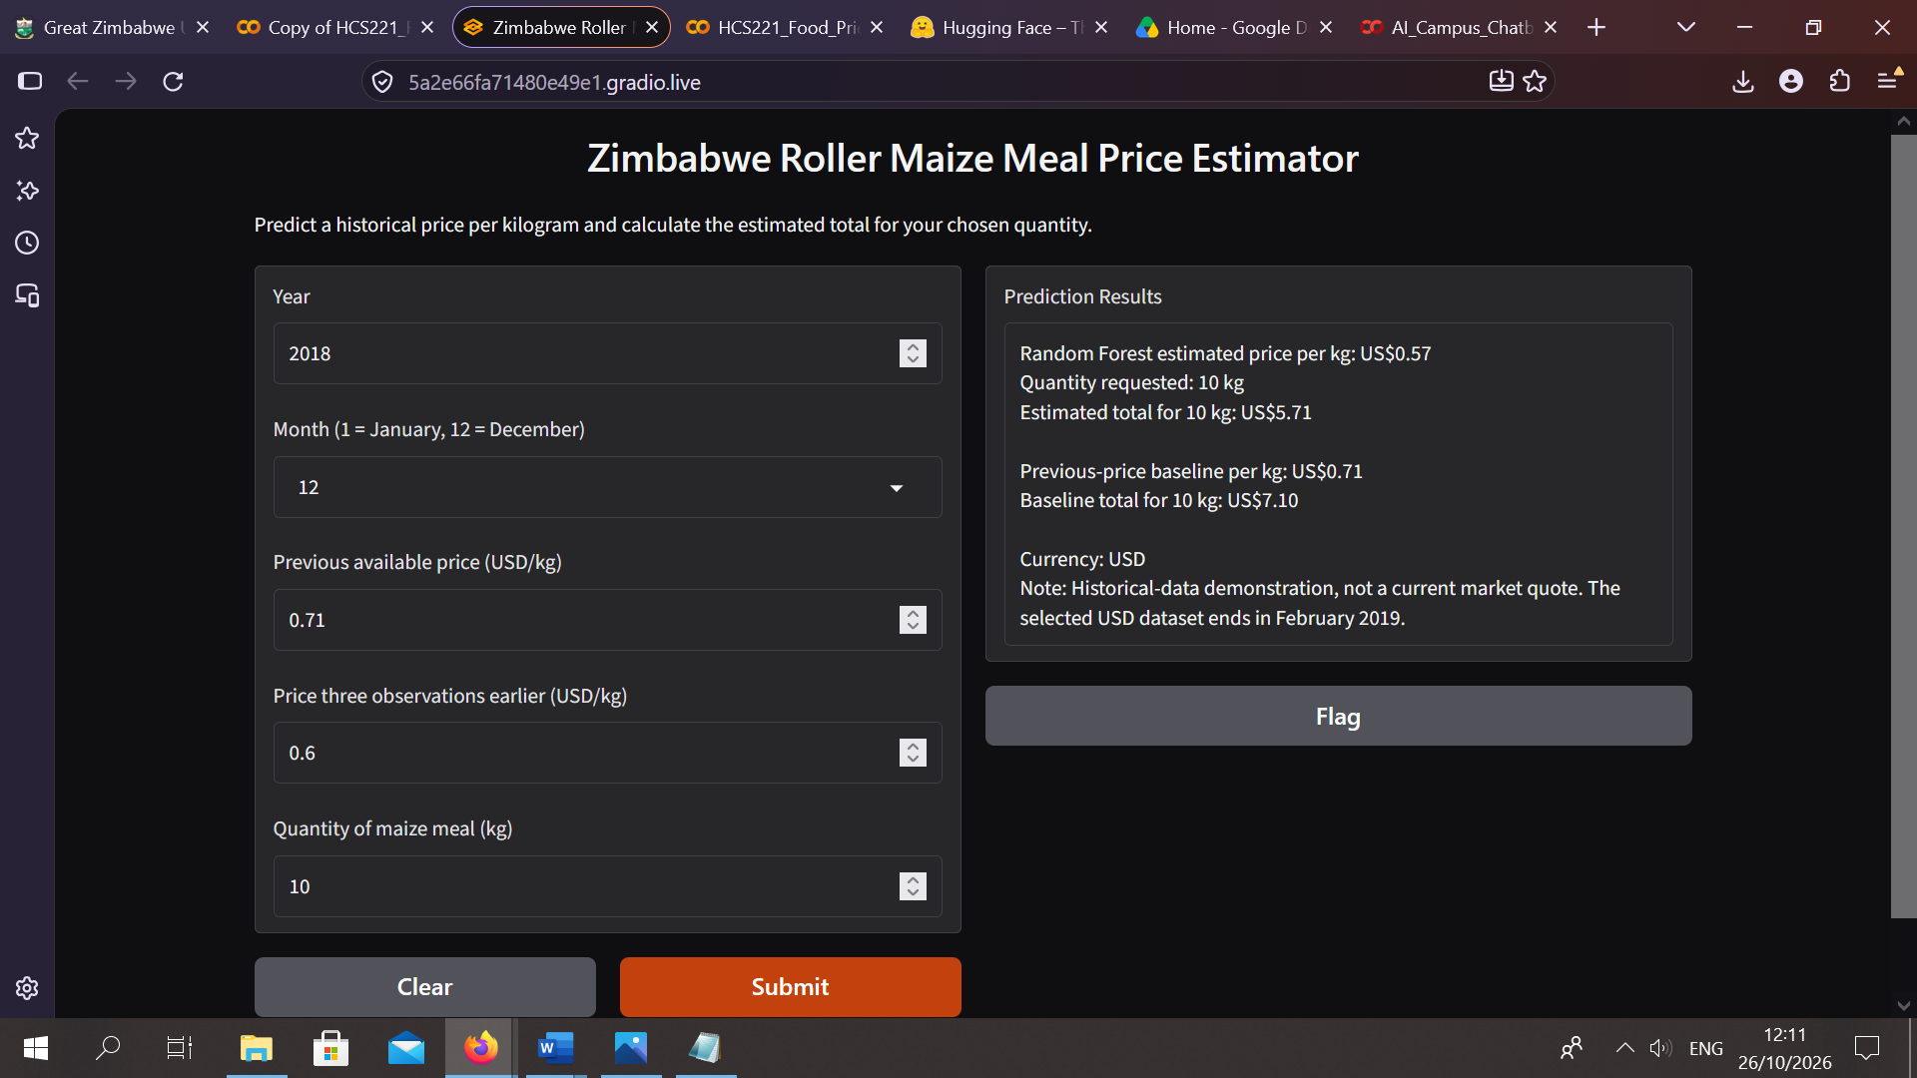
Figure 1**Figure 8.1: Gradio-based prototype for Roller Maize Meal price estimation and quantity-based cost calculation.**
A prototype was developed using Gradio to provide a simple interface for estimating historical Roller Maize Meal prices. The interface accepts the year, month, previous available price, price three observations earlier, and the quantity required in kilograms.
The system passes the numerical input features to the trained Random Forest regression model to produce an estimated price per kilogram. It also calculates the estimated total cost by multiplying the predicted unit price by the requested quantity. A previous-price baseline estimate and its corresponding total cost are displayed for comparison.
The prototype demonstrates how a trained regression model can be integrated into a user-facing application. However, it is an experimental demonstration rather than a validated service for current market prices. The underlying USD price series ends in February 2019, and the test results show that the previous-price baseline outperformed the machine learning models. Consequently, the predictions should not be interpreted as current market quotations or relied upon for financial decisions.
9. Limitations, Ethics and Recommendations
The main limitation is that the selected USD series ends in February 2019. Zimbabwe's currency and economic conditions have changed, and the historical model does not include current exchange-rate conditions, inflation, fuel and transport costs, weather, supply disruptions, market-specific factors or other drivers of food prices. The small sample of 169 USD observations—and 166 after lag creation—also limits the complexity that can be learned and the reliability of generalisation.
Missing months complicate the meaning of the lag features. In addition, combining training and test partitions supplied by the repository was appropriate for exploratory inspection in this project, but a production workflow should document the source partitioning and preserve an independent, time-ordered evaluation design. The experiment uses a chronological holdout and a validation subset for tuning, but additional rolling-origin validation would give a stronger indication of stability across time.
Ethical practice requires transparent communication of the data period, currency, units, errors and limitations. The model should not be used to advise households or businesses about current prices without newer data and further validation. The dataset's attribution and licence conditions should be followed. No personal customer data were used in the experiment.
Future work should obtain more recent and regularly updated market data, preserve market identifiers where sufficient records are available, and investigate additional explanatory variables such as transport costs, rainfall, supply conditions and market location. Alternative forecasting methods and rolling time-series validation could be tested. The baseline should remain part of future evaluations so that any added complexity must demonstrate a meaningful improvement.
10. Conclusion
This project implemented the main stages of a supervised machine learning workflow for estimating historical Roller Maize Meal prices in Zimbabwe. These stages included data acquisition, cleaning, exploratory data analysis, feature engineering, model training, hyperparameter tuning, evaluation and development of a prototype application.
The results showed that incorporating previous price observations provided useful information for price estimation. However, the previous-observation baseline outperformed both Linear Regression and Random Forest Regression on the reserved test set, achieving the lowest MAE and RMSE and the highest R². This demonstrates the importance of evaluating machine learning models against simple alternatives rather than assuming that more complex algorithms will produce better results.
The developed prototype demonstrates how a trained model can be integrated into a user interface for experimental price estimation and quantity-based cost calculations. Nevertheless, the model is based on historical data ending in February 2019 and should not be treated as a reliable source of current market prices.
Future work should incorporate more recent data, investigate additional factors affecting food prices, and use repeated time-based evaluation to assess model performance more robustly. Overall, the project demonstrates the practical application of regression techniques while highlighting the importance of evidence-based model selection, reproducibility and responsible interpretation of predictions.
References
Electric Sheep Africa. (n.d.). Africa FEWS NET staple food price data for Zimbabwe—monthly [Data set]. Hugging Face. https://huggingface.co/datasets/electricsheepafrica/africa-fewsnet-staple-food-price-data-for-zimbabwe-monthly-4566
Famine Early Warning Systems Network. (n.d.). FEWS NET. https://fews.net/
Humanitarian Data Exchange. (n.d.). The Humanitarian Data Exchange. https://data.humdata.org/
McKinney, W. (2010). Data structures for statistical computing in Python. In Proceedings of the 9th Python in Science Conference (pp. 56–61). https://doi.org/10.25080/Majora-92bf1922-00a
Pedregosa, F., Varoquaux, G., Gramfort, A., Michel, V., Thirion, B., Grisel, O., Blondel, M., Prettenhofer, P., Weiss, R., Dubourg, V., VanderPlas, J., Passos, A., Cournapeau, D., Brucher, M., Perrot, M., & Duchesnay, É. (2011). Scikit-learn: Machine learning in Python. Journal of Machine Learning Research, 12, 2825–2830. https://jmlr.org/papers/v12/pedregosa11a.html
The pandas development team. (n.d.). pandas documentation. https://pandas.pydata.org/docs/
The scikit-learn developers. (n.d.). LinearRegression. https://scikit-learn.org/stable/modules/generated/sklearn.linear_model.LinearRegression.html
The scikit-learn developers. (n.d.). RandomForestRegressor. https://scikit-learn.org/stable/modules/generated/sklearn.ensemble.RandomForestRegressor.html

