ESE_Python_1st_assignment 12532723 刘院芳

1. When the input values are a = 5, b = 15, c = 10, the output is empty.
2. A run output

[71, 2, 86, 16, 52, 61, 5, 44, 81, 22, 28, 32, 19, 78, 41]

[166, 5, 201, 38, 122, 143, 12, 103, 189, 52, 66, 75, 45, 182, 96]

3、Score 35 yields the maximum of Number_of_ways.

4、It can be seen from the image that when N increases to 90, the curve grows exponentially, and the values are extremely large.

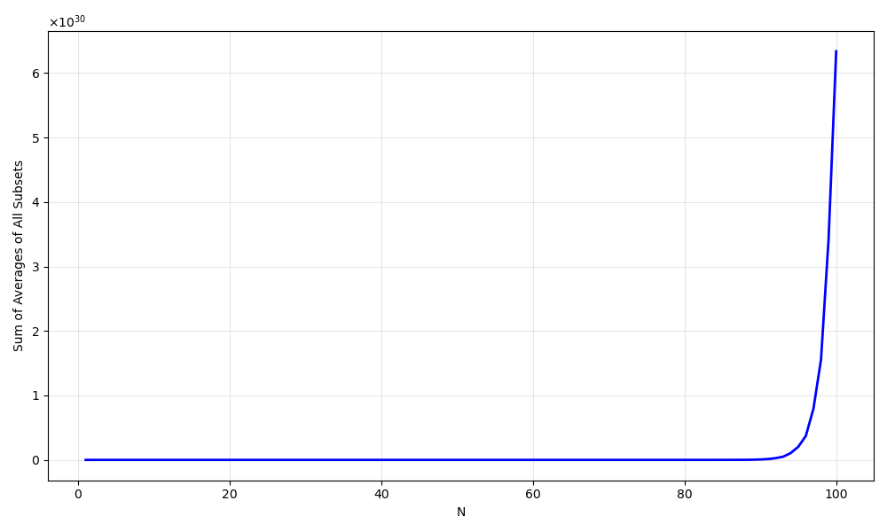

5、the mean of total number of paths from the 1000 runs is 0.4410